Part1.
Iteration 0: finds better clustering, latest reconstruction error is: 78.85566582597727
Iteration 2: finds better clustering, latest reconstruction error is: 78.851441426146
Score diff smaller than 1%, stop.

plot reconstruction error with k:
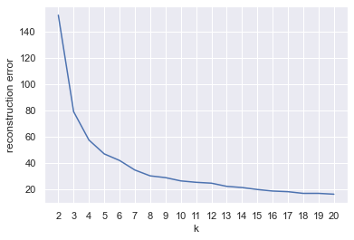
Manually found elbow: 6

Self-implemented algorithm to find it programmatically:
Try to do it algorithmically by calculating the speed of reconstruction error decline
Finding elbow k programatically...
Decline ratios calculated.
inspecting no.0 in raios
inspecting no.1 in raios
inspecting no.2 in raios
inspecting no.3 in raios
valid ratio counts inside window: 2, less than a half. Stop!
Found the elbow idx in ratios: 5, transforming to k...
The elbow k found: 8

Cannot calculate Accuracy Score because the number of classes is not the same as the number of clusters

confusion matrix:
cluster0 cluster1 cluster2 cluster3 cluster4 cluster5
setosa 0 22 0 0 0 28
versicolor 0 0 26 0 24 0
virginica 24 0 13 12 1 0

Classify the entire iris data set using cluster k=3
Accuracy score: 0.8933333333333333
confusion matrix:
cluster0 cluster1 cluster2
setosa 0 50 0
versicolor 48 0 2
virginica 14 0 36
Part2.
Iteration 0: found better lower_bound_ score: -1.2014746139064725
Iteration 44: found better lower_bound_ score: -1.2014746139064734
Score diff smaller than 1%, stop.

Plot AIC with k:
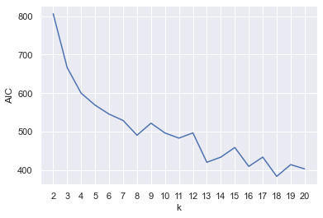

The elbow of the curve (aic_elbow_k): 8

Plot BIC with k:
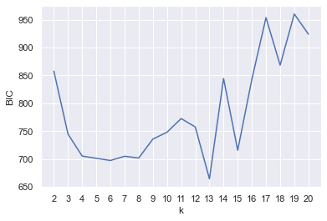
The elbow of the curve (bic_elbow_k): 4

Classify the entire iris data set using aic_elbow_k=8
Cannot calculate Accuracy Score because the number of classes is not the same as the number of clusters
confusion matrix:
cluster0 cluster1 cluster2 cluster3 cluster4 cluster5 \
setosa 15 0 0 0 0 35
versicolor 0 9 1 21 4 0
virginica 0 12 25 1 0 0

cluster6 cluster7
setosa 0 0
versicolor 15 0
virginica 0 12

Classify the entire iris data set using bic_elbow_k=4
Cannot calculate Accuracy Score because the number of classes is not the same as the number of clusters.
confusion matrix:
cluster0 cluster1 cluster2 cluster3
setosa 0 50 0 0
versicolor 33 0 1 16
virginica 0 0 45 5

Classify the entire iris data set using k=3
Accuracy score: 0.9666666666666667
confusion matrix:
cluster0 cluster1 cluster2
setosa 0 50 0
versicolor 45 0 5
virginica 0 0 50

