The original dataset for the semester project is the US border crossing dataset that purely focuses on border-crossing stats such as port information and crossing measurement. In order to excavate extra info, two datasets are joined: the GDP stats of each state, and the average temperature of each state, to explore the relation between border-crossing behavior and economical/thermal state.

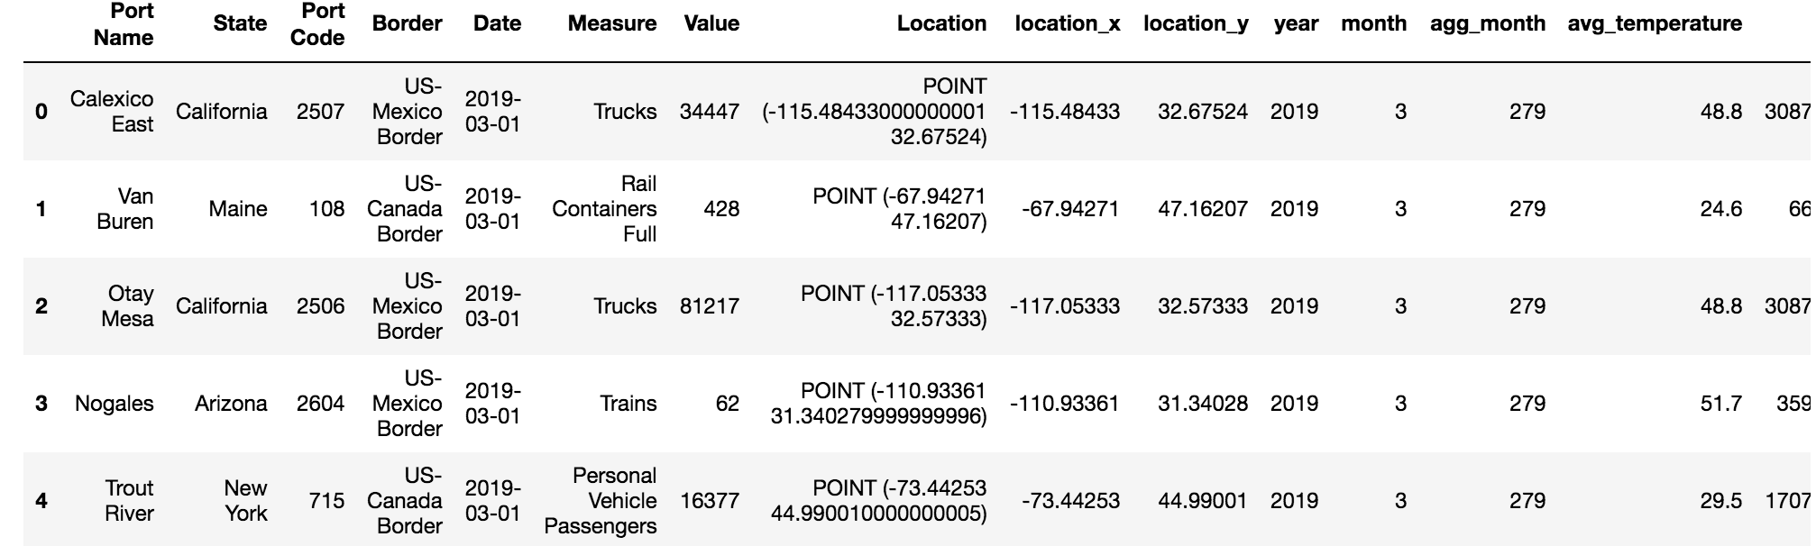
Original dataset
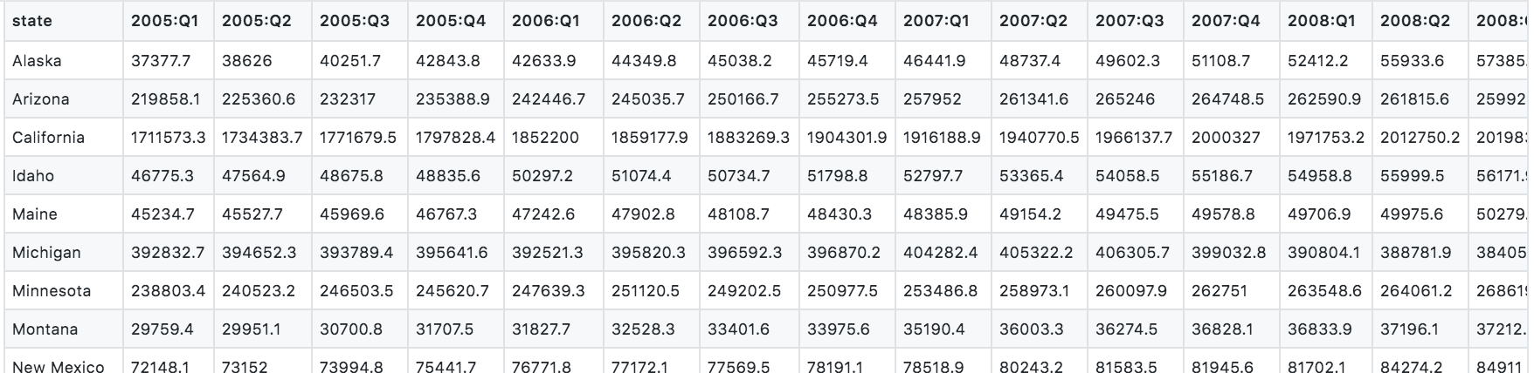
GDP by state dataset

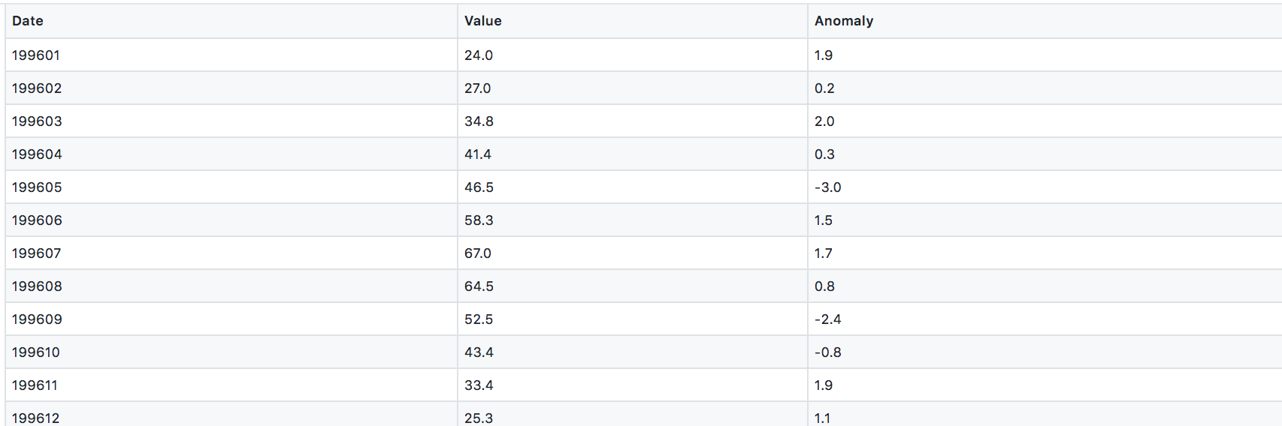
Average temperature by state dataset

Both these two datasets are on the grain of each state. After joining these two datasets, the visualization below shows the relation between border crossing values with state GDP.
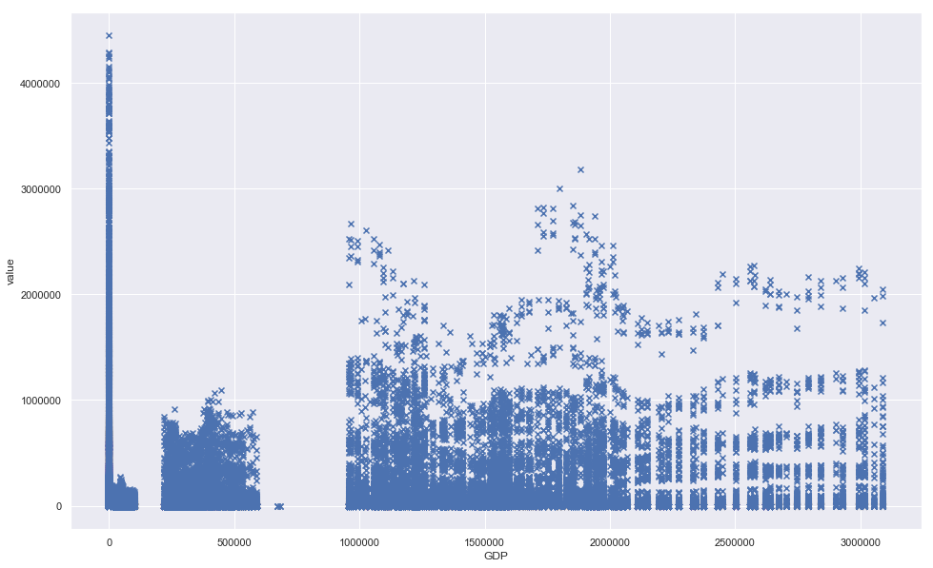

In general, border crossing values seem to distribute randomly on GDP quantity, with some outliers on low GDP states.
Then look at temperature factor. The below scatter chat plots the border crossing values going with state average temperature. It becomes quite obvious that there are more border crossing records when temperature rises, and the temperature window of [45, 85] locates a large proportion of border crossing activities.
