Below are some visualization analysis on the US border crossing dataset. These visualizations and analysis are done to get a holistic overview of our data, to get a high level knowledge of what’s happening inside each feature, and to induce what data wrangling & preprocessing can be done for further analysis and modeling.

First, above is the overall cross-border value quantity going over time. There are some salient seasonality in the data, with spikes and troughs observed.
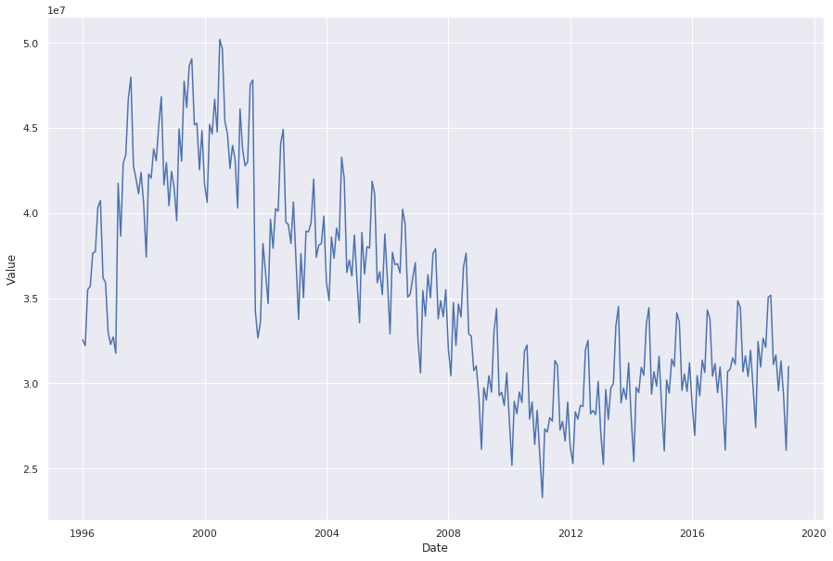

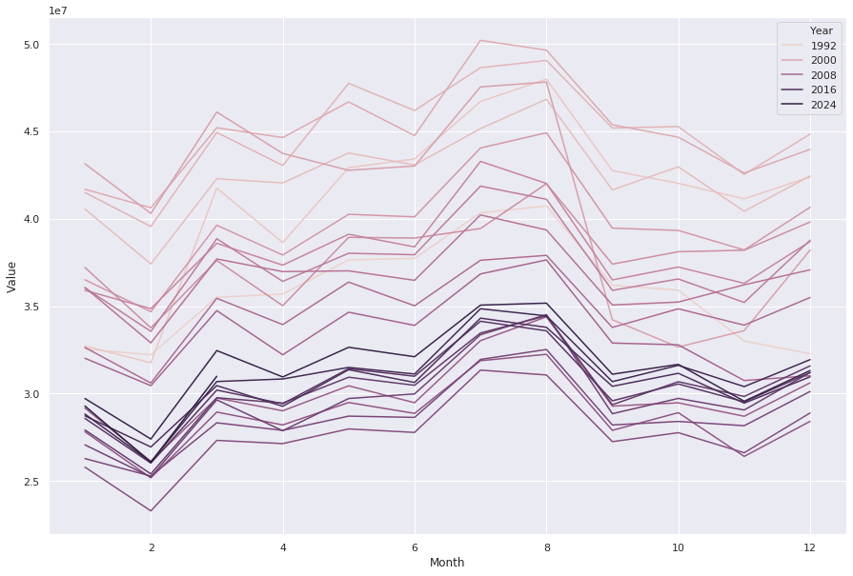
Above is the value breakdown in months. Obviously July and August are peak months in border-crossing behavior, probably due to weather patterns.

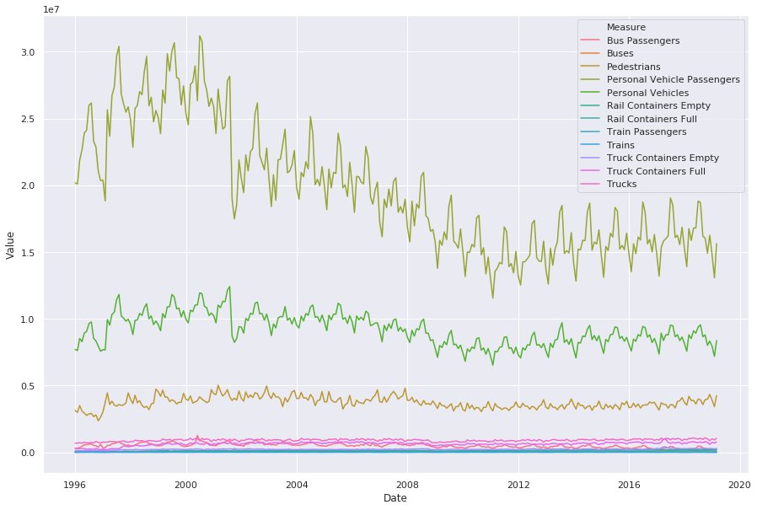
Here comes the border-crossing measure breakdown. It could be observed that personal vehicle passengers largely outperform all other approaches, going over time, but there’s a trend that the overall quantity declined since 2000.

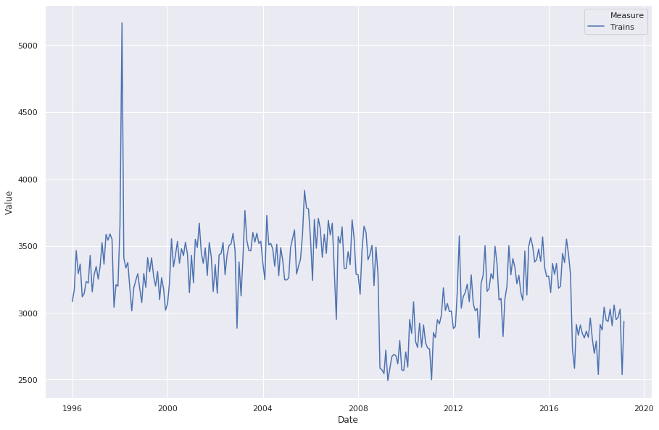
When deep diving into trains measure, there seems to be some irregular patterns going over time, with some big spikes and valleys. This leads to our efforts of doing anomaly detection.

Anomaly detection is done using isolation forest. Below is a visualization that shows the anomalies after data is squashed into 2-dimension using PCA.
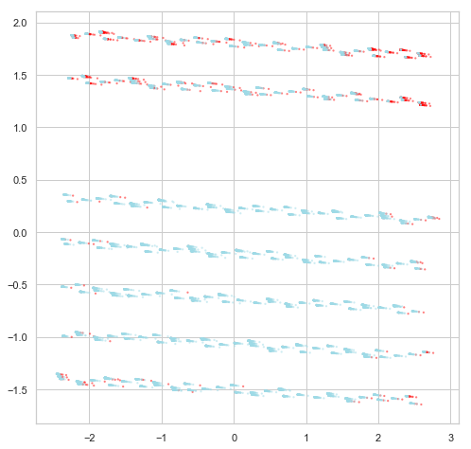

We can further show the anomalies detected in 3-d plot using plotly, shown below.
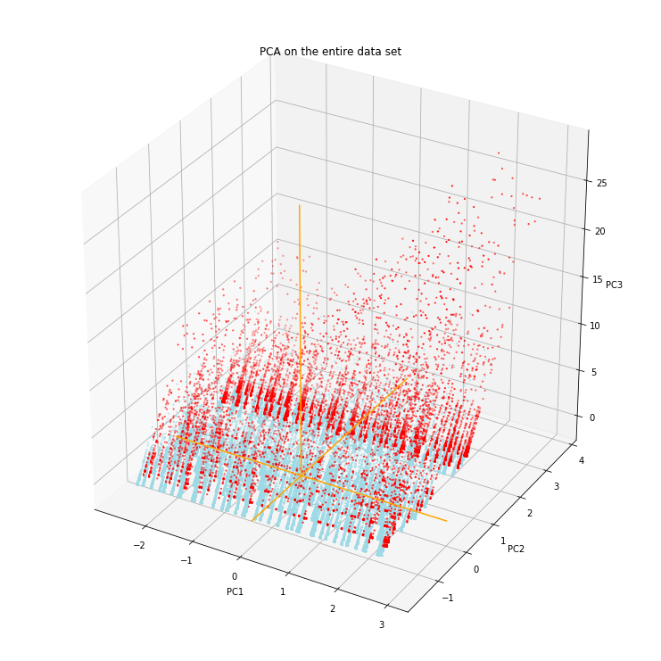
Anomalies are distributed mainly on the verge of these asparagus-like spikes. Below is the anomaly distribution pattern compressed using t-SNE.
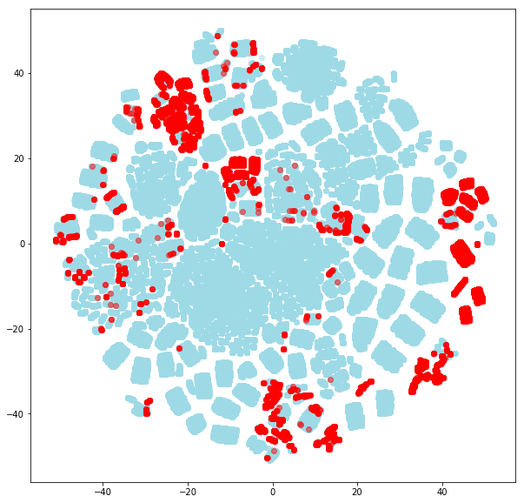
And they are also visualized in 3-d graph below. Anomalies are distributed around the peripheral areas of each clusters.
