The dataset chosen: The forest fire dataset.
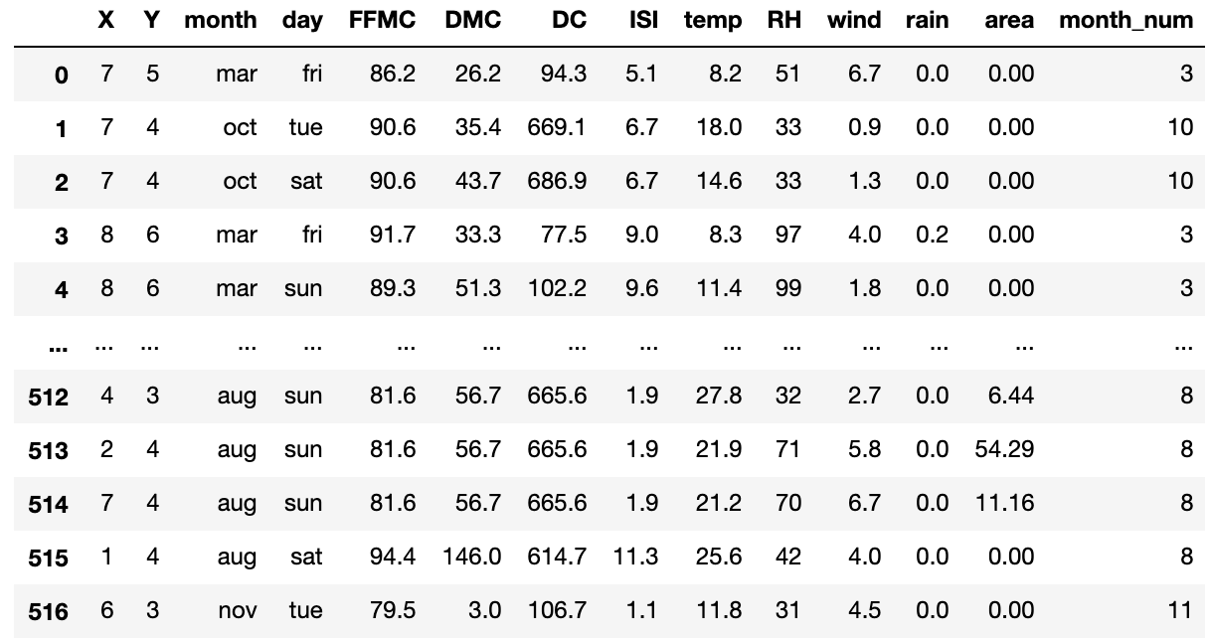

Distributions for each feature:
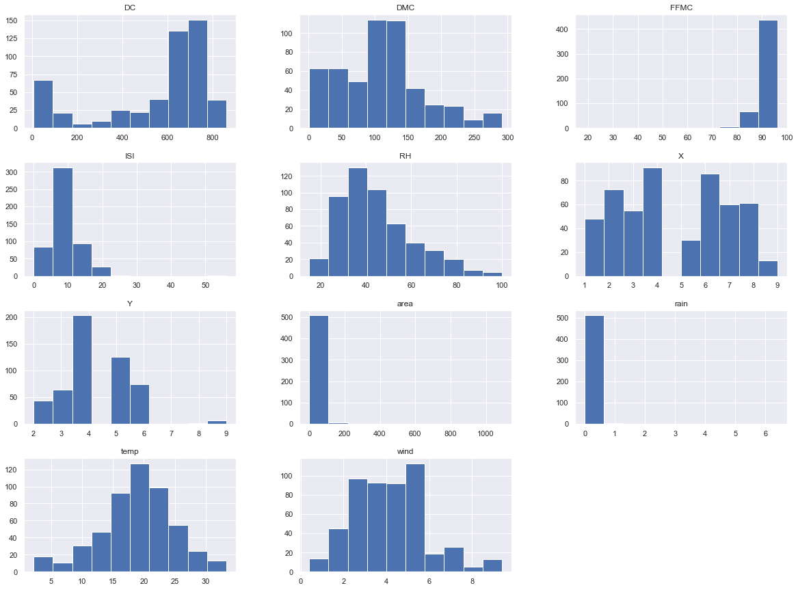
The pair plot between each two features:
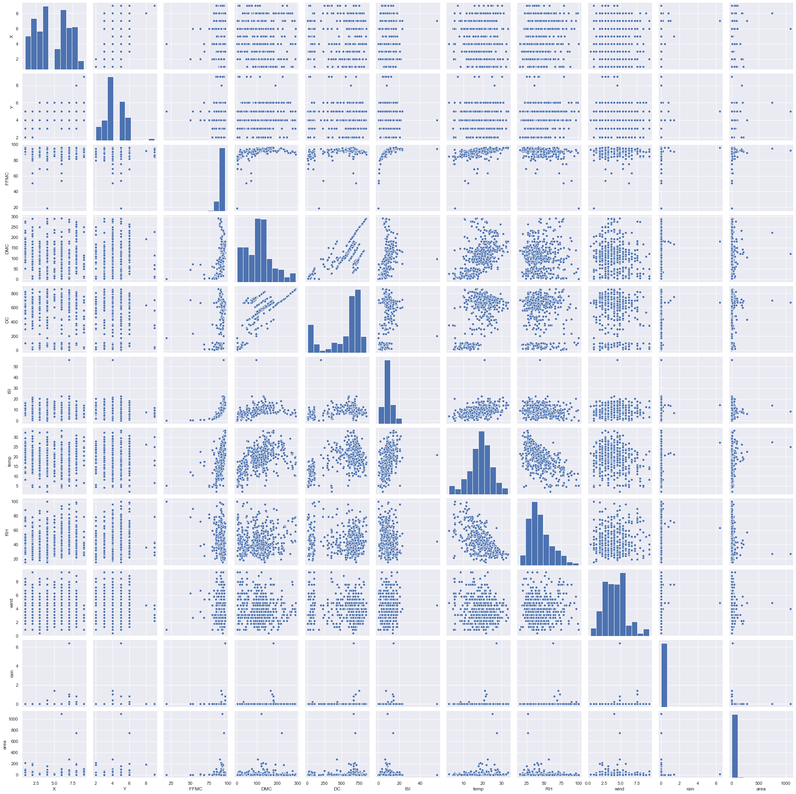

One example that holds to the expressiveness principle:
The below chart is a scatter plot between two features: DMC and FFMC, with the color channel indicating month. We can observe from the color channel that the value of DMC generally tends to increase with month until Sep, and there doesn’t seem to be a salient correlation between FFMC and month.
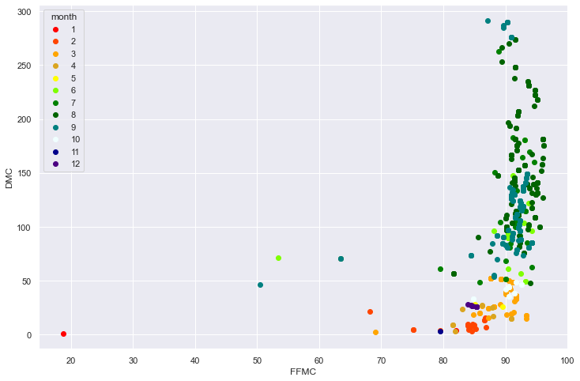

One example that violates the expressiveness principle:
Below is a line chart plotted between two features: temperature and wind. Since there’s no indicated order in the dataset, the default sample order, which does not make any sense, generates highly chaotic line charts for any two features.
