The below dataset is a housing price data competition on Kaggle, which contains 79 features and a label(sale price) for Boston housing.
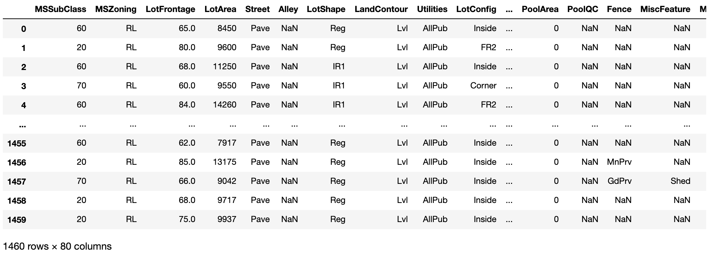

Columns that contain missing values:
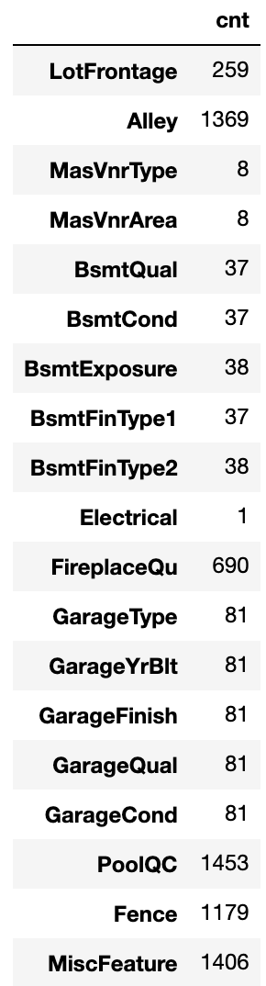

Try to impute missing values for numeric column “LotFrontage” and categorical column “FireplaceQu”.
For feature “LotFrontage”, below is a plot between “LotFrontage” and the label.
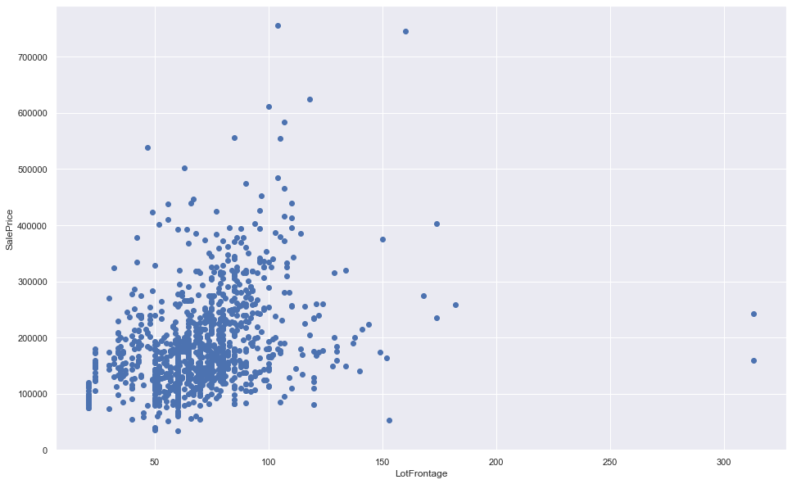

After imputing missing values with LotFrontage mean, the scatter plot looks like below.
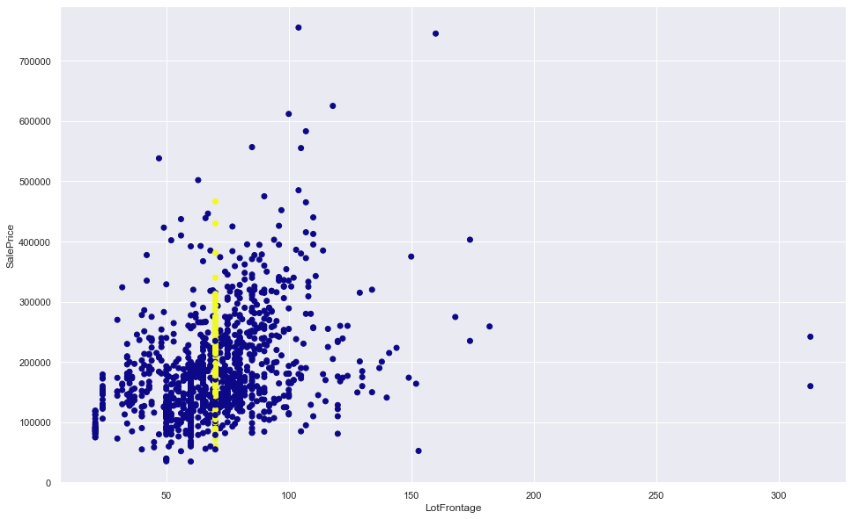
The yellow dots represent original missing values which are imputed with the mean.

For categorical column “FireplaceQu”, the original box plots of different categories are shown as below.
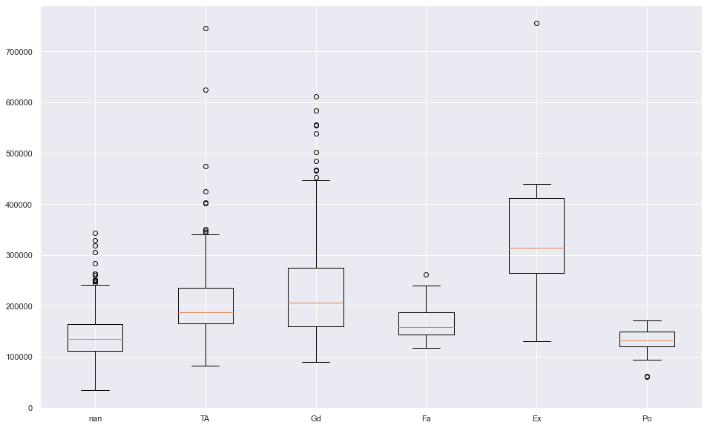

After imputing missing values with the FireplaceQu mode, the box plots are updated below.
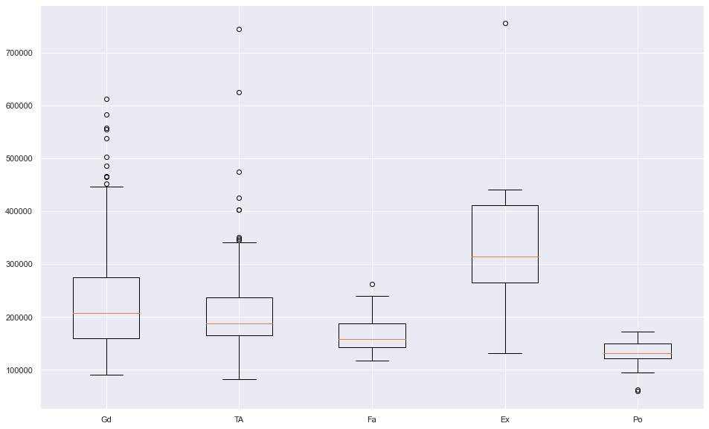
As shown above, the “nan” category disappears, which contributes to value “Gd” (though the difference in boxplot is not obvious enough to distinguish).

