Congratulations to Mr. Saurabh Sharma for successfully delivering his Open Seminar.
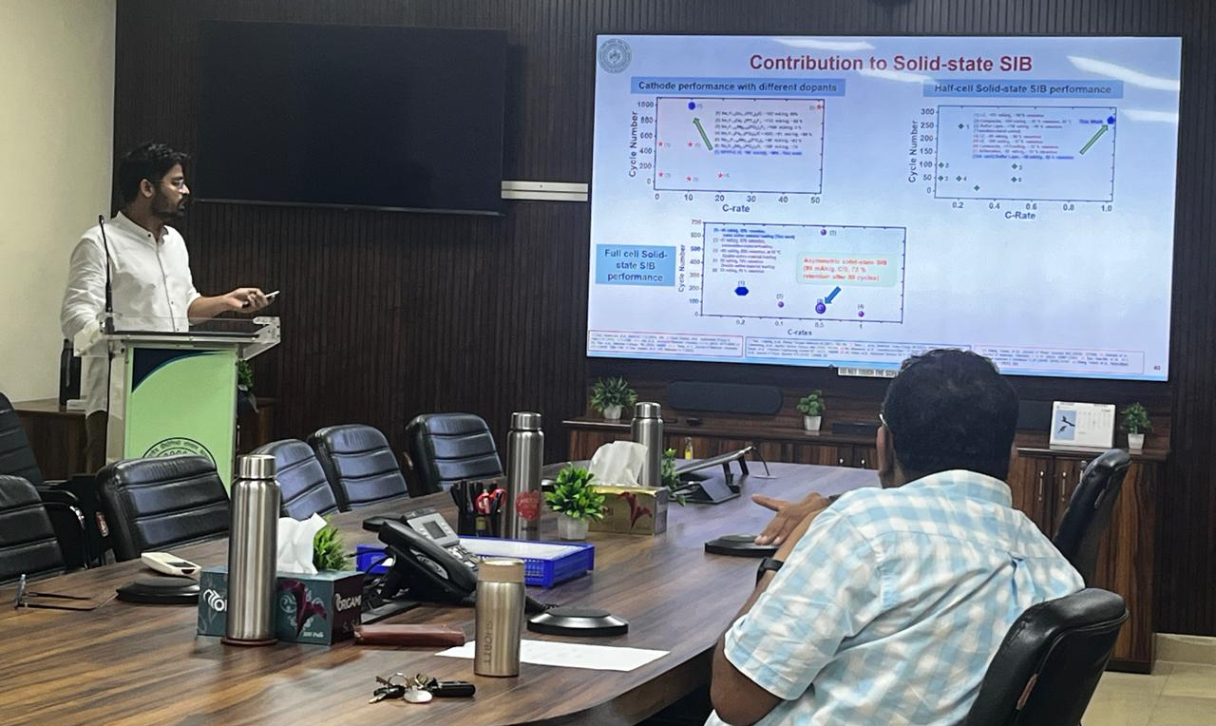

Congratulations to Mr. Saurabh Sharma for receiving the Lotus and RSD prize.

Mr. Sandipan has attended the Sintering 2026 conference (September).

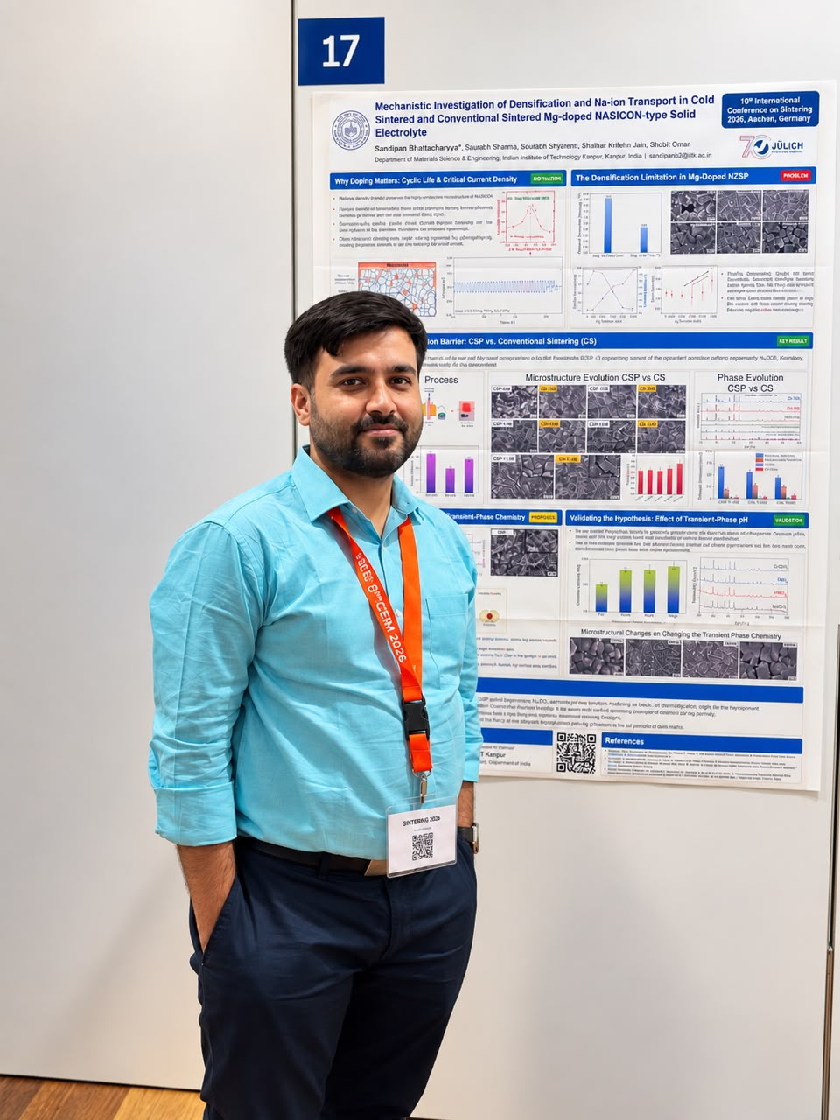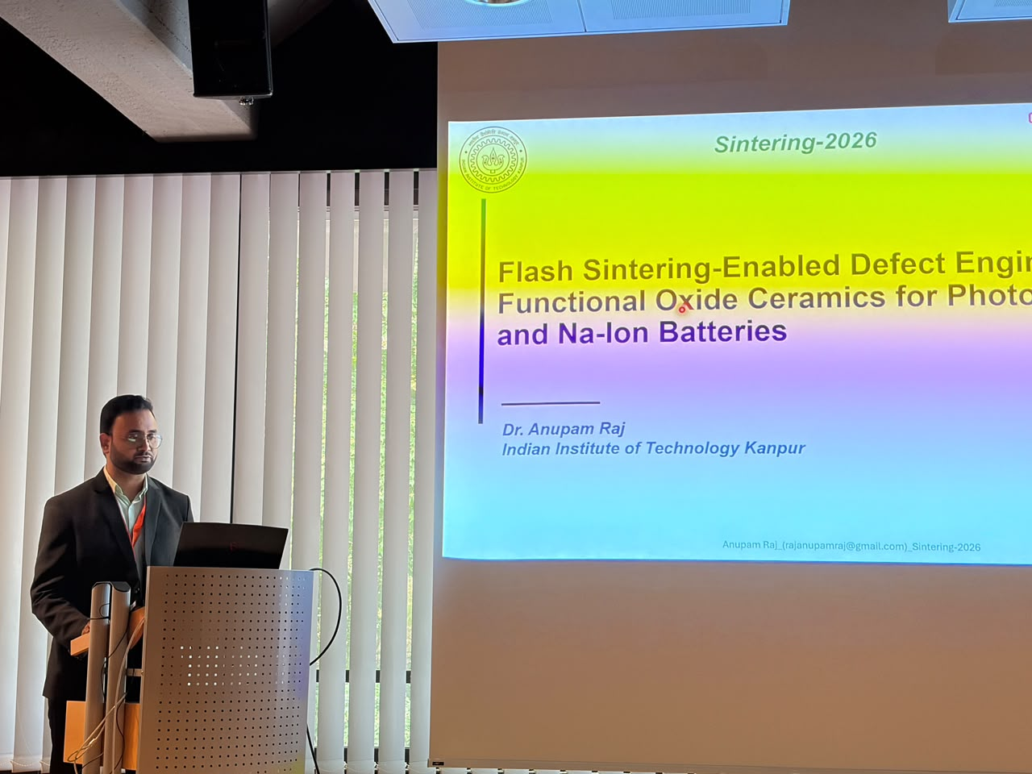

Congratulations to Mr. Thutta Mohan for successfully defending his M.Tech. thesis, joining Exide Industries
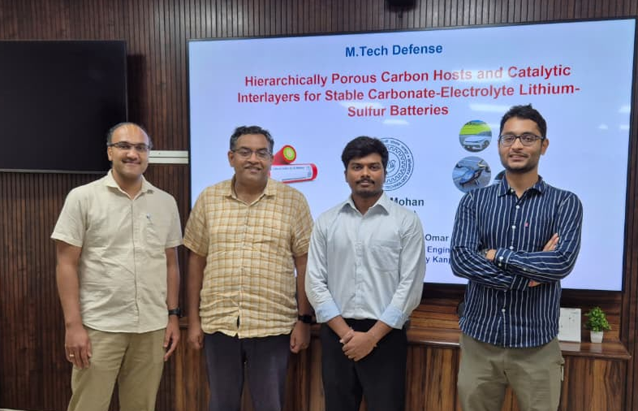

Congratulations to Dr. Anupam Raj for attending a conference and successfully defending his Ph.D. thesis, 5th feb 2026
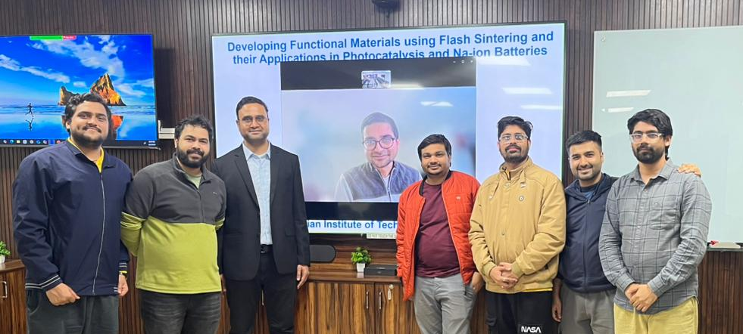

Congratulations to Mr. Pritam Ghosh for completing his internship at TCG.

May to July 2026: Congratulations to SURGE intern Anshika and SARIF intern Tejal for completing their internship and giving a presentation.

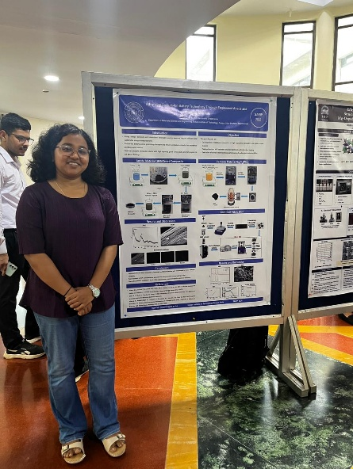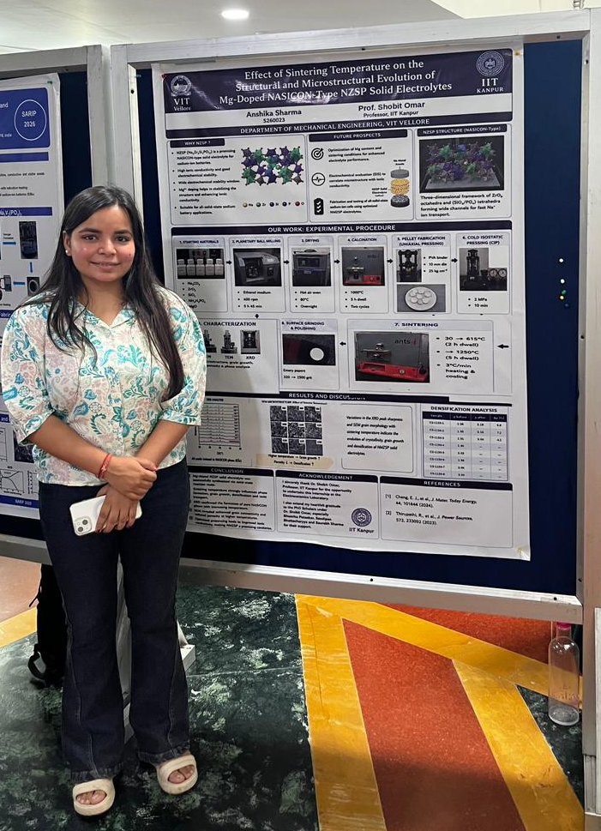

Mr. Suraj Kalia has attended a conference.

Prof. Shobit Omar visited IIT Jammu and IIT (BHU) Varanasi.

Congratulations to Mr. Darshil for successfully defending his M.Tech. thesis.

Congratulations to Mr. Anant for successfully defending his M.Tech. thesis.

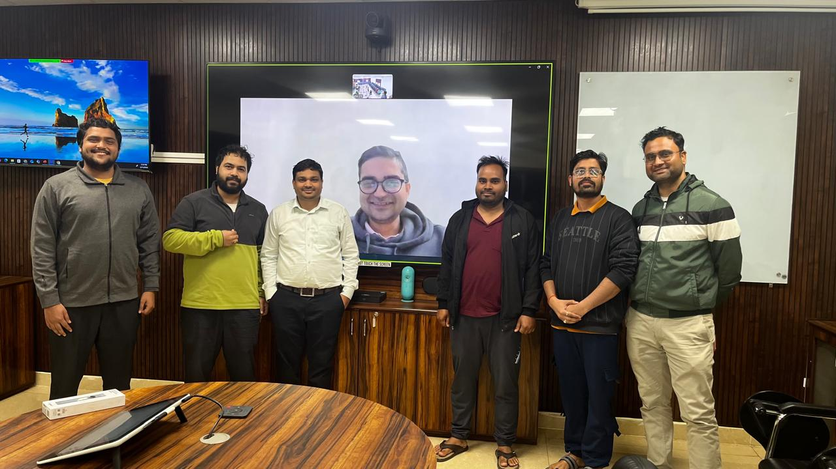
19 February 2026: Congratulations to Mr. Raghav for successfully delivering his Open Seminar

We welcome Melita and Ankan to the Electroceramics Laboratory.

Congratulations to Ms. Bhumika for successfully completing her comprehensive examination and SOTA seminar.
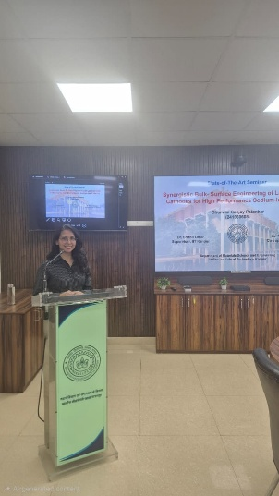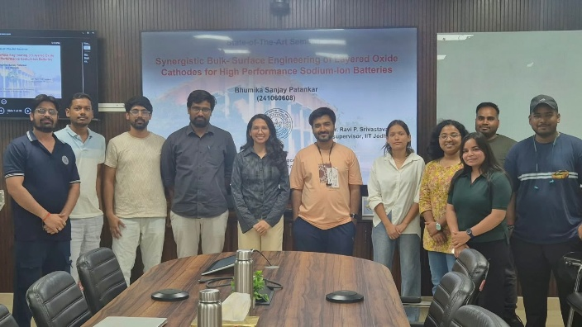

Congratulations to Ms. Raj Nandani for successfully completing her comprehensive examination. (25th Aug 2026)

24th March 2026 Congratulations to Dr. Mohd. Aman for successfully defending his Ph.D. thesis.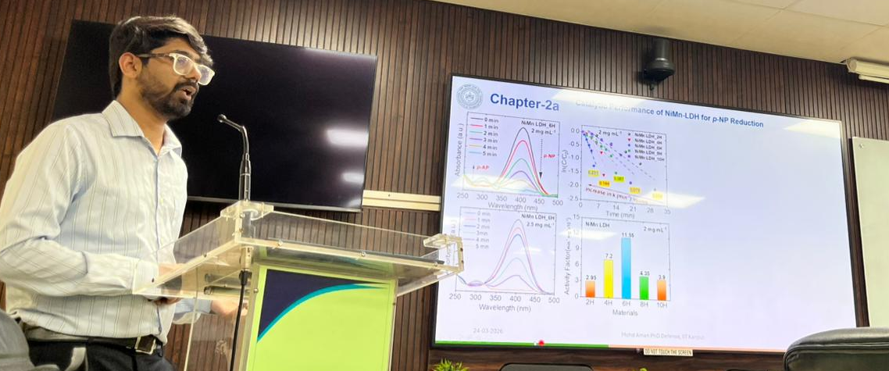

15th July 2026
Congratulations to Dr. Mohd. Aman and Thutta Mohan for receiving his degree at the convocation.
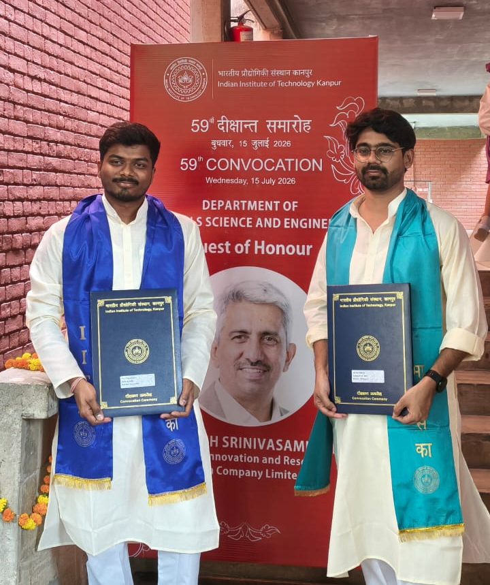

June 2026
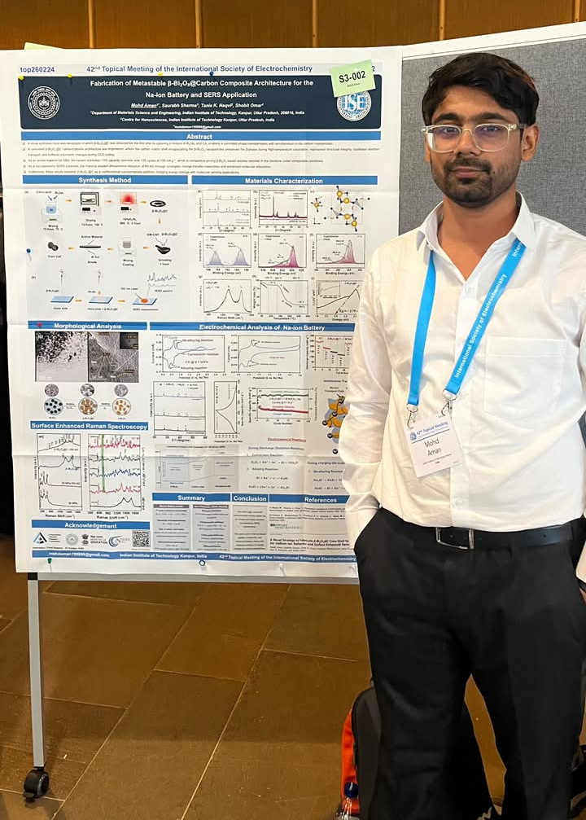
Dr. Mohd. Aman has attended the The 42nd Topical Meeting of the International Society of Electrochemistry (ISE) took place from June 23 to 26, 2026, at Aalto University in Espoo (Helsinki), Finland

Two new projects have been initiated with:
HYUNDAI Motors Company : Development of Solid electrolyte and Interface Engineering for high performance Solid State Sodium-on Batteries. (9 to 10 months) 2026
UPNADA: Centre Of Excellence On Innovative And Integrated Ecosystem For Green Hydrogen. ( July 2026 – July 2031 )

