Few words about John Grisham

**John Ray Grisham, Jr.** is an American lawyer, politician, and author, best known for his popular legal thrillers. His books have been translated into forty-two different languages. He began writing his first novel “[A Time to Kill](http://en.wikipedia.org/wiki/A_Time_to_Kill_%28Grisham_novel%29)” in 1984, and it was published in June 1989. As of 2012, his books had sold over 275 million copies worldwide.

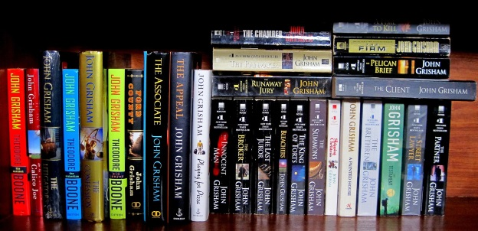

# Last Book

**Gray Mountain**

John Grisham has a new hero…

The year is 2008 and Samantha Kofer’s career at a huge Wall Street law firm is on the fast track—until the recession hits and she gets downsized, furloughed, escorted out of the building. Samantha, though, is one of the “lucky” associates. She’s offered an opportunity to work at a legal aid clinic for one year without pay, after which there would be a slim chance that she’d get her old job back…

## Some good words for the book

* “An important new novel… Grisham’s work—always superior entertainment—is evolving into something more serious, more powerful, more worthy of his exceptional talent.” –Patrick Anderson, The Washington Post
* “John Grisham makes a powerful closing argument against Big Coal, but the message never obscures a satisfying, old fashioned, good guy-bad guy legal thriller.” —Christian Science Monitor
* “Grisham has written one of his best legal dramas in quite some time with this dive into small-town politics. There’s a mystery, but that’s a minor portion of the story. The main thrust that will engage readers is Samantha Kofer and the cast of characters that help her discover her passion.” —Associated Press

# Most Popular Books in Thriller

|  |  |  |
| --- | --- | --- |
| Book name | Year | Genre |
| Gray Mountain | 2014 | Novel |
| Sycamore Row | 2013 | Novel |
| The Racketeer | 2012 | Novel |
| Calico Joe | 2012 | Novel |
| The Litigators | 2010 | Novel |
| The Confession | 2010 | Novel |

# Non-fiction books

1. The Wavedancer Benefit: A tribute to Frank Muller (2002)
2. The Innocent Man: Murder and Injustice in a Small Town(2006)