RadRichTextBox for Silverlight/WPF

Overview
RadRichTextBox is a control that offers Microsoft Word-like authoring and editing in your applications using a familiar interface for end users. The experience is enhanced by the support of multilevel bullet and numbered lists, tables, inline and floating images. More advanced options include external and in-document hyperlinks, bookmarks and comments.
The control can preview and edit text in various languages thanks to the Input Method Editor and the Right-to-Left support, which makes it an appropriate choice in a wide range of applications. Even more sweetness is added by the integrated spell-checker and image editor allowing immediate detection and correction of spelling mistakes and in-place tweaking of images.

MS Word-like Authoring
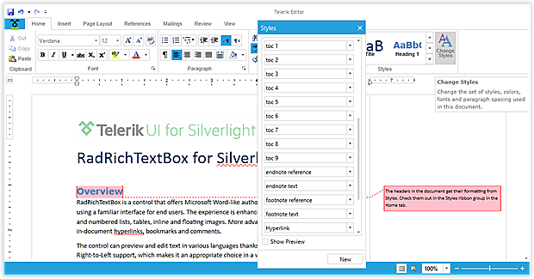
Provide Microsoft Word-like authoring and editing in your applications using a familiar interface for your end users.

Rich Document Model Support
Get a more complete rich text editing experience with support for Lists, Tables, Inline and Floating Images, Hyperlinks, Bookmarks and Comments.

With SpellChecker & Image Editor
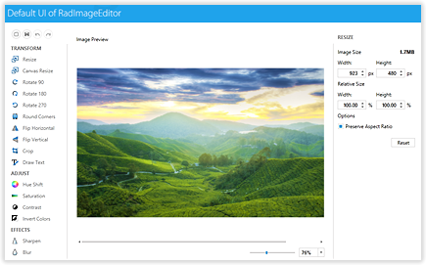
With integrated SpellChecker and ImageEditor, provide on-the-fly proofing and tweaking of images, all without leaving the document UI.

Markup & Navigation
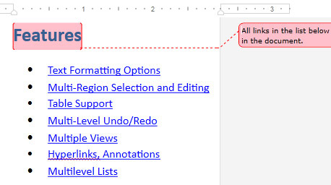

Markup your documents with Word-like comments and enable document navigation with a built-in Bookmark system.

Import & Export
Import and export to and from Docx, RTF, HTML, XAML and Txt, as well as export to PDF - all without writing a single line of code.

Document Protection
Define different editing restrictions and enforce them on different parts of the document. Import and export protected documents in the supported file formats.

VS Wizard
Add a fully featured rich text editor to your solution in under a minute thanks to the click-through interface provided by Visual Studio's wizard.

Different Views & Printing
Use a standard TextBox-like layout or a Paged view with various sizes and Headers and Footers. Utilize the printing functionality that comes out of the box.

Mail Merge
Create or open existing templates and fill in different data taken from database, spreadsheet or any other source. Preview the results in the RichTextBox or proceed with exporting.

RTL and IME
Allow entering text in various languages thanks to the built-in Input Method Editor and Right-to-Left support.

Intuitive Editing Experience
Provide an intuitive editing experience thanks to the integrated RibbonView, context menus, mini toolbars and dozens of dialogs designed to gear the functionality of the control.

Performance
Ensure quick loading even of larger documents. Further editing can be performed without significant performance hit due to the built-in UI Virtualization.

