To better understand the spatial patterns of CitiBike usage, an exploratory spatial data analysis (ESDA) was conducted, encompassing spatial visualization, spatial autocorrelation diagnostics, and assessments of spatial heterogeneity.

**Ride Activity Distribution**

The spatial distribution of CitiBike ride activity exhibits notable temporal and spatial variations across January, July, and October of 2019. In January, ride activity is relatively low, with most stations recording fewer than 7,654 rides, concentrated in Manhattan’s central and southern areas. As expected, activity increases significantly in July, a peak summer month, with several stations in Manhattan and parts of Brooklyn showing ride counts exceeding 14,895. This surge reflects heightened demand during warmer weather and tourist seasons. The number of stations also increased dynamically, with 792 stations in January, 841 in July, and 848 in October, reflecting operational adjustments by the provider. By October, while the overall ride activity decreases compared to July, it remains higher than in January, with prominent clusters of high activity persisting in Manhattan and select areas of Brooklyn. Across all months, Manhattan consistently dominates as the primary hub of CitiBike usage, particularly in densely populated and transit-heavy zones. This pattern underscores the influence of seasonality, urban density, and transit accessibility on bike-sharing demand.

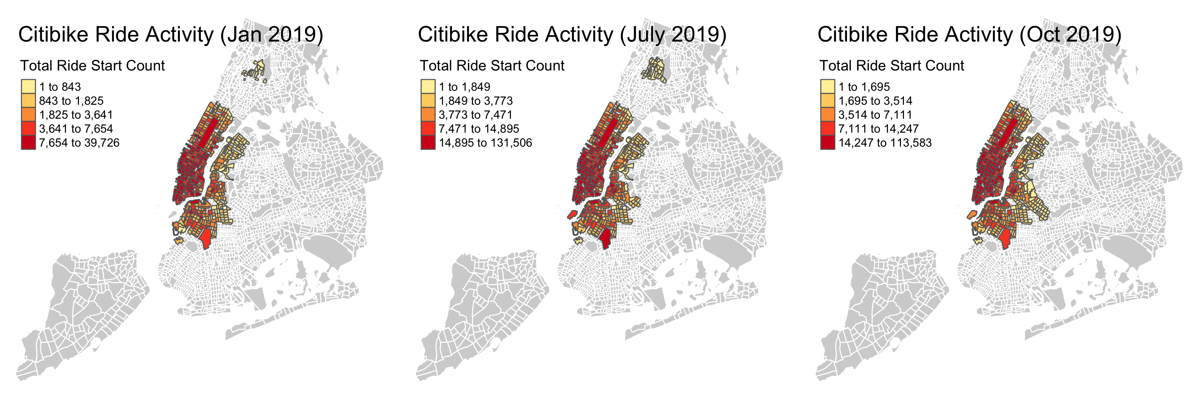

说明

**Spatial Autocorrelation Analysis**

The Moran's I analysis for January, July, and October reveals significant spatial autocorrelation in CitiBike ride activity. The weight matrix was computed using adjacency lists based on aggregated polygon boundaries. January's Moran's I is 0.474, July's is 0.445, and October's is 0.478, all with extremely low p-values (<2.2e-16), indicating strong spatial clustering. The positive Moran’s I values suggest that areas with high or low ride counts are spatially clustered.

**| **Month** | **Moran's I** | **Expected I** | **Variance** | **p-value** |**

**|-------------|---------------|----------------|--------------|-------------------|**

**| January | 0.474 | -0.00243 | 0.00101 | < 2.2e-16 |**

**| July | 0.445 | -0.00228 | 0.00092 | < 2.2e-16 |**

**| October | 0.478 | -0.00231 | 0.00091 | < 2.2e-16 |**

The Local Moran’s I maps reveal spatial heterogeneity in CitiBike usage across January, July, and October. High Local Moran’s I values (in red) indicate significant clusters of high activity, primarily concentrated in lower Manhattan and parts of Brooklyn. In January, clustering is limited to central areas, reflecting reduced winter demand. July exhibits broader clustering, with intensified hotspots in Manhattan and new clusters in Brooklyn, correlating with peak summer ridership. October shows a similar pattern to July, but with slightly reduced intensity. These results highlight seasonal shifts in spatial clustering while maintaining consistent core hotspots in high-demand areas.

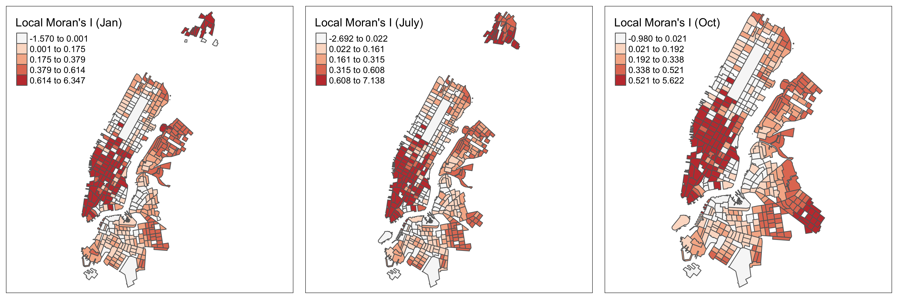

说明

The Moran scatterplots for January, July, and October provide further insight into the spatial distribution of CitiBike ride activity. Each scatterplot compares the total ride start count at individual stations to their spatially lagged counterparts, revealing distinct seasonal patterns. In January, the majority of stations cluster near the origin, indicating low overall activity. However, a few stations in central Manhattan, such as those near Union Square and Grand Central, exhibit high ride counts and strong spatial influence. By July, the scatterplot displays a broader distribution, with more stations showing high activity and spatial influence, particularly in Manhattan and parts of Brooklyn. Notable hotspots include Central Park and Times Square, reflecting increased summer demand. In October, the scatterplot resembles July’s but with a slight contraction in the range of high-activity stations, consistent with the seasonal decline. Across all months, high-activity stations exhibit strong positive spatial autocorrelation, reinforcing the clustering patterns observed in the Local Moran’s I analysis.

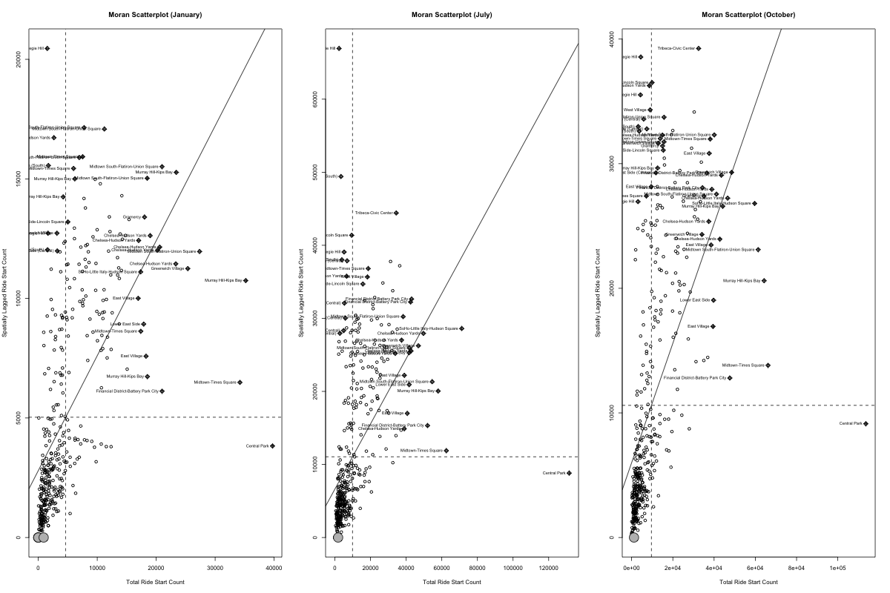

说明