Hyun Lee

31 May 2022

Foundations in Programming: Python

Assignment 07

<https://github.com/teletubbymilk/IntroToProg-Python-Mod07>

# Pickling and Structured Error Handling

## Introduction

This week, through the module I learned how to work with text files, binary files, and use structured error handling. The assignment for this week instructed me to demonstrate my understanding and knowledge of pickling and structured error handling.

## Creating the Script

This week, I started by writing pseudo codes and guides for my script for structure. Afterwards I started my pickling, which is using the import and the pickle function, to import code from another code file. Then, I created variables to capture the id and name of the user, and added it to a list. Then I stored data in with the pickle dump function. I also read the data back with the load function. (Figure 1)

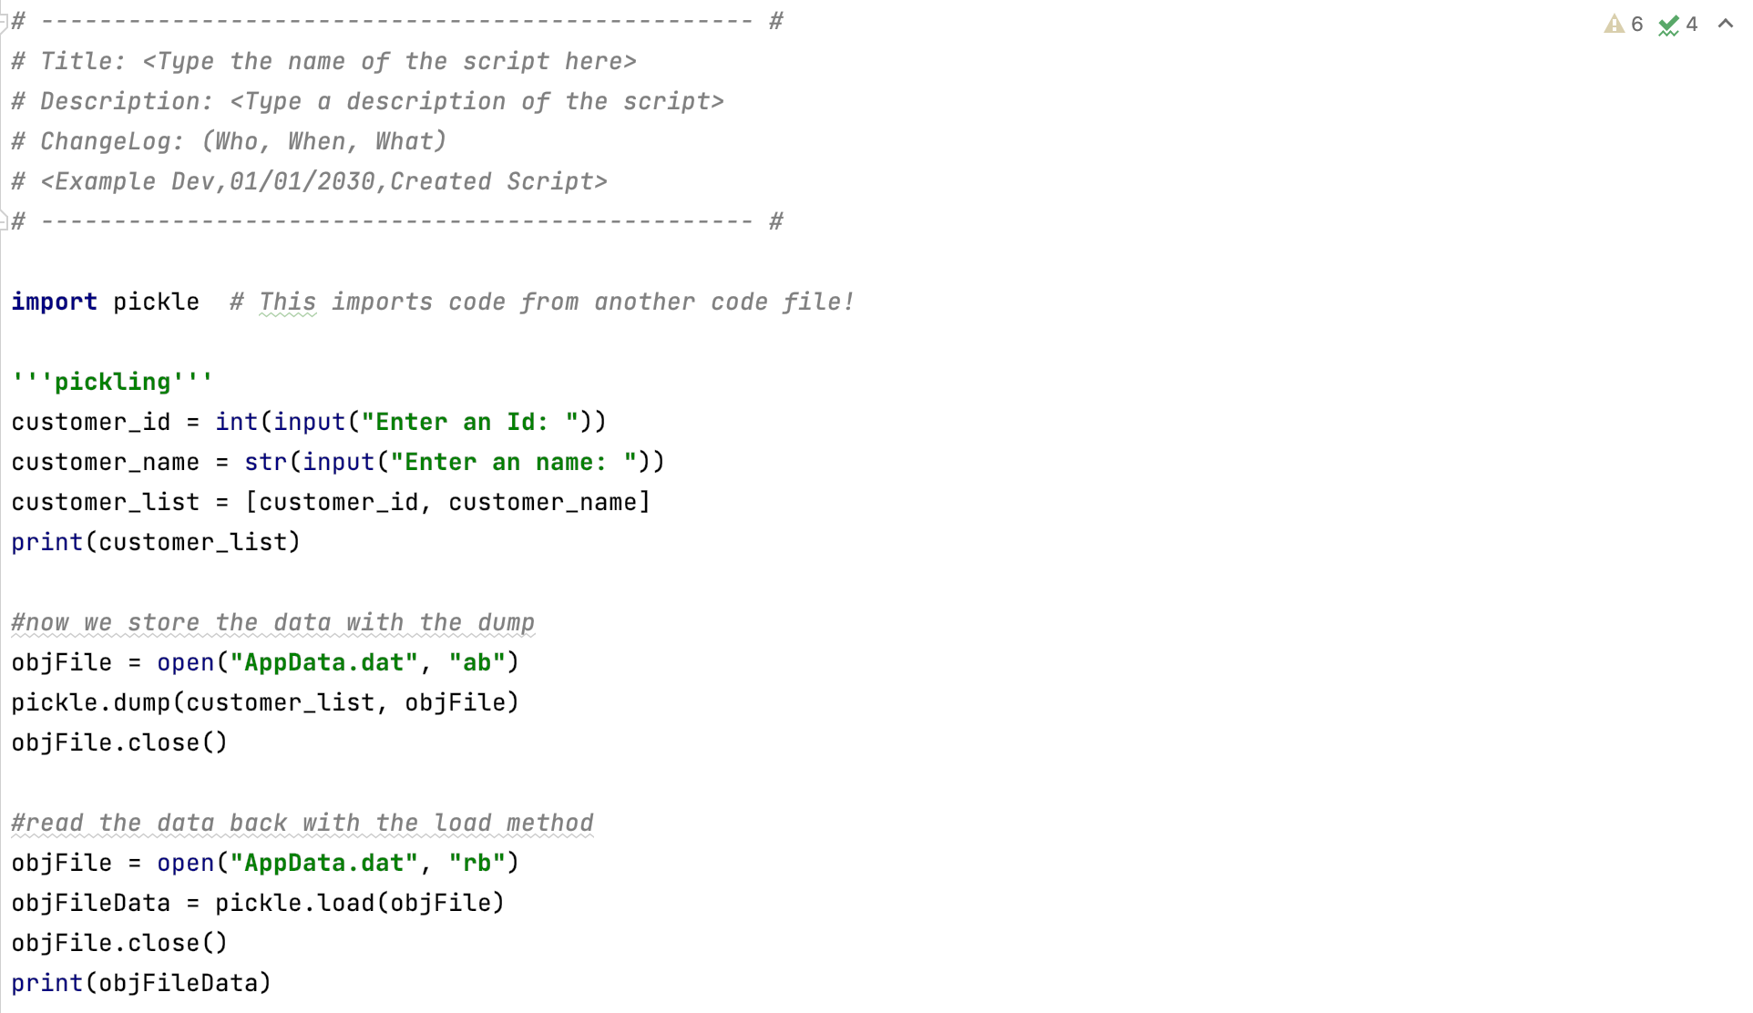

***Figure 1: demonstrating how to pickle***

I demonstrated my understanding for structured error handling in three ways. First is just printing a customized message when the code does not work, by using the try and except function. (Figure 2) Another way was to print the message but also show what type of error occurred. (Figure 3)

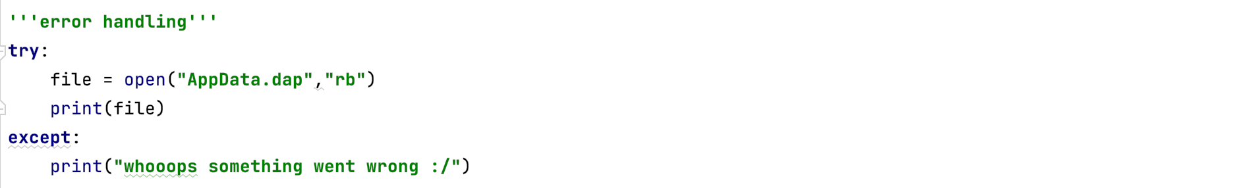

***Figure 2: customizing error messages to make it user friendly***

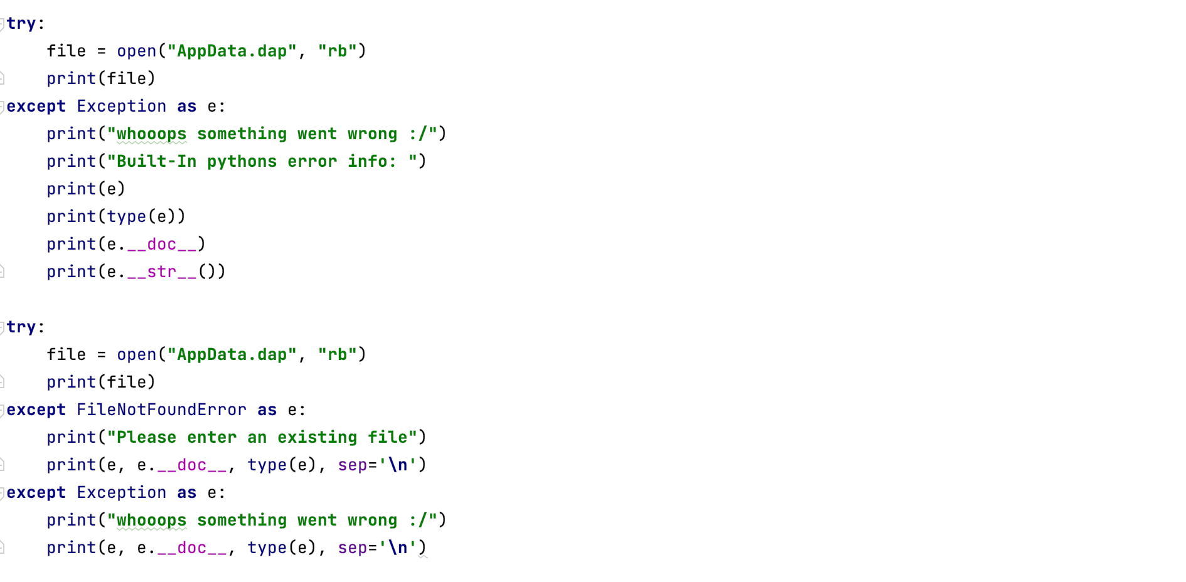

***Figure 3: showing what went wrong / errors***

## Running the script

First, I ran the script in PyCharm to check if it is running correctly. (Figure 4&5)

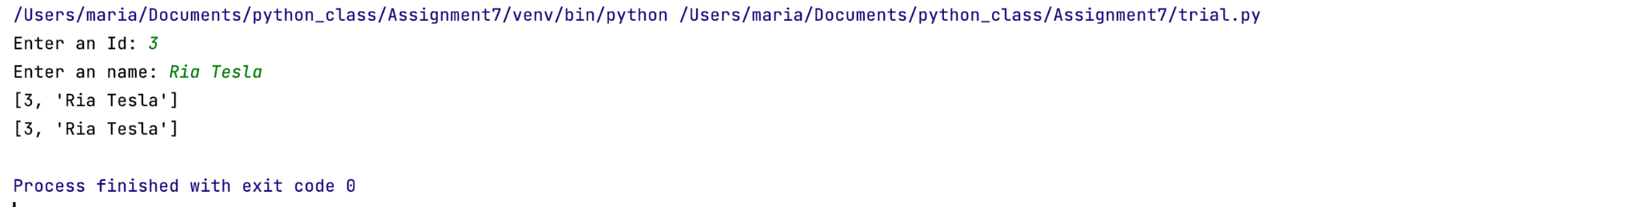

***Figure 4: running the pickling part of the script in pycharm***

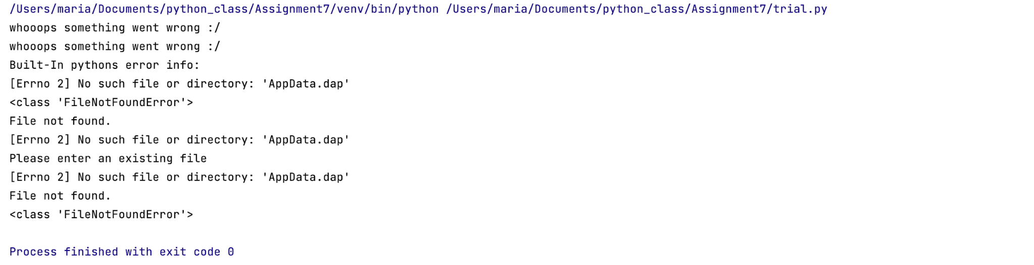

***Figure 5: running the error handling part of the script in pycharm***

I also ran the script in Command Shell/ Terminal to check that it also runs on the computer. To test this script on terminal, I searched for terminal on spotlight search. Then I copied the file path on the terminal and ran it through python. (Figure 6&7)

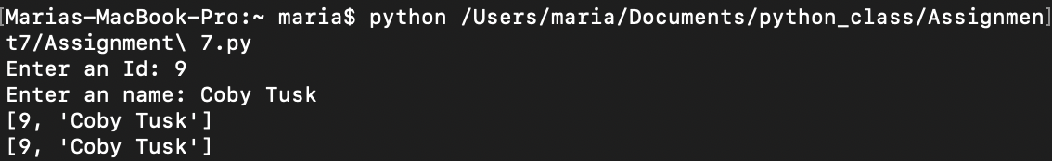

***Figure 6: running the pickling part of the script on terminal***

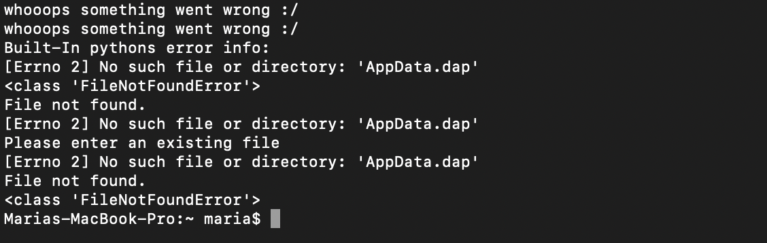

***Figure 7: running the error handling part of the script on terminal***

## Summary

By going through the module course notes and reading the python programming book, I was able to successfully create a python script that shows how to use pickling and structured error handling. This program demonstrates my understanding of how to use text files, binary files, and error handling.