Hyun Lee

15 May 2022

Foundations in Programming: Python

Assignment 05

# Task and Priority

## Introduction

This week, through the module I learned how to use lists, dictionaries and methods to improve my script. The assignment for this week works with what I learnt this week, lists, dictionaries and files. The script template was created by Randall Root, and I added codes so that the programme will load rows of data into a text file and add a dictionary row to the table.

## Creating Script

This week, I didn’t have to start by writing pseudo codes and guides for my script as it was already written by my professor. So first I started loading data, so that when the programme starts it would have data starting with it. I made a dictionary row, opened a file, wrote the data into the file, added a dictionary row to the list table and closed the file. (Figure 1)

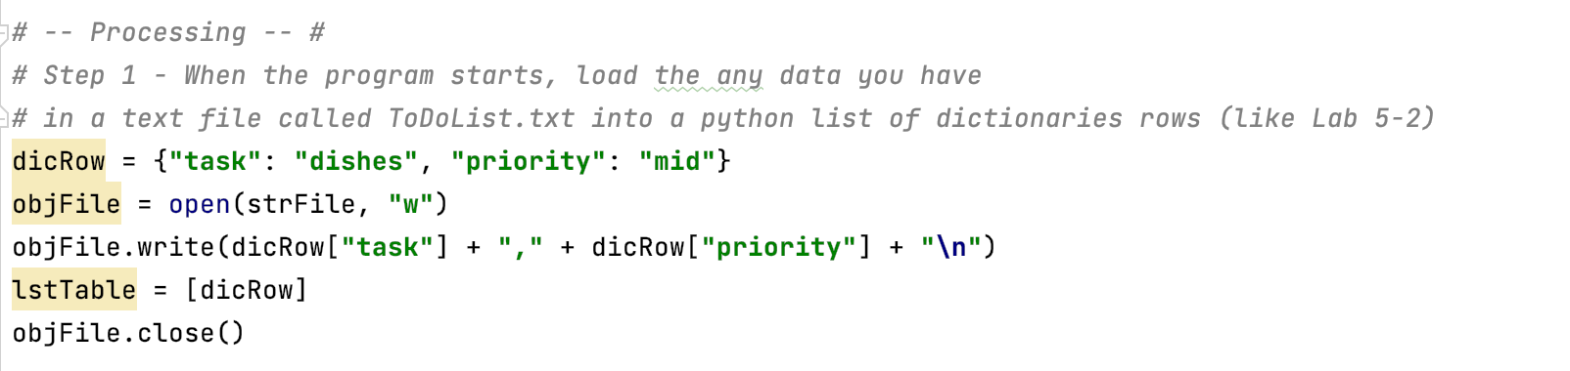

***Figure 1: processing initial data and connecting dictionary to list/table***

I added in the if function so that when the users enter option one they would be able to view current data. I used the print function for the row in the list table to present all the current data in the table. (Figure 2)

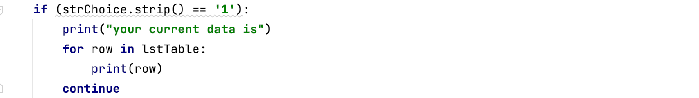

***Figure 2: coding that allows the users to view current data***

For the second user option I used the input function to capture user data. This way the users could enter a task and the priority of the task into the program. I added the captured data into the dictionary and labeled them task and priority. Then I appended the dictionary row to the list table. (Figure 3)

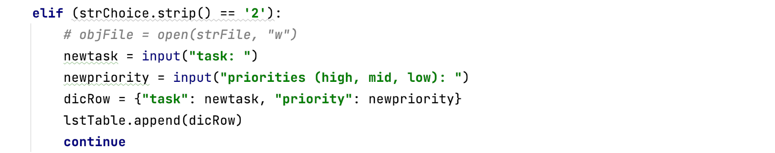

***Figure 3: users entering new tasks and priorities***

The third option allows the user to remove data from the file. I added the input function to capture the task that the user wants to remove. By using the if and remove function, if the task entered by users matches the task currently in file, it will delete the row of data including the priority. (Figure 4)

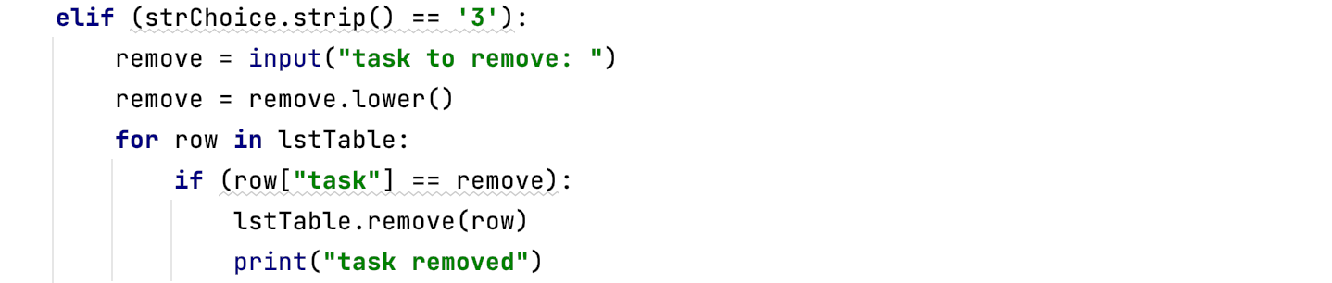

***Figure 4: removing tasks, followed by the priority***

To save data in the file, I opened the file with “w” to write in it. This would save both the task and the priority that has been imputed to the program by the user into the file. (Figure 5)

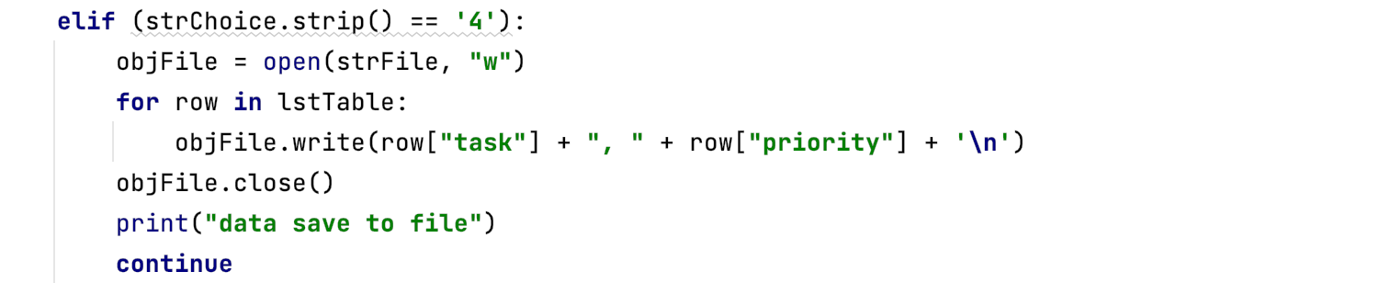

***Figure 5: writing data into files***

For option five, I used the print function to inform the user that they have successfully exited the program. (Figure 6)



***Figure 6: exiting program***

## Running the script

First, I ran the script in PyCharm to check if it is running correctly. (Figure 7)

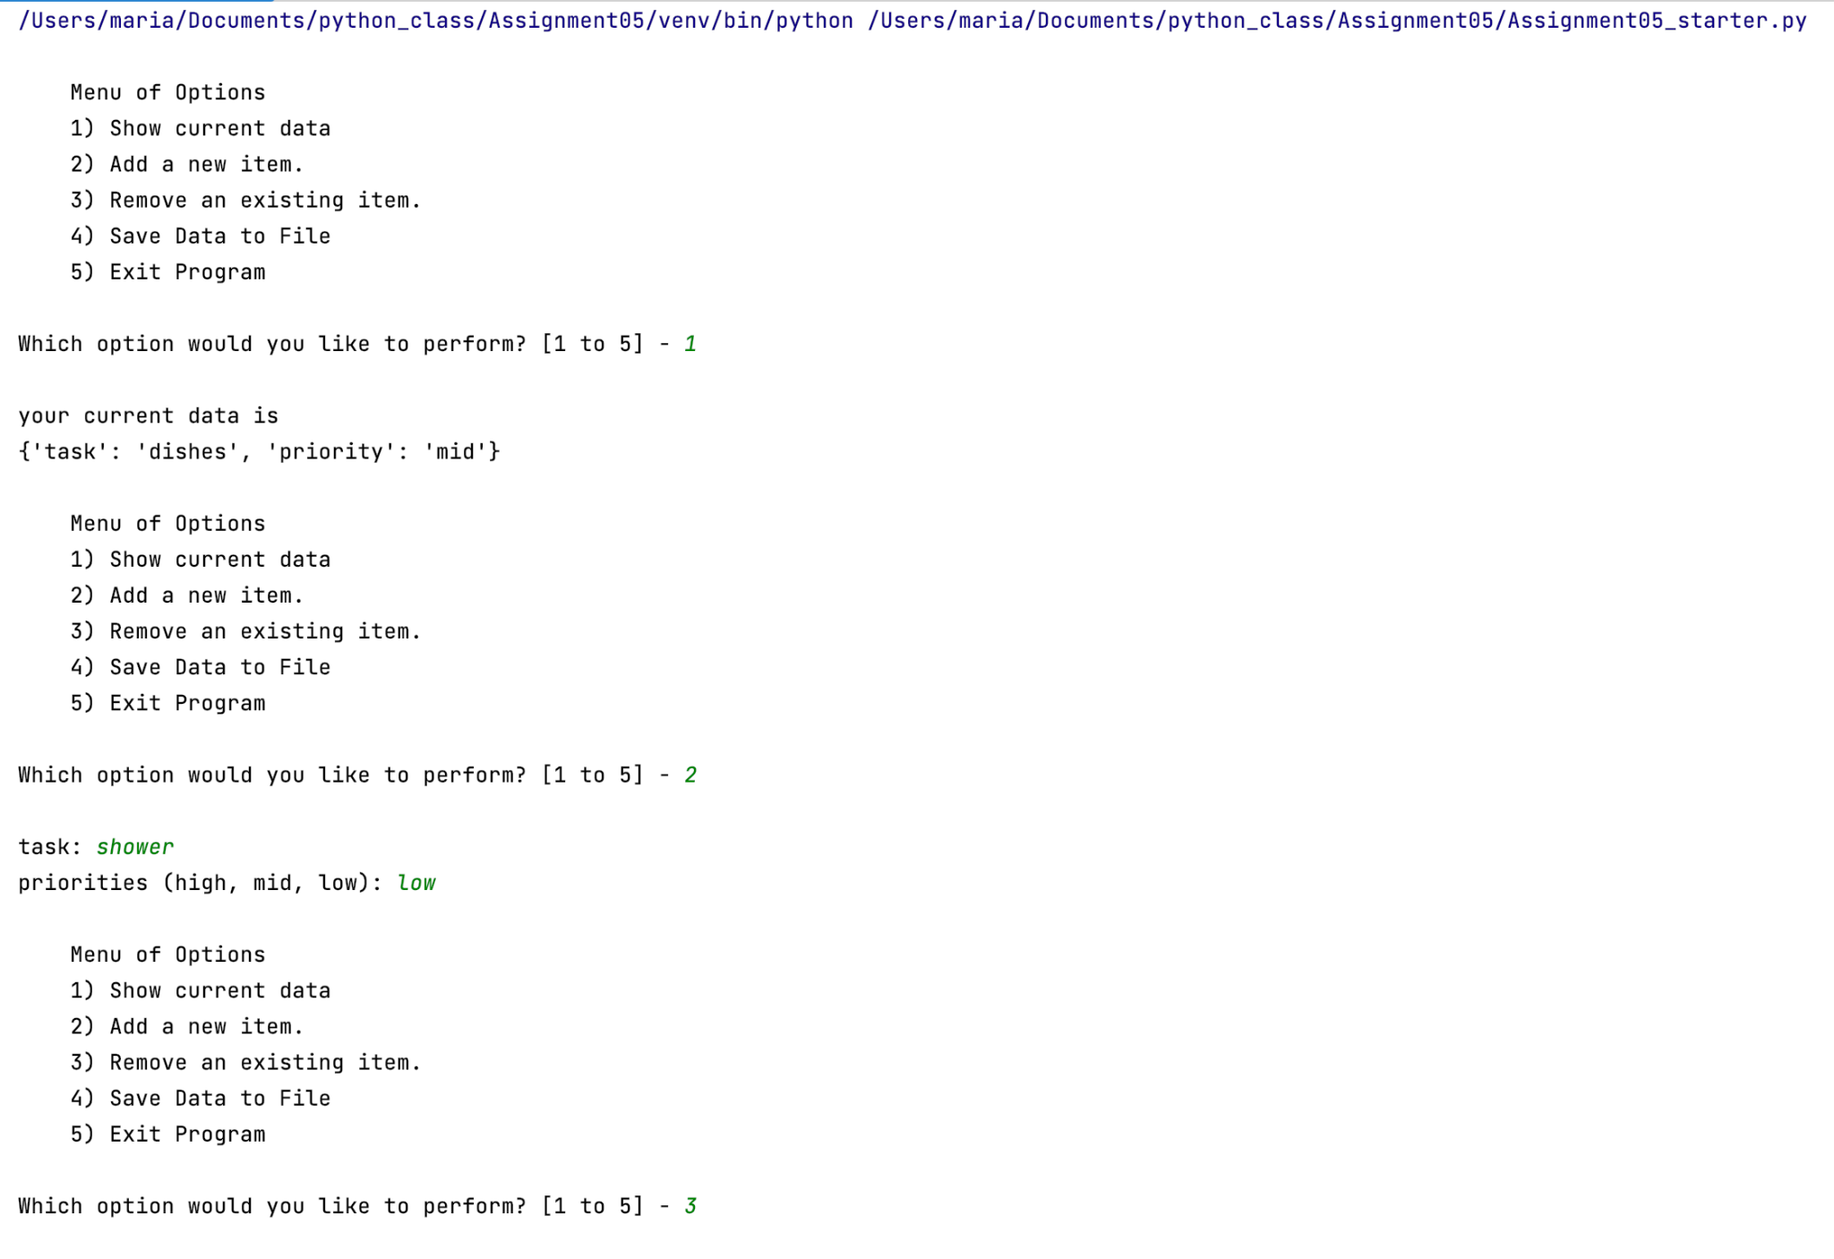

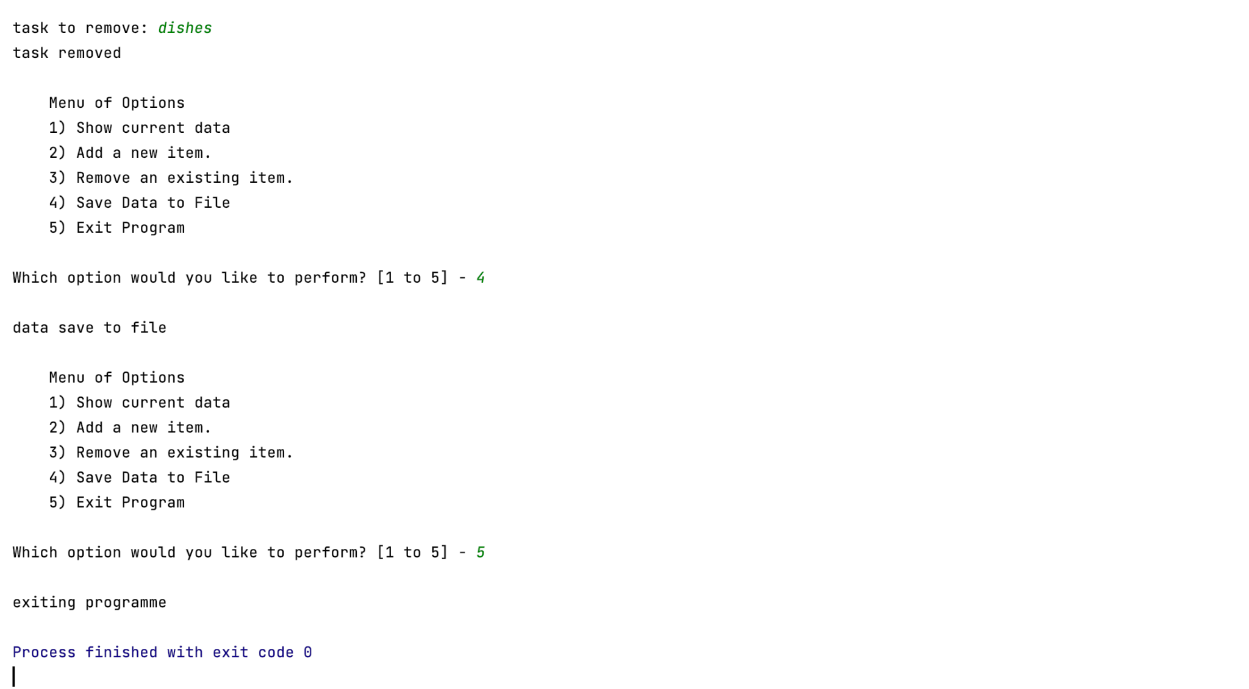

***Figure 7: Running the script on PyCharm***

I also ran the script in Command Shell/ Terminal to check that it also runs on the computer. To test this script on terminal, I searched for terminal on spotlight search. Then I copied the file path on the terminal and ran it through python. (Figure 8)

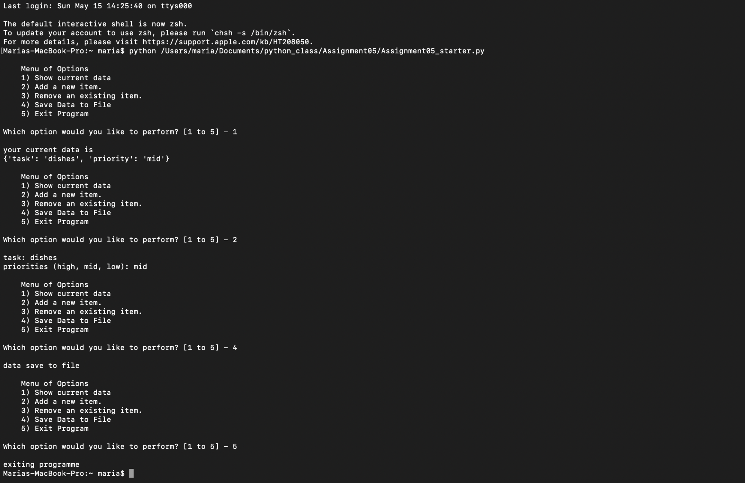

***Figure 8: Running script on terminal***

Then I checked if the task and priority had been saved to the text file. (Figure 9)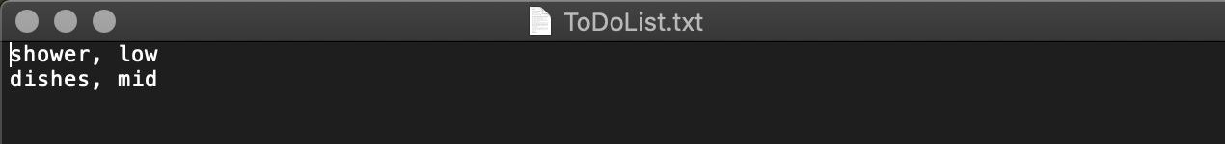

***Figure 9: checking if data saved to text file***

## Summary

By going through the module course notes and reading the python programming book, I was able to successfully create a python script that enabled users to enter the task and priority of items, view current, choose if they want to save the data to file, and remove data they want. This program demonstrates my understanding of lists, dictionaries, and the using files.