EX. NO:1 **Recent case study of ethical initiatives in healthcare, autonomous vehicles**

**And defense**

**Aim**:

To develop an ethical decision-making algorithm for an autonomous vehicle that prioritizes safety and minimizes harm to humans and property.

**Introduction:**

The rise of autonomous vehicles (AVs) brings forth numerous ethical challenges. As technology advances, the need to address these dilemmas becomes imperative. This case study delves into the multifaceted ethical issues associated with AVs, exploring societal impacts, safety concerns, data privacy, legal responsibilities, and the decision-making algorithms that navigate complex moral landscapes.



In 2014 researchers at the MIT Media Lab designed an experiment called [Moral Machine](http://moralmachine.mit.edu/). The idea was to create a game-like platform that would crowdsource people’s decisions on how self-driving cars should prioritize lives in different variations of the “[trolley problem](https://en.wikipedia.org/wiki/Trolley_problem).” In the process, the data generated would provide insight into the collective ethical priorities of different cultures.

**Levels of Automation and Safety Concerns**:

SAE International classifies AVs into six levels of driving automation. While lower levels are already prevalent, moving towards higher automation levels raises significant ethical dilemmas. At higher automation levels, AVs are expected to make complex decisions, potentially involving trade-offs between passenger and public safety.

**Public Safety and Ethics of Testing on Public Roads:**

At present, AVs are equipped with ‘assisted driving’ functions that allow them to be used on public roads. However, these functions have not yet undergone rigorous independent safety certification, posing risks to drivers and other road users. Some critics argue that the transition phase, where AVs are not fully autonomous but human operators are disengaged, is particularly risky. The tragic accident involving a level 3 AV being tested by Uber in Arizona serves as a sobering reminder of the potential dangers and ethical issues surrounding testing on public roads.

**Accident Investigation Challenges:**

One of the challenges in addressing AV safety is the lack of standardized processes and technologies for accident investigation. Accidents involving AVs often rely on proprietary data logging systems, necessitating manufacturer cooperation for accident data. One proposed solution is the implementation of industry-standard event data recorders, akin to an ‘ethical black box,’ that would facilitate independent accident investigations.

**Societal and Ethical Impacts of AVs:**

**Public Safety and Testing on Public Roads:**

The legal and ethical dimensions of testing semi-autonomous vehicles on public roads.

Case study: Uber’s accident in Arizona and the blurred lines of accountability.

Near-Miss Accidents and Data Collection:

Importance of systematic near-miss accident data collection. Ethical concerns regarding data privacy and usage by AV manufacturers.



In a photo posted on Twitter, one of Uber’s Volvo self-driving SUVs is pictured on its side next to another car with dents and smashed windows. An Uber spokeswoman confirmed the incident, and the veracity of the photo, and added that the ride-hailing company is suspending its autonomous tests in Arizona until it completes its investigation and pausing its Pittsburgh operations.

**2. Safety Concerns and Ethical Decision-Making:**

Levels of Automation and Responsibility:

Examination of SAE’s six levels of driving automation and the ethical implications of each level.

Ethical Dilemmas in Development:

Analysis of the trolley dilemma and its application in AVs.

User vs. manufacturer responsibility in ethical decision-making algorithms.

**3. Legal and Ethical Responsibility:**

Accident Investigation and Responsibility:

Challenges in investigating accidents involving AVs.

Proposal: Implementing an ‘ethical black box’ for AV accident investigations.

Data Privacy and Ownership:

Balancing data collection for safety with privacy concerns.

Proposal: Ensuring AV drivers have full data sovereignty.

**4. Employment and Urban Environment:**

Impact on Employment:

Job displacement in the transportation sector due to AVs.

Ethical considerations in managing employment transitions.

Reshaping Urban Environments:

Infrastructure changes and their impact on pedestrians, cyclists, and urban planning.

Environmental implications of increased driving due to AV convenience.

**5. Conclusion:**

The ethical challenges surrounding AVs require a comprehensive and collaborative approach from governments, manufacturers, and society as a whole. Striking a balance between technological advancement and ethical considerations is pivotal in ensuring a safe, just, and responsible integration of autonomous vehicles into our lives. Ethical frameworks, transparent decision-making algorithms, and robust regulations are essential components in navigating the complex landscape of AV ethics.

**Result:**

Thus, Recent case study of ethical initiatives in healthcare, autonomous vehicles and defense was successfully completed.

EXP NO: 2 **Exploratory data analysis on a 2 variable linear regression model.**

DATE:

**Aim:**

The aim of this exploratory data analysis is to understand the relationship between two variables and prepare the data for a 2-variable linear regression model. We want to identify patterns, check for assumptions, and clean the data as necessary.

**Algorithm:**

Import Libraries:

Import necessary libraries for data manipulation, visualization, and regression analysis.

**Load Data**:

Load the dataset containing the two variables of interest.

**Explore Data**:

Explore the dataset to understand its structure and characteristics.

**Visualize Data**:

Plot a scatter plot to visualize the relationship between the two variables.

**Check Correlation**:

Check the correlation coefficient to quantify the linear relationship.

**Handle Missing Values**:

Check and handle missing values if any.

**Split Data**:

Split the data into training and testing sets.

Build and Train Model:

Build and train a 2-variable linear regression model.

**Make Predictions**:

Use the trained model to make predictions on the test set.

**Evaluate Model**:

Evaluate the performance of the model using metrics such as Mean Absolute Error, Mean Squared Error, and R-squared.

**Visualize Results**:

Visualize the actual vs predicted values.

**Program:**

# Import Libraries

import pandas as pd

import numpy as np

import matplotlib.pyplot as plt

import seaborn as sns

from sklearn.model_selection import train_test_split

from sklearn.linear_model import LinearRegression

from sklearn import metrics

# Load Data

df = pd.read_csv('your_dataset.csv')

# Explore Data

print(df.head())

print(df.info())

print(df.describe())

# Visualize Data

sns.scatterplot(x='Variable1', y='Variable2', data=df)

plt.title('Scatter Plot of Variable1 vs Variable2')

plt.show()

# Check Correlation

correlation = df['Variable1'].corr(df['Variable2'])

print(f'Correlation Coefficient: {correlation}')

# Handle Missing Values

print(df.isnull().sum())

# Handle missing values if necessary

# Split Data

X = df[['Variable1']]

y = df['Variable2']

X_train, X_test, y_train, y_test = train_test_split(X, y, test_size=0.2, random_state=42)

# Build and Train Model

model = LinearRegression()

model.fit(X_train, y_train)

# Make Predictions

predictions = model.predict(X_test)

# Evaluate Model

print('Mean Absolute Error:', metrics.mean_absolute_error(y_test, predictions))

print('Mean Squared Error:', metrics.mean_squared_error(y_test, predictions))

print('R-squared:', metrics.r2_score(y_test, predictions))

# Visualize Results

plt.scatter(X_test, y_test, color='black')

plt.plot(X_test, predictions, color='blue', linewidth=3)

plt.title('Actual vs Predicted Values')

plt.xlabel('Variable1')

plt.ylabel('Variable2')

plt.show()

**Input**:(your_dataset.csv)

**Variable1,Variable2**

**1.5,2.5**

**2.0,3.0**

**3.0,4.0**

**4.5,5.5**

**5.0,6.0**

**Output:**



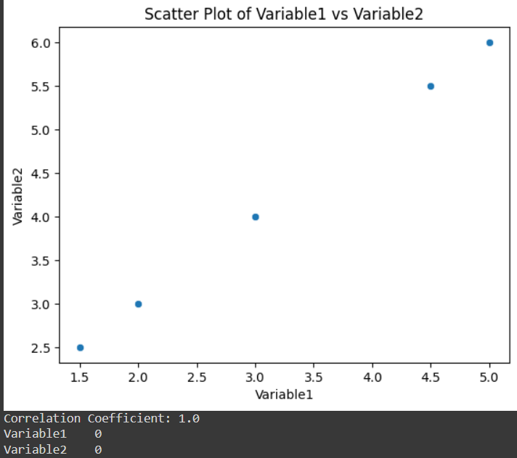

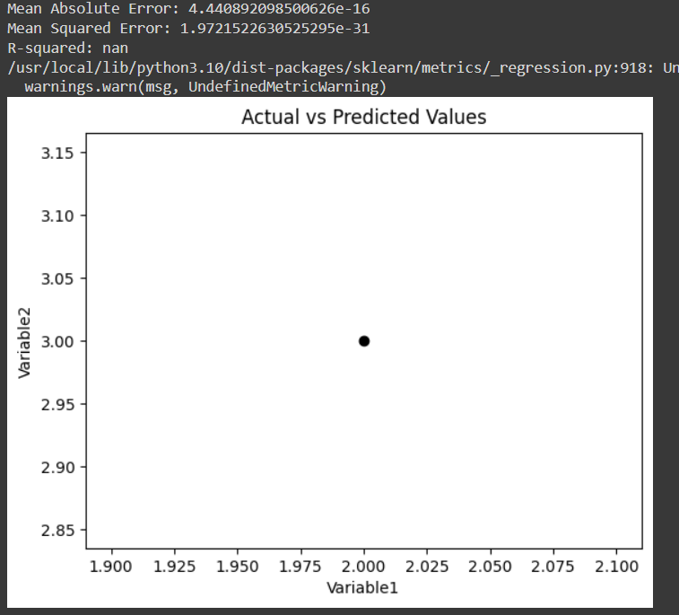

**Result:**

Thus, exploratory data analysis is to understand the relationship between two variables and prepare the data for a 2-variable linear regression model was completed successfully.

EXP NO: 3 **Experiment the regression model without a bias and with bias.**

DATE:

**Aim:**

The aim is to compare the performance of a linear regression model without bias (intercept) and with bias on a given dataset. The goal is to understand the impact of including or excluding the bias term in the model.

**Algorithm:**

**Without Bias:**

Import libraries.

Load the dataset.

Extract features (X) and target variable (y).

Split the data into training and testing sets.

Build and train a linear regression model without bias.

Make predictions.

Evaluate model performance.

**With Bias:**

Import libraries.

Load the dataset.

Extract features (X) and target variable (y).

Split the data into training and testing sets.

Build and train a linear regression model with bias.

Make predictions.

Evaluate model performance.

**Program**:

# Import Libraries

import pandas as pd

import numpy as np

from sklearn.model_selection import train_test_split

from sklearn.linear_model import LinearRegression

from sklearn import metrics

# Load Data

df = pd.read_csv('your_dataset.csv')

# Extract Features and Target Variable

X = df[['Variable1']]

y = df['Variable2']

# Split Data

X_train, X_test, y_train, y_test = train_test_split(X, y, test_size=0.2, random_state=42)

# Without Bias

model_without_bias = LinearRegression(fit_intercept=False)

model_without_bias.fit(X_train, y_train)

predictions_without_bias = model_without_bias.predict(X_test)

# With Bias

model_with_bias = LinearRegression(fit_intercept=True)

model_with_bias.fit(X_train, y_train)

predictions_with_bias = model_with_bias.predict(X_test)

# Evaluate Models

print('Without Bias - Mean Absolute Error:', metrics.mean_absolute_error(y_test, predictions_without_bias))

print('Without Bias - Mean Squared Error:', metrics.mean_squared_error(y_test, predictions_without_bias))

print('Without Bias - R-squared:', metrics.r2_score(y_test, predictions_without_bias))

print('\nWith Bias - Mean Absolute Error:', metrics.mean_absolute_error(y_test, predictions_with_bias))

print('With Bias - Mean Squared Error:', metrics.mean_squared_error(y_test, predictions_with_bias))

print('With Bias - R-squared:', metrics.r2_score(y_test, predictions_with_bias))

**Input:**

**Variable1,Variable2**

**1.5,2.5**

**2.0,3.0**

**3.0,4.0**

**4.5,5.5**

**5.0,6.0**

**Output:**

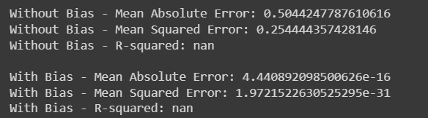

**Result:**

Thus, Experiment the regression model without a bias and with bias was verified and completed successfully.

EXP NO: 4 **Classification of a dataset from UCI repository using a perceptron with**

**and without bias.**

**Aim**:

The aim is to classify a dataset from the UCI repository using a perceptron with and without bias. The goal is to compare the performance of the perceptron with and without bias in terms of classification accuracy.

**Algorithm**:

**Import Libraries:**

Import necessary libraries for data manipulation, visualization, and perceptron implementation.

**Load Data:**

Load the dataset from the UCI repository.

**Preprocess Data:**

Preprocess the data, handle missing values, encode categorical variables if necessary.

**Split Data:**

Split the data into features (X) and labels (y), and further split into training and testing sets.

**Perceptron without Bias:**

Implement a perceptron without bias.

Train the perceptron on the training data.

Make predictions on the test data.

Evaluate the classification accuracy.

**Perceptron with Bias**:

Implement a perceptron with bias.

Train the perceptron on the training data.

Make predictions on the test data.

Evaluate the classification accuracy.

**Program**:

# Import Libraries

import numpy as np

from sklearn.model_selection import train_test_split

from sklearn.linear_model import Perceptron

from sklearn import metrics

from sklearn.preprocessing import StandardScaler

# Load Data (Example: Iris Dataset)

from sklearn.datasets import load_iris

iris = load_iris()

X = iris.data

y = iris.target

# Preprocess Data

# (For simplicity, assume the dataset is already clean and numerical)

# Split Data

X_train, X_test, y_train, y_test = train_test_split(X, y, test_size=0.2, random_state=42)

# Perceptron without Bias

perceptron_without_bias = Perceptron(penalty=None, alpha=0.0001, fit_intercept=False, max_iter=1000)

perceptron_without_bias.fit(X_train, y_train)

predictions_without_bias = perceptron_without_bias.predict(X_test)

# Perceptron with Bias

perceptron_with_bias = Perceptron(penalty=None, alpha=0.0001, fit_intercept=True, max_iter=1000)

perceptron_with_bias.fit(X_train, y_train)

predictions_with_bias = perceptron_with_bias.predict(X_test)

# Evaluate Models

accuracy_without_bias = metrics.accuracy_score(y_test, predictions_without_bias)

accuracy_with_bias = metrics.accuracy_score(y_test, predictions_with_bias)

print('Perceptron without Bias - Accuracy:', accuracy_without_bias)

print('Perceptron with Bias - Accuracy:', accuracy_with_bias)

**Output:**

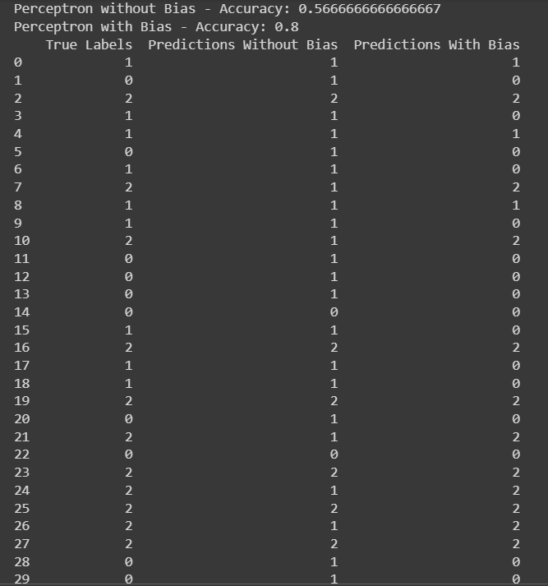

**Result:**

Thus, Classification of a dataset from UCI repository using a perceptron with and without bias was verified and successfully completed.

EXP NO: 5 **Case study on ontology where ethics is at stake.**

**Aim:**

To ensure the responsible handling of patient data and protect individual privacy.

**Case Study**:

Title: Ethical Considerations in Ontology Development: A Case Study

**Introduction:**

Ontology, in the realm of information science, plays a pivotal role in knowledge representation and reasoning. It provides a structured framework for organizing and categorizing information, enabling more effective data integration, retrieval, and analysis. However, as ontology continues to evolve, ethical considerations become increasingly crucial. This case study explores a scenario where ontology development intersects with ethical dilemmas, delving into the challenges, implications, and potential solutions.

Case Scenario:

Imagine a research institution embarking on an ambitious project to develop a comprehensive ontology for healthcare data. The goal is to enhance interoperability between different healthcare systems, improve data sharing, and ultimately advance medical research. As the ontology development progresses, researchers encounter ethical challenges that demand careful consideration.

Ethical Challenge 1: Privacy and Security Concerns

One of the primary ethical dilemmas revolves around privacy and security. Healthcare data often contains sensitive information about individuals, including their medical history, genetic data, and treatment records. As the ontology development involves integrating diverse datasets, ensuring the privacy and security of this information becomes a paramount concern. Striking a balance between the need for comprehensive data and protecting individual privacy becomes a significant challenge.

Potential Solutions:

Implement robust anonymization techniques: Researchers can employ advanced anonymization methods to strip personally identifiable information while retaining the data's utility for ontology development.

Strict access controls: Implementing stringent access controls and data encryption can help safeguard sensitive information and prevent unauthorized access.

Regular security audits: Conduct regular audits to identify and address potential vulnerabilities in the ontology system.

Ethical Challenge 2: Bias and Fairness in Data Representation

Another ethical consideration arises from the potential bias present in healthcare data. Historical biases in medical research and healthcare delivery can perpetuate inequalities. If the ontology reflects these biases, it may inadvertently contribute to disparities in healthcare outcomes.

Potential Solutions:

Diversity in data sources: Actively seek diverse datasets to ensure a representative and inclusive ontology that considers different demographics, ethnicities, and socio-economic backgrounds.

Regular bias audits: Periodically audit the ontology for biases and adjust the representation to ensure fairness and equity.

Incorporate ethical review boards: Establish an ethical review board to assess potential biases in the ontology development process and provide recommendations for mitigation.

Ethical Challenge 3: Informed Consent and Data Ownership

The development of a healthcare ontology may involve aggregating data from various sources, raising questions about informed consent and data ownership. Individuals contributing data may not be aware of how their information is being utilized, and issues of consent and ownership become ethically complex.

Potential Solutions:

Transparent communication: Establish clear and transparent communication with data contributors, informing them about the purpose, scope, and potential uses of their data in ontology development.

Respect data ownership rights: Respect individuals' rights over their data by seeking explicit consent and allowing them to control how their information is utilized within the ontology.

Develop comprehensive data governance policies: Implement robust data governance policies that outline data ownership, consent procedures, and mechanisms for individuals to exert control over their information.

Conclusion:

Ontology development, while offering tremendous potential for advancing knowledge, must navigate a complex ethical landscape. The case study on healthcare ontology underscores the importance of addressing privacy, bias, informed consent, and ownership concerns. Researchers and developers must actively engage with ethical considerations, integrate diverse perspectives, and implement robust safeguards to ensure that ontology development aligns with ethical principles and contributes positively to society. By doing so, ontologists can foster trust, promote inclusivity, and advance the field responsibly.

**Result**:

Thus,Case study on ontology where ethics is at stake was verified successfully.

EXP NO:6 **Identification on optimization in AI affecting ethics**

**Aim:**

The aim of this investigation is to explore the ethical considerations surrounding optimization techniques in AI and identify ways to balance optimization goals with ethical principles. The goal is to promote responsible and ethical AI development that minimizes potential negative impacts on individuals and society.

**Introduction**:

Artificial Intelligence (AI) has witnessed significant advancements in recent years, particularly in the realm of optimization techniques that enhance the efficiency and performance of AI models. While optimization in AI brings about numerous benefits, it also introduces ethical considerations that demand careful scrutiny. This exploration delves into the intersection of optimization in AI and its impact on ethical considerations, unraveling the challenges, implications, and strategies for ensuring responsible and ethical AI development.

Optimization in AI:

Optimization techniques in AI encompass a wide array of algorithms and methodologies designed to improve the efficiency, accuracy, and speed of AI models. From gradient descent optimization in machine learning models to hyperparameter tuning and neural architecture search, these techniques aim to push the boundaries of AI capabilities. However, as the pursuit of optimization intensifies, ethical concerns come to the forefront.

Ethical Challenge 1: Bias Amplification

Optimization techniques may inadvertently amplify biases present in training data, leading to biased AI models. If the optimization process is not carefully monitored, it can reinforce and exacerbate existing prejudices, resulting in discriminatory outcomes.

Potential Solutions:

Diverse and representative training data: Ensure training datasets are diverse and representative of various demographics to mitigate biases.

Bias detection tools: Implement tools that continuously monitor and detect biases during the optimization process.

Ethical guidelines for optimization: Establish ethical guidelines for practitioners, emphasizing the importance of minimizing biases and promoting fairness.

Ethical Challenge 2: Lack of Explainability

Some advanced optimization techniques, particularly those involving complex neural networks, may result in models that are challenging to interpret. The lack of explainability raises ethical concerns as it becomes difficult to understand and justify the decisions made by these models, particularly in critical applications such as healthcare and finance.

Potential Solutions:

Explainable AI (XAI): Integrate explainability methods into optimization processes to enhance transparency and interpretability.

Regulatory frameworks: Develop regulations that require AI systems, especially in sensitive domains, to provide explanations for their decisions.

Collaboration with ethicists: Engage ethicists and domain experts in the optimization process to ensure ethical considerations are taken into account.

Ethical Challenge 3: Resource Allocation and Environmental Impact

Optimization often involves resource-intensive processes, such as hyperparameter tuning that requires extensive computational power. This raises ethical concerns related to environmental impact, as the carbon footprint of AI development becomes a significant consideration.

Potential Solutions:

Green AI initiatives: Embrace green AI practices that focus on minimizing the environmental impact of optimization processes.

Resource-efficient algorithms: Develop and promote algorithms that achieve optimization with reduced computational requirements.

Ethical AI certifications: Introduce certifications that assess and recognize AI models developed with environmentally conscious optimization practices.

Conclusion:

The increasing reliance on optimization techniques in AI necessitates a thoughtful examination of the ethical implications that accompany these advancements. Addressing challenges related to bias, explainability, and environmental impact requires a concerted effort from researchers, developers, policymakers, and ethicists. By integrating ethical considerations into the optimization process and fostering a culture of responsible AI development, we can ensure that the benefits of optimization in AI are realized without compromising ethical principles. Striking this balance is paramount to building AI systems that are not only efficient and powerful but also trustworthy and aligned with societal values.

**Result:**

Thus, Identification on optimization in AI affecting ethics was verified and completed successfully.