**Artificial neural network approach for solving Weyl fractional integral equations of order $α$**

**Abstract.** In this paper, an Artificial Neural Network (ANN) technique is developed to find the solutions of Weyl fractional integral equations of order $α$ (WFIE). In the present approach, we first estimate the unknown function based on the feed forward neural network, then substitute the approximation function in the appropriate error function of WFIE, and Train the network with as few neurons as possible to achieve the desired accuracy. And finally, some illustrative examples are given to demonstrate the accuracy and effectiveness of this method. Comparison of the present results with other available results using conventional methods was also performed.

**Key word.** Weyl fractional order integral; Weyl fractional integral equations; Artificial neural network; feedforward neural network.

1. **Introduction**
2. **Preliminaries**

In this section, we recall general definitions and concepts related to fractional order integrals, Weyl fractional order integrals, the properties of Weyl fractional order integrals, and Weyl fractional order integral equations.

***Definition 2.1: Riemann-Liouville fractional integrals [1]***

Let $φ(x)∈L_{1}(a;b)$. The integrals

$$I_{a+}^{α}φ=\frac{1}{Γ(α)}\int_{a}^{x}{\frac{φ(x)}{{(x-t)}^{1-α}}dt, x>a} (1)$$

$$I_{b-}^{α}φ=\frac{1}{Γ(α)}\int_{x}^{b}{\frac{φ(x)}{{(x-t)}^{1-α}}dt, x<b} (2)$$

where $α>0$, are called fractional integrels of the order $α$. They are sometimes called left-sided and right-sided fractional integrals respectively. The accepted names for the integrals (1) and (2) are the Riemann-Liouville fractional integrals.

***Definition 2.2: Weyl fractional integral [1]***

Let $φ(x)$ be a $2π$-periodic function on $R^{1}$ and satisfy the condition:

$$\int_{0}^{2π}{φ\left(x\right)dx=0 (3)}$$

Integral:

$$I_{±}^{(α)}φ=\frac{1}{2π}\int_{0}^{2π}{φ\left(x-t\right)ψ_{±}^{α}(t)dt, α>0} (4)$$

where

$$ψ_{±}^{α}(t)=\sum_{k=-∞}^{∞}{\frac{e^{-ikt}}{{(±ik)}^{α}}=2\sum_{k=1}^{∞}{\frac{\cos\left(kt∓{απ}/2\right)}{k^{α}}} (5)}$$

The dash indicates that the term $k=0$ is omitted. The right-hand side in (4) will be caled the Weyl fractional integral of order $α$. The series (5) convergence for all $t∈(0,2π)$, if $α>0.$

***Definition 2.3:***

A WFIE is an equation in which the unknown function $φ(x)$ appears under an integral sign. The general form of the WFIE that we consider has the form:

$$\left(I_{+}^{(α)}φ\right)\left(x\right)+(Tφ)(x)=f(x) (6)$$

where

$(I_{+}^{(α)}φ)(x)$ is given in Eq 4,

$\left(Tφ\right)\left(x\right)$ is a definite integral defined by the formula:

$$\left(Tφ\right)\left(x\right)= \int_{a}^{b}{h\left(x,t\right)φ\left(t\right)}dt$$

$f\left(x\right), h\left(x,t\right)$ are known functions; $h\left(x,t\right)$ is an integrable function on $[a,b]$,

$φ\left(x\right)$ is the function to find.

***Lemma 2.1: Weyl integral properties***

Let $φ(x)∈L_{1}(0;2π)$ and be $2π$- periodic, and be satisfed (3).

1. Then the Weyl fractional integral of order $α$ coincides with the Riemann-Liouville fractional integrals on the real line [1]:
$${I_{+}^{(α)}φ=I}_{+}^{α}φ=\frac{1}{Γ(α)}\int_{-∞}^{x}{\frac{φ(t)}{{(x-t)}^{1-α}}dt, 0<α<1} (7)$$

2. ${(I}_{±}^{\left(α\right)}(φ+c)) \left(x\right)= {(I}_{±}^{(α)}φ) \left(x\right)$*,* where c is any constant

In this paper, we consider integrals satisfying this property.

1. **Structure of feed forward neural network**

This article we consider a three layer Feed-forward neural network model for the present problem. Fig. 1 depicts the structure of neural network architecture, which consists of an input layer with single input node, one hidden layer and output layer consisting one output node. Initial weights $w_{j}$ from input to hidden layer and $v_{j}$ from hidden to output layer are considered as random.

The output $N\left(x,Ω\right)$ is expressed as

$$N\left(x,Ω\right)=f^{2}\left(\sum_{j=1}^{m}{v_{j}f^{1}(z_{j})}\right) (9)$$

Where $z_{j}=w_{j}x+b_{j}$ and $w_{j}$ is weight from input to hidden unit, $v_{j}$ denotes the weight from the hidden unit to output unit, and $b_{j}$ is the bias for hidden node and output node, m illustrate the numbers of the hidden units, and $f^{1}$, $f^{2}$ are called the activation functions, two activation functions are used by us in the article:

1. *Linear: $f\left(x\right)=x$*
2. *Tan-Sigmoid: $f\left(x\right)=\frac{2}{1+e^{-2x}}-1$*

Architecture of the three layer Feed-forward neural network with five hidden nodes, single input and output layer (with one node):

Input layer

Hidden layer

Output layer

**Fig. 1** Proposed Feed-forward neural network architecture

$$v_{1}$$

$$v_{5}$$

∑

$$f^{1}$$

$$b_{1}^{ }$$

∑

∑

$$f^{1}$$

$$b_{5}^{ }$$

$$f^{2}$$

$$z_{1}^{ }$$

$$z_{5}^{ }$$

$$a_{1}^{ }$$

$$a_{5}^{ }$$

…

$$w_{1}$$

$$w_{5}$$

$$N\left(x,Ω\right)$$

$$z_{j}=(w_{j}x+b_{j})$$

$$a_{j}=f^{1}(z_{j})$$

$$N\left(x,Ω\right)=f^{2}(\sum_{j=1}^{5}{v_{j}a_{j}})$$

$$x$$

Multilayer perceptron (MLP) networks is kind of feed-forward neural network with different transfer functions. MLP correspond the input units to the output units by a specific nonlinear mapping. The most important application of MLP networks is their ability in function approximation. In order to approximate function $φ(x_{1},x_{2},…, x_{n})$ where $(x_{1},x_{2},…, x_{n})$ are n independent input variables, a two-layer perceptron network with n inputs, m hidden neurons by tan-sigmoid transfer function and one output neuron by linear transfer function is selected. In this article, we consider the functions to be found as single-variable functions corresponding to a neural network with one input node $x$. So, we can write Eq. 9 as follows:

$$φ\left(x\right)=\sum_{j=1}^{m}{v_{j}f^{1}\left(z_{j}\right)} (10)$$

1. **Illustration of the Method**

Consider Weyl fractional order integral equation is of the form Eq. 7:

$$\left(I_{+}^{(α)}φ\right)\left(x\right)+(Tφ)(x)=f(x) (11)$$

here $φ\left(x\right)$ is an unknown function, $0<α<1$

***The main idea of the method:***

Let $φ\left(t_{i}\right)$ be approximate solution determined by a feedforward neural network with adjustable parameters (weights and bias) and have the same form Eq. 10. The neural network with one input, and one output, where $t_{i}=x_{i}$ is the variable of $φ$.

So, Eq. 11 will be represented:

$$\left(I_{+}^{\left(α\right)}φ\right)\left(t_{i}\right)+(φ)(t_{i})=f(t_{i}) (12)$$

The $φ\left(t_{i}\right)$ is the approximate solution with the adjustable parameters (weights and biases) and has the same form of Eq. 10. So, the problem Eq. 12 can be transformed to the following sum squared error (SSE) minimization problem respect to the network parameters (w and b).

$$\min_{w, b}\sum_{i}{{\left\{\left(I_{+}^{\left(α\right)}φ\right)\left(t_{i}\right)+ (Tφ)(t_{i})-f(t_{i})\right\}}^{2}} (13)$$

The approximate solution $φ\left(t_{i}\right)$ employs a MLP network, and the parameters are found by using the above minimization problem.

There are a lot of optimization techniques available to solve the problem, such as steepest decent methods, conjugate gradient methods or quasi-Newton methods, or other techniques. Here, the quasi-Newton BFGS (Broyden–Fletcher–Goldfarb–Shanno) method is used.

After the optimization step, optimal values of the weights are obtained, so by replacing the optimal parameters $w^{*}, b^{*}$ in Eq. 10, the trial solution $φ\left(t_{i}\right)$ will be the approximated solution of integral Eq. 12.

1. **Numerical Examples**

In this section we give four examples to illustrate our results. The program is written in Python. We use a three-layer neural network (input layer, hidden layer and output layer), error function - SSE, activation functions for the hidden layer – Tan sigmoid, for the output layer - linear. More neurons can be used for the hidden layer to get more reliable results. The approximate results by ANN model are compared with analytical\existing numerical solutions of each example.

***Example 5.1***

Consider the Weyl fractional order integral of the form:

$$\frac{1}{2π}\int_{0}^{2π}{φ\left(x-t\right)ψ_{+}^{15/16}(t)dt }+\int_{0}^{π/2}{φ\left(t\right)dt} =1-cos\left(x+\frac{π}{32}\right)$$

where $h\left(x,t\right)=1, α=\frac{15}{16}$

This equation has the analytical solution

$$φ\left(t\right)=\sin{t}$$

We train the network for ten equidistant points in the domain $\left[0;1\right]$ with five hidden nodes and $α=\frac{15}{16}.$ Table 1 shows comparison between analytical and approximate ANN solutions for $α=\frac{15}{16}.$ Comparison between analytical and ANN solutions are depicted in Fig. 2. Error function has been plotted in Fig. 3. Fig. 4 Check if ANN (after optimization of w and b) is a solution of the integral equation.

**Table 1.** Analytical results and ANN results for $α=\frac{15}{16}$ (Example 5.1)

|  |  |  |  |
| --- | --- | --- | --- |
| **X** | **Analytical** | **ANN** | **Error** |
| 0.1 | 0.882833 | 0.886318 | 0.003484 |
| 0.2 | 0.981669 | 0.983959 | 0.00229 |
| 0.3 | 1.07852 | 1.079748 | 0.001228 |
| 0.4 | 1.172418 | 1.172738 | 0.000319 |
| 0.5 | 1.262426 | 1.262008 | 0.000418 |
| 0.6 | 1.347642 | 1.34667 | 0.000972 |
| 0.7 | 1.427218 | 1.425883 | 0.001335 |
| 0.8 | 1.500356 | 1.498851 | 0.001505 |
| 0.9 | 1.566327 | 1.564842 | 0.001485 |
| 1 | 1.624471 | 1.623186 | 0.001285 |

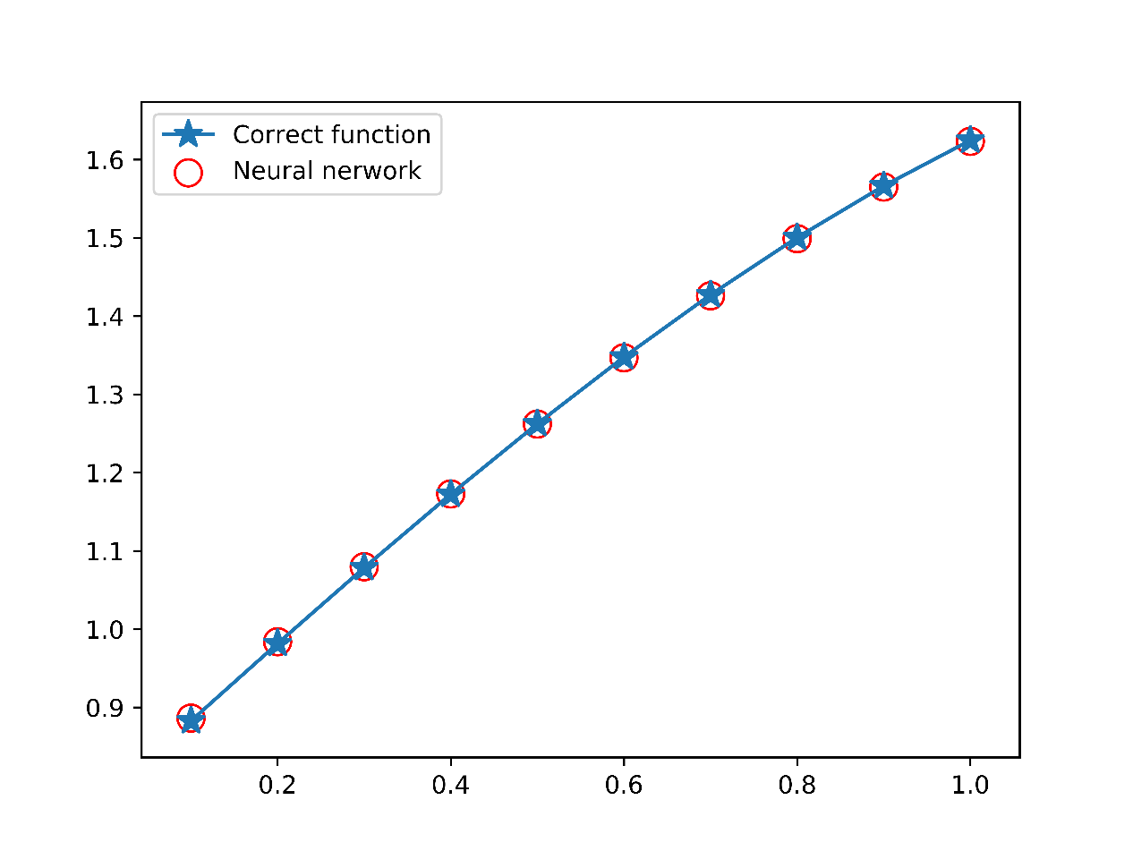

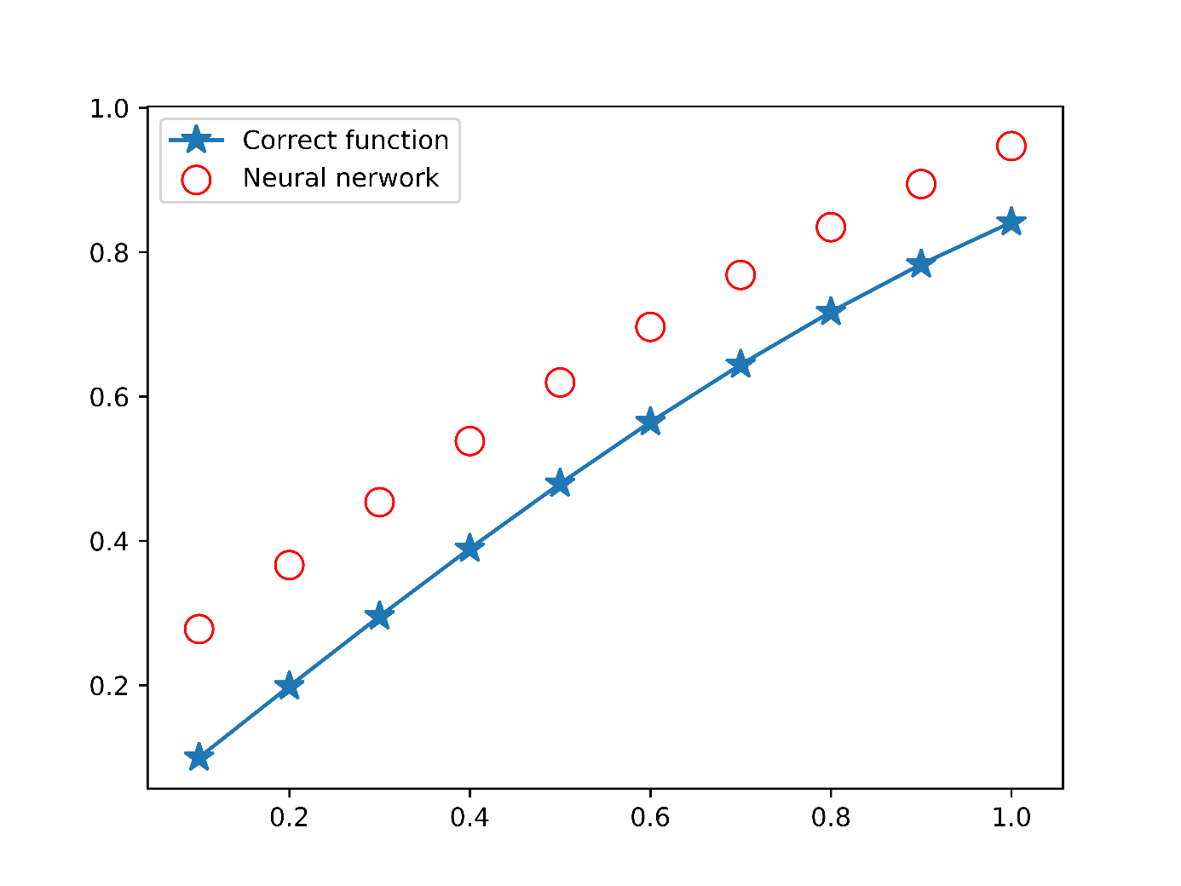

**Fig 2.** Graph of analysis results and ANN for $α=\frac{15}{16}$ (Example 5.1)

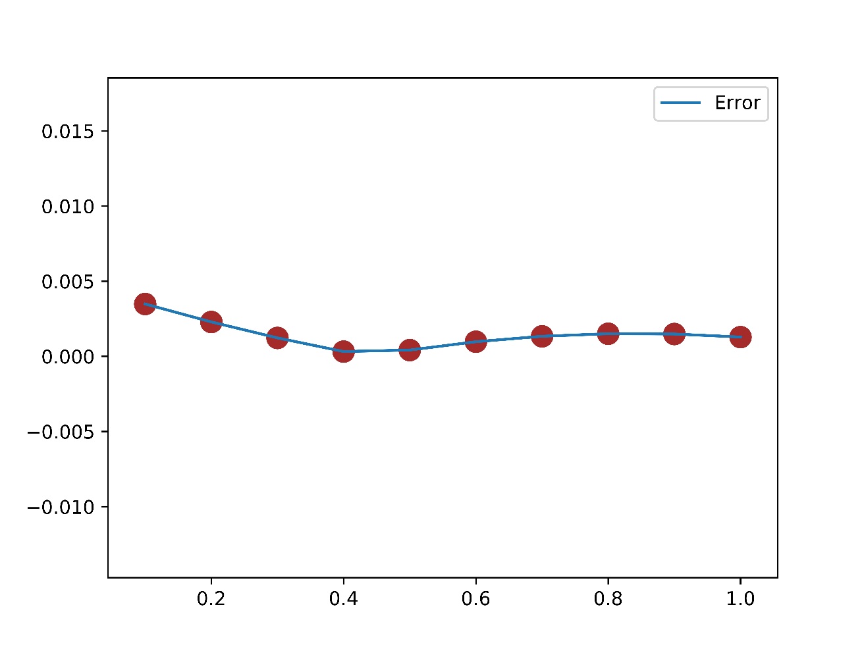

**Fig 3.** Graph of error between analytical results and ANN results for $α=\frac{15}{16}$ (Example 5.1)

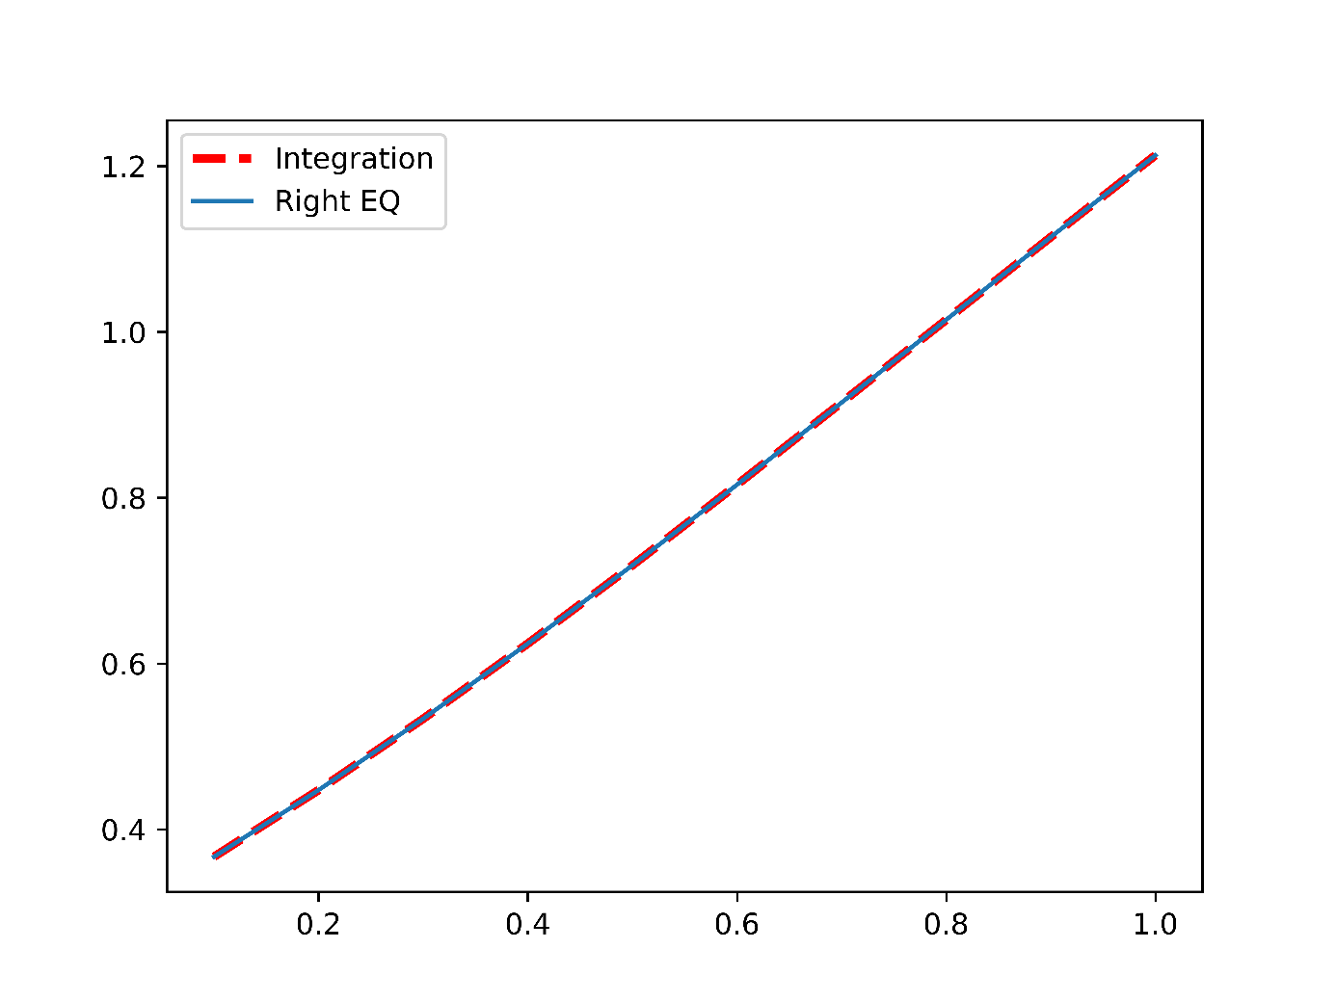

**Fig 4.** Graph of ANN is the solution of the integral equation

***Example 5.2***

Consider the Weyl fractional order integral of the form Eq. 11 that:

$$\frac{1}{2π}\int_{0}^{2π}{φ\left(x-t\right)ψ_{+}^{15/16}(t)dt}+ \int_{0}^{π}{\left(xt\right)φ\left(t\right)dt}=\sin{(x}+\frac{π}{32})-2x$$

where $h\left(x,t\right)=xt, α=\frac{15}{16}$

This equation has the analytical solution

$$φ\left(t\right)=\cos{t}$$

We train the network for ten equidistant points in the domain $[0;1]$ with ten hidden nodes and $α=\frac{15}{16}.$ Table 2 shows comparison between analytical and approximate ANN solutions for $α=\frac{15}{16}.$ Comparison between analytical and ANN solutions are depicted in Fig. 4. Error function has been plotted in Fig. 5.

**Table 2.** Analytical results and ANN results for $α=\frac{15}{16}$ (Example 5.2)

…

…

**Fig 5.** Graph of analysis results and ANN for $α=\frac{15}{16}$ (Example 5.2)

…

**Fig 6.** Graph of error between analytical results and ANN results for $α=\frac{15}{16}$ (Example 5.2)

………….

**Fig 7.** Plot khiểm tra mạng NN có là nghiệm không

***Example 5.3***

Let us consider the Weyl fractional order integral equation

$$\frac{1}{2π}\int_{0}^{2π}{φ\left(x-t\right)ψ_{+}^{\frac{15}{16}}\left(t\right)dt}+ \int_{0}^{π}{e^{x}}φ\left(t\right)dt=4e^{x}-2cos\left(x+\frac{π}{32}\right)$$

where $h\left(x,t\right)=e^{x}, α=\frac{15}{16}$

This equation has the analytical solution

$$φ\left(t\right)=2sin{t}$$

In this example we use 10 neurons for the hidden layer, the training data is taken in $[0;2π]$. Table 3 incorporates the analytical and ANN solutions for $α=0.75.$ Fig. 5 shows comparison between analytical and ANN results for $α=0.75$. The error function for $α=0.75$ are shown in Fig. 7.

**Table 3.** Analytical results and ANN results for $α=\frac{15}{16}$ (Example 5.3)

…

…

**Fig 8.** Graph of analysis results and ANN for $α=\frac{15}{16}$ (Example 5.3)

…

**Fig 9.** Graph of error between analytical results and ANN results for $α=\frac{15}{16}$ (Example 5.3)

…..

**Fig 10.** Plot khiểm tra mạng NN có là nghiệm không?

***Example 5.4***

Consider the Weyl fractional order integral of the form Eq. 11 that:

$$\frac{1}{2π}\int_{0}^{2π}{φ\left(x-t\right)ψ_{+}^{7/8}(t)dt}+ \int_{0}^{π}{\sin{(t)}}φ\left(t\right)dt=sin (x+\frac{π}{16}){-\cos{(x+\frac{π}{16})}}+\frac{π}{2}$$

where $h\left(x,t\right)=\sin{t}, α=\frac{7}{8}$

This equation has the analytical solution