/***************************************************************

*@brief for TLSR chips

* @date March 29, 2021

***************************************************************/

**Patch for Flash driver and low voltage detection: used for “telink_sig_mesh_sdk” SDK version V3.3.2 and prior.**

In order to update patch, you need to do the following things:

1. **Update flash driver：**
2. replace file " **\proj\drivers\flash.c** , **flash.h**"
3. add folder "**\drivers\8258\flash**" to path "\**drivers\8258**”
4. add "**\drivers\8258\flash_mesh_extend.c**" to path "**\drivers\8258**”
5. update file " **\proj\mcu\ compiler.h**" to add define of “_attribute_ram_code_sec_” and “_attribute_ram_code_sec_noinline_”

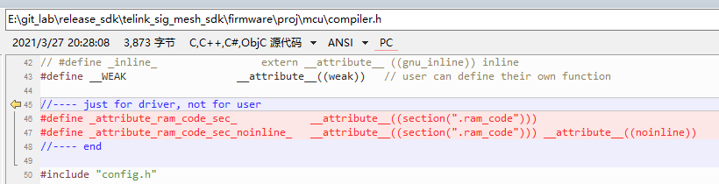

1. **Add low voltage detection function：**
2. replace file " **\drivers\8258\ adc.c, adc.h**", " **\drivers\8278\ adc.c, adc.h**"
3. add " \vendor\common\battery_check.c, battery_check.h, battery_check_827x.c" to path "\**vendor\common\**”
4. update "proj_lib\ble\blt_config.h” to add "LOW_BATT_FLG” and “LOW_BATT_LOOP_FLG”

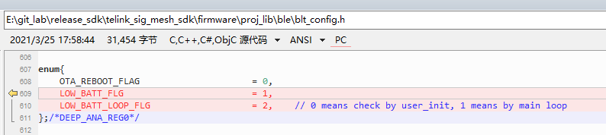

1. update " vendor/common/light.c” to add "|BIT(LOW_BATT_FLG)” and “|BIT(LOW_BATT_LOOP_FLG)” as shown below:

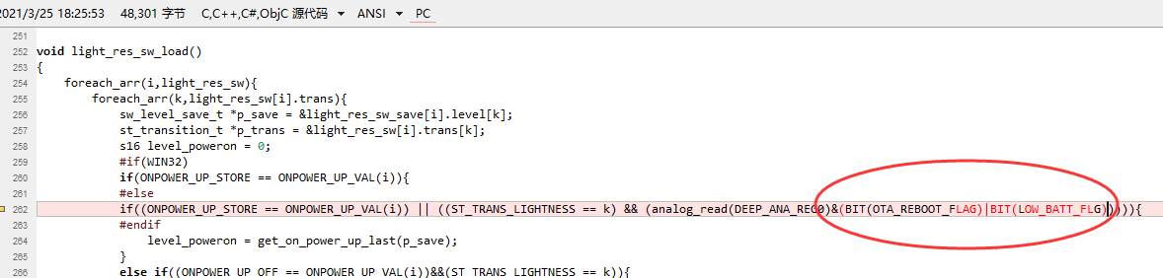

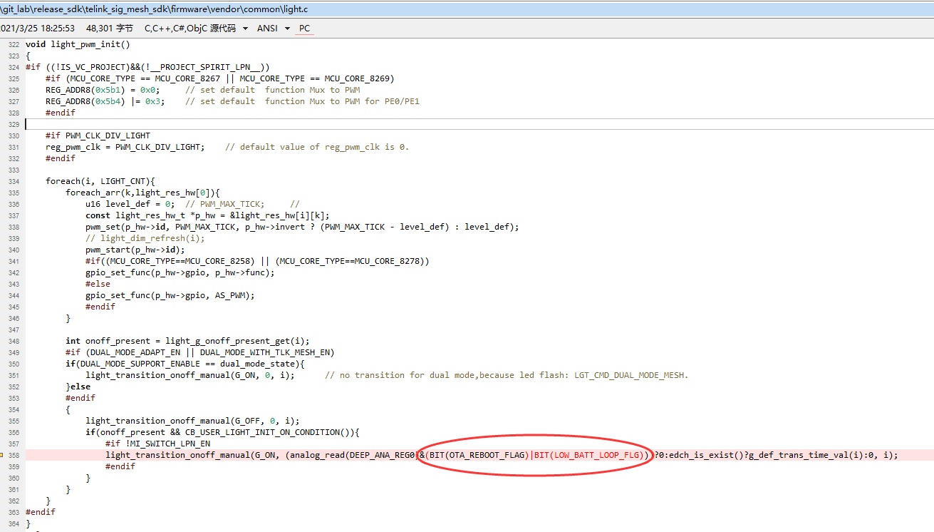

1. update " vendor/common/mesh_common.h” to add “#include "battery_check.h"

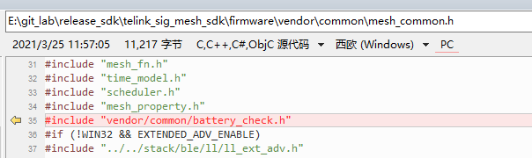

1. update to add define of “BATT_CHECK_ENABLE” and IO setting into

firmware/vendor/boot_loader/app_config_8258.h

firmware/vendor/boot_loader/app_config_8278.h

firmware/vendor/mesh/app_config_8258.h

firmware/vendor/mesh/app_config_8278.h

firmware/vendor/mesh_gw_node_homekit/app_config_8258.h

firmware/vendor/mesh_lpn/app_config_8258.h

firmware/vendor/mesh_lpn/app_config_8278.h

firmware/vendor/mesh_provision/app_config_8258.h

firmware/vendor/mesh_provision/app_config_8278.h

firmware/vendor/mesh_switch/app_config_8258.h

firmware/vendor/mesh_switch/app_config_8278.h

firmware/vendor/spirit_lpn/app_config_8258.h

firmware/vendor/spirit_lpn/app_config_8278.h

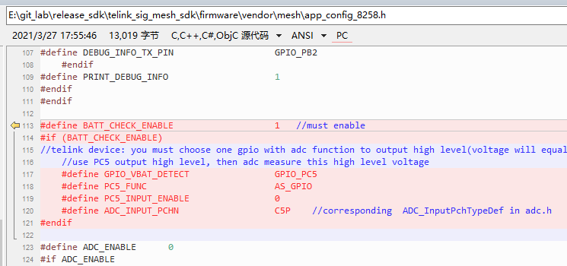

1. update to add function calling of “app_battery_power_check_and_sleep_handle(1);” in all main_loop(), and “app_battery_power_check_and_sleep_handle(0);” at the first of all user_init(). Include:

firmware/vendor/mesh/app.c

firmware/vendor/mesh_gw_node_homekit/app.c

firmware/vendor/mesh_lpn/app.c

firmware/vendor/mesh_provision/app.c

firmware/vendor/mesh_switch/app.c

firmware/vendor/spirit_lpn/app.c

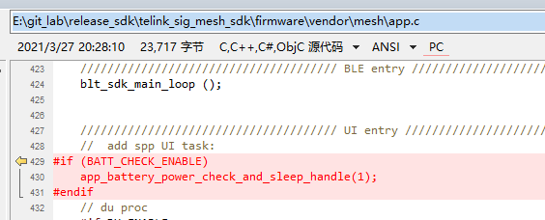

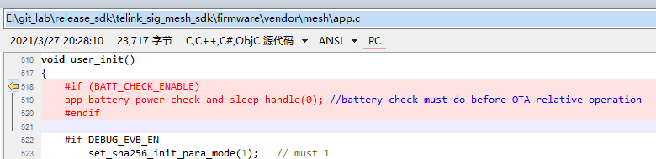

1. update “\vendor\boot_loader\main.c” to add function calling of “app_battery_power_check_and_sleep_handle(1);” and “app_battery_power_check_and_sleep_handle(0);”

