/***************************************************************
*@brief for TLSR chips
* @date May 06, 2021
***************************************************************/

Patch for Flash driver and low voltage detection: used for “telink_private_mesh_sdk” SDK version V1.R and prior.
Note: if you are developing based on V1.R, please update to V1.S for all patch. Other versions, in order to update patch, you need to do the following things:

Patch Release Note

Features
- Support ZBit flash.
- Improve the efficiency of ota when using ZBit flash.
- Calibrate the flash vref according to the reading value from flash.
- add low voltage detection function: if low voltage is detected, the chip will enter sleep state. for more details, please refer to the codes of 'BATT_CHECK_ENABLE'.

BUG FIXS
- N/A

BREAKING CHANGES
- Flash::Modify some Flash API usage for compitible.
- void flash_read_mid(unsigned char* mid) change to unsigned int flash_read_mid(void),the mid from 3byte change to 4byte.
- The API of flash_read_status、flash_write_status not provide to external use,you need use the API in the directory of flash depend on mid(eg:flash_write_status_midxxxxxx).
- •The first argument of API int flash_read_mid_uid_with_check( unsigned int *flash_mid ,unsigned char *flash_uid),flash_mid need 4byte space.The second argument need 16byte,has two case,8byte or 16byte,if the flash only has 8byte uid,flash_uid[8:15] will be clear to zero.
- The API of flash_lock,flash_unlock will be instead of flash_lock_midxxxxxx and flash_unlock_midxxxxxx.

Features
- 支持ZBit flash。
- 根据校准值校准Flash电压。
- 当使用ZBit Flash时提升OTA效率。
- 增加低电压检测功能：如果检测到低电压，芯片进入休眠状态。具体请参考BATT_CHECK_ENABLE对应的代码。

Bug fixs
- N/A

BREAKING CHANGES
- Flash:为兼容不同的Flash型号，Flash驱动结构做了调整，修改了部分Flash接口调用方式。
- void flash_read_mid(unsigned char* mid) 改为 unsigned int flash_read_mid(void),mid由3byte改为4byte,最高byte用于区分mid相同但是功能存在差异的flash。 *为兼容不同型号的Flash,flash_read_status、flash_write_status不提供给外部使用，需要使用对应接口时，需要根据mid去选择flash目录下的接口(例如：flash_write_status_midxxxxxx)。
- 接口int flash_read_mid_uid_with_check( unsigned int *flash_mid ,unsigned char *flash_uid)的第一个参数flash_mid需要4个字节空间，第二个参数需要16byte空间， 现有flash的uid有两种情况，一种16byte，一种8byte，如果是8byte，flash_uid[8:15]会被清零。
接口flash_lock、flash_unlock由flash_lock_midxxxxxx和flash_unlock_midxxxxxx替代。

Update flash driver
- replace file " \proj\drivers\flash.c , flash.h"
- add folder "\proj\drivers\flash" to path "\proj\drivers\”
- add "\proj\drivers\flash_mesh_extend.c" to path "\proj\drivers\”
- update file " \proj\mcu\ compiler.h" to add define of “_attribute_ram_code_sec_” and “_attribute_ram_code_sec_noinline_”
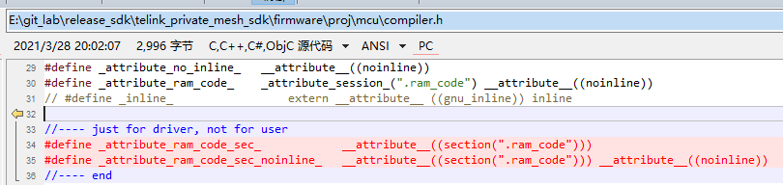

Add low voltage detection function
- replace file " \proj\drivers\ adc_8258.c, adc_8258.h, adc_8278.c, adc_8278.h"
- add " \vendor\common\battery_check.c, battery_check.h, battery_check_827x.c" to path "\vendor\common\”
- update "\vendor\common\common.h” to add “#include "battery_check.h"” and “LOW_BATT_FLG”
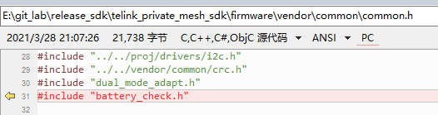

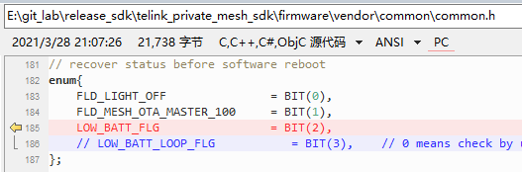
- update to add define of “BATT_CHECK_ENABLE” and IO setting into
firmware/vendor/light_8258/light.h,
firmware/vendor/light_8278/light.h
firmware/vendor/light_gateway/light_gateway_8258.h
firmware/vendor/light_gateway/light_gateway_8278.h
firmware/vendor/light_lpn/light_lpn_8258.h
firmware/vendor/light_lpn/light_lpn_8278.h
firmware/vendor/light_switch/light_switch_8258.h
firmware/vendor/light_switch/light_switch_8278.h

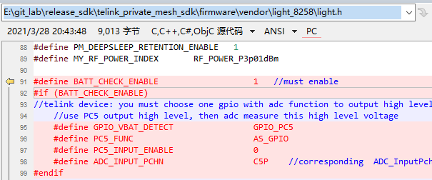

- update to add function calling of “app_battery_power_check_and_sleep_handle(1);” in all main_loop(), and “app_battery_power_check_and_sleep_handle(0);” at the first of all user_init(). Include:
firmware/vendor/light_8258/main_light.c
firmware/vendor/light_8278/main_light.c
firmware/vendor/light_gateway/main_light.c
firmware/vendor/light_lpn/light_lpn.c
firmware/vendor/light_switch/light_switch.c

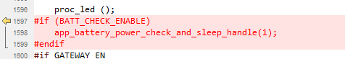

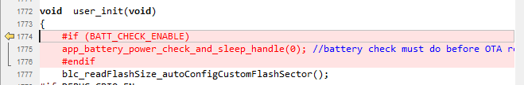
- <EN> If customer has already used the ADC function before, if it is to detect the power supply voltage, you can combining the detection with BATT_CHECK_ENABLE; if it is the ADC detection of other functions, you need to reinitialize the ADC to read, and then set “adc_hw_initialized = 0;” to inform the function “app_battery_power_check()” to run ADC initialization again. Otherwise, the ADC detection will be error.
<CN>假如客户之前已经有使用了 ADC 功能，如果是检测电源电压的话，可以考虑和 BATT_CHECK_ENABLE 合并检测；如果是其它功能的ADC 检测，则需要重新初始化 ADC 才能读取，然后 设置 adc_hw_initialized = 0；让 BATT_CHECK_ENABLE 对应的ADC 检测函数(app_battery_power_check())读取ADC时，先执行 ADC 的初始化。否则ADC检测异常。

Calibrate flash vref by reading value from flash, improve the efficiency of OTA when using ZBit flash
- replace " \proj_lib\pm_8258.h" for V1.R, or update this file to add codes in red.
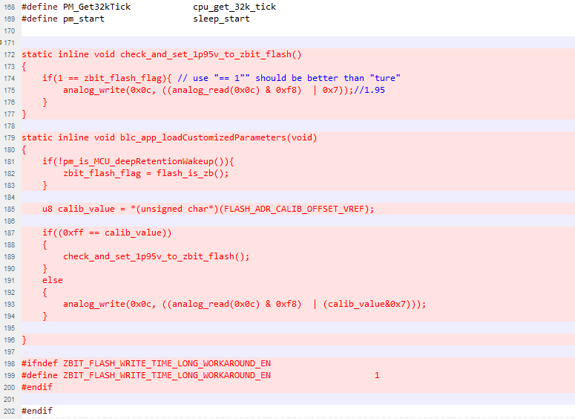
- replace " \proj_lib\pm_8278.h" for V1.R, or update this file to add codes in red.
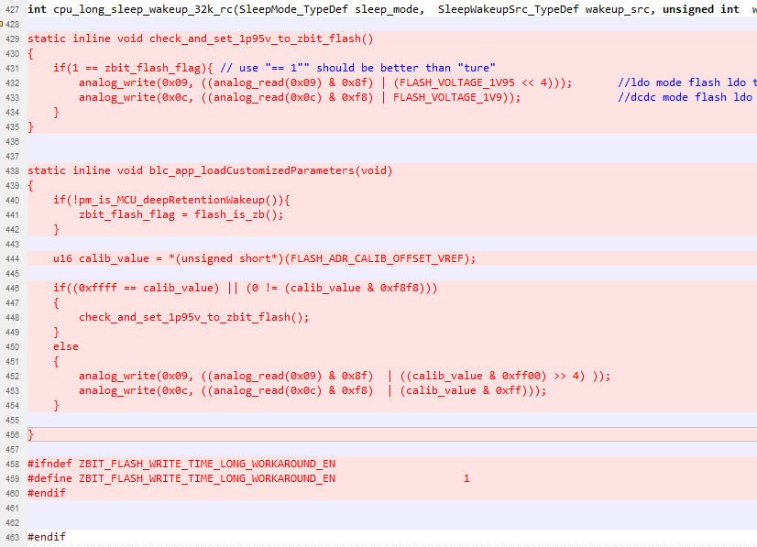
- update the function “rf_link_slave_data_ota_save()” in file “\vendor\common\common.c” to add the codes in red.
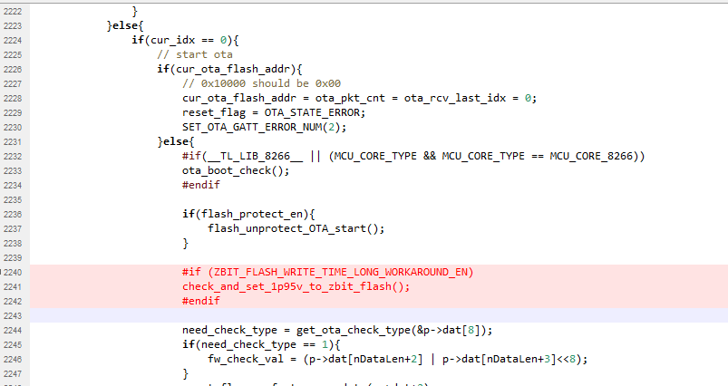
- update file “\vendor\common\user_config.h” to add the codes in red.
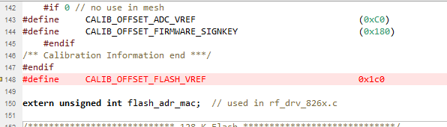

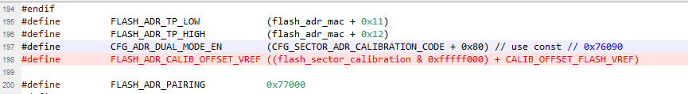
- update the function “main()” in file “\vendor\light_8258\main.c” to add the codes in red.
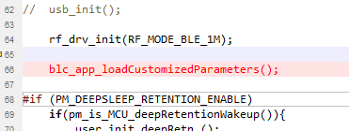
- update the function “main()” in file “\vendor\light_8278\main.c” to add the codes in red.
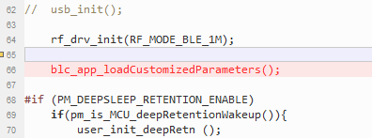
- update the function “main()” in file “\vendor\light_gateway\main.c” to add the codes in red.
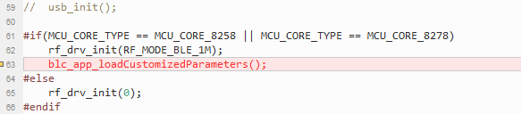
- update the function “main()” in file “\vendor\light_lpn\main.c” to add the codes in red.
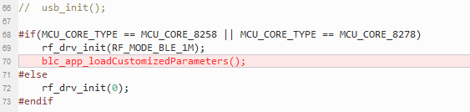
- update the function “main()” in file “\vendor\light_switch\main.c” to add the codes in red.
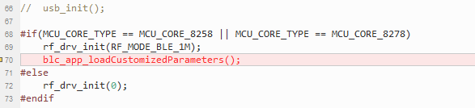
- <EN>if customer has added your own OTA process, you need to call check_and_set_1p95v_to_zbit_flash() when OTA start. as shown below:
<CN>假如客户有增加了自己的OTA 流程，需要在 OTA start 的时候，调用check_and_set_1p95v_to_zbit_flash();如下图：
