/***************************************************************

*@brief for TLSR chips

* @date March 29, 2021

***************************************************************/

**Patch for Flash driver and low voltage detection: used for “telink_private_mesh_sdk” SDK version V1.R and prior.**

Note: if you are developing base on V1.R, please update to V1.S for all patch. Other version,

in order to update patch, you need to do the following things:

1. **Update flash driver：**
2. replace file " **\proj\drivers\flash.c** , **flash.h**"
3. add folder "**\proj\drivers\flash**" to path "\**proj\drivers\**”
4. add "**\proj\drivers\flash_mesh_extend.c**" to path "\**proj\drivers\**”
5. update file " **\proj\mcu\ compiler.h**" to add define of “_attribute_ram_code_sec_” and “_attribute_ram_code_sec_noinline_”

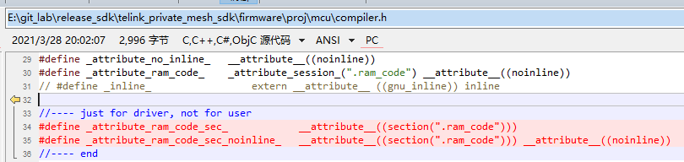

1. **Add low voltage detection function：**
2. replace file " **\proj\drivers\ adc_8258.c, adc_8258.h**, **adc_8278.c, adc_8278.h**"
3. add " \vendor\common\battery_check.c, battery_check.h, battery_check_827x.c" to path "\**vendor\common\**”
4. update "\**vendor\common\common.h**” to add “#include "battery_check.h"” and “LOW_BATT_FLG”

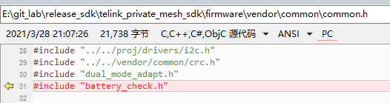

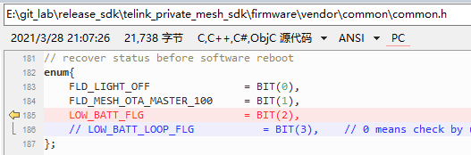

1. update to add define of “BATT_CHECK_ENABLE” and IO setting into

firmware/vendor/light_8258/light.h,

firmware/vendor/light_8278/light.h

firmware/vendor/light_gateway/light_gateway_8258.h

firmware/vendor/light_gateway/light_gateway_8278.h

firmware/vendor/light_lpn/light_lpn_8258.h

firmware/vendor/light_lpn/light_lpn_8278.h

firmware/vendor/light_switch/light_switch_8258.h

firmware/vendor/light_switch/light_switch_8278.h

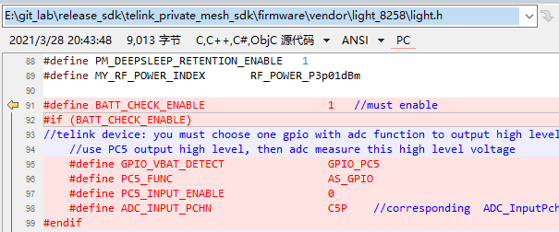

1. update to add function calling of “app_battery_power_check_and_sleep_handle(1);” in all main_loop(), and “app_battery_power_check_and_sleep_handle(0);” at the first of all user_init(). Include:

firmware/vendor/light_8258/main_light.c

firmware/vendor/light_8278/main_light.c

firmware/vendor/light_gateway/main_light.c

firmware/vendor/light_lpn/light_lpn.c

firmware/vendor/light_switch/light_switch.c

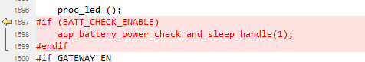

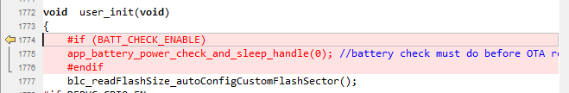

1. **Calibrate the flash vref according to the reading value from flash.：**
2. replace " \proj_lib\pm_8258.h" for V1.R, or update this file to add codes in red.

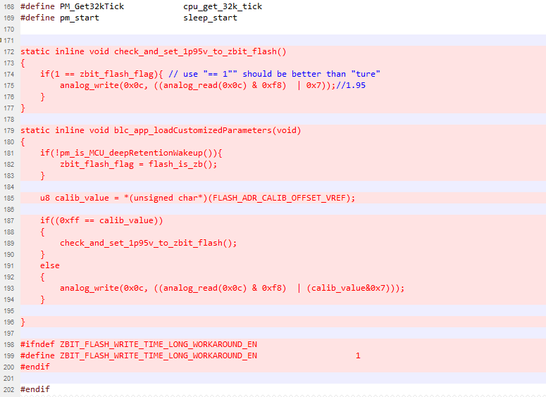

1. replace " \proj_lib\pm_8278.h" for V1.R, or update this file to add codes in red.

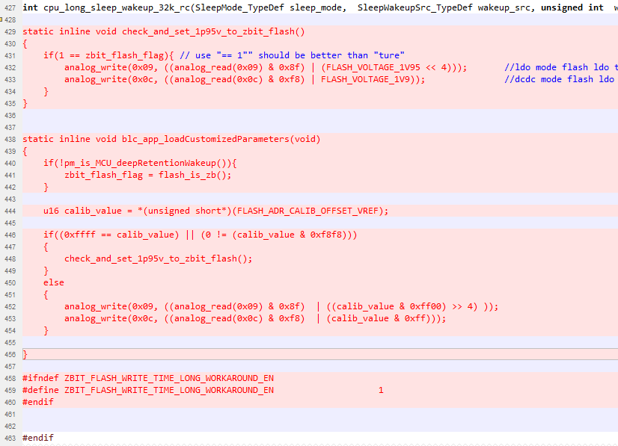

1. update the function “rf_link_slave_data_ota_save()” in file “\vendor\common\common.c” to add the codes in red.

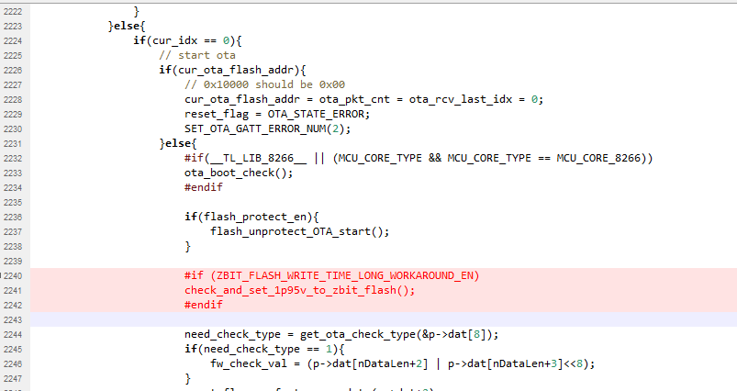

1. update file “\vendor\common\user_config.h” to add the codes in red.

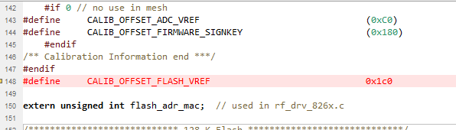

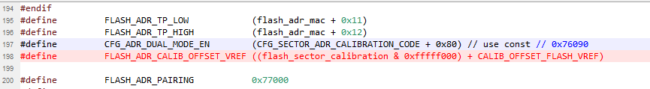

1. update the function “main()” in file “\vendor\light_8258\main.c” to add the codes in red.

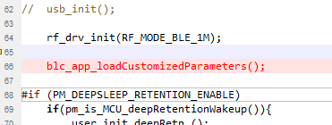

1. update the function “main()” in file “\vendor\light_8278\main.c” to add the codes in red.

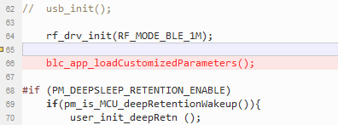

1. update the function “main()” in file “\vendor\light_gateway\main.c” to add the codes in red.

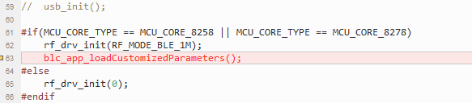

1. update the function “main()” in file “\vendor\light_lpn\main.c” to add the codes in red.

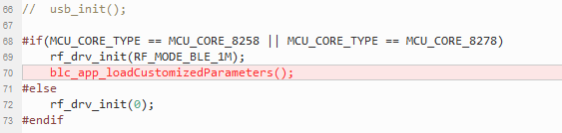

1. update the function “main()” in file “\vendor\light_switch\main.c” to add the codes in red.

