/***************************************************************
*@brief for TLSR chips
* @date May 06, 2021
***************************************************************/

Patch for Flash driver and low voltage detection: used for “telink_sig_mesh_sdk” SDK version V3.3.2 and prior.
Note: if you are developing based on V3.3.2, please update to V3.3.3 for all patch. Other versions,
in order to update patch, you need to do the following things:

Patch Release Note

Features
- Support ZBit flash.
- Improve the efficiency of ota when using ZBit flash.
- Calibrate the flash vref according to the reading value from flash.
- add low voltage detection function: if low voltage is detected, the chip will enter sleep state. for more details, please refer to the codes of 'BATT_CHECK_ENABLE'.

BUG FIXS
- N/A

BREAKING CHANGES
- Flash::Modify some Flash API usage for compitible.
- void flash_read_mid(unsigned char* mid) change to unsigned int flash_read_mid(void),the mid from 3byte change to 4byte.
- The API of flash_read_status、flash_write_status not provide to external use,you need use the API in the directory of flash depend on mid(eg:flash_write_status_midxxxxxx).
- •The first argument of API int flash_read_mid_uid_with_check( unsigned int *flash_mid ,unsigned char *flash_uid),flash_mid need 4byte space.The second argument need 16byte,has two case,8byte or 16byte,if the flash only has 8byte uid,flash_uid[8:15] will be clear to zero.
- The API of flash_lock,flash_unlock will be instead of flash_lock_midxxxxxx and flash_unlock_midxxxxxx.

Features
- 支持ZBit flash。
- 根据校准值校准Flash电压。
- 当使用ZBit Flash时提升OTA效率。
- 增加低电压检测功能：如果检测到低电压，芯片进入休眠状态。具体请参考BATT_CHECK_ENABLE对应的代码。

Bug fixs
- N/A

BREAKING CHANGES
- Flash:为兼容不同的Flash型号，Flash驱动结构做了调整，修改了部分Flash接口调用方式。
- void flash_read_mid(unsigned char* mid) 改为 unsigned int flash_read_mid(void),mid由3byte改为4byte,最高byte用于区分mid相同但是功能存在差异的flash。 *为兼容不同型号的Flash,flash_read_status、flash_write_status不提供给外部使用，需要使用对应接口时，需要根据mid去选择flash目录下的接口(例如：flash_write_status_midxxxxxx)。
- 接口int flash_read_mid_uid_with_check( unsigned int *flash_mid ,unsigned char *flash_uid)的第一个参数flash_mid需要4个字节空间，第二个参数需要16byte空间， 现有flash的uid有两种情况，一种16byte，一种8byte，如果是8byte，flash_uid[8:15]会被清零。
- 接口flash_lock、flash_unlock由flash_lock_midxxxxxx和flash_unlock_midxxxxxx替代。

Update flash driver
- replace file " \drivers\8258\flash.c , flash.h"
- add folder "\drivers\8258\flash" to path "\drivers\8258”
- add "\drivers\8258\flash_mesh_extend.c" to path "\drivers\8258”
- update file " \proj\mcu\ compiler.h" to add define of “_attribute_ram_code_sec_” and “_attribute_ram_code_sec_noinline_”
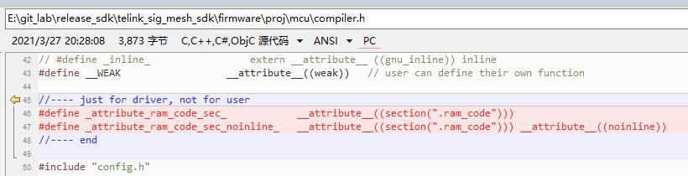

Add low voltage detection function
- replace file " \drivers\8258\ adc.c, adc.h", " \drivers\8278\ adc.c, adc.h"
- add " \vendor\common\battery_check.c, battery_check.h, battery_check_827x.c" to path "\vendor\common\”
- update "proj_lib\ble\blt_config.h” to add” FLD_OTA_REBOOT_FLAG”, ” FLD_LOW_BATT_FLG” and “LOW_BATT_LOOP_FLG”
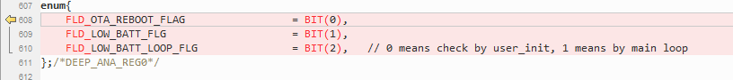
- update " vendor/common/light.c” to add or update ” FLD_OTA_REBOOT_FLAG”, ” FLD_LOW_BATT_FLG” and “LOW_BATT_LOOP_FLG”, as shown below:
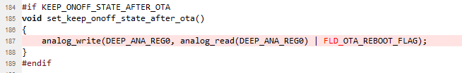

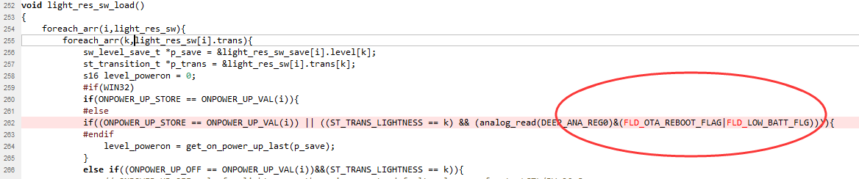

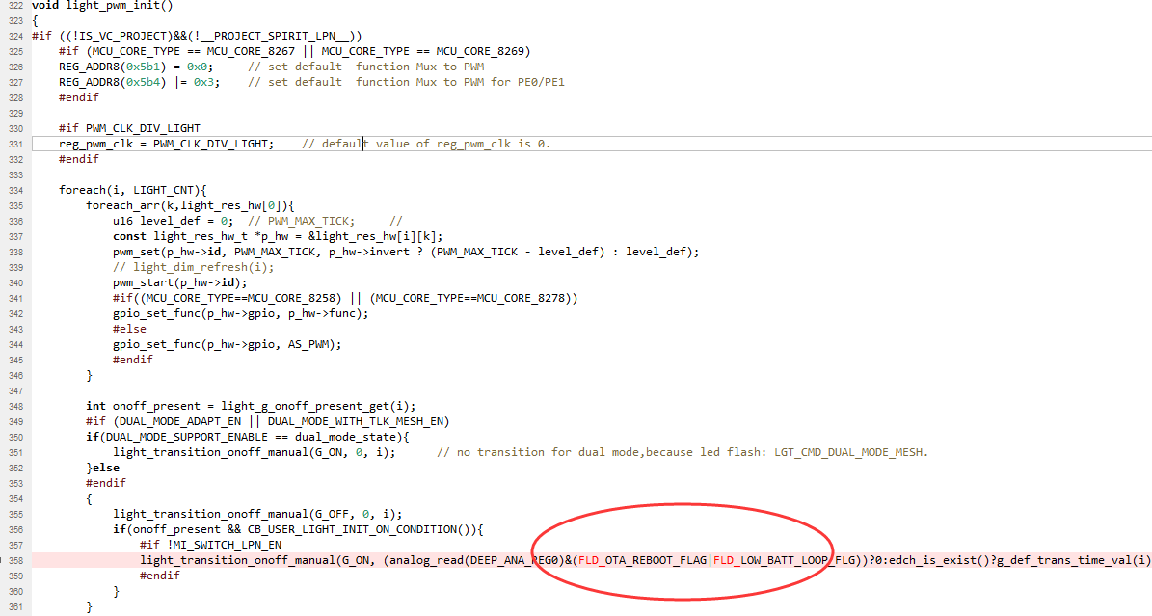

- update " vendor/common/mesh_common.h” to add “#include "battery_check.h"
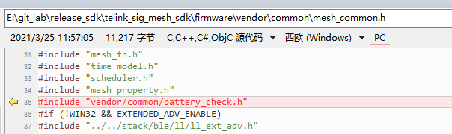

- update to add define of “BATT_CHECK_ENABLE” and IO setting into
firmware/vendor/boot_loader/app_config_8258.h
firmware/vendor/boot_loader/app_config_8278.h
firmware/vendor/mesh/app_config_8258.h
firmware/vendor/mesh/app_config_8278.h
firmware/vendor/mesh_gw_node_homekit/app_config_8258.h
firmware/vendor/mesh_lpn/app_config_8258.h
firmware/vendor/mesh_lpn/app_config_8278.h
firmware/vendor/mesh_provision/app_config_8258.h
firmware/vendor/mesh_provision/app_config_8278.h
firmware/vendor/mesh_switch/app_config_8258.h
firmware/vendor/mesh_switch/app_config_8278.h
firmware/vendor/spirit_lpn/app_config_8258.h
firmware/vendor/spirit_lpn/app_config_8278.h
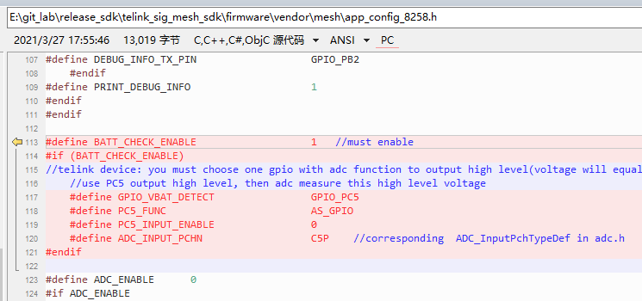

- update to add function calling of “app_battery_power_check_and_sleep_handle(1);” in all main_loop(), and “app_battery_power_check_and_sleep_handle(0);” at the first of all user_init(). Include:
firmware/vendor/mesh/app.c
firmware/vendor/mesh_gw_node_homekit/app.c
firmware/vendor/mesh_lpn/app.c
firmware/vendor/mesh_provision/app.c
firmware/vendor/mesh_switch/app.c
firmware/vendor/spirit_lpn/app.c
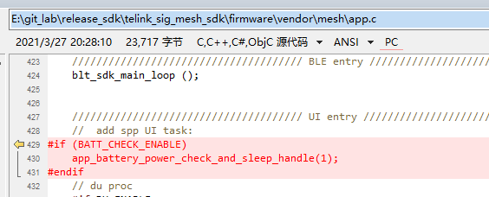

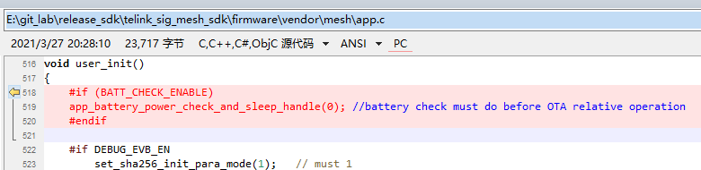

- update “\vendor\boot_loader\main.c” to add function calling of “app_battery_power_check_and_sleep_handle(1);” and “app_battery_power_check_and_sleep_handle(0);”
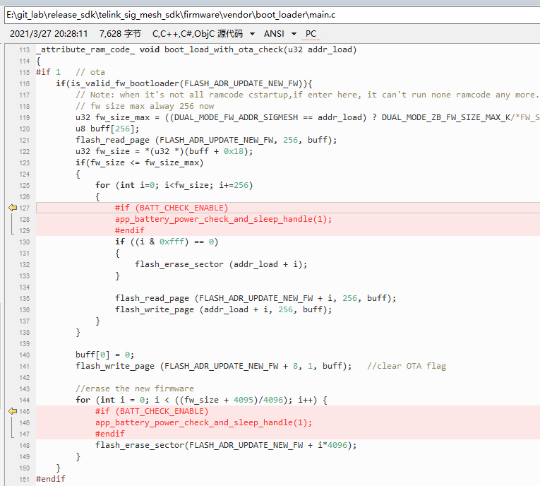

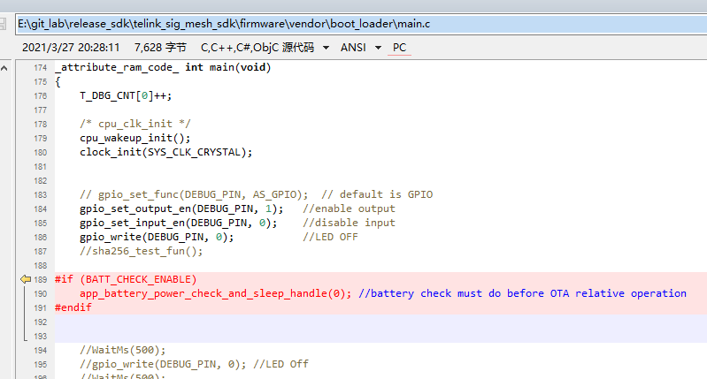

- for sdk version v3.2.1 and prior, 825x serials, update the function “random_generator_pre_init()” in file “drivers\8258\random.c” , change ADC_VREF_0P6V to ADC_VREF_1P2V as followed:
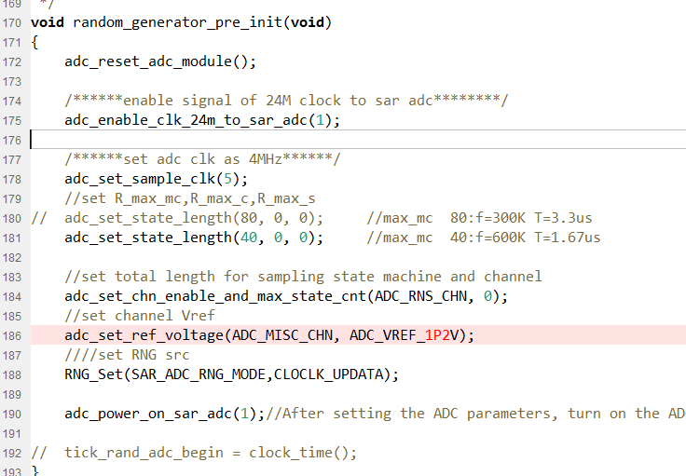

Calibrate the flash vref according to the reading value from flash
- update "proj_lib\ble\blt_config.h” to add ” CALIB_OFFSET_FLASH_VREF” in red.
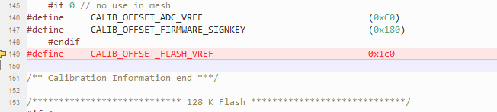
- update “\stack\ble\blt_config.h” to add codes in red:
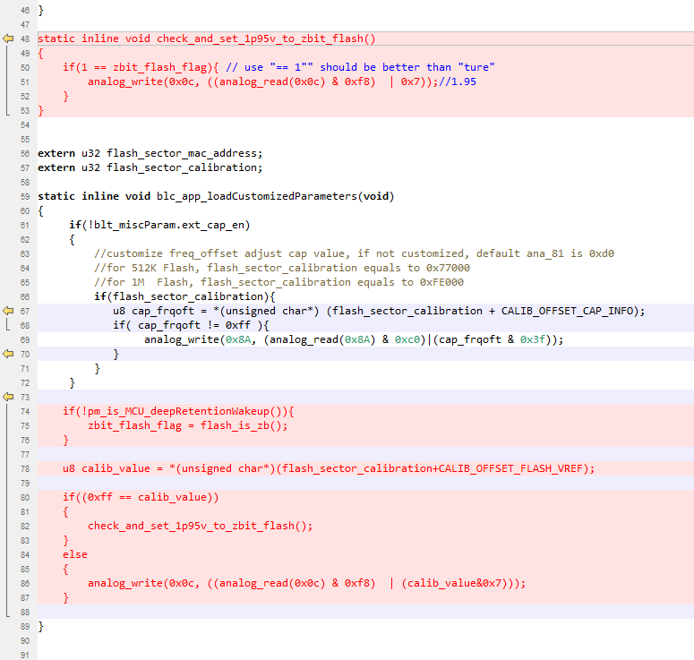

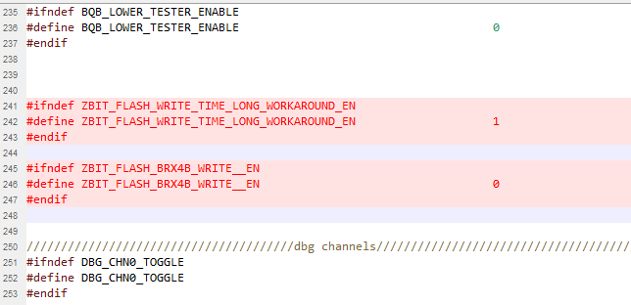
- update “\stack\ble_8278\blt_config.h” to add codes in red:
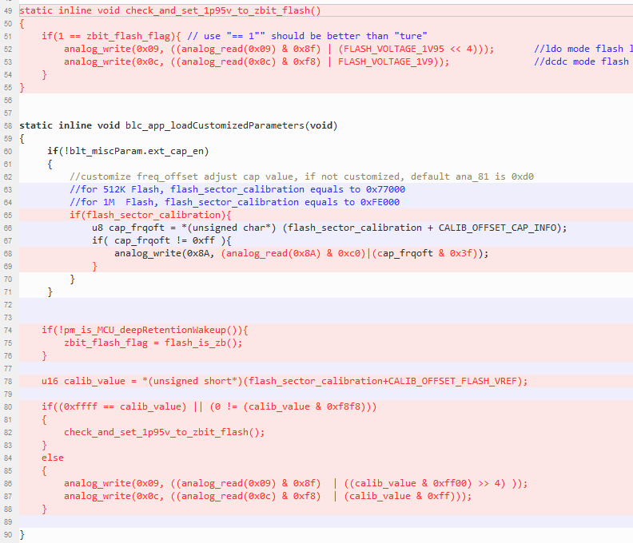

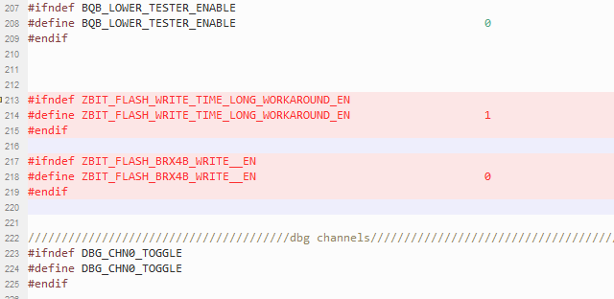
- update the function “main()” in file “\vendor\boot_loader\main.c” to add the codes in red.
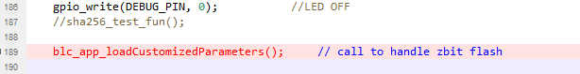
- update the functions in file “\vendor\common\ble_ll_ota.c” to add the codes in red:
“otaWrite ()”:
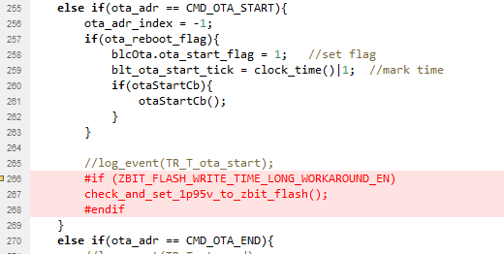

“ais_ota_req”:
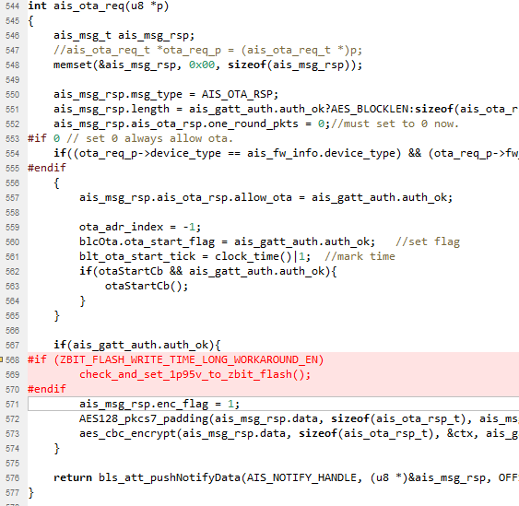
- update the function “mible_dfu_handler()” in file “\vendor\common\mi_api\telink_sdk_mible_api.c” to add the codes in red:
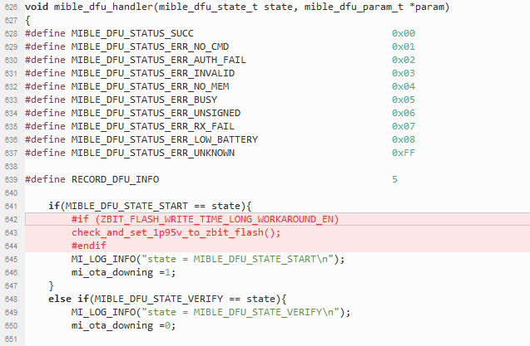

- update the function “mesh_cmd_sig_blob_transfer_handle ()” in file “\vendor\common\mesh_ota.c” to add the codes in red, if “mesh_ota.c” is existed:
