**Solutions Architecture Tips – Types of Architecture Diagrams**

**Below are different types of diagrams you should make depending on five different audiences.**

# The Flow Diagram

## Description

A medium-to-high-level diagram that shows all the pieces of a workflow. This diagram illustrates the moving parts in a business process. This could be termed as a Data-Flow-Diagram or DFD. A DFD diagram describes the flow of data within a system; however, this same diagram can be used with business processes – DFD can be employed as a business modeling tool, describing business events and interactions or the physical systems involving data storage and transfer.

### Information Architecture

Information Architecture (IA) is a broad and abstract term. It describes the structure of a system, how the different pieces of information are related at the system and represents their relationships.

## Audience

The audience for this type of diagram is generally technical. It may be used to pitch an idea to an architecture board or describe how a business process works to a developer.

## Considerations

The major component of the architecture flow diagram is the inclusion of all moving parts. In the case of a serverless AWS environment, we label each managed service and which ones communicate with each other. **NOTE**: No details on how the pieces interact with each other are described in the diagram, but the diagram does show the connections. It shows how data flows through the system.

## Examples of the Flow Diagram

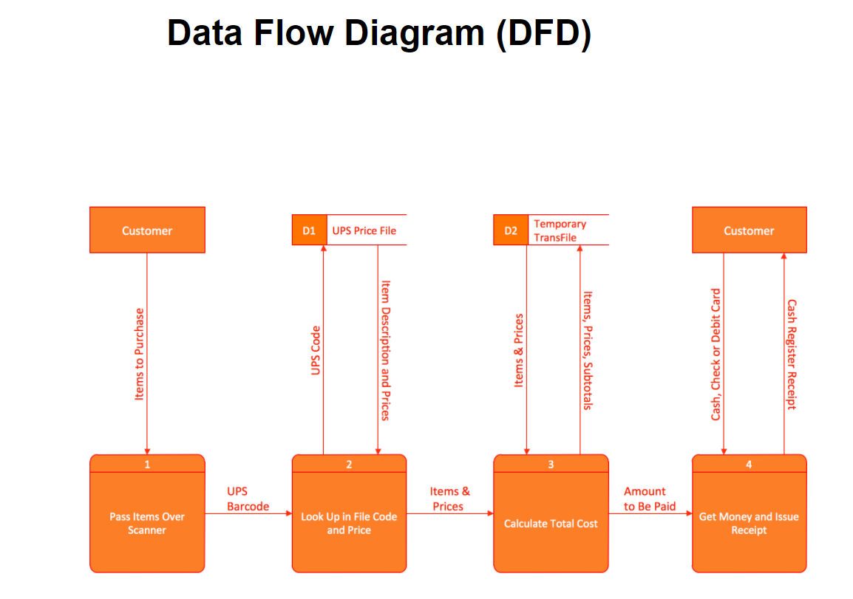

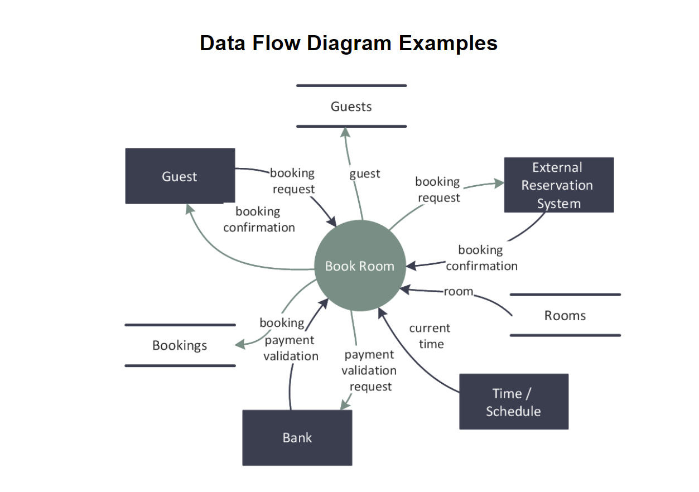

## Example of Business Process Flow Chart – Event-Driven Process Chain (EPC) diagrams

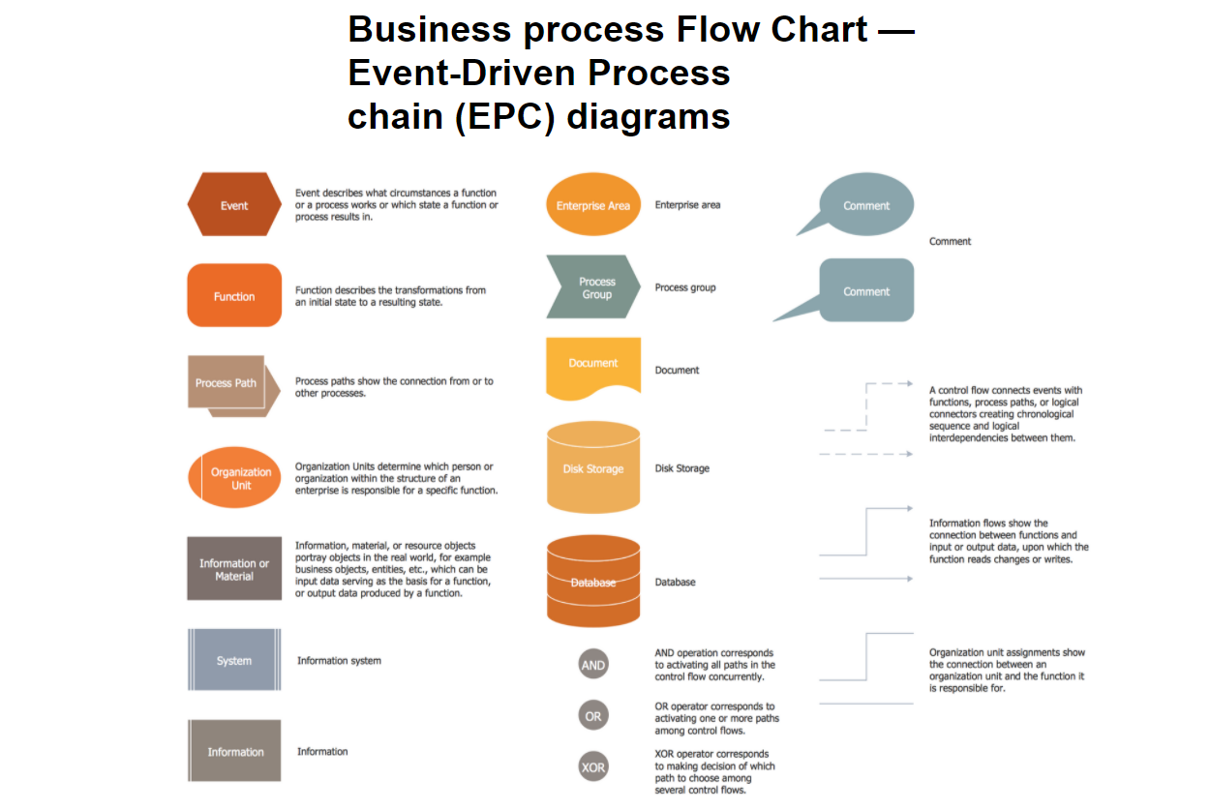

# The Service Diagram

## Description

A service diagram illustrates connectivity from a high level. It does not show any details on how the workflow or service works but instead shows the major pieces at play. This is a diagram intended to show the internal VS external services used in the application.

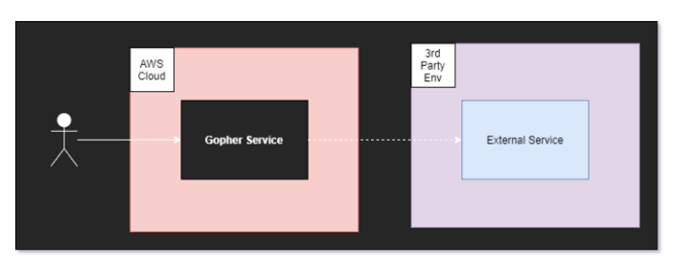

## Audience

IT and Network Engineers tend to be most interested in this type of diagram. They care about any connections you’re making to outside services. Plus, they need to know if any internal connectivity needs to be monitored.

Used mostly to describe how the systems work to executives. They want to know the connections between major applications, and there is nothing better than the service diagram to represent those connections.

## Considerations

When building an architecture service diagram, it’s good to list all the microservices that make up your application or ecosystem. Label which services communicate with each other and be sure to make the distinction between services your company owns and services that are external.

Details on how the services work are not necessary for this high-level diagram. This is all about the services that make an application run.

# The Persona Diagram

## Description

It is important to show that your architecture solves the business problem. A persona diagram describes a chronological view and actors in a particular workflow. This is your best tool for proving that you’ve taken the business into consideration when developing your solution.

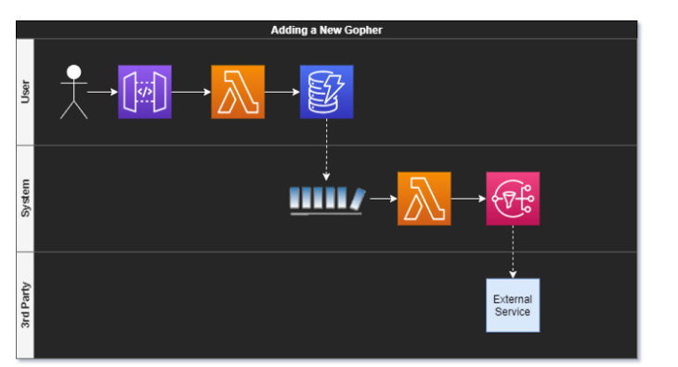

## Audience

Business-Oriented individuals and product owners are the intended audiences for this type of diagram. They are focused on personas and how they interact with the system. Showing them a graph of who does what and when will perfectly describe what your system is doing.

## Considerations

The architecture persona diagram dips into the BPMN model (<https://www.bpmn.org/>) a little bit. Make use of swim lanes to show the different actors in a workflow. This type of diagram tends to be lower-level, as it includes more detail than the others. Be sure to label the personas, the workflow, and any assumptions of how the business process gets from one step to the other.

These diagrams also help developers who are new to a domain and offer insightful context into what they will be building.

**Architecture Diagrams Software**

**Useful Links**

# yED Drawing Tool

URL: https://www.yworks.com/yed-live/  
Good business process and programming diagrams

# Gliffy Drawing Tool

URL: <https://go.gliffy.com/go/html5/launch>  
Good for UML, FlowCharts, Wireframes, Images  
**Need to UPGRADE to a single user on April 9th – Pay Quarterly of $29.95**

