Liberty Consulting Services, LLC

Technology Focus

# Overview

The purpose of this document is to state the market niche and type of Architecture Styles, as well as, technology stack that Liberty Consulting Services, LLC will leverage in building custom systems or Enterprise Systems for companies.

The types of applications that will be build by Liberty Consulting Services, LLC are, but not limited to:

* Mobile Applications
* Web Applications
* Desktop Applications
* Distributed Systems (APIs, RESTFul Services or MicroServices)
* Messaging Systems
* Full Stack Systems

The tiers that Liberty Consulting Services, LLC will focus on are: (See Diagram Below)

* Layered Architecture Style/Tier
* 3-Tier
* N-Tier
* Middleware
* Distributed Systems (RESTFul Services and MicroServices)
* Messaging Systems or Orchestration

Below is a basic diagram of Layered or 3-Tier Architectural Style. This is an industry common style that is leveraged in most or all companies. There are other architectural styles that can be used with this style (some may include Object-Oriented Programming or Object-Oriented Analysis and Design, Middleware, MicroServices or Services Oriented Architecture – SOA).

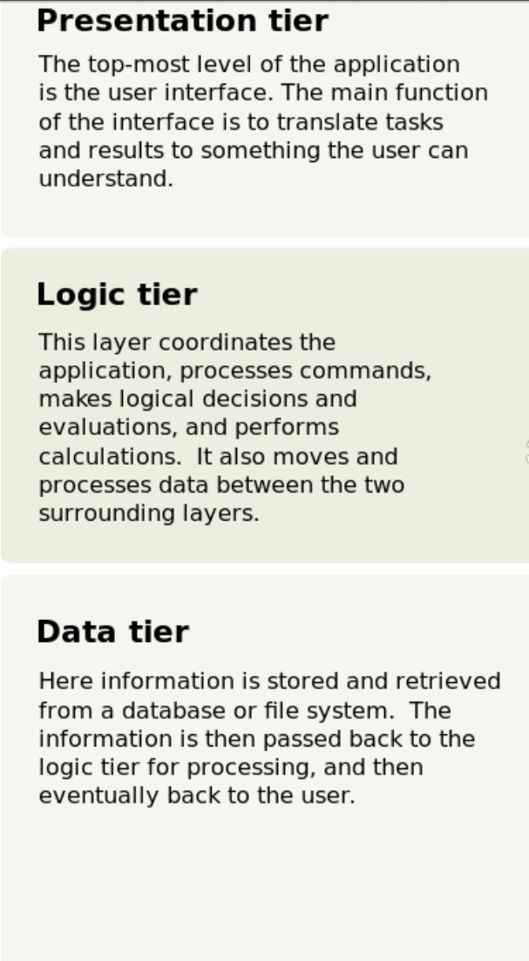

The Layered Architectural Style may include layers such as Services Tier/Layer (Above the Logic tier). The purpose of this layer will serve as:

* Services Oriented Architecture (SOA)
* RESTFul Services

One of Liberty Consulting Services, LLC goals will be to focus on Microsoft Applications. Becoming a Microsoft Partner is one of my long term goals. This will let companies know that I am fluent with Microsoft Technologies. It would state that I am specialized in several cross cutting concerns or non-functional space within the Microsoft Arena. Becoming a Microsoft Partner will enable Liberty Consulting Services, LLC be a promoter of Windows solutions primarily in Desktop, Web and Mobile Development. It will also include cloud based architecture; such as:

* Maintaining a Software As A Service (SaaS) and On-Premise Web Application in Microsoft Azure or IIS
* Maintaining a Desktop Application on Windows 7 or Above. I choose Windows 7 and not only Windows 10 to increase my market
* Maintaining Hybrid solutions in Android, Apple Store or Microsoft Store using XAMARIN.
* Maintaining all Data store either on-premise or cloud-base (PaaS or Platform As A Service) using Microsoft Azure, SQL Server Azure and SQL Server
* Monitoring the Software Development Life Cycle using Azure DevOps
* Maintain Continuous Integration and Continuous Deployment using Azure DevOps
* Manage Project timelines and Project Plans using Microsoft Project
* Maintaining documents, spreadsheets, meeting notes, publications, presentations, and emails using Microsoft Office
* Building cross platform and Windows Base Services using ASP.Net Core API or ASP.Net WEB API Framework, as well as;
* Building Services Oriented Applications and Micro Services using Windows Communication Framework (WCF)

**Will not focus on becoming certified in any area that Microsoft provides with certifications. These are certifications like Azure Solution Architect, MCAD, MCSE, .etc.**

Becoming a Microsoft Partner will prove to companies that Liberty Consulting Services, LLC can fully leverage most Microsoft Technology Stack or tools to architect, design and build Windows or Cross Platform Systems. The goal is to become a partner within a year or two.

# Kinds of Applications that I will be Building For Clients

* Migration from Legacy Applications to Modern or bleeding-edge systems
* Building greenfield or new applications using full stack development
* Be a part of a team serving as a stakeholder/developer/lead/solution-architect in building a system

# Acceptable Roles I which to serve in

This section primarily answers what kind of titles I may be willing to serve as:

* Solution Architect AND Technical Lead => leading the design and being a major SME or implementor of building a system or suite of systems
* Senior Developer
* Junior Developer
* UI Developer
* API Developer
* Full Stack Developer

# Focus Technology Stack Based on Layered Architecture

## Web Application or Web Sites (**This is NOT a Microsoft’s Partner Tool**)

### User Interface (Presentation Layer)

* Angular version 4 or Above
  + This will allow Legacy System like Internet Explorer 11.
  + Using Internet Explorer 11 means I will serve as an augmentation to a company’s staff.
  + I will focus on Modern browsers or, mostly, responsive web applications. Using Progressive Web Applications, such as, Angular Universal, Angular Service Workers.
  + Build Shared Libraries using Angular for multiple Web Application Front-Ends (almost like an Enterprise System).
  + Using Node Package Manager for maintaining and storing libraries in NPM’s registry
* HTML5/CSS3/SAAS-Compiler
* Web Frameworks for Angular
  + Bootstrap
  + Angular Material
  + PRIMENG
  + Willing to learn other popular web frameworks, such as:
    - Kendo UI
* Unit Testing Tools => Jasmine and Karma or other unit test tools
* TypeScript
* Angular ngRx Store for State Management
* Redux Chrome Plugin
* Microsoft Edge
* Chrome
* Mozilla FireFox
* Internet Explorer 11 ONLY

# Desktop Application

## User Interface (Presentation Layer)

* Windows Presentation Framework (WPF) using C# ONLY
  + Using PRISM Framework for building modular systems or Enterprise Systems
  + Using Model-View-ViewModel (MvvM) Pattern for Desktop User Interface Applications
* Windows Forms (Legacy System) Using C# ONLY
  + Using Model-View-Presenter (MVP) Pattern for Desktop User Interface Applications

# API or Services

## Services Layer

* Using MicroServices Architecture for building services
* Using Services Oriented Architecture for building services
* Using REST Architecture Style for building RESTFul Services

## Technology Stack

* ASP.Net WEB API Core => use for building RESTFul Services on cross-platform services (such as Windows, Linux, MAC)
* ASP.Net WEB API => use for building RESTFul Services for building services on Windows
* Windows Communication Framework (WCF) => use for building SOA or MicroServices

# Logic Tier/Layer

## Business Logic

* C# ONLY
  + Using Object Oriented Analysis and Design
  + Using Object Oriented Analysis and Programming
  + Using Gang-of-Four Design Pattern
  + Using Middleware Pattern
  + Using Services Oriented Architecture Style
  + Using MicroServices
  + Using C# Unit Testing Tools
* Object-Relational-Model (ORM) used for building Data Type Objects or Data Models
  + Entity Framework for .Net Core => Cross Platform systems
  + Entity Framework for .Net => Windows Systems
  + ADO.Net => for Connecting to Data Layer or Databases – SQL Server
* AutoFac.Net => Dependency Injection
* AutoMapper.Net => Data type Object Model transformation

# Data Tier/Layer

## Technology Stack

* SQL Server for Relational Databases => On-Premise Online Transactional Databases
  + Normalization Rules
  + Stored Procedures
  + Common Table Types
  + Performance and Optimization for Queries and CRUDs
  + Other Database Development Principles
* NoSql Languages => Non-Relational Database, like Facebook, search queries, .etc
  + Elastic Search Tool
* SQL Server Azure for Cloud PaaS
  + Maintaining a Database in the cloud

# Project Management and Software Development LifeCycle

## Technology Stack

* Microsoft Project
* SCRUM/Agile Framework Software Development LifeCycle (SDLC) => Azure DevOps
* Waterfall => used for strict requirements, minimal change request
* Microsoft Office => used for sending emails, managing documents, spreadsheets, publications, presentations, note taking, .etc
  + OneNote
  + Word
  + Excel
  + Publisher
  + PowerPoint
  + Outlook
* Continuous Integration
  + GIT
  + GIT FLOW
  + Azure GIT Repo
* Continuous Deployment
  + Azure DevOps
    - Pipelines
    - Release
* Testing
  + Azure DevOps Test Plans
  + Quality Assurance Management
    - Smoke Testing => Determining the system health check
    - Integration Testing
    - Unit Testing
    - BETA Testing
    - User Acceptance Testing
    - System Testing
    - Determining TestBeds
    - Determining Test Suites
  + Determining Testing Environments (Development, Staging/QA, UAT, Production, .etc)

# Non-Functional or Cross-Cutting Concerns

## Technology Stack (C# ONLY)

* Providers for Logging
  + Log4Net
  + Splunk.Net
* Configuration Management Providers
* Middleware Providers
* AutoFac
* AutoMapper
* EntityFramework .Net Core
* EntityFramework for Windows
* Azure Services => other Azure services for messaging systems
* RabbitMQ => used for messaging systems
* Developing Distributed Communication Systems using some form of Messaging Pattern

**Tellek Edward Liberty**

Issues To Be Addressed

1) Article of Incorporation.

2) Why S-Cooperation?  How fees will be handled by partners.

Complying with corporate formalities like bylaws & holding board and shareholders meeting.

List of board members and shareholders.

* Open discussion???

Types of Companies (**NON-PROFIT IS NOT LISTED BELOW**) This was one of the sites that I looked at when doing my research. This is more of partnerships. Comfort and I are two, when bringing in more with diverse relations and experiences plus motives (**motives meaning what do I want personally that right now I don’t want to state to everyone; however, if I foresee this, I can stay or when I decide to leave the company, how am I protected**).

**Research: (URL:** [**https://smallbusiness.findlaw.com/incorporation-and-legal-structures/benefits-and-drawbacks-of-different-types-of-business-entities.html#:~:text=%20%20%20Professional%20Corporation%20%20%20Owners,Partners%20remain%20personally%20liable%20for%20ob%20...%20**](https://smallbusiness.findlaw.com/incorporation-and-legal-structures/benefits-and-drawbacks-of-different-types-of-business-entities.html#:~:text=%20%20%20Professional%20Corporation%20%20%20Owners,Partners%20remain%20personally%20liable%20for%20ob%20...%20)**)**

NOTE: The main objective of MY research is more of a disadvantageous research instead of what are the benefits of each. My definition of disadvantage will be, but not limited to:

* Disagreements
* Losses
* Walking away from the company, just in case
* .etc

SUMAMRY:

* Which company structure is best for walking away from disputes, losses, .etc? Limited Partnership specifies that members can leave the company or partnership without dissolving the company; however, it was stated that it is good for real estate investment groups or film industry – **Verify with Accountant or Lawyer**
* Which company structure is best for NOT being liable for debts?

KEY BENEFITS TO TAKE NOTE OFF:

* Regular Corporation Benefits
  + With good accounting, owners and business may be able to pay lower taxes by splitting the business profits among owners – **Verify with Accountant or Lawyer**
  + Owners share profits
  + **NOTE: Please take a look at the disadvantages before approving or considering this type of corporation**
* S Corporation Benefits
  + Owners share profits
  + **Owners share the net business loss???**
  + **NOTE: Please take a look at the disadvantages before approving or considering this type of corporation**
* Professional Corporation Benefits
  + **Owners are not personally liable for the malpractice of other owners – VERY IMPORTANT!!!**
  + **NOTE: Please take a look at the disadvantages before approving or considering this type of corporation**

DETAILED Listing As Described on Website above:

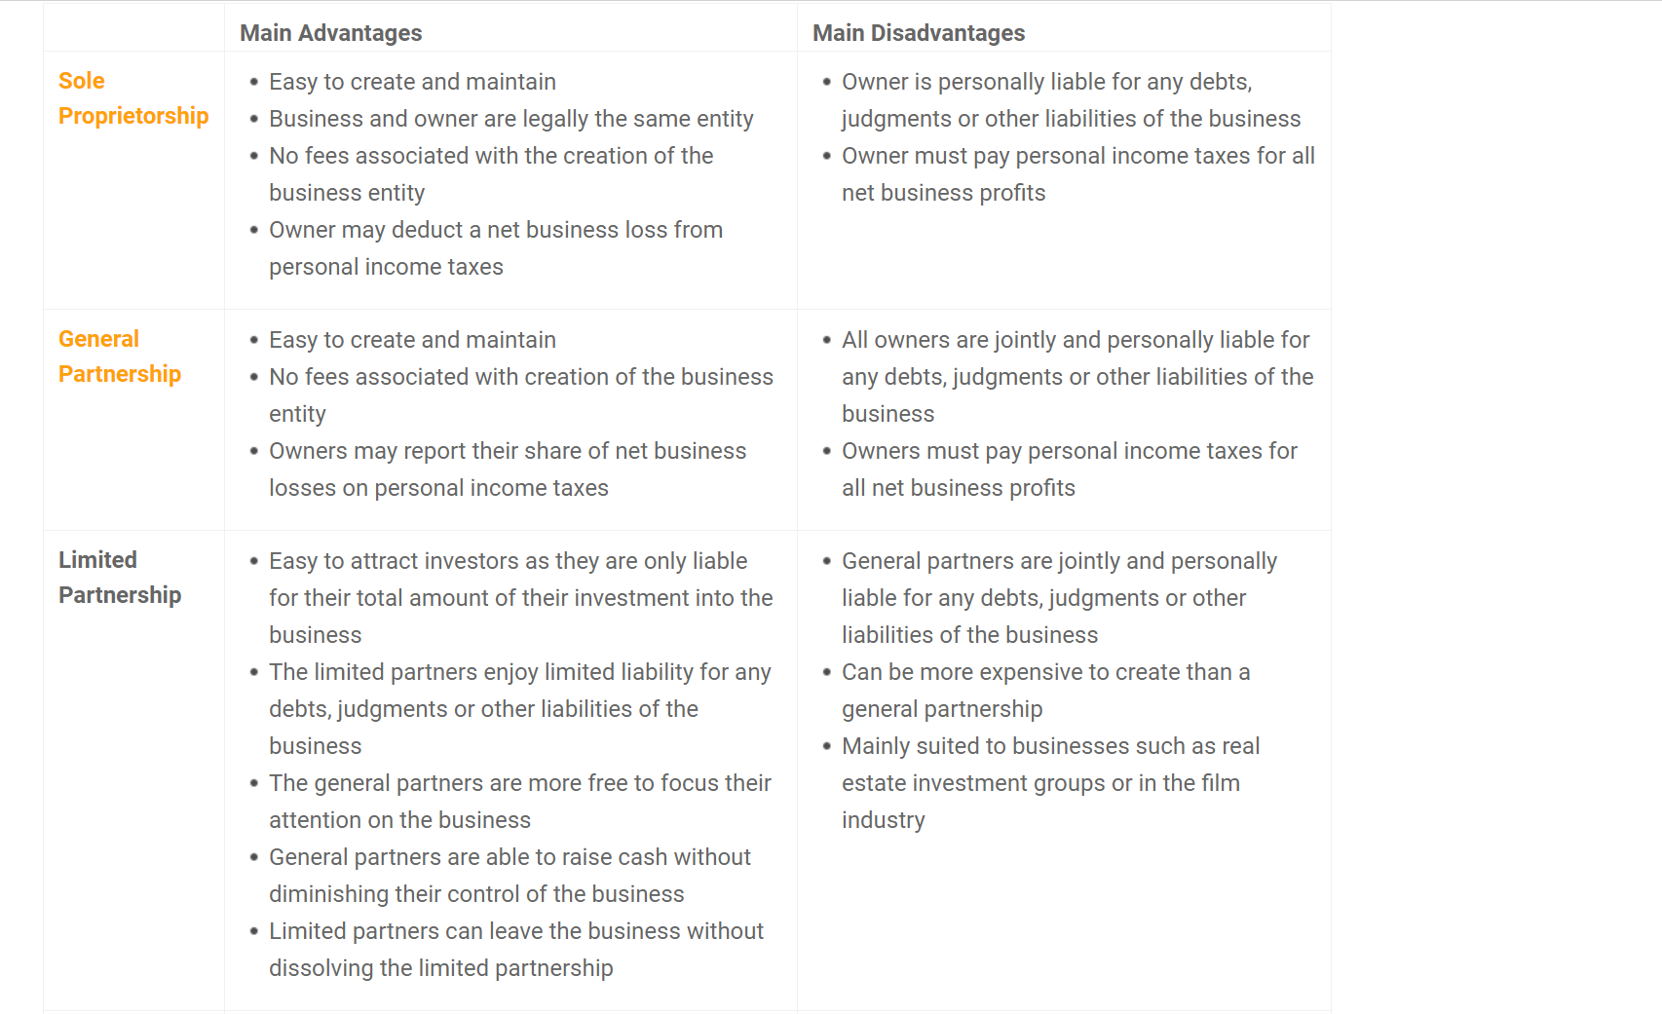

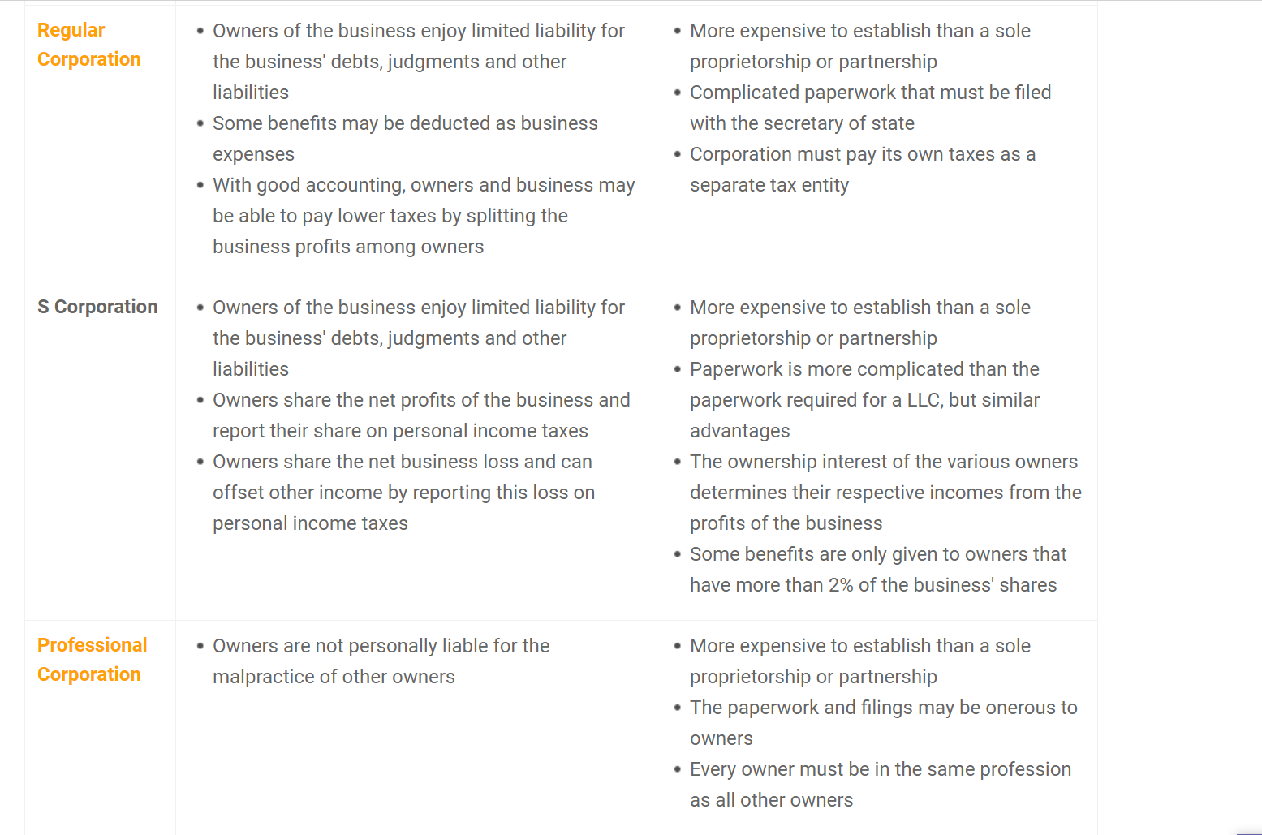

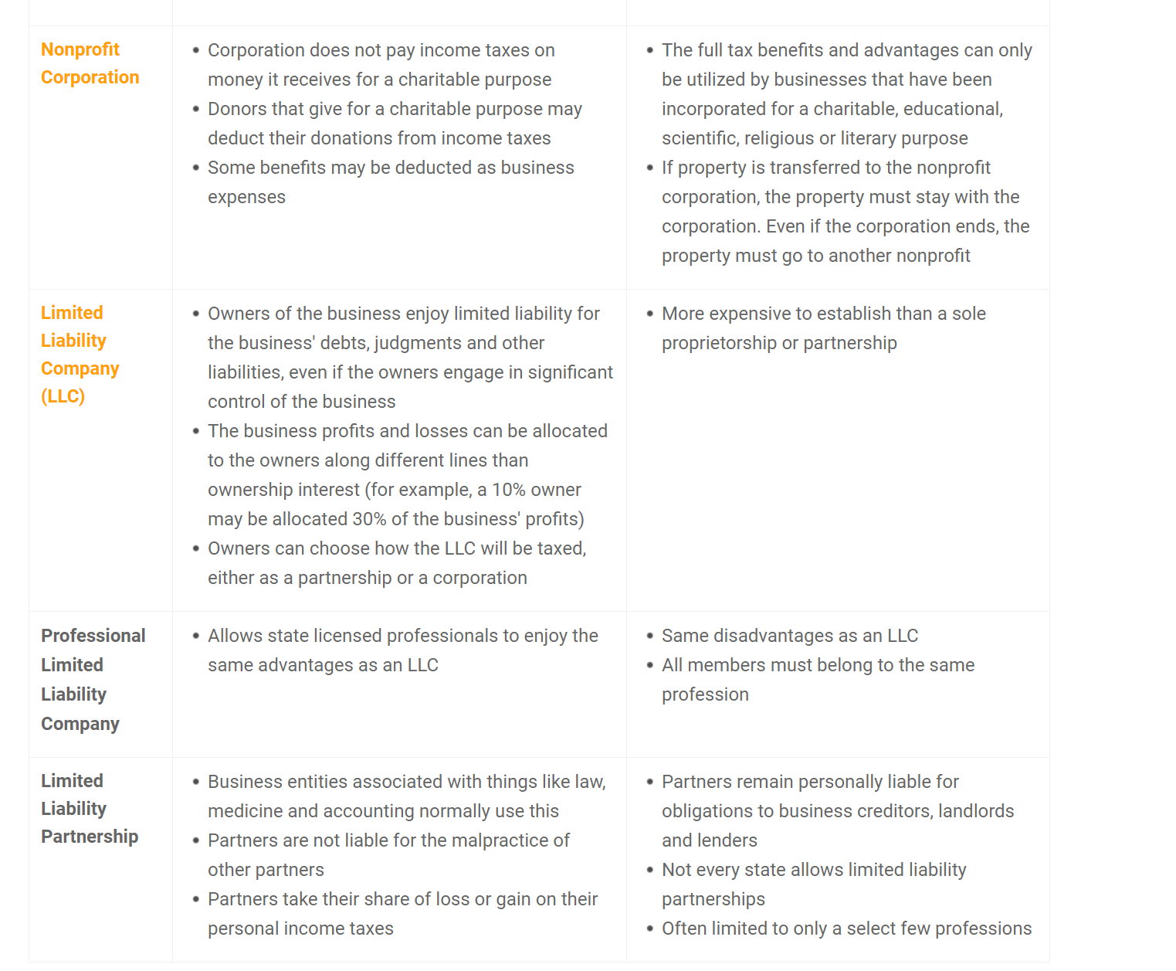

Helpful Links:

- Contracts Attorneys: <https://lawyers.findlaw.com/lawyer/practice/contracts>

- Incorporation Lawyers: <https://lawyers.findlaw.com/lawyer/practice/business-organizations>

- Business Formation Legal Help: <https://smallbusiness.findlaw.com/incorporation-and-legal-structures/legal-help.html>

- Business Formation Resources: <https://smallbusiness.findlaw.com/incorporation-and-legal-structures/resources.html>

- Choosing a Legal Structure: <https://smallbusiness.findlaw.com/incorporation-and-legal-structures/choosing-a-legal-structure.html>

- Corporations: <https://smallbusiness.findlaw.com/incorporation-and-legal-structures/corporations.html>

- LLCs: <https://smallbusiness.findlaw.com/incorporation-and-legal-structures/llcs.html>

- Nonprofit Organizations: <https://smallbusiness.findlaw.com/incorporation-and-legal-structures/non-profit-organizations.html>

- Partnerships: <https://smallbusiness.findlaw.com/incorporation-and-legal-structures/partnerships.html>

- Sole Proprietorships: <https://smallbusiness.findlaw.com/incorporation-and-legal-structures/sole-proprietorships.html>

3) The expectations for maintaining a lawyer. ex. Legal implications of liabilities per ceo/owner/partner.

Terms & Conditions of Partnership. etc.

**Research:**

Fees for maintaining a:

- Lawyers

Determining what kind of Lawyer to hire?

- What services do we need from a Lawyer?

-- Short Term: Getting advises on what company type to select

-- Determining advantages of selecting a domestic or international company type

- What are the fees for the work needed by the Lawyer when specified?

-- Company Setup based on Company Type

4)The expectations for maintaining an accountant. ex. Bookkeeping, Fees and payment etc.

**Research:**

Fees for maintaining a:

- Accountants

What are the fees for the work needed from an Accountant?

-- Bookkeeping???

-- Setup company when company type has been determined

5) The exact construct of the organization and all members.

**Research:**

- The construct of our organization structure and roles or job descriptions have to be carefully defined.

- These members/names below have to have the same or equal or almost equal rights and authority with the listed functionalities of the company

**Names/Members**

--- Lawrence Morgan

--- Rebecca Morgan

--- Comfort Liberty

--- Tellek Liberty

--- Togba Liberty

--- Georgia Godfrey

**Managerial Decisions that all members should have the same or equal or almost equal rights on**

--- Contracts Selections

---- What kinds of contracts should be selected

---- Who should work on these contracts

---- Approval of Project Charter, Cost, Estimates, Milestones, Project Plans, .etc

---- **Everything about a contract should have either everyone’s approval??? POSSIBLY, we can word this differently**

--- Marketing Strategies

---- Market Niche Selection

---- What kind of businesses or markets should we target (Federal, State, ????)

--- Financial (Everything that has to do with the financial stability or finances of the company)

---- Accounting (profits, losses, debts, .etc)

---- Accounting Systems or Bookkeeping Systems Selections

--- Selection, removal or research inquiry on Accounting or legal matters

--- Employment when work is more or deciding to hire new people on board

---- Everything about hiring? Who should we contact? Should we hire part-time, full-time, contract, add a new employee? Adding a new employee does not give that person the right or rights of any of the individuals above. All the above names can serve as employees of those positions that are opened if see fit – save cost; if not, person should serve as defined in the job description or role being fill

-- Others???

6) Any miscellaneous that has not been addressed.