Gentlemen,

Please find below the proposed agenda for next week Sunday.  Please feel free to add as you see fit.  The whole idea is for us to start the conversation and start something.  WE SEEK OPPORTUNITIES; THEY NEVER FIND YOU!!!!

1. Introduction of the purpose of Call – Wendell to discuss how we build a minority company to take advantage of Government Contracts
2. Discuss options on set-up of company.  It is important that we be very focused on a specific industry in order to be perceived as SME in the area of concentration.

**Web and Desktop Applications – Full Stack Development**

1. Request for Individual thoughts
   1. Lawrence – Input on future of opportunities with Government-Military.  Note that nothing can be done here while Lawrence is actively engage with the Navy directly.
   2. Tellek to discuss what his current role is with Hennepin County, Minnesota.  How do we duplicate the same in other areas, states, counties where we have contacts.

**Role: Technical UI Lead – building modern web application or front-end application. Title is Technical Lead; however, served as Architect for the front-end web application. Application went to production and was given more responsibilities. I now serve as an Architect helping other departments with architectural guidance. Some guidance include using best practices to implement specific front-end technologies.**

**Duplicate the same in other areas, states: I can not help with this. I did not start my LLC with this in mind. Most of all, I believe every state has their vendors that they deal with; like I told you Uncle Wendell, I was asked to join the state and refused. They then asked that I be paid directly instead of using a third party (temp agency).**

* 1. Tellek to elaborate on how we can migrate his current contract to “Our New Co” while maintaining his current contract.  He continues to receive all benefits from his current agreement.  Expansion will then include the “Our New Co”.

**This can not be discussed. I am building a relationship with Hennepin and every thing I do with them is confidential. I can’t switch companies when just started with one. I am on the path of building a long term relationship with Hennepin County and based on the discussion with Hennepin, they have promised a long term relationship. So, I will not speak on this. Sorry.**

* 1. Togba to elaborate on his thoughts on how we can build Mobile Applications and anything that will complement both Lawrence and Tellek.  We would need to focus on development for a specific industry.

1. Agree to setup a company (All input); Get registered; Determine the NAICS codes we want to add to the business portfolio in the federal system; state and local to be determined.

**You only need to register in your state. I used my tax account to help me register my business. He walked me through the process of doing so.**

**You need to indicate the type of business. I chose LLC**

**You need to get EIN or TAX ID.**

**These are the basic things I recall doing. I did not need the CERT below; that was a benefit for getting into Hennepin’s vendor list.**

**NAICS Code: see screenshot below:**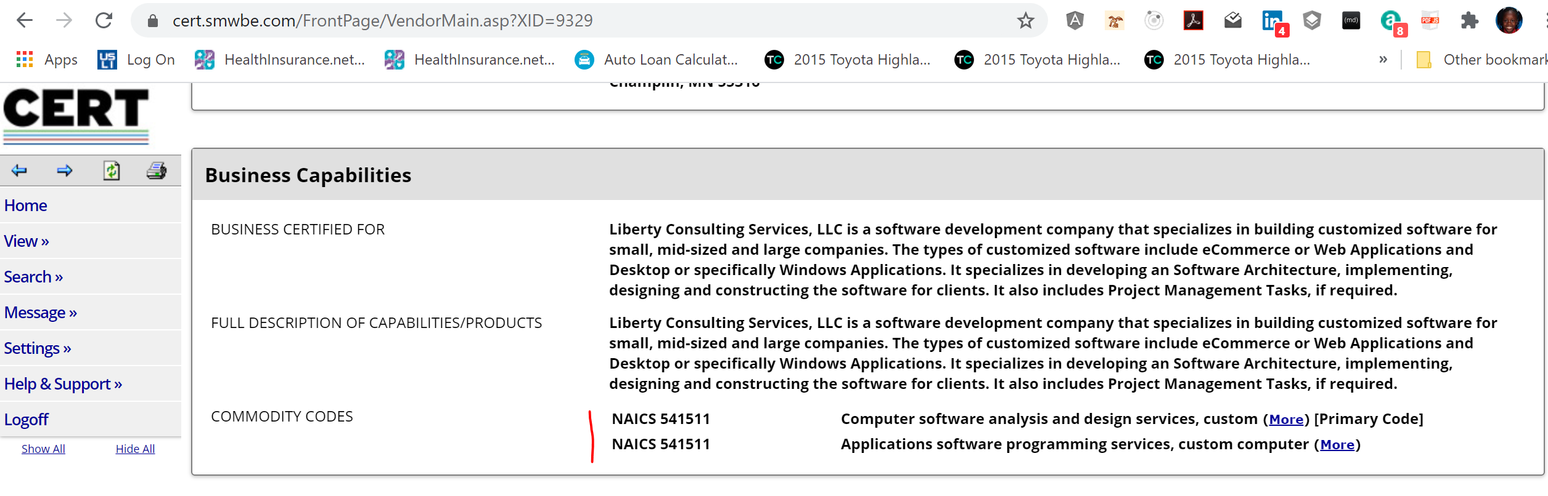

**CERT Application Status – screenshot below:**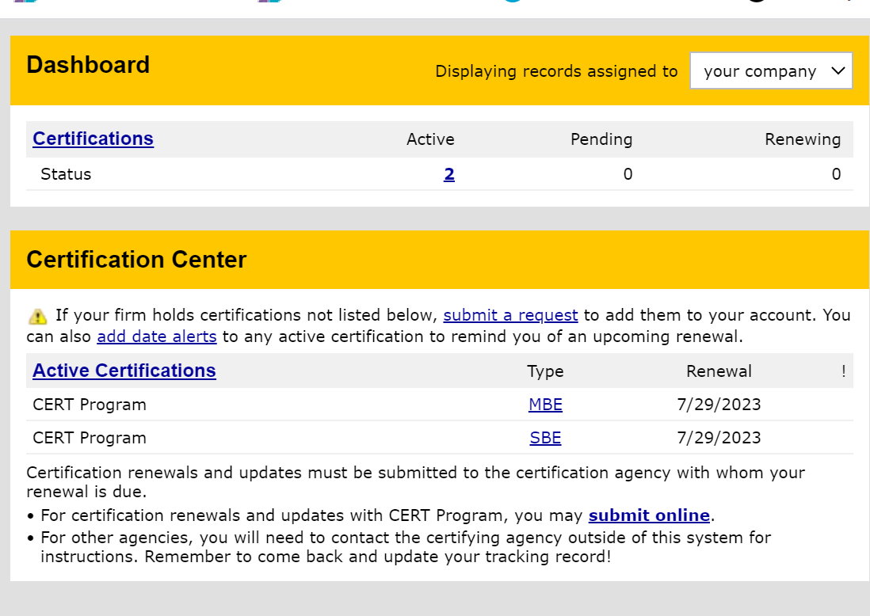

1. Discussion on how we partner with a major contractor; Seek Minority participation; etc

Strategy I used so far:

**Since I was approached by Hennepin and I was given the opportunity to understand and know the process of how to enter their (Hennepin’s) vendor list; I have some ideas. Nevertheless, I am the only one doing all of the work, so I am VERY cautious on taking work from companies. Because of the COVID-19 pandemic, most companies are doing a lot of remote work. So, I am taking advantage of this. I turned on REMOTE status on LinkedIn as my work type and I have been approached by several companies on doing this type of work. Also, I don’t just take any kind of work, I try to take jobs/contracts that I enjoy doing and I have control over the technology stack to minimize the learning curve when it comes to the tools that I’ve used and I am very open when the company’s UX designer approaches about new technologies. So, I am flexible. To the point, since I was approached by another company, I am starting soon to help build their system. Now, the catch is, I am using my company through a temp agency and giving the temp agency my rate and working for a company in MN – will not disclose this.**

**Also note, I don’t have a website, office or anything that will cause me money. I reach out through LinkedIn and temp agencies. You all can give more ideas.**

1. Plan on the next meeting to include discussion with Brian Long, my son-in-law.  He lives in San Antonio and works with a firm that has contracts with the Military Base in the City.  His background is Mechanical Engineering (Auburn University).  If agreed, we will have a conversation with him on opportunities there in the space we choose to work in.

Enjoy the weekend.

Wendell