

***Front-End Essentials***

Exam

|  |  |
| --- | --- |
| **Document Code** |  |
| **Version** | **1** |
| **Effective Date** |  |

**RECORD OF CHANGES**

|  |  |  |  |  |  |
| --- | --- | --- | --- | --- | --- |
| **No** | **Effective Date** | **Change Description** | **Reason** | **Reviewer** | **Approver** |
| 1 | 08/06/2023 | Create a new Project Coding Test | Create new | DongNT11 | VinhNV |
|  |  |  |  |  |  |
|  |  |  |  |  |  |
|  |  |  |  |  |  |
|  |  |  |  |  |  |
|  |  |  |  |  |  |
|  |  |  |  |  |  |
|  |  |  |  |  |  |
|  |  |  |  |  |  |
|  |  |  |  |  |  |

**Contents**

Problem 01: Build a Landing Page 4

Overviews: 4

Requirements 6

Problem 02: Build a Abbreviate name app 5

Requirements: ........................................................................................................................................

|  |  |  |
| --- | --- | --- |
|  | **CODE:** | **FRONTEND_ET_Practice02** |
| **TYPE:** | **Medium** |
| **LOC:** | **N/A** |
| **DURATION:** | **N/A** |

**Working tools and delivery requirements**

* **Working tools**: Visual Studio Code
* **Delivery**: Source code in a compressed archive (.zip extension is required)

**Technologies**

The product illustrates: Front-end Essentials

# Problem 01: Build a Landing Page

## Overviews:

Given the design from **Desktop.png** file for desktop, **Mobile.png** file for mobile and the other images inside **resources** folder, you have to implement a website that match the design.

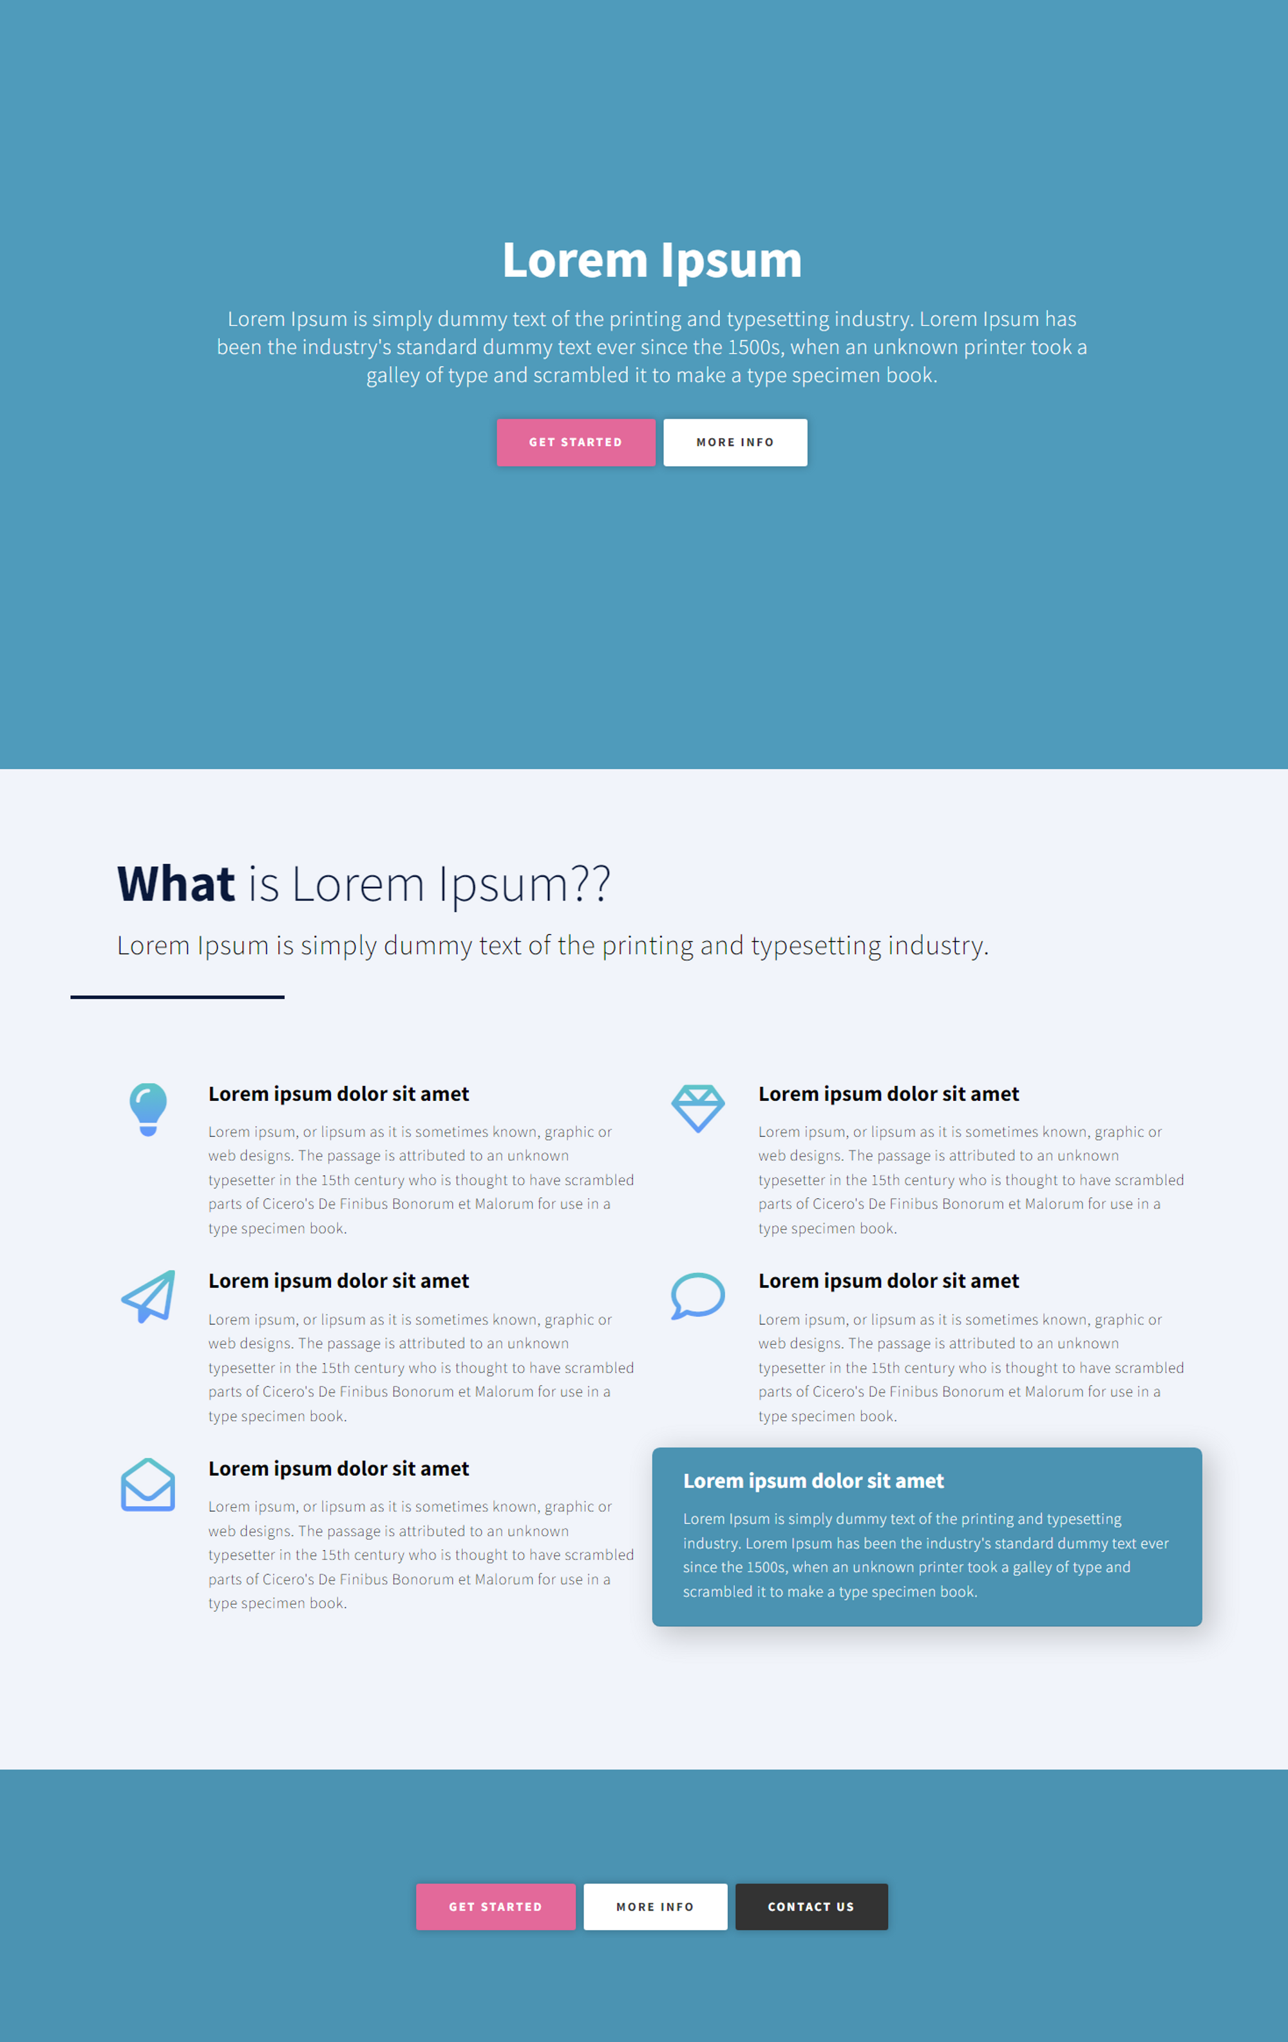

## Requirements:

* You must replicate the design in HTML & CSS (CSS Frameworks/Libraries are not allowed).
* **Color codes:**
* Button’s Background: #E26598
* Section’s Background: #4B93B2
* **Text contents:** use [Lipsum generator](https://www.lipsum.com/)

# Problem 02: Abbreviate Name

**Overviews:**

Your task is to create a web page like figure below:

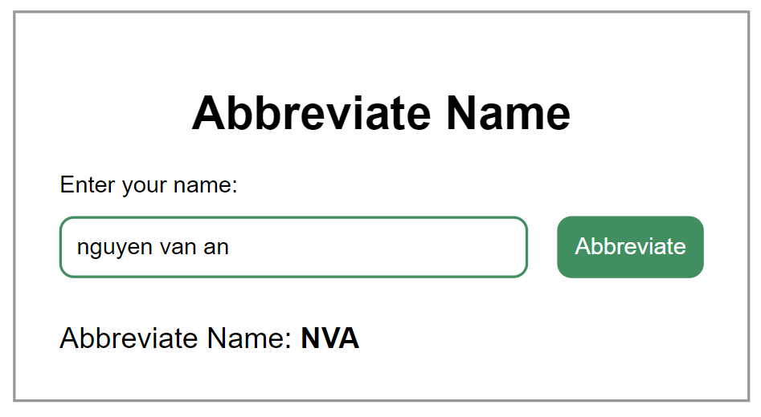

**Functionalities:**

The app must fulfill below functionalities:

* User can type into the input a full name (can be uppercase or lowercase name).
* When user press Abbreviate, a abbreviate name is abbreviated and displayed after ‘Abbreviate Name:’

**Technical Requirements:**

* + Must use plain JavaScript to interact with DOM.
  + Must not use Bootstrap or any CSS Framework
  + **Color Codes:**
* Box’s Border: #999
* Input’ Border and Button’s Background: #418e61

--0--

**The End!**