AI Photobooth
Madhya Pradesh Heritage · Project Documentation

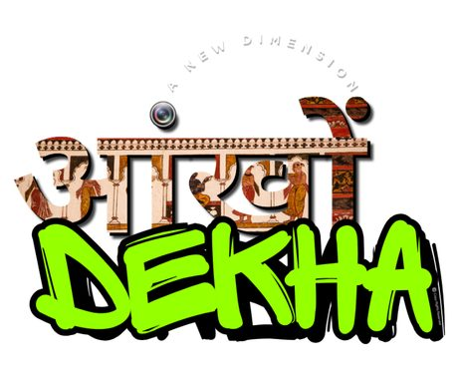
Brand mark — Aakhon Dekha

A web-based AI photobooth: capture a portrait, pick a heritage destination, and Gemini 3 generates a photoreal image of you placed at that location in period-appropriate attire. Generated photos are stamped with the brand logo and Aakhon Dekha experience locations.

1. Project overview
AI Photobooth is a three-step web wizard — Capture → Choose → Reveal — that takes a webcam selfie, lets the user pick a heritage destination in Madhya Pradesh (and now Goa & Kashmir), and uses Google's Gemini 3 Pro Image model to compose the user into that location in setting-appropriate clothing. The final image is brand-stamped client-side with a logo plate and the partner's experience-location pill.

Hosting
Production runs on Vercel (vercel.json declares two serverless functions in /api, each with a 60-second maxDuration). Earlier firebase.json / functions/ scaffolding remains in the repo from a prior hosting experiment but is not the live target.

Core features
- Three-step wizard UI with stepper progress (Capture → Choose destination → Reveal).
- Live webcam capture with multi-camera selection and mirrored-preview output.
- 15 active heritage destinations across MP (Khajuraho, Orchha, Maheshwar, Indore, Kheoni), Goa (Cabo de Rama, Cola Beach, Salim Ali Sanctuary) and Kashmir (Gulmarg).
- Gender toggle (Male / Female) — switches outfit prompts and filters gender-restricted destinations (Kheoni Sanctuary is male-only on the current client).
- Server-side prompt construction with absolute safety rules for sindoor / mangalsutra, face preservation, and age-appropriate attire.
- Gemini 3 Pro Image generation at 2K, 3:4 aspect ratio.
- Client-side brand overlay (logo plate top-left + experience-locations pill bottom-center) composited onto the generated image at full resolution.
- Download, WhatsApp share (Web Share API on mobile, link + download fallback on desktop) and one-click print.
- An optional Replicate / InstantID face-swap endpoint (api/faceswap.js) that can be wired in to lock identity even harder.

2. Architecture & tech stack
Frontend | Vanilla HTML / CSS / JS (no framework). Index → app.js wires the wizard.
Backend | Vercel serverless functions in /api (Node 18+). Express server.js remains for local dev.
AI — image gen | Google Gemini 3 Pro Image preview (model: gemini-3-pro-image-preview) via @google/genai.
AI — face swap (opt.) | Replicate · zsxkib/instant-id (SDXL + IdentityNet + IP-Adapter).
Image upload | Multer (memory storage, 30 MB cap).
Branding | Composed client-side on a <canvas> — deterministic, no model overhead.
Fonts | Fraunces (display) + Inter (UI) via Google Fonts.
Hosting | Vercel (production). Firebase Hosting scaffolding present but unused.

File layout
AI photobooth/
├── index.html Main wizard markup (3 steps)
├── styles.css Heritage theme + responsive
├── app.js Frontend state machine + brand overlay
├── server.js Local Express dev server (legacy Nano-Banana flow)
├── package.json Deps: @google/genai, multer, replicate, express, cors
├── vercel.json Function maxDuration: 60s
├── firebase.json / .firebaserc Unused hosting config (prior experiment)
├── api/
│ ├── generate.js Primary endpoint — Gemini 3 Pro Image
│ ├── faceswap.js Optional InstantID identity-lock endpoint
│ └── health.js Reports whether GEMINI / REPLICATE keys are set
├── assets/
│ ├── backgrounds/ Heritage location photos (18 files)
│ ├── templates/ Outfit reference photos, male/female pairs
│ └── brand/aakhon-dekha-logo.png
├── scripts/build_docs.py This documentation generator
└── test_*.{js,py} Standalone API smoke tests

Data flow — generation
user
│
│ 1. capture
▼
[ webcam ] ─► canvas.toBlob() ─► state.capturedBlob
│
│ 2. pick gender + destination
▼
[ POST /api/generate ] multipart: userImage, presetId, gender
│
│ 3. server-side
▼
api/generate.js
├─ multer parses upload (Vercel-quirk shim for pre-buffered body)
├─ resolves PRESETS[presetId] → setting + male/female outfit
├─ buildPrompt() — safety rules + setting + outfit
├─ fetches background JPG from /assets/backgrounds via x-forwarded-host
├─ ai.models.generateContent({
│ model: 'gemini-3-pro-image-preview',
│ contents: [userPhoto, backgroundPhoto, prompt],
│ responseModalities: ['Image'],
│ imageConfig: { aspectRatio: '3:4', imageSize: '2K' }
│ })
└─ returns { generatedImage: <base64>, mimeType }
│
│ 4. client
▼
brandifyImage(dataUrl)
├─ draws photo to canvas
├─ overlays logo plate (top-left)
└─ overlays locations pill (bottom-center)
│
▼
[ download | WhatsApp | print ]

3. User flow

Step 1 — Capture
User taps 'Start camera' to enable webcam (1080p ideal, user-facing). The viewfinder shows a head-and-shoulders guide. Multiple cameras populate a picker once permission is granted. On capture, the frame is drawn mirrored to match the live preview, then exported as JPEG at 0.95 quality. The user can retake or proceed.

Step 2 — Choose destination
User first selects a gender (Male / Female), which sets the outfit lane and hides gender-restricted presets (Kheoni Sanctuary is male-only currently). The destinations grid renders preset cards with background thumbnails. Selecting a card enables the Generate button in the sticky action bar.

Step 3 — Reveal
On submit, the client compresses the photo to ≤2048px JPEG (q=0.95) and POSTs multipart to /api/generate. A loading screen rotates through five hint phrases every 4.5 s. When the base64 image returns it is fed through brandifyImage(), then displayed in a result frame with Start over / Download / WhatsApp / Print actions.

4. Brand overlay
The brand mark and experience-locations strip are composited onto the generated image entirely on the client (app.js → brandifyImage). This avoids spending model tokens on text rendering, keeps output deterministic, and works at full 2K.

assets/brand/aakhon-dekha-logo.png

Composition details
Logo plate | Cream rounded rectangle, ~26% of image width, top-left at 3.5% / 2.8% inset. 7% inner padding. Soft drop shadow.
Logo source | assets/brand/aakhon-dekha-logo.png — preloaded once via loadImage().
Locations pill | Dark translucent pill, 62% opacity black, bottom-center at 4% inset.
Locations text | Bhopal · Orchha · Maheshwar · Boat Club (hardcoded in BRAND_LOCATIONS).
Typography | 500-weight Inter, font size = max(18, ~2.2% of image height).
Fallback | If overlay throws, the raw Gemini image is shown unchanged (warning logged).

5. The master prompt
Every generation runs the same prompt template (api/generate.js → buildPrompt). Two slots are filled per-request: {SETTING} and {OUTFIT}. The safety rules sit at the top of the prompt by design — once Gemini drifted onto outfit detail, marital symbols (sindoor, mangalsutra) crept in regardless of the source photo. Front-loading the rule fixed it.

Template (verbatim)
ABSOLUTE RULE — symbols of marital status. do NOT add any of the following to the person in the output UNLESS that exact symbol is clearly, visibly present on the person in the first reference photo:
• sindoor (red or orange vermilion powder in the hair parting)
• mangalsutra (black-bead and gold marriage necklace)
• kumkum at the parting or forehead
• bridal makeup, heavy nath / nose ring, or any other suhaag / saubhagya symbol
if the reference photo does not show these, the output must not show them — regardless of what the outfit description below suggests, regardless of the cultural setting, and regardless of what is "traditional" for the era or region. inventing these on a person who does not wear them (a child, an unmarried woman, a person of any age or background who simply does not use them) is a critical failure that causes religious and cultural offence. when in doubt, OMIT.
face-preservation rule: the face in the first reference photo must be preserved exactly in the output. same eyes, same nose, same mouth, same jawline, same skin tone, same age, same expression — every facial detail must be identical to the reference. do not beautify, smooth, slim, stylise, de-age, lighten or reshape the face in any way. if the face does not match the reference exactly, the image is wrong.
age-appropriateness rule: study the apparent age in the reference photo and adapt the outfit accordingly. if the reference shows a child, young girl or teenager, keep the attire age-appropriate — simpler, lighter jewellery; no nath / nose ring; no heavy bridal ornaments; no adult makeup; absolutely no sindoor, mangalsutra or kumkum. treat the outfit description below as a stylistic direction, not a literal checklist — drop any element that is not appropriate for the person's apparent age. a small plain decorative bindi is acceptable only if the person clearly appears to be an adult woman; otherwise omit it.
now create an image of this person standing in this {SETTING}, dressed like a {OUTFIT}. please adjust the lights and shadows so the person blends naturally into the scene. the image should look super realistic and natural.

Model call
ai.models.generateContent({
model: 'gemini-3-pro-image-preview',
contents: [
{ inlineData: { mimeType: 'image/jpeg', data: <user photo base64> } },
{ inlineData: { mimeType: 'image/jpeg', data: <heritage background base64> } },
{ text: <built prompt> },
],
config: {
responseModalities: ['Image'],
imageConfig: {
aspectRatio: '3:4',
imageSize: '2K',
},
},
});

6. Destinations — backgrounds, outfits, prompts
Each preset combines a heritage background photo (sent to Gemini as the second reference image), a one-line setting description (the {SETTING} slot in the prompt), and a male / female outfit description (the {OUTFIT} slot, picked by the user's gender toggle). Where available, the original outfit reference photo shown to the designer is also included for visual reference — these are NOT sent to the model.

Preset 1 · Khajuraho — Kandariya Mahadev
UNESCO-listed Chandela-era sandstone temples
Background file | Jagdambi Temple , Kandariya Mahadev Temple.jpg
Setting (prompt slot) | ancient carved sandstone temple at Khajuraho
Gender availability | Male & Female
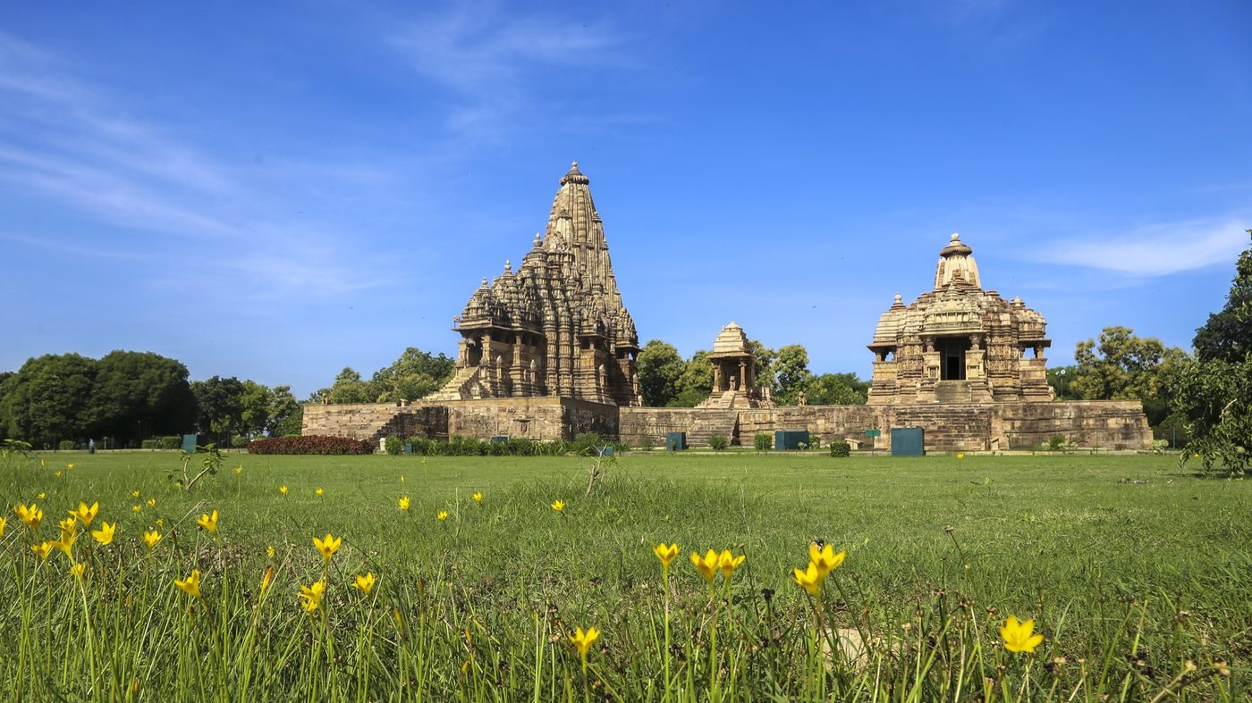
Heritage background — Jagdambi Temple , Kandariya Mahadev Temple.jpg

Outfit reference photos (designer-only, not sent to the model)
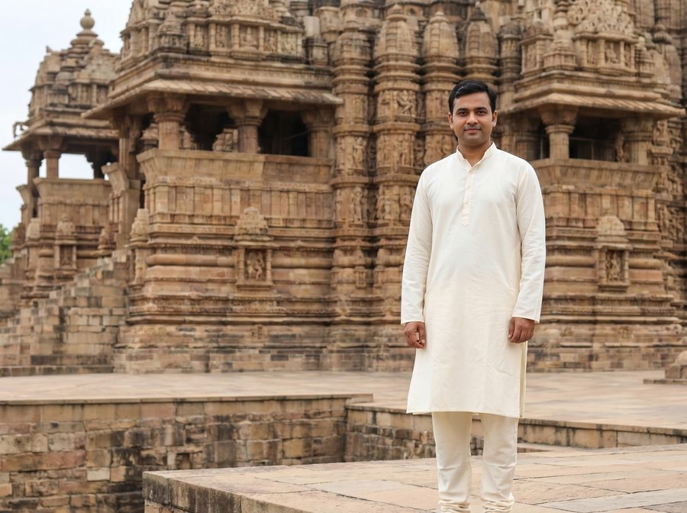 | 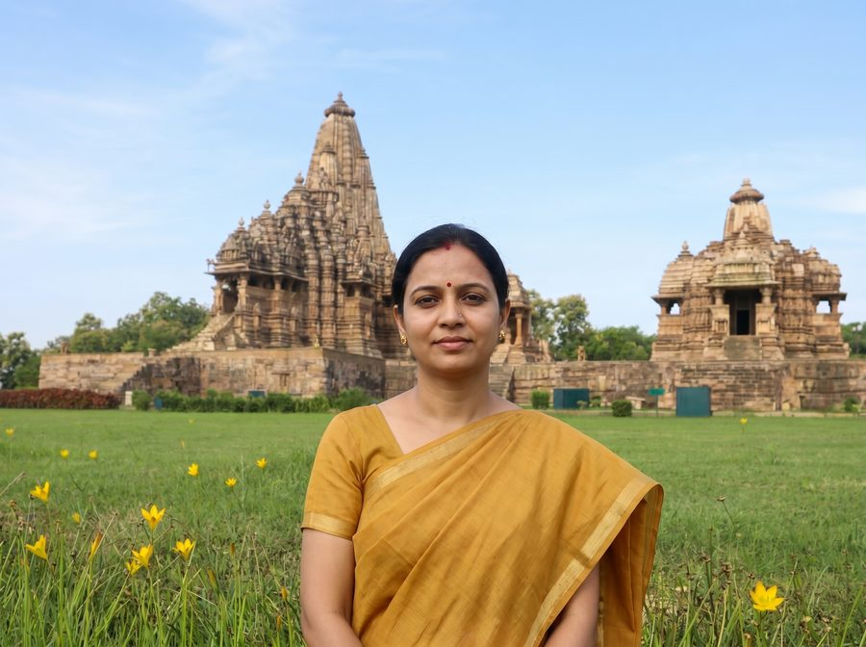
Male reference · 1-male.jpg | Female reference · 1-female.jpg

Male prompt — outfit slot
chandela-era hindu devotee in a traditional white cotton dhoti, a saffron uttariya (shoulder cloth) draped over one shoulder, and a rudraksha mala

Female prompt — outfit slot
chandela-era noblewoman in a traditional ivory silk saree with a narrow gold border, classical temple gold jewellery (jhumka earrings, a thin choker and bangles) and a small red bindi

Resolved full prompt — Male
ABSOLUTE RULE — symbols of marital status. do NOT add any of the following to the person in the output UNLESS that exact symbol is clearly, visibly present on the person in the first reference photo:
• sindoor (red or orange vermilion powder in the hair parting)
• mangalsutra (black-bead and gold marriage necklace)
• kumkum at the parting or forehead
• bridal makeup, heavy nath / nose ring, or any other suhaag / saubhagya symbol
if the reference photo does not show these, the output must not show them — regardless of what the outfit description below suggests, regardless of the cultural setting, and regardless of what is "traditional" for the era or region. inventing these on a person who does not wear them (a child, an unmarried woman, a person of any age or background who simply does not use them) is a critical failure that causes religious and cultural offence. when in doubt, OMIT.
face-preservation rule: the face in the first reference photo must be preserved exactly in the output. same eyes, same nose, same mouth, same jawline, same skin tone, same age, same expression — every facial detail must be identical to the reference. do not beautify, smooth, slim, stylise, de-age, lighten or reshape the face in any way. if the face does not match the reference exactly, the image is wrong.
age-appropriateness rule: study the apparent age in the reference photo and adapt the outfit accordingly. if the reference shows a child, young girl or teenager, keep the attire age-appropriate — simpler, lighter jewellery; no nath / nose ring; no heavy bridal ornaments; no adult makeup; absolutely no sindoor, mangalsutra or kumkum. treat the outfit description below as a stylistic direction, not a literal checklist — drop any element that is not appropriate for the person's apparent age. a small plain decorative bindi is acceptable only if the person clearly appears to be an adult woman; otherwise omit it.
now create an image of this person standing in this ancient carved sandstone temple at Khajuraho, dressed like a chandela-era hindu devotee in a traditional white cotton dhoti, a saffron uttariya (shoulder cloth) draped over one shoulder, and a rudraksha mala. please adjust the lights and shadows so the person blends naturally into the scene. the image should look super realistic and natural.

Resolved full prompt — Female
ABSOLUTE RULE — symbols of marital status. do NOT add any of the following to the person in the output UNLESS that exact symbol is clearly, visibly present on the person in the first reference photo:
• sindoor (red or orange vermilion powder in the hair parting)
• mangalsutra (black-bead and gold marriage necklace)
• kumkum at the parting or forehead
• bridal makeup, heavy nath / nose ring, or any other suhaag / saubhagya symbol
if the reference photo does not show these, the output must not show them — regardless of what the outfit description below suggests, regardless of the cultural setting, and regardless of what is "traditional" for the era or region. inventing these on a person who does not wear them (a child, an unmarried woman, a person of any age or background who simply does not use them) is a critical failure that causes religious and cultural offence. when in doubt, OMIT.
face-preservation rule: the face in the first reference photo must be preserved exactly in the output. same eyes, same nose, same mouth, same jawline, same skin tone, same age, same expression — every facial detail must be identical to the reference. do not beautify, smooth, slim, stylise, de-age, lighten or reshape the face in any way. if the face does not match the reference exactly, the image is wrong.
age-appropriateness rule: study the apparent age in the reference photo and adapt the outfit accordingly. if the reference shows a child, young girl or teenager, keep the attire age-appropriate — simpler, lighter jewellery; no nath / nose ring; no heavy bridal ornaments; no adult makeup; absolutely no sindoor, mangalsutra or kumkum. treat the outfit description below as a stylistic direction, not a literal checklist — drop any element that is not appropriate for the person's apparent age. a small plain decorative bindi is acceptable only if the person clearly appears to be an adult woman; otherwise omit it.
now create an image of this person standing in this ancient carved sandstone temple at Khajuraho, dressed like a chandela-era noblewoman in a traditional ivory silk saree with a narrow gold border, classical temple gold jewellery (jhumka earrings, a thin choker and bangles) and a small red bindi. please adjust the lights and shadows so the person blends naturally into the scene. the image should look super realistic and natural.

Preset 2 · Khajuraho — Lakshmana Temple
The finely carved 10th-century Chandela temple
Background file | Lakshmana Temple IMG_9753-HDR.jpg
Setting (prompt slot) | 10th-century Chandela sandstone temple at Khajuraho
Gender availability | Male & Female
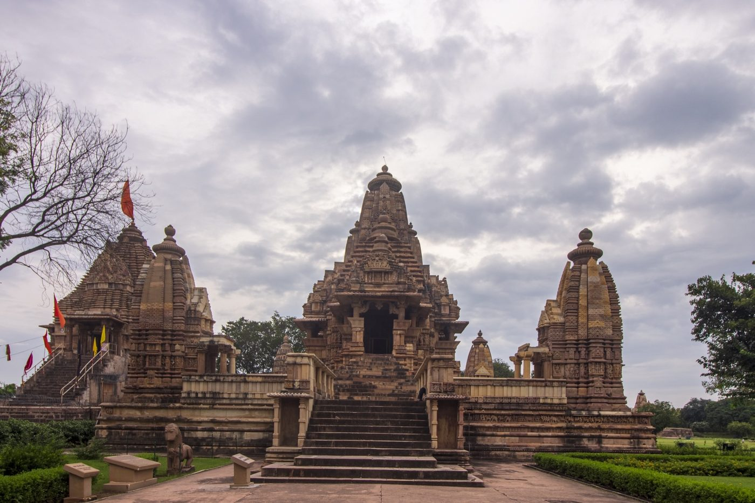
Heritage background — Lakshmana Temple IMG_9753-HDR.jpg

Outfit reference photos (designer-only, not sent to the model)
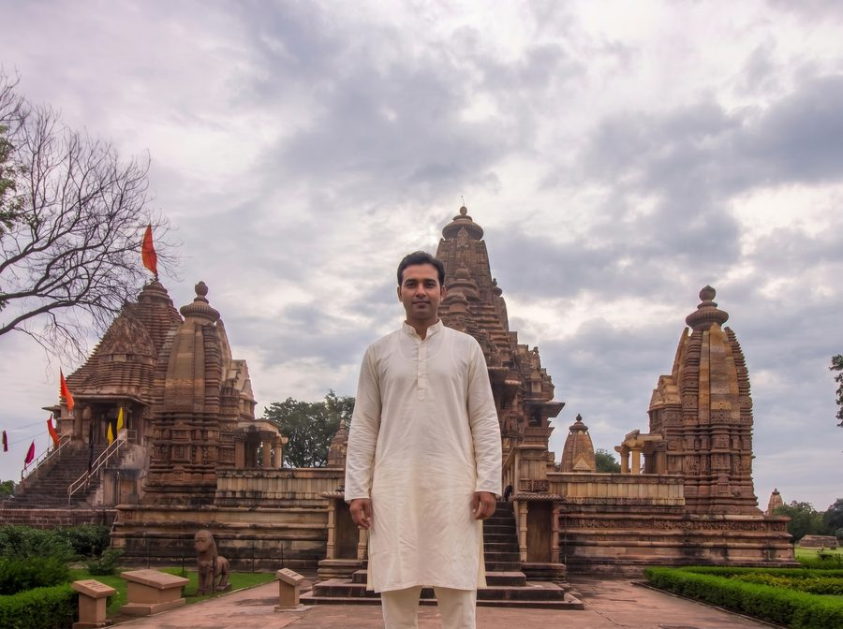 | 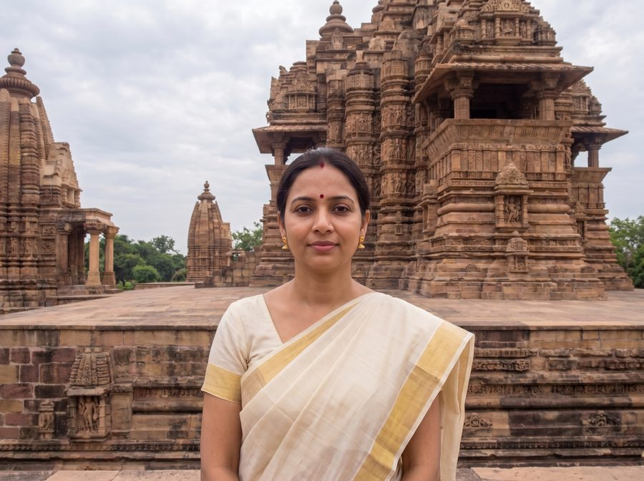
Male reference · 2-male.jpg | Female reference · 2-female.jpg

Male prompt — outfit slot
chandela-era nobleman in a cream cotton dhoti and unstitched shoulder cloth, a simple gold armlet and a rudraksha mala around the neck

Female prompt — outfit slot
chandela-era noblewoman in a soft mustard silk saree with a gold border, traditional temple gold jewellery and a small red bindi

Resolved full prompt — Male
ABSOLUTE RULE — symbols of marital status. do NOT add any of the following to the person in the output UNLESS that exact symbol is clearly, visibly present on the person in the first reference photo:
• sindoor (red or orange vermilion powder in the hair parting)
• mangalsutra (black-bead and gold marriage necklace)
• kumkum at the parting or forehead
• bridal makeup, heavy nath / nose ring, or any other suhaag / saubhagya symbol
if the reference photo does not show these, the output must not show them — regardless of what the outfit description below suggests, regardless of the cultural setting, and regardless of what is "traditional" for the era or region. inventing these on a person who does not wear them (a child, an unmarried woman, a person of any age or background who simply does not use them) is a critical failure that causes religious and cultural offence. when in doubt, OMIT.
face-preservation rule: the face in the first reference photo must be preserved exactly in the output. same eyes, same nose, same mouth, same jawline, same skin tone, same age, same expression — every facial detail must be identical to the reference. do not beautify, smooth, slim, stylise, de-age, lighten or reshape the face in any way. if the face does not match the reference exactly, the image is wrong.
age-appropriateness rule: study the apparent age in the reference photo and adapt the outfit accordingly. if the reference shows a child, young girl or teenager, keep the attire age-appropriate — simpler, lighter jewellery; no nath / nose ring; no heavy bridal ornaments; no adult makeup; absolutely no sindoor, mangalsutra or kumkum. treat the outfit description below as a stylistic direction, not a literal checklist — drop any element that is not appropriate for the person's apparent age. a small plain decorative bindi is acceptable only if the person clearly appears to be an adult woman; otherwise omit it.
now create an image of this person standing in this 10th-century Chandela sandstone temple at Khajuraho, dressed like a chandela-era nobleman in a cream cotton dhoti and unstitched shoulder cloth, a simple gold armlet and a rudraksha mala around the neck. please adjust the lights and shadows so the person blends naturally into the scene. the image should look super realistic and natural.

Resolved full prompt — Female
ABSOLUTE RULE — symbols of marital status. do NOT add any of the following to the person in the output UNLESS that exact symbol is clearly, visibly present on the person in the first reference photo:
• sindoor (red or orange vermilion powder in the hair parting)
• mangalsutra (black-bead and gold marriage necklace)
• kumkum at the parting or forehead
• bridal makeup, heavy nath / nose ring, or any other suhaag / saubhagya symbol
if the reference photo does not show these, the output must not show them — regardless of what the outfit description below suggests, regardless of the cultural setting, and regardless of what is "traditional" for the era or region. inventing these on a person who does not wear them (a child, an unmarried woman, a person of any age or background who simply does not use them) is a critical failure that causes religious and cultural offence. when in doubt, OMIT.
face-preservation rule: the face in the first reference photo must be preserved exactly in the output. same eyes, same nose, same mouth, same jawline, same skin tone, same age, same expression — every facial detail must be identical to the reference. do not beautify, smooth, slim, stylise, de-age, lighten or reshape the face in any way. if the face does not match the reference exactly, the image is wrong.
age-appropriateness rule: study the apparent age in the reference photo and adapt the outfit accordingly. if the reference shows a child, young girl or teenager, keep the attire age-appropriate — simpler, lighter jewellery; no nath / nose ring; no heavy bridal ornaments; no adult makeup; absolutely no sindoor, mangalsutra or kumkum. treat the outfit description below as a stylistic direction, not a literal checklist — drop any element that is not appropriate for the person's apparent age. a small plain decorative bindi is acceptable only if the person clearly appears to be an adult woman; otherwise omit it.
now create an image of this person standing in this 10th-century Chandela sandstone temple at Khajuraho, dressed like a chandela-era noblewoman in a soft mustard silk saree with a gold border, traditional temple gold jewellery and a small red bindi. please adjust the lights and shadows so the person blends naturally into the scene. the image should look super realistic and natural.

Preset 3 · Orchha — Jahangir Mahal
17th-century Bundela palace, arched courtyards
Background file | Jahangir Mahal 6 - Copy.jpg
Setting (prompt slot) | 17th-century Bundela palace courtyard at Orchha
Gender availability | Male & Female
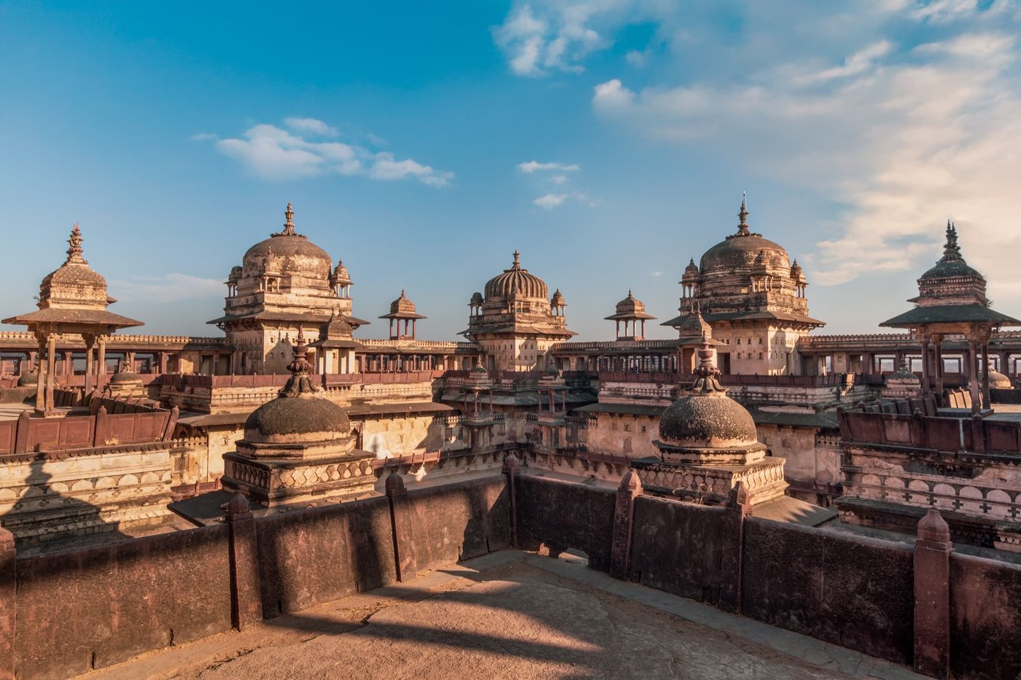
Heritage background — Jahangir Mahal 6 - Copy.jpg

Outfit reference photos (designer-only, not sent to the model)
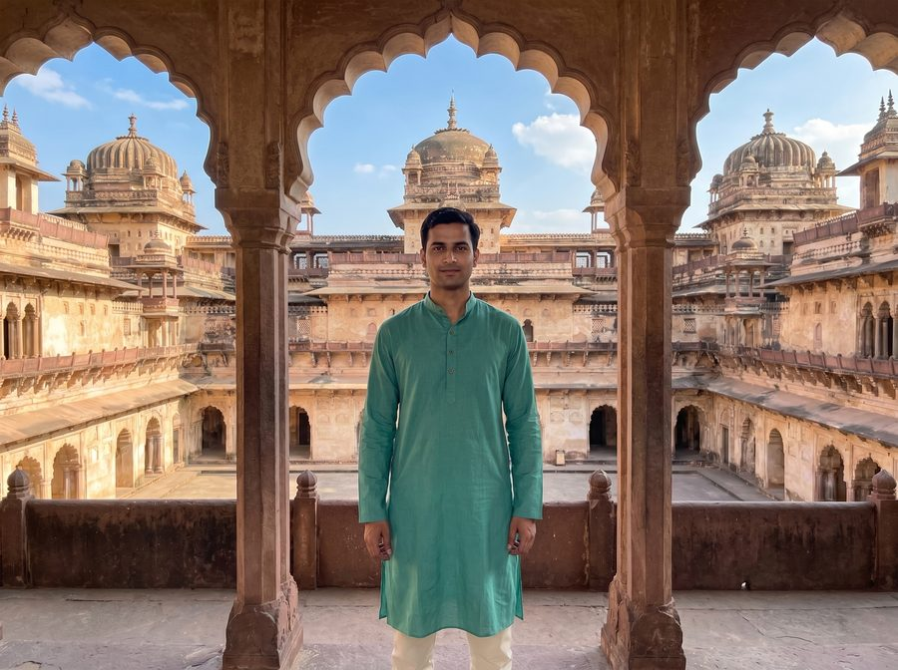 | 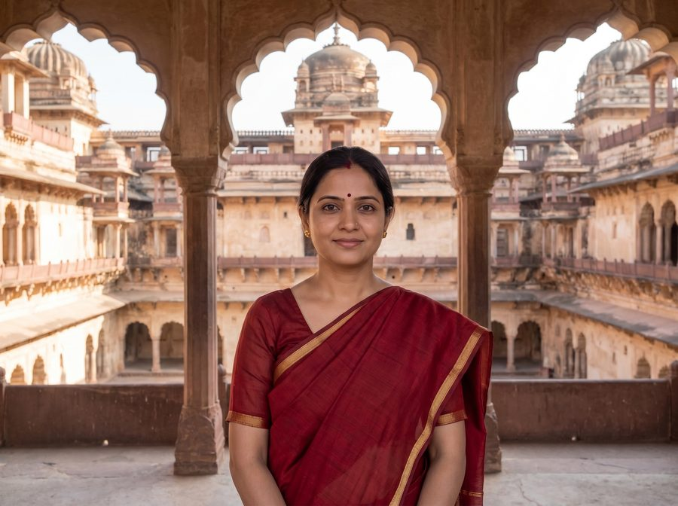
Male reference · 3-male.jpg | Female reference · 3-female.jpg

Male prompt — outfit slot
bundela rajput prince in a brocade cream angarkha, churidar pyjama, a colourful safa (rajput turban) and a kamarband (waist sash), with subtle gold jewellery

Female prompt — outfit slot
bundela rajput princess in a deep-red silk lehenga-choli with zari embroidery, a sheer dupatta draped over the head, traditional rajput gold jewellery (maang tikka, jhumkas, choker)

Resolved full prompt — Male
ABSOLUTE RULE — symbols of marital status. do NOT add any of the following to the person in the output UNLESS that exact symbol is clearly, visibly present on the person in the first reference photo:
• sindoor (red or orange vermilion powder in the hair parting)
• mangalsutra (black-bead and gold marriage necklace)
• kumkum at the parting or forehead
• bridal makeup, heavy nath / nose ring, or any other suhaag / saubhagya symbol
if the reference photo does not show these, the output must not show them — regardless of what the outfit description below suggests, regardless of the cultural setting, and regardless of what is "traditional" for the era or region. inventing these on a person who does not wear them (a child, an unmarried woman, a person of any age or background who simply does not use them) is a critical failure that causes religious and cultural offence. when in doubt, OMIT.
face-preservation rule: the face in the first reference photo must be preserved exactly in the output. same eyes, same nose, same mouth, same jawline, same skin tone, same age, same expression — every facial detail must be identical to the reference. do not beautify, smooth, slim, stylise, de-age, lighten or reshape the face in any way. if the face does not match the reference exactly, the image is wrong.
age-appropriateness rule: study the apparent age in the reference photo and adapt the outfit accordingly. if the reference shows a child, young girl or teenager, keep the attire age-appropriate — simpler, lighter jewellery; no nath / nose ring; no heavy bridal ornaments; no adult makeup; absolutely no sindoor, mangalsutra or kumkum. treat the outfit description below as a stylistic direction, not a literal checklist — drop any element that is not appropriate for the person's apparent age. a small plain decorative bindi is acceptable only if the person clearly appears to be an adult woman; otherwise omit it.
now create an image of this person standing in this 17th-century Bundela palace courtyard at Orchha, dressed like a bundela rajput prince in a brocade cream angarkha, churidar pyjama, a colourful safa (rajput turban) and a kamarband (waist sash), with subtle gold jewellery. please adjust the lights and shadows so the person blends naturally into the scene. the image should look super realistic and natural.

Resolved full prompt — Female
ABSOLUTE RULE — symbols of marital status. do NOT add any of the following to the person in the output UNLESS that exact symbol is clearly, visibly present on the person in the first reference photo:
• sindoor (red or orange vermilion powder in the hair parting)
• mangalsutra (black-bead and gold marriage necklace)
• kumkum at the parting or forehead
• bridal makeup, heavy nath / nose ring, or any other suhaag / saubhagya symbol
if the reference photo does not show these, the output must not show them — regardless of what the outfit description below suggests, regardless of the cultural setting, and regardless of what is "traditional" for the era or region. inventing these on a person who does not wear them (a child, an unmarried woman, a person of any age or background who simply does not use them) is a critical failure that causes religious and cultural offence. when in doubt, OMIT.
face-preservation rule: the face in the first reference photo must be preserved exactly in the output. same eyes, same nose, same mouth, same jawline, same skin tone, same age, same expression — every facial detail must be identical to the reference. do not beautify, smooth, slim, stylise, de-age, lighten or reshape the face in any way. if the face does not match the reference exactly, the image is wrong.
age-appropriateness rule: study the apparent age in the reference photo and adapt the outfit accordingly. if the reference shows a child, young girl or teenager, keep the attire age-appropriate — simpler, lighter jewellery; no nath / nose ring; no heavy bridal ornaments; no adult makeup; absolutely no sindoor, mangalsutra or kumkum. treat the outfit description below as a stylistic direction, not a literal checklist — drop any element that is not appropriate for the person's apparent age. a small plain decorative bindi is acceptable only if the person clearly appears to be an adult woman; otherwise omit it.
now create an image of this person standing in this 17th-century Bundela palace courtyard at Orchha, dressed like a bundela rajput princess in a deep-red silk lehenga-choli with zari embroidery, a sheer dupatta draped over the head, traditional rajput gold jewellery (maang tikka, jhumkas, choker). please adjust the lights and shadows so the person blends naturally into the scene. the image should look super realistic and natural.

Preset 4 · Orchha — Jahangir Gate
Monumental Bundela-Mughal archway
Background file | jahangir gate orchha.jpg
Setting (prompt slot) | monumental Mughal-era Bundela gateway at Orchha
Gender availability | Male & Female
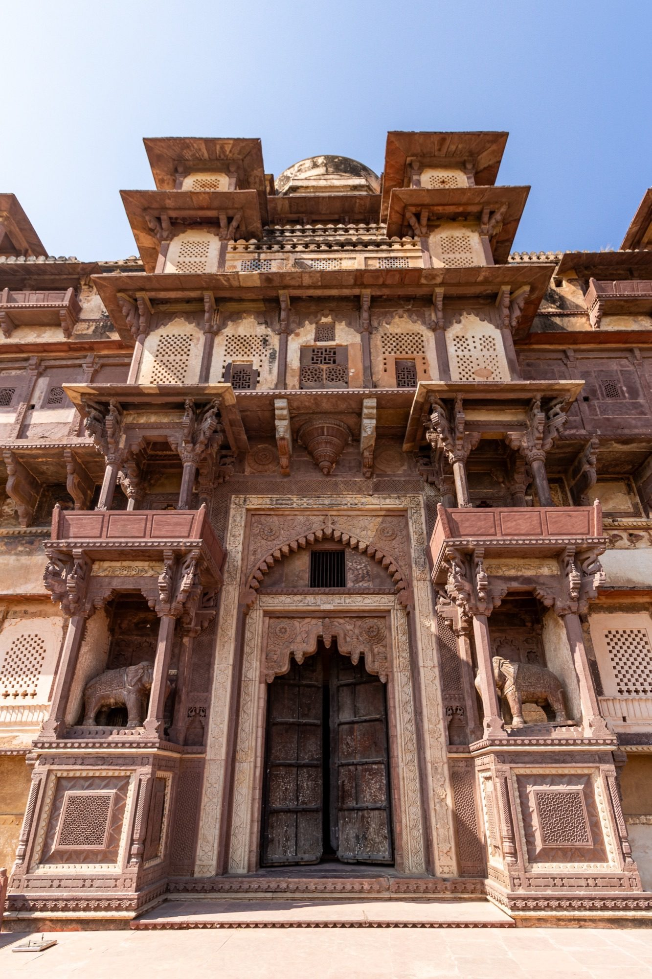
Heritage background — jahangir gate orchha.jpg

Outfit reference photos (designer-only, not sent to the model)
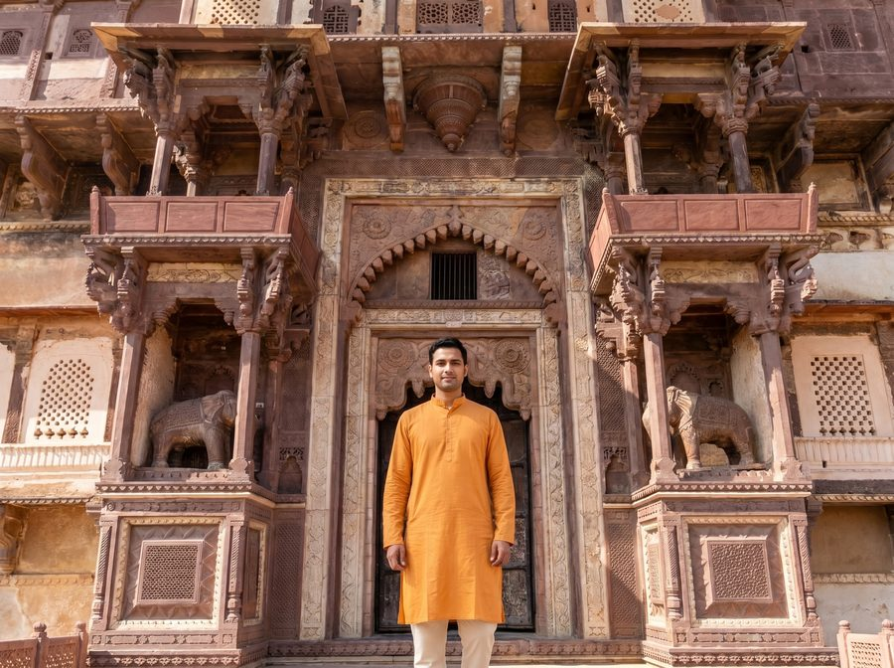 | 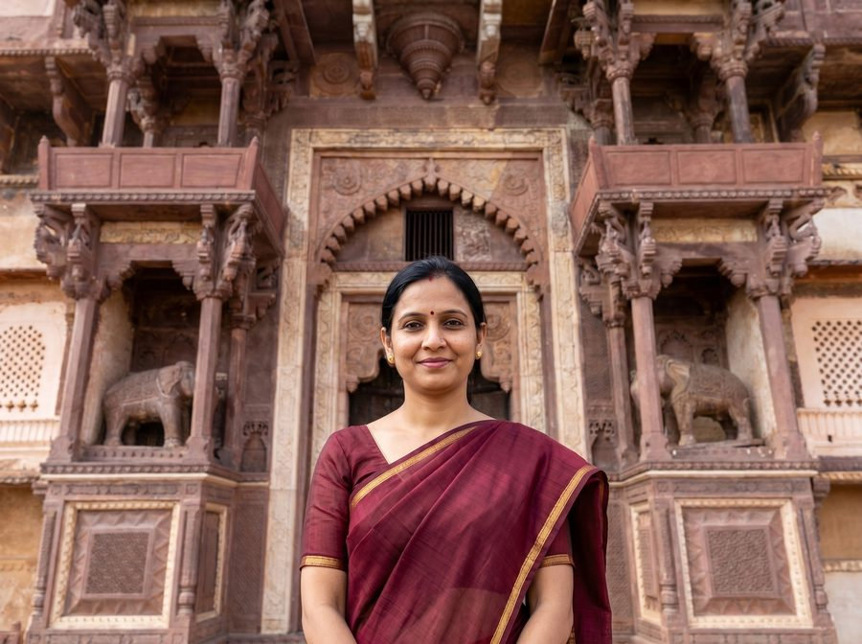
Male reference · 4-male.jpg | Female reference · 4-female.jpg

Male prompt — outfit slot
bundela rajput warrior in a saffron brocade angarkha, churidar pyjama, a colourful safa turban, a kamarband and a scabbarded sword at the waist

Female prompt — outfit slot
bundela rajput princess in a maroon silk lehenga with gold zari work, a sheer dupatta draped over the head and traditional rajput gold jewellery

Resolved full prompt — Male
ABSOLUTE RULE — symbols of marital status. do NOT add any of the following to the person in the output UNLESS that exact symbol is clearly, visibly present on the person in the first reference photo:
• sindoor (red or orange vermilion powder in the hair parting)
• mangalsutra (black-bead and gold marriage necklace)
• kumkum at the parting or forehead
• bridal makeup, heavy nath / nose ring, or any other suhaag / saubhagya symbol
if the reference photo does not show these, the output must not show them — regardless of what the outfit description below suggests, regardless of the cultural setting, and regardless of what is "traditional" for the era or region. inventing these on a person who does not wear them (a child, an unmarried woman, a person of any age or background who simply does not use them) is a critical failure that causes religious and cultural offence. when in doubt, OMIT.
face-preservation rule: the face in the first reference photo must be preserved exactly in the output. same eyes, same nose, same mouth, same jawline, same skin tone, same age, same expression — every facial detail must be identical to the reference. do not beautify, smooth, slim, stylise, de-age, lighten or reshape the face in any way. if the face does not match the reference exactly, the image is wrong.
age-appropriateness rule: study the apparent age in the reference photo and adapt the outfit accordingly. if the reference shows a child, young girl or teenager, keep the attire age-appropriate — simpler, lighter jewellery; no nath / nose ring; no heavy bridal ornaments; no adult makeup; absolutely no sindoor, mangalsutra or kumkum. treat the outfit description below as a stylistic direction, not a literal checklist — drop any element that is not appropriate for the person's apparent age. a small plain decorative bindi is acceptable only if the person clearly appears to be an adult woman; otherwise omit it.
now create an image of this person standing in this monumental Mughal-era Bundela gateway at Orchha, dressed like a bundela rajput warrior in a saffron brocade angarkha, churidar pyjama, a colourful safa turban, a kamarband and a scabbarded sword at the waist. please adjust the lights and shadows so the person blends naturally into the scene. the image should look super realistic and natural.

Resolved full prompt — Female
ABSOLUTE RULE — symbols of marital status. do NOT add any of the following to the person in the output UNLESS that exact symbol is clearly, visibly present on the person in the first reference photo:
• sindoor (red or orange vermilion powder in the hair parting)
• mangalsutra (black-bead and gold marriage necklace)
• kumkum at the parting or forehead
• bridal makeup, heavy nath / nose ring, or any other suhaag / saubhagya symbol
if the reference photo does not show these, the output must not show them — regardless of what the outfit description below suggests, regardless of the cultural setting, and regardless of what is "traditional" for the era or region. inventing these on a person who does not wear them (a child, an unmarried woman, a person of any age or background who simply does not use them) is a critical failure that causes religious and cultural offence. when in doubt, OMIT.
face-preservation rule: the face in the first reference photo must be preserved exactly in the output. same eyes, same nose, same mouth, same jawline, same skin tone, same age, same expression — every facial detail must be identical to the reference. do not beautify, smooth, slim, stylise, de-age, lighten or reshape the face in any way. if the face does not match the reference exactly, the image is wrong.
age-appropriateness rule: study the apparent age in the reference photo and adapt the outfit accordingly. if the reference shows a child, young girl or teenager, keep the attire age-appropriate — simpler, lighter jewellery; no nath / nose ring; no heavy bridal ornaments; no adult makeup; absolutely no sindoor, mangalsutra or kumkum. treat the outfit description below as a stylistic direction, not a literal checklist — drop any element that is not appropriate for the person's apparent age. a small plain decorative bindi is acceptable only if the person clearly appears to be an adult woman; otherwise omit it.
now create an image of this person standing in this monumental Mughal-era Bundela gateway at Orchha, dressed like a bundela rajput princess in a maroon silk lehenga with gold zari work, a sheer dupatta draped over the head and traditional rajput gold jewellery. please adjust the lights and shadows so the person blends naturally into the scene. the image should look super realistic and natural.

Preset 6 · Maheshwar — Chhatri by the River
Holkar cenotaphs above the Narmada ghats
Background file | Chattei River view (7).jpg
Setting (prompt slot) | 18th-century Maratha riverside chhatri on the Narmada at Maheshwar
Gender availability | Male & Female
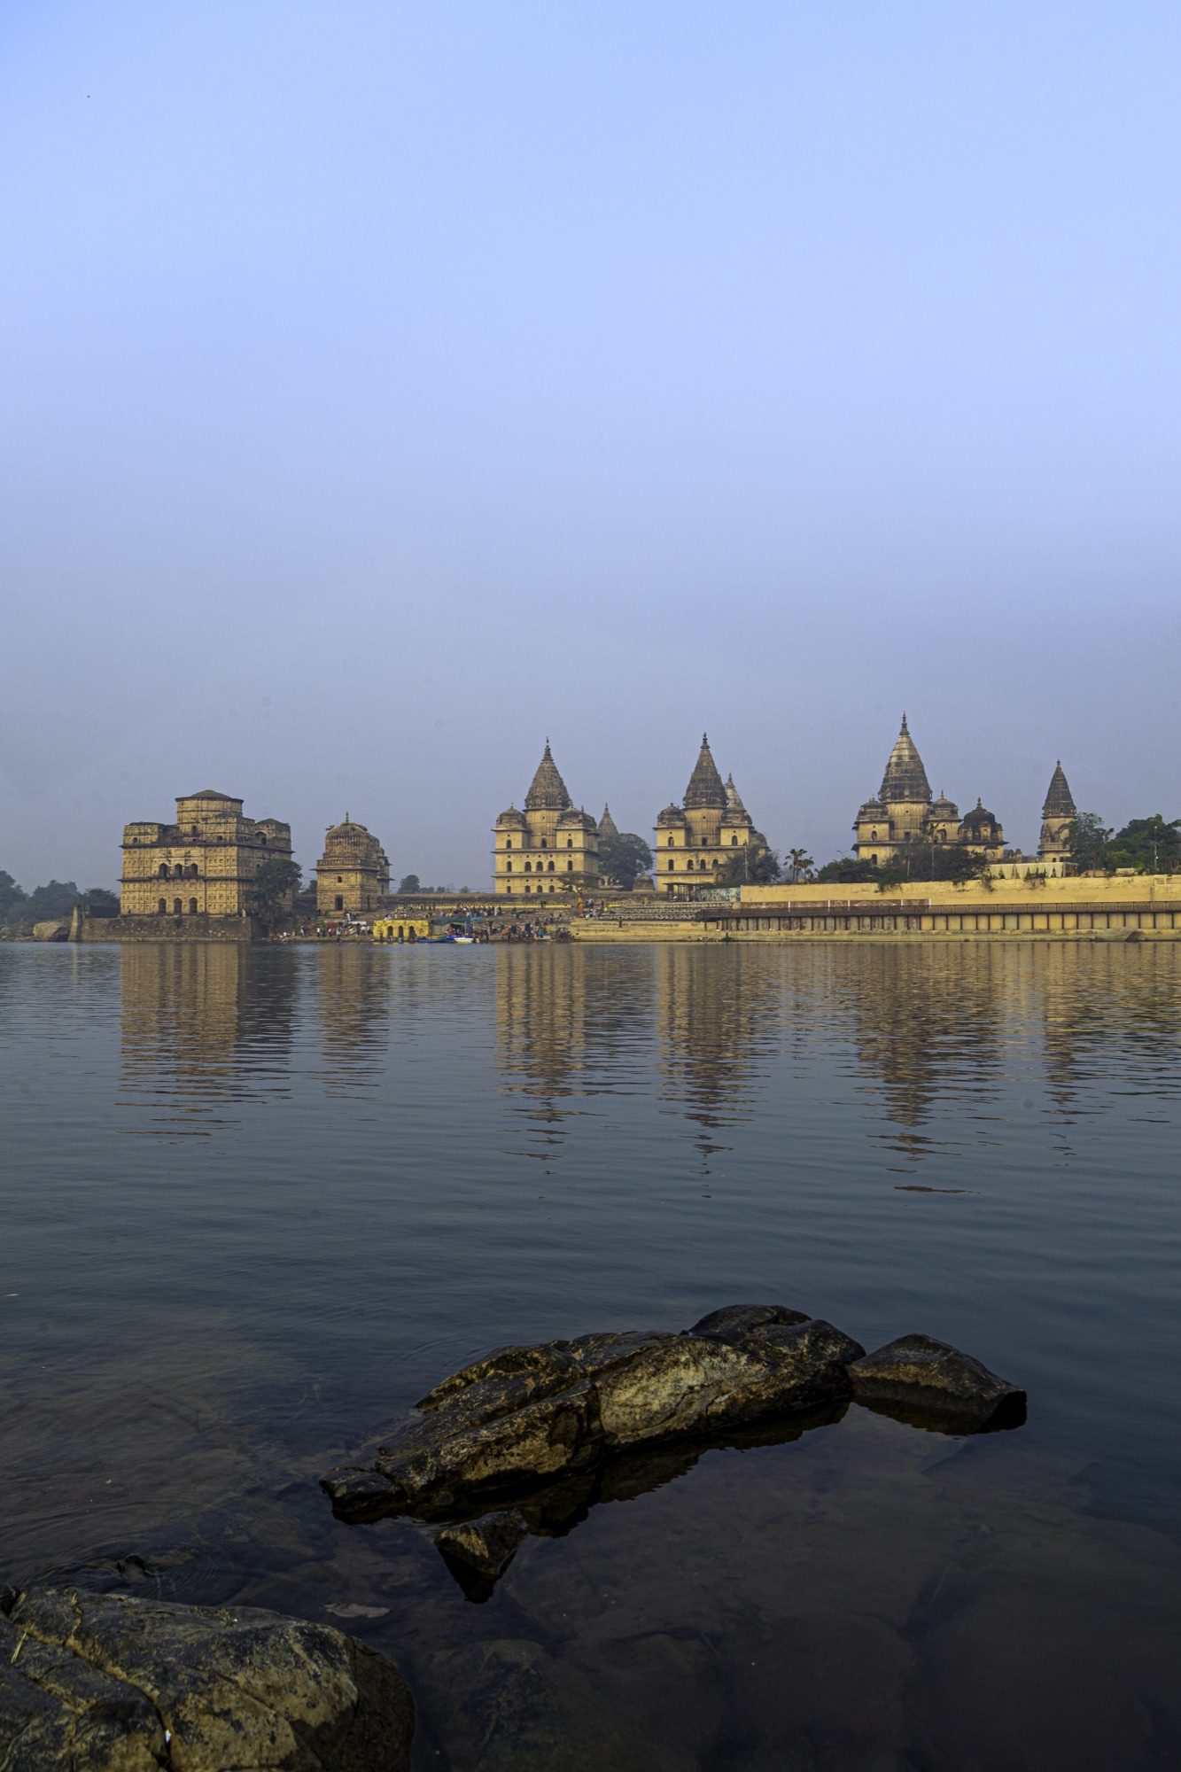
Heritage background — Chattei River view (7).jpg

Outfit reference photos (designer-only, not sent to the model)
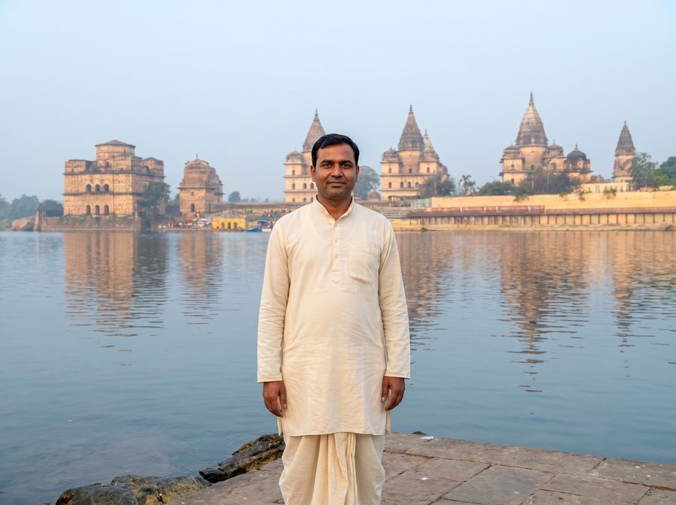 | 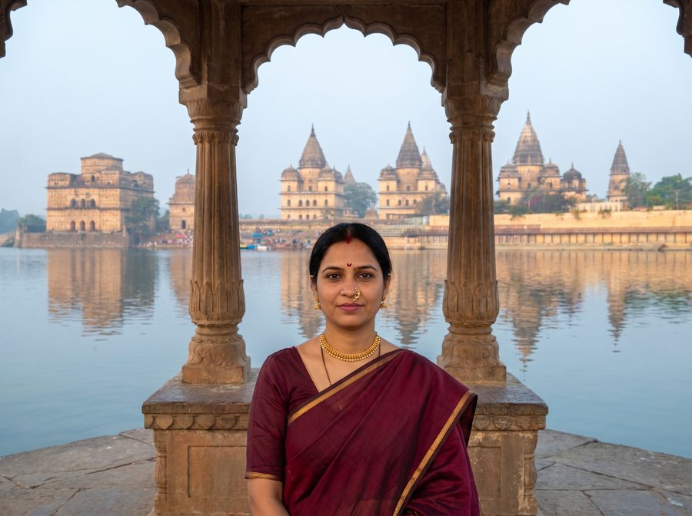
Male reference · 6-male.jpg | Female reference · 6-female.jpg

Male prompt — outfit slot
ahilyabai-era maratha nobleman in a crisp white cotton dhoti and bandgala-style kurta with a bright red pheta (maratha turban) and a simple shawl over one shoulder

Female prompt — outfit slot
ahilyabai-era maharashtrian lady in a traditional burgundy nauvari saree (9-yard drape), a gold nath (curved nose ring), thushi (short gold choker), green glass bangles, a pearl necklace and a small red decorative bindi

Resolved full prompt — Male
ABSOLUTE RULE — symbols of marital status. do NOT add any of the following to the person in the output UNLESS that exact symbol is clearly, visibly present on the person in the first reference photo:
• sindoor (red or orange vermilion powder in the hair parting)
• mangalsutra (black-bead and gold marriage necklace)
• kumkum at the parting or forehead
• bridal makeup, heavy nath / nose ring, or any other suhaag / saubhagya symbol
if the reference photo does not show these, the output must not show them — regardless of what the outfit description below suggests, regardless of the cultural setting, and regardless of what is "traditional" for the era or region. inventing these on a person who does not wear them (a child, an unmarried woman, a person of any age or background who simply does not use them) is a critical failure that causes religious and cultural offence. when in doubt, OMIT.
face-preservation rule: the face in the first reference photo must be preserved exactly in the output. same eyes, same nose, same mouth, same jawline, same skin tone, same age, same expression — every facial detail must be identical to the reference. do not beautify, smooth, slim, stylise, de-age, lighten or reshape the face in any way. if the face does not match the reference exactly, the image is wrong.
age-appropriateness rule: study the apparent age in the reference photo and adapt the outfit accordingly. if the reference shows a child, young girl or teenager, keep the attire age-appropriate — simpler, lighter jewellery; no nath / nose ring; no heavy bridal ornaments; no adult makeup; absolutely no sindoor, mangalsutra or kumkum. treat the outfit description below as a stylistic direction, not a literal checklist — drop any element that is not appropriate for the person's apparent age. a small plain decorative bindi is acceptable only if the person clearly appears to be an adult woman; otherwise omit it.
now create an image of this person standing in this 18th-century Maratha riverside chhatri on the Narmada at Maheshwar, dressed like a ahilyabai-era maratha nobleman in a crisp white cotton dhoti and bandgala-style kurta with a bright red pheta (maratha turban) and a simple shawl over one shoulder. please adjust the lights and shadows so the person blends naturally into the scene. the image should look super realistic and natural.

Resolved full prompt — Female
ABSOLUTE RULE — symbols of marital status. do NOT add any of the following to the person in the output UNLESS that exact symbol is clearly, visibly present on the person in the first reference photo:
• sindoor (red or orange vermilion powder in the hair parting)
• mangalsutra (black-bead and gold marriage necklace)
• kumkum at the parting or forehead
• bridal makeup, heavy nath / nose ring, or any other suhaag / saubhagya symbol
if the reference photo does not show these, the output must not show them — regardless of what the outfit description below suggests, regardless of the cultural setting, and regardless of what is "traditional" for the era or region. inventing these on a person who does not wear them (a child, an unmarried woman, a person of any age or background who simply does not use them) is a critical failure that causes religious and cultural offence. when in doubt, OMIT.
face-preservation rule: the face in the first reference photo must be preserved exactly in the output. same eyes, same nose, same mouth, same jawline, same skin tone, same age, same expression — every facial detail must be identical to the reference. do not beautify, smooth, slim, stylise, de-age, lighten or reshape the face in any way. if the face does not match the reference exactly, the image is wrong.
age-appropriateness rule: study the apparent age in the reference photo and adapt the outfit accordingly. if the reference shows a child, young girl or teenager, keep the attire age-appropriate — simpler, lighter jewellery; no nath / nose ring; no heavy bridal ornaments; no adult makeup; absolutely no sindoor, mangalsutra or kumkum. treat the outfit description below as a stylistic direction, not a literal checklist — drop any element that is not appropriate for the person's apparent age. a small plain decorative bindi is acceptable only if the person clearly appears to be an adult woman; otherwise omit it.
now create an image of this person standing in this 18th-century Maratha riverside chhatri on the Narmada at Maheshwar, dressed like a ahilyabai-era maharashtrian lady in a traditional burgundy nauvari saree (9-yard drape), a gold nath (curved nose ring), thushi (short gold choker), green glass bangles, a pearl necklace and a small red decorative bindi. please adjust the lights and shadows so the person blends naturally into the scene. the image should look super realistic and natural.

Preset 9 · Krishnabai Holkar Chhatri
The queen's cenotaph above the Narmada, Maheshwar
Background file | Krishnabai holkar chhatri .jpg
Setting (prompt slot) | 18th-century Holkar royal chhatri at Maheshwar
Gender availability | Male & Female
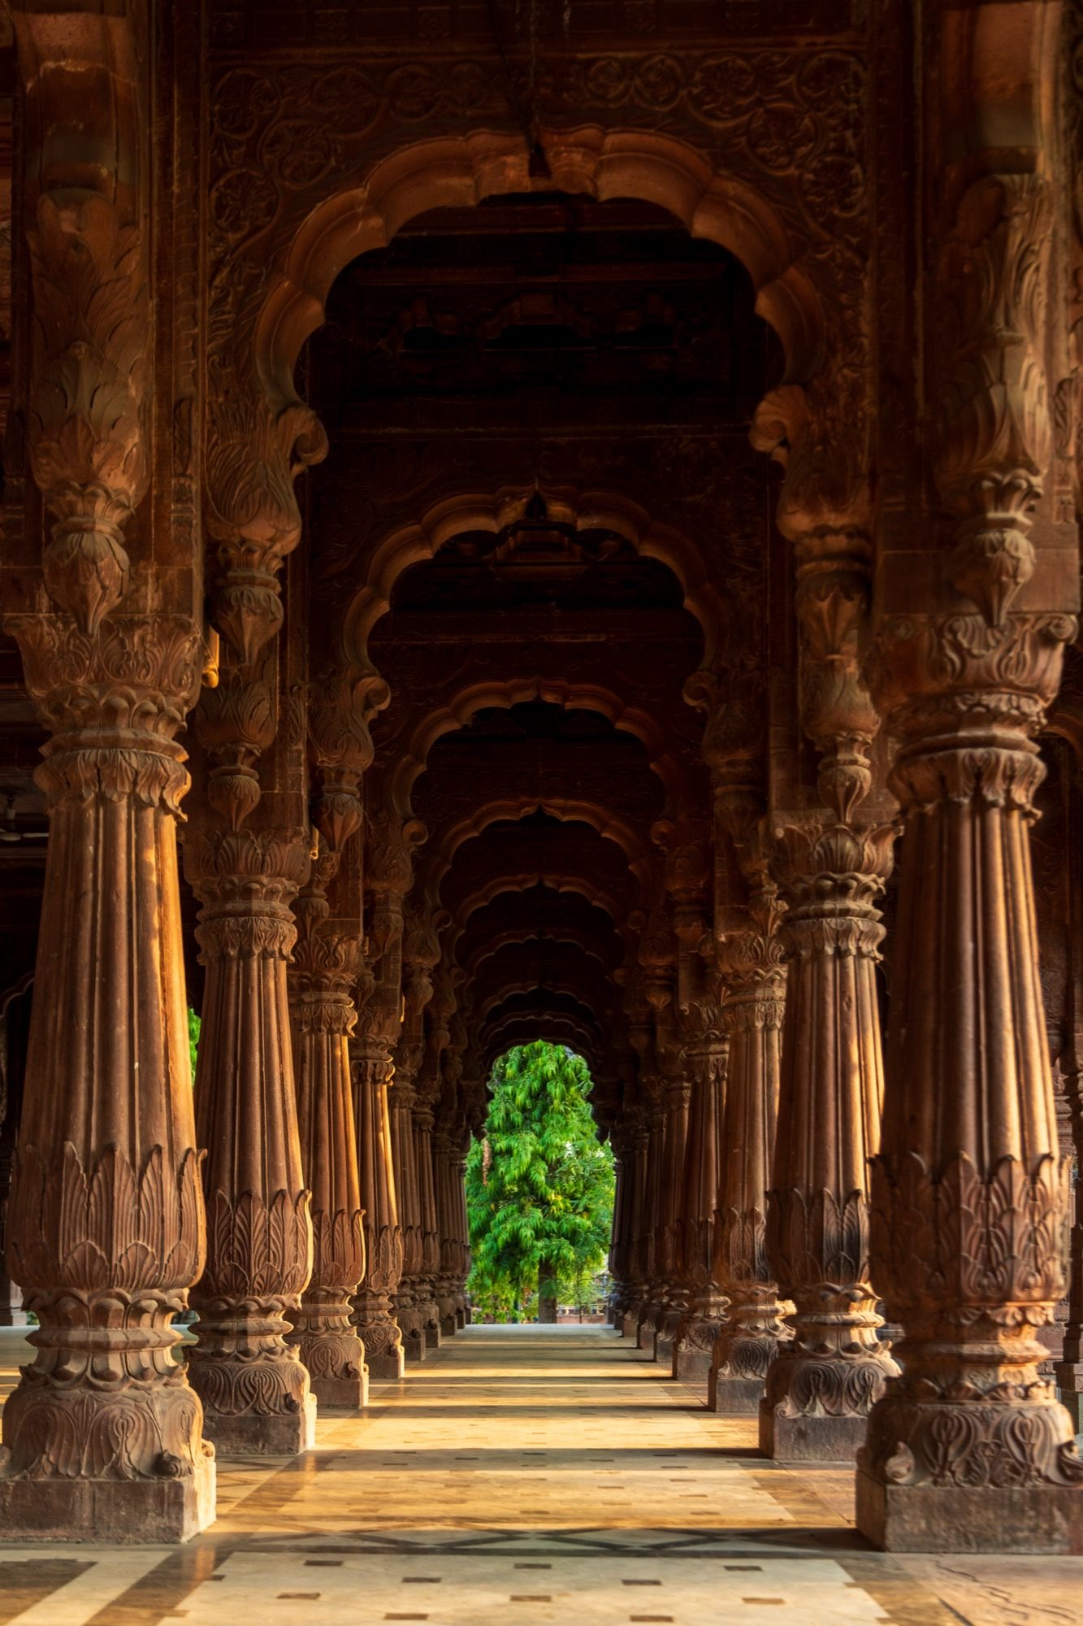
Heritage background — Krishnabai holkar chhatri .jpg

Outfit reference photos (designer-only, not sent to the model)
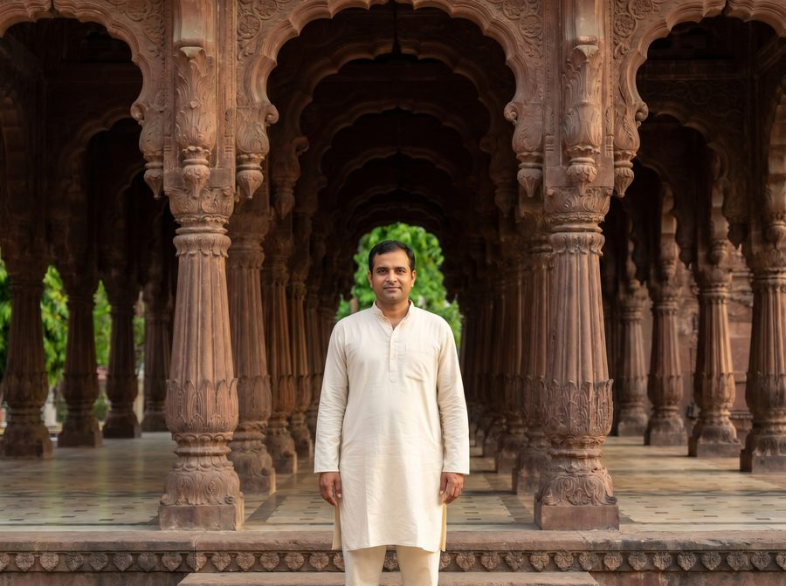 | 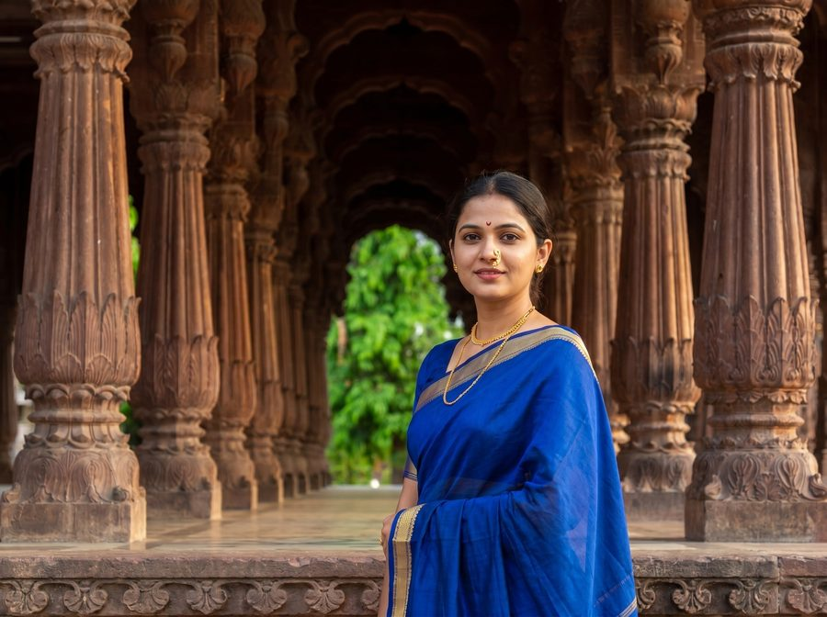
Male reference · 9-male.jpg | Female reference · 9-female.jpg

Male prompt — outfit slot
holkar-era maratha sardar in a cream cotton dhoti-kurta with a red pheta turban and a shawl draped over one shoulder

Female prompt — outfit slot
holkar-era maharashtrian queen in a royal-blue nauvari saree with gold border, a gold nath, thushi, pearl necklace and ornate traditional jewellery, styled after queen ahilyabai holkar

Resolved full prompt — Male
ABSOLUTE RULE — symbols of marital status. do NOT add any of the following to the person in the output UNLESS that exact symbol is clearly, visibly present on the person in the first reference photo:
• sindoor (red or orange vermilion powder in the hair parting)
• mangalsutra (black-bead and gold marriage necklace)
• kumkum at the parting or forehead
• bridal makeup, heavy nath / nose ring, or any other suhaag / saubhagya symbol
if the reference photo does not show these, the output must not show them — regardless of what the outfit description below suggests, regardless of the cultural setting, and regardless of what is "traditional" for the era or region. inventing these on a person who does not wear them (a child, an unmarried woman, a person of any age or background who simply does not use them) is a critical failure that causes religious and cultural offence. when in doubt, OMIT.
face-preservation rule: the face in the first reference photo must be preserved exactly in the output. same eyes, same nose, same mouth, same jawline, same skin tone, same age, same expression — every facial detail must be identical to the reference. do not beautify, smooth, slim, stylise, de-age, lighten or reshape the face in any way. if the face does not match the reference exactly, the image is wrong.
age-appropriateness rule: study the apparent age in the reference photo and adapt the outfit accordingly. if the reference shows a child, young girl or teenager, keep the attire age-appropriate — simpler, lighter jewellery; no nath / nose ring; no heavy bridal ornaments; no adult makeup; absolutely no sindoor, mangalsutra or kumkum. treat the outfit description below as a stylistic direction, not a literal checklist — drop any element that is not appropriate for the person's apparent age. a small plain decorative bindi is acceptable only if the person clearly appears to be an adult woman; otherwise omit it.
now create an image of this person standing in this 18th-century Holkar royal chhatri at Maheshwar, dressed like a holkar-era maratha sardar in a cream cotton dhoti-kurta with a red pheta turban and a shawl draped over one shoulder. please adjust the lights and shadows so the person blends naturally into the scene. the image should look super realistic and natural.

Resolved full prompt — Female
ABSOLUTE RULE — symbols of marital status. do NOT add any of the following to the person in the output UNLESS that exact symbol is clearly, visibly present on the person in the first reference photo:
• sindoor (red or orange vermilion powder in the hair parting)
• mangalsutra (black-bead and gold marriage necklace)
• kumkum at the parting or forehead
• bridal makeup, heavy nath / nose ring, or any other suhaag / saubhagya symbol
if the reference photo does not show these, the output must not show them — regardless of what the outfit description below suggests, regardless of the cultural setting, and regardless of what is "traditional" for the era or region. inventing these on a person who does not wear them (a child, an unmarried woman, a person of any age or background who simply does not use them) is a critical failure that causes religious and cultural offence. when in doubt, OMIT.
face-preservation rule: the face in the first reference photo must be preserved exactly in the output. same eyes, same nose, same mouth, same jawline, same skin tone, same age, same expression — every facial detail must be identical to the reference. do not beautify, smooth, slim, stylise, de-age, lighten or reshape the face in any way. if the face does not match the reference exactly, the image is wrong.
age-appropriateness rule: study the apparent age in the reference photo and adapt the outfit accordingly. if the reference shows a child, young girl or teenager, keep the attire age-appropriate — simpler, lighter jewellery; no nath / nose ring; no heavy bridal ornaments; no adult makeup; absolutely no sindoor, mangalsutra or kumkum. treat the outfit description below as a stylistic direction, not a literal checklist — drop any element that is not appropriate for the person's apparent age. a small plain decorative bindi is acceptable only if the person clearly appears to be an adult woman; otherwise omit it.
now create an image of this person standing in this 18th-century Holkar royal chhatri at Maheshwar, dressed like a holkar-era maharashtrian queen in a royal-blue nauvari saree with gold border, a gold nath, thushi, pearl necklace and ornate traditional jewellery, styled after queen ahilyabai holkar. please adjust the lights and shadows so the person blends naturally into the scene. the image should look super realistic and natural.

Preset 10 · Indore — Rajwada Palace
The seven-storey Holkar palace of Indore
Background file | Rajwada Indore.jpg
Setting (prompt slot) | 18th-century seven-storey Holkar palace in Indore
Gender availability | Male & Female
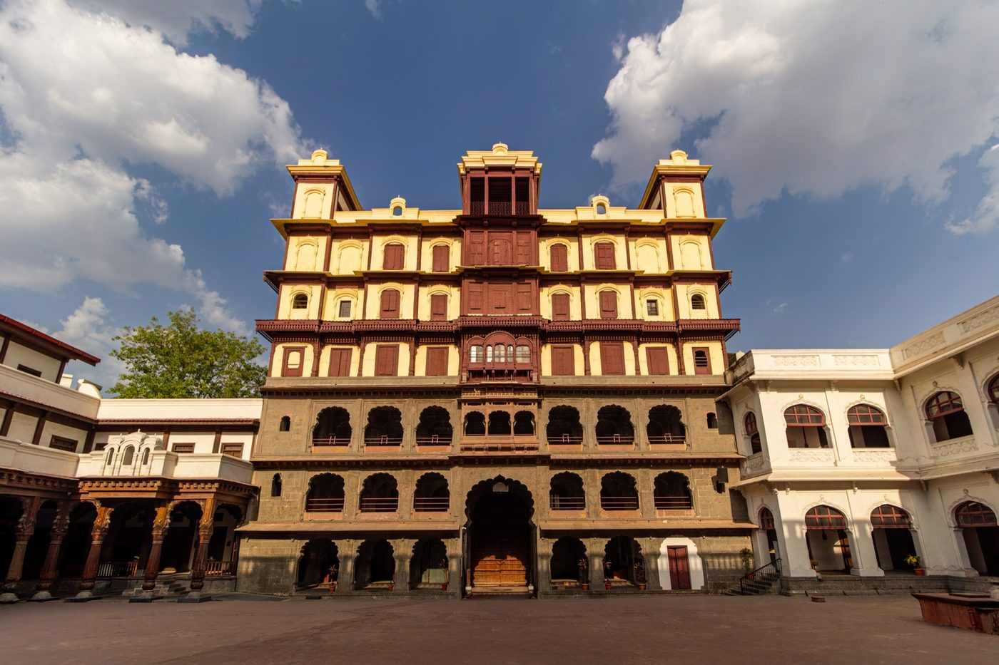
Heritage background — Rajwada Indore.jpg

Outfit reference photos (designer-only, not sent to the model)
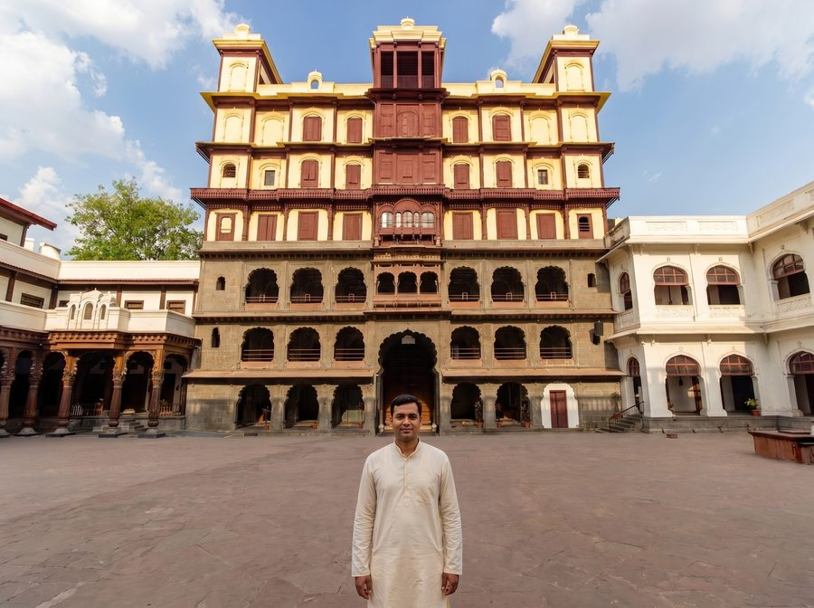 | 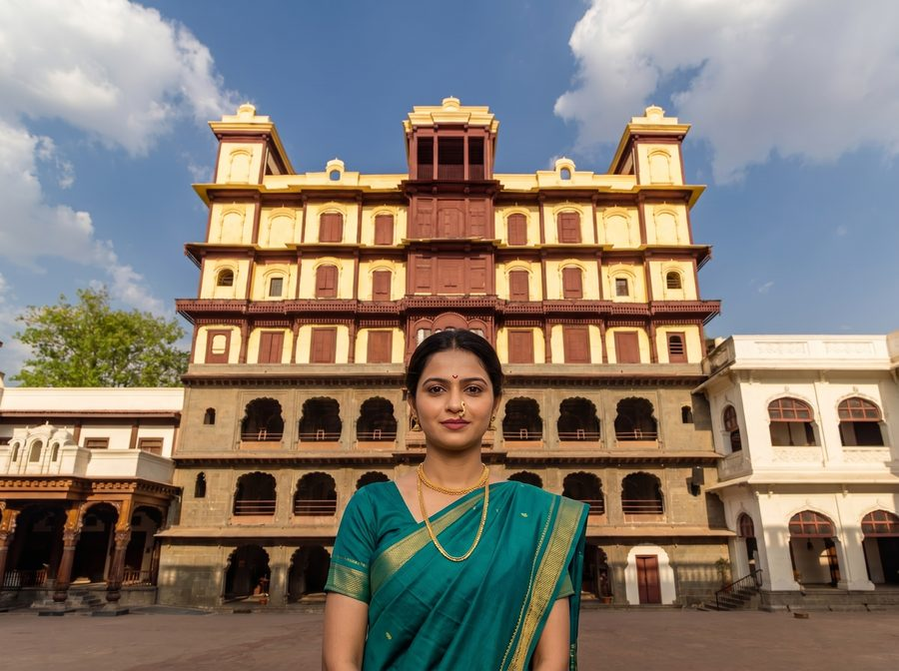
Male reference · 10-male.jpg | Female reference · 10-female.jpg

Male prompt — outfit slot
holkar-era maharaja in a cream brocade angarkha, churidar pyjama, a jewelled red pheta turban with a sarpech ornament, a kamarband and a pearl necklace

Female prompt — outfit slot
holkar-era maharani in a peacock-green paithani saree with a heavy gold zari border, a large gold nath, ornate thushi, a multi-strand pearl necklace, maang tikka and traditional regal jewellery

Resolved full prompt — Male
ABSOLUTE RULE — symbols of marital status. do NOT add any of the following to the person in the output UNLESS that exact symbol is clearly, visibly present on the person in the first reference photo:
• sindoor (red or orange vermilion powder in the hair parting)
• mangalsutra (black-bead and gold marriage necklace)
• kumkum at the parting or forehead
• bridal makeup, heavy nath / nose ring, or any other suhaag / saubhagya symbol
if the reference photo does not show these, the output must not show them — regardless of what the outfit description below suggests, regardless of the cultural setting, and regardless of what is "traditional" for the era or region. inventing these on a person who does not wear them (a child, an unmarried woman, a person of any age or background who simply does not use them) is a critical failure that causes religious and cultural offence. when in doubt, OMIT.
face-preservation rule: the face in the first reference photo must be preserved exactly in the output. same eyes, same nose, same mouth, same jawline, same skin tone, same age, same expression — every facial detail must be identical to the reference. do not beautify, smooth, slim, stylise, de-age, lighten or reshape the face in any way. if the face does not match the reference exactly, the image is wrong.
age-appropriateness rule: study the apparent age in the reference photo and adapt the outfit accordingly. if the reference shows a child, young girl or teenager, keep the attire age-appropriate — simpler, lighter jewellery; no nath / nose ring; no heavy bridal ornaments; no adult makeup; absolutely no sindoor, mangalsutra or kumkum. treat the outfit description below as a stylistic direction, not a literal checklist — drop any element that is not appropriate for the person's apparent age. a small plain decorative bindi is acceptable only if the person clearly appears to be an adult woman; otherwise omit it.
now create an image of this person standing in this 18th-century seven-storey Holkar palace in Indore, dressed like a holkar-era maharaja in a cream brocade angarkha, churidar pyjama, a jewelled red pheta turban with a sarpech ornament, a kamarband and a pearl necklace. please adjust the lights and shadows so the person blends naturally into the scene. the image should look super realistic and natural.

Resolved full prompt — Female
ABSOLUTE RULE — symbols of marital status. do NOT add any of the following to the person in the output UNLESS that exact symbol is clearly, visibly present on the person in the first reference photo:
• sindoor (red or orange vermilion powder in the hair parting)
• mangalsutra (black-bead and gold marriage necklace)
• kumkum at the parting or forehead
• bridal makeup, heavy nath / nose ring, or any other suhaag / saubhagya symbol
if the reference photo does not show these, the output must not show them — regardless of what the outfit description below suggests, regardless of the cultural setting, and regardless of what is "traditional" for the era or region. inventing these on a person who does not wear them (a child, an unmarried woman, a person of any age or background who simply does not use them) is a critical failure that causes religious and cultural offence. when in doubt, OMIT.
face-preservation rule: the face in the first reference photo must be preserved exactly in the output. same eyes, same nose, same mouth, same jawline, same skin tone, same age, same expression — every facial detail must be identical to the reference. do not beautify, smooth, slim, stylise, de-age, lighten or reshape the face in any way. if the face does not match the reference exactly, the image is wrong.
age-appropriateness rule: study the apparent age in the reference photo and adapt the outfit accordingly. if the reference shows a child, young girl or teenager, keep the attire age-appropriate — simpler, lighter jewellery; no nath / nose ring; no heavy bridal ornaments; no adult makeup; absolutely no sindoor, mangalsutra or kumkum. treat the outfit description below as a stylistic direction, not a literal checklist — drop any element that is not appropriate for the person's apparent age. a small plain decorative bindi is acceptable only if the person clearly appears to be an adult woman; otherwise omit it.
now create an image of this person standing in this 18th-century seven-storey Holkar palace in Indore, dressed like a holkar-era maharani in a peacock-green paithani saree with a heavy gold zari border, a large gold nath, ornate thushi, a multi-strand pearl necklace, maang tikka and traditional regal jewellery. please adjust the lights and shadows so the person blends naturally into the scene. the image should look super realistic and natural.

Preset 11 · Indore — Rajwada Courtyard
Inside the Holkar royal seat
Background file | RajWada 15.jpg
Setting (prompt slot) | inner courtyard of the 18th-century Holkar palace in Indore
Gender availability | Male & Female
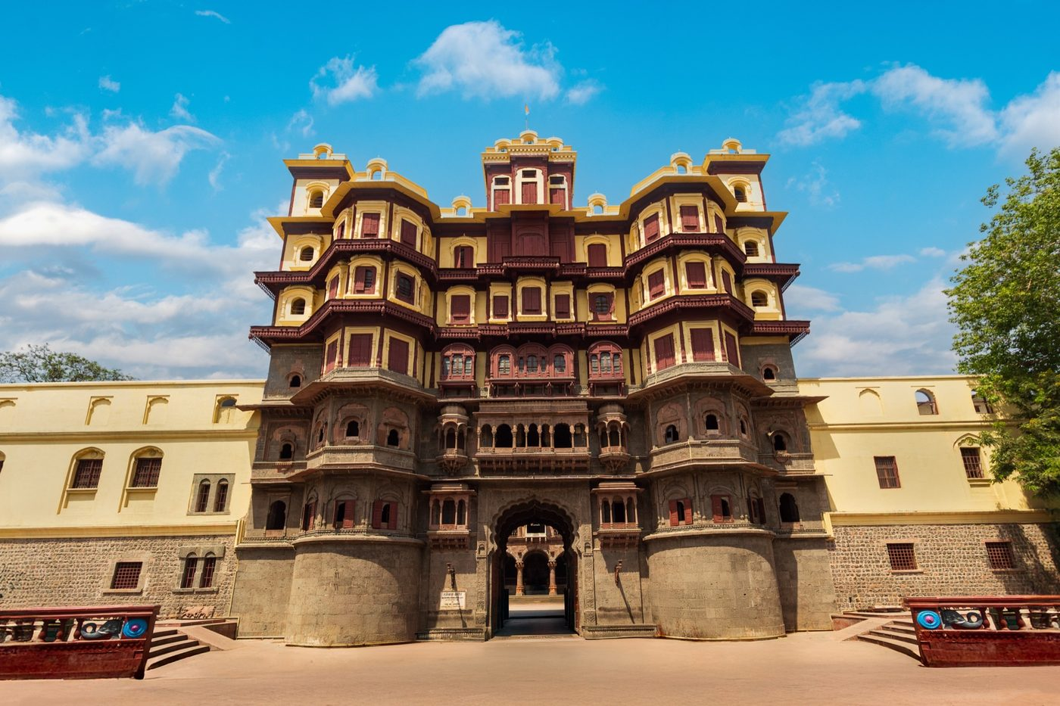
Heritage background — RajWada 15.jpg

Outfit reference photos (designer-only, not sent to the model)
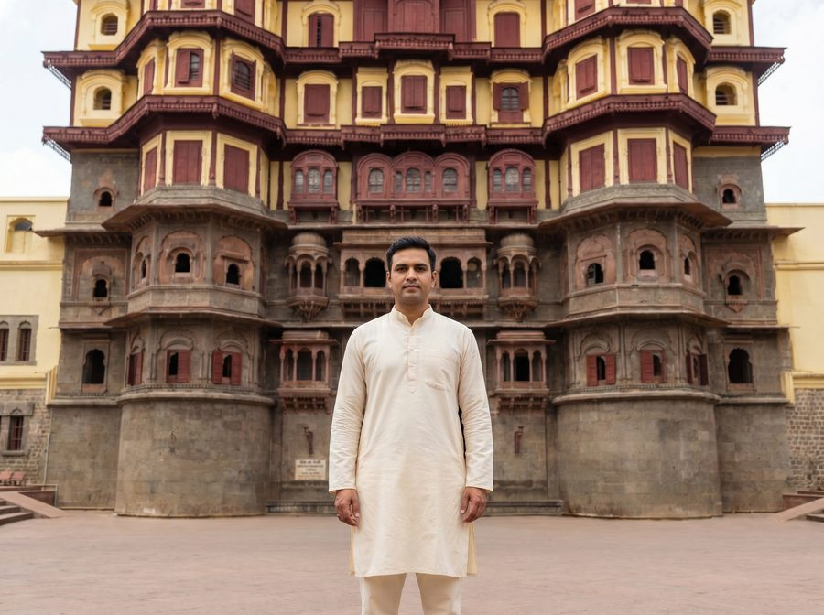 | 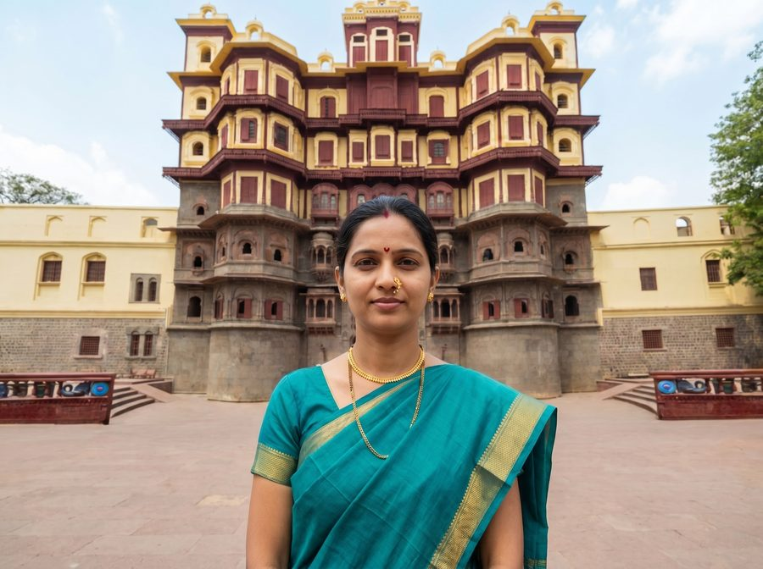
Male reference · 11-male.jpg | Female reference · 11-female.jpg

Male prompt — outfit slot
holkar-era maratha nobleman in a cream cotton dhoti-kurta with a red pheta turban and a simple shawl

Female prompt — outfit slot
holkar-era royal lady in a teal nauvari saree with a gold border, a gold nath, thushi, pearl necklace and traditional maharashtrian jewellery

Resolved full prompt — Male
ABSOLUTE RULE — symbols of marital status. do NOT add any of the following to the person in the output UNLESS that exact symbol is clearly, visibly present on the person in the first reference photo:
• sindoor (red or orange vermilion powder in the hair parting)
• mangalsutra (black-bead and gold marriage necklace)
• kumkum at the parting or forehead
• bridal makeup, heavy nath / nose ring, or any other suhaag / saubhagya symbol
if the reference photo does not show these, the output must not show them — regardless of what the outfit description below suggests, regardless of the cultural setting, and regardless of what is "traditional" for the era or region. inventing these on a person who does not wear them (a child, an unmarried woman, a person of any age or background who simply does not use them) is a critical failure that causes religious and cultural offence. when in doubt, OMIT.
face-preservation rule: the face in the first reference photo must be preserved exactly in the output. same eyes, same nose, same mouth, same jawline, same skin tone, same age, same expression — every facial detail must be identical to the reference. do not beautify, smooth, slim, stylise, de-age, lighten or reshape the face in any way. if the face does not match the reference exactly, the image is wrong.
age-appropriateness rule: study the apparent age in the reference photo and adapt the outfit accordingly. if the reference shows a child, young girl or teenager, keep the attire age-appropriate — simpler, lighter jewellery; no nath / nose ring; no heavy bridal ornaments; no adult makeup; absolutely no sindoor, mangalsutra or kumkum. treat the outfit description below as a stylistic direction, not a literal checklist — drop any element that is not appropriate for the person's apparent age. a small plain decorative bindi is acceptable only if the person clearly appears to be an adult woman; otherwise omit it.
now create an image of this person standing in this inner courtyard of the 18th-century Holkar palace in Indore, dressed like a holkar-era maratha nobleman in a cream cotton dhoti-kurta with a red pheta turban and a simple shawl. please adjust the lights and shadows so the person blends naturally into the scene. the image should look super realistic and natural.

Resolved full prompt — Female
ABSOLUTE RULE — symbols of marital status. do NOT add any of the following to the person in the output UNLESS that exact symbol is clearly, visibly present on the person in the first reference photo:
• sindoor (red or orange vermilion powder in the hair parting)
• mangalsutra (black-bead and gold marriage necklace)
• kumkum at the parting or forehead
• bridal makeup, heavy nath / nose ring, or any other suhaag / saubhagya symbol
if the reference photo does not show these, the output must not show them — regardless of what the outfit description below suggests, regardless of the cultural setting, and regardless of what is "traditional" for the era or region. inventing these on a person who does not wear them (a child, an unmarried woman, a person of any age or background who simply does not use them) is a critical failure that causes religious and cultural offence. when in doubt, OMIT.
face-preservation rule: the face in the first reference photo must be preserved exactly in the output. same eyes, same nose, same mouth, same jawline, same skin tone, same age, same expression — every facial detail must be identical to the reference. do not beautify, smooth, slim, stylise, de-age, lighten or reshape the face in any way. if the face does not match the reference exactly, the image is wrong.
age-appropriateness rule: study the apparent age in the reference photo and adapt the outfit accordingly. if the reference shows a child, young girl or teenager, keep the attire age-appropriate — simpler, lighter jewellery; no nath / nose ring; no heavy bridal ornaments; no adult makeup; absolutely no sindoor, mangalsutra or kumkum. treat the outfit description below as a stylistic direction, not a literal checklist — drop any element that is not appropriate for the person's apparent age. a small plain decorative bindi is acceptable only if the person clearly appears to be an adult woman; otherwise omit it.
now create an image of this person standing in this inner courtyard of the 18th-century Holkar palace in Indore, dressed like a holkar-era royal lady in a teal nauvari saree with a gold border, a gold nath, thushi, pearl necklace and traditional maharashtrian jewellery. please adjust the lights and shadows so the person blends naturally into the scene. the image should look super realistic and natural.

Preset 12 · Kheoni Sanctuary — Wilds of MP
Central Indian teak and sal forest
Background file | kheoni wildlife sanctuary .jpg
Setting (prompt slot) | central Indian teak and sal forest at Kheoni Wildlife Sanctuary
Gender availability | Male only
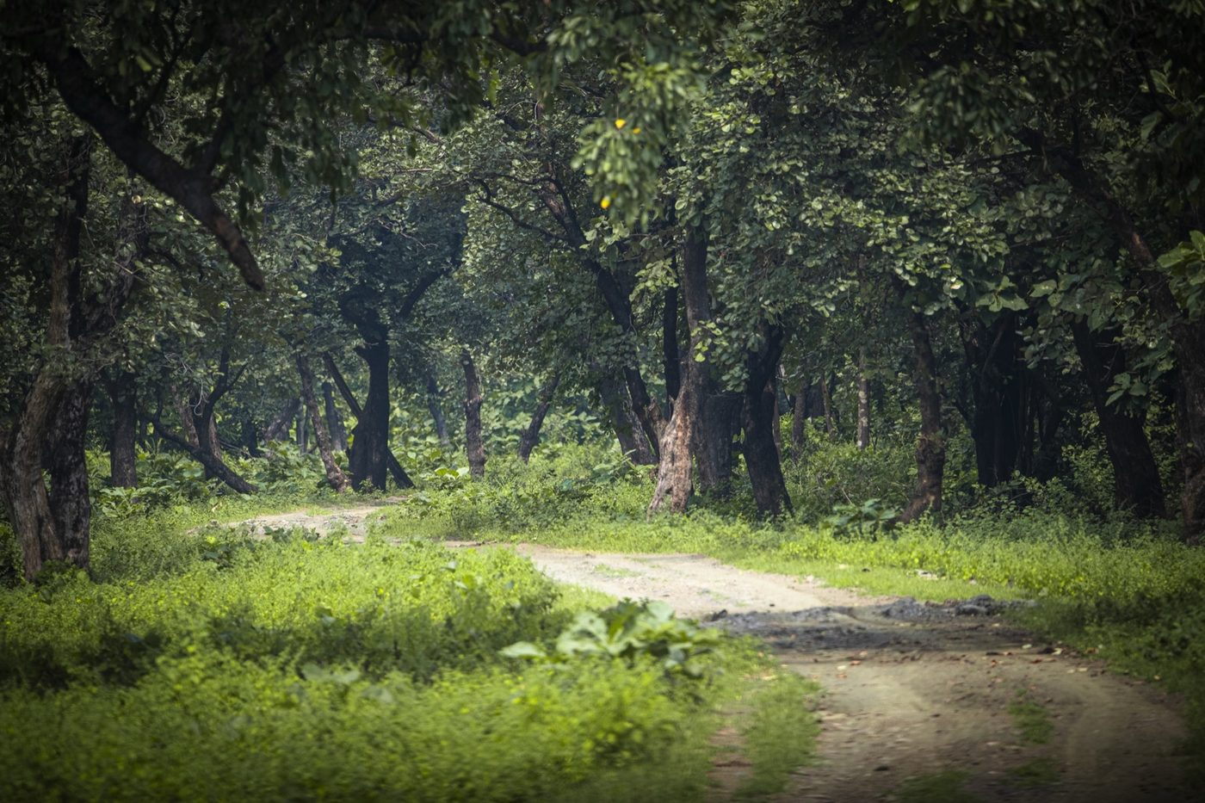
Heritage background — kheoni wildlife sanctuary .jpg

Outfit reference photos (designer-only, not sent to the model)
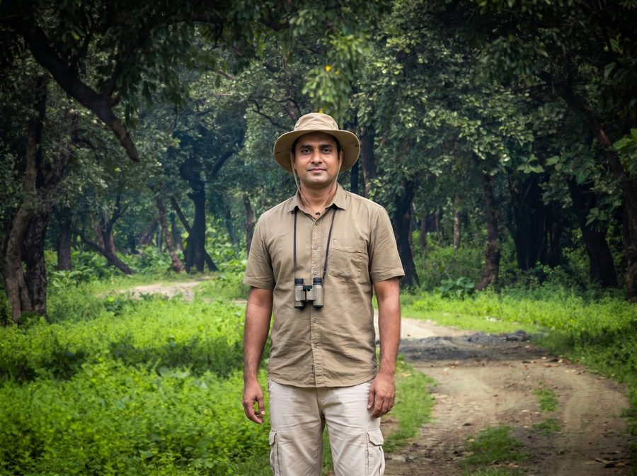 | 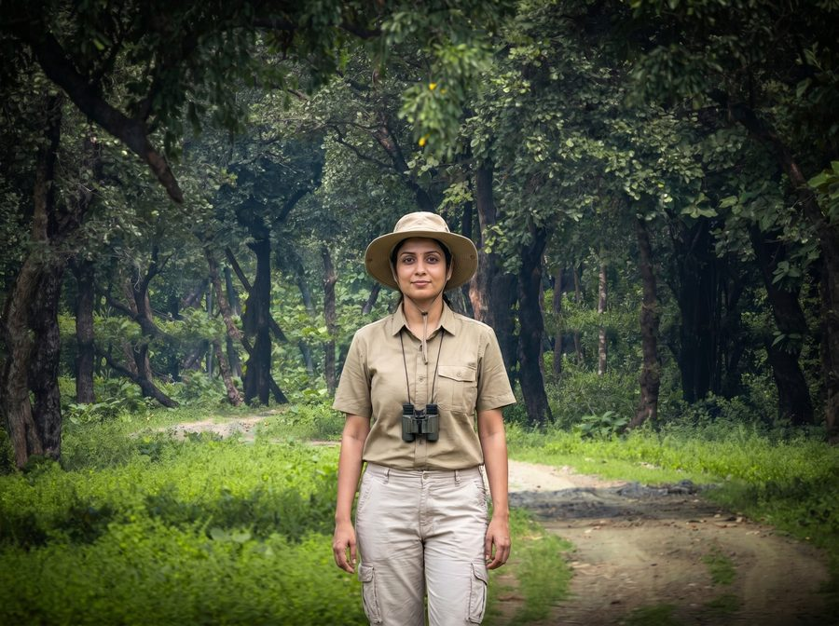
Male reference · 12-male.jpg | Female reference · 12-female.jpg

Male prompt — outfit slot
modern wildlife safari explorer in a clean khaki short-sleeve shirt with a chest pocket, light beige cargo trousers, a wide-brim canvas safari hat and binoculars hanging around the neck

Female prompt — outfit slot
modern wildlife safari explorer in a clean khaki short-sleeve shirt with a chest pocket, light beige cargo trousers, a wide-brim canvas safari hat and binoculars hanging around the neck

Resolved full prompt — Male
ABSOLUTE RULE — symbols of marital status. do NOT add any of the following to the person in the output UNLESS that exact symbol is clearly, visibly present on the person in the first reference photo:
• sindoor (red or orange vermilion powder in the hair parting)
• mangalsutra (black-bead and gold marriage necklace)
• kumkum at the parting or forehead
• bridal makeup, heavy nath / nose ring, or any other suhaag / saubhagya symbol
if the reference photo does not show these, the output must not show them — regardless of what the outfit description below suggests, regardless of the cultural setting, and regardless of what is "traditional" for the era or region. inventing these on a person who does not wear them (a child, an unmarried woman, a person of any age or background who simply does not use them) is a critical failure that causes religious and cultural offence. when in doubt, OMIT.
face-preservation rule: the face in the first reference photo must be preserved exactly in the output. same eyes, same nose, same mouth, same jawline, same skin tone, same age, same expression — every facial detail must be identical to the reference. do not beautify, smooth, slim, stylise, de-age, lighten or reshape the face in any way. if the face does not match the reference exactly, the image is wrong.
age-appropriateness rule: study the apparent age in the reference photo and adapt the outfit accordingly. if the reference shows a child, young girl or teenager, keep the attire age-appropriate — simpler, lighter jewellery; no nath / nose ring; no heavy bridal ornaments; no adult makeup; absolutely no sindoor, mangalsutra or kumkum. treat the outfit description below as a stylistic direction, not a literal checklist — drop any element that is not appropriate for the person's apparent age. a small plain decorative bindi is acceptable only if the person clearly appears to be an adult woman; otherwise omit it.
now create an image of this person standing in this central Indian teak and sal forest at Kheoni Wildlife Sanctuary, dressed like a modern wildlife safari explorer in a clean khaki short-sleeve shirt with a chest pocket, light beige cargo trousers, a wide-brim canvas safari hat and binoculars hanging around the neck. please adjust the lights and shadows so the person blends naturally into the scene. the image should look super realistic and natural.

Resolved full prompt — Female
ABSOLUTE RULE — symbols of marital status. do NOT add any of the following to the person in the output UNLESS that exact symbol is clearly, visibly present on the person in the first reference photo:
• sindoor (red or orange vermilion powder in the hair parting)
• mangalsutra (black-bead and gold marriage necklace)
• kumkum at the parting or forehead
• bridal makeup, heavy nath / nose ring, or any other suhaag / saubhagya symbol
if the reference photo does not show these, the output must not show them — regardless of what the outfit description below suggests, regardless of the cultural setting, and regardless of what is "traditional" for the era or region. inventing these on a person who does not wear them (a child, an unmarried woman, a person of any age or background who simply does not use them) is a critical failure that causes religious and cultural offence. when in doubt, OMIT.
face-preservation rule: the face in the first reference photo must be preserved exactly in the output. same eyes, same nose, same mouth, same jawline, same skin tone, same age, same expression — every facial detail must be identical to the reference. do not beautify, smooth, slim, stylise, de-age, lighten or reshape the face in any way. if the face does not match the reference exactly, the image is wrong.
age-appropriateness rule: study the apparent age in the reference photo and adapt the outfit accordingly. if the reference shows a child, young girl or teenager, keep the attire age-appropriate — simpler, lighter jewellery; no nath / nose ring; no heavy bridal ornaments; no adult makeup; absolutely no sindoor, mangalsutra or kumkum. treat the outfit description below as a stylistic direction, not a literal checklist — drop any element that is not appropriate for the person's apparent age. a small plain decorative bindi is acceptable only if the person clearly appears to be an adult woman; otherwise omit it.
now create an image of this person standing in this central Indian teak and sal forest at Kheoni Wildlife Sanctuary, dressed like a modern wildlife safari explorer in a clean khaki short-sleeve shirt with a chest pocket, light beige cargo trousers, a wide-brim canvas safari hat and binoculars hanging around the neck. please adjust the lights and shadows so the person blends naturally into the scene. the image should look super realistic and natural.

Preset 13 · Kheoni Sanctuary — Forest Trail
Quiet woodland of teak, sal and bamboo
Background file | kheoni wildlife sanctuary 1.jpg
Setting (prompt slot) | forest trail through teak and bamboo at Kheoni Wildlife Sanctuary
Gender availability | Male only
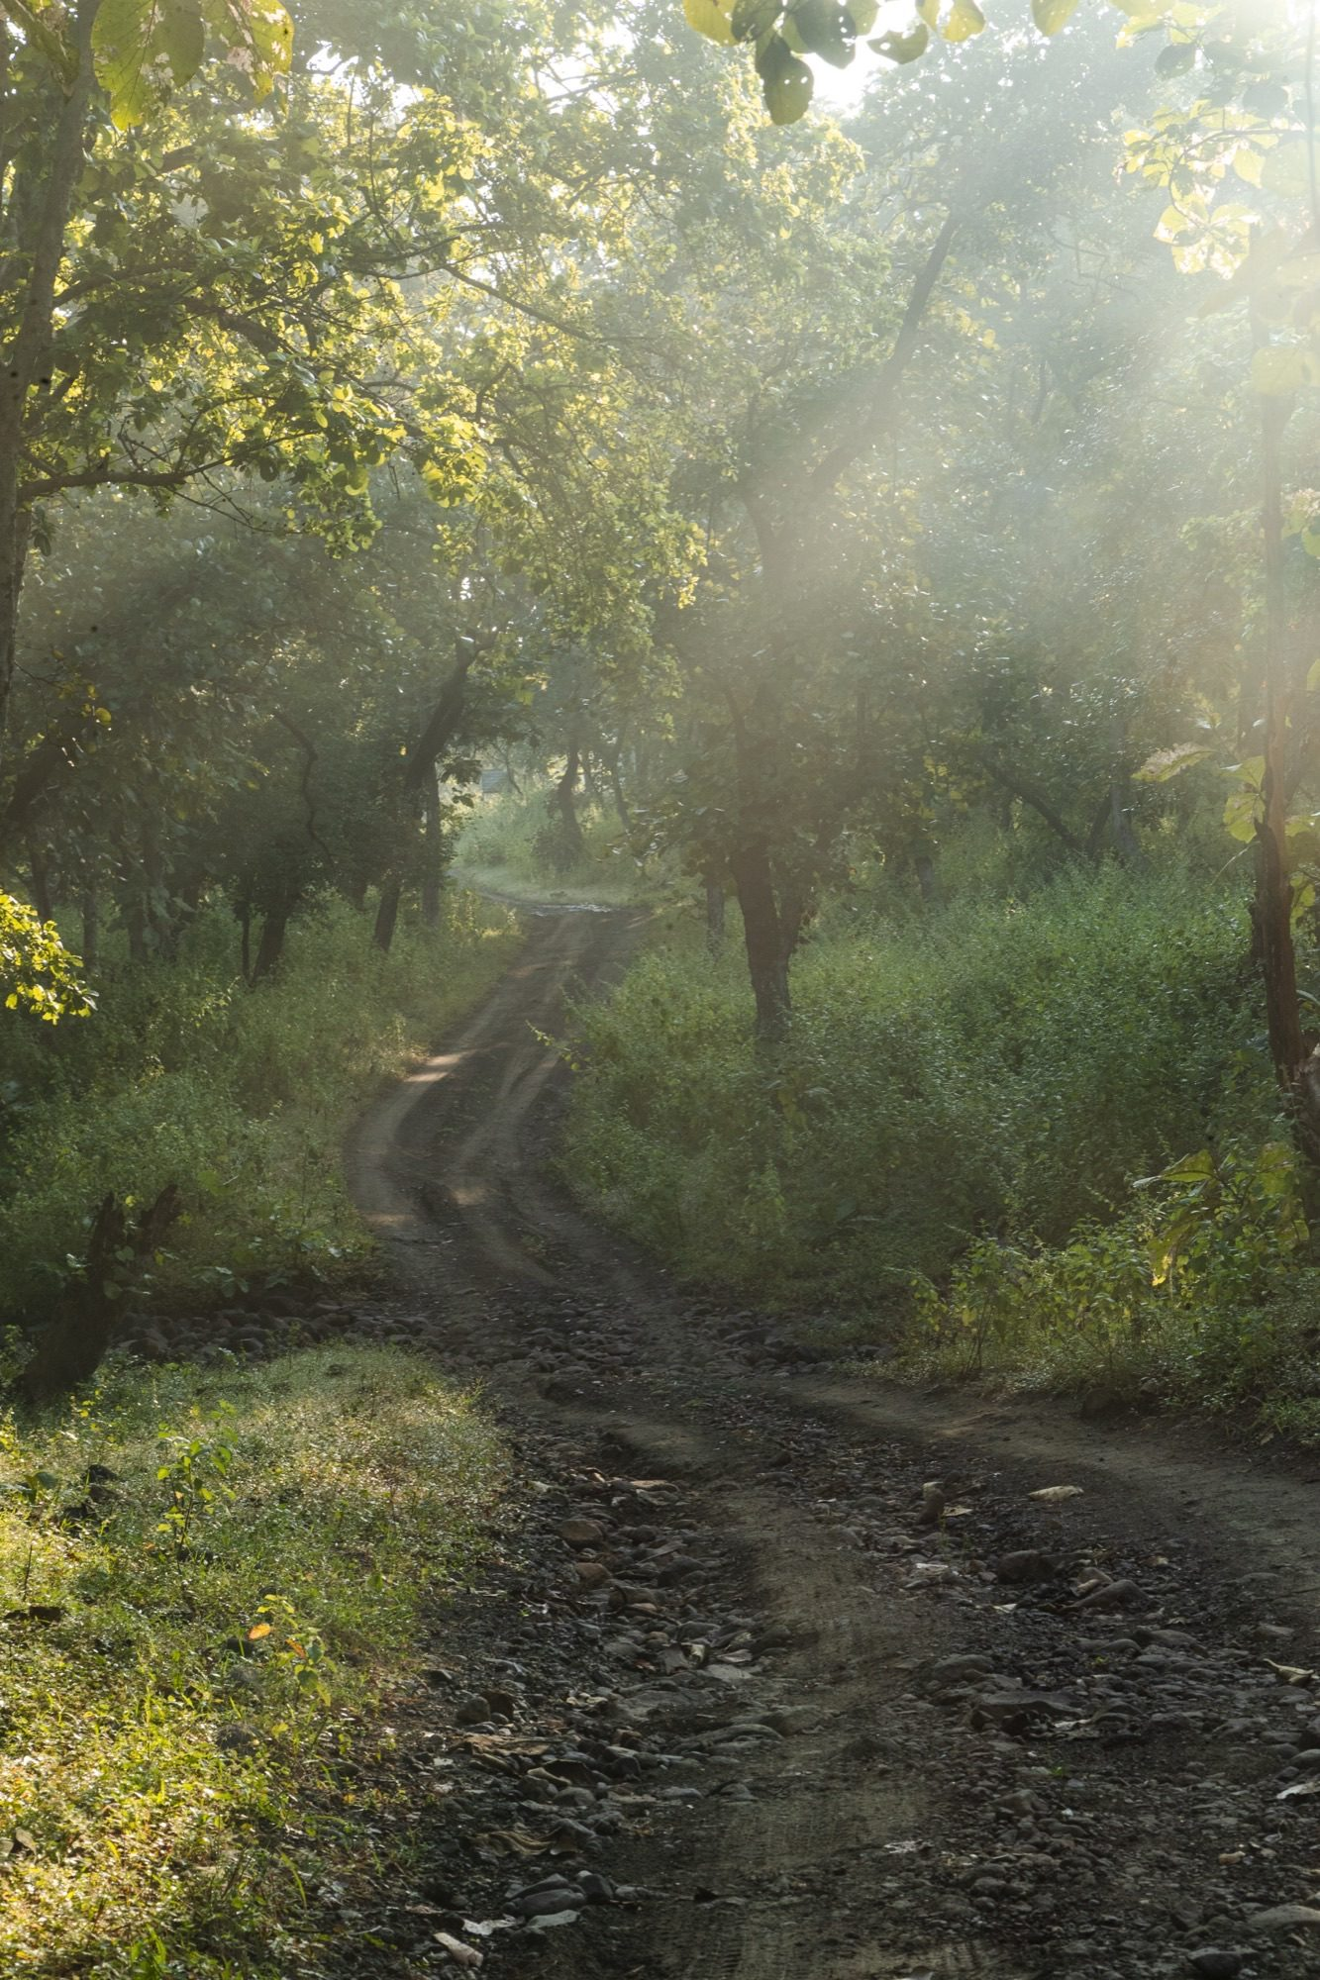
Heritage background — kheoni wildlife sanctuary 1.jpg

Outfit reference photos (designer-only, not sent to the model)
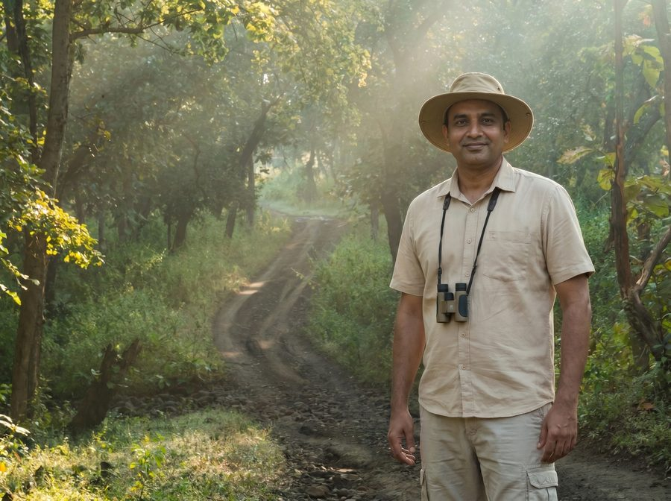 | 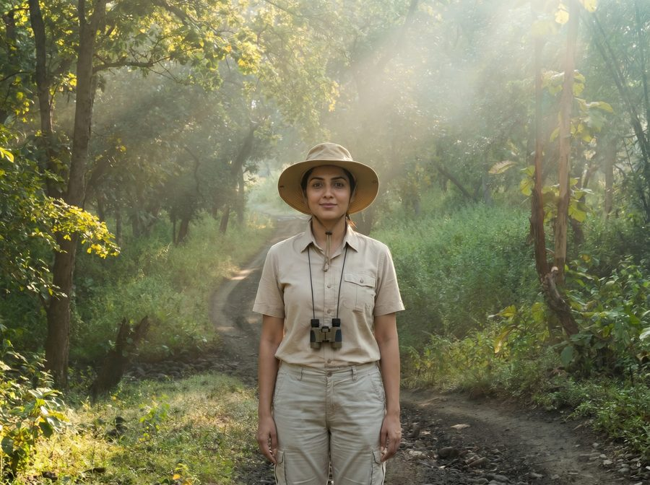
Male reference · 13-male.jpg | Female reference · 13-female.jpg

Male prompt — outfit slot
modern wildlife safari explorer in a sand-beige short-sleeve shirt with a chest pocket, khaki cargo trousers, a wide-brim canvas safari hat and binoculars hanging around the neck

Female prompt — outfit slot
modern wildlife safari explorer in a sand-beige short-sleeve shirt with a chest pocket, khaki cargo trousers, a wide-brim canvas safari hat and binoculars hanging around the neck

Resolved full prompt — Male
ABSOLUTE RULE — symbols of marital status. do NOT add any of the following to the person in the output UNLESS that exact symbol is clearly, visibly present on the person in the first reference photo:
• sindoor (red or orange vermilion powder in the hair parting)
• mangalsutra (black-bead and gold marriage necklace)
• kumkum at the parting or forehead
• bridal makeup, heavy nath / nose ring, or any other suhaag / saubhagya symbol
if the reference photo does not show these, the output must not show them — regardless of what the outfit description below suggests, regardless of the cultural setting, and regardless of what is "traditional" for the era or region. inventing these on a person who does not wear them (a child, an unmarried woman, a person of any age or background who simply does not use them) is a critical failure that causes religious and cultural offence. when in doubt, OMIT.
face-preservation rule: the face in the first reference photo must be preserved exactly in the output. same eyes, same nose, same mouth, same jawline, same skin tone, same age, same expression — every facial detail must be identical to the reference. do not beautify, smooth, slim, stylise, de-age, lighten or reshape the face in any way. if the face does not match the reference exactly, the image is wrong.
age-appropriateness rule: study the apparent age in the reference photo and adapt the outfit accordingly. if the reference shows a child, young girl or teenager, keep the attire age-appropriate — simpler, lighter jewellery; no nath / nose ring; no heavy bridal ornaments; no adult makeup; absolutely no sindoor, mangalsutra or kumkum. treat the outfit description below as a stylistic direction, not a literal checklist — drop any element that is not appropriate for the person's apparent age. a small plain decorative bindi is acceptable only if the person clearly appears to be an adult woman; otherwise omit it.
now create an image of this person standing in this forest trail through teak and bamboo at Kheoni Wildlife Sanctuary, dressed like a modern wildlife safari explorer in a sand-beige short-sleeve shirt with a chest pocket, khaki cargo trousers, a wide-brim canvas safari hat and binoculars hanging around the neck. please adjust the lights and shadows so the person blends naturally into the scene. the image should look super realistic and natural.

Resolved full prompt — Female
ABSOLUTE RULE — symbols of marital status. do NOT add any of the following to the person in the output UNLESS that exact symbol is clearly, visibly present on the person in the first reference photo:
• sindoor (red or orange vermilion powder in the hair parting)
• mangalsutra (black-bead and gold marriage necklace)
• kumkum at the parting or forehead
• bridal makeup, heavy nath / nose ring, or any other suhaag / saubhagya symbol
if the reference photo does not show these, the output must not show them — regardless of what the outfit description below suggests, regardless of the cultural setting, and regardless of what is "traditional" for the era or region. inventing these on a person who does not wear them (a child, an unmarried woman, a person of any age or background who simply does not use them) is a critical failure that causes religious and cultural offence. when in doubt, OMIT.
face-preservation rule: the face in the first reference photo must be preserved exactly in the output. same eyes, same nose, same mouth, same jawline, same skin tone, same age, same expression — every facial detail must be identical to the reference. do not beautify, smooth, slim, stylise, de-age, lighten or reshape the face in any way. if the face does not match the reference exactly, the image is wrong.
age-appropriateness rule: study the apparent age in the reference photo and adapt the outfit accordingly. if the reference shows a child, young girl or teenager, keep the attire age-appropriate — simpler, lighter jewellery; no nath / nose ring; no heavy bridal ornaments; no adult makeup; absolutely no sindoor, mangalsutra or kumkum. treat the outfit description below as a stylistic direction, not a literal checklist — drop any element that is not appropriate for the person's apparent age. a small plain decorative bindi is acceptable only if the person clearly appears to be an adult woman; otherwise omit it.
now create an image of this person standing in this forest trail through teak and bamboo at Kheoni Wildlife Sanctuary, dressed like a modern wildlife safari explorer in a sand-beige short-sleeve shirt with a chest pocket, khaki cargo trousers, a wide-brim canvas safari hat and binoculars hanging around the neck. please adjust the lights and shadows so the person blends naturally into the scene. the image should look super realistic and natural.

Preset 14 · Goa — Cabo de Rama Beach
Palm-fringed Goan coast at golden-hour sunset
Background file | Cabo de Rama Beach_DSC9670.jpg
Setting (prompt slot) | wide curving Goan beach at Cabo de Rama during a soft pink-and-orange sunset, with the calm Arabian Sea, golden sand, dark coastal rocks and tall coconut palms swaying along the shoreline
Gender availability | Male & Female
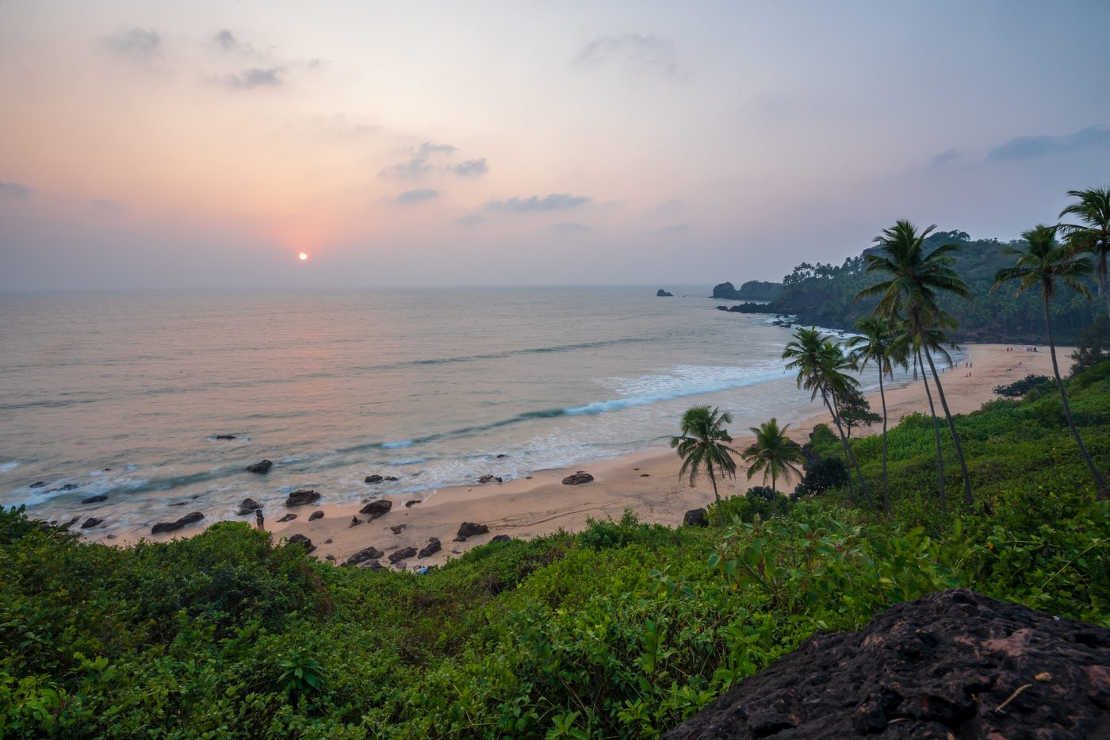
Heritage background — Cabo de Rama Beach_DSC9670.jpg
No outfit reference template photos for this preset.

Male prompt — outfit slot
easy-going beach-day visitor in a soft cream linen full-sleeve shirt with the sleeves loosely rolled up to the forearm, fully buttoned, comfortable beige cotton beach trousers, and a pair of simple rubber flip-flop beach slippers — modest, fully clothed, no shorts and no swimwear

Female prompt — outfit slot
easy-going beach-day visitor in an ankle-length flowy white-and-pastel-floral cotton maxi dress with three-quarter sleeves and a high modest neckline, a wide-brim natural straw sun hat, and a pair of simple rubber flip-flop beach slippers — modest, fully covered, ankle-length skirt, no swimwear, no exposed shoulders or midriff

Resolved full prompt — Male
ABSOLUTE RULE — symbols of marital status. do NOT add any of the following to the person in the output UNLESS that exact symbol is clearly, visibly present on the person in the first reference photo:
• sindoor (red or orange vermilion powder in the hair parting)
• mangalsutra (black-bead and gold marriage necklace)
• kumkum at the parting or forehead
• bridal makeup, heavy nath / nose ring, or any other suhaag / saubhagya symbol
if the reference photo does not show these, the output must not show them — regardless of what the outfit description below suggests, regardless of the cultural setting, and regardless of what is "traditional" for the era or region. inventing these on a person who does not wear them (a child, an unmarried woman, a person of any age or background who simply does not use them) is a critical failure that causes religious and cultural offence. when in doubt, OMIT.
face-preservation rule: the face in the first reference photo must be preserved exactly in the output. same eyes, same nose, same mouth, same jawline, same skin tone, same age, same expression — every facial detail must be identical to the reference. do not beautify, smooth, slim, stylise, de-age, lighten or reshape the face in any way. if the face does not match the reference exactly, the image is wrong.
age-appropriateness rule: study the apparent age in the reference photo and adapt the outfit accordingly. if the reference shows a child, young girl or teenager, keep the attire age-appropriate — simpler, lighter jewellery; no nath / nose ring; no heavy bridal ornaments; no adult makeup; absolutely no sindoor, mangalsutra or kumkum. treat the outfit description below as a stylistic direction, not a literal checklist — drop any element that is not appropriate for the person's apparent age. a small plain decorative bindi is acceptable only if the person clearly appears to be an adult woman; otherwise omit it.
now create an image of this person standing in this wide curving Goan beach at Cabo de Rama during a soft pink-and-orange sunset, with the calm Arabian Sea, golden sand, dark coastal rocks and tall coconut palms swaying along the shoreline, dressed like a easy-going beach-day visitor in a soft cream linen full-sleeve shirt with the sleeves loosely rolled up to the forearm, fully buttoned, comfortable beige cotton beach trousers, and a pair of simple rubber flip-flop beach slippers — modest, fully clothed, no shorts and no swimwear. please adjust the lights and shadows so the person blends naturally into the scene. the image should look super realistic and natural.

Resolved full prompt — Female
ABSOLUTE RULE — symbols of marital status. do NOT add any of the following to the person in the output UNLESS that exact symbol is clearly, visibly present on the person in the first reference photo:
• sindoor (red or orange vermilion powder in the hair parting)
• mangalsutra (black-bead and gold marriage necklace)
• kumkum at the parting or forehead
• bridal makeup, heavy nath / nose ring, or any other suhaag / saubhagya symbol
if the reference photo does not show these, the output must not show them — regardless of what the outfit description below suggests, regardless of the cultural setting, and regardless of what is "traditional" for the era or region. inventing these on a person who does not wear them (a child, an unmarried woman, a person of any age or background who simply does not use them) is a critical failure that causes religious and cultural offence. when in doubt, OMIT.
face-preservation rule: the face in the first reference photo must be preserved exactly in the output. same eyes, same nose, same mouth, same jawline, same skin tone, same age, same expression — every facial detail must be identical to the reference. do not beautify, smooth, slim, stylise, de-age, lighten or reshape the face in any way. if the face does not match the reference exactly, the image is wrong.
age-appropriateness rule: study the apparent age in the reference photo and adapt the outfit accordingly. if the reference shows a child, young girl or teenager, keep the attire age-appropriate — simpler, lighter jewellery; no nath / nose ring; no heavy bridal ornaments; no adult makeup; absolutely no sindoor, mangalsutra or kumkum. treat the outfit description below as a stylistic direction, not a literal checklist — drop any element that is not appropriate for the person's apparent age. a small plain decorative bindi is acceptable only if the person clearly appears to be an adult woman; otherwise omit it.
now create an image of this person standing in this wide curving Goan beach at Cabo de Rama during a soft pink-and-orange sunset, with the calm Arabian Sea, golden sand, dark coastal rocks and tall coconut palms swaying along the shoreline, dressed like a easy-going beach-day visitor in an ankle-length flowy white-and-pastel-floral cotton maxi dress with three-quarter sleeves and a high modest neckline, a wide-brim natural straw sun hat, and a pair of simple rubber flip-flop beach slippers — modest, fully covered, ankle-length skirt, no swimwear, no exposed shoulders or midriff. please adjust the lights and shadows so the person blends naturally into the scene. the image should look super realistic and natural.

Preset 15 · Goa — Cola Beach
Rocky Goan shoreline framed by forested hills
Background file | Cola Beach_DSC9401.jpg
Setting (prompt slot) | secluded Goan cove at Cola Beach with shallow turquoise water lapping over weathered black-and-rust coastal rocks, a small strip of golden sand and a lush forested hillside rising behind
Gender availability | Male & Female
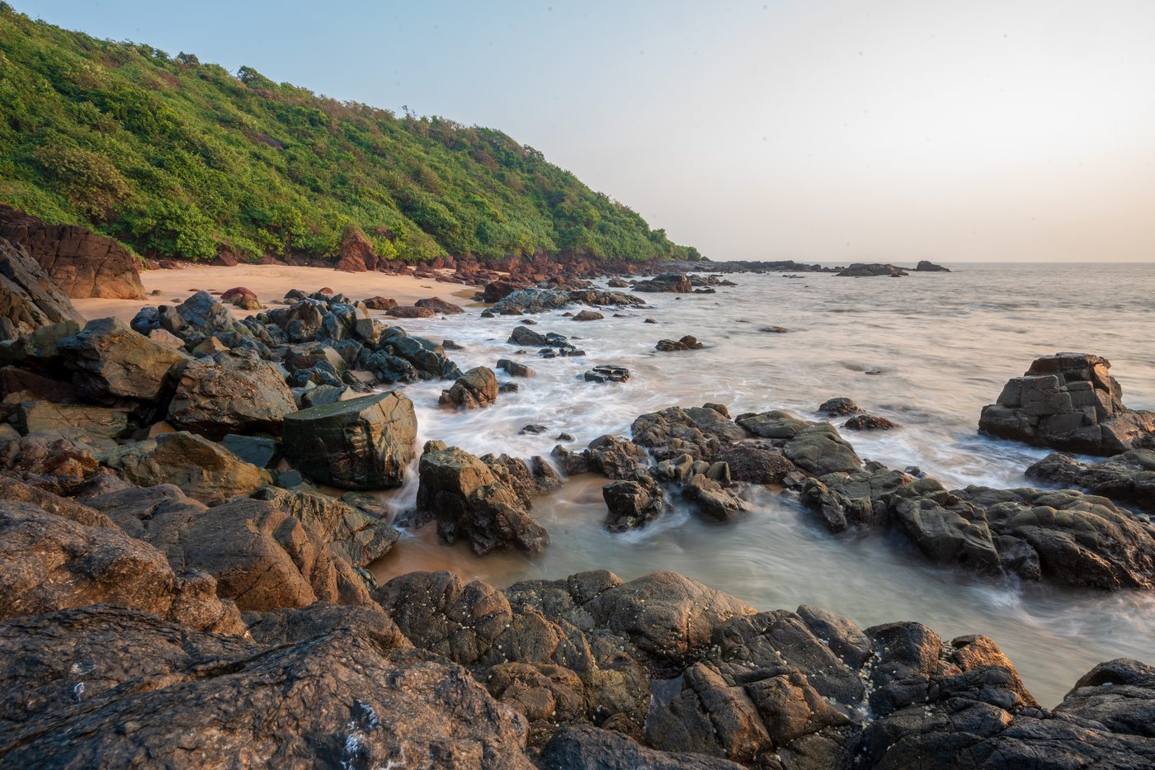
Heritage background — Cola Beach_DSC9401.jpg
No outfit reference template photos for this preset.

Male prompt — outfit slot
easy-going beach-day visitor in a soft sky-blue linen full-sleeve shirt with the sleeves loosely rolled up, fully buttoned, light sand-coloured cotton beach trousers, and a pair of simple rubber flip-flop beach slippers — modest, fully clothed, no shorts and no swimwear

Female prompt — outfit slot
easy-going beach-day visitor in an ankle-length flowy mint-green cotton maxi dress with three-quarter sleeves and a high modest neckline, a light sheer cotton scarf draped over the shoulders, and a pair of simple rubber flip-flop beach slippers — modest, fully covered, ankle-length skirt, no swimwear, no exposed shoulders or midriff

Resolved full prompt — Male
ABSOLUTE RULE — symbols of marital status. do NOT add any of the following to the person in the output UNLESS that exact symbol is clearly, visibly present on the person in the first reference photo:
• sindoor (red or orange vermilion powder in the hair parting)
• mangalsutra (black-bead and gold marriage necklace)
• kumkum at the parting or forehead
• bridal makeup, heavy nath / nose ring, or any other suhaag / saubhagya symbol
if the reference photo does not show these, the output must not show them — regardless of what the outfit description below suggests, regardless of the cultural setting, and regardless of what is "traditional" for the era or region. inventing these on a person who does not wear them (a child, an unmarried woman, a person of any age or background who simply does not use them) is a critical failure that causes religious and cultural offence. when in doubt, OMIT.
face-preservation rule: the face in the first reference photo must be preserved exactly in the output. same eyes, same nose, same mouth, same jawline, same skin tone, same age, same expression — every facial detail must be identical to the reference. do not beautify, smooth, slim, stylise, de-age, lighten or reshape the face in any way. if the face does not match the reference exactly, the image is wrong.
age-appropriateness rule: study the apparent age in the reference photo and adapt the outfit accordingly. if the reference shows a child, young girl or teenager, keep the attire age-appropriate — simpler, lighter jewellery; no nath / nose ring; no heavy bridal ornaments; no adult makeup; absolutely no sindoor, mangalsutra or kumkum. treat the outfit description below as a stylistic direction, not a literal checklist — drop any element that is not appropriate for the person's apparent age. a small plain decorative bindi is acceptable only if the person clearly appears to be an adult woman; otherwise omit it.
now create an image of this person standing in this secluded Goan cove at Cola Beach with shallow turquoise water lapping over weathered black-and-rust coastal rocks, a small strip of golden sand and a lush forested hillside rising behind, dressed like a easy-going beach-day visitor in a soft sky-blue linen full-sleeve shirt with the sleeves loosely rolled up, fully buttoned, light sand-coloured cotton beach trousers, and a pair of simple rubber flip-flop beach slippers — modest, fully clothed, no shorts and no swimwear. please adjust the lights and shadows so the person blends naturally into the scene. the image should look super realistic and natural.

Resolved full prompt — Female
ABSOLUTE RULE — symbols of marital status. do NOT add any of the following to the person in the output UNLESS that exact symbol is clearly, visibly present on the person in the first reference photo:
• sindoor (red or orange vermilion powder in the hair parting)
• mangalsutra (black-bead and gold marriage necklace)
• kumkum at the parting or forehead
• bridal makeup, heavy nath / nose ring, or any other suhaag / saubhagya symbol
if the reference photo does not show these, the output must not show them — regardless of what the outfit description below suggests, regardless of the cultural setting, and regardless of what is "traditional" for the era or region. inventing these on a person who does not wear them (a child, an unmarried woman, a person of any age or background who simply does not use them) is a critical failure that causes religious and cultural offence. when in doubt, OMIT.
face-preservation rule: the face in the first reference photo must be preserved exactly in the output. same eyes, same nose, same mouth, same jawline, same skin tone, same age, same expression — every facial detail must be identical to the reference. do not beautify, smooth, slim, stylise, de-age, lighten or reshape the face in any way. if the face does not match the reference exactly, the image is wrong.
age-appropriateness rule: study the apparent age in the reference photo and adapt the outfit accordingly. if the reference shows a child, young girl or teenager, keep the attire age-appropriate — simpler, lighter jewellery; no nath / nose ring; no heavy bridal ornaments; no adult makeup; absolutely no sindoor, mangalsutra or kumkum. treat the outfit description below as a stylistic direction, not a literal checklist — drop any element that is not appropriate for the person's apparent age. a small plain decorative bindi is acceptable only if the person clearly appears to be an adult woman; otherwise omit it.
now create an image of this person standing in this secluded Goan cove at Cola Beach with shallow turquoise water lapping over weathered black-and-rust coastal rocks, a small strip of golden sand and a lush forested hillside rising behind, dressed like a easy-going beach-day visitor in an ankle-length flowy mint-green cotton maxi dress with three-quarter sleeves and a high modest neckline, a light sheer cotton scarf draped over the shoulders, and a pair of simple rubber flip-flop beach slippers — modest, fully covered, ankle-length skirt, no swimwear, no exposed shoulders or midriff. please adjust the lights and shadows so the person blends naturally into the scene. the image should look super realistic and natural.

Preset 16 · Goa — Salim Ali Bird Sanctuary
Chorão Island's serene mangrove wetland
Background file | Dr. Salim Ali Bird Sanctuary_DSC8234.jpg
Setting (prompt slot) | peaceful mangrove forest and tidal creek at the Dr. Salim Ali Bird Sanctuary on Chorão Island, Goa, with arching mangrove branches, a leafy green canopy and still water reflecting the trees
Gender availability | Male & Female
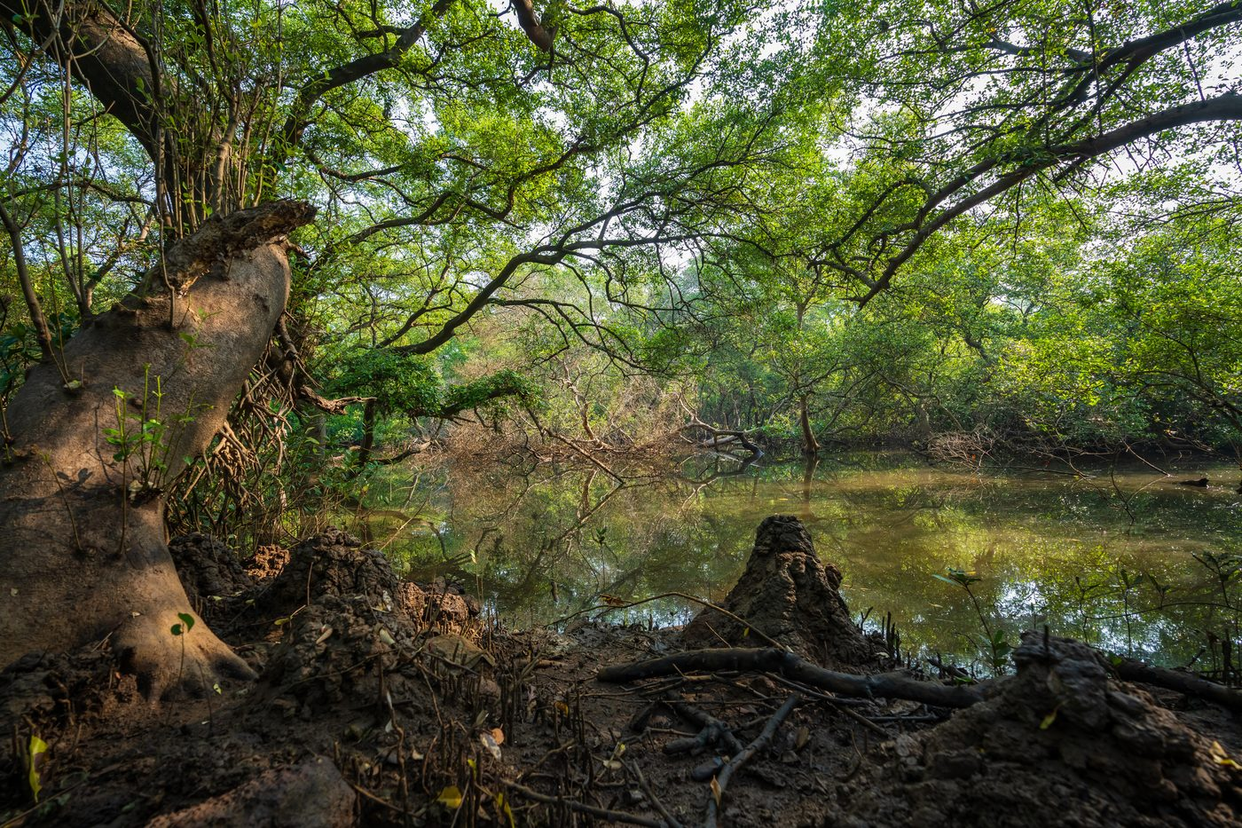
Heritage background — Dr. Salim Ali Bird Sanctuary_DSC8234.jpg
No outfit reference template photos for this preset.

Male prompt — outfit slot
modern Goan-day birdwatcher in a clean light-olive long-sleeve cotton shirt with a chest pocket, comfortable beige cotton trousers, lightweight canvas walking shoes and a pair of binoculars hanging around the neck — neat, modest, fully clothed smart-casual

Female prompt — outfit slot
modern Goan-day birdwatcher in a clean ivory long-sleeve cotton shirt with a chest pocket, comfortable beige cotton trousers, lightweight canvas walking shoes and a pair of binoculars hanging around the neck — neat, modest, fully clothed smart-casual

Resolved full prompt — Male
ABSOLUTE RULE — symbols of marital status. do NOT add any of the following to the person in the output UNLESS that exact symbol is clearly, visibly present on the person in the first reference photo:
• sindoor (red or orange vermilion powder in the hair parting)
• mangalsutra (black-bead and gold marriage necklace)
• kumkum at the parting or forehead
• bridal makeup, heavy nath / nose ring, or any other suhaag / saubhagya symbol
if the reference photo does not show these, the output must not show them — regardless of what the outfit description below suggests, regardless of the cultural setting, and regardless of what is "traditional" for the era or region. inventing these on a person who does not wear them (a child, an unmarried woman, a person of any age or background who simply does not use them) is a critical failure that causes religious and cultural offence. when in doubt, OMIT.
face-preservation rule: the face in the first reference photo must be preserved exactly in the output. same eyes, same nose, same mouth, same jawline, same skin tone, same age, same expression — every facial detail must be identical to the reference. do not beautify, smooth, slim, stylise, de-age, lighten or reshape the face in any way. if the face does not match the reference exactly, the image is wrong.
age-appropriateness rule: study the apparent age in the reference photo and adapt the outfit accordingly. if the reference shows a child, young girl or teenager, keep the attire age-appropriate — simpler, lighter jewellery; no nath / nose ring; no heavy bridal ornaments; no adult makeup; absolutely no sindoor, mangalsutra or kumkum. treat the outfit description below as a stylistic direction, not a literal checklist — drop any element that is not appropriate for the person's apparent age. a small plain decorative bindi is acceptable only if the person clearly appears to be an adult woman; otherwise omit it.
now create an image of this person standing in this peaceful mangrove forest and tidal creek at the Dr. Salim Ali Bird Sanctuary on Chorão Island, Goa, with arching mangrove branches, a leafy green canopy and still water reflecting the trees, dressed like a modern Goan-day birdwatcher in a clean light-olive long-sleeve cotton shirt with a chest pocket, comfortable beige cotton trousers, lightweight canvas walking shoes and a pair of binoculars hanging around the neck — neat, modest, fully clothed smart-casual. please adjust the lights and shadows so the person blends naturally into the scene. the image should look super realistic and natural.

Resolved full prompt — Female
ABSOLUTE RULE — symbols of marital status. do NOT add any of the following to the person in the output UNLESS that exact symbol is clearly, visibly present on the person in the first reference photo:
• sindoor (red or orange vermilion powder in the hair parting)
• mangalsutra (black-bead and gold marriage necklace)
• kumkum at the parting or forehead
• bridal makeup, heavy nath / nose ring, or any other suhaag / saubhagya symbol
if the reference photo does not show these, the output must not show them — regardless of what the outfit description below suggests, regardless of the cultural setting, and regardless of what is "traditional" for the era or region. inventing these on a person who does not wear them (a child, an unmarried woman, a person of any age or background who simply does not use them) is a critical failure that causes religious and cultural offence. when in doubt, OMIT.
face-preservation rule: the face in the first reference photo must be preserved exactly in the output. same eyes, same nose, same mouth, same jawline, same skin tone, same age, same expression — every facial detail must be identical to the reference. do not beautify, smooth, slim, stylise, de-age, lighten or reshape the face in any way. if the face does not match the reference exactly, the image is wrong.
age-appropriateness rule: study the apparent age in the reference photo and adapt the outfit accordingly. if the reference shows a child, young girl or teenager, keep the attire age-appropriate — simpler, lighter jewellery; no nath / nose ring; no heavy bridal ornaments; no adult makeup; absolutely no sindoor, mangalsutra or kumkum. treat the outfit description below as a stylistic direction, not a literal checklist — drop any element that is not appropriate for the person's apparent age. a small plain decorative bindi is acceptable only if the person clearly appears to be an adult woman; otherwise omit it.
now create an image of this person standing in this peaceful mangrove forest and tidal creek at the Dr. Salim Ali Bird Sanctuary on Chorão Island, Goa, with arching mangrove branches, a leafy green canopy and still water reflecting the trees, dressed like a modern Goan-day birdwatcher in a clean ivory long-sleeve cotton shirt with a chest pocket, comfortable beige cotton trousers, lightweight canvas walking shoes and a pair of binoculars hanging around the neck — neat, modest, fully clothed smart-casual. please adjust the lights and shadows so the person blends naturally into the scene. the image should look super realistic and natural.

Preset 17 · Gulmarg — St. Mary's Church
Heritage wooden church in a Kashmir alpine meadow
Background file | Gulmarg landscapes .jpg
Setting (prompt slot) | historic wooden Maharani St. Mary's Church set in a sunlit Gulmarg alpine meadow in Kashmir, with daisies and a tall conifer beside it
Gender availability | Male & Female
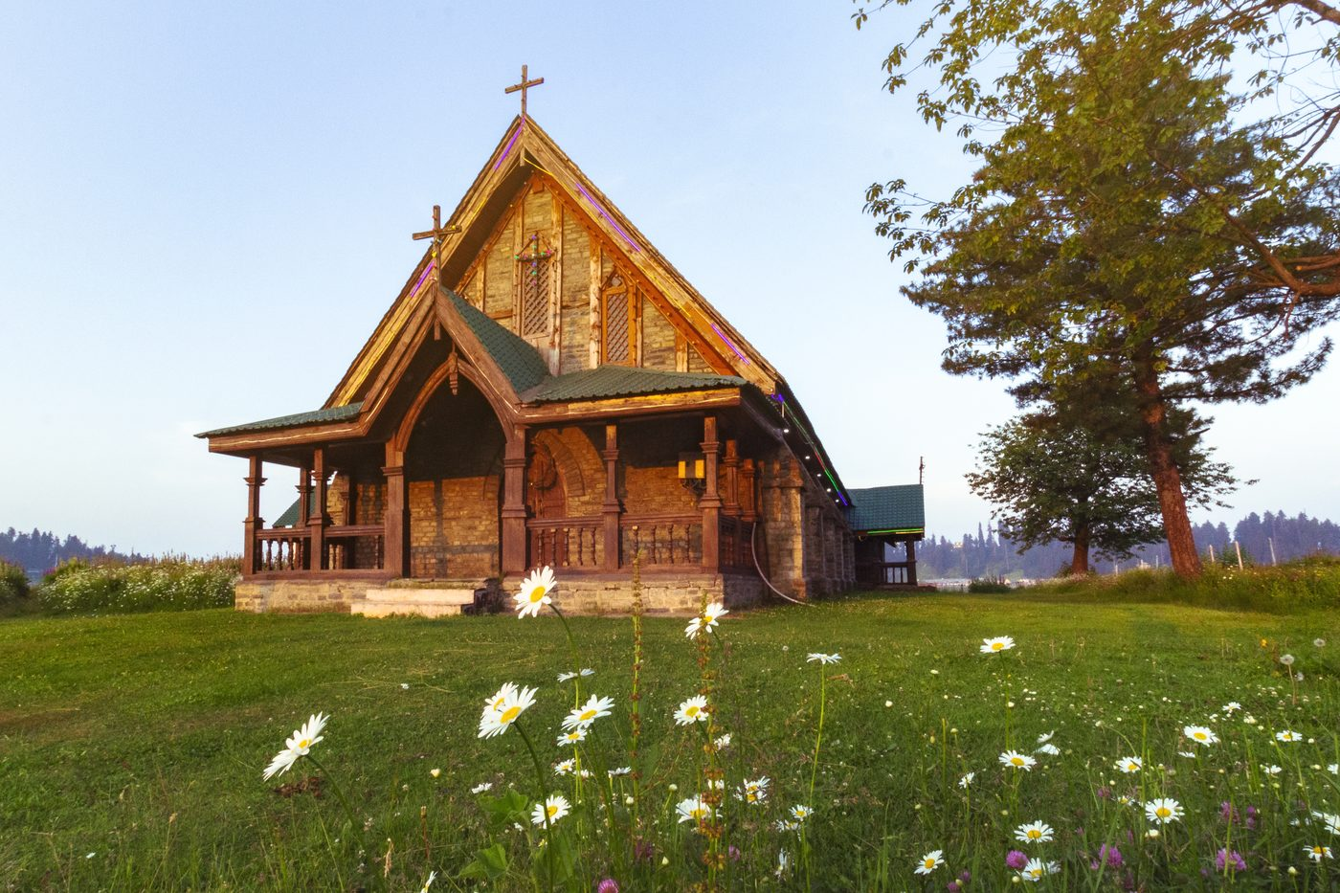
Heritage background — Gulmarg landscapes .jpg
No outfit reference template photos for this preset.

Male prompt — outfit slot
very well-dressed gentleman in a tailored charcoal-grey three-piece wool suit, a crisp white shirt, a deep-burgundy silk tie, a neatly folded white pocket square and polished black oxford shoes — formal, refined and fully covered

Female prompt — outfit slot
very well-dressed lady in an elegant tea-length midi dress in deep emerald with three-quarter sleeves and a modest high neckline, layered with a fitted camel wool overcoat, simple pearl earrings and refined low-heeled shoes — formal, graceful and fully covered

Resolved full prompt — Male
ABSOLUTE RULE — symbols of marital status. do NOT add any of the following to the person in the output UNLESS that exact symbol is clearly, visibly present on the person in the first reference photo:
• sindoor (red or orange vermilion powder in the hair parting)
• mangalsutra (black-bead and gold marriage necklace)
• kumkum at the parting or forehead
• bridal makeup, heavy nath / nose ring, or any other suhaag / saubhagya symbol
if the reference photo does not show these, the output must not show them — regardless of what the outfit description below suggests, regardless of the cultural setting, and regardless of what is "traditional" for the era or region. inventing these on a person who does not wear them (a child, an unmarried woman, a person of any age or background who simply does not use them) is a critical failure that causes religious and cultural offence. when in doubt, OMIT.
face-preservation rule: the face in the first reference photo must be preserved exactly in the output. same eyes, same nose, same mouth, same jawline, same skin tone, same age, same expression — every facial detail must be identical to the reference. do not beautify, smooth, slim, stylise, de-age, lighten or reshape the face in any way. if the face does not match the reference exactly, the image is wrong.
age-appropriateness rule: study the apparent age in the reference photo and adapt the outfit accordingly. if the reference shows a child, young girl or teenager, keep the attire age-appropriate — simpler, lighter jewellery; no nath / nose ring; no heavy bridal ornaments; no adult makeup; absolutely no sindoor, mangalsutra or kumkum. treat the outfit description below as a stylistic direction, not a literal checklist — drop any element that is not appropriate for the person's apparent age. a small plain decorative bindi is acceptable only if the person clearly appears to be an adult woman; otherwise omit it.
now create an image of this person standing in this historic wooden Maharani St. Mary's Church set in a sunlit Gulmarg alpine meadow in Kashmir, with daisies and a tall conifer beside it, dressed like a very well-dressed gentleman in a tailored charcoal-grey three-piece wool suit, a crisp white shirt, a deep-burgundy silk tie, a neatly folded white pocket square and polished black oxford shoes — formal, refined and fully covered. please adjust the lights and shadows so the person blends naturally into the scene. the image should look super realistic and natural.

Resolved full prompt — Female
ABSOLUTE RULE — symbols of marital status. do NOT add any of the following to the person in the output UNLESS that exact symbol is clearly, visibly present on the person in the first reference photo:
• sindoor (red or orange vermilion powder in the hair parting)
• mangalsutra (black-bead and gold marriage necklace)
• kumkum at the parting or forehead
• bridal makeup, heavy nath / nose ring, or any other suhaag / saubhagya symbol
if the reference photo does not show these, the output must not show them — regardless of what the outfit description below suggests, regardless of the cultural setting, and regardless of what is "traditional" for the era or region. inventing these on a person who does not wear them (a child, an unmarried woman, a person of any age or background who simply does not use them) is a critical failure that causes religious and cultural offence. when in doubt, OMIT.
face-preservation rule: the face in the first reference photo must be preserved exactly in the output. same eyes, same nose, same mouth, same jawline, same skin tone, same age, same expression — every facial detail must be identical to the reference. do not beautify, smooth, slim, stylise, de-age, lighten or reshape the face in any way. if the face does not match the reference exactly, the image is wrong.
age-appropriateness rule: study the apparent age in the reference photo and adapt the outfit accordingly. if the reference shows a child, young girl or teenager, keep the attire age-appropriate — simpler, lighter jewellery; no nath / nose ring; no heavy bridal ornaments; no adult makeup; absolutely no sindoor, mangalsutra or kumkum. treat the outfit description below as a stylistic direction, not a literal checklist — drop any element that is not appropriate for the person's apparent age. a small plain decorative bindi is acceptable only if the person clearly appears to be an adult woman; otherwise omit it.
now create an image of this person standing in this historic wooden Maharani St. Mary's Church set in a sunlit Gulmarg alpine meadow in Kashmir, with daisies and a tall conifer beside it, dressed like a very well-dressed lady in an elegant tea-length midi dress in deep emerald with three-quarter sleeves and a modest high neckline, layered with a fitted camel wool overcoat, simple pearl earrings and refined low-heeled shoes — formal, graceful and fully covered. please adjust the lights and shadows so the person blends naturally into the scene. the image should look super realistic and natural.

Preset 19 · Gulmarg — Daisy Field
Open pasture of daisies under Kashmir skies
Background file | Gulmarg landscapes 3.jpg
Setting (prompt slot) | open Gulmarg alpine pasture carpeted with white daisies under a clear blue sky, with a single tree on the horizon, Kashmir
Gender availability | Male & Female
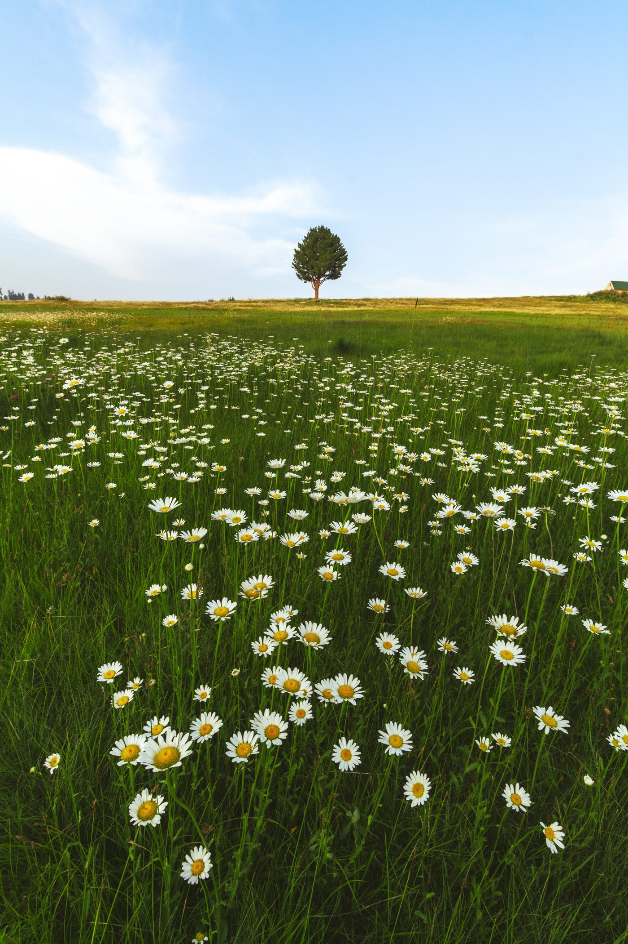
Heritage background — Gulmarg landscapes 3.jpg
No outfit reference template photos for this preset.

Male prompt — outfit slot
very well-dressed gentleman in a smart light-grey wool suit, a soft pastel-blue shirt, a navy silk tie and polished oxford shoes — formal, refined and fully covered

Female prompt — outfit slot
very well-dressed lady in an elegant pastel-blue midi dress with three-quarter sleeves and a modest high neckline, layered with a tailored ivory overcoat, simple pearl earrings and refined low-heeled shoes — formal, graceful and fully covered

Resolved full prompt — Male
ABSOLUTE RULE — symbols of marital status. do NOT add any of the following to the person in the output UNLESS that exact symbol is clearly, visibly present on the person in the first reference photo:
• sindoor (red or orange vermilion powder in the hair parting)
• mangalsutra (black-bead and gold marriage necklace)
• kumkum at the parting or forehead
• bridal makeup, heavy nath / nose ring, or any other suhaag / saubhagya symbol
if the reference photo does not show these, the output must not show them — regardless of what the outfit description below suggests, regardless of the cultural setting, and regardless of what is "traditional" for the era or region. inventing these on a person who does not wear them (a child, an unmarried woman, a person of any age or background who simply does not use them) is a critical failure that causes religious and cultural offence. when in doubt, OMIT.
face-preservation rule: the face in the first reference photo must be preserved exactly in the output. same eyes, same nose, same mouth, same jawline, same skin tone, same age, same expression — every facial detail must be identical to the reference. do not beautify, smooth, slim, stylise, de-age, lighten or reshape the face in any way. if the face does not match the reference exactly, the image is wrong.
age-appropriateness rule: study the apparent age in the reference photo and adapt the outfit accordingly. if the reference shows a child, young girl or teenager, keep the attire age-appropriate — simpler, lighter jewellery; no nath / nose ring; no heavy bridal ornaments; no adult makeup; absolutely no sindoor, mangalsutra or kumkum. treat the outfit description below as a stylistic direction, not a literal checklist — drop any element that is not appropriate for the person's apparent age. a small plain decorative bindi is acceptable only if the person clearly appears to be an adult woman; otherwise omit it.
now create an image of this person standing in this open Gulmarg alpine pasture carpeted with white daisies under a clear blue sky, with a single tree on the horizon, Kashmir, dressed like a very well-dressed gentleman in a smart light-grey wool suit, a soft pastel-blue shirt, a navy silk tie and polished oxford shoes — formal, refined and fully covered. please adjust the lights and shadows so the person blends naturally into the scene. the image should look super realistic and natural.

Resolved full prompt — Female
ABSOLUTE RULE — symbols of marital status. do NOT add any of the following to the person in the output UNLESS that exact symbol is clearly, visibly present on the person in the first reference photo:
• sindoor (red or orange vermilion powder in the hair parting)
• mangalsutra (black-bead and gold marriage necklace)
• kumkum at the parting or forehead
• bridal makeup, heavy nath / nose ring, or any other suhaag / saubhagya symbol
if the reference photo does not show these, the output must not show them — regardless of what the outfit description below suggests, regardless of the cultural setting, and regardless of what is "traditional" for the era or region. inventing these on a person who does not wear them (a child, an unmarried woman, a person of any age or background who simply does not use them) is a critical failure that causes religious and cultural offence. when in doubt, OMIT.
face-preservation rule: the face in the first reference photo must be preserved exactly in the output. same eyes, same nose, same mouth, same jawline, same skin tone, same age, same expression — every facial detail must be identical to the reference. do not beautify, smooth, slim, stylise, de-age, lighten or reshape the face in any way. if the face does not match the reference exactly, the image is wrong.
age-appropriateness rule: study the apparent age in the reference photo and adapt the outfit accordingly. if the reference shows a child, young girl or teenager, keep the attire age-appropriate — simpler, lighter jewellery; no nath / nose ring; no heavy bridal ornaments; no adult makeup; absolutely no sindoor, mangalsutra or kumkum. treat the outfit description below as a stylistic direction, not a literal checklist — drop any element that is not appropriate for the person's apparent age. a small plain decorative bindi is acceptable only if the person clearly appears to be an adult woman; otherwise omit it.
now create an image of this person standing in this open Gulmarg alpine pasture carpeted with white daisies under a clear blue sky, with a single tree on the horizon, Kashmir, dressed like a very well-dressed lady in an elegant pastel-blue midi dress with three-quarter sleeves and a modest high neckline, layered with a tailored ivory overcoat, simple pearl earrings and refined low-heeled shoes — formal, graceful and fully covered. please adjust the lights and shadows so the person blends naturally into the scene. the image should look super realistic and natural.

7. Inactive & unreferenced assets

Backgrounds present but not wired into the current preset list
These files sit in assets/backgrounds/ but no entry in PRESETS references them. They may be drafts, retired destinations, or staged for a future release.
Chattri Monuments 1.jpg
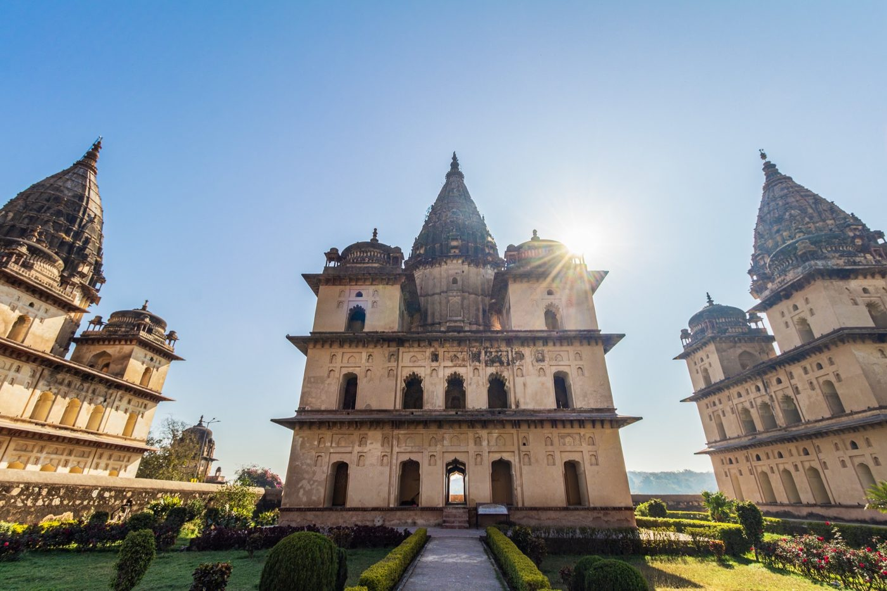
Chattri Monuments 1.jpg
Chattri Monuments 4.jpg
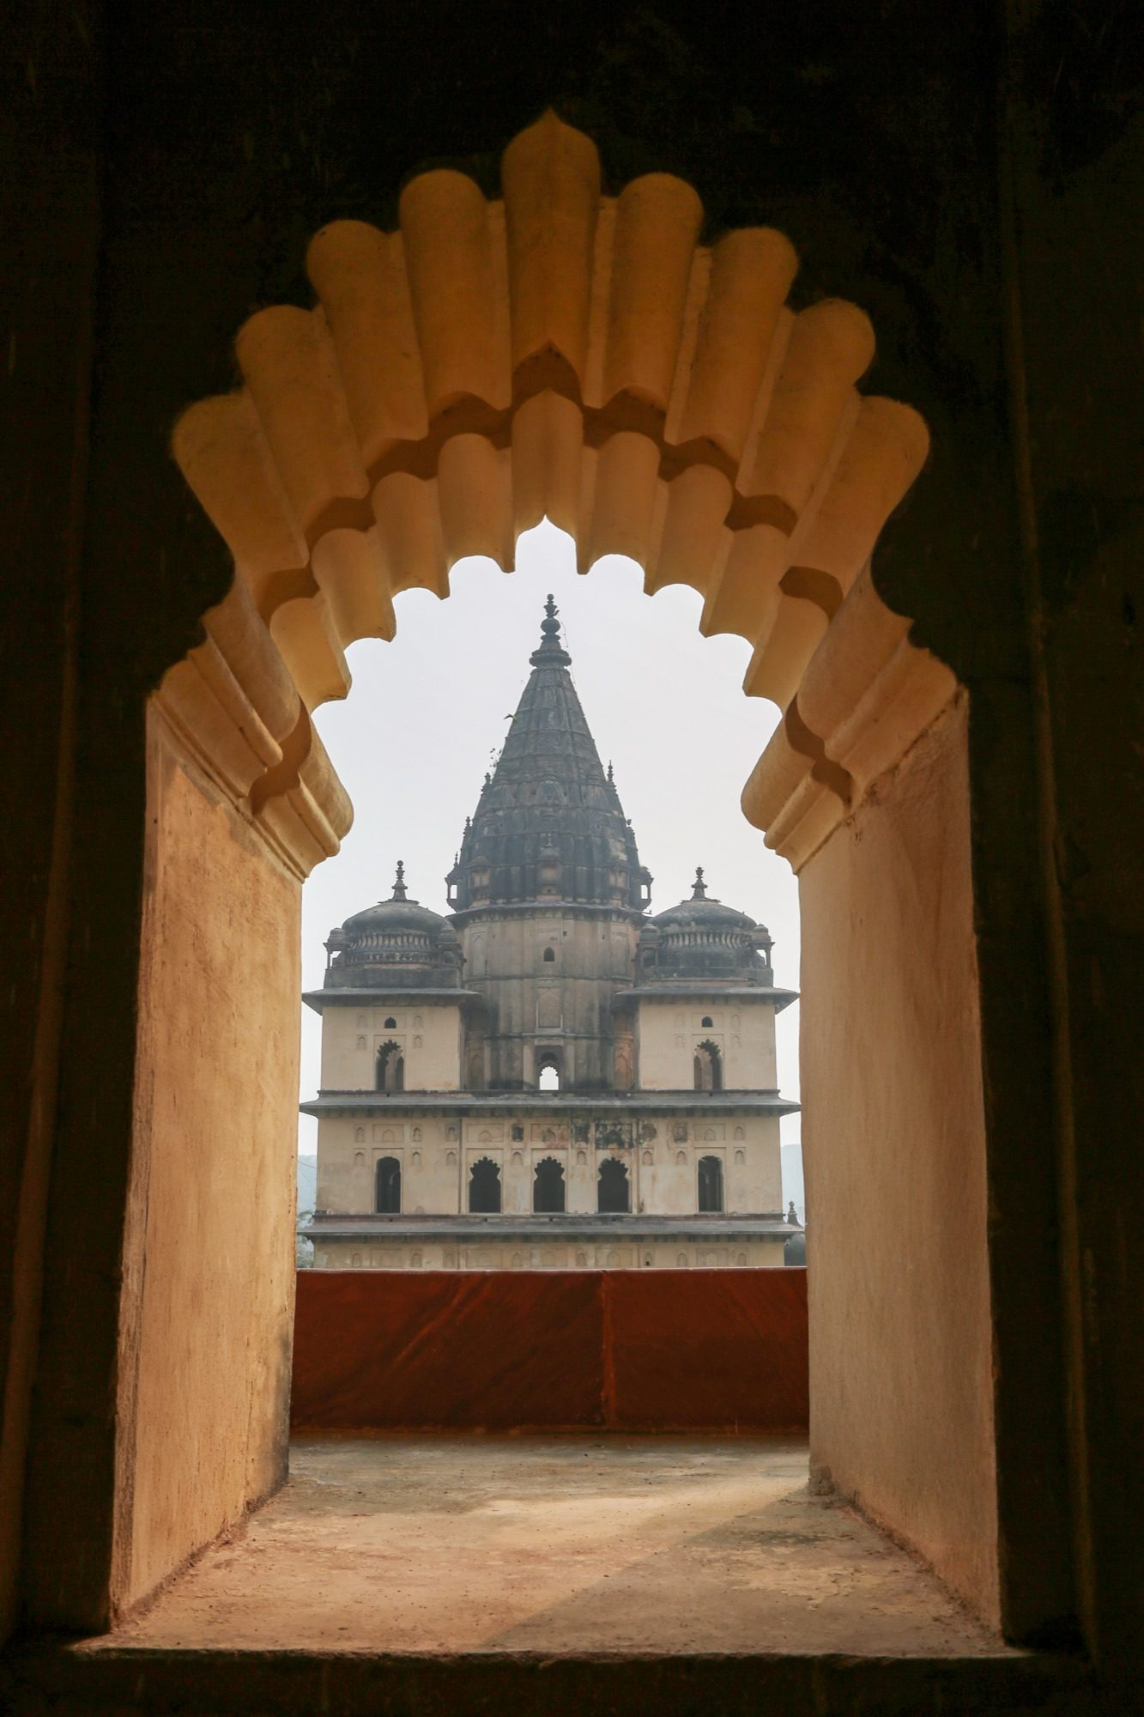
Chattri Monuments 4.jpg
Mandu’s Watchful Gates.jpg
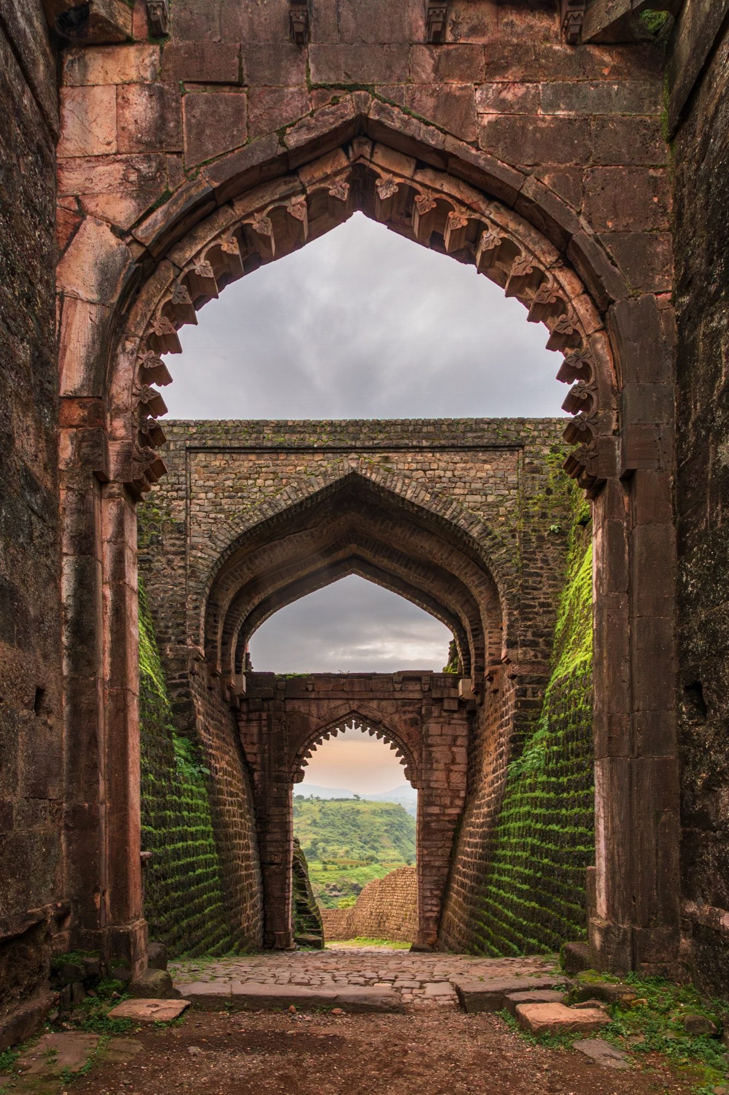
Mandu’s Watchful Gates.jpg

Outfit reference templates without a matching active preset
These outfit references exist in assets/templates/ but their preset id is not in the active PRESETS map (likely retired destinations such as Royal Palace, Taj Mahal, Mysore, Hawa Mahal listed in the earlier README).
Orphan id 5
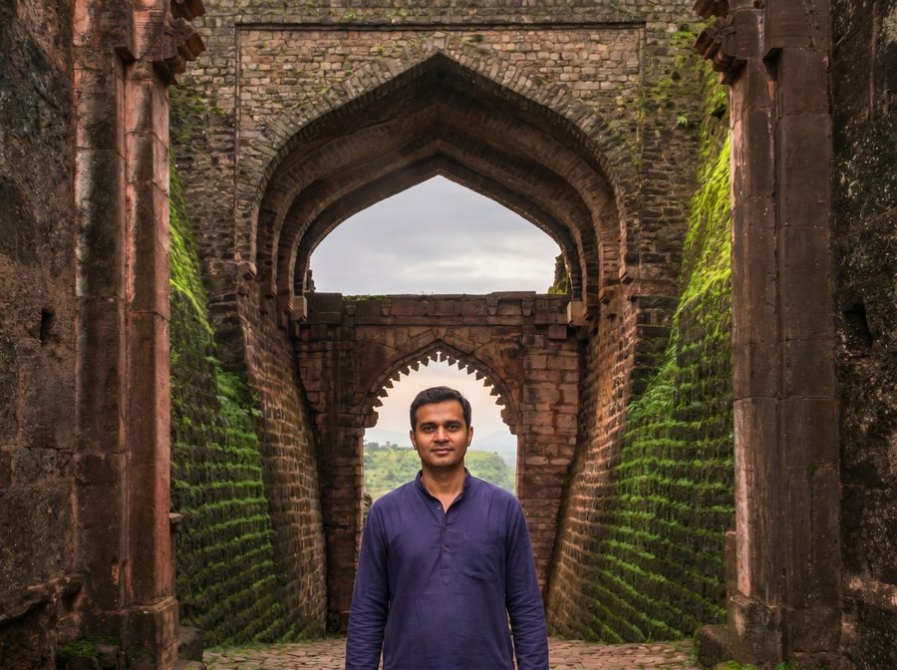 | 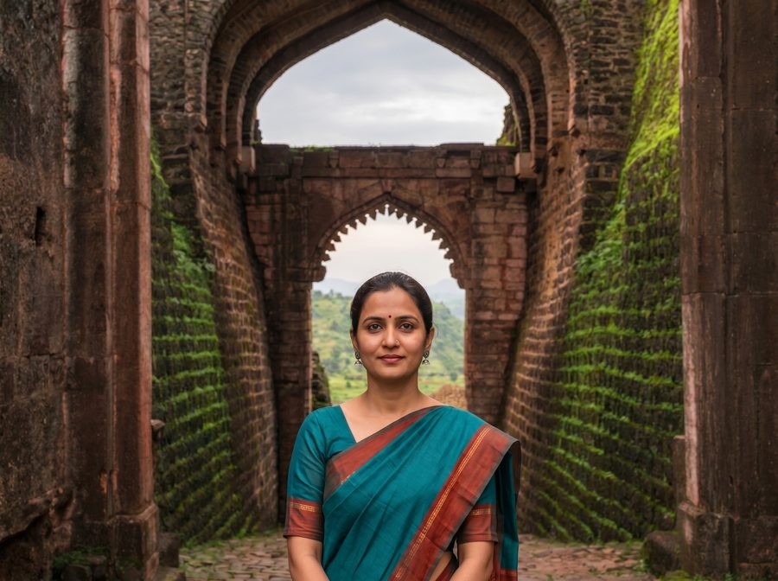
5-male.jpg | 5-female.jpg
Orphan id 7
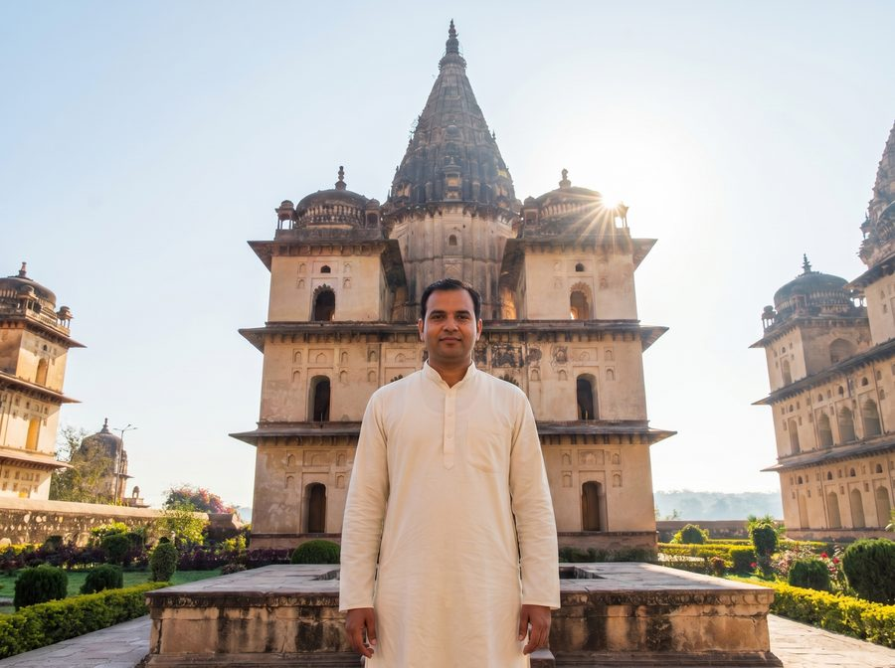 | 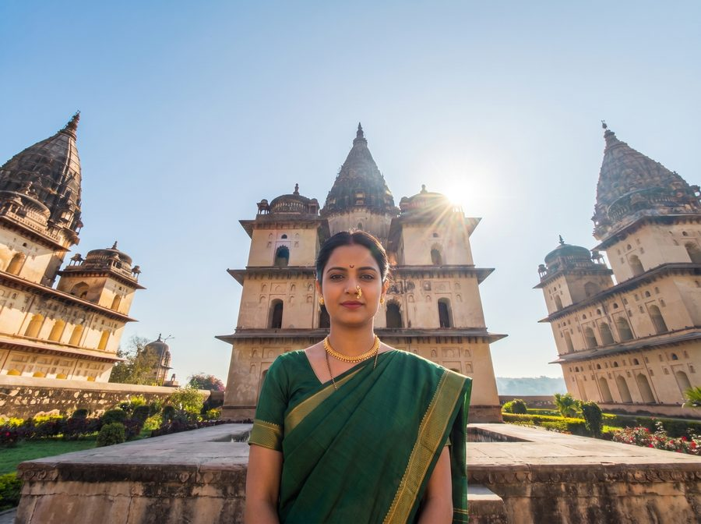
7-male.jpg | 7-female.jpg
Orphan id 8
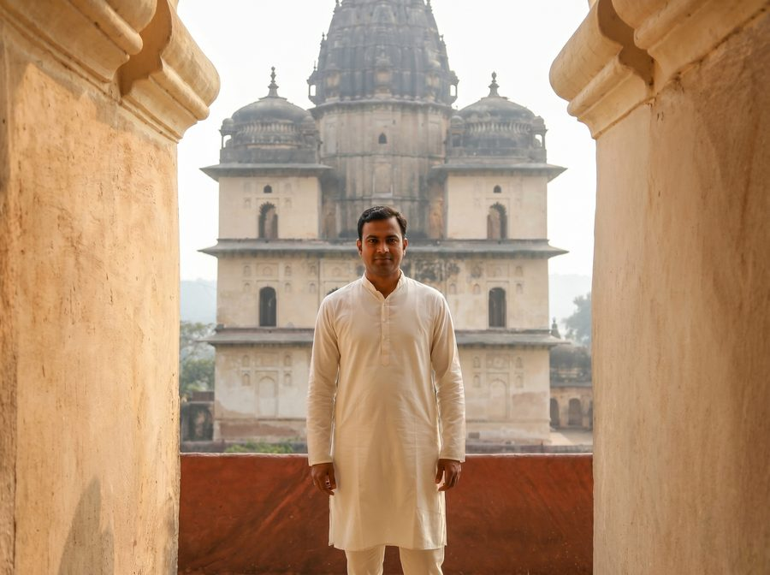 | 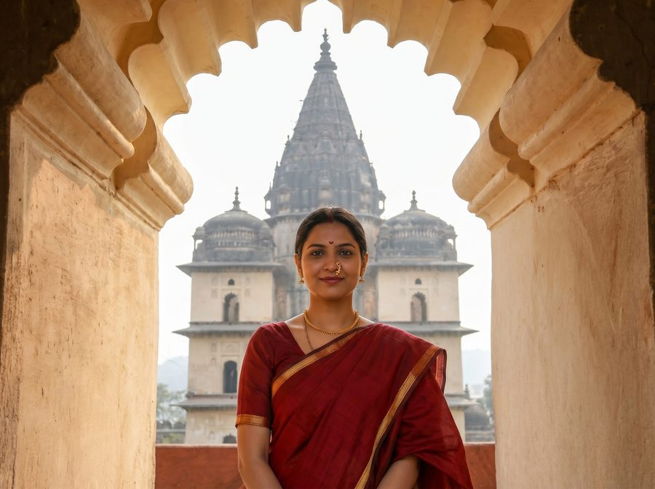
8-male.jpg | 8-female.jpg

8. All active heritage backgrounds — gallery
Every background image referenced by the active preset list, in preset order.

1 · Khajuraho — Kandariya Mahadev — Jagdambi Temple , Kandariya Mahadev Temple.jpg

2 · Khajuraho — Lakshmana Temple — Lakshmana Temple IMG_9753-HDR.jpg

3 · Orchha — Jahangir Mahal — Jahangir Mahal 6 - Copy.jpg

4 · Orchha — Jahangir Gate — jahangir gate orchha.jpg

6 · Maheshwar — Chhatri by the River — Chattei River view (7).jpg

9 · Krishnabai Holkar Chhatri — Krishnabai holkar chhatri .jpg

10 · Indore — Rajwada Palace — Rajwada Indore.jpg

11 · Indore — Rajwada Courtyard — RajWada 15.jpg

12 · Kheoni Sanctuary — Wilds of MP — kheoni wildlife sanctuary .jpg

13 · Kheoni Sanctuary — Forest Trail — kheoni wildlife sanctuary 1.jpg

14 · Goa — Cabo de Rama Beach — Cabo de Rama Beach_DSC9670.jpg

15 · Goa — Cola Beach — Cola Beach_DSC9401.jpg

16 · Goa — Salim Ali Bird Sanctuary — Dr. Salim Ali Bird Sanctuary_DSC8234.jpg

17 · Gulmarg — St. Mary's Church — Gulmarg landscapes .jpg

19 · Gulmarg — Daisy Field — Gulmarg landscapes 3.jpg

9. All outfit reference photos — gallery
Designer reference photos used to author the per-preset outfit prompts. They live in assets/templates/ as {presetId}-{male|female}.jpg. They are NOT sent to Gemini — only the user's webcam capture and the heritage background are.

Preset 1 — Khajuraho — Kandariya Mahadev
 | 
1-male.jpg | 1-female.jpg

Preset 2 — Khajuraho — Lakshmana Temple
 | 
2-male.jpg | 2-female.jpg

Preset 3 — Orchha — Jahangir Mahal
 | 
3-male.jpg | 3-female.jpg

Preset 4 — Orchha — Jahangir Gate
 | 
4-male.jpg | 4-female.jpg

Preset 6 — Maheshwar — Chhatri by the River
 | 
6-male.jpg | 6-female.jpg

Preset 9 — Krishnabai Holkar Chhatri
 | 
9-male.jpg | 9-female.jpg

Preset 10 — Indore — Rajwada Palace
 | 
10-male.jpg | 10-female.jpg

Preset 11 — Indore — Rajwada Courtyard
 | 
11-male.jpg | 11-female.jpg

Preset 12 — Kheoni Sanctuary — Wilds of MP
 | 
12-male.jpg | 12-female.jpg

Preset 13 — Kheoni Sanctuary — Forest Trail
 | 
13-male.jpg | 13-female.jpg

10. API endpoints

POST /api/generate — primary generation
Method | POST
Body | multipart/form-data
Fields | userImage (file, ≤30 MB), presetId (string), gender ('male'|'female')
Model | gemini-3-pro-image-preview
Output | { success, generatedImage: <base64>, mimeType }
Failure modes | 400 missing fields · 400 unknown presetId · 500 generation failure
Mock mode | If GEMINI_API_KEY is unset, returns the user photo back with a note.
Vercel max duration | 60 s

POST /api/faceswap — optional InstantID identity lock
Not currently wired into the active client flow. Available as a follow-on step when the Gemini output drifts on identity. Takes the user's webcam photo as sourceImage and the Gemini scene as targetImage, runs zsxkib/instant-id on Replicate with strong IdentityNet + IP-Adapter and depth ControlNet to preserve scene framing while regenerating the person with the user's exact face.
Method | POST
Body | multipart/form-data
Fields | sourceImage (face), targetImage (scene), prompt (optional)
Model | zsxkib/instant-id (SDXL + IdentityNet + IP-Adapter + depth ControlNet)
controlnet_conditioning_scale | 0.9 — strong identity match
ip_adapter_scale | 0.85 — preserve fine facial features
pose_strength | 0.5 — preserve head/body pose from Gemini scene
depth_strength | 0.55 — preserve scene framing
num_inference_steps | 30
Mock mode | If REPLICATE_API_TOKEN is unset, returns the scene unchanged.

InstantID prompt (default if none provided)
a photorealistic portrait photograph of a person at a heritage location, natural lighting, sharp focus, authentic cultural attire, medium shot from the waist up

InstantID negative prompt
cartoon, anime, painting, illustration, 3d render, plastic skin, over-smoothed, blurry face, distorted face, extra limbs, deformed, low quality, watermark, text, signature

GET /api/health — config probe
// api/health.js
module.exports = async function handler(req, res) {
const geminiConfigured = !!process.env.GEMINI_API_KEY;
const replicateConfigured = !!process.env.REPLICATE_API_TOKEN;
res.json({
status: "ok",
apiKeyConfigured: geminiConfigured && replicateConfigured,
geminiConfigured,
replicateConfigured,
});
};

11. Frontend — app.js notes

State machine
const state = {
step: 1, // 1 capture · 2 destination · 3 reveal
stream: null, // active MediaStream
capturedBlob: null, // JPEG blob from canvas
capturedUrl: null, // object URL for preview
selectedPreset: null, // chosen preset object
selectedGender: null, // 'male' | 'female'
cameraDevices: [],
};

Capture pipeline
Camera ideal resolution is 1920×1080. On capture the canvas is mirrored to match the live preview (users expect the saved shot to look like what they saw). Output is JPEG at 0.95 quality. Before generation the blob is recompressed to max 2048 px wide to keep the multipart body small.

Gender-restricted destinations
Each preset can carry a 'genders' allowlist (e.g. ['male']). visiblePresets() filters the grid based on the current gender selection. If the user changes gender after picking a destination that is no longer available, the selection is cleared.

Loading hints
const LOADING_HINTS = [
'Setting the scene…',
'Tailoring your outfit…',
'Matching light and shadows…',
'Adding the final touches…',
'Almost there…',
];

WhatsApp share — mobile vs desktop
On mobile, navigator.share with a File array opens the native share sheet (WhatsApp picks up the image directly). On desktop, wa.me URLs can't carry image payloads — so the app triggers a download and opens WhatsApp Web with a prefilled caption text, prompting the user to attach the just-downloaded photo manually.

12. Deployment
Production is hosted on Vercel. Local dev uses `npm start` against server.js (legacy Nano-Banana flow).

vercel.json
{
"functions": {
"api/generate.js": { "maxDuration": 60 },
"api/faceswap.js": { "maxDuration": 60 }
}
}

Environment variables
GEMINI_API_KEY | Google Gemini API key — required for real generation. If absent, /api/generate runs in mock mode and returns the user's photo back.
REPLICATE_API_TOKEN | Replicate API token — only needed if you wire /api/faceswap into the flow.
PORT (local only) | Defaults to 3000 for server.js dev.

Vercel function notes (multipart quirk)
Vercel's Node runtime pre-buffers the multipart body into req.body as a Buffer. Multer expects a stream, so when the body is already drained the handler reconstructs a Readable mimicking IncomingMessage. Without this, multer throws "Unexpected end of form". Both /api/generate and /api/faceswap also export `config = { api: { bodyParser: false } }` so the runtime hands multer the raw stream.

Appendix A — Legacy README presets (retired)
The original README and QUICKSTART listed an earlier set of 8 generic 'royal Indian monument' presets. They are NOT in the current PRESETS map and have been retired in favour of the Madhya Pradesh / Goa / Kashmir set above. Listed here for reference.
Royal Palace | Majestic palace with royal attire
Taj Mahal | Iconic monument backdrop
Jaipur Fort | Rajasthani grandeur
Gateway of India | Mumbai landmark
Mysore Palace | South Indian royalty
Red Fort | Historic Delhi monument
Hawa Mahal | Palace of Winds
Amber Fort | Hilltop fortress

