Setup

Requirements
- 8-channel audio system. The speaker layout is as specified below, but can be changed in config.scd in the “channelMaps” entry. Speakers are labeled 0 through 7.
FRONT
0 4 1
2 3
6 5 7
BACK
- Webcam and tripod.
- LaunchPad X Controller.
- Two performers.

Installing the Software
This piece requires Max, SuperCollider and
- Install SuperCollider version 3.14 or greater from https://supercollider.github.io/
- Install Max/MSP version 9 from https://cycling74.com/downloads.
- Download the patch from https://github.com/tellmewyatt/horse/. To download, click the green “Code” button, then “Download Zip”. Extract the zip contents somewhere in your file system.

Performance Setup

Starting and Playing the Piece
- After plugging the LaunchPad X in, set it to “Programming Mode” by holding the “Session Button” and then pressing the orange “Scene Launch” button. Tap the Session button again until the LaunchPad is blank.
- Open “live-visuals.maxpat” in Max. Click the “On/Off” toggle.
- Open “horse.scd” in SuperCollider. Click anywhere in the code region and hit CMD+Enter. In a few moments you should see the LaunchPad’s pads light up. You should also see video appear on the Max jit.world window. Tap pad 11 to verify sound.
- Maximize the jit.world window. You are now ready to play the piece.

Pad Mapping
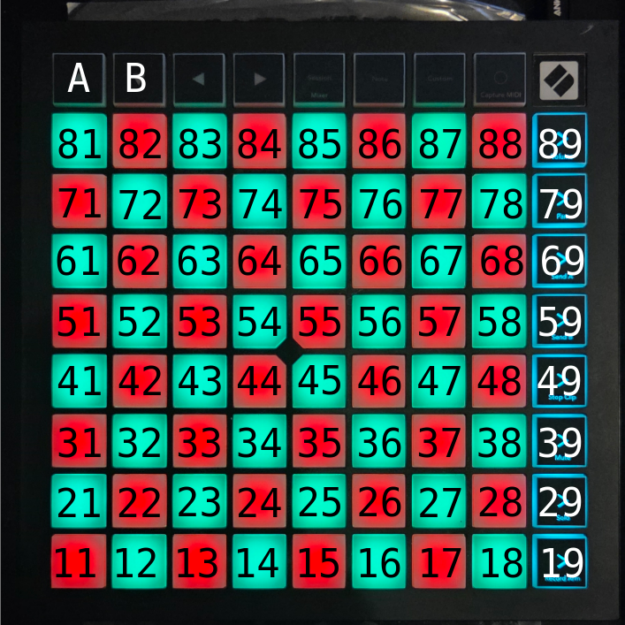
Each sound is a one-off and velocity controlled unless otherwise stated. A sound marked “sustained” requires the performer to hold the pad down until cutoff. A sound marked “triggered” will be sustained until tapped again. Triggered pads are marked purple. Switching between the A and B maps is accomplished by tapping on the pads marked “A” and “B” in the figure.

Map A
Column 1:
- 81, 71, 61, 51: Vocoded “What am I?”
- 41: Horse Gallops
- 31: Horse Neighs
- 21: “Snare” drum
- 11: Bass drum
Column 2: Bright, flute-like sound
Column 3: Vocoded horse neighs
Column 4:
- 84 and 74: Noisy fall
- 64: Distorted Neighs (sustained)
- 54: Distorted Gallops (sustained)
- 44, 34, 24, and 14: Distorted “What am I?” (sustained)
Column 5: Distorted sine wave. The amount of distortion varies with the number of toggled pads in this column.

Map B
Columns 1 – 3, 6 – 8: Bells (toggled)
Columns 4 and 5: Noisy fall, enables a row
Column 9: Stops column 5 from Map A and replaces it with a new vocal sample. After this, toggles this sound.

Performance Notes
This piece is composed of two movements, with the first movement consisting of the A map and the second movement consisting of the B map. The first movement is for solo performer while the second movement is for two. To perform this way, the performers sit across from one another, splitting the LaunchPad over its x-axis. In other words, the first performer will have pads 11, 21, 31, etc. closest to them, while the second performer will have pads 19, 29, 39, etc. closest to them.
To transition between movements, the first player builds up a line of toggled buttons in column 5 and then presses the “B” map change button. At this point the second performer, who was previously offstage walks on stage, and looks at the first performer for a second before pressing 89 and 88 simultaneously. The two performers then take turns toggling the bells closest to them on, with the second performer toggling both columns 8 and 9.
Once this is done, the performers simultaneously press a pad in columns 4 and 5 to enable playing in that row. They gradually continue until all rows are unlocked. At this point they can hit the pads with an open palm. The performers slow down and reduce energy. This should result in a random dispersion of toggled and untoggled bell pads. Then, the second player presses a pad in column 9 while simultaneously toggling on another bell pad in that column. The first player toggles on one of their bell pads in turn. If all the pads in the row are already toggled, the performer can untoggle and retoggle one. Once this row’s bell pads have all been toggled on, the performers move to another row and repeat this process. The piece ends with the performers toggling off the final column 9 pad and pads 14 and 15. The performers play on pads 11 and 18 slowly as the remaining sounds fade away.

