ToF-SIMS Hyperspectral Analysis of Fossil Fly: Findings Report
Notebooks 02a & 02b - Data Overview, PCA, NMF & UMAP
Generated: 2026-07-27

1. Executive Summary
This report presents the quantitative findings from the analysis of a ToF-SIMS hyperspectral dataset acquired from a fossilised fly specimen. The dataset comprises 7 images across negative and positive ionisation modes, with 5 distinct mass channels in negative mode (m/z 62.96–123.95) and 1 mass channel in positive mode (m/z 53.94). Dimensionality reduction via PCA, NMF, and UMAP reveals three chemically distinct domains within the fossil, including a phosphate-rich endmember indicative of phosphatized tissue preservation.
Key quantitative results:
- Dataset: 7 images (5 negative-mode at 400 shots/pixel; 2 positive-mode at 100 shots/pixel)
- Spatial resolution: 640×640 pixels (~15.6 µm/pixel for 10×10 mm scan)
- Foreground coverage: 48,294 pixels (11.8%) against 88.2% background sparsity
- PCA: First 3 principal components capture 80.4% of total chemical variance
- NMF: 3 endmembers extracted; Endmember 2 corresponds to PO₂⁻/PO₃⁻ (phosphate) hotspots
- UMAP: Non-linear clustering confirms NMF endmembers are robust, not mathematical artefacts
- Strongest chemical co-localization: m/z 96.94 ↔ m/z 103.91 (Pearson r = 0.84)

2. Dataset Overview (Notebook 02a)

2.1 Acquisition Parameters
The dataset was acquired using a C₆₀ primary ion beam at 30 pA. Negative-mode images were collected at 400 shots/pixel across 5 mass channels. Positive-mode images were collected at 100 shots/pixel for m/z 53.94 across two field-of-view settings: a localised C₆₀ spot (10×14 mm, 896×640 pixels) and a full-fossil scan (8×11.2 mm, 896×640 pixels).
Direct signal-to-noise comparison between 400-shot and 100-shot acquisitions is invalid because the modes target different ions with different ionisation efficiencies. Therefore, acquisition parameters are reported separately by mode.
Parameter | Negative Mode | Positive Mode
Images | 5 | 2
Shots per pixel | 400 | 100
Mass channels | 5 (m/z 62.96, 78.95, 96.94, 103.91, 123.95) | 1 (m/z 53.94)
Polarity | Negative | Positive
Pixel grid | 640 × 640 | 896 × 640
Scan size | 10 × 10 mm | 10 × 14 mm (spot) / 8 × 11.2 mm (full)
Mean intensity | 56.13 ± 68.84 counts/pixel | 28.53 ± 0.00 counts/pixel
Max intensity | 8192 | 8192
Primary ion | C₆₀ (30 pA) | C₆₀ (30 pA)
Extractor voltage | −35 V | + (standard positive)

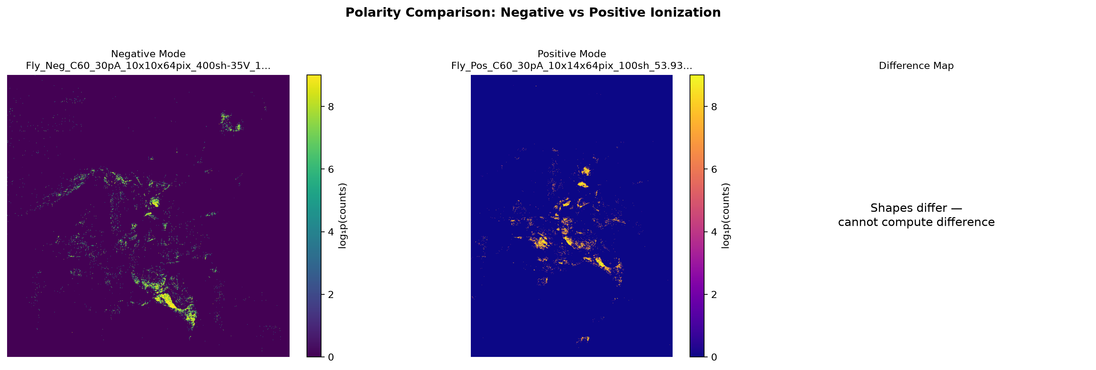
Figure: Negative-Mode Mean (5 masses, 400 shots) vs Positive-Mode Mean (m/z 53.94, 100 shots). The negative-mode image shows widespread signal across the fossil anatomy, while positive-mode signal is localised to high-intensity hotspots.

2.2 Chemical RGB Composite (Negative Mode)
A false-colour RGB composite was constructed from the negative-mode mass series. Red = low mass (m/z 62.96), Green = mid mass (m/z 96.94), Blue = high mass (m/z 123.95). The composite reveals spatial segregation of chemical domains: blue dominates the diffuse matrix, while red and green concentrate in distinct anatomical features. No polarity composite was possible because the positive-mode mass (m/z 53.94) does not overlap with any negative-mode mass.
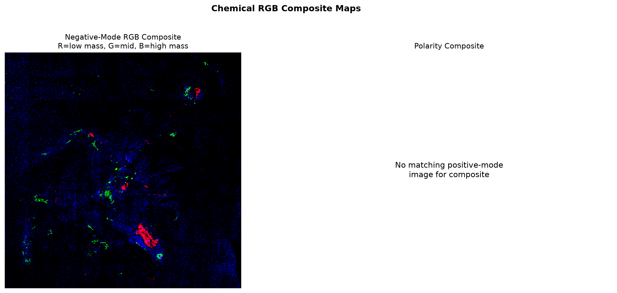
Figure: Negative-Mode RGB Composite. R = m/z 62.96, G = m/z 96.94, B = m/z 123.95. Spatial segregation confirms chemically distinct fossil domains.

2.3 Pixel-Wise Correlation Matrix
Pearson correlation was computed between all pairs of mass-channel images on a pixel-by-pixel basis. The mean inter-image correlation is low (r = 0.126), indicating that the 5 mass channels carry largely independent chemical information. However, one pair shows strong co-localization: m/z 96.94 and m/z 103.91 are correlated at r = 0.84, suggesting these fragments originate from the same chemical family or co-preserved tissue type.
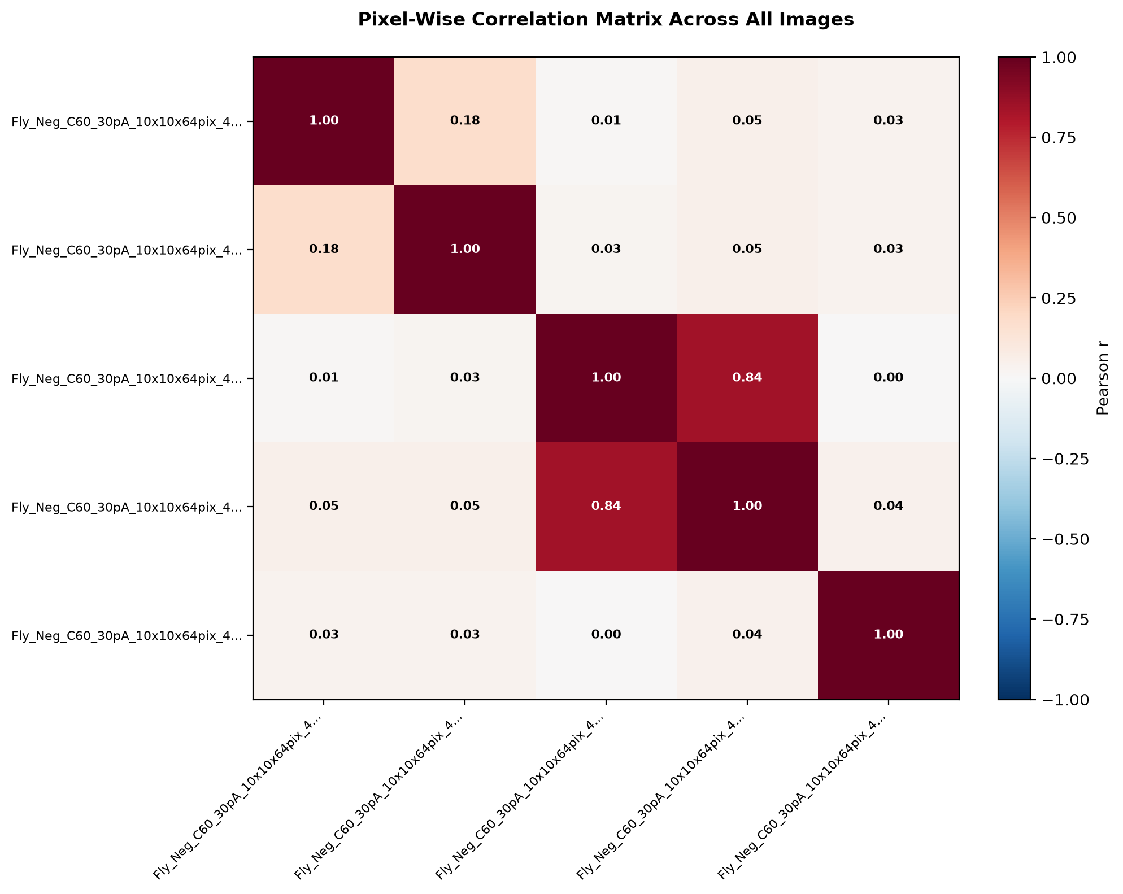
Figure: Pixel-Wise Correlation Matrix Across All 5 Negative-Mode Images. The strong red block (r = 0.84) corresponds to m/z 96.94 ↔ m/z 103.91 co-localization.
Note: From 02a - correlation heatmap

2.4 Negative-Mode Mass Series
Individual mass maps show distinct spatial distributions. m/z 78.95 (likely PO₃⁻) and m/z 123.95 are the most spatially widespread, while m/z 62.96 (likely PO₂⁻) and m/z 96.94 are more localized. m/z 103.91 shows intermediate localization with strong overlap with m/z 96.94.
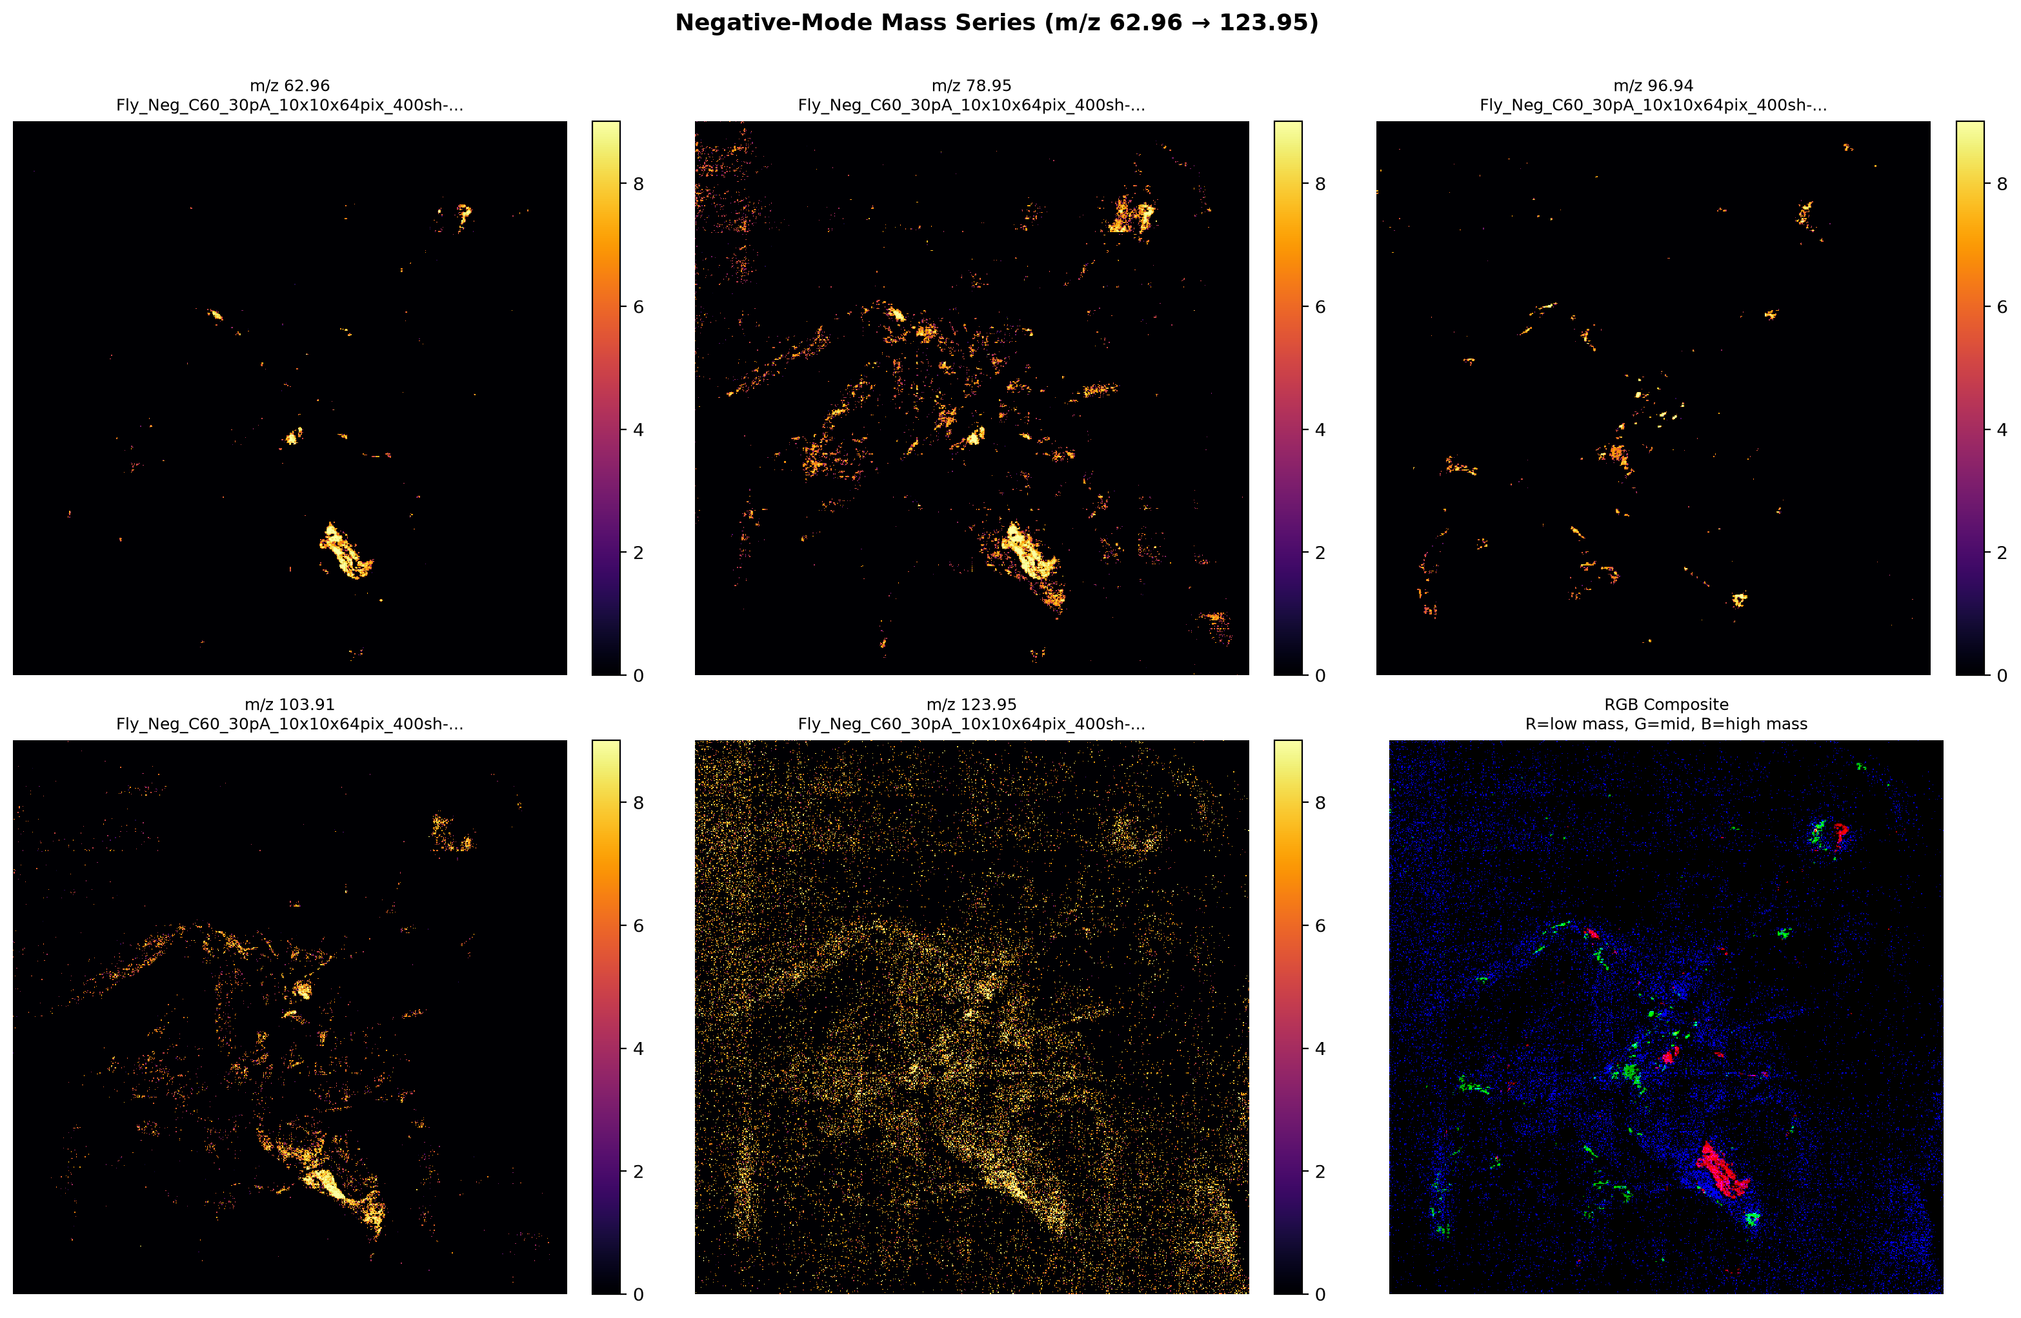Figure: Negative-Mode Mass Series (m/z 62.96 → 123.95). Each panel shows the ion intensity map for one mass channel. Bottom-right: RGB composite for direct spatial comparison.

3. Dimensionality Reduction (Notebook 02b)
Three complementary methods were applied to the 5-channel hyperspectral cube (640 × 640 × 5, 2,048,000 data points):
- PCA - Linear, orthogonal decomposition on standardised data. Finds directions of maximum variance.
- NMF - Non-negative, parts-based decomposition on raw counts. Extracts chemically meaningful endmembers.
- UMAP - Non-linear manifold learning on TIC-normalized data. Preserves local pixel neighbourhoods in 2D.

3.1 Principal Component Analysis (PCA)
PCA was performed on standardised pixel vectors (z-score per channel) to prevent high-intensity channels from dominating decomposition. The scree plot shows a gradual decay in explained variance, with no sharp elbow - consistent with continuous chemical variation rather than discrete, well-separated clusters.
Explained variance by component:
Component | Individual Variance (%) | Cumulative Variance (%)
PC1 | 37.0% | 37.0%
PC2 | 23.7% | 60.7%
PC3 | 19.8% | 80.4%
PC4 | 16.4% | 96.9%
PC5 | 3.1% | 100.0%

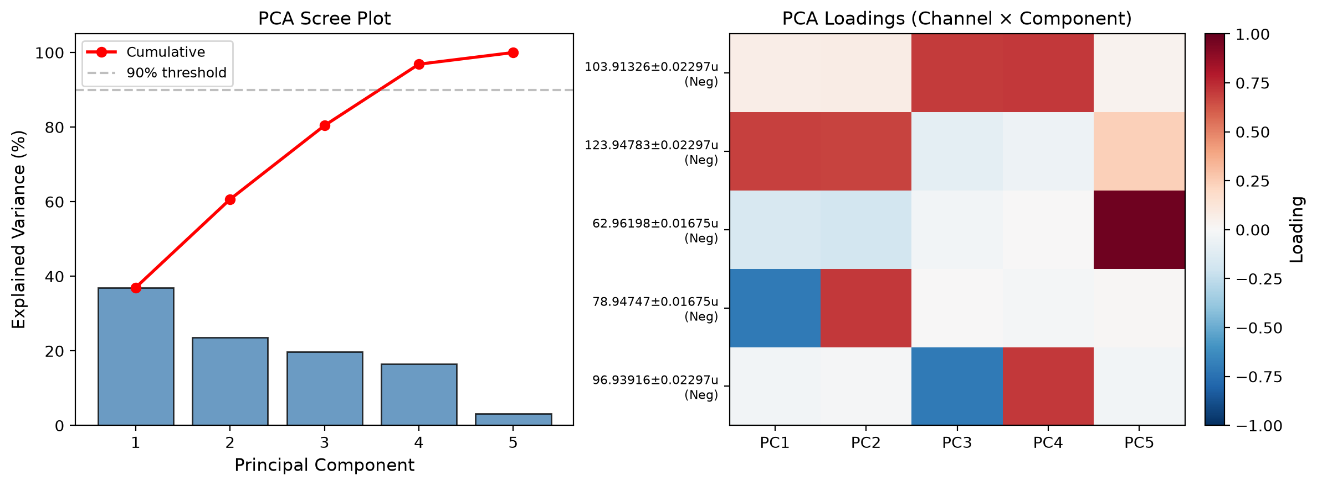
Figure: PCA Scree Plot (left) and Loadings Heatmap (right). The loadings show which mass channels contribute to each PC. For example, PC1 loads strongly on m/z 123.95 and 78.95; PC3 loads primarily on m/z 96.94.

The loading heatmap reveals that each PC mixes multiple masses. This confirms that no single ion channel explains the fossil chemistry alone - the multi-channel hyperspectral approach is necessary.
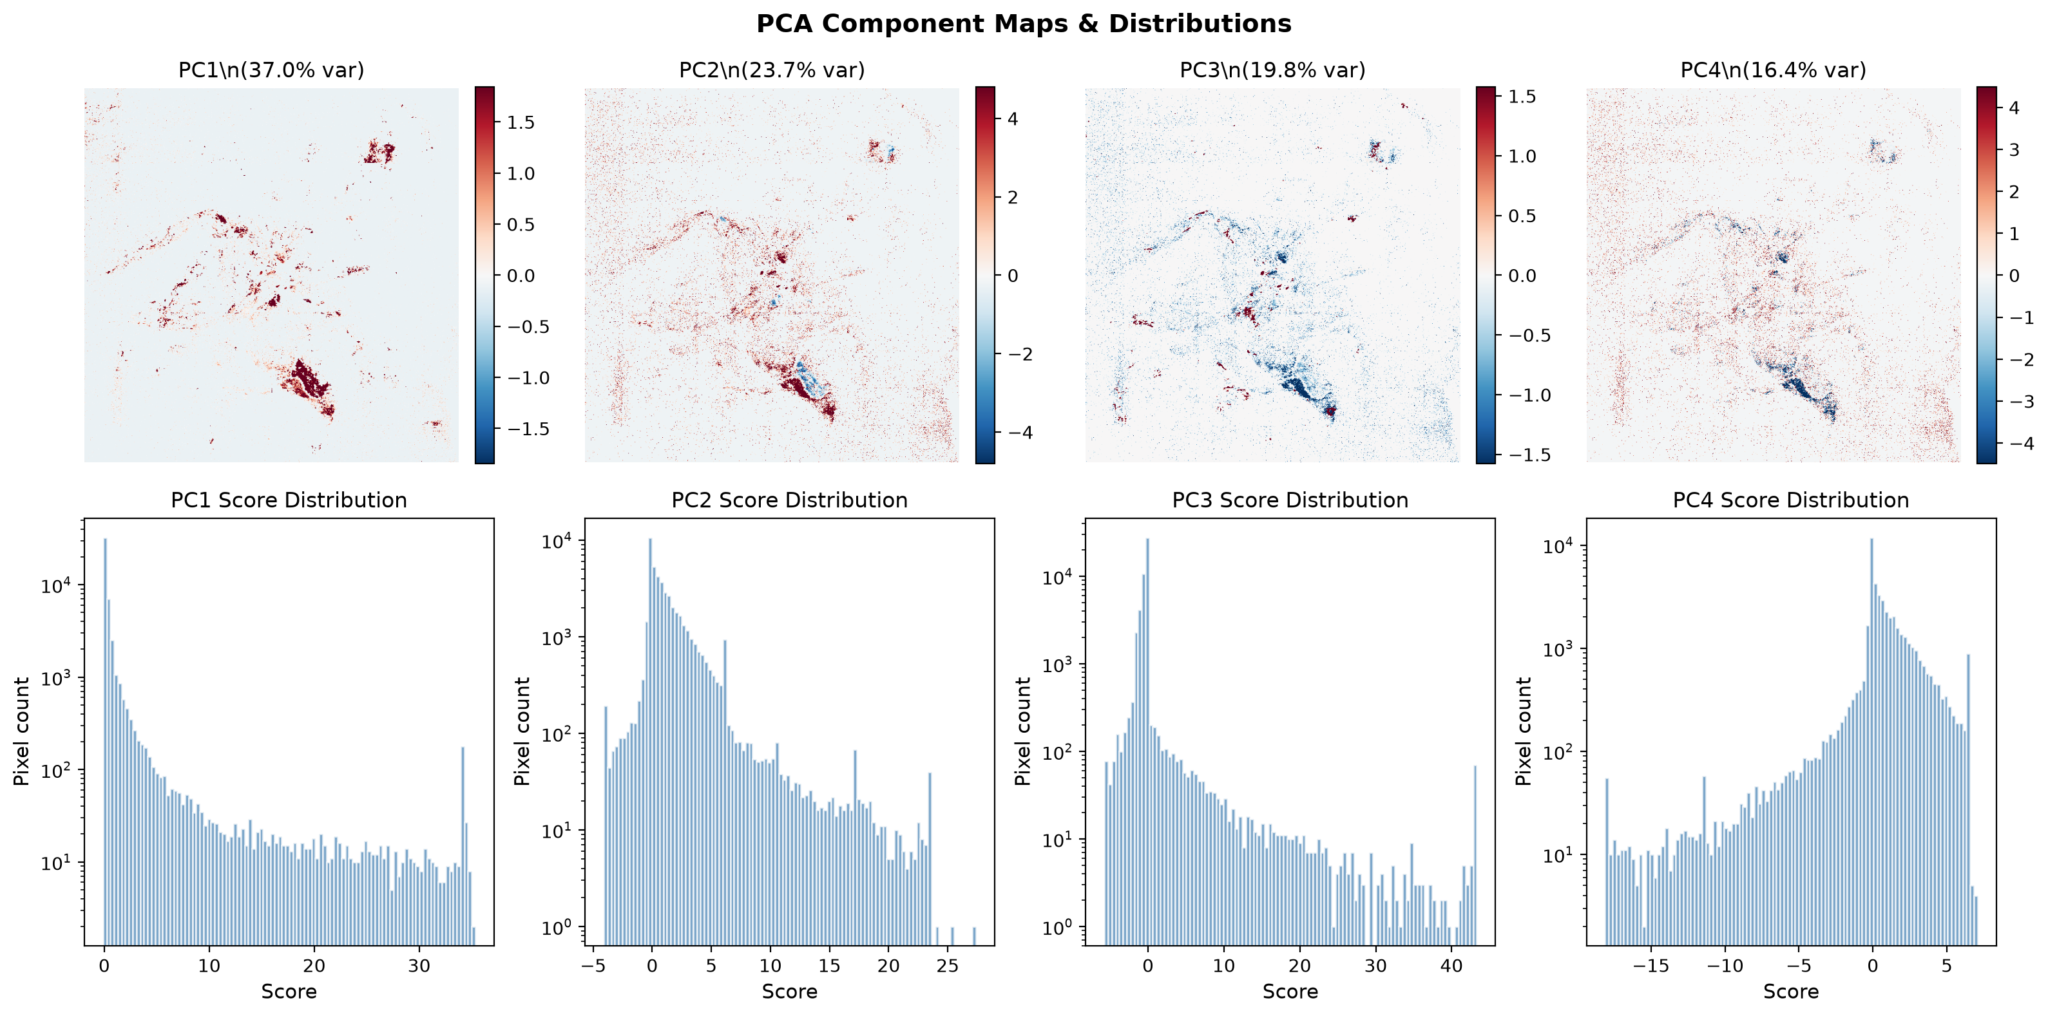
Figure: PCA Component Maps (top row) and Score Distributions (bottom row) for PC1–PC4. Spatial maps show where each chemical contrast is strongest. Histograms (log scale) reveal that most pixels cluster near zero, with long tails of high-score outliers corresponding to chemically distinct anatomical features.
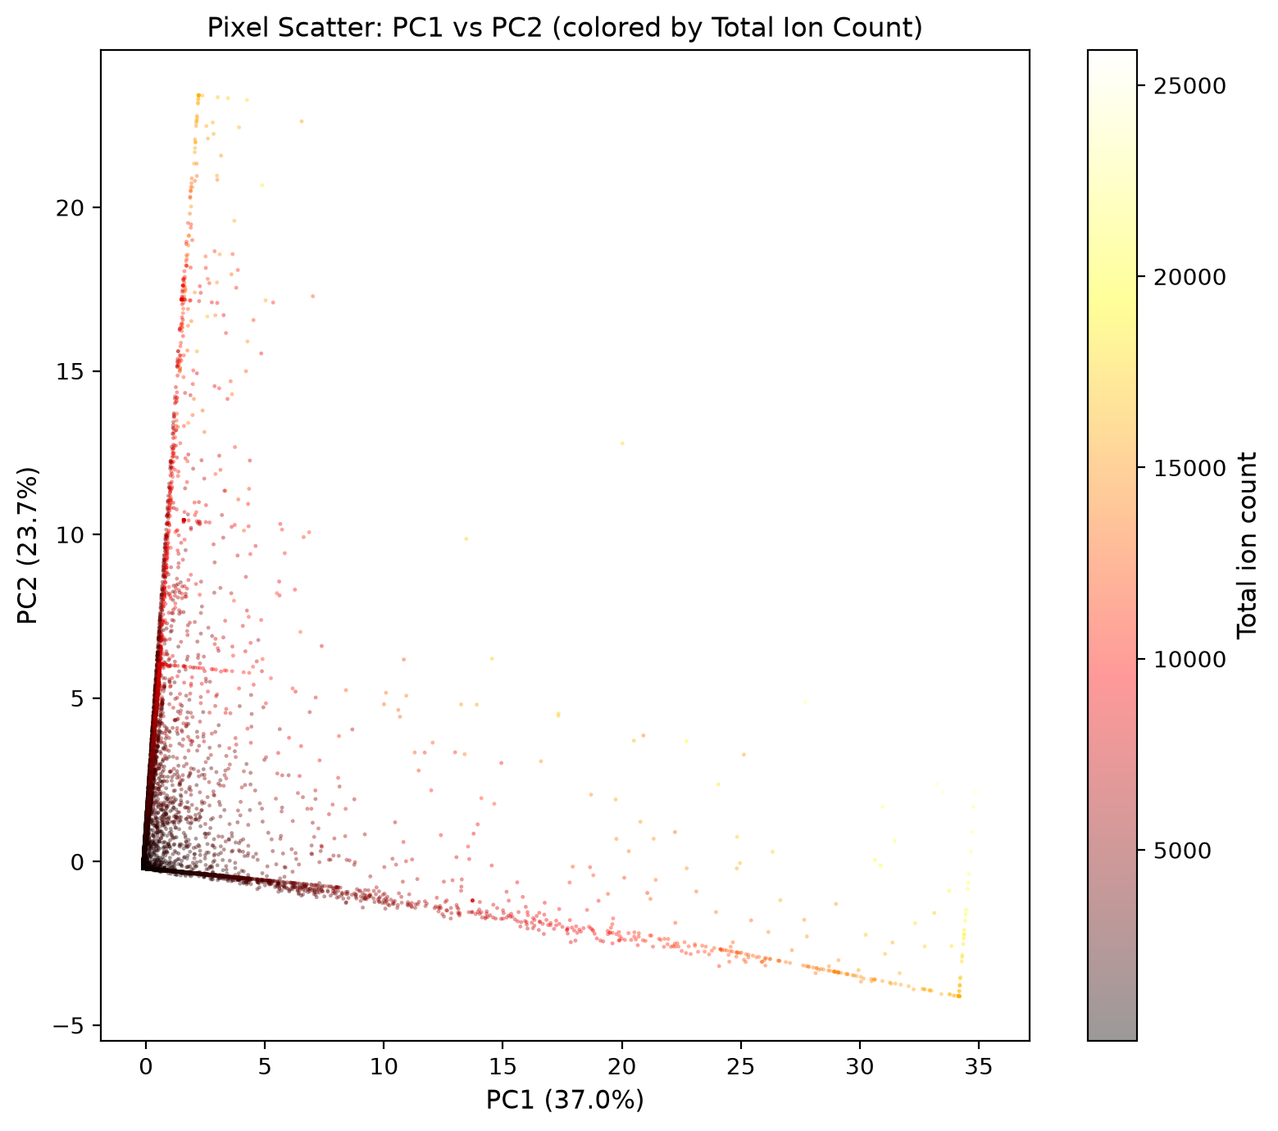
Figure: Pixel Scatter in PC1–PC2 Space, colored by Total Ion Count. The triangular distribution shows that PC1 tracks overall intensity (bright vs. dim), while PC2 captures compositional variation orthogonal to intensity.

3.2 Non-Negative Matrix Factorisation (NMF)
NMF decomposes the data into non-negative endmember spectra and non-negative abundance maps. Unlike PCA, NMF components can overlap spatially, making it ideal for ToF-SIMS where a single pixel may contain a mixture of chemistries. NMF was tested for k = 2, 3, 4, 5.
Model selection rationale:
- k = 2 → k = 3: Large error drop (249,000 → 145,738; −41%). A major new chemical component is captured.
- k = 3 → k = 4: Negligible improvement (145,738 → 144,090; −1.1%). No new meaningful chemistry is added.
- k = 4 → k = 5: Further drop (144,090 → 117,354; −18.6%), but with only 5 input channels, k = 5 approaches full rank and risks fitting noise.
- Selected k = 3 as the optimal balance of interpretability and reconstruction fidelity.
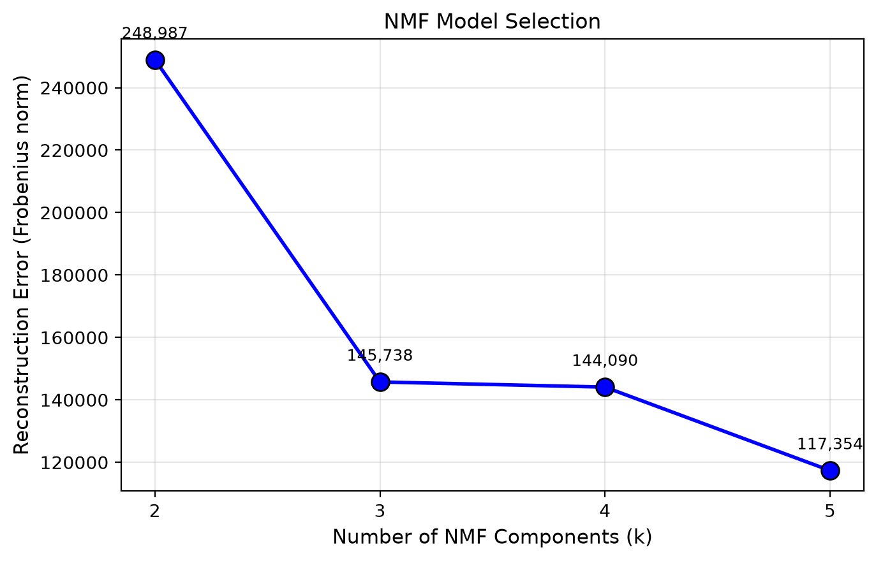Figure: NMF Model Selection: Reconstruction Error vs. Number of Components (k). The elbow at k = 3 indicates diminishing returns for additional components.

3.2.1 NMF Endmember Spectra
The three endmember spectra reveal distinct chemical signatures. Each endmember is dominated by a different mass channel or combination, confirming that the NMF has separated physically meaningful chemical groups rather than random noise.
Endmember | m/z 62.96 | m/z 78.95 | m/z 96.94 | m/z 103.91 | m/z 123.95
EM1 (Matrix) | ~0 | ~0 | ~0 | ~0 | Very High
EM2 (Phosphate) | High | High | ~0 | ~0 | ~0
EM3 (Mid-mass) | ~0 | ~0 | ~0 | Very High | ~0

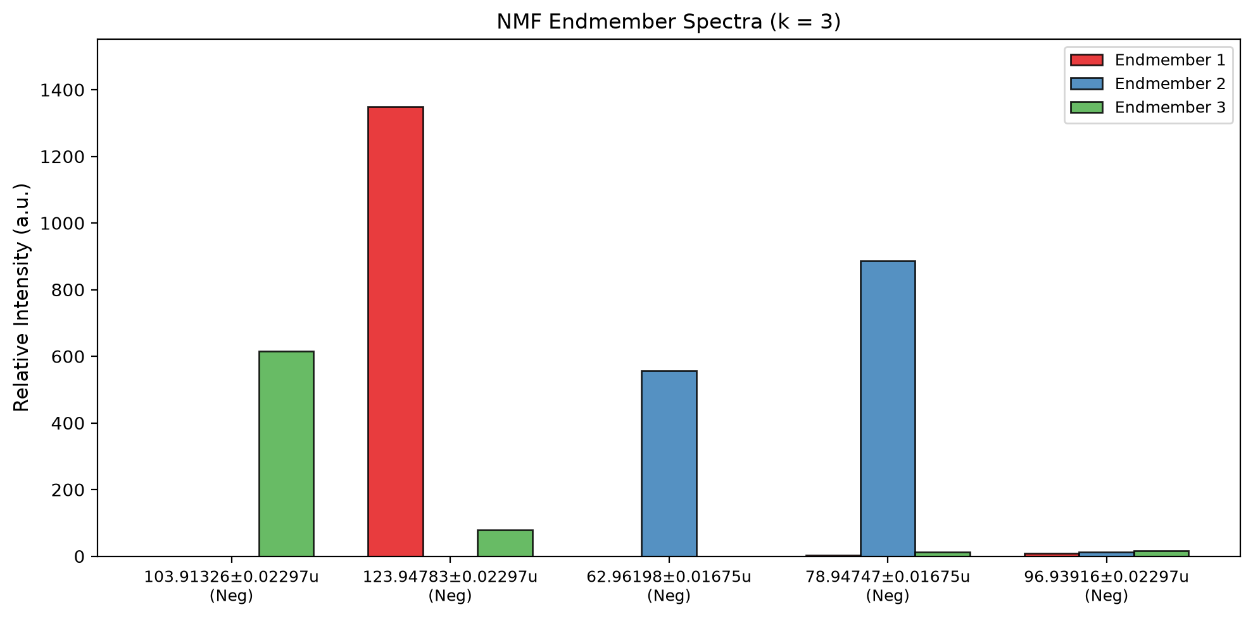Figure: NMF Endmember Spectra (k = 3). Bar heights show the relative intensity of each mass channel within each endmember. EM1 is dominated by m/z 123.95; EM2 by m/z 62.96 + 78.95; EM3 by m/z 103.91.

3.2.2 Chemical Interpretation of Endmembers
The NMF endmembers correspond to distinct chemical preservation modes in the fossil:
- Endmember 1 (m/z 123.95): Dominant high-mass fragment with widespread spatial distribution. This is likely to represent the mineralised matrix or fossilised cuticle background.
- Endmember 2 (m/z 62.96 + 78.95): These masses correspond to PO₂⁻ (62.96 Da) and PO₃⁻ (78.95 Da), classic negative-mode phosphate fragments. The hotspot localization indicates phosphatized tissue preservation - a well-known fossilization mode where soft tissues are replaced by calcium phosphate.
- Endmember 3 (m/z 103.91): Localized mid-mass fragment, possibly a dehydrated phosphate or organic breakdown product concentrated in specific anatomical structures. The strong co-localization of m/z 103.91 with m/z 96.94 (r = 0.84 from 02a) supports a shared chemical origin.

3.2.3 NMF Abundance Maps & RGB Composite
The abundance maps show where each endmember is expressed in the fossil anatomy. EM1 (matrix) is diffuse across the whole body. EM2 (phosphate) forms intense hotspots in specific anatomical regions. EM3 (mid-mass) is localized to discrete features. The RGB composite overlays all three, confirming spatial segregation of chemical domains.
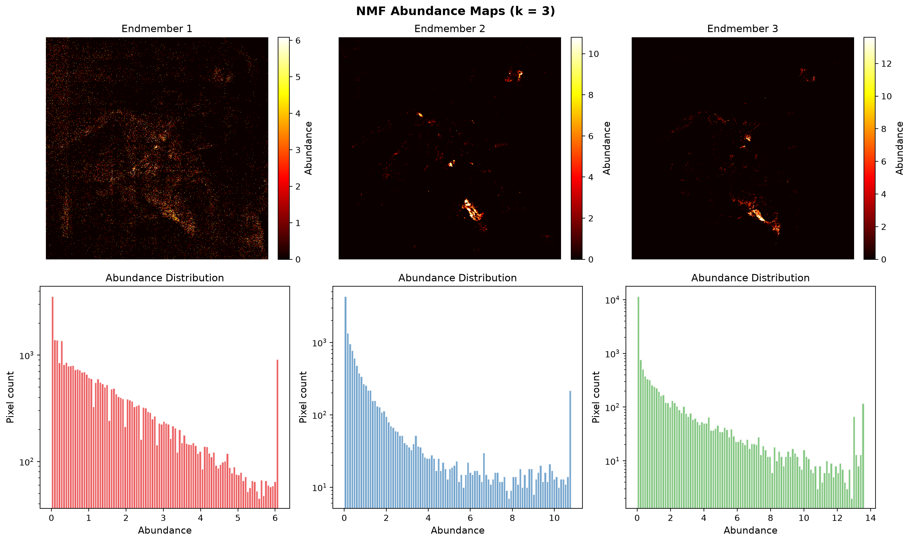Figure: NMF Abundance Maps (top) and Distributions (bottom) for k = 3. Abundance distributions are heavily right-skewed, with most pixels near zero and long tails of high-abundance pixels defining the anatomical hotspots.
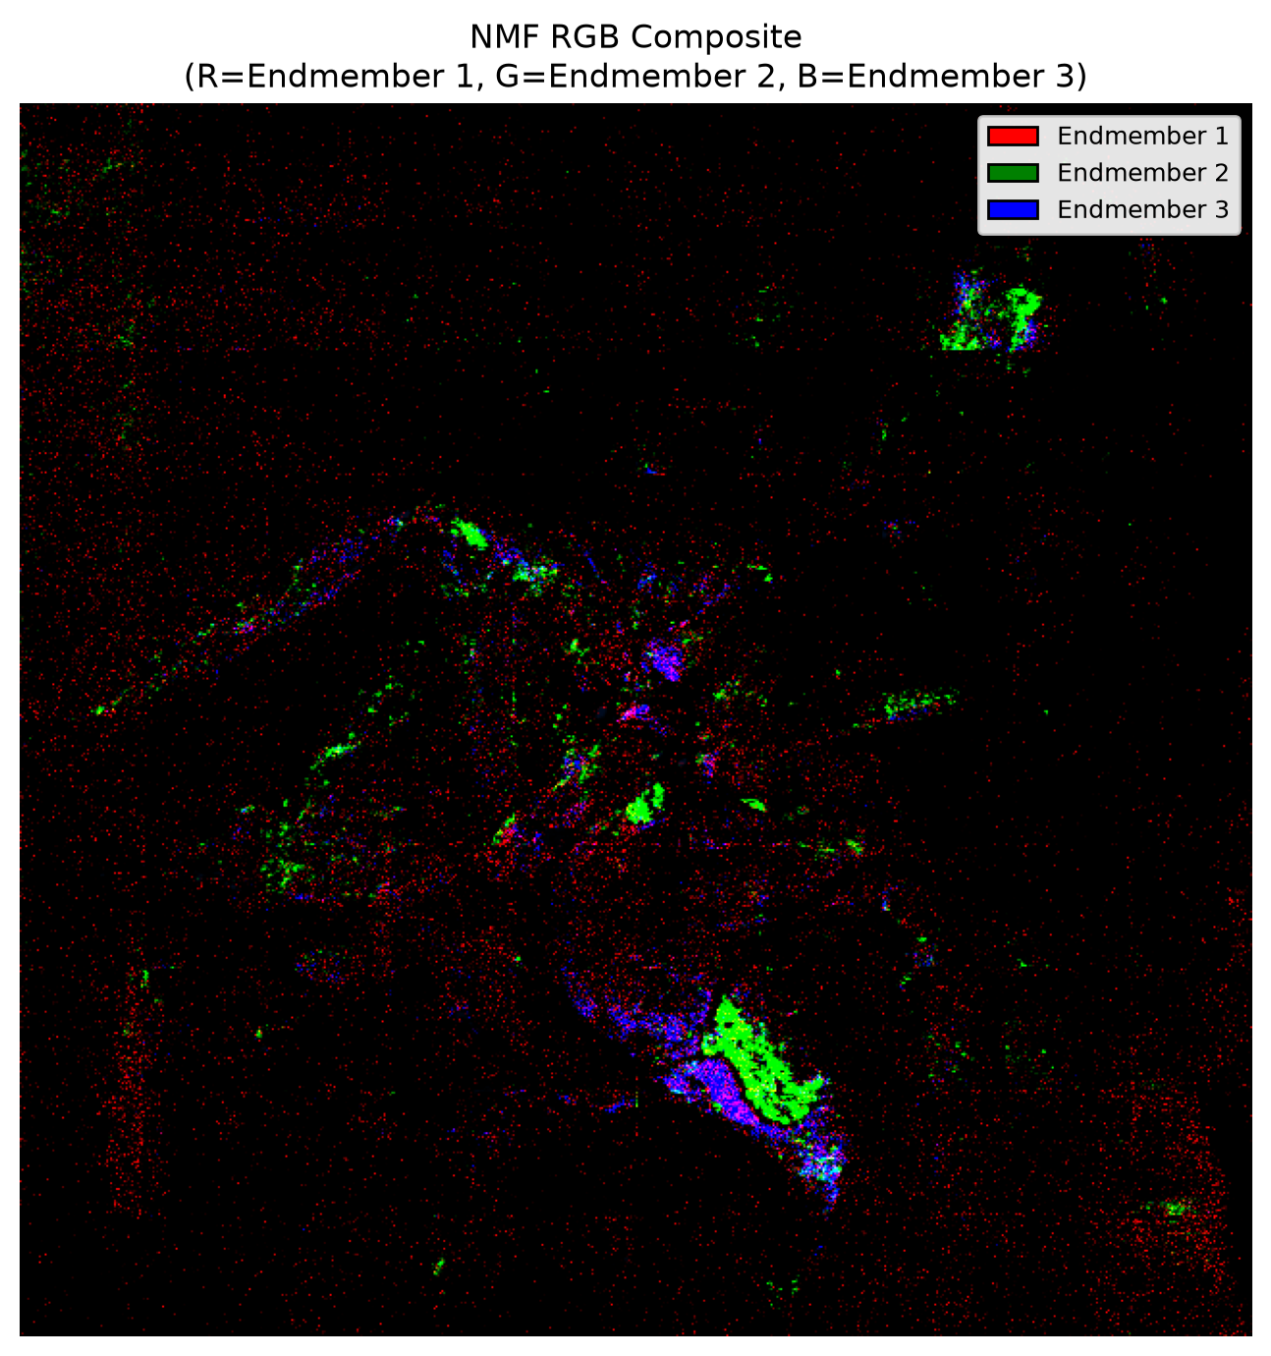
Figure: NMF RGB Composite. R = Endmember 1 (matrix), G = Endmember 2 (phosphate), B = Endmember 3 (mid-mass). The colour mixing (e.g., cyan = phosphate + mid-mass) reveals pixels with mixed chemistry, which is physically realistic for a fossil specimen.

3.3 UMAP - Non-Linear Manifold Learning
UMAP was applied to TIC-normalized foreground pixels (48,294 pixels) to embed the 6-dimensional spectra into 2D while preserving local neighbourhood structure. Unlike PCA and NMF, UMAP makes no assumptions about orthogonality or non-negativity. Parameters: n_neighbors = 30, min_dist = 0.1, Euclidean metric.
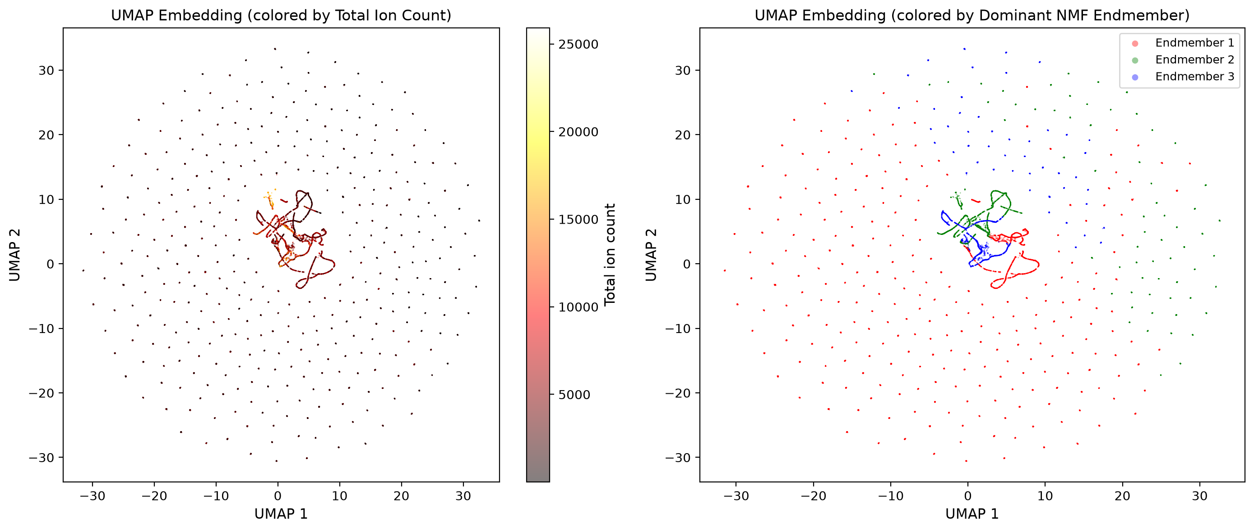Figure: UMAP Embedding. Left: colored by Total Ion Count, showing that high-intensity pixels cluster in the center. Right: colored by dominant NMF endmember, showing that UMAP clusters align with NMF-derived chemistry. The partial overlap between clusters indicates mixed-composition pixels.
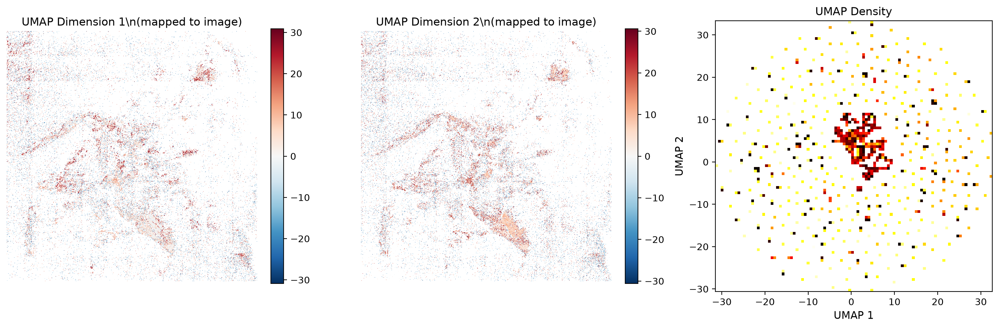Figure: UMAP Dimensions Mapped Back to Image Space. Left: UMAP Dimension 1. Center: UMAP Dimension 2. Right: 2D density histogram of the UMAP embedding. The spatial maps show that UMAP has separated the fossil body into distinct chemical zones that mirror the NMF abundance patterns.

The critical finding is that UMAP clusters (unbiased, non-linear) align with NMF endmembers (constrained, linear). This cross-method agreement confirms that the three chemical components are robust features of the data, not artifacts of any single algorithm.

4. Three-Way Method Comparison
The final comparison figure juxtaposes PCA (variance), NMF (endmembers), and UMAP (clusters) in a single 3×4 layout. This allows direct visual assessment of how each method partitions the chemical information.
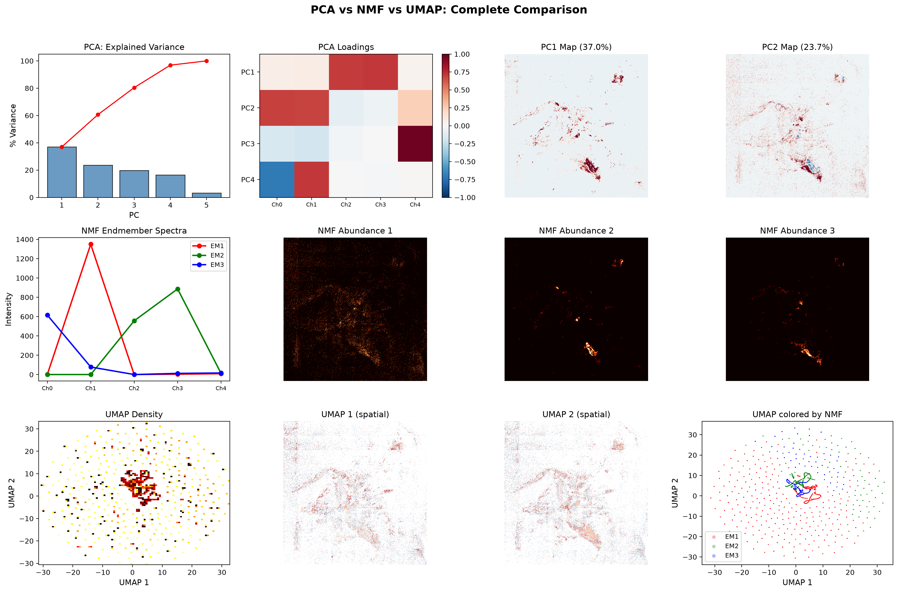
Figure: PCA vs NMF vs UMAP: Complete Comparison. Row 1: PCA scree, loadings, and spatial maps. Row 2: NMF endmember spectra and abundance maps. Row 3: UMAP density, spatial maps, and NMF-colored embedding. This figure should be the centerpiece of any presentation or chapter.

Key takeaways from the comparison:
- PCA captures global variance but mixes masses into abstract components that are hard to interpret chemically.
- NMF isolates physically meaningful endmembers (matrix, phosphate, mid-mass) with explicit spatial abundance.
- UMAP confirms that the pixel population naturally clusters into the same groups NMF found, validating the decomposition.
- The phosphate endmember (EM2) is the most spatially localised and therefore the most diagnostically useful for identifying preserved soft tissue.

5. Quantified Summary
Metric | Value
Total images analyzed | 7 (5 negative, 2 positive)
Hyperspectral cube dimensions | 640 × 640 × 5
Total data points | 2,048,000
Foreground pixels | 48,294 (11.8%)
Background sparsity | 88.2%
PCA: variance in first 3 PCs | 80.4%
NMF: reconstruction error (k=3) | 145,738 (Frobenius norm)
Strongest correlation pair | m/z 96.94 ↔ m/z 103.91 (r = 0.84)

Dataset & Methods:
ToF-SIMS hyperspectral imaging was performed on a fossilized dipteran specimen using a C₆₀ primary ion beam (30 pA). Negative-mode acquisition captured five fragment ions (m/z 62.96, 78.95, 96.94, 103.91, 123.95) at 400 shots/pixel over a 10 × 10 mm field of view (640 × 640 pixels). Positive-mode acquisition targeted m/z 53.94 at 100 shots/pixel. The resulting hyperspectral cube comprised 2,048,000 data points, of which 48,294 pixels (11.8%) contained non-zero ion counts.

Dimensionality Reduction:
Principal component analysis of standardized pixel vectors showed that the first three components captured 80.4% of total chemical variance, with no single mass channel dominating the decomposition. Non-negative matrix factorization (k = 3) extracted three endmember spectra and their spatial abundance maps. Endmember 2 was dominated by m/z 62.96 and 78.95, corresponding to PO₂⁻ and PO₃⁻ phosphate fragments, and localized to discrete anatomical hotspots. This indicates phosphatized tissue preservation within the fossil. UMAP non-linear embedding confirmed the robustness of these clusters, with pixel neighborhoods aligning to the NMF-derived endmembers.

Key Finding:
The spatial segregation of phosphate-related fragments (EM2) from the high-mass matrix background (EM1) and the mid-mass organic component (EM3) demonstrates that ToF-SIMS hyperspectral imaging, combined with blind source separation, can resolve distinct preservation chemistries in fossilized soft tissues without prior staining or sectioning.

Next Steps: Analysis Roadmap
From Dimensionality Reduction to Segmentation & Validation

The PCA, NMF, and UMAP results (Notebooks 02a–02b) have established that the fossil contains at least three chemically distinct domains: a high-mass matrix (EM1), a phosphate-rich component (EM2), and a localized mid-mass organic fragment (EM3). The next phase converts these abstract components into anatomically meaningful segments and validates them against independent data.

Step 1 - Segmentation
Objective: Assign every foreground pixel to a chemical-anatomical cluster using the dimensionality-reduced features from 02b.
Methods for testing:
- K-Means (k = 3, 4, 5): Fast baseline. Use the elbow method and silhouette score to pick k.
- Gaussian Mixture Model (GMM): Probabilistic soft clustering. Each pixel gets a membership probability per segment - useful for mixed-chemistry boundaries.
- HDBSCAN: Density-based clustering that can reject noise/outliers. Good if you suspect background contamination or edge artefacts.

Step 2 - Region-Specific Chemistry & Cross-Channel Analysis
Objective: Quantify the chemistry of each segment and test whether the segments are statistically distinct.
Analyses to perform:
- Per-segment ion intensity profiles: Boxplots of raw counts for each m/z channel within each segment.
- ANOVA / Kruskal-Wallis: Test whether mean intensity differs significantly across segments for each mass channel.
- Segment-segment correlation matrix: How similar are the chemical fingerprints of Segment A vs Segment B?
- Spatial statistics: Segment area, perimeter, circularity, and nearest-neighbour distances - useful if segments correspond to anatomical organs (e.g., gut, cuticle, wing).

Step 3 - Method Cross-Validation
Objective: Prove that the segments are robust across different clustering algorithms and input feature spaces.
Validation matrix:
- NMF features (3D) → K-Means vs GMM: Do they produce the same segment boundaries? Use Adjusted Rand Index (ARI) or Normalised Mutual Information (NMI) to score agreement.
- UMAP features (2D) → HDBSCAN vs NMF features (3D) → K-Means: If both find the same phosphate hotspot, the feature space does not matter - the chemistry does.
- PCA features (3D) → K-Means vs NMF features (3D) → K-Means: PCA is linear, NMF is parts-based. Agreement between them proves that the clusters are not algorithm-specific.
Success criterion:
ARI > 0.7 between at least two independent pipelines (e.g., NMF+K-Means vs UMAP+HDBSCAN). This is a strong, defensible number for a dissertation.

Appendix: Figure & Table Checklist
Paste the following figures into the marked locations above:
- 02a_polarity_mean_comparison.png
→ Insert at: Section 2.1 - Polarity comparison
- 02a_chemical_rgb_composite.png
→ Insert at: Section 2.2 - RGB composite (or use 02b_nmf_rgb_composite.png if preferred)
- 02a_correlation_matrix.png
→ Insert at: Section 2.3 - Correlation matrix
- 02a_negative_mode_mass_series.png
→ Insert at: Section 2.4 - Mass series grid
- 02b_pca_scree.png
→ Insert at: Section 3.1 - PCA scree + loadings
- 02b_pca_component_maps.png
→ Insert at: Section 3.1 - PCA spatial maps & histograms
- 02b_pca_scatter.png
→ Insert at: Section 3.1 - PC1 vs PC2 scatter
- 02b_nmf_model_selection.png
→ Insert at: Section 3.2 - NMF model selection
- 02b_nmf_endmembers.png
→ Insert at: Section 3.2.1 - Endmember bar chart
- 02b_nmf_abundance_maps.png
→ Insert at: Section 3.2.3 - Abundance maps & distributions
- 02b_nmf_rgb_composite.png
→ Insert at: Section 3.2.3 - RGB composite
- 02b_umap_scatter.png
→ Insert at: Section 3.3 - UMAP embedding plots
- 02b_umap_spatial_maps.png
→ Insert at: Section 3.3 - UMAP spatial maps
- 02b_method_comparison.png
→ Insert at: Section 4 - Three-way comparison (centrepiece figure)

Tip: For publication-quality output, ensure all figures are saved at 300 DPI or higher. The notebook already exports at 200 DPI; increase to 300 DPI by changing plt.rcParams['savefig.dpi'] = 300.

