New Zealand – Event Report

# **EVENTS PER MONTH**

This analysis provides us with the number of events per month in Country .

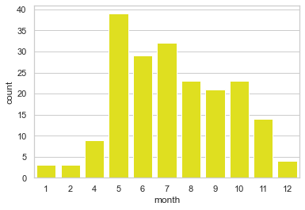

# **EVENTS PER SEGMENT**

This analysis provides us with the number of events per segment. Event segments are the broadest classification of events.

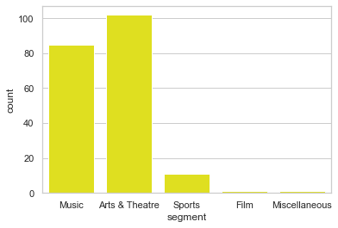

# **AVERAGE PRICE PER GENRE**

The Genre of an event is a sub-category of the segment. With this analysis it’s possible to understand the price distribution based on the genre.

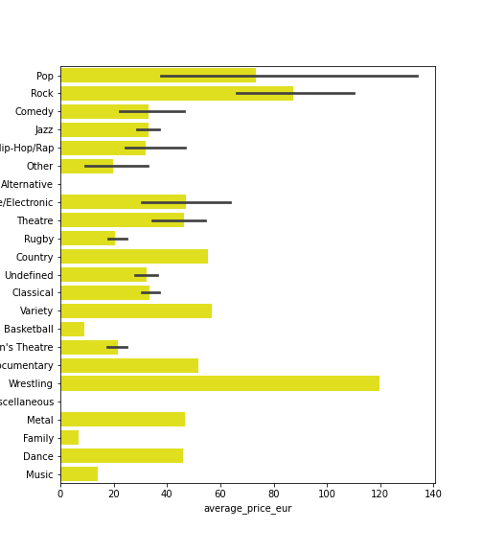

# **STATUS PER SEGMENT**

The Status of an event can be one of the following: On sale (which means that there are tickets for sale), Reschedule or Cancelled. With this analysis it’s possible to understand the status of the event per segment.

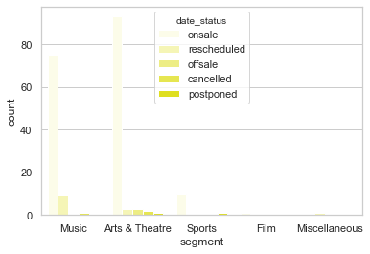

Telma Batista