dir --- It shows list of files and directroy

cls -- for clear screen

exit -- for ends power shell

Get-Process ---

(Del) erases the character to the right of the cursor
(Esc) to delete your entire current line.
(Insert) you can switch between insert and type-over modes.
You can display all the commands in your history by pressing (F7) and then scrolling up and down the list to selectcommands using (Arrow up) and (Arrow down) and (Enter).

(F8) provides more functionality than (Arrow up) as it doesn't just show the last command you entered, but keeps a record of the characters you've already typed in. If, for example, you'd like to see all the commands you've entered that begin with "d",

type: d(F8) --- Press (F8) several times. Every time you press a key another command will be displayed from the command history

cd -- changes the directory

Select the text using your mouse and PowerShell will highlight it. After you've selected the text, press (Enter) or right-click on the marked area

Set-ExecutionPolicy RemoteSigned --- This command for enabling permission for exicute scripts in powers shell
& "C:\Scripts\My First Script.ps1" or .\script.ps1 ---- to exicute script

$host.ui.rawui.ForegroundColor = "Yellow" (Enter)
$host.ui.rawui.WindowTitle = "My Console" (Enter)
above tochange thae colors and temporary

Get-Process | more (Enter) ----- Outputting Information Page by Page

Help > help.txt (Enter) ------ Storing Information in Files

Get-Content "d:\projects\powershell\wakeup.dat" ---- to read content of file

$result = Ping 10.10.10.10 --- it will store the output of ping into reult variable
$result --- it will print content of result variable

4GB / 720MB (Enter)
out put ---5.68888888888889

(12+5) * 3 / 4.5 (Enter)
12 + 0xAF (Enter) ---- it takes hexa decimal values also
out put – 187
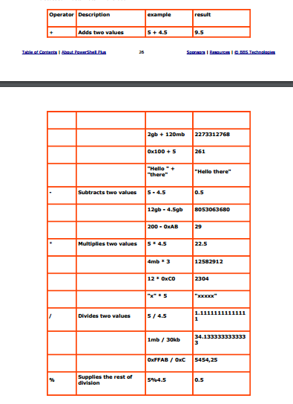

notepad (enter) – it will open notepad
explorer (eneter) – it will open explorer
cmd (enter) – it will switch to old console i.e command prompt and type exit go back
Cmd /c Help -- Using this command will return a list of many other useful external console commands.
del file --- to delete file
cat file --- to display file content
ls – to list dir conetnt

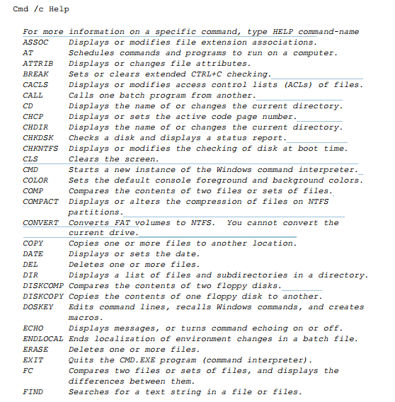

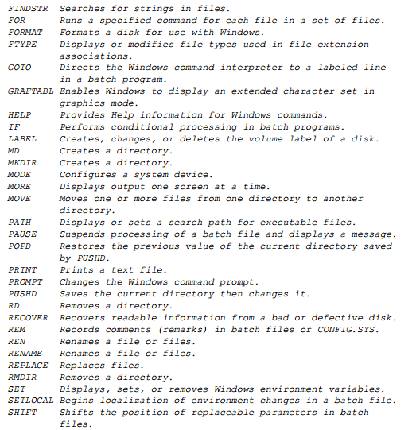

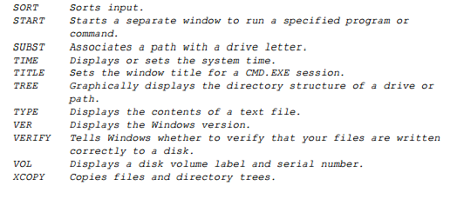

wordpad – it will give error due to security restrictions
& "C:\programs\Windows NT\accessories\wordpad.exe" – it will open wordpad

get-command -verb get

Command type Name Defination

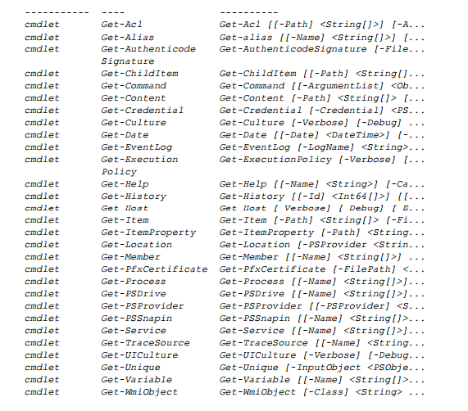

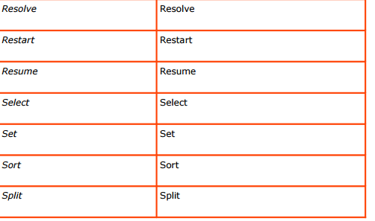

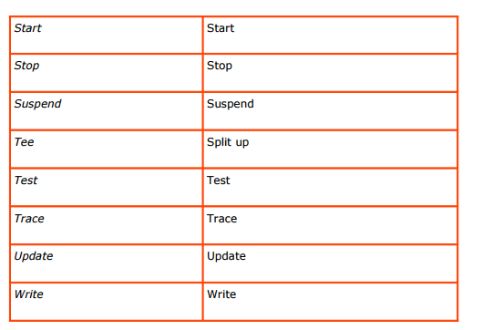

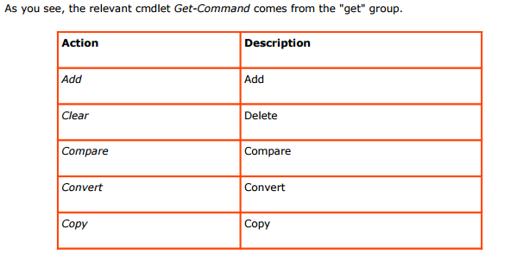
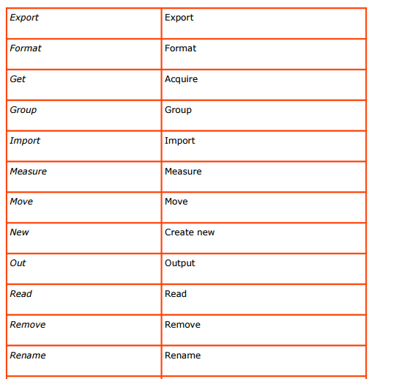

You can look up help for any cmdlet using
Get-Help:
Get-Help Get-Command -detailed

