PROJECT 3: FACIAL EXPRESSION EMOTION PERCEPTION

Face and Gesture Analysis

# INTRODUCTION

In recent years, facial emotion recognition has become one of the most challenging tasks in computer vision due to its subjective nature. Nevertheless, it remains one of the most intriguing and popular fields of study thanks to its diverse applications, e.g. human-robot interactions, healthcare, security monitoring, or psychological analysis. In this lab we will compare the handmade annotated dissimilarity matrix against a randomly generated matrix. Moreover, plot the similarity and consistency matrix by distance and compute the accuracy of the random matrix and the handame annotated matrix. Last but not least, we will apply MDS to obtain the best two bases.

# STATE OF THE ART

Human beings provide a lot of information apart from verbal communication through nonverbal routes such as gestures and facial expressions which are immediately recognizable by human beings, yet a heavy task for a machine. This leads to two main theories which state that emotions are universal to all humans and innate to our condition, or relative to our cultural and geographical background. Nowadays the general consensus is the existence of seven universal emotions, which was proposed by Ekman in 1976 [1]: happiness, surprise, sadness, fear, disgust, anger, and contempt, the latter being added some years after. This notion combined with the *Dimensional Theory of Emotion* originated from Wundt [2] and later followed by Scholsberg [3] proposed that emotions can be defined as a combination of three dimensions: pleasant-unpleasant, tension-relaxation, and excitation-calm. However, later on many other researchers found that the tension-relaxation and excitation-calm axes were overlapping and hence could be combined into one. As a consequence, the theory could be reduced into two axes denominated valence and arousal which are nowadays the most commonly used ones. Lastly, Russell [4] proposed the *Circumplex Model of Affect* in which all emotions can be arranged in a circle governed by the previously mentioned dimensions (valence and arousal) with which elementary emotions can be categorized by their plotting.

Besides the above mentioned dimensional models of emotions, many others have been developed (e.g.: the vector model, PANA model, Plutchik's model or the PAD emotional state model).

# EXPERIMENTAL PROCEDURE AND MDS DESCRIPTION

This project required handmade annotations on the distances between emotions to provide a subjective human perspective on the perceived emotional similarities or dissimilarities which will later on be used as the input to *Multidimensional Scaling* (MDS). MDS is a set of statistical procedures used for exploratory data analysis and dimensionality reduction. For a set of similarities (or distances), in this case our handmade annotated similarity measurements of the emotions in the given images, outputs a representation in a lower dimensional space such that the interitem distances almost match the original distances [7]. In other words, produces a map where similar items are located close to each other, and dissimilar items are located proportionately further apart [5]. MDS will then compute the new positions of emotions in a lower dimension subspace, most commonly in 2D where the axes are valence and arousal [see section STATE OF THE ART], such that the distances between emotions correspond as closely as possible to the annotated distances.

The classical scaling algorithm procedure is as described in the following steps extracted from [6]:

1. Given an $(n×n)$ matrix of interpoint distances $Δ=(δ_{ij})$, form the $(n×n)$ matrix $A=(a_{ij})$, where $a_{ij}=-\frac{1}{2}{ δ}_{ij}^{2}$.
2. Form the *doubly centered* symmetric $(n×n)$ matrix $B=HAH$, where $H=I_{n}-n^{-1}J_{n}$ and $J_{n}=1_{n}1_{n}^{T}$ is an $(n×n)$ matrix of ones.
3. Compute the eigenvalues and eigenvectors of $B$. Let $Λ = diag\{λ_{1}, ··· , λ_{n}\}$ be the diagonal matrix of the eigenvalues of $B$ and let $V = diag\{v_{1}, ··· , v_{n}\}$ be the matrix whose columns are the eigenvectors of $B$. Then, by the spectral theorem, $B=VΛV^{T}$.
4. If $B$ is nonnegative-definite with rank $r(B)=t<n$, the largest $t$ eigenvalues will be positive and the remaining $n-t$ eigenvalues will be zero. Denote by $Λ_{1}=diag\{λ_{1}, ··· , λ_{n}\}$ the $(t×t)$ diagonal matrix of the positive eigenvalues of $B$ and let $V_{1}=(v_{1}, ··· ,v_{t})$ be the correpsonign matrix of eigenvectors of $B$. Then,

$B=V_{1}Λ_{1}V_{1}^{T}=(V_{1}Λ_{1}^{1/2})(Λ_{1}^{1/2}V_{1})=YY^{T}$,

where ${Y=V}_{1}Λ_{1}^{1/2}=(\sqrt{λ_{1}}v_{1}, ··· ,\sqrt{λ_{t}}v_{t})={(y_{1}, ··· ,y_{t})}^{T}$.

1. The *principal coordinates,* which are the columns, ${(y_{1}, ··· ,y_{t})}^{}$, of the $(t × n)$ matrix $Y^{T}$, yield the $n$ points in $t$-dimensional space whose interpoint distances $d_{ij}=\left|\left|y_{i}-y_{j}\right|\right|$ are equal to the distances $δ_{ij}^{}$ in the matrix $Δ$.
2. If the eigenvalues of $B$ are not all nonnegative, then either ignore the negative eigenvalues (and associated eigenvectors) or add a suitable constant to the dissimilarities (i.e., $δ_{ij}←δ_{ij}+c$ if $i≠j$, and unchanged otherwise) and return to step 1. If $t$ is too large for practical purposes, then the largest $t'<t$ positive eigenvalues and associated eigenvectors of $B$ can be used to construct a reduced set of principal coordinates. In this case, the interpoint distances $d_{ij}$ approximate the $δ_{ij}$ from the matrix $Δ$.

To validate the meaningfulness of the handmade annotations we provided, we conducted an experiment involving another random matrix which was created by averaging 20 random matrices, in order to provide homogeneity and about outliers. Then we compared this random matrix to the matrix derived from our annotations. It is important to note that as the averaging process involves a large number of randomly generated matrices, the mean tends to converge to an overall value of 4.5 on a scale of 0-9, following the principles of the *Central Limit Theorem*. If the mean from the annotations significantly deviates from the expected mean (4.5 in this case) based on random matrices, it suggests that the annotations are capturing a distinct pattern or structure in the data, in other words it implies some non-randomness that is not likely to happen by chance.

# VISUALIZING THE RESULTS

Before stepping into the MDS, we first need to take a look at our data. From the similarity matrix we can see that there are some emotions that were easier to spot for us: laughter, sadness and surprise. There are other emotions that were not as easy to spot, as we can see that anger, boredom and disgust were quite uneasy to spot for us. In addition to that, we were not able to distinguish clearly between friendliness, happiness and laughter.

In the consistency matrix we can see that we were quite consistent labeling happiness and laughter emotions, but it does not give us any more useful information.

From this matrix C we were able to construct the dissimilarity matrix D using the formula given in the handout $d_{ij} = \sqrt{c_{ii}-2c_{ij}+c_{jj}}$. The result can be seen in *(Fig. 2)*.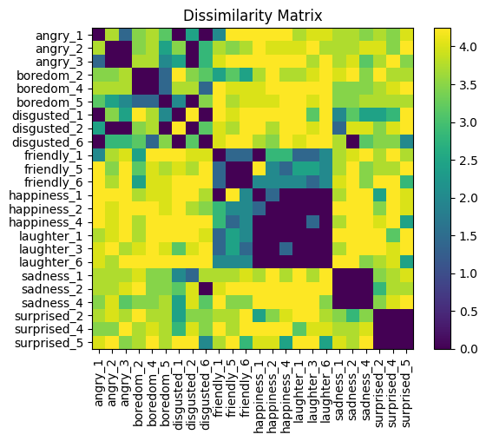

Using this dissimilarity matrix we can perform a MDS as explained above. From the spectral decomposition we will only keep the first two eigenvalues with their corresponding eigenvectors. Finally we can project the data into the eigenspace and plot it using the Circumplex Model of Affect, taking the eigenvector with highest eigenvalue as the Valence, and the second one as the Arousal. Before doing so, we have to resize the projection to the range [-1, 1] to be able to see the representation properly. The resulting plot can be seen in *Figure 3*.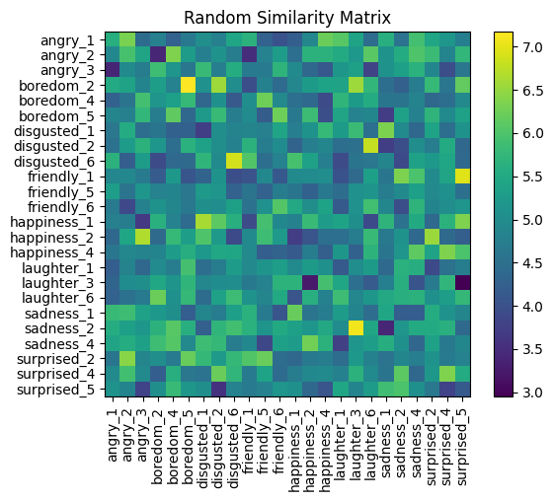

From the random matrix we created, we can do the same process (compute dissimilarity and perform MDS). The resulting plot can also be seen in *Figure 3*.

We can also have a metric for the accuracy of our annotations. We have created a *cheat matrix* that has a perfect accuracy (i.e.: its annotations are 9 if the emotion is the same, 0 otherwise). From that matrix we have calculated the accuracy of our annotations with respect to it, and also the accuracy of the random annotations. This calculation was done using the Mean Square Error metric.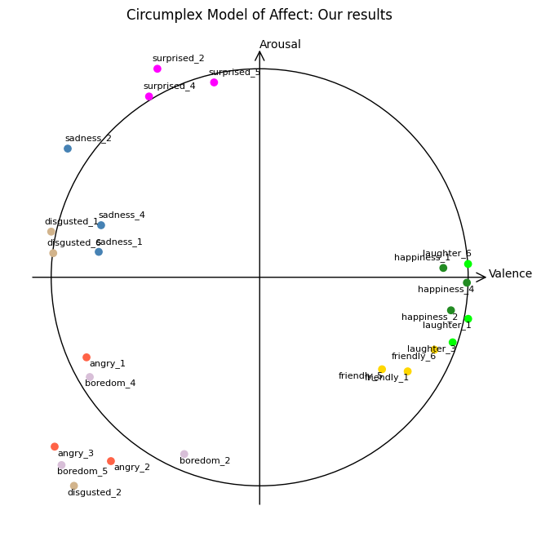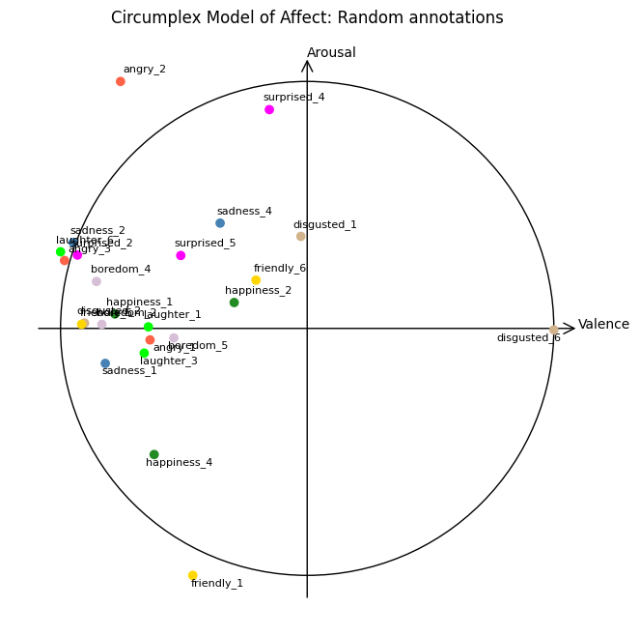

*Fig. 3 Circumplex Model of Affect of Handmade Annotation and Random Values*

# 

# ANALYZING THE RESULTS

Analyzing our plot for the CMA, we can see that it is relatively consistent mapping positive and negative in the valence axis. However, we can see that there are some inconsistencies regarding the arousal axis, which probably means that the annotations in the images were not as accurate as expected. In addition, we can see that most of the same emotions are kind of grouped in the same quadrant (or are very near to each other) meaning that there is a pattern, or a trend in the images that are clustered together.

That is a thing that we are not able to see in the randomized symmetric matrix plot where the different images are placed randomly in the plot. We can also remark that the points in the randomized plot tend to be near, since the matrix is not exactly random since it is averaged 20 times.

When looking at the accuracy of our results, we see that the annotated symmetric matrix has a much lower error, precisely half, than the randomized symmetric matrix. The accuracy against the *cheat* matrix is 12.68 for the manually-annotated images, and around 25 for the randomized matrix.

Analyzing visually the matrices, we can see that in the manually annotated images there is a kind of consistent block structure along the diagonal, while in the randomized matrix we are only able to see an “averaged” noise.

From these results, we can conclude that the human-annotated images provide a much better insight into the emotions that an image contains than some random annotated images.

# REFERENCES

### [1] Ekman P. Are there basic emotions? Psychol Rev. 1992 Jul;99(3):550-3. doi: 10.1037/0033-295x.99.3.550. PMID: 1344638.

### [2] Wundt W. M. (1897). Outlines of Psychology. New York, NY: Thoemmes Continuum press; 10.1037/12908-000

### [3] Scholsberg H. (1954). Three dimensions of emotions. Psychol. Rev. 61 81–88. 10.1037/h0054570

### [4] Russell J. A. (1980). A circumplex model of affect. J. Pers. Soc. Psychol. 39 1161–1178. 10.1037/h0077714

### [5] Hout, M. C., Papesh, M. H., & Goldinger, S. D. (2013). Multidimensional scaling. Wiley interdisciplinary reviews. Cognitive science, 4(1), 93–103. <https://doi.org/10.1002/wcs.1203>

### [6] A.J. Izemman; Modern Multivariate Statistical Techniques. Springer Texts in Statistics, Springer, 2008. (Chapter 13, Multidimensional Scaling)

### [7] Johnson, R. A., & Wichern, D. W. (2014). *Applied Multivariate Statistical Analysis* (pp. 706-709). Pearsons Education Limited.