PROJECT 2: PRINCIPAL COMPONENT ANALYSIS

# INTRODUCTION

In this project we will extract ten principal components from a dataset, composed by a set of facial images and another one of facial landmarks, using the PCA algorithm. Moreover, the concept of meaningful in terms of the principal component will be determined with a specific non-trivial criterion that will be discussed afterwards.

# STATE OF THE ART

Face recognition is a field that has been under study for over twenty years. Recognition of faces plays a crucial role in many different fields such as security systems, biometrics, access control and criminal identification. Due to the nature of the problem, building computational models for face recognition is a complicated task since many different parameters can be involved in the procedure. It has been shown that face recognition can be done using eigenfaces, which is based on decomposing “face images into eigenfaces like a small set of characteristic feature images. Recognition is done by comparing its position in the face space with the places of known people" [1]. In consequence any set of faces can be recognised by storing a number of values for each face and a relatively small number of pictures that represent the average of a face, called eigenpictures [2].

Nevertheless, eigenfaces is a method that is nowadays considered traditional, given the existence of more advanced and sophisticated methods in the current state of the art. Today, due to deep learning, these methods have become obsolete, e.g. DeepFace, a deep learning facial recognition system created by a research group at FaceBook, claims a performance near 97% of the human eye [3].

# EIGENFACES ALGORITHM

The eigenfaces algorithm is based on dimensionality reduction via Principal Component Analysis (PCA). PCA is a method used to transform high-dimensional images in datasets into a new coordinate system where the data's variance is maximized along the newer (and fewer) axes. By doing so, PCA simplifies the dataset to dimensions that explain more of the data while retaining as much of the original information as possible. In this context, 'explaining' refers to capturing and representing the variability present in the original dataset [4]. The eigenfaces method works by finding the most representative features on a face and showing that face as a linear combination of these features.

Next we will explain how the PCA algorithm works.

The average face is computed as: , where is the number of images and is the vector of flattened preprocessed images. This average face is needed to normalize each one of the images in into , which can be written as . A is needed to compute the covariance matrix .

From this covariance matrix we will extract its eigenvectors with their corresponding eigenvalues. Knowing that the eigenvectors with higher eigenvalue are the ones that have more variability of data, hence the ones that will have the most statistical impact when projecting the data into the eigenspace. In other words, those eigenvectors are the ones that, on average, will generate less loss when projecting the data with them.

Therefore what we want is to sort the eigenvectors in descending order of eigenvalue, and keep the most meaningful [see section MEANINGFUL BASES: CRITERION] ones. Once we have them sorted and selected, the PCA algorithm will terminate, returning the calculated eigenvectors, eigenvalues, and the projection of the preprocessed data into the eigenspace.

The eigenfaces algorithm can be applied to face recognition, adding an extra step done by projecting some input image that we want to recognize into the calculated eigenspace and then trying to find if it “is near to the eigenfaces hyperplane” through Euclidean distance [4], difference from face space () [5] or other methods.

The flowchart of a face recognition algorithm is shown in the first part of *Fig. 1* extracted from [4]. The last can be done through Euclidean distance or through , which would be calculated as follows:

if , then is a face, where is the and a decision threshold [5].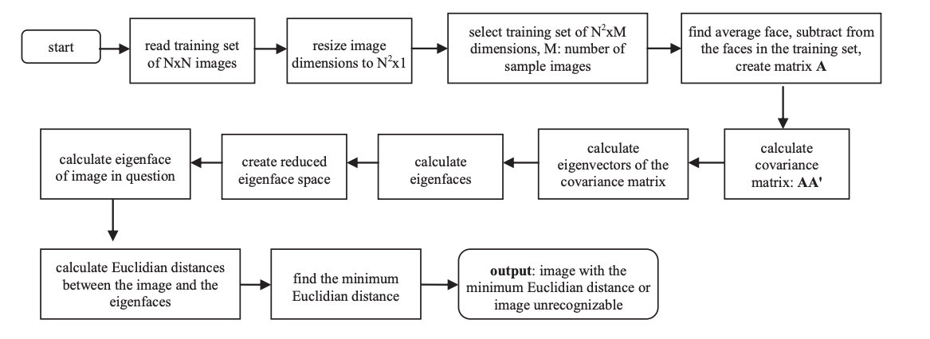

# *Fig. 1 Flowchart of the algorithm of the eigenfaces method*

# DATASET

The used dataset consists of 2330 images, all of them containing 194 landmarks from the Helen dataset [6]. This dataset consists of images of different individuals and varying poses, expressions, backgrounds, accessories, scaling, occlusions and lighting. An important invariant in this dataset is that each image is cropped in such a way that it contains only one face.

It is also remarkable that some of the landmarks are located outside of their image (predicting the position of the landmark in case a face is cut outside the image). These landmarks were discarded in our implementation because they gave problems resizing the images from the dataset.

# MEANINGFUL BASES: CRITERION

As a criterion to choose which features were the most meaningful, we chose to take the most statistically significant ones. In other words, from the spectral decomposition of the covariance matrix , we chose to order the eigenvectors with descending eigenvalue order, and take the first 10 components (as requested in the handout).

The objective is to perform dimensionality reduction *Fig. 2 Explained variance by PCA components* while retaining as much information as possible, and this method ensures that we get the least projection loss out of 10 components, i.e. we get the ten components that explain the highest percentage of variance in the dataset to maximize information retention. Nevertheless, by analyzing *Fig. 2* we can notice that the the explained variance w.r.t. the number of components tends to approximately 80% which may be considered acceptable, but perhaps is too low.

# RESULTS:

## FACIAL IMAGES

The results obtained were not extraordinary, since we could only retain 10 components. We can see in the plot of *Fig. 2* that with the 10 best components of the decomposition, we are able to capture approximately 60% of the variance of the dataset.

Despite the low variance captured, we found out that the eigenfaces that were captured were quite interesting. We have to take into account that the changes in brightness represent that there is some kind of variability of the data captured in the eigenface. For instance, we can see in *Fig. 3* that the first eigenface recognizes that the background of the image is different from the face of the person. The second eigenvector recognizes that the face and the background are different from the clothes that the person is wearing. There are cases where these differences might not be describable with words or may not make sense to the naked eye, as the third one. However, each principal component provides different information regarding the faces.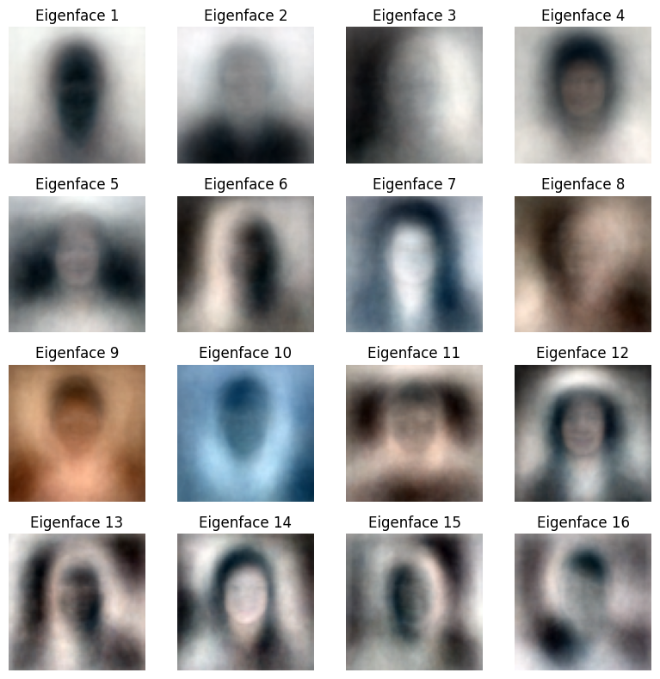



*Fig. 3 First 16 eigenfaces extracted from the facial images*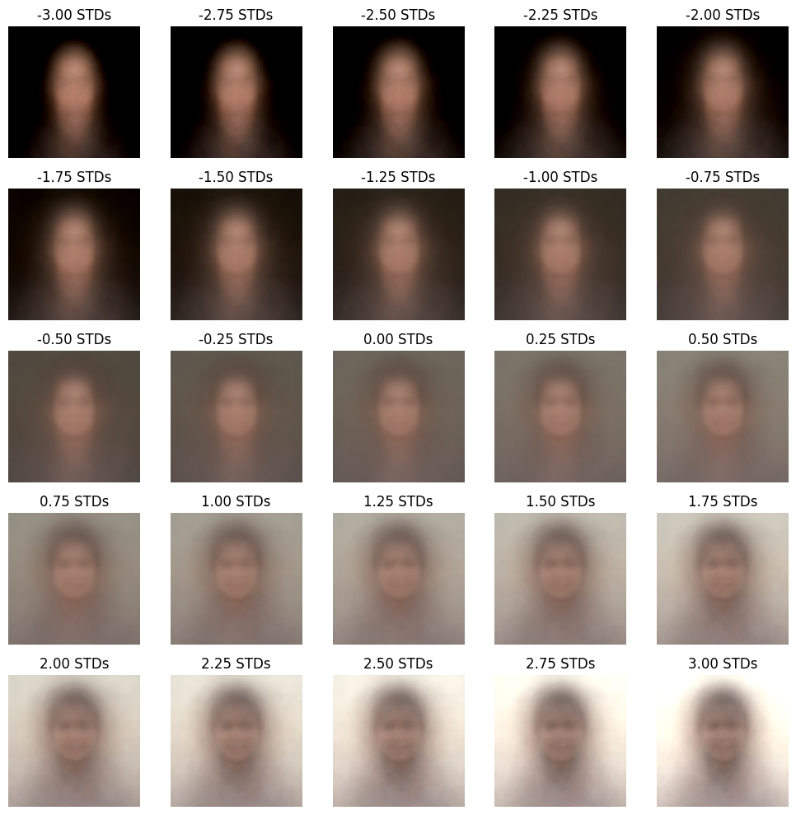

For the modes of variation of *Fig. 4* what we are doing is selecting the mean image in the center, and from there we are adding and subtracting different amounts of standard deviations from the eigenface chosen. The exact formula for a variant with chosen component is , where is the standard deviation chosen, are the eigenvalues and is the array of eigenvectors.

In the case of *Fig. 4* we have chosen the first eigenvector, but since the variance of the calculated eigenfaces is not very significant and the mean face weighs a lot in this step, it does not change significantly if we were to choose another component instead.

*Fig. 4 Modes of variation*

In *Fig. 5* we can see the reconstruction of a facial image according to the number of components used in the reconstruction. It is easy to observe that because the total variance of the 10 first eigenfaces is approximately 60% it is not sufficient to fully reconstruct the original image. This may be because the number of components is not enough, however if we compare the reconstructed images using 15 components it is still not sufficient to reconstruct the original image. In consequence it must be because of the assumptions that eigenfaces make regarding facial variation. If variations in the dataset are more complex or nonlinear w.r.t. the eigenfaces of the reconstruction will not accurately match the original image. Hence other facial recognition methods may be more appropriate for handling this dataset.

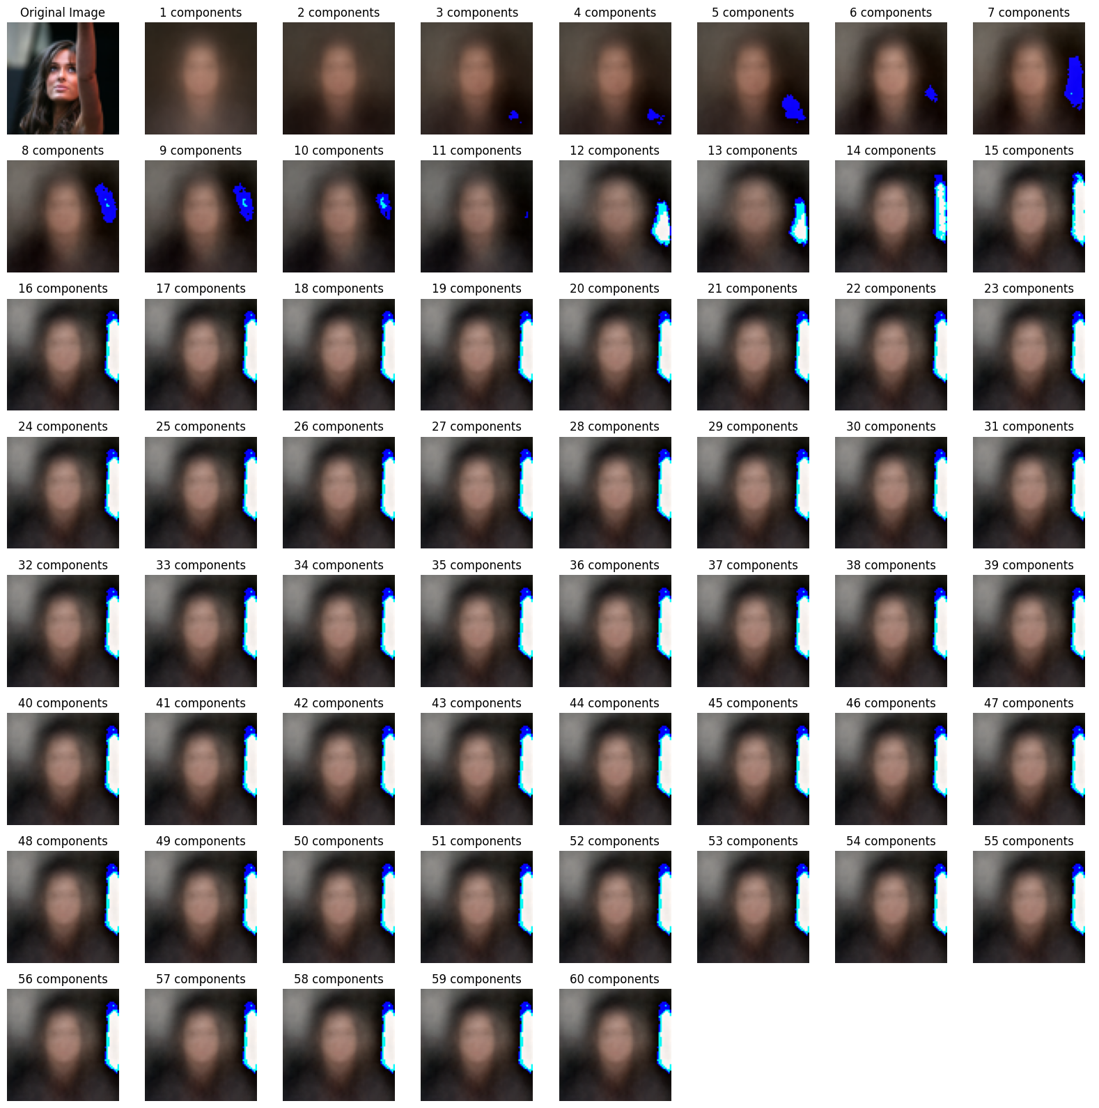*Fig. 5 Original image and the reconstruction comparison with up to 15 components*

## FACIAL LANDMARKS

Principal components analysis follows the same structure with facial landmarks with facial images, hence the following figures are not explicitly explained, yet the concepts are the same.

Despite using the same functions, the preprocessing is a little different. We have seen that by resizing a point in the original image and then select that pixel in the array as a landmark, as well as its surrounding pixels gives us better results regarding the explained variance than just placing the pixel in the resized image (before at most 30% with 40 components, now up to 60% explained variance with the same components).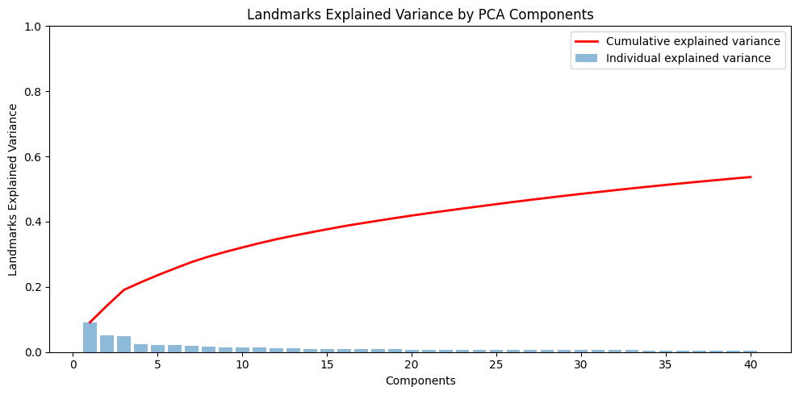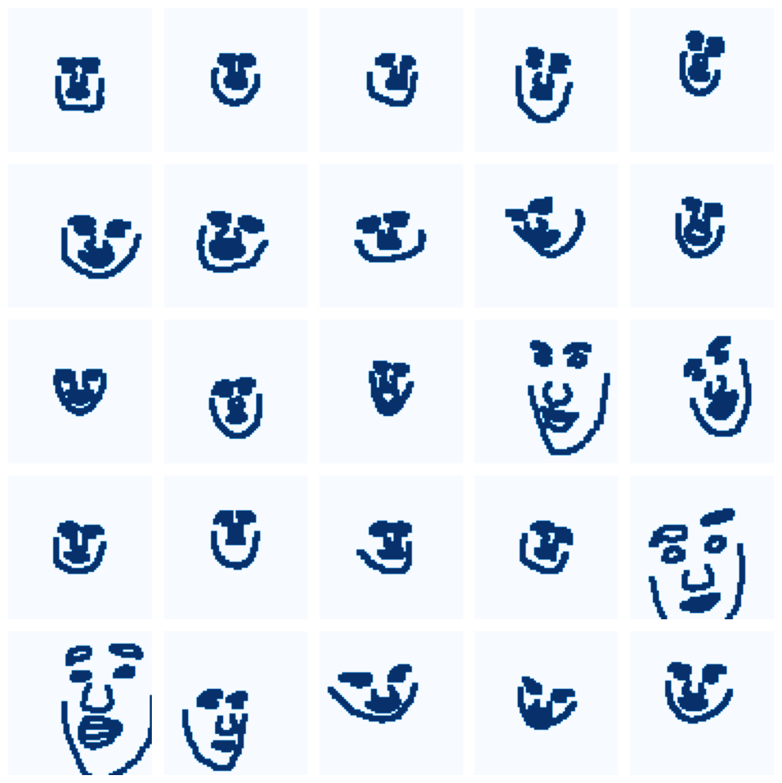

*Fig. 6 First 10 principal components of the landmarks Fig. 7 Landmarks explained variance by PCA components*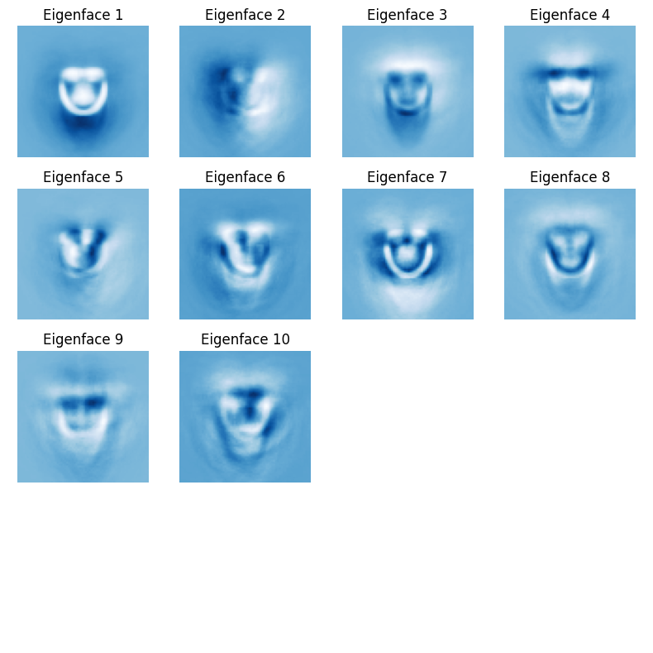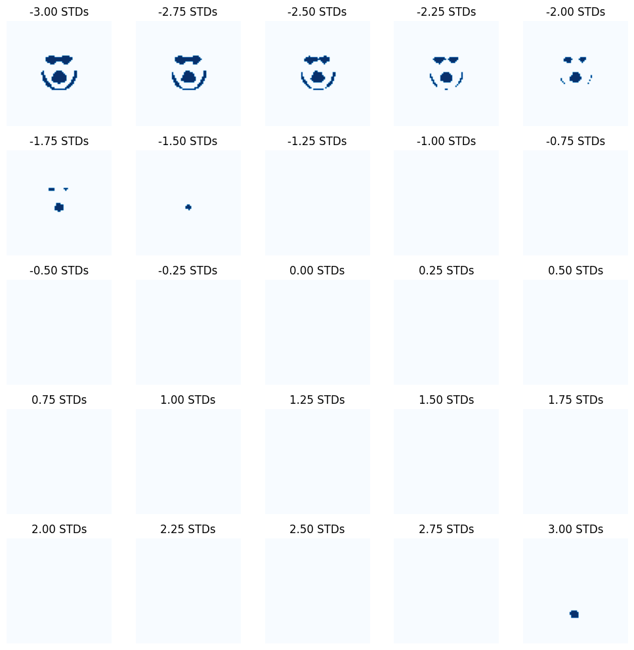

*Fig. 8 First 10 eigenfaces extracted from the facial images Fig. 9 Modes of variation of the landmarks*

# REFERENCES

### [1] Jalaja, V., & Anjaneyulu, G. S. G. N. (2020). Face recognition by using eigenface method. ORL, 96(24), 5.

### [2] Sirevich L., & Kirby, M (1987). Low-dimensional procedure for the characterization of human faces. Journal Of The Optical Society Of America A, 4(3), 519. doi: 10.1364/josaa.4.000519

### [3] Adjabi, I.; Ouahabi, A.; Benzaoui, A.; Taleb-Ahmed, A. Past, Present, and Future of Face Recognition: A Review. Electronics 2020, 9, 1188. https://doi.org/10.3390/electronics9081188

### [4] M.üge Çarıkçı, & Abstract Face recognition systems are built on the idea that each person has a particular face structure. (2012, May 23). A face recognition system based on eigenfaces method. Procedia Technology.

### [5] Sukno, F. (2024, January). Face and Gesture Analysis & Automatic Facial Analysis. Slides Theory 2 - Eigenfaces & Active Shape Models. Barcelona.

### [6] Vuong et al., (2012). Helen dataset [Data set]. Retrieved January 17, 2024. http://www.ifp.illinois.edu/~vuongle2/helen/