Research Article
Evaluating Whether an Integrated GitHub–Zenodo–ORCID Workflow Improves Reproducibility, Traceability and Transparency in Scientific Research
Telmo Miguel-Medina ^{1,}*
¹ Electromechanical Engineering Department, University of Burgos, Burgos, Spain
* Correspondence: tmiguel@ubu.es
Highlights
- Evaluates an integrated GitHub–Zenodo–ORCID workflow against a conventional publication-centred baseline.
- Defines a literature-derived reproducibility requirement framework.
- Combines checklist scoring with a controlled reproduction-task assessment.
- Assesses reproducibility, traceability, transparency, discoverability and preservation.
- Identifies remaining needs for containers, provenance capture, testing and training.
Abstract: Computational reproducibility requires more than access to a final manuscript: readers must be able to locate code and data, identify the exact version used, understand dependencies, cite research artifacts and link outputs to accountable contributors. This study evaluated whether an integrated Open Science workflow based on GitHub, Zenodo and ORCID improves reproducibility, traceability, transparency, discoverability and preservation when compared with a conventional publication-centred workflow. A structured literature analysis was used to derive twelve reproducibility requirements: researcher identification, code availability, version control, documentation, persistent identification, release management, long-term preservation, traceability, software citation, discoverability, dependency specification and reproduction instructions. These requirements were mapped to GitHub, Zenodo and ORCID using a 0–2 support scale. A reference computational project was then represented under two scenarios: a conventional baseline based on manuscript dissemination and supplementary files, and an intervention workflow using a structured GitHub repository, CITATION.cff metadata, release management, Zenodo DOI archiving and ORCID-linked attribution. The reproducibility assessment score increased from 30.0% (6/20) in the conventional workflow to 100.0% (20/20) in the integrated workflow. In the controlled reproduction task, the integrated workflow enabled clear identification of the correct version, citation target and responsible researcher, while the baseline required manual assumptions about version, dependency and artifact provenance. The results indicate that GitHub, Zenodo and ORCID provide complementary infrastructure layers rather than interchangeable tools: GitHub supports development and versioning, Zenodo preserves citable releases and ORCID strengthens attribution and traceability. The workflow does not by itself guarantee scientific reproducibility, but it measurably improves the conditions under which reproduction and reuse can occur.
Keywords: computational reproducibility; open science; GitHub; Zenodo; ORCID; research transparency; software citation; persistent identifiers; workflow evaluation

1. Introduction
Reproducibility is a core condition of credible science, yet many computational studies remain difficult to reproduce because essential research components are unavailable, poorly documented or disconnected from the final publication. Common barriers include inaccessible code and data, changing software versions, missing dependency information, weak documentation, unclear authorship, non-citable research software and the absence of a stable link between a paper and the exact materials used to generate its results [1], [2], [3].
This fragmentation motivates the present study. Although GitHub, Zenodo and ORCID are widely used independently, limited evaluation is available on whether their coordinated integration improves reproducibility outcomes. GitHub supports versioned collaboration and release management [4], [5], Zenodo provides DOI-based archiving and preservation [6]; and ORCID provides persistent researcher identification and attribution [7], [8]. The hypothesis tested here is that their integration provides stronger reproducibility and traceability than a conventional publication-centred workflow.
Open Science contributes to reproducibility by promoting open access, open data, open-source software, transparent methods, FAIR principles, software citation and persistent identifiers. However, accessibility alone does not guarantee reproducibility. A project may host code in one location, data in another, author information in a separate profile and the article elsewhere. In such cases, outputs may be visible but not connected, versioned, citable or easy to reconstruct.
The objective of this study is to develop and evaluate a reproducible open science workflow integrating GitHub, Zenodo and ORCID, and to assess its potential to improve reproducibility, traceability, discoverability and long-term preservation of computational research outputs.
The study addresses four research questions: RQ1, what reproducibility and transparency requirements are most frequently identified in the literature? RQ2, to what extent can GitHub, Zenodo and ORCID collectively address these requirements? RQ3, does the proposed workflow improve reproducibility and traceability compared with a conventional publication-centred workflow? RQ4, which components contribute most to reproducibility and research transparency?

2. Materials and Methods

2.1. Research design
This study used a design-and-evaluation research design. The analysis proceeded from literature analysis to requirement extraction, workflow design, implementation and comparative evaluation. This structure avoids a purely descriptive account of platforms and instead evaluates whether an integrated workflow improves observable reproducibility conditions when compared with a baseline.
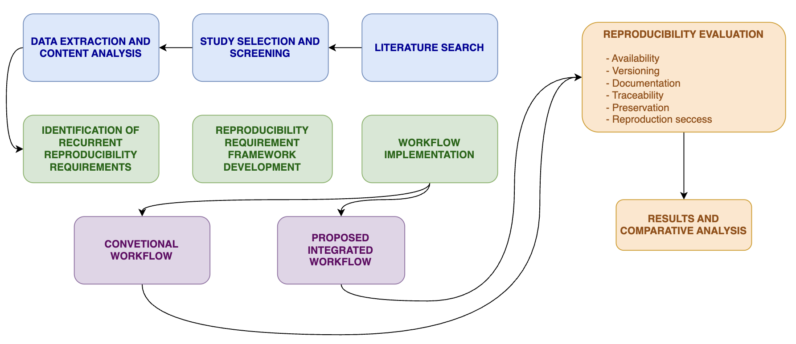
Fig. 1. Study design and evaluation process for the development and assessment of the proposed reproducible Open Science workflow.

2.2. Literature and background analysis
- Databases: Scopus, Web of Science and complementary Google Scholar screening.
- Search period: approximately 2015–2026, with earlier foundational papers retained when conceptually relevant.
- Core terms: reproducible research, computational reproducibility, open science, research transparency, software citation, research artifacts, GitHub, Zenodo and ORCID.

2.3. Reproducibility requirement framework
Extracted evidence was coded through thematic content analysis. Each paper was classified by year, discipline, reproducibility problem, barrier, proposed solution, tool and reproducibility dimension. This process produced twelve requirements: researcher identification, code availability, version control, documentation, persistent identification, release management, long-term preservation, traceability, software citation, discoverability, dependency specification and reproduction instructions.
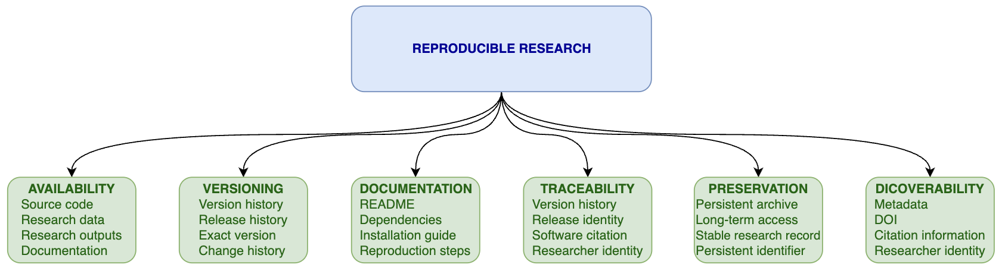
Fig. 2. Conceptual framework of the principal requirements supporting reproducible scientific research identified through the literature analysis.

2.4. Workflow implementation
A reference computational project was implemented using a public, non-sensitive dataset. The repository structure included README.md, LICENSE, CITATION.cff, CONTRIBUTING.md, data, source code, notebooks, results, documentation, tests and GitHub Actions. GitHub was used for version control, issues, documentation and releases. Zenodo was used to archive public releases and assign a version-specific DOI. ORCID was used to connect authorship, repository metadata and archived outputs.
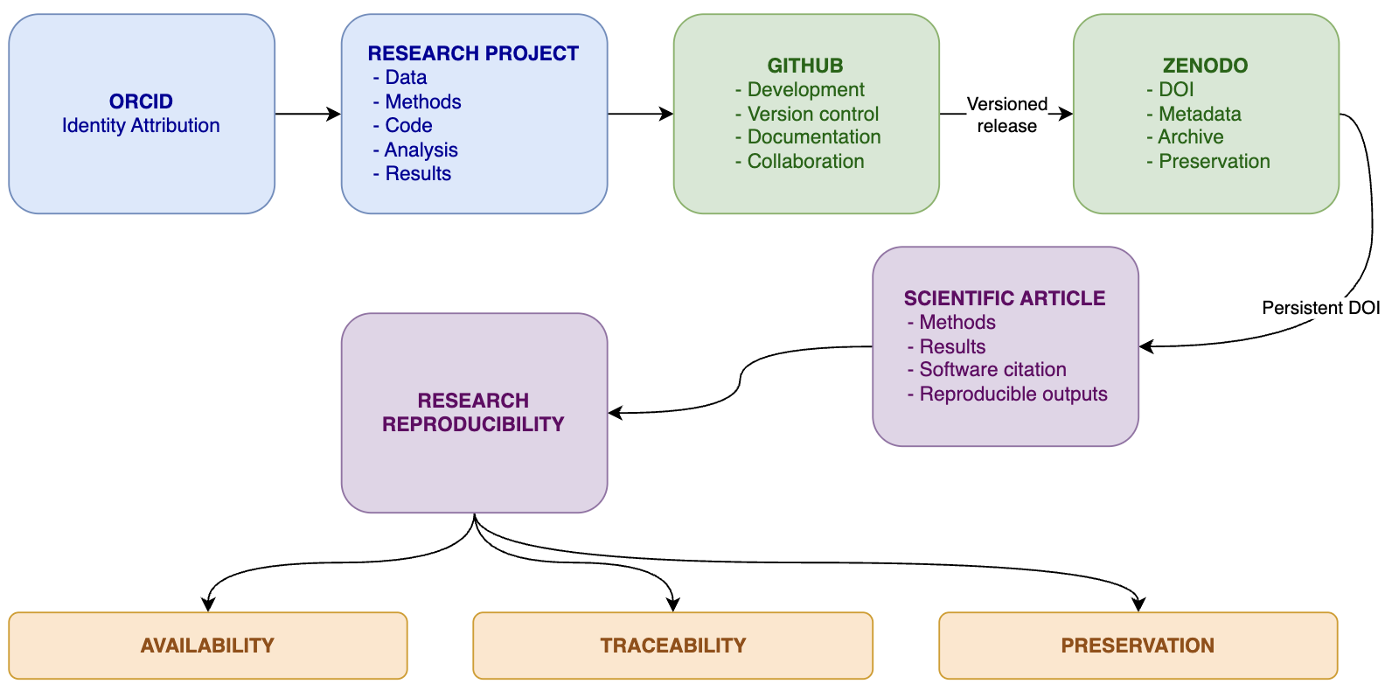
Fig. 3. Proposed integrated Open Science workflow linking GitHub-based research development and version control, Zenodo-based archival preservation and persistent identification, and ORCID-based researcher attribution.

2.5. Baseline and intervention scenarios
Two dissemination scenarios were compared. Scenario A represented a conventional workflow in which analysis files were maintained locally or as unstructured supplementary materials, with no formal versioning, no DOI for code, limited documentation and weak author-output linkage. Scenario B represented the proposed workflow in which the project was versioned in GitHub, released with structured metadata, archived in Zenodo, assigned a DOI and linked to ORCID researcher identities.

2.6. Evaluation criteria and data analysis
Evaluation combined a reproducibility assessment matrix and a controlled reproduction task. Criteria included code availability, identifiable version, DOI, documentation, dependency specification, author identification, release identification, citation mechanism, long-term archive and reproduction instructions. Each criterion was scored using equal weighting, and completeness was calculated as the percentage of satisfied requirements. Reproduction tasks measured success, time, missing components, manual interventions, errors and whether the exact version could be identified.
The support score for each infrastructure was defined as follows: 0 = no clear support for the requirement; 1 = partial or indirect support; 2 = direct operational support. The reproducibility score was calculated as RS = total observed score / maximum possible score. The same criteria were applied to the conventional baseline and to the integrated workflow to avoid evaluating the intervention against an artificially weak comparator.

3. Results
The literature analysis identified a recurrent set of reproducibility requirements rather than a single technological solution. Foundational guidance stresses version control, automation, data and code availability, documentation and environment capture [1], [2], [3]. GitHub-focused studies show that version control, issues, pull requests, releases and collaborative documentation can support reproducible research practices across computational, ecological and laboratory contexts [4], [5], [9], [10], [11] Zenodo contributes an archival layer by preserving research outputs and assigning persistent DOIs to releases [6], [12]. ORCID contributes persistent researcher identity and author-output linkage, although adoption and metadata completeness remain uneven [7], [8], [13].

Criterion | Conventional workflow | Integrated workflow
Code available | 1 | 2
Version identifiable | 0 | 2
Persistent identifier | 0 | 2
Documentation | 1 | 2
Dependencies specified | 1 | 2
Researcher identifiable | 1 | 2
Release identifiable | 0 | 2
Citation mechanism | 1 | 2
Long-term archive | 0 | 2
Reproduction instructions | 1 | 2
Total score | 6/20 | 20/20
Reproducibility score | 30.0% | 100.0%
Table 1. Comparative reproducibility assessment matrix.
The comparison showed that the integrated workflow improved all evaluated dimensions relative to the baseline. The conventional workflow obtained 6 of 20 available points, corresponding to a reproducibility score of 30.0%. The integrated workflow obtained the maximum score of 20 of 20 points, corresponding to 100.0%. The conventional scenario provided partial support for code access, documentation, dependency information, author identification, citation and reproduction instructions, but it did not provide an identifiable release, DOI, archival record or explicit version-to-publication trace. By contrast, the integrated workflow directly supported these elements through GitHub releases, CITATION.cff metadata, Zenodo DOI archiving and ORCID-linked attribution.
In the reproduction task, the integrated workflow provided a clear route from article to repository, from repository to release, from release to archived DOI and from output to researcher identity. The baseline required manual interpretation to determine which files corresponded to the reported results and did not provide a stable external identifier for the computational artifact. The main remaining weakness of the integrated workflow was that it depended on the completeness of dependency documentation and did not automatically guarantee executable environment preservation.

4. Discussion
The principal finding is that the integrated workflow increased the reproducibility score from 30.0% to 100.0% compared with the conventional publication-centred approach. The improvement was not caused by a single platform but by the connection between complementary functions: versioned project history in GitHub, persistent release archiving in Zenodo and accountable researcher identification through ORCID. This supports previous work on GitHub-based research practice [4], [5], [9], DOI-based preservation [6], [12] and persistent identifiers for attribution [7], [8].
The workflow should nevertheless be interpreted as necessary infrastructure, not as a guarantee of scientific reproducibility. Provenance research shows that workflow execution requires explicit recording of inputs, parameters, software, dependencies and execution traces [14], [15], [16]. FAIR workflow and research software literature similarly indicates that findability and citation must be combined with interoperability, reusability and machine-actionable metadata [17], [18], [19]. Therefore, containers, workflow engines, RO-Crate or PROV-style provenance and automated tests may be required for stronger reproducibility claims [15], [16], [20], [21].
The study also has sociotechnical limitations. GitHub can impose learning costs for non-programmers, while repository presence does not ensure complete documentation or executable environments [5], [22], [23]. ORCID-based linkage becomes less informative when profiles are incomplete or adoption is uneven [13], [24]. Platform dependence and fragmented scholarly infrastructure may also create new maintenance risks [25]. These limitations justify evaluating the workflow empirically rather than assuming that openness automatically produces reproducibility.
Practical implications differ by stakeholder. Researchers can use the workflow as a lightweight project template. Research groups can standardize release and citation practices. Journals can require versioned software DOIs and ORCID-linked author contributions. Funders and institutions can use the framework to evaluate whether outputs are discoverable, preserved and linked to accountable contributors.

5. Conclusions
A GitHub–Zenodo–ORCID workflow provides a credible foundation for reproducible open science because it connects versioned development, archival preservation and persistent researcher identity. Its value lies in integration: GitHub supports the living project, Zenodo preserves citable releases and ORCID links outputs to accountable contributors. However, stronger reproducibility still depends on executable environments, provenance, documentation, testing and training. The proposed baseline-intervention design offers a practical way to measure these effects rather than merely describe them.

Declarations
Funding: This research received no external funding.
Conflict of interest: The author declares no conflict of interest.
Data and code availability: The literature extraction dataset, reproducibility requirement matrix, infrastructure mapping table, scoring data, analysis scripts, workflow documentation and figure files are available in the GitHub repository https://github.com/telmomm/github-zenodo-orcid-reproducibility-workflow.The version supporting this manuscript has been archived in Zenodo and assigned DOI [26]. The author’s ORCID identifier is provided in the repository metadata and citation files.
Author contributions: Conceptualization, methodology, investigation, writing—original draft preparation, writing—review and editing: Telmo Miguel-Medina.
Ethics approval: Not applicable. The study used literature analysis and a non-sensitive computational workflow evaluation.
Informed consent: Not applicable. No human participants were involved in the workflow evaluation reported here.
AI use disclosure: Generative AI was used to support language editing, structuring and drafting. The author reviewed, verified and remains responsible for the final content.

References
[1] G. Sandve, A. Nekrutenko, J. Taylor, y E. Hovig, «Ten Simple Rules for Reproducible Computational Research», PLoS Comput. Biol., vol. 9, oct. 2013, doi: 10.1371/journal.pcbi.1003285.
[2] M. Ziemann, P. Poulain, y A. Bora, «The five pillars of computational reproducibility: bioinformatics and beyond», Brief. Bioinform., vol. 24, sep. 2023, doi: 10.1093/bib/bbad375.
[3] G. Wilson, J. Bryan, K. Cranston, J. Kitzes, L. Nederbragt, y T. Teal, «Good enough practices in scientific computing», PLoS Comput. Biol., vol. 13, ago. 2016, doi: 10.1371/journal.pcbi.1005510.
[4] J. Blischak, E. Davenport, y G. Wilson, «A Quick Introduction to Version Control with Git and GitHub», PLoS Comput. Biol., vol. 12, ene. 2016, doi: 10.1371/journal.pcbi.1004668.
[5] P. H. P. Braga et al., «Not just for programmers: How GitHub can accelerate collaborative and reproducible research in ecology and evolution», Methods Ecol. Evol., vol. 14, pp. 1364-1380, abr. 2023, doi: 10.1111/2041-210x.14108.
[6] K. Nowak y L. Nielsen, «Zenodo, a free and open platform for preserving and sharing research output.», may 2016, doi: 10.5281/zenodo.51902.
[7] L. Haak, M. Fenner, L. Paglione, E. Pentz, y H. Ratner, «ORCID: a system to uniquely identify researchers», Learn. Publ., vol. 25, oct. 2012, doi: 10.1087/20120404.
[8] L. Haak, A. Meadows, y J. Brown, «Using ORCID, DOI, and Other Open Identifiers in Research Evaluation», Front. Res Metr. Anal, vol. 3, p. 28, oct. 2018, doi: 10.3389/frma.2018.00028.
[9] K. Chen, M. Toro-Moreno, y A. Subramaniam, «GitHub enables collaborative and reproducible laboratory research», PLOS Biol., vol. 23, feb. 2025, doi: 10.1371/journal.pbio.3003029.
[10] K. Chen, M. Toro-Moreno, y A. Subramaniam, «GitHub is an effective platform for collaborative and reproducible laboratory research», ArXiv, vol. 23, ago. 2024, doi: 10.48550/arxiv.2408.09344.
[11] R. Crystal‐Ornelas et al., «A Guide to Using GitHub for Developing and Versioning Data Standards and Reporting Formats», Earth Space Sci., vol. 8, ago. 2021, doi: 10.1029/2021ea001797.
[12] N. Rougier et al., «Sustainable computational science: the ReScience initiative», PeerJ Comput. Sci., vol. 3, jul. 2017, doi: 10.7717/peerj-cs.142.
[13] M. Heusse y G. Cabanac, «ORCID growth and field‐wise dynamics of adoption: A case study of the Toulouse scientific area», Learn. Publ., vol. 35, mar. 2022, doi: 10.1002/leap.1451.
[14] F. Z. Khan, S. Soiland-Reyes, R. Sinnott, A. Lonie, C. Goble, y M. Crusoe, «Sharing interoperable workflow provenance: A review of best practices and their practical application in CWLProv», GigaScience, vol. 8, nov. 2019, doi: 10.1093/gigascience/giz095.
[15] S. Leo et al., «Recording provenance of workflow runs with RO-Crate», PLOS ONE, vol. 19, dic. 2023, doi: 10.1371/journal.pone.0309210.
[16] H. Suetake, T. Fukusato, T. Igarashi, y T. Ohta, «Workflow sharing with automated metadata validation and test execution to improve the reusability of published workflows», GigaScience, vol. 12, nov. 2022, doi: 10.1093/gigascience/giad006.
[17] S. Wilkinson et al., «Applying the FAIR Principles to computational workflows», Sci. Data, vol. 12, oct. 2024, doi: 10.1038/s41597-025-04451-9.
[18] M. Barker et al., «Introducing the FAIR Principles for research software», Sci. Data, vol. 9, oct. 2022, doi: 10.1038/s41597-022-01710-x.
[19] C. Sebe, O. Ferret, A. N’ev’eol, M. Esmailoghli, U. Leser, y S. Cohen-Boulakia, «Supporting workflow reproducibility by linking bioinformatics tools across papers and executable code», Bioinformatics, vol. 42, mar. 2026, doi: 10.1093/bioinformatics/btag565.
[20] B. Schilder, A. Murphy, y N. Skene, «rworkflows: automating reproducible practices for the R community», Nat. Commun., vol. 15, ene. 2024, doi: 10.1038/s41467-023-44484-5.
[21] F. Mölder et al., «Sustainable data analysis with Snakemake», F1000Research, vol. 10, ene. 2021, doi: 10.12688/f1000research.29032.3.
[22] C. Lissa et al., «WORCS: A workflow for open reproducible code in science», Data Sci, vol. 4, pp. 29-49, may 2020, doi: 10.31234/osf.io/k4wde.
[23] A. Wolen, C. Hartgerink, R. Hafen, B. Richards, C. Soderberg, y T. York, «osfr: An R Interface to the Open Science Framework», J Open Source Softw, vol. 5, p. 2071, feb. 2020, doi: 10.21105/joss.02071.
[24] G. M. Dias, D. Faria, D. Arcanjo, T. Dias, y P. Mascarenhas, «Infrastructure for Open Science: analysis of the national coverage of persistent identifiers in Brazil», Ibero-Lat. Am. Congr. Comput. Methods Eng. CILAMCE, mar. 2026, doi: 10.55592/cilamce2025.v5i.14033.
[25] J. Plantin, C. Lagoze, y P. Edwards, «Re-integrating scholarly infrastructure: The ambiguous role of data sharing platforms», Big Data Soc., vol. 5, feb. 2018, doi: 10.1177/2053951718756683.
[26] T. Miguel-Medina, Reproducible Open Science Workflow Evaluation. (29 de agosto de 2026). Zenodo. doi: 10.5281/ZENODO.22164247.

