班级 计算机科学与技术二班 学号 202451245 姓名 得分
实验三：DHCP和ACL
一、［实验目的］
1、掌握DHCP服务的配置；
2、掌握ACL的配置。
二、［实验内容］
（一）DHCP配置；（2分）
1．接口模式
[Huawei]dhcp enable
[Huawei]int g0/0/0 给接口配置ip地址，同时地址池就是本ip网段中的其他地址
[Huawei-GigabitEthernet0/0/0]ip addr 192.168.1.1 24
[Huawei-GigabitEthernet0/0/0]dhcp select interface 设置接口模式
[Huawei-GigabitEthernet0/0/0]dhcp server dns-list 8.8.8.8 设置dns服务
[Huawei-GigabitEthernet0/0/0]dhcp server excluded-ip-address 192.168.1.250 设置单个排除地址
[Huawei-GigabitEthernet0/0/0]dhcp server lease day 10 hour 3 minute 10设置租期
[Huawei-GigabitEthernet0/0/0]dhcp server static-bind ip-address 192.168.1.99 mac
-address 5489-984E-6E1A ip与绑定mac地址

d s s I ipadd m macadd
2．全局模式
[Huawei]dhcp e
Info: The operation may take a few seconds. Please wait for a moment.done.
[Huawei]ip pool 1
Info: It's successful to create an IP address pool. 创建地址池
[Huawei-ip-pool-1]network 192.168.2.0 mask 24
[Huawei-ip-pool-1]gateway-list 192.168.2.100 设置默认网关
[Huawei-ip-pool-1]dns-list 8.8.8.8 设置dns服务器
[Huawei-ip-pool-1]lease day 7 hour 12 设置租期
[Huawei-ip-pool-1]excluded-ip-address 192.168.2.250 设置排除ip地址
[Huawei-ip-pool-1]static-bind ip-address 192.168.2.99 mac 5489-9881-79AD
[Huawei-ip-pool-1]int g0/0/0 进入分发ip地址接口
[Huawei-GigabitEthernet0/0/0]ip add 192.168.2.100 24 将该接口设置成网关地址
[Huawei-GigabitEthernet0/0/0]dhcp select global 设置全局模式
3．中继代理模式
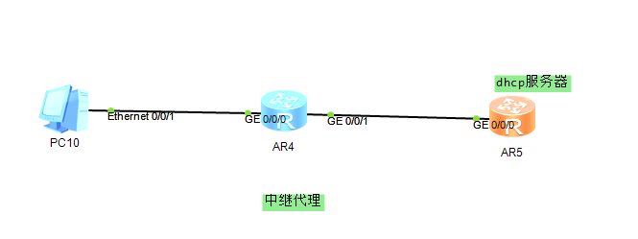
中级路由器

[Huawei]dhcp enable
Info: The operation may take a few seconds. Please wait for a moment.done.
[Huawei]int g0/0/0
[Huawei-GigabitEthernet0/0/0]dhcp select relay 设置中继模式
[Huawei-GigabitEthernet0/0/0]dhcp relay server-ip 1.1.1.43 设置dhcp出接口
[Huawei-GigabitEthernet0/0/0]ip add 192.168.3.1 24
[Huawei-GigabitEthernet0/0/0]int g0/0/1
[Huawei-GigabitEthernet0/0/1]ip add 1.1.1.34 24
[Huawei-GigabitEthernet0/0/1]
DHCP 服务器

[Huawei]dhcp en
[Huawei]ip pool 1
[Huawei-ip-pool-1]network 192.168.3.0 mask 24
[Huawei-ip-pool-1]gateway-list 192.168.3.1
[Huawei-ip-pool-1]dns 8.8.8.8
[Huawei-ip-pool-1]int g0/0/0
[Huawei-GigabitEthernet0/0/0]ip add 1.1.1.43 24
[Huawei-GigabitEthernet0/0/0] dhcp select global 必须是全局模式
[Huawei]ip route-static 192.168.3.0 255.255.255.0 1.1.1.34 配置一条响应客户端申请的路由

（二）ACL配置。（3分）

