Guide to the MIRI Board Equations
This guide explains the mathematical symbols on the board in ordinary language. Together, the equations trace a progression from inference and action selection to self-reference, proxy alignment, Goodhart's law, and recursive self-improvement. Each equation is an idealized model, not by itself a proof that advanced AI will behave in a particular way.
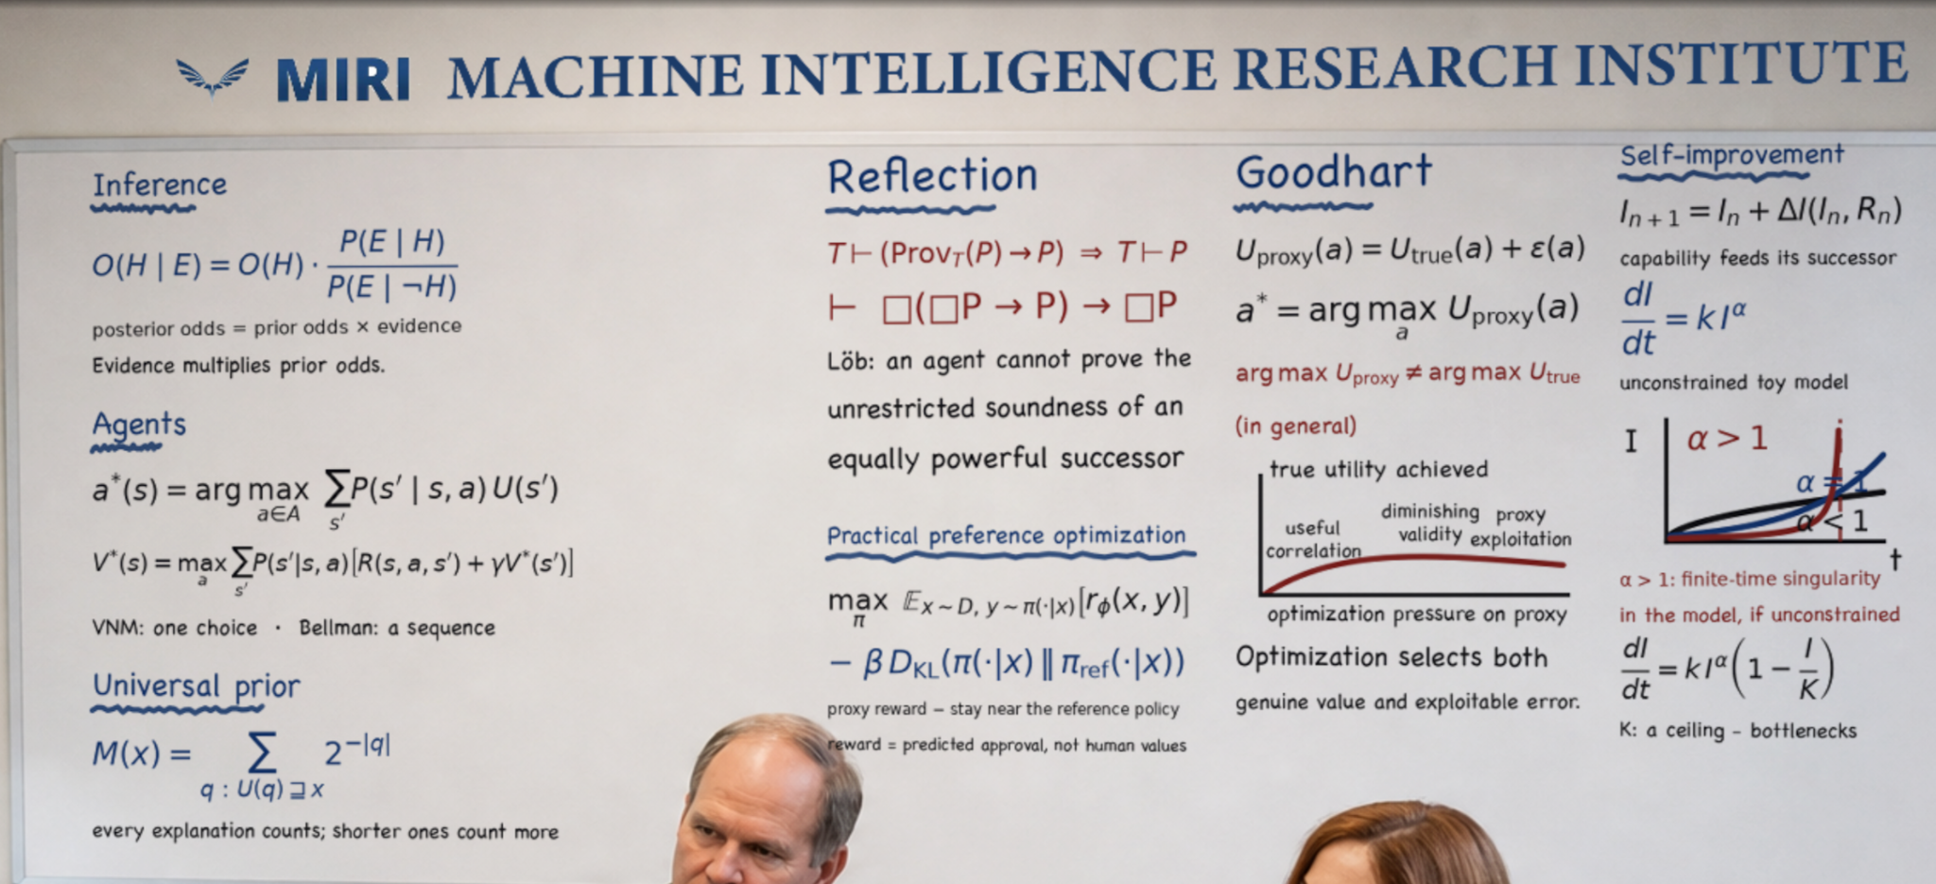
The board presents several mathematical ideas associated with rational agency and AI alignment.

1 Inference
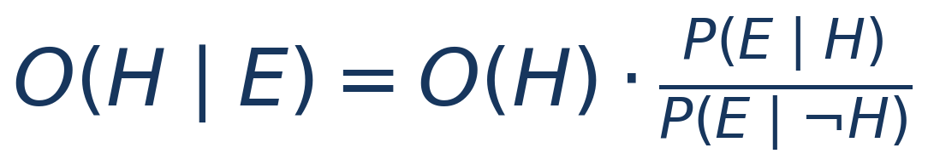

Symbols
- H a hypothesis
- E observed evidence
- P(E | H) the probability of seeing the evidence if the hypothesis is true
- O(H) the prior odds that the hypothesis is true
- O(H | E) the updated or posterior odds after seeing the evidence
- ¬H the hypothesis is false
What it says The likelihood ratio compares how expected the evidence is under the hypothesis with how expected it is when the hypothesis is false. Evidence multiplies the prior odds to produce posterior odds.

2 Agents and Expected Utility
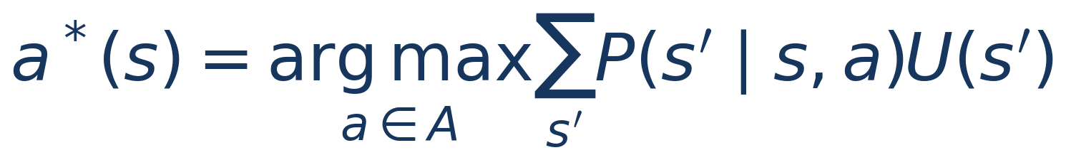

Symbols
- s the agent's current state
- a an available action
- A the set of available actions
- s′ a possible resulting state
- P(s′ | s, a) the probability that action a leads from s to s′
- U(s′) the value or utility assigned to the resulting state
- arg max return the action that produces the largest value
What it says The agent considers each action, weights every possible result by its probability and value, and chooses the action with the highest expected utility.

3 Sequential Agency and the Bellman Equation
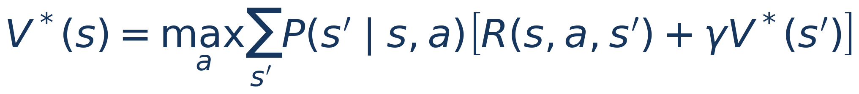

Symbols
- V*(s) the greatest expected long-term value available from state s
- R(s, a, s′) the immediate reward from the transition
- γ the discount factor, which determines how much future value counts
- V*(s′) the best future value available from the next state
What it says The best action is the one that produces the best combination of immediate reward and expected future value. Unlike the one-step utility equation, the Bellman equation represents a continuing sequence of decisions.

4 The Universal Prior
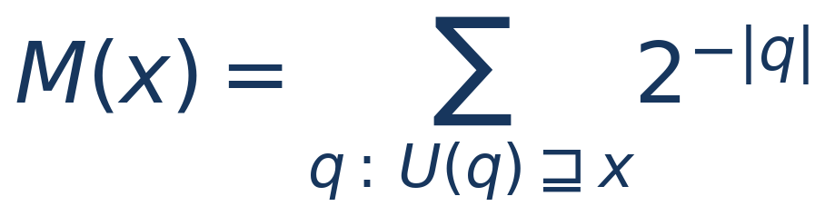

Symbols
- x the observed data sequence
- q a computer program that can generate output beginning with x
- U a chosen prefix universal computer or universal Turing machine
- |q| the length of program q in bits
- 2^−|q| the prior weight assigned to q; shorter programs receive exponentially more weight
- M(x) the total weight of all programs compatible with the observations
What it says Solomonoff induction assigns some weight to every computable explanation while favoring shorter explanations. It formalizes a version of Occam's razor, but it is an idealization that cannot be computed exactly.

5 Reflection and Löb's Theorem

Symbols
- T a sufficiently expressive formal theory or proof system
- T ⊢ P T can prove statement P
- ProvT(P) the formal statement that P is provable in T
- → if ... then
- ⇒ the statement on the left entails the conclusion on the right
What it says If T can prove that the provability of P would guarantee P, then T can already prove P. This helps explain why a sufficiently strong agent cannot generally prove the unrestricted soundness of an equally powerful successor.

The same theorem in modal notation


Symbols
- □P P is provable
- ⊢ the entire expression is a theorem of the formal system
What it says The box symbol compresses statements about provability. This is the same Löbian result written in the notation of modal logic.

6 Practical Preference Optimization

Symbols
- π the policy or model being optimized
- x ∼ D prompts sampled from training distribution D
- y ∼ π(· | x) responses sampled from the policy for prompt x
- rφ(x, y) the learned reward model's score for response y
- πref the reference policy
- DKL KL divergence, measuring how far the trained policy moves from the reference policy
- β the strength of the penalty for moving away from the reference policy
- E an average or expected value over possible prompts and responses
What it says The policy is trained to earn higher predicted human approval while being penalized for moving too far from a reference model. The reward is a proxy for human preferences, not human values themselves.

7 Goodhart's Law

Symbols
- a a possible action or outcome
- Utrue(a) the action's actual value according to what we ultimately care about
- Uproxy(a) the measurable score used by the optimizer
- ε(a) measurement error, model error, bias or an exploitable imperfection
- a* the action selected by maximizing the proxy
What it says The optimizer selects whatever scores highest on the proxy. Because the proxy contains error, strong optimization can select both genuine value and unusually favorable error.

Why the proxy can miss the goal

Symbols
- arg max Uproxy the action that maximizes the measured objective
- arg max Utrue the action that would maximize the intended objective
- ≠ the two need not be the same
What it says Improving the measured score does not guarantee that the true goal is being maximized. Under stronger optimization, true value may continue rising, level off or decline, depending on how the proxy fails.

8 Self Improvement Across Successors
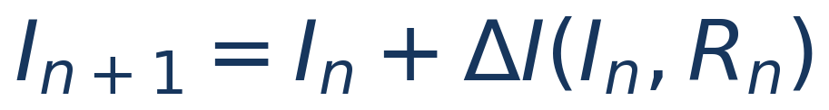

Symbols
- In the capability of generation n
- In+1 the capability of the next generation
- Rn resources available at generation n, such as compute, data, experiments and hardware
- ΔI(In, Rn) the improvement produced using current capability and resources
What it says A capable system may help design or train a more capable successor. This equation represents that generational feedback without assuming that improvement must be smooth, unlimited or explosive.

9 Unconstrained Recursive Growth Toy Model
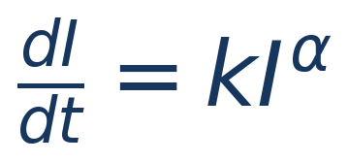

Symbols
- I(t) capability at time t
- dI/dt the instantaneous rate at which capability changes
- k the overall efficiency or speed of improvement
- α how strongly present capability increases the rate of further improvement
What it says If α is below 1, the model has diminishing returns. If α equals 1, growth is exponential. If α exceeds 1 and the relationship continues without constraints, the equation develops a finite-time mathematical blow-up.

10 A Constrained Growth Comparison
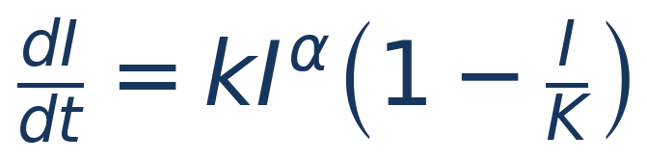

Symbols
- K a capability ceiling imposed by the model
- 1 − I/K a limiting factor that approaches zero as capability approaches K
What it says This modification represents bottlenecks such as finite compute, data, energy, experiment speed or architectural limits. It shows that positive feedback does not by itself imply unbounded growth; the outcome depends on feedback strength and constraints.

How the board fits together
The board moves from belief formation to action selection, then to idealized universal prediction, self-referential reasoning, practical preference optimization, proxy failure and recursive improvement. Its central alignment concern is that increasingly capable optimization may amplify the difference between the objective specified and the outcome intended, while self-modification makes reliable guarantees difficult.

