WhiteBoard
by Team x:

SLACK CHANNEL: https://csc483w18.slack.com

Final Document
For: Dr Mark Allison

On:

Table of Contents

Abstract 3
1.1. Purpose of System 4
1.2. Scope of System 4
1.3. Development Methodology 4
1.4. Definitions, Acronyms, and Abbreviations 4
1.5. Overview of Document 4
2. Current System 4
3. Project Plan 5
3.1. Project Organization 5
3.2. Software and Hardware Requirements 6
3.3. Work Breakdown 6
4. Requirements of System 7
4.1. Functional and Nonfunctional Requirements 7
4.2. IDENTIFY Personas 7
4.3. Use Case Diagram 7
4.3. Requirements Analysis 9
5. Software Architecture 10
5.1. Overview 10
5.2. Subsystem Decomposition 11
5.4. Persistent Data Management 12
6. Object Design 13
6.1. Overview 13
6.2. Object Interaction 13
6.3. Detailed Class Design 14
7. Testing Process 15
8. Glossary 16
9. Appendix 16
9.1. Appendix A – Gantt Chart 16
9.2. Appendix B – Use Cases 17
9.3. Appendix C – User Interface Designs 19
9.5. Appendix E – Class Interfaces for Implemented Subsystems 19

Abstract
The WhiteBoard system is designed to students to access course materials online, and outside of the normal course times. The students will have access to each of their registered courses for the semester. This will range from students being able to find their instructor’s contact information, to accessing online homework assignments, to chatting with students, tutors, and instructors in real-time.
There will also be a feature in the system that will allow students to take notes, and also be able to give access to other students to be able to collaborate during the class time to take notes, enhancing the students’ learning capabilities. The instructor(s) and tutor(s) will also be able to access these notes in order to help clarify any unclear topics of the lecture and to make sure that the student is learning the techniques correctly.

1. Introduction
In this chapter we will introduce the motivation for building the system.

1.1. Purpose of System
The purpose of WhiteBoard is to allow students to have access to their course resources online. This will range from being able to view digital assignments, to being able to view grades that the grader or instructor have posted for a given assignment, to being able to chat and share collaborative notes with other students that are also in the class.

1.2. Scope of System
The scope of the system will be restricted to students, tutors, graders, the instructor(s) for the course, as well as the administrators of the system. While the system will only be designed for courses that plan to implement digital resources for their students, it will still be able to be used if the instructor only plans on tracking grades.

1.3. Development Methodology
Our team will be developing the WhiteBoard software utilizing the agile methodology. This will allow for rapid development cycles, while focusing on producing a quality piece of software for the customer. This will also allow our team to adapt to any changes in the requirements, should they come up during development.
Choosing agile development will increase the chances of our team producing a high-quality product in the end that satisfies all of the needs of the customer.

1.4. Definitions, Acronyms, and Abbreviations
Actors: External entities that interact with the system.
Advisor: A faculty member at the University of Michigan who gives advice to the students, looks over their class schedule and guides them in getting their intended degree.
DD: Design Document.
Deliverable: Work product for client.
Active Courses: Courses that are offered and running for the current semester

1.5. Overview of Document
The rest of the document to follow is our project plan, requirements of the system, software architecture, object design, and testing process. Each of these sections are broken up into their own chapters.

2. Current System
Not applicable due to this system being completely new.

3. Project Plan

3.1. Project Organization
Phase 1 (add Dates)
Editor
System Architect
Leader
Minute Keeper
Secretary/Diary Keeper

Phase 2 (add Dates)
Leader
Validater/Architect
Minute Keeper
Diary Keeper/Tester
Editor

3.2. Software and Hardware Requirements
Hardware: laptop/PC (Pentium 8 or newer CPU, 10 GB of RAM, 15 GB free of hard disk space, CD drive); computer printer, cell phones;.
Software: Rational Rose, MS Word or compatible, MS Power Point or compatible, MS Project, Macromedia Dreamweaver, Adobe Photoshop, IntelliJ IDEA, PHP, Tomcat, MySQL.

3.3. Work Breakdown
Task # | Task | Description | Duration | Dependencies
1 | Project Plan | Get to know team members, brainstorm, assign roles, decide project topic | 3 days
6 | Create use cases | Identify use cases, assign use cases to team members, each team member develops their assigned use cases | 8 days | 1
10 | Review and completion of use cases | Present use case diagrams to professor, correct use cases | 5 days | 6
13 | Development of Personas | Complete | 12 days | 10 (M1) (D1)
17 |  | Present SRD to class, submit SRD to professor | 1 day | 13
18 | Software Architecture | Divide project into subsystems, identify objects, complete design document, | 2 days | 17
22 | Object Design | Transition of software models into source code. | 18 days | 17
30 | Implementation | Database design. Interface Layer, Application Layer and Storage Layer coding. | 40 days | 27 (M3)
35 | Testing Process | Subsystem, System and Evaluation tests. Creation of the User’s Guide. | 16 days | 27
40 | Creation of FD | Complete FD, create Power Point presentation. | 23 days | 30, 35  (M4) (D3)
45 | Presentation of FD | Present and submit the FD. | 1 day | 40

M – Milestone D – Deliverable

4. Requirements of System
The system we are proposing

4.1. Functional and Nonfunctional Requirements
Functional Requirements:
- Users must be able to sign into the system successfully. This applies to all actors.
- The student user/actor must be able to
  - View all active courses they are a member of
  - View all available content within those courses
  - Upload assignments within due date window
  - View their grade in the course
  - Participate in the Live Chat Feed for a course and tutoring appointments
  - Sign up for tutoring sessions for each of their courses
    - Manage their appointments
- The Grader user/actor must be able to
  - View all active courses they are a member of
  - View all available content within those courses
  - View all assignments that are due and assigned in each of those courses
  - Grade all assignments that are uploaded for a given course
  - View all grades that are posted within the course
  - Notify the instructor when an assignment(s) have been graded
- The Tutor user/actor must be able to
  - View all active courses that they are a tutor for
  - View all available assignments within each of those courses
  - Manage tutoring sessions/appointments
  - Create Live Chat Feeds for tutoring appointments
  - Participate in the Live Chat Feed for each course and in tutoring appointments
  - Create notes on tutoring session
- The Instructor user/actor must be able to
  - View all active courses they are teaching or assisting on
  - Create content for their courses
  - Grade all assignments that are uploaded for each course
  - Approve grades that graders submit for each course
  - Assign students to the course and section for active courses
  - Export Grades for each course they are teaching
  - Participate in the Live Chat Feed for each course they are assigned to
  - Create Live Chat Feeds for courses they are teaching
- The Admin user/actor must be able to
  - Have full management rights over the system
  - Access to any course to troubleshoot any issue that may arise

Nonfunctional Requirements:
- The system must provide secure and reliable log on capabilities for users.
- The system must respond to user interactions quickly and efficiently.
- The system must be properly secured from a physical standpoint
- The system must encrypt all traffic and its databases
- The system must be FERPA Compliant

4.2. IDENTIFied Personas

4.3. Use Case Diagram
The next figure depicts the interaction between the actors and the previously described use cases. A description for each actor follows.
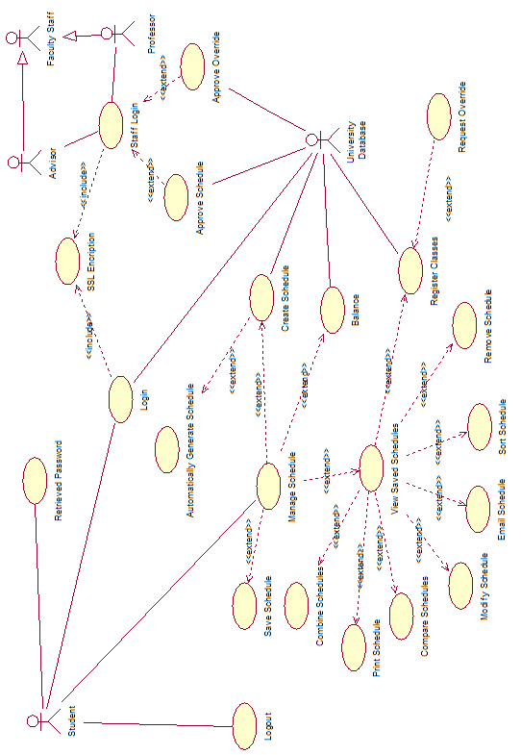
Figure 1: Use Case Diagram

4.3. Requirements Analysis
After identifying the client’s requirements we, as system designers, are in a position to devise the most appropriate solution. By using the use cases to capture all potential requirements, the team will device the most suitable software architecture, which meets the user’s needs. This will ensure the attainment of customer’s expectations as well as providing a functional final product.

5. Software Architecture
.

5.1. Overview
After evaluating and analyzing the main structure and functionalities of our project, the proven, and highly utilized three-tier architecture was chosen for our project. The selection of a three-tier architecture will allow our team to effectively divide the work during our implementation phase. A team member’s area of expertise will dictate which part of the system they’ll work with; this way our team takes full advantage of our multidisciplinary aspects.

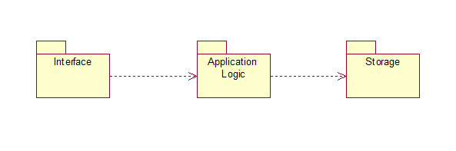
Figure 2: Schedule Maker Package Diagram

5.2. Subsystem Decomposition
.

5.4. Persistent Data Management

6. Object Design
This chapter will build on the architecture and design.

6.1. Overview

6.2. Object Interaction

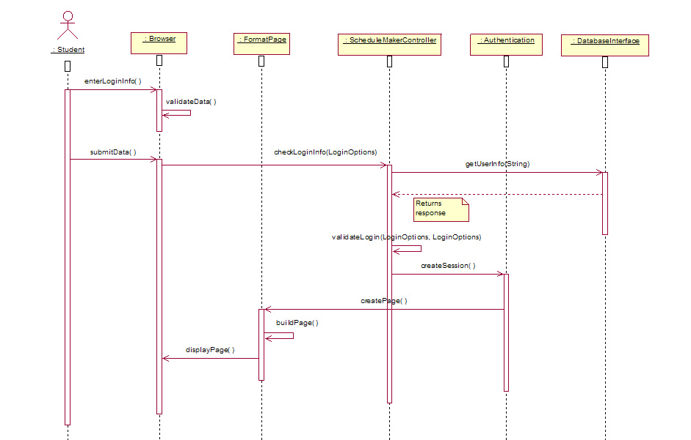
Figure 3: Sequence Diagram for Use Case Team2_Login
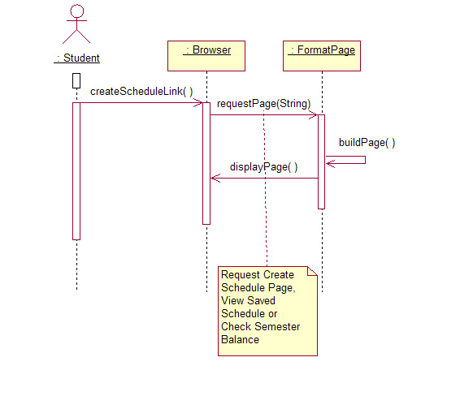
Figure 4: Sequence Diagram for Use Case Team2_ManageSchedule

6.3. Detailed Class Design

7. Testing Process
7.1. User Experience Tests

7.2. Systems Tests

7.3 Subsystems Tests

8. Glossary

9. Appendix

9.1. Appendix A – Gantt Chart
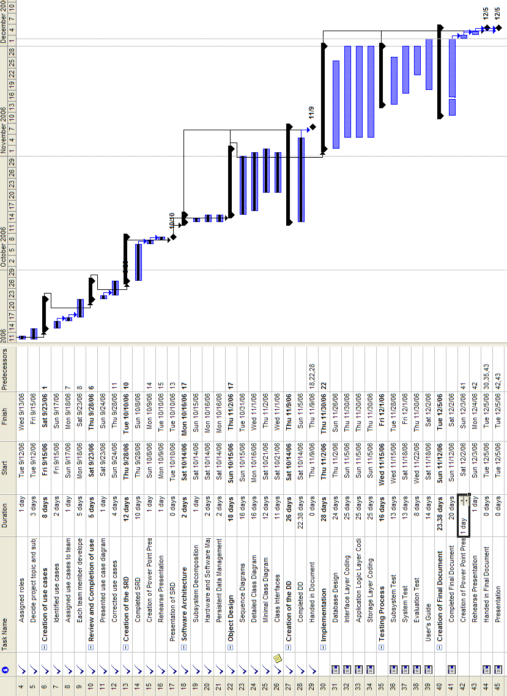
Figure 5: Gantt Chart

9.3. Appendix C – User Interface Designs
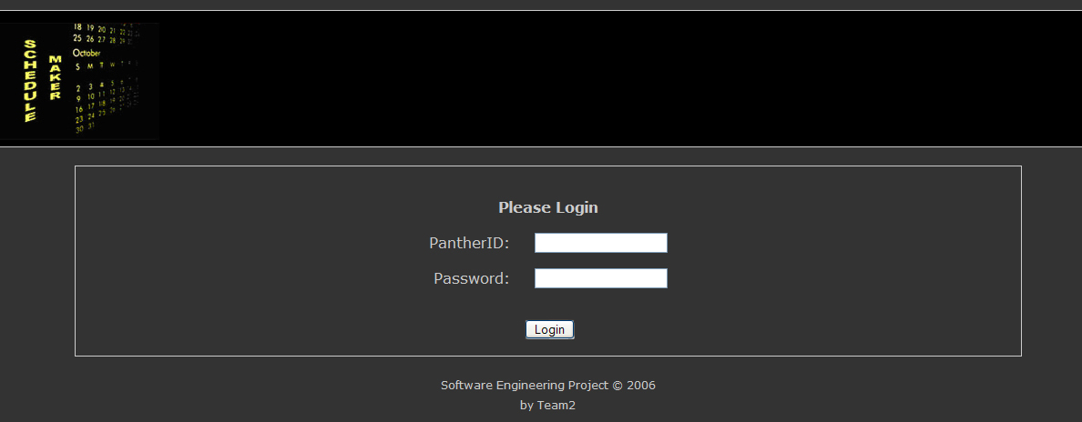
Figure 6: Login Screen

9.5. Appendix E – Class Interfaces for Implemented Subsystems
Interface Subsystem

Browser.java
package Interface;
public class Browser
{
public void enterData()
{}

public void validateData()
{}

public void submitData()
{}

public void displaySchedules()
{}

public void createScheduleLink()
{}

public void displayPage()
{}
public void viewSavedScheduleLink()
{}

public void checkSemesterBalanceLink()
{}

public void displayBalance()
{}

public void enterLoginInfo()
{}

public void clicksLogOut()
{}
}

Application Logic Subsystem

Authentication.java
package ApplicationLogic;
public class Authentication
{
public void createSession()
{}

public void closeSession(String sessionID)
{}
}

FormatPage.java
package ApplicationLogic;
import Storage.Schedule;
public class FormatPage
{
public void createPage()
{}

public void createPage(Schedule schedule[])
{}

public void buildPage()
{}

public void requestPage(String pageName)
{}
}

LoginOption.java
package ApplicationLogic;
public class LoginOption
{
private String pantherID;
private String password;

public LoginOption(String pantherID, String password)
{}

public String getPantherID()
{}

public void setPantherID(String pantherID)
{}

public String getPassword()
{}
public void setPassword(String password)
{}
}

ScheduleMakerController.java
package ApplicationLogic;
public class ScheduleMakerController {

private boolean conflict(Collection c)
{}

private boolean sizeIsOne(Collection c)
{}

private void findSchedule(Collection<Collection<ClassDetails>> c, int cursor, Collection<Schedule> schedules)
{}

public Collection<Schedule> createSchedule(ScheduleOptions schOpt)
{}

public Collection<Schedule> createSchedule(String term, Collection<String> courses, String cmp, String SPDays)
{}

public void sortSchedules()
{}

public void getSavedSchedule()
{}

public void getBalance()
{}

private void findClasses()
{}

public void saveSchedules(Collection<Schedule> schedules)
{}
}

