What is a Join?
A join is an SQL operation that combines rows from two or more tables into a single result set, based on a related column between them. In a relational database, data is split across several tables and connected by keys: a primary key in one table and a foreign key in another. A join follows those keys to bring the related data back together when we need it.
In a hospital system, patient details live in the patients table, doctor details in the doctors table, and each appointment stores only patient_id and doctor_id. To print a report such as "Rahul Verma visited Dr. Ravi Kumar on 10 June", we must join the three tables.
1.2 Why Do We Need Joins?
• Avoid data redundancy: a doctor's name and salary are stored once in doctors, not repeated in every appointment row (this is normalization).
• Combine related data: reports usually need columns from several tables at once, such as patient name, doctor name and fee.
• Maintain data integrity: updating a doctor's specialization in one place automatically reflects everywhere it is joined.
• Answer business questions: appointments per department, patients with no visits, doctors with no appointments, and so on.
• Save storage and improve consistency compared with keeping one giant table with repeated values.
• Flexibility: the same tables can be combined in many different ways depending on the question asked.
1.3 Advantages of Joins
• Retrieve related data from multiple tables in one query instead of several separate queries.
• Reduce duplicate data and storage because tables can stay normalized.
• Work directly in the database engine, which is optimized for joins and can use indexes.
• Support many types of relationships (one-to-one, one-to-many, many-to-many, hierarchical using self join).
• Outer joins reveal missing data such as unmatched or orphan records.
• Enable aggregation across tables (COUNT, SUM, AVG with GROUP BY).
• Standard SQL feature, portable across MySQL, PostgreSQL, SQL Server, Oracle and SQLite.
1.4 Disadvantages of Joins
• Performance cost: joining large tables without indexes on the join columns can be slow.
• Complexity: queries with many joins are harder to read, write and debug.
• Accidental Cartesian products: forgetting the join condition multiplies rows (m x n).
• NULL surprises: NULL values never match in equality joins, so rows can silently disappear in an INNER JOIN.
• Incorrect join type or duplicate keys can produce missing or duplicated rows and wrong totals.
• Higher memory and CPU usage for joins across very large tables; very heavy joins may need denormalization or caching.
• NATURAL JOIN can break silently when new columns with the same name are added.
types of joins in MySQL
------------------------
1.inner join
2.left join
3. right join
4. full join
5. cross join
6. self join
1. INNER JOIN
Returns only the rows that have matching values in both tables.
Syntax
—----------
SELECT columns
FROM table1
INNER JOIN table2
ON table1.common_column = table2.common_column;

2. LEFT JOIN (or LEFT OUTER JOIN)
Returns all rows from the left table and the matched rows from the right table. If no match, NULL values appear for right table columns.
Syntax
—------
SELECT columns
FROM table1
LEFT JOIN table2
ON table1.common_column = table2.common_column;

3.RIGHT JOIN (or RIGHT OUTER JOIN)
Returns all rows from the right table and the matched rows from the left table. If no match, NULL values appear for left table columns.
SELECT columns
FROM table1
RIGHT JOIN table2
ON table1.common_column = table2.common_column;

4. FULL OUTER JOIN (Not directly supported in MySQL)
To simulate, use the UNION of LEFT JOIN and RIGHT JOIN.
SELECT columns
FROM table1
LEFT JOIN table2
ON table1.common_column = table2.common_column
UNION
SELECT columns
FROM table1
RIGHT JOIN table2
ON table1.common_column = table2.common_column;

5. CROSS JOIN
Returns Cartesian product — every row from the first table with every row from the second table.
SELECT columns
FROM table1
CROSS JOIN table2;

6. SELF JOIN
A table joined with itself.
SELECT a.columns, b.columns
FROM table1 a
INNER JOIN table1 b
ON a.common_column = b.common_column;

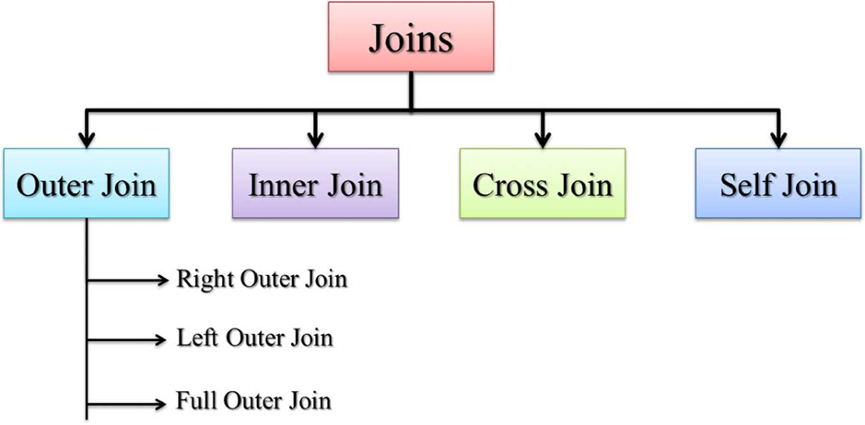
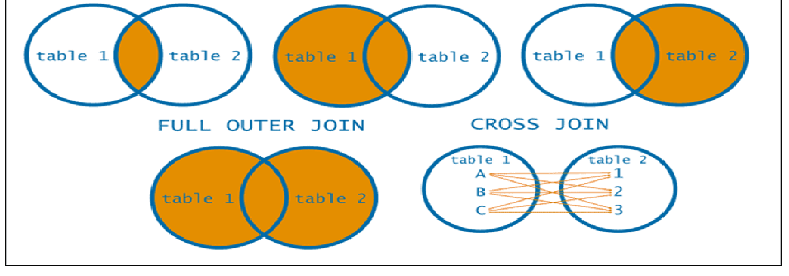

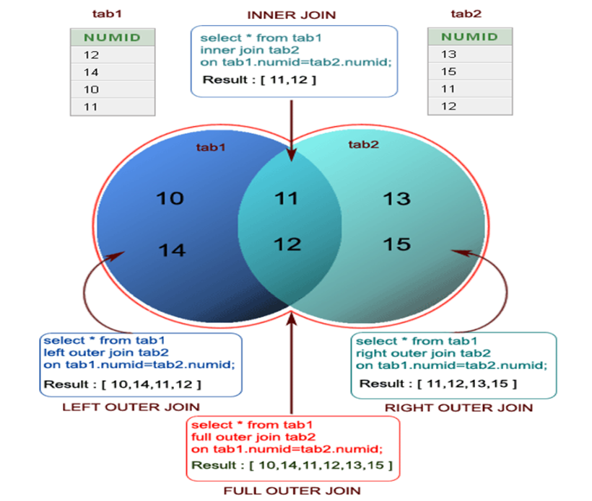

CREATE TABLE TAB1(NUMID INT(3));
CREATE TABLE TAB2 (NUMID INT(3));
INSERT INTO TAB1 VALUES(10);
INSERT INTO TAB1 VALUES(11);
INSERT INTO TAB1 VALUES(12);
INSERT INTO TAB1 VALUES(14);
INSERT INTO TAB2 VALUES(11);
INSERT INTO TAB2 VALUES(12);
INSERT INTO TAB2 VALUES(13);
INSERT INTO TAB2 VALUES(15);
SELECT * FROM TAB1;
SELECT* FROM TAB2;

INNER JOIN:- • Only matched records in both the tables

SELECT*FROM TAB1 INNER JOIN TAB2
ON
TAB1.NUMID=TAB2.NUMID

LEFT JOIN:- Matched records+ unmatched from left table dept
SELECT*FROM TAB1 LEFT JOIN TAB2
ON
TAB1.NUMID=TAB2.NUMID

RIGHT JOIN:- Matched records+ unmatched from right table emp

SELECT*FROM TAB1 RIGHT JOIN TAB2
ON
TAB1.NUMID=TAB2.NUMID
FULL JOIN:- Matched records + unmatched records from both the tables
FULL JOIN NOT SUPPORTED mysql:

CrossJoin:- SELECT *
FROM TAB1
CROSS JOIN TAB2;
Join Exercise Questions part-1
=====================
Employees / Departments / Projects

CREATE TABLE Employees (
emp_id INT PRIMARY KEY,
name VARCHAR(100),
department_id INT,
salary DECIMAL(10,2)
);

CREATE TABLE Departments (
department_id INT PRIMARY KEY,
department_name VARCHAR(100)
);

CREATE TABLE Projects (
project_id INT PRIMARY KEY,
project_name VARCHAR(100),
emp_id INT
);

INSERT INTO Departments (department_id, department_name) VALUES
(1, 'Human Resources'), (2, 'Engineering'), (3, 'Marketing'), (4, 'Finance'), (5, 'Operations');

INSERT INTO Employees (emp_id, name, department_id, salary) VALUES
(101, 'Arjun', 1, 50000), (102, 'Bhavana', 2, 65000), (103, 'Charan', 2, 72000),
(104, 'Divya', 3, 45000), (105, 'Eswar', NULL, 40000), (106, 'Farhan', 4, 55000),
(107, 'Gowri', 2, 62000), (108, 'Harish', 5, 48000), (109, 'Ishita', NULL, 53000),
(110, 'Jagan', 3, 60000);

INSERT INTO Projects (project_id, project_name, emp_id) VALUES
(201, 'Website Redesign', 102), (202, 'Mobile Banking App', 103), (203, 'Marketing Campaign', 104),
(204, 'Payroll System', 106), (205, 'Backend Optimization', 107), (206, 'Cloud Migration', 102),
(207, 'Customer Analytics', 110), (208, 'Inventory System', NULL);

Key facts this data is built to exercise:
● Eswar and Ishita have department_id = NULL — employees with no department.
● Arjun, Harish have no project. Bhavana has *two* projects.
● Project 208 "Inventory System" has emp_id = NULL — a project with no one assigned.
● Every department has at least one employee, so no department is ever "empty" in this dataset (unlike the Students set below — see Part 2).

INNER JOIN
Q1. Get all employees with their department names.
SELECT e.emp_id, e.name, d.department_name
FROM Employees e
INNER JOIN Departments d ON e.department_id = d.department_id;

emp_id | name | department_name
101 | Arjun | Human Resources
102 | Bhavana | Engineering
103 | Charan | Engineering
104 | Divya | Marketing
106 | Farhan | Finance
107 | Gowri | Engineering
108 | Harish | Operations
110 | Jagan | Marketing

8 rows — Eswar and Ishita are correctly dropped (NULL department, no match).
Q2. List all employees who are assigned to a project.
SELECT DISTINCT e.emp_id, e.name
FROM Employees e
INNER JOIN Projects p ON e.emp_id = p.emp_id;

emp_id | name
102 | Bhavana
103 | Charan
104 | Divya
106 | Farhan
107 | Gowri
110 | Jagan

Q3. Show employee names and their project names.
SELECT e.name, p.project_name
FROM Employees e
INNER JOIN Projects p ON e.emp_id = p.emp_id;

name | project_name
Bhavana | Website Redesign
Charan | Mobile Banking App
Divya | Marketing Campaign
Farhan | Payroll System
Gowri | Backend Optimization
Bhavana | Cloud Migration
Jagan | Customer Analytics

7 rows (no DISTINCT here, so Bhavana correctly appears twice for her two projects).

LEFT JOIN
Q1. All employees and their department names (even if no department).
SELECT e.emp_id, e.name, d.department_name
FROM Employees e
LEFT JOIN Departments d ON e.department_id = d.department_id;

emp_id | name | department_name
101 | Arjun | Human Resources
102 | Bhavana | Engineering
103 | Charan | Engineering
104 | Divya | Marketing
105 | Eswar | NULL
106 | Farhan | Finance
107 | Gowri | Engineering
108 | Harish | Operations
109 | Ishita | NULL
110 | Jagan | Marketing

Q2. All employees and their project names (if assigned).
SELECT e.name, p.project_name
FROM Employees e
LEFT JOIN Projects p ON e.emp_id = p.emp_id;

name | project_name
Arjun | NULL
Bhavana | Website Redesign
Bhavana | Cloud Migration
Charan | Mobile Banking App
Divya | Marketing Campaign
Eswar | NULL
Farhan | Payroll System
Gowri | Backend Optimization
Harish | NULL
Ishita | NULL
Jagan | Customer Analytics

11 rows — Arjun, Eswar, Harish, Ishita show NULL (no project); Bhavana still gets 2 rows.
Q3. All departments and the employees working in them.
SELECT d.department_name, e.name
FROM Departments d
LEFT JOIN Employees e ON d.department_id = e.department_id;

department_name | name
Human Resources | Arjun
Engineering | Bhavana
Engineering | Charan
Engineering | Gowri
Marketing | Divya
Marketing | Jagan
Finance | Farhan
Operations | Harish

(No NULL rows here — every department in this dataset has at least one employee.)

RIGHT JOIN
Q1. All departments and the employees in them (even if none).
SELECT D.DEPARTMENT_NAME,E.NAME
FROM DEPARTMENTS D
RIGHT JOIN EMPLOYEES E
ON D.DEPARTMENT_ID=E.DEPARTMENT_ID;

Same 8 rows as LEFT JOIN Q3 above — because every department happens to have an employee, RIGHT JOIN here produces no visible NULLs. (LEFT and RIGHT only look different when there's actually an unmatched row on the "preserved" side.)
Q2. All projects and their assigned employees (even if none).
SELECT P.PROJECT_NAME,E.NAME
FROM PROJECTS P
RIGHT JOIN EMPLOYEES E
-ON P.EMP_ID=E.EMP_ID;

8 rows — Inventory System correctly shows `NULL` for its unassigned employee. This is the row that actually proves the RIGHT JOIN is doing something LEFT JOIN wouldn't.
Q3. Employees and departments using RIGHT JOIN.
SELECT e.name, d.department_name
FROM Departments d
RIGHT JOIN Employees e ON d.department_id = e.department_id;

name | department_name
Arjun | Human Resources
Bhavana | Engineering
Charan | Engineering
Gowri | Engineering
Divya | Marketing
Jagan | Marketing
Farhan | Finance
Harish | Operations
Eswar | NULL
Ishita | NULL

10 rows — Eswar and Ishita show up with NULL department, since Employees is on the "preserved" (right) side here.

SELF JOIN
Q1. Employees who share the same department.
SELECT e1.name AS Employee1, e2.name AS Employee2, e1.department_id
FROM Employees e1
JOIN Employees e2 ON e1.department_id = e2.department_id AND e1.emp_id <> e2.emp_id;

Employee1 | Employee2 | department_id
Bhavana | Charan | 2
Bhavana | Gowri | 2
Charan | Bhavana | 2
Charan | Gowri | 2
Divya | Jagan | 3
Gowri | Bhavana | 2
Gowri | Charan | 2
Jagan | Divya | 3

Note: this returns both directions of each pair (Bhavana↔Charan appears twice). That's expected from <> — if you only want each pair once, use e1.emp_id < e2.emp_id instead, which would cut this to 4 rows.
Q2. Pairs of employees where one salary is more than the other.
SELECT e1.name AS Higher_Salary_Employee, e2.name AS Lower_Salary_Employee, e1.salary, e2.salary
FROM Employees e1
JOIN Employees e2 ON e1.salary > e2.salary;

This returns 45 rows — every possible higher/lower salary pairing among all 10 employees (since all 10 salaries happen to be distinct, this is the full C(10,2) = 45 combinations). It's not wrong, but it's a lot of noise for an exercise answer — worth being aware the result set explodes quickly as employee count grows. (Full 45-row output available on request; omitted here for length — first few rows: Arjun > Divya, Arjun > Eswar, Arjun > Harish, Bhavana > Arjun, Bhavana > Divya…)
Q3. Employee names and colleagues from the same department.
SELECT e1.name AS Employee, e2.name AS Colleague, d.department_name
FROM Employees e1
JOIN Employees e2 ON e1.department_id = e2.department_id AND e1.emp_id <> e2.emp_id
JOIN Departments d ON e1.department_id = d.department_id;

Employee | Colleague | department_name
Bhavana | Charan | Engineering
Bhavana | Gowri | Engineering
Charan | Bhavana | Engineering
Charan | Gowri | Engineering
Divya | Jagan | Marketing
Gowri | Bhavana | Engineering
Gowri | Charan | Engineering
Jagan | Divya | Marketing

FULL JOIN (simulated via UNION — MySQL has no native FULL JOIN)
Q1. All employees and all departments (even if no match).
SELECT e.name, d.department_name FROM Employees e LEFT JOIN Departments d ON e.department_id = d.department_id
UNION
SELECT e.name, d.department_name FROM Employees e RIGHT JOIN Departments d ON e.department_id = d.department_id;

name | department_name
Arjun | Human Resources
Bhavana | Engineering
Charan | Engineering
Divya | Marketing
Eswar | NULL
Farhan | Finance
Gowri | Engineering
Harish | Operations
Ishita | NULL
Jagan | Marketing

10 rows — every employee, including Eswar/Ishita with NULL department. (No department-side NULL rows appear because every department has at least one employee.)
Q2. All projects and employees (even if some don't match).
SELECT e.name, p.project_name FROM Employees e LEFT JOIN Projects p ON e.emp_id = p.emp_id
UNION
SELECT e.name, p.project_name FROM Employees e RIGHT JOIN Projects p ON e.emp_id = p.emp_id;

name | project_name
NULL | Inventory System
Arjun | NULL
Bhavana | Website Redesign
Bhavana | Cloud Migration
Charan | Mobile Banking App
Divya | Marketing Campaign
Eswar | NULL
Farhan | Payroll System
Gowri | Backend Optimization
Harish | NULL
Ishita | NULL
Jagan | Customer Analytics

12 rows — this is the one query in Part 1 that shows NULLs on both sides at once: Inventory System has no employee, and Arjun/Eswar/Harish/Ishita have no project.
Q3. All department names and employee names, with or without a match.
SELECT d.department_name, e.name FROM Departments d LEFT JOIN Employees e ON d.department_id = e.department_id
UNION
SELECT d.department_name, e.name FROM Departments d RIGHT JOIN Employees e ON d.department_id = e.department_id;

department_name | name
NULL | Eswar
NULL | Ishita
Engineering | Bhavana
Engineering | Charan
Engineering | Gowri
Finance | Farhan
Human Resources | Arjun
Marketing | Divya
Marketing | Jagan
Operations | Harish

JOIN + GROUP BY
Q1. Count employees per department.
SELECT d.department_name, COUNT(e.emp_id) AS Total_Employees
FROM Departments d
LEFT JOIN Employees e ON d.department_id = e.department_id
GROUP BY d.department_name;

department_name | Total_Employees
Engineering | 3
Finance | 1
Human Resources | 1
Marketing | 2
Operations | 1

Q2. Total salary per department.
SELECT d.department_name, SUM(e.salary) AS Total_Salary
FROM Departments d
LEFT JOIN Employees e ON d.department_id = e.department_id
GROUP BY d.department_name;

department_name | Total_Salary
Engineering | 199000
Finance | 55000
Human Resources | 50000
Marketing | 105000
Operations | 48000

Q3. Number of projects per employee.
SELECT e.name, COUNT(p.project_id) AS Total_Projects
FROM Employees e
LEFT JOIN Projects p ON e.emp_id = p.emp_id
GROUP BY e.name;

name | Total_Projects
Arjun | 0
Bhavana | 2
Charan | 1
Divya | 1
Eswar | 0
Farhan | 1
Gowri | 1
Harish | 0
Ishita | 0
Jagan | 1

JOIN + ORDER BY
Q1. Employees with department names, ordered by salary (highest first).
SELECT e.name, d.department_name, e.salary
FROM Employees e
JOIN Departments d ON e.department_id = d.department_id
ORDER BY e.salary DESC;

name | department_name | salary
Charan | Engineering | 72000
Bhavana | Engineering | 65000
Gowri | Engineering | 62000
Jagan | Marketing | 60000
Farhan | Finance | 55000
Arjun | Human Resources | 50000
Harish | Operations | 48000
Divya | Marketing | 45000

(Eswar/Ishita excluded — plain JOIN behaves as INNER JOIN.)
Q2. Employee names and project names, ordered by employee name.
SELECT e.name, p.project_name
FROM Employees e
JOIN Projects p ON e.emp_id = p.emp_id
ORDER BY e.name;

name | project_name
Bhavana | Website Redesign
Bhavana | Cloud Migration
Charan | Mobile Banking App
Divya | Marketing Campaign
Farhan | Payroll System
Gowri | Backend Optimization
Jagan | Customer Analytics

Q3. Departments and employee count, ordered by count (highest first).
SELECT d.department_name, COUNT(e.emp_id) AS Employee_Count
FROM Departments d
LEFT JOIN Employees e ON d.department_id = e.department_id
GROUP BY d.department_name
ORDER BY Employee_Count DESC;

department_name | Employee_Count
Engineering | 3
Marketing | 2
Operations | 1
Human Resources | 1
Finance | 1

JOIN + GROUP BY + ORDER BY + HAVING
Q1. Departments with more than 1 employee, ordered by count.
SELECT d.department_name, COUNT(e.emp_id) AS Employee_Count
FROM Departments d
JOIN Employees e ON d.department_id = e.department_id
GROUP BY d.department_name
HAVING COUNT(e.emp_id) > 1
ORDER BY Employee_Count DESC;

department_name | Employee_Count
Engineering | 3
Marketing | 2

Q2. Employees with more than 1 project, ordered by count.
SELECT e.name, COUNT(p.project_id) AS Project_Count
FROM Employees e
JOIN Projects p ON e.emp_id = p.emp_id
GROUP BY e.name
HAVING COUNT(p.project_id) > 1
ORDER BY Project_Count DESC;

name | Project_Count
Bhavana | 2

Q3. Departments with total salary > 50000, ordered by total salary.
SELECT d.department_name, SUM(e.salary) AS Total_Salary
FROM Departments d
JOIN Employees e ON d.department_id = e.department_id
GROUP BY d.department_name
HAVING SUM(e.salary) > 50000
ORDER BY Total_Salary DESC;

department_name | Total_Salary
Engineering | 199000
Marketing | 105000
Finance | 55000

(Human Resources = 50000 and Operations = 48000 are correctly excluded — neither is strictly greater than 50000.)

Join Exercise Part-2
================
PART 2 — Students / Courses / Enrollments
Setup
CREATE TABLE Students (student_id INT PRIMARY KEY, name VARCHAR(100), age INT);
CREATE TABLE Courses (course_id INT PRIMARY KEY, course_name VARCHAR(100));
CREATE TABLE Enrollments (enrollment_id INT PRIMARY KEY, student_id INT, course_id INT);

INSERT INTO Students VALUES
(1, 'Arjun', 20), (2, 'Bhavana', 21), (3, 'Charan', 22), (4, 'Divya', 20),
(5, 'Eswar', 23), (6, 'Farhan', 21), (7, 'Gowri', 22);

INSERT INTO Courses VALUES
(101, 'Mathematics'), (102, 'Physics'), (103, 'Biology'), (104, 'Chemistry'), (105, 'Computer Science');

INSERT INTO Enrollments VALUES
(1, 1, 101), (2, 2, 101), (3, 2, 102), (4, 3, 103),
(5, 4, 101), (6, 5, 104), (7, 1, 102), (8, 6, 105);

Q1. List all students with the courses they are enrolled in.
SELECT s.name AS Student_Name, c.course_name AS Course_Name
FROM Students s
INNER JOIN Enrollments e ON s.student_id = e.student_id
INNER JOIN Courses c ON e.course_id = c.course_id;

Student_Name | Course_Name
Arjun | Mathematics
Bhavana | Mathematics
Bhavana | Physics
Charan | Biology
Divya | Mathematics
Eswar | Chemistry
Arjun | Physics
Farhan | Computer Science

8 rows — Gowri correctly excluded (no enrollments, INNER JOIN drops her).
Q2. Show course names along with student names.
SELECT c.course_name, s.name AS Student_Name
FROM Courses c
INNER JOIN Enrollments e ON c.course_id = e.course_id
INNER JOIN Students s ON e.student_id = s.student_id;

Same 8 pairs as Q1, just column order swapped.
Q3. Get names of students enrolled in "Physics".
SELECT s.name
FROM Students s
INNER JOIN Enrollments e ON s.student_id = e.student_id
INNER JOIN Courses c ON e.course_id = c.course_id
WHERE c.course_name = 'Physics';

| name |
|---|
| Bhavana |
| Arjun |
Q4. List all students with their courses (if enrolled).
SELECT s.name AS Student_Name, c.course_name
FROM Students s
LEFT JOIN Enrollments e ON s.student_id = e.student_id
LEFT JOIN Courses c ON e.course_id = c.course_id;

Student_Name | course_name
Arjun | Mathematics
Arjun | Physics
Bhavana | Mathematics
Bhavana | Physics
Charan | Biology
Divya | Mathematics
Eswar | Chemistry
Farhan | Computer Science
Gowri | NULL

9 rows — Gowri now appears with `NULL` since LEFT JOIN preserves all students.
Q5. Show all courses and the students who enrolled (even if none).
SELECT c.course_name, s.name AS Student_Name
FROM Courses c
LEFT JOIN Enrollments e ON c.course_id = e.course_id
LEFT JOIN Students s ON e.student_id = s.student_id;

course_name | Student_Name
Mathematics | Arjun
Mathematics | Bhavana
Mathematics | Divya
Physics | Arjun
Physics | Bhavana
Biology | Charan
Chemistry | Eswar
Computer Science | Farhan

Only 8 rows, no NULLs — because (as noted above) every course actually has at least one enrolled student, so there's nothing for this LEFT JOIN to "rescue."
Q6. Display all students with course details, even if some courses have no enrollments.
SELECT s.name AS Student_Name, c.course_name
FROM Students s
LEFT JOIN Enrollments e ON s.student_id = e.student_id
LEFT JOIN Courses c ON e.course_id = c.course_id;

Q7. List all students and all courses, even if there is no match (simulate full join).
SELECT s.name AS Student_Name, c.course_name FROM Students s
LEFT JOIN Enrollments e ON s.student_id = e.student_id
LEFT JOIN Courses c ON e.course_id = c.course_id
UNION
SELECT s.name AS Student_Name, c.course_name FROM Courses c
LEFT JOIN Enrollments e ON c.course_id = e.course_id
LEFT JOIN Students s ON e.student_id = s.student_id;

Student_Name | course_name
Arjun | Mathematics
Arjun | Physics
Bhavana | Mathematics
Bhavana | Physics
Charan | Biology
Divya | Mathematics
Eswar | Chemistry
Farhan | Computer Science
Gowri | NULL

This returns exactly the same 9 rows as Q4 — the query logic is correct for simulating a FULL JOIN, but with *this* dataset every course has an enrolled student, so the "courses side" of the UNION never contributes a new NULL-course row. The query would only visibly demonstrate the FULL JOIN's extra behavior if a 6th course (e.g. (106, 'History')) were added with no enrollments — then you'd see an extra NULL | History row appear here that doesn't appear in Q4.
Q8. Show pairs of students who have the same age.
SELECT s1.name AS Student1, s2.name AS Student2, s1.age
FROM Students s1
JOIN Students s2 ON s1.age = s2.age AND s1.student_id < s2.student_id;

Student1 | Student2 | age
Arjun | Divya | 20
Bhavana | Farhan | 21
Charan | Gowri | 22

Each pair appears exactly once, thanks to student_id < rather than <>.
Q9. Count how many students are enrolled in each course.
SELECT c.course_name, COUNT(e.student_id) AS Total_Students
FROM Courses c
LEFT JOIN Enrollments e ON c.course_id = e.course_id
GROUP BY c.course_name;

course_name | Total_Students
Biology | 1
Chemistry | 1
Computer Science | 1
Mathematics | 3
Physics | 2

Q10. Show number of courses each student is enrolled in.
SELECT s.name AS Student_Name, COUNT(e.course_id) AS Total_Courses
FROM Students s
LEFT JOIN Enrollments e ON s.student_id = e.student_id
GROUP BY s.name;

Student_Name | Total_Courses
Arjun | 2
Bhavana | 2
Charan | 1
Divya | 1
Eswar | 1
Farhan | 1
Gowri | 0

Gowri correctly shows 0 (LEFT JOIN + COUNT gives 0, not NULL, since COUNT ignores the NULL row but still counts the group).
Q11. List all students and courses ordered by student name.
SELECT s.name AS Student_Name, c.course_name
FROM Students s
INNER JOIN Enrollments e ON s.student_id = e.student_id
INNER JOIN Courses c ON e.course_id = c.course_id
ORDER BY s.name;

Student_Name | course_name
Arjun | Mathematics
Arjun | Physics
Bhavana | Mathematics
Bhavana | Physics
Charan | Biology
Divya | Mathematics
Eswar | Chemistry
Farhan | Computer Science

Q12. Show student names and course names ordered by course name.
SELECT s.name AS Student_Name, c.course_name
FROM Students s
INNER JOIN Enrollments e ON s.student_id = e.student_id
INNER JOIN Courses c ON e.course_id = c.course_id
ORDER BY c.course_name;

Student_Name | course_name
Charan | Biology
Eswar | Chemistry
Farhan | Computer Science
Arjun | Mathematics
Bhavana | Mathematics
Divya | Mathematics
Bhavana | Physics
Arjun | Physics

Q13. Show only courses with more than 1 student enrolled.
SELECT c.course_name, COUNT(e.student_id) AS Student_Count
FROM Courses c
JOIN Enrollments e ON c.course_id = e.course_id
GROUP BY c.course_name
HAVING COUNT(e.student_id) > 1;

course_name | Student_Count
Mathematics | 3
Physics | 2

Q14. List students enrolled in more than 1 course.
SELECT s.name, COUNT(e.course_id) AS Course_Count
FROM Students s
JOIN Enrollments e ON s.student_id = e.student_id
GROUP BY s.name
HAVING COUNT(e.course_id) > 1;

name | Course_Count
Arjun | 2
Bhavana | 2

Q15. Display student names and count of enrollments, ordered by highest enrollment.
SELECT s.name AS Student_Name, COUNT(e.enrollment_id) AS Enrollment_Count
FROM Students s
LEFT JOIN Enrollments e ON s.student_id = e.student_id
GROUP BY s.name
ORDER BY Enrollment_Count DESC;

Student_Name | Enrollment_Count
Bhavana | 2
Arjun | 2
Farhan | 1
Eswar | 1
Divya | 1
Charan | 1
Gowri | 0

