Customer Data Cleaning, Formatting & Validation Pipeline using SQL
STEP 1 : CREATE DATABASE
create database sql_project;
use sql_project;
Step 2: Import CSV File into MySQL Workbench
Open MySQL Workbench.
Select the created database.
Right click on the schema.
Choose Table Data Import Wizard.
Browse and select the CSV file.
Create a new table named customers.
Complete the import process.
Step 3: View Raw Data
Display the imported customer records.
SELECT * FROM customers;
Step 6: Standardize Text Case
update customers set full_name=upper(full_name),city=upper(city),email=lower(email),username=lower(username),comments=upper(comments);
Step 7: Remove Special Characters
UPDATE Customers SET
username = REGEXP_REPLACE(username, '[^a-zA-Z0-9]', ''),
full_name = REGEXP_REPLACE(full_name, '[^a-zA-Z0-9 ]', '');
Step 8: Standardize Phone Numbers
update customers set phone = regexp_replace(phone, '[^0-9]','');
Step 9: Validate Email Addresses
SELECT *
FROM Customers
WHERE email NOT LIKE '%@%.%';
Step 10 : PHONE NUMBER VALIDATION
SELECT *
FROM Customers
WHERE LENGTH(phone) <> 10;
Step 11 : CHECK MISSING VALUES
SELECT *
FROM Customers
WHERE full_name IS NULL
OR full_name = ''
OR city IS NULL
OR city = ''
OR email IS NULL
OR email = '';
Step 12 : DETECT DUPLICATE RECORDS
SELECT
phone,
COUNT(*) AS duplicate_count
FROM Customers
GROUP BY phone
HAVING COUNT(*) > 1;
Step 13 : CREATE FINAL CLEAN TABLE
create table final_customers as SELECT * FROM customers
WHERE customer_id IN (
SELECT MIN(customer_id)
FROM customers
GROUP BY phone
)
ORDER BY customer_id ASC;

Step 14 : VIEW FINAL CLEAN DATA
select * from final_customers;
output:
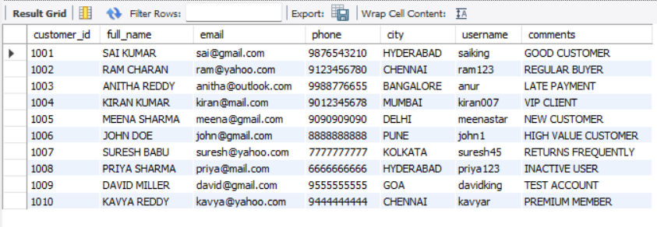
Step 15 : ENABLE SAFE MODE AGAIN
SET SQL_SAFE_UPDATES = 1;

