EECS 665: Lab 7 Report

For this lab, I will be looking into the MIPS and ARM processor architectures.

Accoriding to https://scottiestech.info/2011/11/24/what-is-an-arm-processor-and-whats-the-big-deal/, the ARM architecture is a RISC architecture. It sacrifices a high number of instructions needed for a program in order to maximize the performance of an individual instruction. The ARM architecture’s cache is layed out in the following way. Each cache is “physically indexed and physically addressed. The cache sizes are configurable with sizes in the range of 1 to 64KB, but the maximum clock frequency might be affected if you increase the cache sizes beyond 16KB. Both the instruction cache and the data cache are capable of providing two words per cycle for all requesting sources.
The cache way size can be varied between 1KB and 16KB in powers of 2. A 1KB cache size must be implemented as a 1 way cache, and a 2KB cache must be implemented as a 2 way cache. All other cache sizes must be implemented as 4 way set associative. The cache line length is fixed at eight words (32 bytes).” (http://infocenter.arm.com/help/index.jsp?topic=/com.arm.doc.ddi0338g/Chdjdeci.html) The ARM architecture has a fixed width of 32 bits per instruction (https://www.coursera.org/learn/comparch/lecture/WXq25/isa-characteristics). The data types supported and their bit-widths can be found in the following table taken from http://www.keil.com/support/man/docs/armcc/armcc_chr1359125009502.htm .
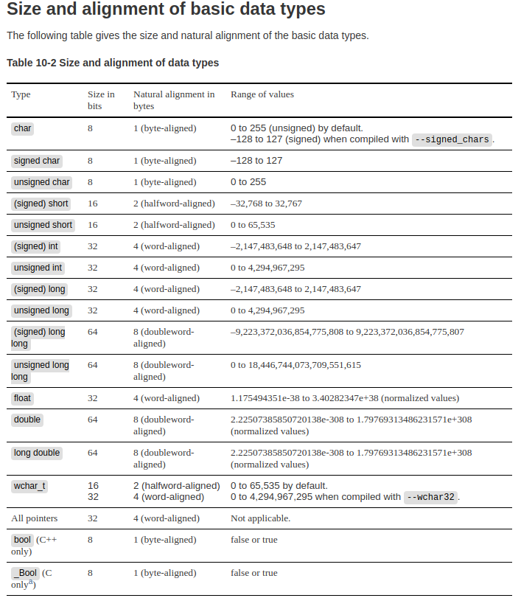

The data types can be stored in either big endian or little endian depending on how the implementer of the ISA chooses according to http://www.keil.com/support/man/docs/armcc/armcc_chr1359125009502.htm .
Information about the ARM registers can be found in the following table taken from http://www.davespace.co.uk/arm/introduction-to-arm/registers.html

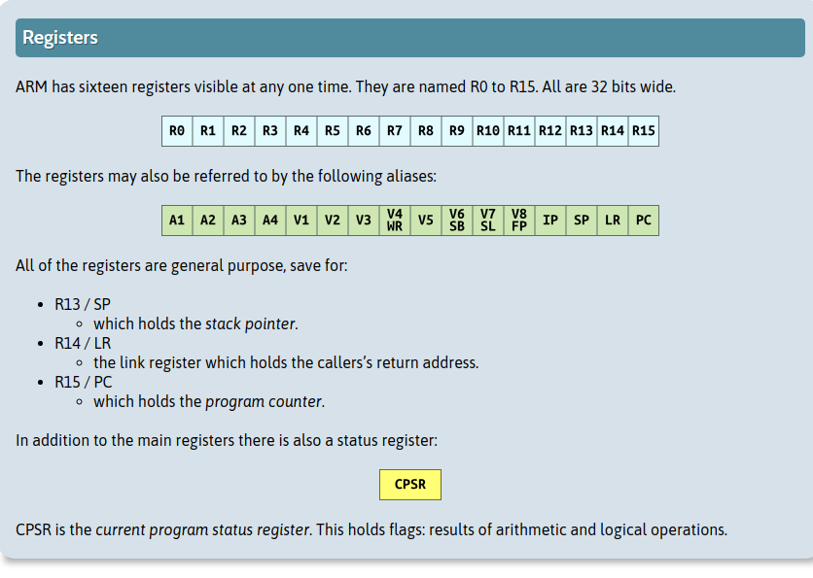
The instruction set is three address. Each instruction needs operand1, operand 2, and the destination of the operation. https://alisdair.mcdiarmid.org/arm-immediate-value-encoding/

The MIPS processor architecture is also a RISC architecture. (http://booksite.elsevier.com/samplechapters/9780120884216/Sample_Chapters/02~Chapter_1.pdf)

The MIPS instructions are all fixed to 32 bits wide (http://booksite.elsevier.com/samplechapters/9780120884216/Sample_Chapters/02~Chapter_1.pdf)

The Data types supported by the MIPS ISA are bytes(8 bits), halfwords(2 bytes), and words(4 bytes)
a char requires 1 byte while an integer requires 4 bytes. (http://logos.cs.uic.edu/366/notes/mips%20quick%20tutorial.htm)

MIPS is a big endian architecture http://logos.cs.uic.edu/366/notes/mips%20quick%20tutorial.htm

The MIPS registers are all 32 bits wide and are organized in the following way ( http://logos.cs.uic.edu/366/notes/mips%20quick%20tutorial.htm )
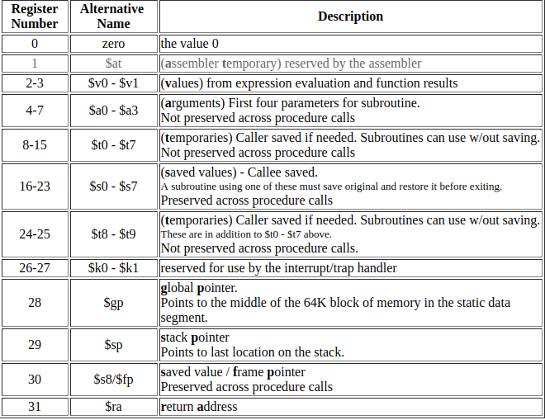
MIPS is a 3 address ISA. Each instruction requires operand1, operand2, and destination for the instruction.

