EECS 560: Lab 6 Report

Comparing Min 3 Heap with Binary Search Tree

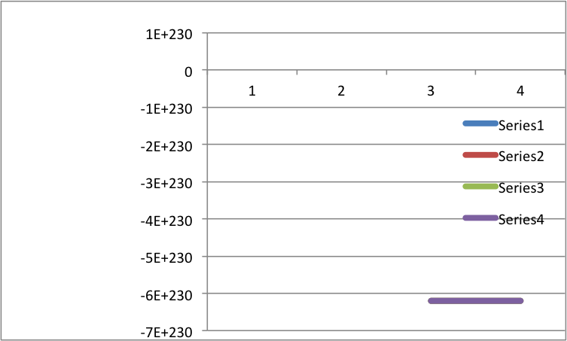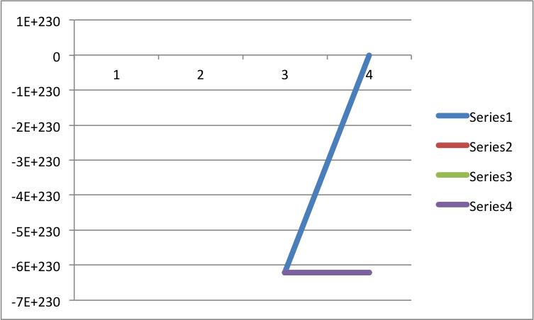

For this experiment, I decided to break it into two parts. The first part would test how long it takes to build the structures for the given value of n, the second part would test how long it would take to complete the various operations. I kept track of the average over 5 different seeds for the generator for all of the data. I noticed that the heap was generally created faster, however delete max operations took longer.