**University Of Eswatini**



CSC 393 Mini Project

NOV 2024

SYSTEM ANALYSIS AND DESIGN

**COURSE INSTRUCTOR:** Dr. M Nxumalo

GROUP MEMBERS:

202203677 - Sihlanganisiwe Mkhonta B.Sc.IT

202200778 - Temalungelo Malaza B.Sc.IT

**TABLE OF CONTENTS**

* PART ONE (Software Problem) -------------------------------------- 3

(Reference & Citation) ---------------------------------- 3

* PART TWO (Planning)---------------------------------------------- 4 – 5
* PART THREE (Requirement Analysis) --------------------------- 5 – 7
* PART FOUR (System Design) -----------------------------------------8 – 9

**PART ONE: SOFTWARE SYSTEM PROBLEM (IDENTIFICATION)**

L U R E

Lure is a newly established jewelry and accessories business that specializes mainly in; bracelets, necklaces and crocheted bags. Its main selling point is that all the products are handmade by the owners, and the beads used for the jewelry are made from pure freshwater pearls.

This project is about transforming the existing system of manually taking orders, into a sophisticated online ordering-inventory system. The current process of taking orders involves the owners receiving and taking calls, plus answering texts from customers who want to purchase a product. This method can be very tedious and time consuming, especially during times of high demand. In addition, human error cannot be avoided, which results in incorrect orders.

Furthermore, the current ordering system can be very inefficient for the customers in cases where multiple customers are trying to call the owners at the same time. This form of unavailability could discourage a customer (especially a first-time customer) from placing an order.

These problems helped bring forth a system that could solve them – an online ordering-inventory system that will allow customers to access products, pick their desired purchase and quantity from the catalogue and select their payment method. Once completed, the customer’s order/request is automatically recorded in the system’s database for the owners to easily access.

Reference:

(Faster Capital, n.d.)

**PART TWO: PLANNING**

The project aims to digitalize *Lure*’s ordering system and to keep track of its product inventory. The Core Concepts of System planning (in relation with the project) are discussed below:

1. **CHANGE:** The current system utilizes phone calls and WhatsApp to place and process orders for *Lure*’s products. The project will revolutionize *Lure*’s ordering process by equipping the owners of *Lure* with an online system that will allow customers and potential customers to browse the business’s product catalogue, then placing an order for their desired product without needing direct interaction with *Lure*’s personnel.
2. **NEED:** The current way of processing orders requires the owners to have the orders in their memory and to write each order down. This method cannot avoid human error, so some of the orders can be mistaken. In addition, some of the orders can be forgotten during times when product demand is high.
3. **SOLUTION:** To minimize the effects of human error, the project will automate the records for each order (through the online ordering system) so that the owners can keep track of their customers and ensure that each order is taken care of. The solution will increase time management for the business owners because they will not need to constantly be on phone-calls, taking orders.
4. **STAKEHOLDERS:** Business owners, customers and investors
5. **VALUE TO STAKEHOLDERS:**

* *For the business owners;* they will be able to manage their time efficiently, they will be able to keep track of the orders remotely through their personal devices and the minimizing risk of incorrect/forgotten orders.
* *For the customers;* They can place their order at any time of day, it will be recorded in the business’s system.
* *For the investors;* Sales and profit predictions will be easier to make because there will be a structured record of the orders taken to use as reference. The project will allow the investors to monitor the product inventory and see which products are most popular so they can ensure the product dos not run out.

1. **CONTEXT:** This project can mainly be affected by the availability of a smartphone for business owners, which will allow them to run their business remotely because they will have a log of all the orders that need to be completed and delivered. In addition, internet connectivity is vital for both customers and the business owners because the project is mainly an online system

Assumptions considered:

1. The two business owners are the only ones taking the orders and preparing them
2. Communication only happens when the order is placed, and when the product is ready to be collected/delivered to customer.

**PART THREE: REQUIREMENT ANALYSIS**

The two requirement gathering techniques that will be utilized to compile the SRS document are; Interviews and Questionnaires.

1. Interview: the interview questions are divided into 2 sections – one section for the (2) business owners, the other section for (5) returning customers. The interview aims to highlight and discuss the main processes that happen within the business.

Sample of Interview Questions

**(FOR BUSINESS OWNERS)**

**These interview questions aim to highlight and discuss the main business processes:**

1. On average, how many calls/orders do you take weekly?
2. How long do customers typically wait for their finished product?
3. What is the most common payment method for customers?

(eWallet, Mobile Money (MoMo), Bank transaction, cash-on-delivery?)

1. Do most of your customers have personalized designs or they prefer generic designs?
2. Which product is the most popular to order to date?

**(FOR RETURNING CUSTOMERS)**

**These sample interview questions aim to find out how efficient the current ordering system is.**

1. Do you prefer to make your orders using Whatsapp (social networking app) or through phone calls?
2. Are you open to purchasing product from the business catalogue, or rather a personalized design that you came up with?
3. Are you satisfied with the current way of ordering product? If no, tell us why.
4. Questionnaire: a close-ended questionnaire for the customers is issued to find out the strengths and weaknesses of the current system and the way the business operates.

QUESTIONNAIRE SAMPLE

This questionnaire uses the Likert scale to gauge how customers feel about specific aspects of the business and its current system.

The numbers on the scale represent the following:

**1 – very good 2 – good 3 – average 4 – bad 5 – very bad**

**NOTE: TICK THE NUMBER YOU MOST AGREE WITH**

1. How is the response time when you want to make an order?

**1 – very good 2 – good 3 – average 4 – bad 5 – very bad**

1. How is the range of products offered?

**1 – very good 2 – good 3 – average 4 – bad 5 – very bad**

1. How has your overall experience been with the business?

**1 – very good 2 – good 3 – average 4 – bad 5 – very bad**

1. How is the communication/updates about your order?

**1 – very good 2 – good 3 – average 4 – bad 5 – very bad**

**PART FOUR: SYSTEM DESIGN**

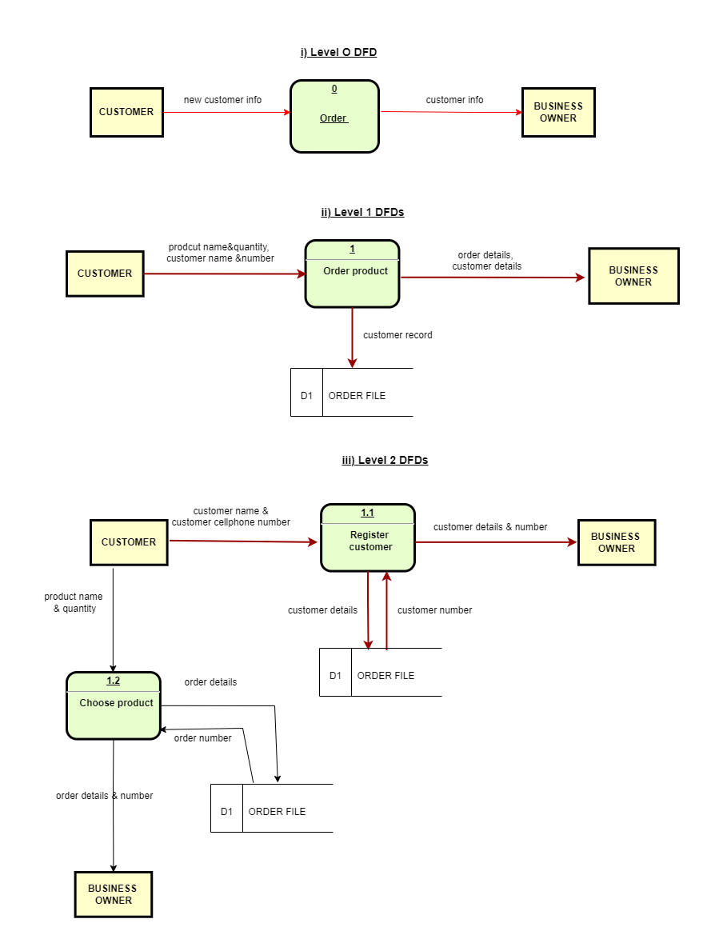This section contains dataflow diagrams for questions; i) ii) and iii)

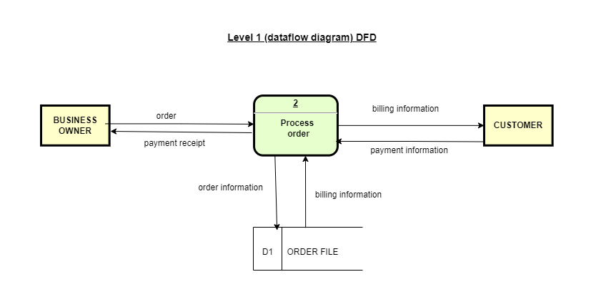

iv) Data Dictionary for dataflow diagrams in i) ii) and iii)

|  |  |  |
| --- | --- | --- |
| **VARIABLE NAME** | **DATA TYPE** | **DESCRIPTION** |
| Customer (name) | String | Full name of new customer |
| Customer (number) | Number | Cellphone number of new customer |
| Product (name) | String | Name/type of product |
| Product (quantity) | Number | How many items/products are being ordered |

**PART FIVE: GitHub username**

<https://github.com/temalungelomalaza>