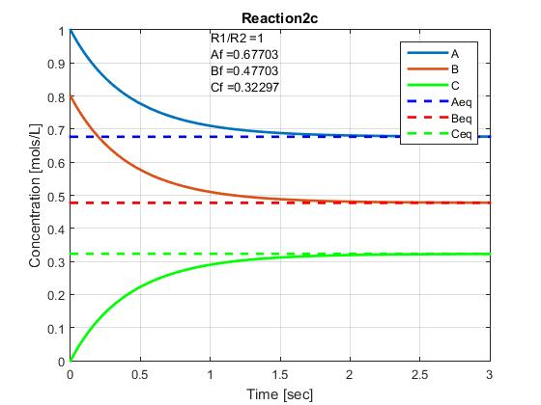Figure 1.) R1/R2 = 1 with A0 = 1, B0 = 0.8, C0 = 0 and equilibrium shown.

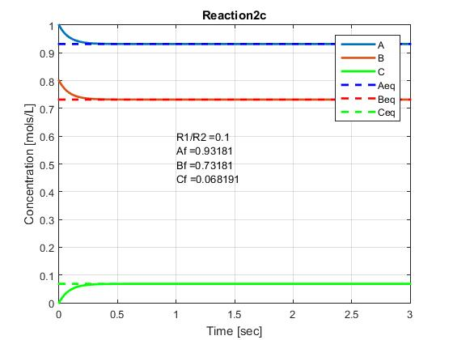Figure 3.) R1/R2 = 0.1 with A0 = 1, B0 = 0.8, C0 = 0 and equilibrium shown.

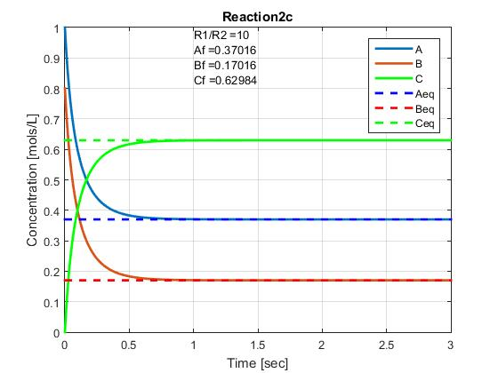Figure 2.) R1/R2 = 10 with A0 = 1, B0 = 0.8, C0 = 0 and equilibrium shown.

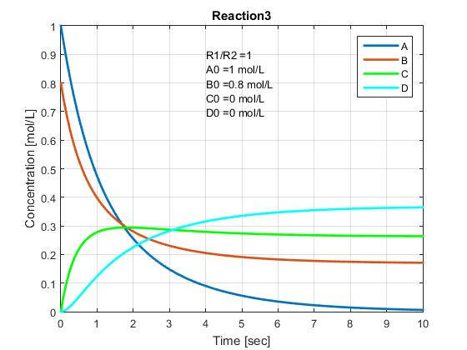Figure 4.) A+B->C & A+C->D with R1/R2 = 1 and A0 = 1, B0 = 0.8, C0 = 0, D0 = 0.

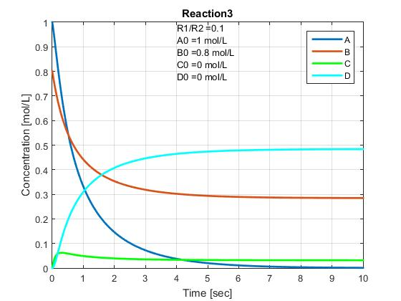Figure 5.) A+B->C & A+C->D with R1/R2 = 0.1 and A0 = 1, B0 = 0.8, C0 = 0, D0 = 0.

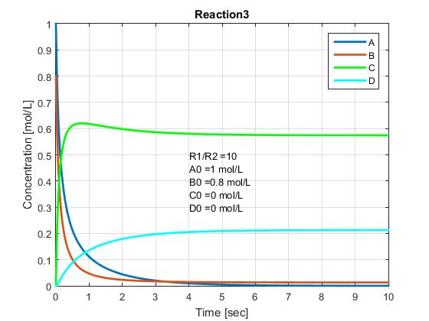Figure 7.) A+B->C & A+C->D with R1/R2 = 10 and A0 = 1, B0 = 0.8, C0 = 0, D0 = 0.

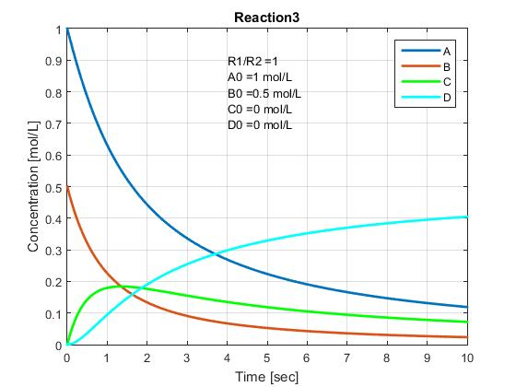Figure 6.) A+B->C & A+C->D with R1/R2 = 1 and A0 = 1, B0 = 0.5, C0 = 0, D0 = 0.

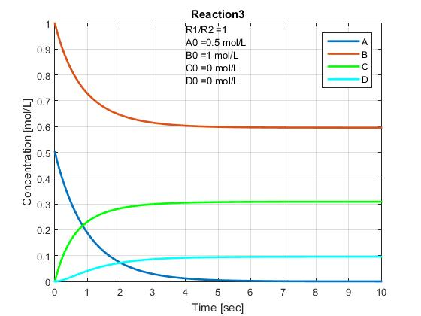Figure 8.) A+B->C & A+C->D with R1/R2 = 1 and A0 = 0.5, B0 = 1, C0 = 0, D0 = 0.

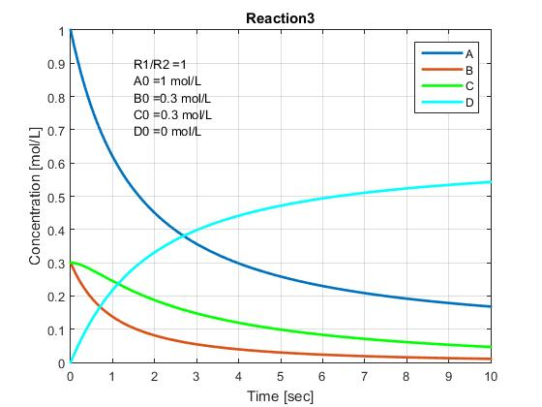Figure 9.) A+B->C & A+C->D with R1/R2 = 1 and A0 = 1, B0 = 0.3, C0 = 0.3, D0 = 0.