2024-11-01

1.added a toolbar along the top with menu [Edit] and [Object]'s all options.

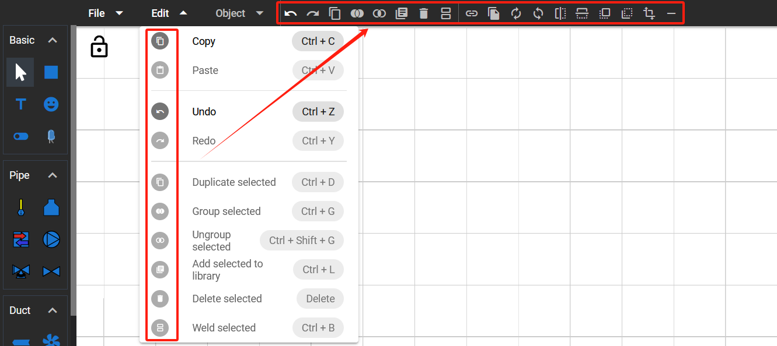

2.added a new option "Weld Selected" to menu [Edit] and top toolbar. Allow user to weld two selected ducts into one duct.

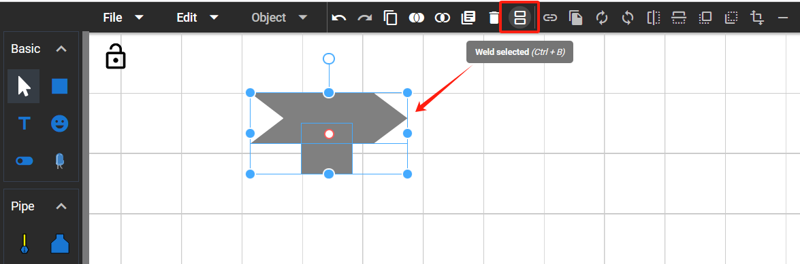

2024-11-22

1. Updated the “Weld Selected” function to make the welded item resizable and moveable.

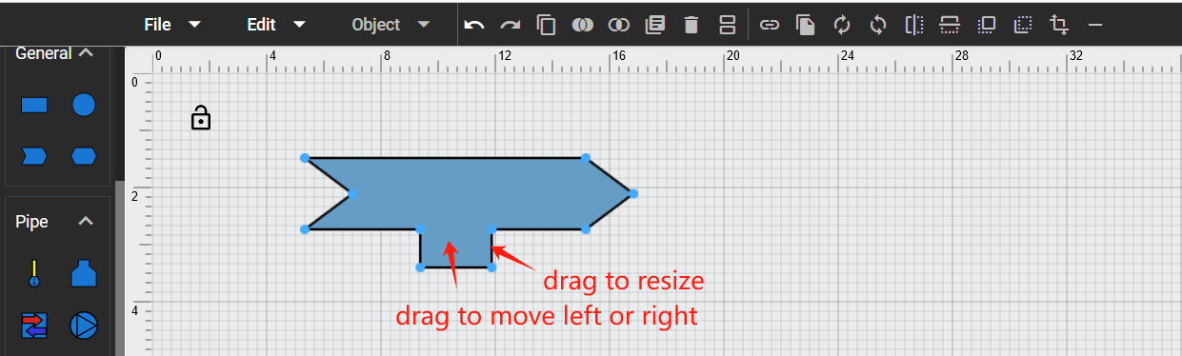

2. Added rulers and grid dots to the drawing area.

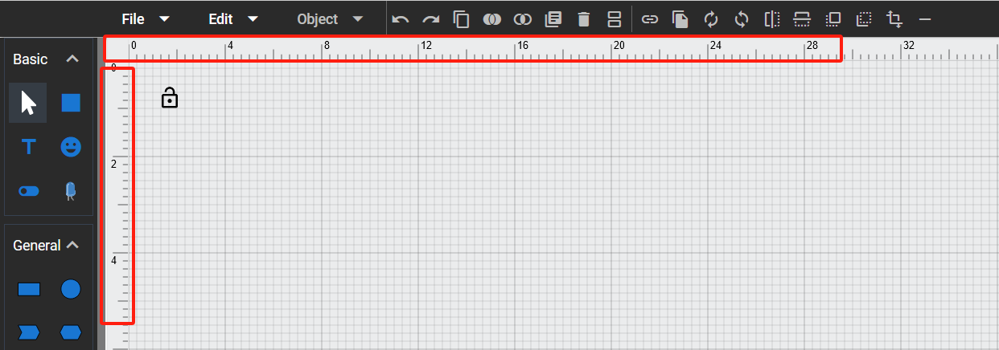

3. Added a new tool category “General” with some basic shapes.

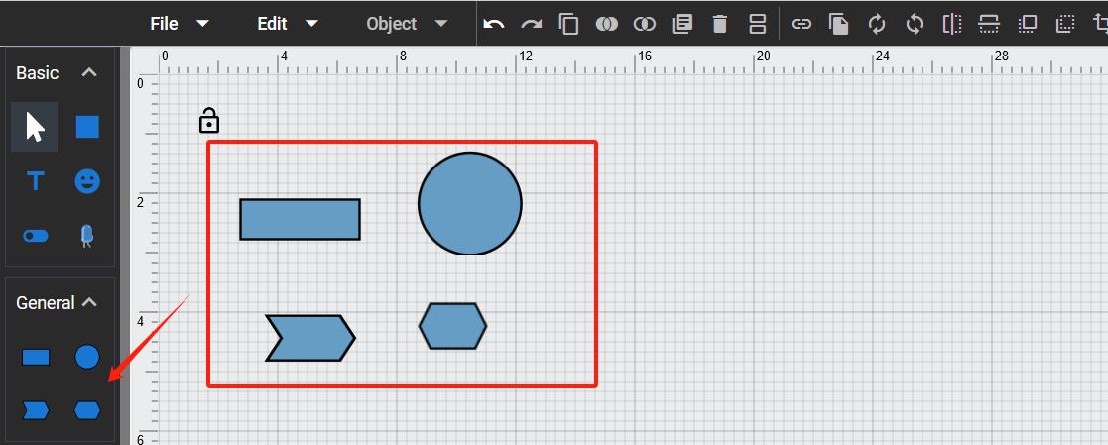

4. Added a new type of wall “Interior/Exterior Wall” to Room tool category.

