T3000 WireGuard Implementation Plan
Document Type: | Software Requirements Specification | Target System: | T3000 Automation
Objective: | Secure Remote Site Connectivity | Status: | Proposed Framework

Overview
This document outlines the proposed implementation of WireGuard support within the T3000 Building Automation System based on the WireGuard gateway concept and accompanying functional user interface layouts. The objective is to allow T3000 to establish secure, high-performance remote connectivity to an entire building network through a WireGuard-enabled gateway field device. Once connected, the T3000 application running on a central or remote PC will be able to seamlessly communicate with and manage all subnet devices located behind the gateway using standard building automation network protocols.
1. Remote Site Configuration Specification
The existing architectural concept of a single "Remote Device" is expanded into a comprehensive "Remote Site" configuration model. Because a WireGuard gateway acts as an edge router, it provides secure pathing to an entire localized building network rather than a single endpoint. The updated T3000 user interface must support full entry of the parameter matrix required to establish a secure VPN connection between the T3000 host PC and the remote network gateway.
The core field requirements comprise:
- Remote Site Name: An alphanumeric identifier for separating and organizing distinct properties.
- Public IP Address or Domain Name: The reachable external WAN endpoint address of the network gateway.
- WireGuard Port Number: The network communication port utilized by the WireGuard service (defaulting to 51820).
- VPN IP Address: The specific internal tunnel virtual address allocated inside the private secure domain.
- Public & Private Keys: Asymmetric cryptographic identities required for connection verification and packet encryption.
- Pre-shared Key (Optional): An additional layer of symmetric encryption for absolute security.
- Connection Status: Real-time operational monitoring metrics (Idle, Connecting, Connected, Error).
2. Configuration & Security Provisioning Workflow
To eliminate human error and bypass manual text configuration modification, an automated pipeline manages key generation, parameter mapping, and hardware provisioning. The entire process follows a streamlined operational lifecycle:
1. Site Creation: The operator creates a new Remote Site entity within the central T3000 PC system profile.
2. Server Parameter Definition: T3000 defines global server connection rules, binding the public port and global subnets.
3. Asymmetric Key Generation: T3000 automatically generates matching cryptographic public/private key pairs for both sides (Host PC and Field Gateway).
4. Modbus RTU Provisioning: The complete parameter stack—including the gateway's private key, T3000 public key, VPN IPs, and port rules—is pushed down directly to the hardware gateway via local Modbus RTU communication.
5. Server-Side Mapping: Upon successful Modbus download, the client gateway details are dynamically registered within the T3000 server list automatically.
6. Tunnel Activation: The host PC starts its local WireGuard interface service to anchor the encrypted tunnel.

Image 1 Reference: WireGuard Server Configuration Screen
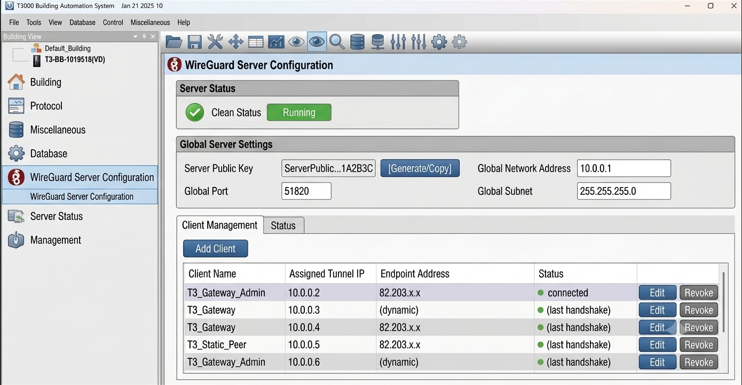
Brief Step Summary: This interface serves as the primary master control for the global WireGuard topology inside T3000. The system displays the global server status (Running) and establishes the absolute Server Public Key used as an anchor. Crucially, the Client Management matrix dynamically registers each endpoint by tracking Assigned Tunnel IPs and active Endpoint WAN Addresses. All non-VPN elements (such as old Modbus port columns) are omitted to focus entirely on clean, high-performance secure connection telemetry.
3. Gateway Provisioning Interface Requirements
The gateway pairing configuration must provide an intuitive layout optimized for operators. Instead of complicated configuration scripts, the deployment relies on an interface separated into two linear visual blocks:
- Phase 1 (Key Generation): Provides an instantaneous mechanism to trigger key creation. Clicking the designated generator element populates the public identity field and confirms that the private key is locked securely within the database storage.
- Phase 2 (Pairing & Modbus RTU Push): Pulls parameters directly from the master server data—mapping Server Public Key, Endpoint WAN, and Port configuration automatically. A clear [Provision Device via Modbus RTU] button initiates download across the hardware link, writing settings safely to non-volatile local memory.
Image 2 Reference: Gateway Configuration & Modbus RTU Provisioning Interface
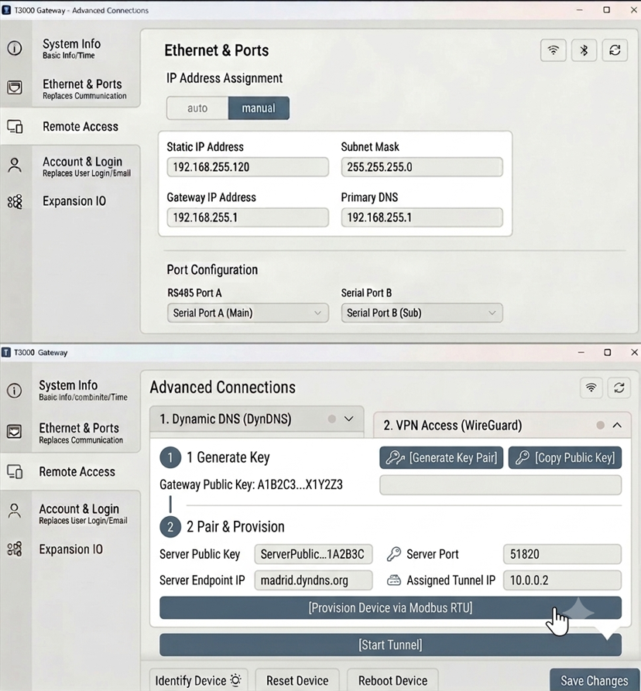
Brief Step Summary: This panel visualizes the exact simplified deployment step on the field gateway. The workspace presents a clear dual-step execution model: (1) Generate cryptographic keys locally, and (2) Instantly execute the Modbus hardware push. Large instructional markers replace wordy explanations. The layout features pre-mapped fields that auto-inherit port and tracking parameters from the central server, culminating in a simple, single-click activation.
4. WireGuard Service Lifecycle & Monitoring
The T3000 core engine takes complete ownership of managing the lifecycle of the active tunnel interface. This mitigates connection issues and ensures highly reliable runtime conditions.
Operational Responsibilities:
- Dynamically assembling and updating native configuration blocks based on active database fields.
- Handling explicit service commands to safely start, pause, or terminate the tunnel.
- Continuously querying endpoint responsiveness to calculate real-time tunnel uptime and byte counters.
- Detecting network disruptions or credential failures, and executing back-off automatic reconnection routines when links return.
UI Status Tracking: The user interface must provide immediate visual indicators representing current connectivity states, explicitly reporting: Connected, Connecting, Disconnected, Authentication Error, or Configuration Error.
5. Secure Building Access End-State Model
Once the active WireGuard cryptographic tunnel is established, the local gateway serves as a transparent routing bridge into the property. It decapsulates incoming secure traffic from the T3000 host PC and directs it across the internal field network without modifying or altering standard application layers.
Image 3 Reference: End-to-End Secure Access Architecture Topology
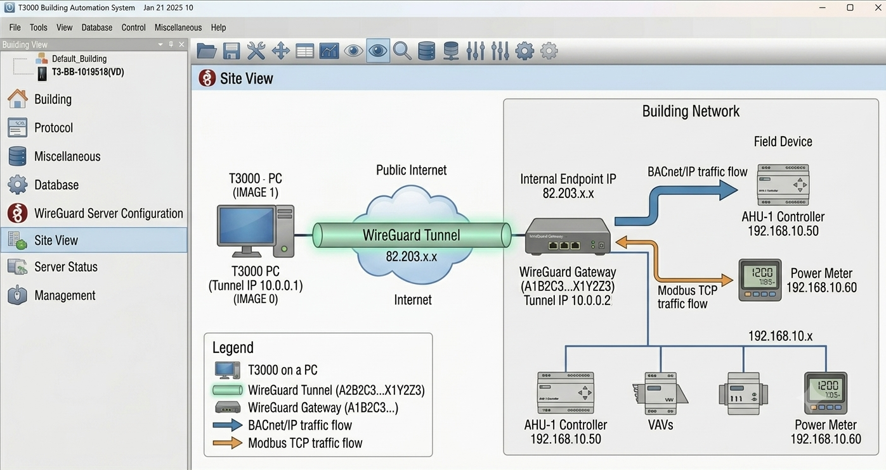
Brief Step Summary: A high-level visual mapping of the operational network routing state. The diagram demonstrates the complete data transmission path from the T3000 workstation (Tunnel IP 10.0.0.1) across the public internet inside a secure WireGuard tunnel. The hardware gateway receives this data, verifies keys, and securely relays multiple concurrent protocols (such as BACnet/IP to an AHU Controller or Modbus TCP to a Power Meter) down to various physical devices across the internal building network.
6. Summary & Future Scope
By moving key generation and tunnel mapping inside the T3000 ecosystem and provisioning hardware over Modbus RTU, this framework eliminates the need for manual network scripts. It ensures secure deployment for field technicians while laying a foundation for upcoming enhancements, including multi-site expansion profiles, BBMD protocol routing, and historical event logging.

