T3000 Building Automation System
Graphic Trendlog Function User Guide

Table of Contents
- 1 System Overview
- 2 Preparations: Data Point Configuration & Trend Log Activation
  - 2.1 Confirm Data Point Status
  - 2.2 Activate Trend Log
- 3 Graphic Trendlog Operation Guide
  - 3.1 Enter Trend Graph Interface
  - 3.2 Core Interface Description
  - 3.3 Detailed Core Operations
- 4 Data Storage & Query
  - 4.1 Data Storage Mechanism
  - 4.2 Data Query & Analysis
- 5 Common Problems & Notes
  - 5.1 Common Problems & Troubleshooting
  - 5.2 Key Notes

1 System Overview
The T3000 Building Automation System is a professional platform for building equipment monitoring and management, enabling centralized control of HVAC, water supply, drainage, electrical and other equipment in buildings.
Output Points: OUT1~OUT24 are system digital/analog output points (e.g., OUT1 (FAN1), OUT2 (FAN2), OUT3 (PUMP1)), used to control field execution equipment.
Custom Variables: VAR1~VAR17 are user-configurable internal variables, used for custom data storage and calculation (e.g., time, temperature, percentage, count).
Core Value of Trendlog: The Graphic Trendlog function can collect, visualize and store all input/output/variable data in the system in real time. It helps operation and maintenance personnel monitor equipment status, analyze fault trends and optimize building energy consumption.

2 Preparations: Data Point Configuration & Trend Log Activation
Complete the basic configuration before using the trend graph to ensure normal data collection.

2.1 Confirm Data Point Status
- Open the OUTPUT interface, confirm that the target output points (e.g., FAN1, FAN2, PUMP1) are in normal status (Status = OK) and Auto/Man mode is set to Auto.
- Open the VARIABLE interface, confirm that custom variables (e.g., TEMP, PERSENT, COUNT) have normal values and Auto/Man mode meets requirements.
- Ensure target data points are configured in the system with no offline/fault marks (no red cross in the left device tree).
- 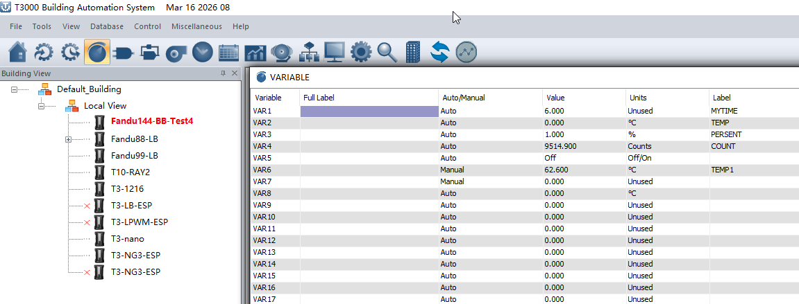

2.2 Activate Trend Log
- Click the Trend Log icon (chart-style button) on the top toolbar to enter the Trend Log configuration interface.
- In the right Input list, select the data points to monitor (e.g., MYTIME, TEMP, COUNT, FAN1, FAN2, PUMP1), and drag/add them to the left monitoring list.
- Name the monitoring group (e.g., TEST1), and set the data collection interval (20s, 5min, 15min are supported; default is 15min, 20s is recommended for high-frequency monitoring).
- Check the target monitoring group and switch the Status to ON to complete trend log activation.
- 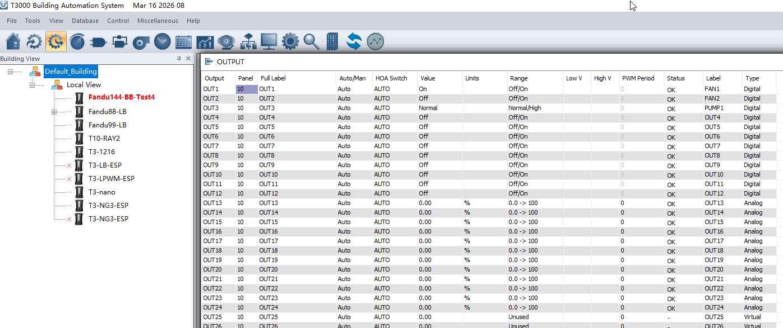

Note: The system supports up to 12 independent trend log groups, which can be configured by equipment/area.

3 Graphic Trendlog Operation Guide

3.1 Enter Trend Graph Interface
In the Trend Log configuration interface, select the activated monitoring group (e.g., TEST1), and click the bottom Graphic / Graphic Beta button to enter the trend graph visualization interface.
Recommendation: The latest version suggests using Graphic Beta for smoother real-time rendering and multi-view switching.
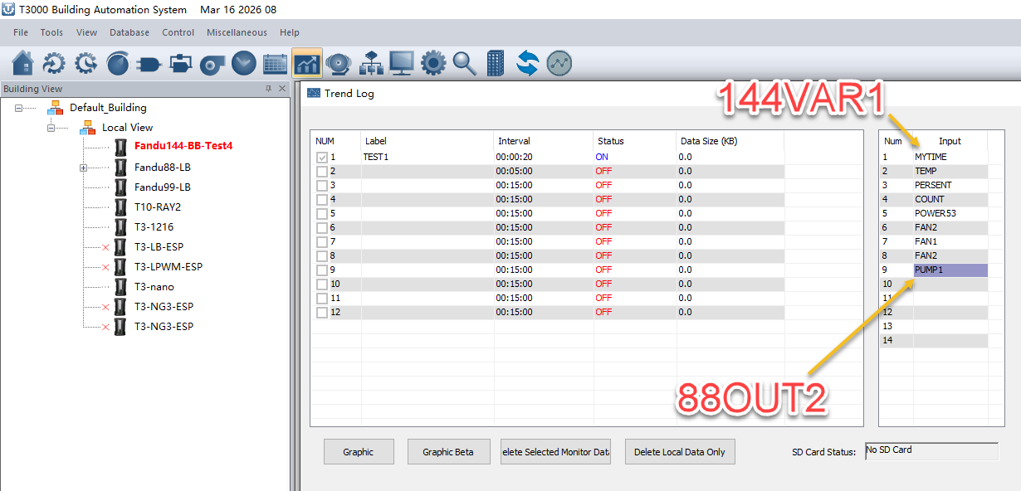

3.2 Core Interface Description
Area | Function Description
Top Toolbar | Core operations such as time base setting, view zoom, real-time monitoring, view switching, configuration export
Left Legend Bar | Displays all monitored data points (including name, type (VAR/IN/OUT), unit, color ID); supports single click to hide/show individual points
Main Chart Area | Visualizes data change trends; X-axis is time axis, Y-axis is value axis of corresponding data points; supports multi-point comparison on the same screen
Bottom Status Bar | Displays current monitoring group info, device SN, collection interval, real-time time, etc.

3.3 Detailed Core Operations

3.3.1 Time Base & View Control
- Time Base Setting: Click the Time Base dropdown to select time ranges (10min, 30min, 1h, 24h) and adjust the time span displayed on the X-axis.
- View Zoom: Click Zoom In to magnify the chart, Zoom Out to reduce the chart, and Reset to restore the default view with one click.
- Real-time Monitoring: Click the Live button (e.g., Live 10min) to enable the real-time scrolling view, which automatically refreshes the latest collected data (suitable for on-site equipment commissioning).
- Historical Backtracking: Use the left/right arrow buttons to backtrack historical data and check equipment status in any time period.

3.3.2 Data Point Management
- Show/Hide Data Points: In the left legend bar, click the color button before the data point to hide/show the curve individually for easy focus on key parameters.
- Filter by Type: Click the By Type dropdown to filter display by All, Digital, Analog, which simplifies the view when multiple data points are monitored.
- Auto Scroll: Turn on the Auto Scroll switch, and the real-time view will automatically scroll to the latest data without manual adjustment.

3.3.3 Multi-view Switching (New Feature of Graphic Beta)
The latest version supports View 1 / View 2 / View 3 three-view switching, which can assign different types of data points (e.g., temperature/fan/pump) to different views to avoid multi-curve overlap.
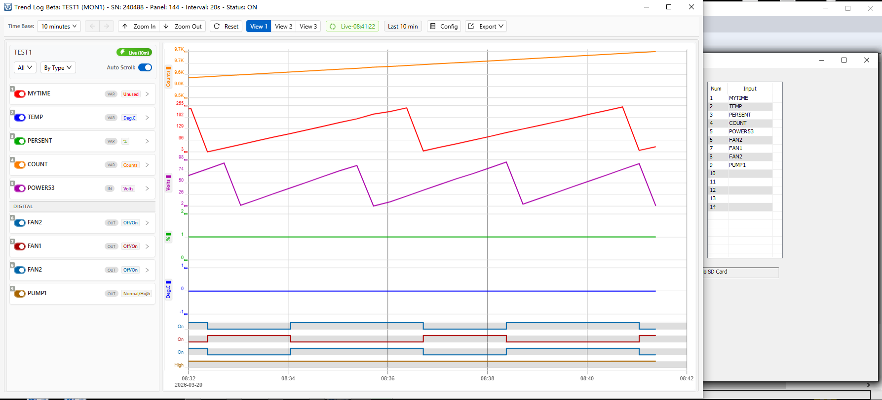
Operation steps:
- Click View 1 / View 2 / View 3 to switch views.
- Check the data points to be displayed in the corresponding view; the system automatically saves the view configuration.
- Apply to multi-dimensional monitoring of complex systems (e.g., View1 for environmental parameters, View2 for fan status, View3 for pump energy consumption).

3.3.4 Data Export & Configuration
- Export Data: Click the Export dropdown; support exporting trend graph as image (PNG/JPG) and raw data as CSV/Excel format for report generation and data analysis.
- Save Configuration: Click the Config button to save the current view configuration (time base, displayed data points, view allocation, etc.), which will be automatically loaded next time.
- Delete Data: In the Trend Log interface, click Delete Selected Monitor Data to delete historical data of the selected monitoring group; click Delete Local Data Only to delete only local cache data.

4 Data Storage & Query

4.1 Data Storage Mechanism
All trend log data is stored in the SQLite local database, with the core table being TRENDLOG_DATA. The table structure is as follows:
Field | Description
SN | Device unique serial number (e.g., 240488)
PANEL | Panel number (e.g., 10, 144)
POINT_NAME | Data point name (e.g., FAN1, TEMP, COUNT)
POINT_TYPE | Data point type (Digital/Analog/Variable)
TIMESTAMP | Data collection timestamp (accurate to second)
VALUE | Collected real-time value
UNIT | Data unit (e.g., ℃, %, Counts, On/Off)

4.2 Data Query & Analysis
- Local Query: Through the built-in database tool of the T3000 system, directly query the TRENDLOG_DATA table and filter historical data of specified devices, time ranges and data points.
- Third-party Analysis: After exporting CSV data, use Excel, Python and other tools for data analysis (e.g., equipment operation time statistics, energy consumption analysis, fault early warning).
- Data Backup: Regularly back up SQLite database files to avoid data loss; the system supports cross-device data migration.
- 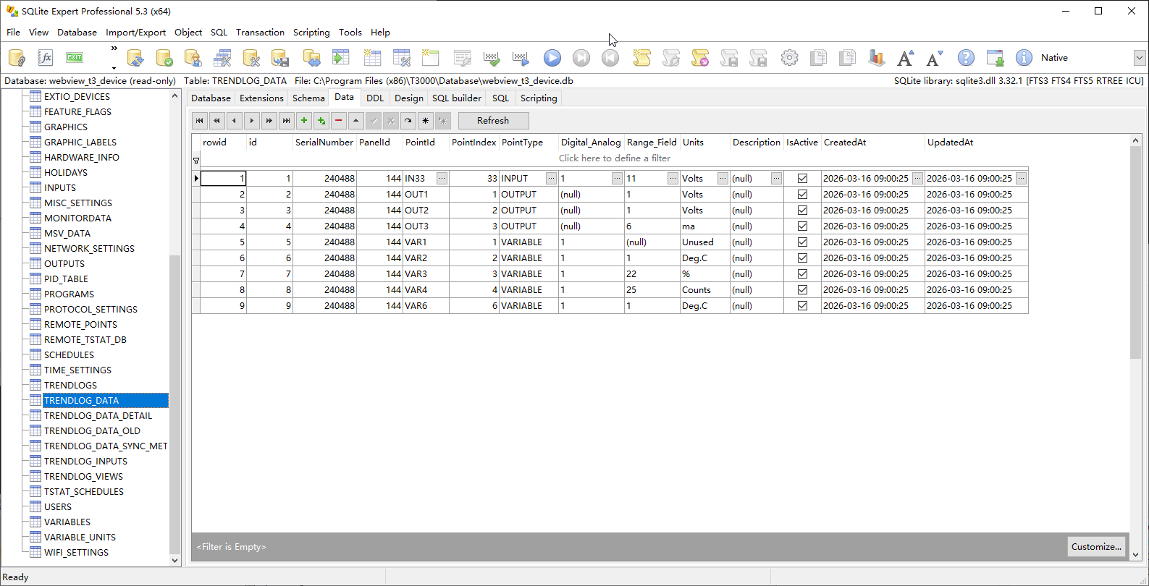

5 Common Problems & Notes

5.1 Common Problems & Troubleshooting
- No data in trend graph: Check if trend log Status is ON, collection interval is reasonable, data points are offline, and the device is powered normally.
- Real-time view lag: Reduce collection frequency (e.g., adjust from 20s to 1min), reduce the number of simultaneous monitoring data points, or switch to the Graphic classic view.
- Data export failed: Ensure the system has sufficient storage space, turn off third-party antivirus software interception, and run T3000 with administrator privileges.

5.2 Key Notes
- High-frequency collection (<1min) will increase system load; it is only for equipment commissioning, and a 15min interval is recommended for daily monitoring.
- Digital points (e.g., FAN1/PUMP1) only record On/Off status, while analog points (e.g., TEMP/PERSENT) record continuous values.
- Without an SD card, data is only stored in the local database; inserting an SD card can automatically back up data to external storage.
- Input Operation Instruction: In the system input field, enter commands such as 144IN3; the number in front represents the PANEL number, which is related to system data monitoring and chart generation.

