.
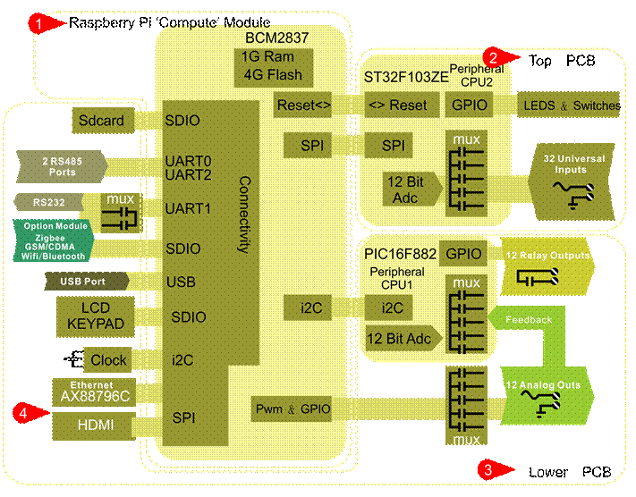

The hardware is made up of a top PCB and lower PCB and the Raspberry Pi compute module plugged into a socket on the lower PCB, showing at Tab1 in the image above.

The GPIO of the Pi are used by the LCD, UARTS and SD card so expansion to the rest of the hardware is offloaded to two auxiliary CPUs. On the top board at Tab2 is the ST32F103ZE which is responsible for managing the LEDS, hand-off-auto switches and the universal inputs. On the bottom board at Tab3 is the second CPU, a PIC16F882 which is

responsible for managing the relays and analog outputs. The Pi communicates to the two auxiliary CPU’s using SPI commands as detailed below.

################## COMMUNICATING WITH THE TOP BOARD #####################
Top board aux CPU is: stm32f103ZE

led -> controls the leds on the top board
spi -> communication with bottom board.
switches -> check the position of all the hand-off-auto switches
timer -> manages the heartbeat LED which blinks once every second during normal operation, two times quickly during bootup.
input.c -> reads the value of all the universal input channels

/******** comm.c comm.h *************/
-> spi code with top board
1. get input values , switch status
2. set input type,read the inputs

commands between BOT and TOP:

//G_TOP_CHIP_INFO -- return information of TOP cpu. (12 bytes) –
0,1 xx xx(2 bytes reserved) +
2,3 xx xx(firmware rev of top cpu)
4-11 xx xx xx xx xx xx xx xx(8 bytes reserved)

This info will be important later as the hardware changes on future board revs.

//G_ALL -- return switch status
(24 * 1 bytes) . 0->SW_OFF 1->SW_AUTO 2->SW_HAND
input value( 32 * 2 bytes)
input value, 2 bytes. Input value’s range is 0-1023, it is raw data, corresponding to the voltage measured by the A/D converter on the universal analog inputs. Full scale is 1023 counts at 3V.( 0x3ff), and raw value is 0 if connected with GND. Bottom board will deal with the raw data by range

high speed counter( 6 * 4bytes) , Total pulse count on the input, max value 0xffffffff
All models have 6 hi speed counters.

//S_ALL -- send LED status to TOP.
Communication LED( 2 bytes)
output led( 24 * 1byte) variable brightness, 0 to 5 levels
input led( 32 * 1 byte) , first four bits for signal type
0=not used
1=0-20ma
2= 0-5V full scale
3= 0-10V full scale
4= dry contact/thermistor, 3v weak pullup

second four bits, led brightness, 0 to 5 levels
flag of high speed counter( 6 * 1) TBD: explain this

If panel is BB, there are 24 outputs and 32 inputs, the detail format is following.
// G_ALL -- switch status (24 * 1 bytes) + input value( 32 * 2 bytes) + high speed counter( 6 * 4bytes)
// S_ALL -- Communication LED( 2 bytes) + output led( 24 * 1byte) + input led( 32 * 1) + flag of high speed counter( 6 * 1)

Communcaition leds can only be on or off so 1 bit required only for each of these LEDS.
Communication.BYTE0 First Byte explained
BIT0 --> UART2_TX
BIT1 --> UART2_RX
BIT2 --> UART0_TX
BIT3 --> UART0_RX
BIT4 --> ETHERNET_TX
BIT5 --> ETHERNET_RX
BIT6 --> UART1_TX
BIT7 --> UART1_RX
Communication.BYTE1 Second Byte Explained
BIT0 --> ZIG_TX
BIT1 --> ZIG_RX

Output led brightness level. If output is digital, only ON(level5) and OFF. If Output is analog, level is decided by voltage value. Highest level is 5, then 4, 3, 2, 1, 0 is OFF.

OUPUT_LED.BYTE0 --> LED brightness level of output1
OUPUT_LED.BYTE1 --> LED brightness level of output2
…
OUPUT_LED.BYTE23 --> LED brightness level of output24

Input Led brightness level, if input is digital, only ON and off. If input is analog, level is decide by input value also.
Highest level is 5, then 4, 3, 2, 1, 0 is OFF.

INPUT_LED.BYTE0 --> LED brightness level of INPUT1
INPUT_LED.BYTE1 --> LED brightness level of INPUT2
…
INPUT_LED.BYTE31 -> LED brightness level of INPUT32

T3-LB Model hardware
If panel is LB, there are 10 outputs and 16 inputs, the detail format is following.
Note that the Pi socket is only available in the BB for now, LB will come later

// G_ALL -- switch status (10 * 1 bytes) + Reserved bytes (14 bytes) + input value( 16 * 2 bytes) + Reserved bytes (32 bytes) + high speed counter( 6 * 4bytes)
// S_ALL -- Communication LED( 2 bytes) + output led( 10 * 1byte) + Reserved bytes (14 bytes) + input led( 16 * 1) + Reserved bytes (16 bytes) + flag of high speedcounter( 6 * 1)

communcaition led only OFF and ON, no level, input led and ouput led have 6 level brightness.
Communication.BYTE0
BIT0 --> UART2_TX
BIT1 --> UART2_RX
BIT2 --> ETHERNET_TX
BIT3 --> ETHERNET_RX
BIT4 --> UART0_TX
BIT5 --> UART0_RX
BIT6 --> UART1_TX
BIT7 --> UART1_RX
Communication.BYTE1 is no used.

Output led brightness level. If output is digital, only ON(level5) and OFF. If Output is analog, level is decided by voltage value. Highest level is 5, then 4, 3, 2, 1, 0 is OFF.

OUPUT_LED.BYTE0 --> LED brightness level of output1
OUPUT_LED.BYTE1 --> LED brightness level of output2
…
OUPUT_LED.BYTE9 --> LED brightness level of output10

Input Led brightness level, if input is digital, only ON and off. If input is analog, level is decide by input value also.
Highest level is 5, then 4, 3, 2, 1, 0 is OFF.

INPUT_LED.BYTE0 --> LED brightness level of INPUT1
INPUT_LED.BYTE1 --> LED brightness level of INPUT2
…
INPUT_LED.BYTE15 -> LED brightness level of INPUT16

T3-TB Model
If panel is TB (new ARM version), no SPI communication . (see newtiny.c)
main cpu take charge of led, switch, inputs feature.
Note that the Pi is not supported in the T3-TB for now.

-----> LED
GPIO1 -- LED_LATCH_1
GPIO2 -- LED_LATCH_2
LED_LATCH_1 -> 1 LED_LATCH_1 -> 0
LED_LATCH_2 -> 0 LED_LATCH_2 -> 1
GPIO3 -- LED_1 LED_DO1 LED_DO4
GPIO4 -- LED_2 LED_DO2 LED_DO5
GPIO5 -- LED_3 LED_DO3 LED_DO6
GPIO6 -- LED_4 LED_IN1 LED_DO7
GPIO7 -- LED_5 LED_IN2 LED_DO8
GPIO8 -- LED_6 LED_IN3 LED_AO1
GPIO9 -- LED_7 LED_IN4 LED_AO2
GPIO10 -- LED_8 LED_IN5 LED_AO3
GPIO11 -- LED_9 LED_IN6 LED_AO4
GPIO12 -- LED_10 LED_IN7 LED_AO5
GPIO13 -- LED_11 LED_IN8 LED_AO6
GPIO14 -- LED_12 LED_MAIN_RS485_TX LED_RS485_TX SUB
GPIO15 -- LED_13 LED_MAIN_RS485_RX LED_RS485_RX SUB
GPIO16 -- LED_14 LED_HEART LED_ETH TX & RX
led status of LB have 6 brightness features.

-----> SWTICH
GPIO1 -- SWITCH_AUTO
GPIO2 -- SWITCH_HAND

GPIO3 -- SWITCH_1
GPIO4 -- SWITCH_2
GPIO5 -- SWITCH_3
GPIO6 -- SWITCH_4
GPIO7 -- SWITCH_5
GPIO8 -- SWITCH_6
GPIO9 -- SWITCH_7
GPIO10 -- SWITCH_8
GPIO11 -- SWITCH_9
GPIO12 -- SWITCH_10
GPIO13 -- SWITCH_11
GPIO14 -- SWITCH_12
GPIO15 -- SWITCH_13
GPIO16 -- SWITCH_14
set AUTO to 1,HAND to 0, get sw_status1, set hand to 0, hand to 1, get sw_status2,
if sw_status equel sw_status2, switch status is SW_OFF.
if sw_status turn from 1 to 0, swtich status is SW_AUTO.
if sw_status turn from 0 to 1, swtich status is SW_HAND.

-----> INPUT

ADC1
GPIO1 -- SEL1_IN
GPIO2 -- SEL2_IN
GPIO3 -- SEL3_IN

SEL1_IN SEL2_IN SEL3_IN
IN1 -> 0 0 0
IN2 -> 1 0 0
IN3 -> 0 1 0
IN4 -> 1 1 0
IN5 -> 0 0 1
IN6 -> 1 0 1
IN7 -> 0 1 1
IN8 -> 1 1 1

-----> SET INPUT RANGE,
note that the LB and TB models use an auxiliary CPU on the bottom board to handle this.
The data structures are largely the same however.
Select input range by software.
GPIO1 -- RANGE_SET0
GPIO2 -- RANGE_SET1

INPUT_0_5V INPUT_0_10V INPUT_0_20MA THERMISTOR
RANGE_SET0 1 0 0 1
RANGE_SET1 0 1 0 1

/*******************Communicating with the Bottom Board ****************
/********** pic.c pic.h ***************/
1. communication with pic chip by I2C protocol
2. pic chip also enables the relays

command enumerate:
enum{

GET_VERSION = 0,
READ_AO_FEEDBACK, // ONLY FOR TINY
SET_RELAY_LOW, // 02 turn on or off relays 1 to 8
SET_RELAY_HI, // 03 turn on or off relays 9 thru 12

READ_AO1_FEEDBACK, // 0x1b read the analog output voltage, used for improving accuracy of analog outputs.
TBD: also can be used to generate alarms if the hardware has problems.
READ_AO2_FEEDBACK, // 0x1c
…
READ_AO12_FEEDBACK, // 0x26 all the way up to channel 12.
READ_NULL = 100,

};

Format of read and write:
I2C device addr is 0xC0, read and write is function, bit0, so
0xC0 is read command,
0xC1 is write command.
Write PIC -- 3 bytes 0XC0 + command + value (1 bit is for 1 output)

COMMNAD value( BIT7 BIT6 BIT5 BIT4 BIT3 BIT2 BIT1 BIT0) // these are for the relay outputs
0x02 OUT8 OUT7 OUT6 OUT5 OUT4 OUT3 OUT2 OUT1
0x03 - - - - OUT12 OUT11 OUT10 OUT9

Example, 0xc0 0x02 0x0f -> open OUTPUT1 to OUPUT4, close OUTPUT5 to OUTPUT 8
0xc0 0x03 0x0C -> open OUTPUT11, and OUTPUT12, close OUTPUT9 and OUTPUT10

read PIC -- 0xc1 + many bytes

Example, 0xC0 + READ_AO1_FEEDBACK // read command
0xC1 + buffer // Write command data

/********* output.c output.h ************/
1. controls the analog output mux, two analog outputs are muxed for up to 12 analog outputs depending on the model

// GPIO1 -> AO_GP1_EN The mux chip enable pin, mux chip number 1, AO1 thru 6
// GPIO2 -> AO_GP2_EN enable pin for mux chip #2, AO7 thu 12.
// GPIO3 -> AO_CHSEL0 select the analog output channel, 3 bits.
// GPIO4 -> AO_CHSEL1
// GPIO6 -> AO_CHSEL2
// PWM1 -> control, PWM signal to generate analog outputs for AO1 thru 6
// PWM2 -> control, PWM signal to generate analog outputs for AO7 thru 12

how to control an OUTPUT?
SET GPIO as following chart, and get corresponding PWM channel.

AO_GP1_EN AO_GP2_EN AO_CHSEL0 AO_CHSEL1 AO_CHSEL2 PWM1 PWM2
1 1 0 0 0 OUT13 OUT19
1 1 1 0 0 OUT14 OUT20
1 1 0 1 0 OUT15 OUT21
1 1 1 1 0 OUT16 OUT22
1 1 0 0 1 OUT17 OUT23
1 1 1 0 1 OUT18 OUT24

note: control anoglog outputs by hardware PWM. There are 12 analog outputs. OUT13-OUT18 (AO1thru 6) are share one channel, OUT19-OUT24 (AO7 thru 12) all share a second PWM channel.
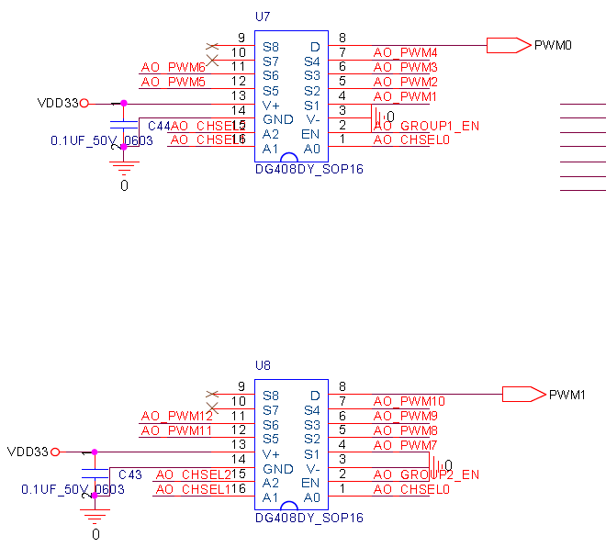

We were successful in establishing communication between CPU2 and Raspberry Pi compute module over SPI interface. And we could read data from the CPU2. We used the command " G_ALL " (0x24) to read the value of inputs from T3000, and we read 113 bytes from the CPU2 (24 bytes representing the switch status (H/O/A), 64 bytes corresponding to the 32 universal input values, and rest of the bytes corresponding to TOP_BOARD_INFO and SPEED_COUNTER. The result containing 113 elements (bytes) are attached with this.

From the output we understood that first 24 values represents the state of the switch, and the next 64 values represents the 32 universal input values, with 2 bytes for each input terminal. While no input is connected to the input pins, the reading showed a value 3 on first byte of each input and a value ranging from 250 to 255 in the second byte. We don't know what are these values and why are they showing this particular value. When we tried to connect an external 5v to the T3000 input, these values were same as that in the case of no inputs. Also when we connected the inputs to the ground terminal of T3000, it resulted in a value of 0 in the first byte and a value in range of 14 to 18 in the second byte.

So please advise us on this scenario and provide us help to interpret the values from the SPI buffer. In the T3000 manual they stated that transducers can be connected directly to the it without any external interfacing and we provided the external voltage according to this. Is any external interfacing needed to apply input to T3000.

Regards,

1] T3000 controller to be up and running from Pi Compute module - IO of T3000 can be programmatically controlled from Compute module.
2] NodeRED setup in Compute module - DONE
3] Install IO node in NodeRED
3.1 Using Node modules connect to CPU2 over an SPI interface to read from 32 universal Inputs
3.2 Using Node modules connect to CPU1 over an I2C interface to write to 12 DO - DONE (Not with Node; but with Python)
3.3 Using Node modules to write to 12 AO by PWM method
4] Internet connectivity to T3000 controller
4.1 using Ethernet cable
4.2 using WiFi - DONE

Thanks for the code snippet and guidance. We were able to crack writing to Digital Output pins. We are now figuring out Analog Output and need your help with the below points.
Using the GPIO & PWM pins of compute module, we are able to write to 12 analog ports.

Challenges:
- Only able to control two outputs simultaneously as there are only two PWM pins in the Compute module. We understand that there is multiplexing. How do we write to 12 outputs simultaneously?
Out13 – out18 share PWM1, out19-out24 share PWM2, see schematic above.

- We are unable to read the AO feedback from PIC over i2c. It is always returning an I/O error in python and all the connected i2c devices disappears after that error and we need to reset the power to bring them back again.
READ_AO1_FEEDBACK1 is 27 (0x1b)
READ_AO2_FEEDBACK1 is 28 (0x1c)
…
READ_AO12_FEEDBACK1 is 38 (0x26)
see above, update it again.
We are trying to read A01_feedback.
bus.write_word_data(0x60,0xc0,0x28) (At times it returns error but devices do NOT disappear from list)
read=bus.read_word_data(0x60,0xc1) (Was able to read the data once successfully using bus.read_byte_data(0x60,0xc1). But returning error in most of cases and devices disappear from list)
- Could baud rate be the issue? Would like to know the baud rate of i2c communication they used.

Baud rate is not big deal, we use software I2C.

