2.0 EXPERIMENTAL SETUP

2.1 Data acquisition

For the purpose of collecting data we developed special questionnaire software, and software for detecting eye blinks in the capture video stream
The video stream was captured with a Logitech HD Pro Webcam C920 . Video stream was stored on a disk drive and later processed for further experiments. Simultaneously we were also recording EEG signals to be able detected eye blinks using blink detection software. For recording EEG signals Mitsar-EEG 201 machine and WinEEG software. For signal process and analysis WinEEG and own MATLAB scripts, respectively, has been used.
The experimental setup is shown on the left of figure 1.

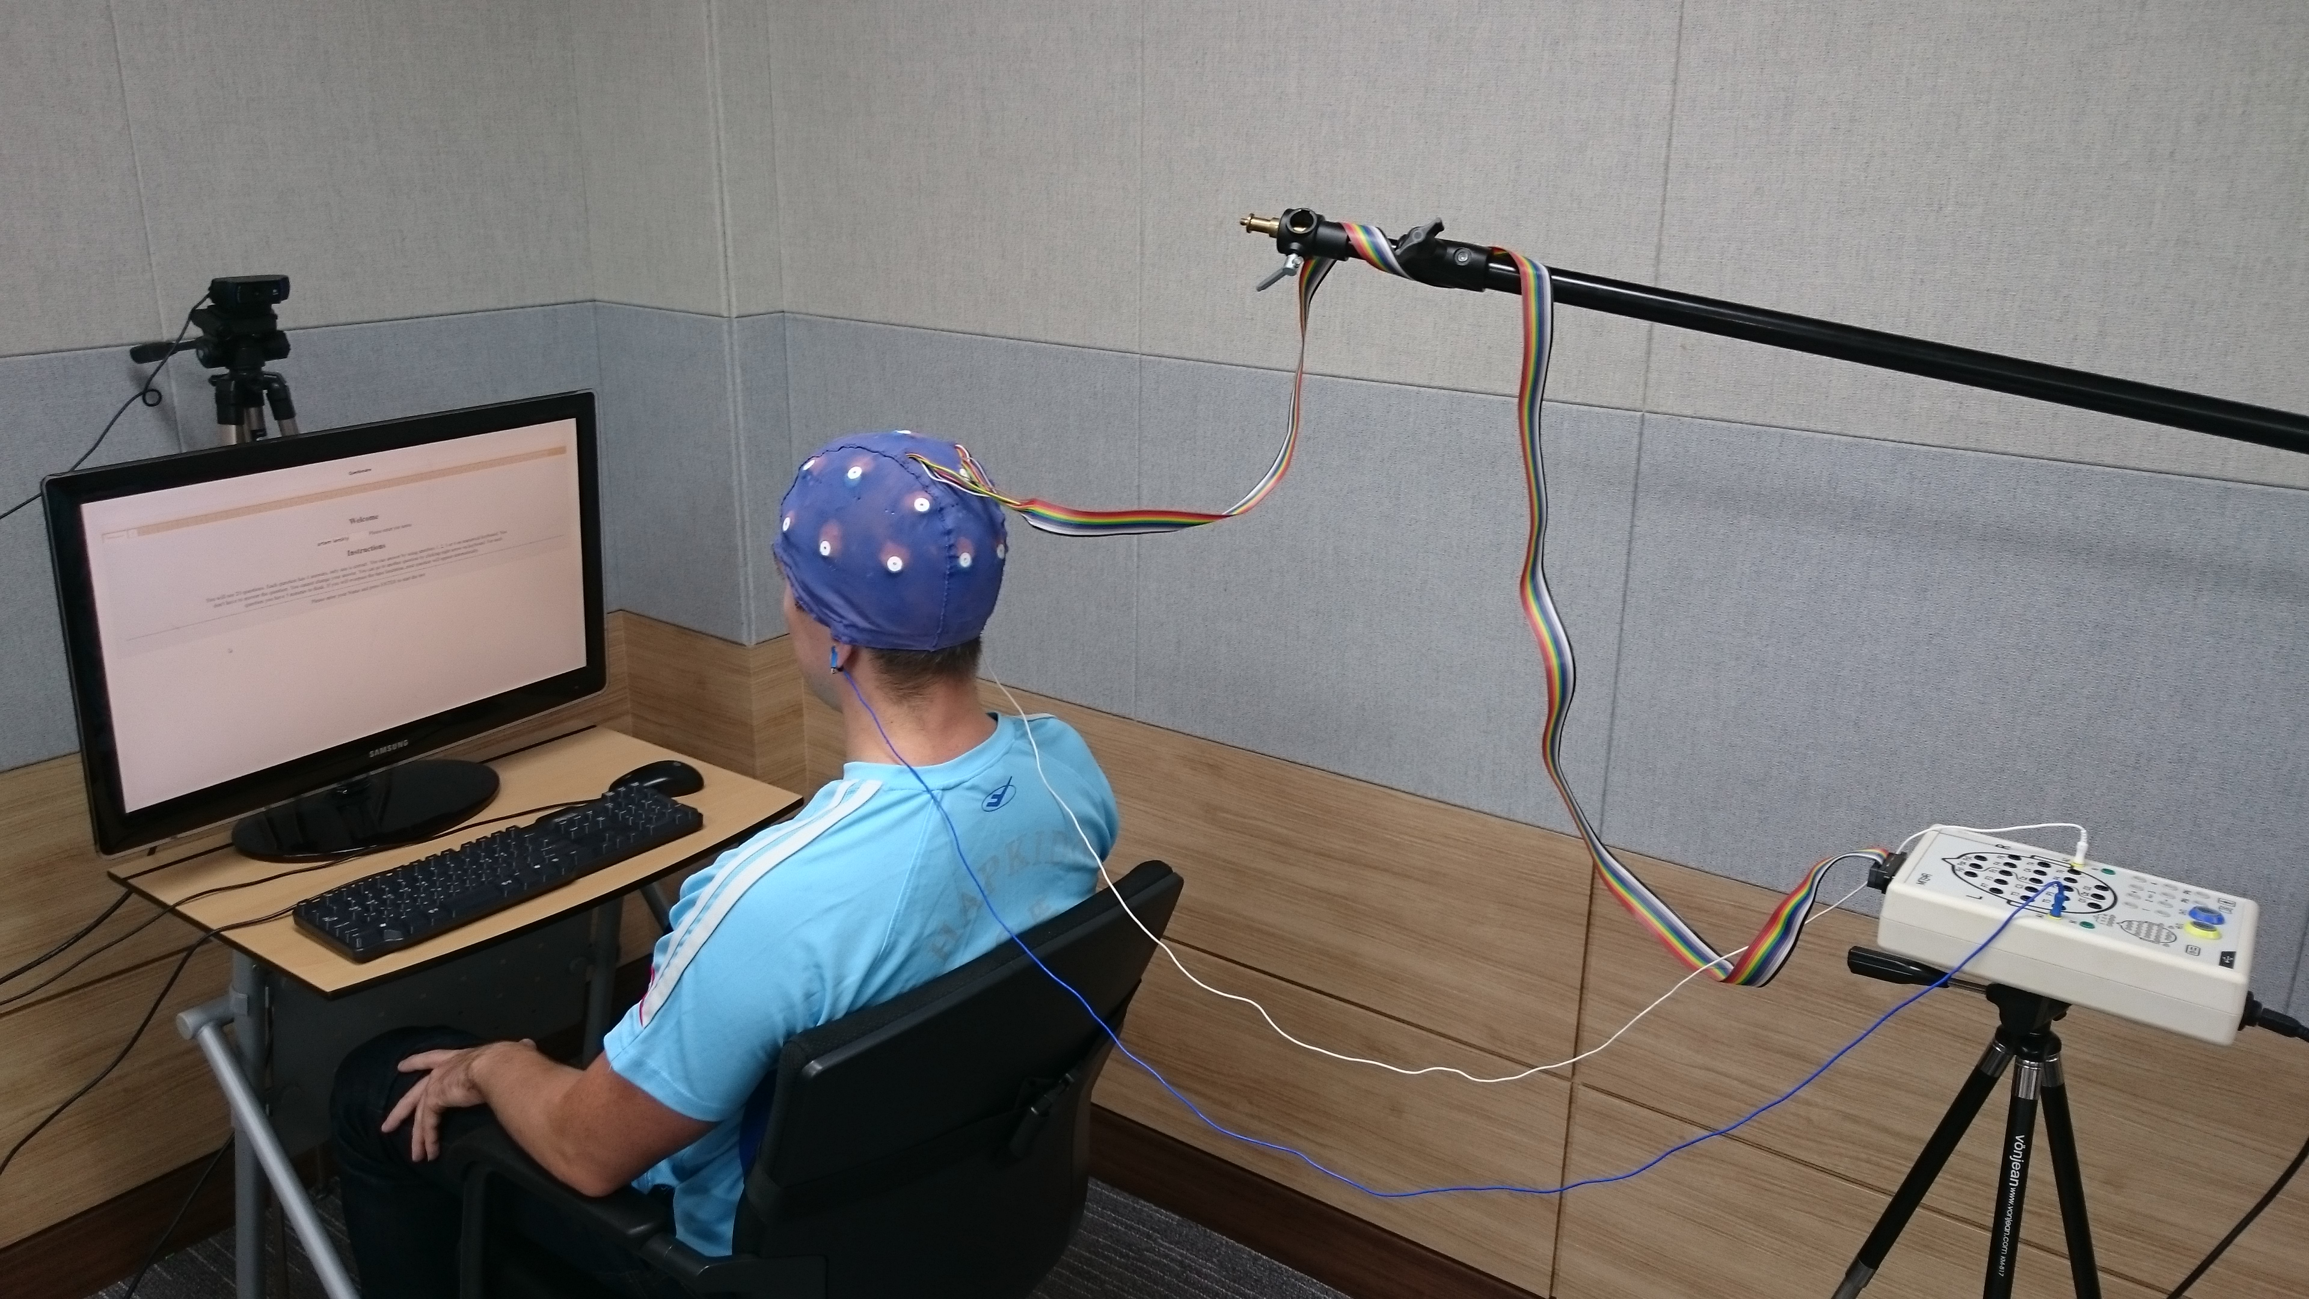Fig 1: experimental setup

2.2 Testing procedure

The recording session consisted of four stages: (a) resting, (b) the IQ test, (c) resting, (d) reading, and (e) the memory test. The testing software was developed in HTML and javascript (jQuery) in such a way that it does not required any interventions. The whole testing session took 1720 seconds, 5 minutes resting before the IQ, 540 seconds the IQ test, 5 minutes resting stage, 5 minutes reading and 280 seconds the memory test. The IQ test consisted of 14 questions. Before the memory test a resting stage and passage about Ethiopia was given. After reading the passage user was presented questions one by one. In the figure 2 an example of a memory test question is shown.

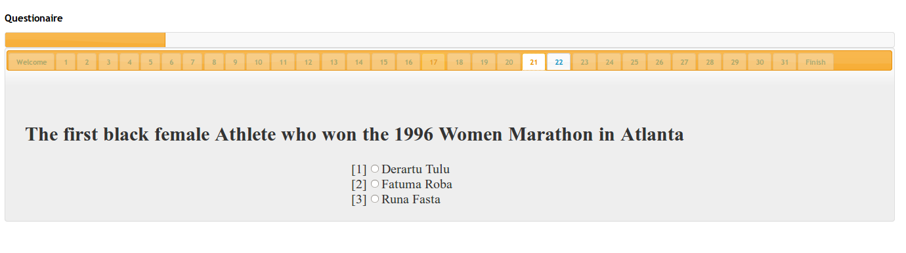Fig 2: User's interface

2.3 Eye blinking detection procedure
@TODO: for professor :)

