Subject: Get free personalized setup from Intuit after you migrate to QuickBooks Online

The QuickBooks Online Customer Support team is offering Free Personalized Setup*, a complimentary one-hour onboarding session to help you get started.

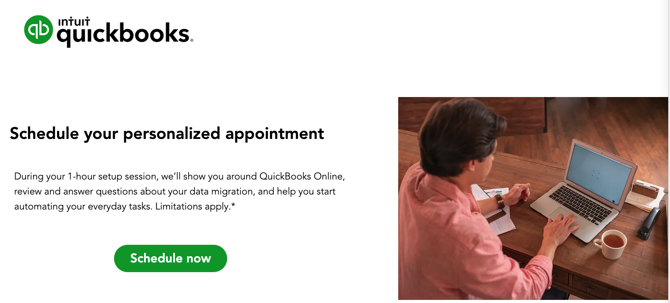

What you can expect:

Intuit experts provide a guided tour of QuickBooks Online, including:
- How the most-used QuickBooks Desktop business tasks and workflows look in QuickBooks Online.
- Comparing specific reports from QuickBooks Desktop to QuickBooks Online to ensure accuracy of data migration.
- A review of the Gear icon, +New button, Banking and more so you get the most out of QuickBooks Online and feel comfortable doing daily tasks.

To learn more about Personalized Setup, please contact Intuit Support at 800-459-5183, M-F, 8:00 AM to 8:00 PM, ET or reach out to me at XX for more information.

Free personalized setup from QuickBooks Desktop Pro, Premier, Mac, or Plus (“Desktop”) to QuickBooks Online Simple Start, Essentials, Plus or Advanced (“QuickBooks Online”), or QuickBooks Desktop Payroll, Payments, or Time to QuickBooks Online Payroll, Payments, or Time is available to small business users who sign up on or until July 17, 2023, and is subject to capacity. Customers must initiate a setup meeting by July 31, 2023. The personalized setup offer is eligible to Desktop customers that are migrating their data, as well as those customers who elect not to migrate their data, who are starting new QuickBooks Online accounts, and setting up QuickBooks Online. Personalized setup is limited to a 1-hour session with a customer success product expert. Intuit reserves the right to limit the number of sessions and the length and scope of each session. Terms and conditions, features, support, pricing, and service options subject to change without notice.

Subject: QuickBooks Online offers peace of mind
Intuit takes data security seriously and relies on industry-recognized security safeguards to keep your financial data private and protected that’s stored on our systems
QuickBooks Online security technology is built on decades of experience protecting customer data.

- Password-protected login, firewall protected servers and encryption when data is stored on our systems. QuickBooks Online has the security elements in place to give you peace of mind.
- You control who accesses your data, and what they can see and do with it. Each person you invite to use QuickBooks Online must create a unique password, with multiple permission levels that let you limit the privileges of each user.
- QuickBooks Online features Always-On Activity Log and Audit Trail, which cannot be turned off by a user. Intuit records every login to the service and any changes made to every financial transaction. So you or your accountant can know when and where changes happen.
For JNN Group, QuickBooks Online’s secure data keeps customers feeling safe and their business booming

To Learn more about Intuit security protocols. Please contact me at XX for more information or to get started with your migration QuickBooks Online.

Subject: Moving to QuickBooks Online just got easier with our improved migration tool
Intuit now offers an easier-to-use, more efficient way to move your QuickBooks Desktop files to QuickBooks Online. Intuit will help you migrate your data via a web-hosted solution without having to purchase a desktop subscription. If you have QuickBooks Desktop software from 2017 or older, you can also use the online Migration Tool for an easier path to convert to QuickBooks Online.
- Migration made easy. Migrate key desktop data to QuickBooks Online with confidence. Do it yourself or let Intuit help you with step-by-step guides, demos, webinars, and customer support.

- Support when you need it. Intuit’s got your back. Specialists are ready to answer your QuickBooks Online questions—so you can hit the ground running.*

- The view you’re used to. To make it easier to move online, there’s now a home screen that looks similar to QuickBooks Desktop.
- View-only mode: See your Desktop data if you have canceled your Desktop subscription and moved to QuickBooks Online. You can view critical data to compare reports, inventory and balances with a view only mode.*

4 out of 5 of QuickBooks Online customers agree that switching from QuickBooks Desktop was well worth the effort.**

Please contact me at XX to review your books in advance of migrating. For instructions about how to access and use the migration tool, see this QuickBooks Online Help article.

*Available only on QuickBooks Desktop 2023 R3 or newer, view-only access remains for 1 year after your subscription ends. In that time, you won’t be able to edit your data with your inactive license, but you can renew your subscription or export your data. To view your data after 1 year, you’ll have to renew your subscription. We recommend you export your data or migrate data to QBO before you cancel your Desktop subscription.
**Based on Intuit survey Jan 2022, amongst remunerated QuickBooks Online users who expressed an opinion, when they compared QuickBooks Online to their prior QuickBooks Desktop Pro, Pro Plus, Premier, Premier Plus or Mac Plus products. Survey did not include Enterprise customers.

Subject: Ready to make the move to QuickBooks Online, our firm is here to help.

If you are ready to migrate from QuickBooks Desktop to QuickBooks Online, our firm can assist you every step of the way. Here are all of the services we offer to make this transition seamless for you and your business.

  - Review and clean-up accounts including getting rid of old data.
  - Backup your files
  - Conduct the migration
  - Verify all of your files were successfully migrated
  - Help ensure your books are updated and balanced
  - Assist in selection of specialized apps

4 out of 5 of QuickBooks Online customers agree that switching from QuickBooks Desktop was well worth the effort.*

Please contact me at XX to engage my firm in your migration.

*Based on Intuit survey Jan 2022, amongst remunerated QuickBooks Online users who expressed an opinion, when they compared QuickBooks Online to their prior QuickBooks Desktop Pro, Pro Plus, Premier, Premier Plus or Mac Plus products. Survey did not include Enterprise customers.
Subject: Move to QuickBooks Online for greater flexibility and real-time collaboration
Business happens quickly. Moving your business to QuickBooks Online can give you added flexibility, and maybe even some extra time, to focus on growing your business or doing other things you love.
What does flexibility and collaboration really look like?

- See live insights from me as your trusted accountant. Keep your books accurate and up-to-date by inviting your accountant to access your QuickBooks data with you virtually.
- Collaborate your way. Work simultaneously with multiple users with live data sharing.*
- Send invoices from anywhere. Send and track invoices from your laptop or mobile device.**
- Anytime, anywhere access. Work where and how you want. QuickBooks Online is in the cloud, so you can access your data from any device.***

97% of QuickBooks Online customers agree that their team can work simultaneously and efficiently from anywhere.****

Real-time accounting helps women-owned WashedPros co-owners stay on the same page
See how moving from QuickBooks Desktop to QuickBooks Online has saved the owner of Rideaway Adventures time, money, and effort

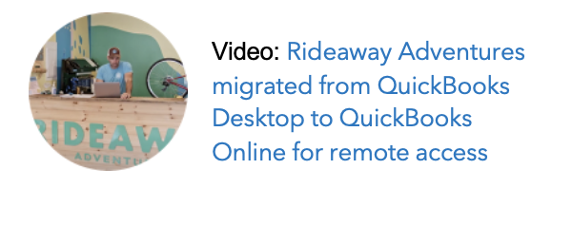
Please contact me at XX for more information or to get started with your migration QuickBooks Online.

*Multiple users: User numbers vary based on plan type.
**Pay-enabled invoices: Requires a separate QuickBooks Payments account which is subject to eligibility criteria, credit and application approval. E-invoicing QuickBooks Payments is an optional fee-based service. Additional fees may apply. Additional terms and conditions apply.
***QuickBooks Online requires a computer with a supported browser (see System Requirements for a list of supported browsers) and an Internet connection (high-speed recommended).
****Based on Intuit survey Jan 2022, amongst remunerated QuickBooks Online users who expressed an opinion, when they compared QuickBooks Online to their prior QuickBooks Desktop Pro, Pro Plus, Premier, Premier Plus or Mac Plus products. Survey did not include Enterprise customers

Subject: It’s easier than ever to manage your books with QuickBooks Online

Moving your accounting to the cloud offers greater flexibility and real-time collaboration, so you can run your business efficiently and keep your books accurate.

These are just some of the ways moving to QuickBooks Online simplifies the process of managing your books:

- Reports tailored to your business. Run custom reports based on your tags for a quick view of insights that matter most to you.

- Automate manual tasks. Save time and speed-up your workflow by automating everyday tasks like invoices and expenses using receipt capture.*

- Seamlessly sync transactions. All of your bank and credit card transactions flow into QuickBooks Online automatically to help you easily track your income and expenses.

- Connect your favorite apps. Integrate with the tools you already use to run your business, plus access hundreds of specialized apps to help you see it all—and do it all—right in QuickBooks Online.**

Cabo Yacht Charter flexibly manages their books

86% of customers say they can reconcile bank and credit card statements faster with QuickBooks Online than QuickBooks Desktop.***

Please contact me at XX for more information or to get started with your migration QuickBooks Online.

*Receipt Capture: Requires QuickBooks Online mobile application. The QuickBooks Online mobile app works with iPhone, iPad, and Android phones and tablets. Devices sold separately; data plan required. Not all features are available on the mobile apps and mobile browser. QuickBooks Online mobile access is included with your QuickBooks Online subscription at no additional cost. Data access is subject to cellular/internet provider network availability and occasional downtime due to system and server maintenance and events beyond your control. Product registration required.
**Third party apps: Apps may require a third-party subscription. Third party applications available on apps.com. Subject to additional terms, conditions, and fees.
***Based on Intuit survey Jan 2022, amongst remunerated QuickBooks Online users who expressed an opinion, when they compared QuickBooks Online to their prior QuickBooks Desktop Pro, Pro Plus, Premier, Premier Plus or Mac Plus products. Survey did not include Enterprise customers.

