Technical Report – Suspicious IP Detection Tool

1. Introduction
The aim of this project was to create a small cybersecurity tool that can help identify potentially suspicious network connections on a computer. The idea is simple: first collect all active network connections using a PowerShell script, and then check the remote IP addresses with a threat‑intelligence API using Python. The tool is meant to support a basic security investigation by showing if any IPs that a device is communicating with have been reported for malicious activity.

2. Tool Design & Implementation

PowerShell Component
The PowerShell script (collect_connections.ps1) uses the Get-NetTCPConnection command to gather the current network connections on the system. For each connection, the script records the process name, local address/port, remote address/port, and the connection state. All this information is saved into a CSV file called connections.csv.
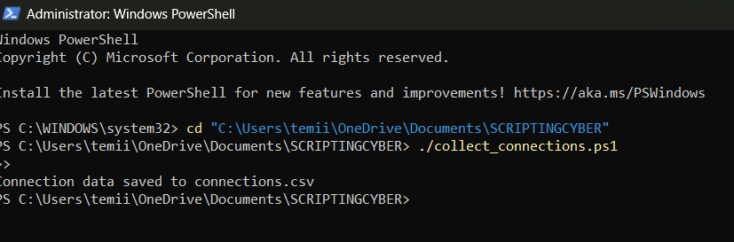

Python Component
The Python script (ip_checker.py) reads the CSV file generated by the PowerShell script. For each remote IP address, it sends a request to the AbuseIPDB API. The API responds with data such as the abuse confidence score and the number of reports. The results are stored in a JSON file named analysis_report.json.
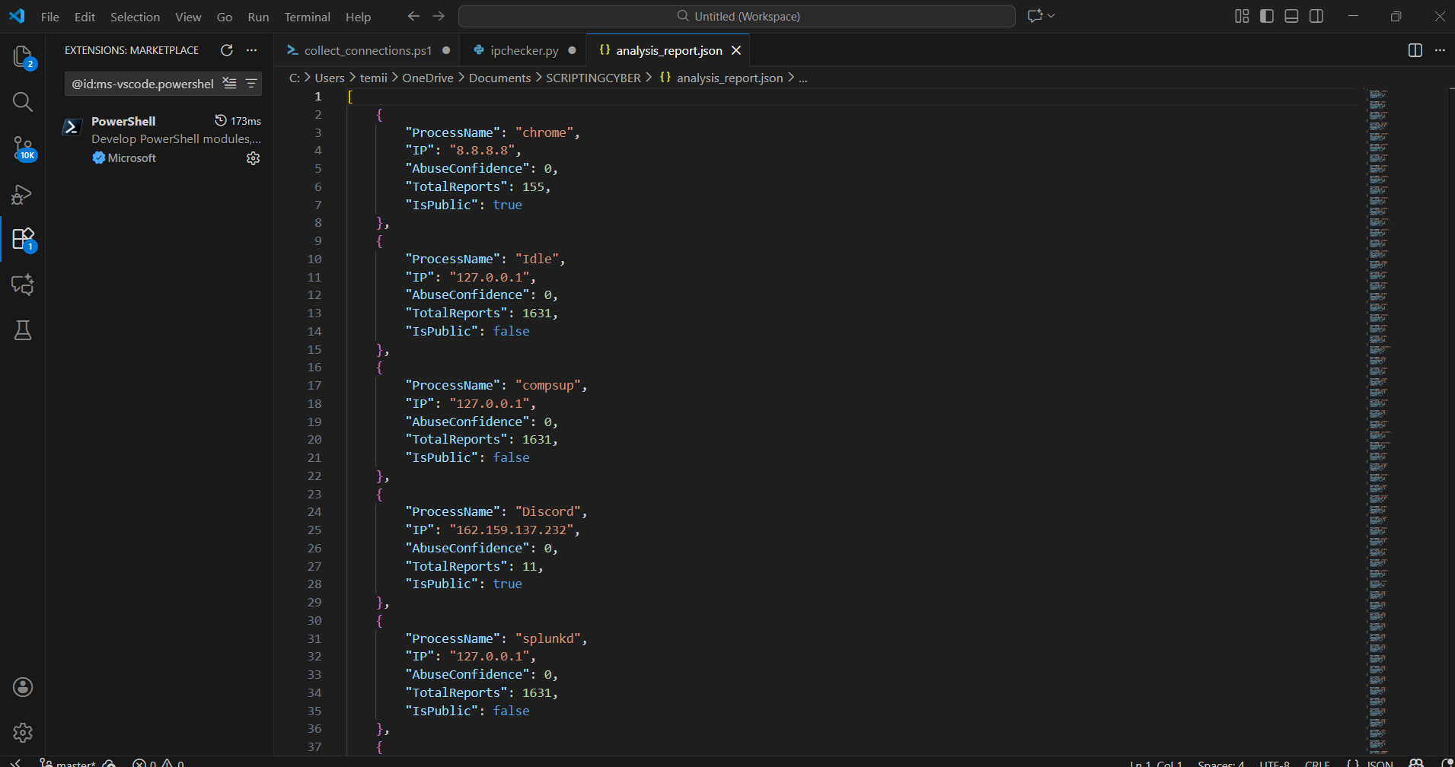

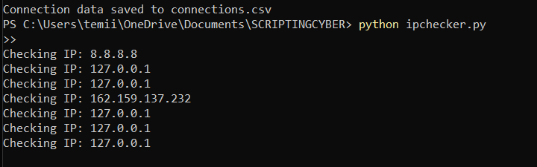

Combined Workflow
1. PowerShell collects network data.
2. PowerShell saves the data into connections.csv.
3. Python reads connections.csv.
4. Python checks each IP via the AbuseIPDB API.
5. Python outputs analysis_report.json.
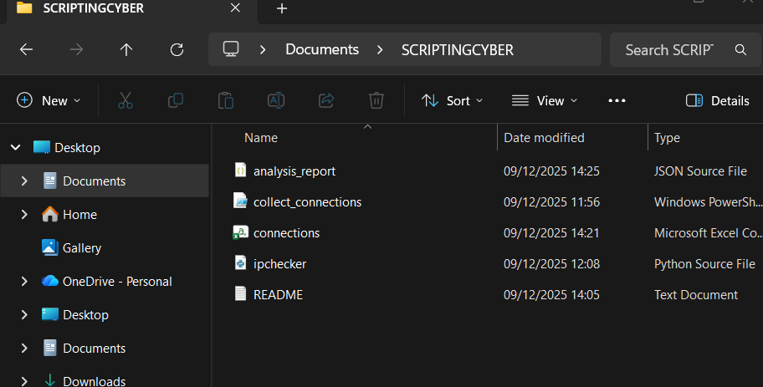

3. Cybersecurity Context
Checking remote IP addresses is a common task in cybersecurity, especially during incident response or when investigating suspicious behaviour. If a computer is compromised, it may communicate with malicious servers. This tool automates part of that investigation by using AbuseIPDB to determine whether any remote IPs have been reported previously. This workflow resembles real processes used in threat hunting and security monitoring.

4. Tool Demonstration

4.1 Running the PowerShell Script
Running the PowerShell script generates the CSV file with active network connections.


4.2 Viewing the Generated CSV File
The generated connections.csv contains the list of processes and their associated network connections.
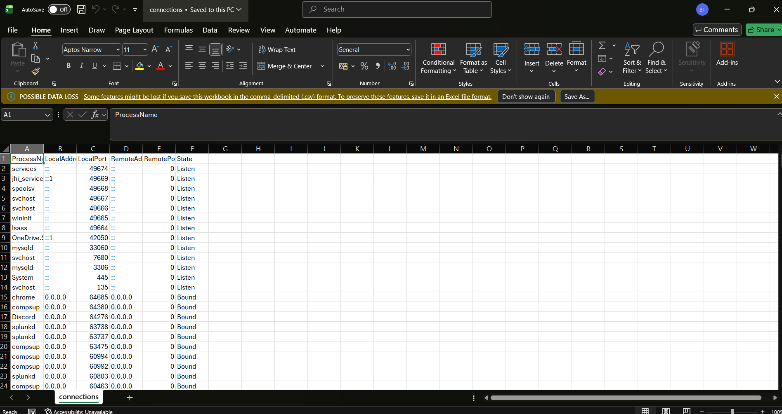

4.3 Running the Python Script
The Python script prints each IP as it is being checked. When finished, it creates the JSON report containing the AbuseIPDB results.
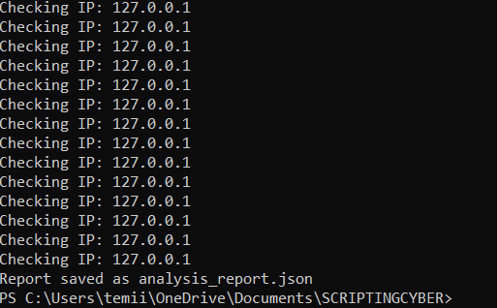

4.4 Viewing the Final Report
The analysis_report.json file displays the API results for each IP address.
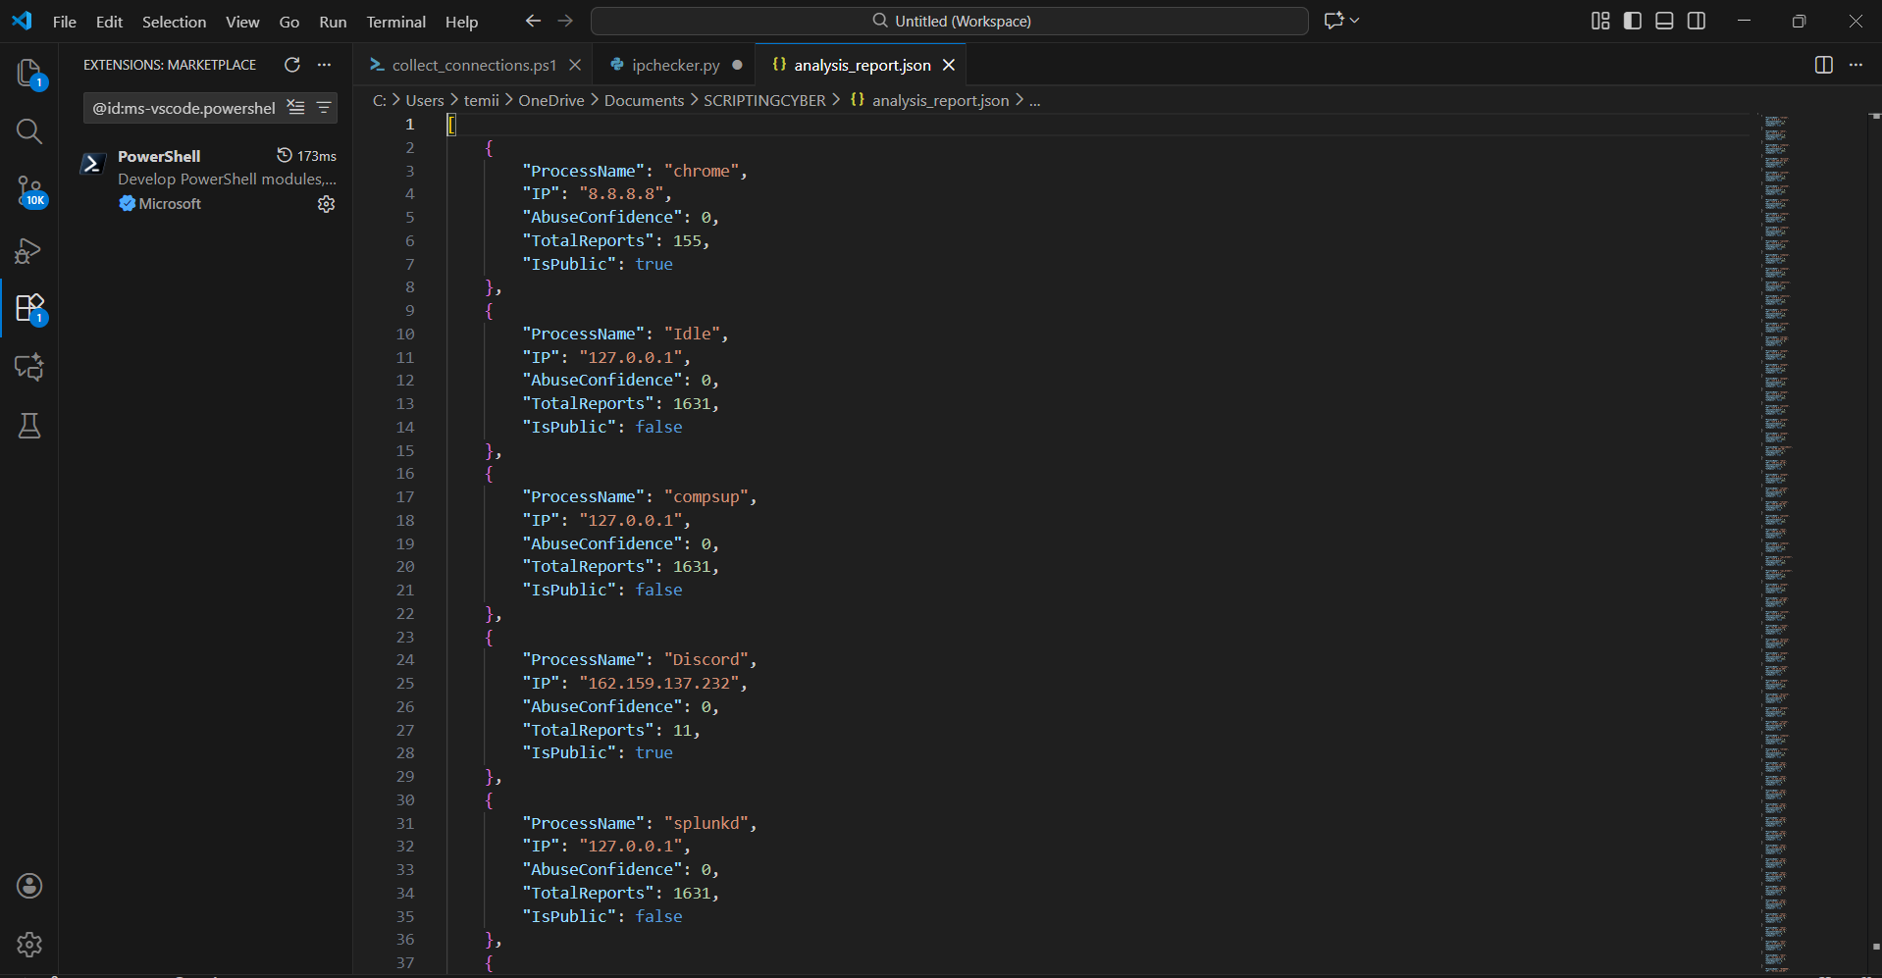

5. Reflection
I worked on this project individually. One of the challenges I faced was correctly navigating the file paths in PowerShell, but once the correct path was identified, the script executed properly. Another challenge was understanding how to structure the API request for AbuseIPDB, but reading the documentation helped resolve this. Overall, the project taught me how Python and PowerShell can be combined in a practical cybersecurity workflow, and it improved my confidence in using both languages.

