SSH Brute-Force Attack Analysis Report
Analyst: Temitope Ilori
Date: 26th November 2025

1. Overview
This report documents my analysis of a simulated SSH brute‑force attack using Splunk. The goal of the investigation was to ingest raw authentication logs, build visualisations, identify suspicious patterns, and determine whether any of the login attempts resulted in successful compromise. All findings below are based on the dashboards and searches I created during the investigation.

2. Data Ingestion Summary
I ingested the Linux authentication log file (large_auth.log) into Splunk using the 'main' index and the sourcetype 'linux_secure'. After validation, Splunk indexed a total of 4,834 failed SSH login attempts and multiple successful logins. This confirmed that the dataset contained a full brute‑force attack sequence.

3. Dashboard Panels & Analysis
Below are the screenshots and explanations for each dashboard panel I created. Each visualisation provides a different angle on the attack, helping to identify attacker behaviour, targeted accounts, and signs of compromise.
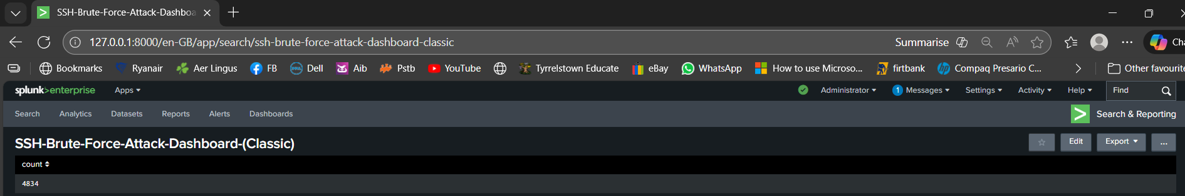
Panel 1 – Total Failed SSH Login Attempts

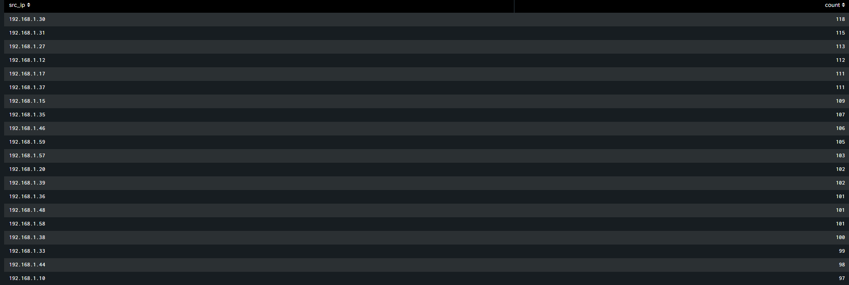
Panel 2 – Top Attacking IP Addresses

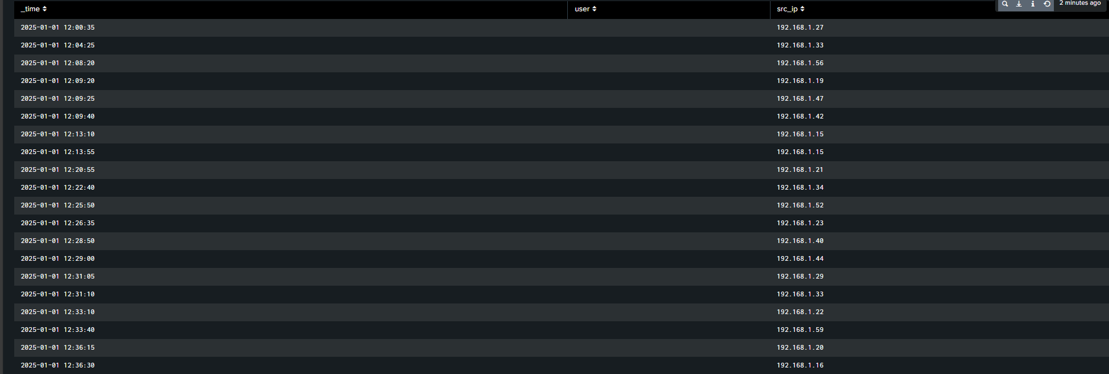
Panel 3 – Failed SSH Attempts Over Time (Timechart)

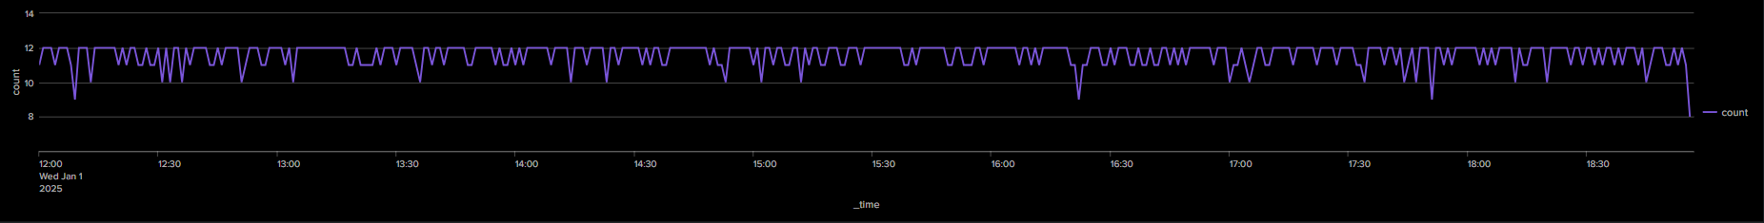
Panel 4 – Successful Login Attempts by Attacker IPs

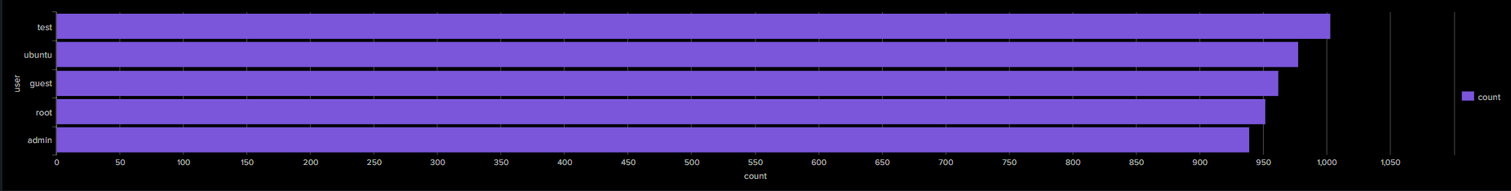
Panel 5 – Most Targeted Usernames

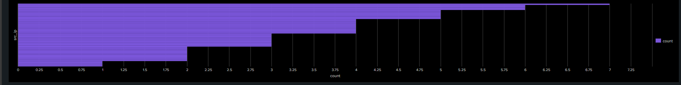
Panel 6 – Distribution of Successful Attacker IPs

4. Key Observations
• The total of 4,834 failed login attempts clearly indicates an automated brute‑force attack.
• Many internal IPs repeatedly attempted authentication, suggesting distributed or scripted behaviour.
• Common usernames such as 'test', 'ubuntu', 'guest', 'root', and 'admin' were heavily targeted—typical for dictionary attacks.
• The timechart shows continuous activity for several hours without meaningful pauses.
• Multiple IPs eventually achieved successful logins, confirming that the brute‑force attack resulted in compromised accounts.

5. Recommendations
Immediate Actions:
• Reset credentials for any accounts that experienced successful logins.
• Block malicious IP addresses at the firewall or network level.
• Enable SSH key‑based authentication and disable password logins.
• Apply rate‑limiting or lockout mechanisms (e.g., fail2ban).
Long‑Term Actions:
• Disable unused or default accounts.
• Introduce multi‑factor authentication (MFA) where possible.
• Review SSH configuration and harden the system.
• Improve monitoring and log forwarding for faster detection.

6. Conclusion
This investigation confirmed that a high‑volume SSH brute‑force attack occurred and was ultimately successful against several accounts. The dashboard visualisations provided a clear view of attacker activity, behaviour patterns, targeted users, and successful compromises. This project strengthened my experience with Splunk, log analysis, threat detection, and building SOC‑ready dashboards.

