Assignment 2: Project Planning for Launching a Food Truck in London, Ontario

Group 03 – SOW Enterprise
Shah Masoom Kshitij, Adeniji Adekunle, Alain Rivera Sanchez, and Himanshu Verma
MGMT6128 Project Management (Online), Section MGMT-6128-01OL-26F
Fanshawe College
October 7, 2026

Author Note
An AI assistant (Claude, developed by Anthropic) was used to cross-check the schedule calculations, generate the diagrams and the Microsoft Project file, and edit the text. The activities, dependencies, and project context come from the group’s Assignment 1 work, and the team reviewed all content before submission.

Assignment 2: Project Planning for Launching a Food Truck in London, Ontario
This report presents the planning baseline for SOW Enterprise’s project to launch a food truck service in London, Ontario. It builds on the Statement of Work (SOW) prepared in Assignment 1, which set a project window from September 8 to December 21, 2026, nine milestones, and a high-level budget (Group 03, 2026a). In line with Project Management Institute (PMI, 2021) practice, the scope was decomposed into a work breakdown structure (WBS), the deliverables were sequenced in a network diagram, and estimated durations were applied to produce a Gantt chart, a milestone plan, and the critical path.
The plan reuses the group’s Assignment 1 activity list and interdependency analysis (Group 03, 2026b, 2026c). Table 1 summarizes the resulting baseline. The 20 numbered activities from the earlier list are cross-referenced in Table 2, so every deliverable can be traced to the earlier work.
Table 1
Schedule Baseline Summary
Item | Baseline
Project start | Tuesday, September 8, 2026
Project finish | Monday, December 21, 2026
Duration | 74 working days (105 calendar days)
Working calendar | Monday to Friday, 8 hours per day; Thanksgiving Day (October 12, 2026) is non-working
Work breakdown structure | 3 levels; 9 deliverable groups; 22 deliverables
Network diagram | 24 nodes (Start, 22 deliverables, End); 38 links (31 FS, 4 SS, 3 FF)
Milestones | 9 (M1 to M9); M9 falls on December 21, 2026
Critical path | 9 deliverables; 74 working days; zero total float
Near-critical deliverables | 7 deliverables with 3 working days of total float
Note. FS = finish-to-start; SS = start-to-start; FF = finish-to-finish. Total float is the number of working days a deliverable can slip without delaying the project finish date.

Work Breakdown Structure
A WBS is a hierarchical decomposition of the total scope of work (PMI, 2019). This WBS has three levels: the project (level 1), nine deliverable groups (level 2), and 22 deliverables, which are its work packages (level 3). That exceeds the 20 deliverables required. Every element has a unique WBS code, and every deliverable is stated as an outcome rather than an action. Figure 1 shows the hierarchy, and Table 2 defines each deliverable.
The WBS follows the 100% rule (PMI, 2019). Together, its elements cover all of the scope in the nine high-level deliverables of the Statement of Work (Group 03, 2026a), plus the project-planning baseline (1.1.2) needed to manage it. The concept maps to 1.1.1; permits and approvals to 1.2; locations and events to 1.8; the purchased and fitted-out truck to 1.3 and 1.4; branding to 1.7.1; menu and pricing to 1.5.1 and 1.5.2; staffing and operating methods to 1.6; marketing and launch to 1.7.2; and the pilot and handover to 1.9. Only the level-3 deliverables carry durations and links. The level-1 and level-2 elements are summary elements whose dates roll up from their children.
Figure 1
Work Breakdown Structure for the Food Truck Project
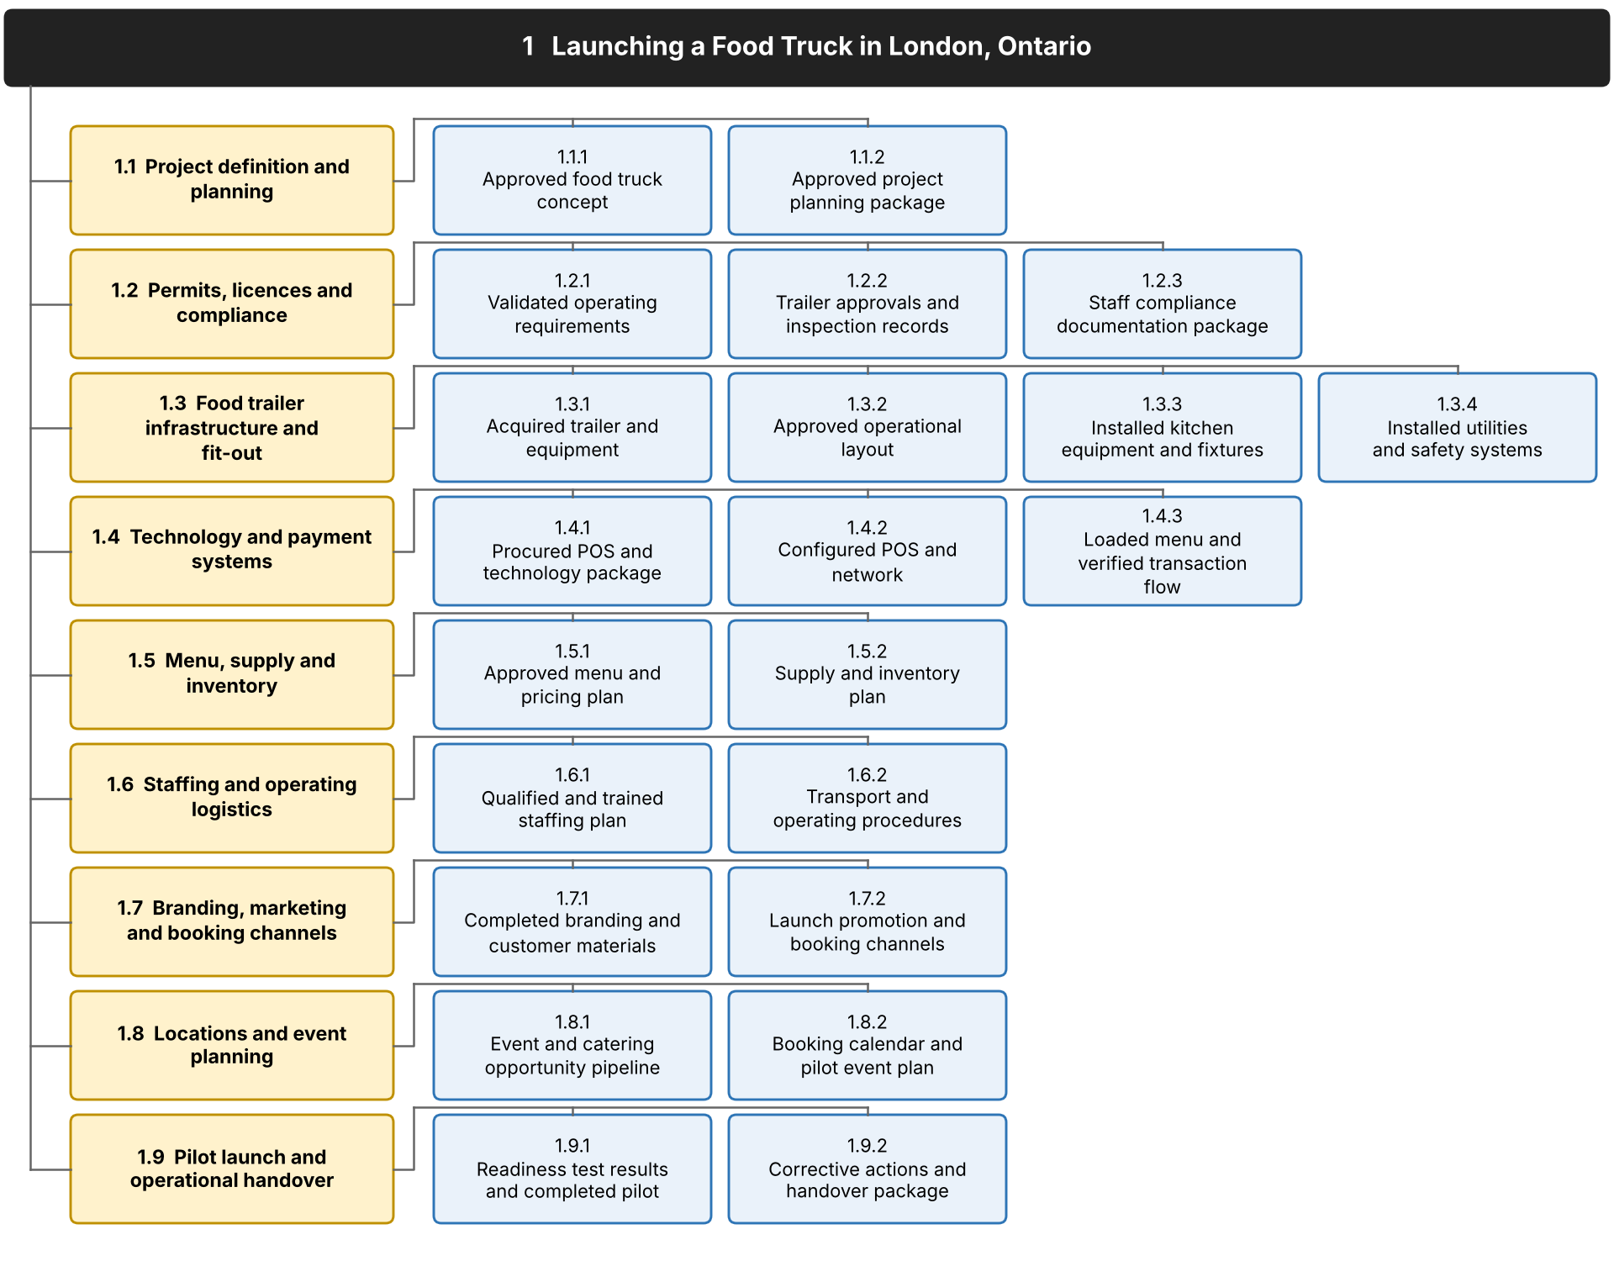
Note. Level 3 deliverables are the schedulable work packages. Codes match the Gantt chart outline (Figure 3). The tree shows decomposition, not sequence.
Table 2
WBS Dictionary
WBS code | Deliverable | Included outputs | Source
1.1 | Project definition and planning
1.1.1 | Approved food truck concept | Target customers, food offer, service style and event operating model. | SOW
1.1.2 | Approved project planning package | Objectives, scope, SOW, budget baseline, schedule baseline and team responsibilities. | SOW
1.2 | Permits, licences and compliance
1.2.1 | Validated operating requirements | Applicable municipal, health, fire, insurance, towing and event requirements. | Act. 1
1.2.2 | Trailer approvals and inspection records | Required approvals and inspection evidence for the fitted mobile unit. | Act. 2
1.2.3 | Staff compliance documentation package | Applicable certifications, safety records, coverage evidence and event documents. | Act. 3
1.3 | Food trailer infrastructure and fit-out
1.3.1 | Acquired trailer and equipment | Suitable concession trailer and required cooking, refrigeration, storage and service equipment. | Act. 4
1.3.2 | Approved operational layout | Kitchen workflow, equipment positions, storage, service access and safe staff movement. | Act. 5
1.3.3 | Installed kitchen equipment and fixtures | Cooking and cold-holding equipment, work surfaces, sinks, shelving and service counter. | Act. 6
1.3.4 | Installed utilities and safety systems | Water, wastewater, power, propane, ventilation and fire protection systems. | Act. 7
1.4 | Technology and payment systems
1.4.1 | Procured POS and technology package | Required ordering and payment hardware, connectivity and software subscriptions. | Act. 8
1.4.2 | Configured POS and network | Installed hardware, network connections, user access, payment settings and order routing. | Act. 9
1.4.3 | Loaded menu and verified transaction flow | Menu and pricing loaded; order routing, payments, loyalty, gift cards and contingencies tested. | Act. 10
1.5 | Menu, supply and inventory
1.5.1 | Approved menu and pricing plan | Food, beverages, modifiers, prices, ingredient needs and food-cost estimates. | Act. 11
1.5.2 | Supply and inventory plan | Demand forecasting, supplier and restaurant production arrangements, loading quantities and inventory returns. | Act. 12
1.6 | Staffing and operating logistics
1.6.1 | Qualified and trained staffing plan | Assigned roles, staffing levels, backup coverage and training in food preparation, service and payments. | Act. 13
1.6.2 | Transport and operating procedures | Towing, loading, setup, opening, service, closing, teardown and return procedures. | Act. 14
1.7 | Branding, marketing and booking channels
1.7.1 | Completed branding and customer materials | Exterior graphics, signage, menu displays, printed menus and event materials. | Act. 15
1.7.2 | Launch promotion and booking channels | Website profile, event request form, social posts, launch announcements and booking promotion. | Act. 16
1.8 | Locations and event planning
1.8.1 | Event and catering opportunity pipeline | Suitable venues, festivals, markets, private events, applications and potential partners. | Act. 17
1.8.2 | Booking calendar and pilot event plan | Confirmed pilot arrangements, calendar, event requirements, inventory, staffing and transport coordination. | Act. 18
1.9 | Pilot launch and operational handover
1.9.1 | Readiness test results and completed pilot | Integrated testing, readiness review, pilot service, customer feedback and issue records. | Act. 19
1.9.2 | Corrective actions and handover package | Resolved issues, retesting, final procedures, lessons learned, launch approval and handover records. | Act. 20
Note. Source gives the numbered activity in the group’s activity list (Group 03, 2026b) or, for 1.1.1 and 1.1.2, the Statement of Work (SOW) phase. Included outputs follow the group’s WBS (Group 03, 2026c). POS = point of sale.

Network Diagram
The network diagram (Figure 2) applies the precedence diagramming method (PMI, 2021). It contains one Start node, the 22 WBS deliverables, and one End node; no node was added to or removed from the WBS. Each node shows the WBS code, deliverable name, duration in working days (d), total float, and early start and finish dates. Red nodes and links form the critical path.
Most links are finish-to-start (FS). The partial dependencies identified in Assignment 1 are modelled as start-to-start (SS) or finish-to-finish (FF) links with a lag, because the successor may start, or may not finish, relative to its predecessor. For example, technology procurement (1.4.1) can start two working days after layout work (1.3.2) starts (SS+2d). Table 4 lists every link and its rationale.
To keep the diagram readable, links already implied by a longer chain are omitted (for example, 1.2.1 → 1.3.2 is implied through 1.3.1). Milestones M1 to M9 appear as tags on the deliverable that triggers them rather than as separate nodes. Table 3 summarizes the integrity checks applied to the network.
Reading the network from the top, the critical path follows the trailer build (1.3.1 to 1.3.3) and the trailer approvals (1.2.2). Beside it, the work fans out into parallel branches: technology (1.4.1 → 1.4.2 → 1.4.3); menu and supply (1.5.1 → 1.5.2); operating procedures and staffing (1.6.2 → 1.6.1 → 1.2.3); branding and promotion (1.7.1 → 1.7.2); and the event pipeline (1.8.1), which feeds the booking calendar (1.8.2). Five deliverables feed the pilot directly (1.2.2, 1.2.3, 1.4.3, 1.7.2, and 1.8.2), so the pilot (1.9.1) cannot start until all of them are complete.
Table 3
Network Integrity Checks
Check | Result
Nodes | 24 (Start, 22 deliverables, End)
Match with the WBS | 22 of 22 level-3 deliverables shown; none added or removed
Links | 38: 36 between deliverables, plus Start → 1.1.1 and 1.9.2 → End
Link types | 31 FS, 4 SS, 3 FF
Start and End | One start (1.1.1 follows Start); one end (1.9.2 precedes End)
Linked to End | 22 of 22 deliverables, directly or indirectly
Circular logic | None; forward and backward passes complete
Longest path | 9 deliverables, 74 working days (critical path)
Note. The schedule was calculated twice with independent methods, and both gave the same dates and float for all deliverables.
Figure 2
Network Diagram of the Food Truck Project Deliverables
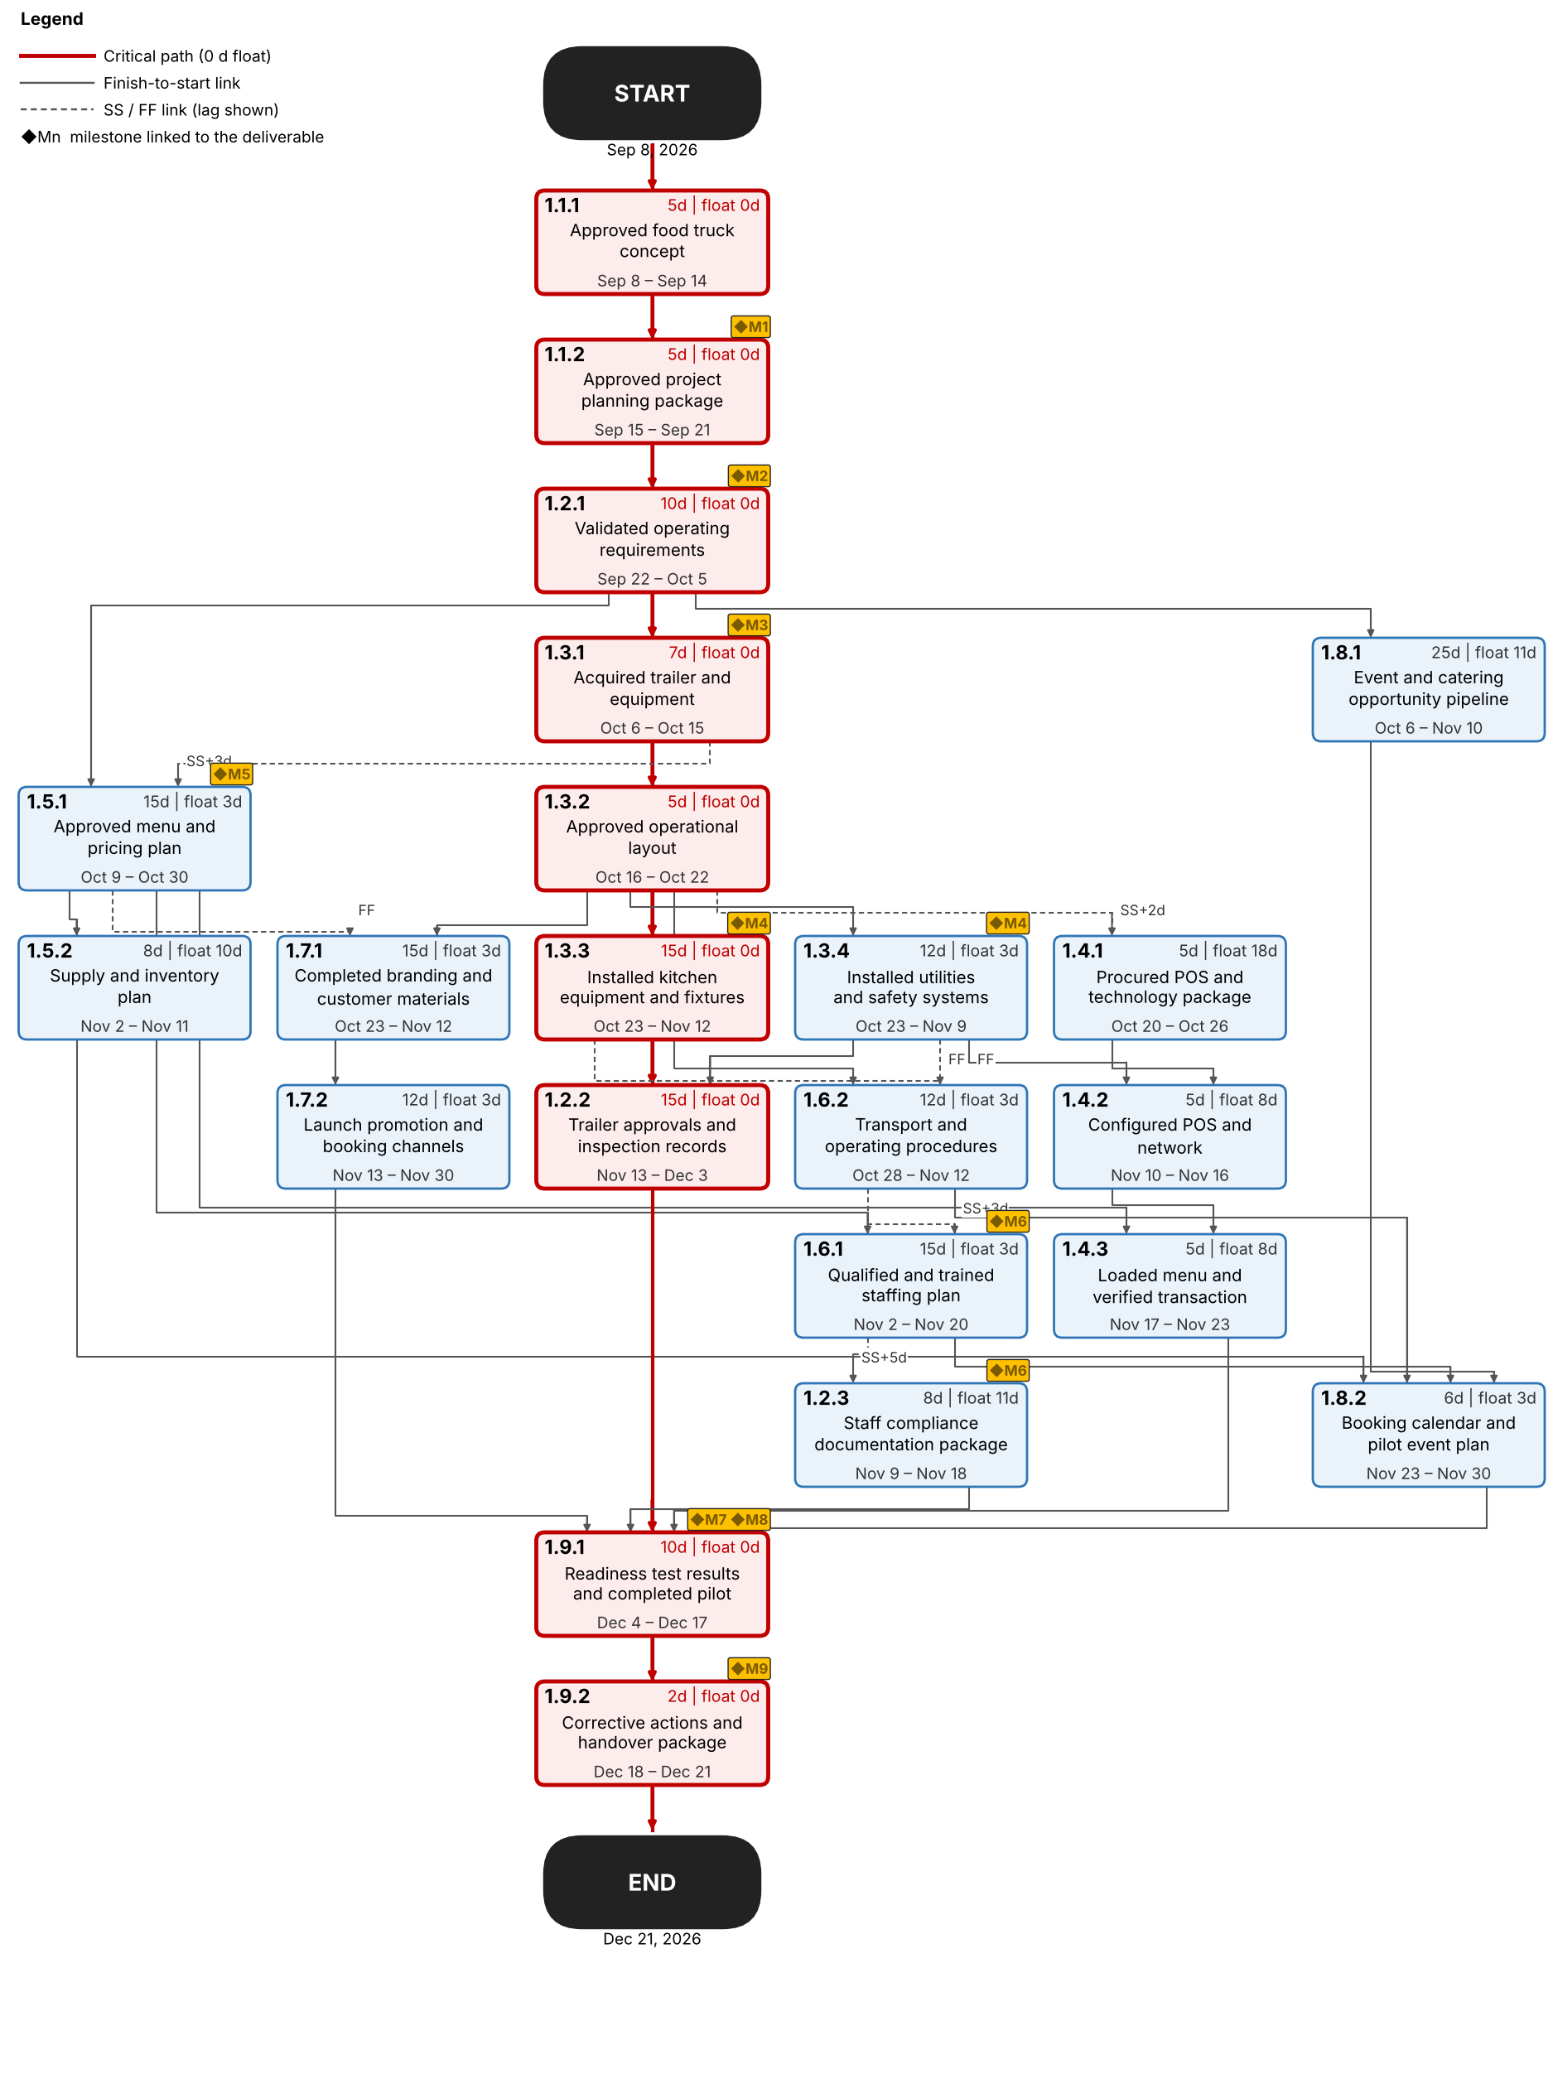
Table 4
Dependencies Between Deliverables
WBS code | Deliverable | Predecessor(s) | Rationale
1.1.1 | Approved food truck concept | Start | Starting point; every other deliverable depends on an approved concept.
1.1.2 | Approved project planning package | 1.1.1 | Scope, budget and schedule baselines require the approved concept.
1.2.1 | Validated operating requirements | 1.1.2 | Regulatory requirements are validated against the approved plan before purchases are made.
1.3.1 | Acquired trailer and equipment | 1.2.1 | Trailer and equipment must reflect the validated requirements.
1.3.2 | Approved operational layout | 1.3.1 | The layout depends on the actual trailer and equipment selected.
1.3.3 | Installed kitchen equipment and fixtures | 1.3.2 | Equipment and fixtures are installed according to the approved layout.
1.3.4 | Installed utilities and safety systems | 1.3.2 | Utilities, propane, ventilation and fire systems follow the approved layout.
1.2.2 | Trailer approvals and inspection records | 1.3.3, 1.3.4 | Final trailer approvals and inspections require the equipment and safety systems to be installed.
1.4.1 | Procured POS and technology package | 1.3.2 SS+2d | Technology procurement can begin shortly after layout work starts (partial dependency, SS+2d).
1.5.1 | Approved menu and pricing plan | 1.2.1, 1.3.1 SS+3d | Menu follows validated requirements; it starts three days into trailer acquisition (partial dependency, SS+3d).
1.4.2 | Configured POS and network | 1.3.4, 1.4.1 | POS and network installation needs the technology package and electrical readiness.
1.4.3 | Loaded menu and verified transaction flow | 1.4.2, 1.5.1 | The menu is loaded and tested only after the POS is configured and the menu is approved.
1.5.2 | Supply and inventory plan | 1.5.1 | Supply and inventory planning depends on the approved menu.
1.6.2 | Transport and operating procedures | 1.3.2, 1.3.3 FF, 1.3.4 FF | Procedures are drafted once the layout is approved and finalized when installation finishes (FF).
1.6.1 | Qualified and trained staffing plan | 1.5.1, 1.6.2 SS+3d | Staffing follows the approved menu and starts three days into procedure development (SS+3d).
1.2.3 | Staff compliance documentation package | 1.6.1 SS+5d | Documents are verified as staffing profiles take shape (SS+5d). Assignment 1 linked staffing and compliance both ways; the link is one-way here to avoid circular logic.
1.7.1 | Completed branding and customer materials | 1.3.2, 1.5.1 FF | Branding needs the approved layout (service windows) and cannot finish before the menu is approved (FF), because menu displays use its content.
1.7.2 | Launch promotion and booking channels | 1.7.1 | Promotion and booking channels reflect the finished branding.
1.8.1 | Event and catering opportunity pipeline | 1.2.1 | Outreach starts once operating requirements are validated. The soft link from promotion (1.7.2) in Assignment 1 is not scheduled as a constraint.
1.8.2 | Booking calendar and pilot event plan | 1.5.2, 1.6.1, 1.6.2, 1.8.1 | The event calendar needs the supply, staffing, logistics and opportunity-pipeline plans.
1.9.1 | Readiness test results and completed pilot | 1.2.2, 1.2.3, 1.4.3, 1.7.2, 1.8.2 | The pilot is the integration point: infrastructure, compliance, POS, staffing, marketing and events must be ready.
1.9.2 | Corrective actions and handover package | 1.9.1 | Handover follows pilot results, corrective actions and retesting.
Note. FS links have no suffix; +nd = lag of n working days. Shaded rows are critical. The recurring event cycle after handover (Group 03, 2026b) is operations, outside this network.

Gantt Chart and Milestones
Figure 3 presents the schedule, built from the WBS and the links in Table 4. All 22 deliverables are scheduled on a Monday-to-Friday, 8-hour calendar that treats Thanksgiving Day (October 12, 2026) as non-working, and the nine level-2 elements roll up as summary tasks. The plan runs from September 8 to December 21, 2026, a total of 74 working days (105 calendar days). Nine milestones (M1 to M9) mark the key decision points; Table 6 lists them.
Durations are the team’s expert-judgment estimates in working days. They are based on the Assignment 1 phase plan, the scope of each deliverable, and the external lead times (municipal, health, fire, Technical Standards and Safety Authority [TSSA], and Electrical Safety Authority [ESA] approvals) that Assignment 1 assumed would be met (Group 03, 2026a). Table 5 gives each deliverable’s duration, dates, predecessors, and total float. The schedule rests on these assumptions:
- The schedule is resource-unconstrained. Resource assignment and leveling should be reviewed before the baseline is approved.
- The trailer, major equipment, and POS hardware can be sourced from regional suppliers within the durations of 1.3.1 and 1.4.1.
- Inspectors can be booked so that all trailer approvals finish within the 15 working days allowed for 1.2.2, which ends on December 3.
- Readiness testing takes the first seven working days of 1.9.1 (December 4 to 14). The go/no-go review (M7) is held on December 15, and the pilot event runs December 15 to 17 (M8).
- The Assignment 1 assumption of a December 10 pilot is superseded, because the pilot cannot precede the final trailer approvals on December 3 and the readiness testing that follows.
- Handover (1.9.2) is allowed two working days because corrective actions are expected to be minor.

Figure 3
Gantt Chart With Milestones and Critical Path
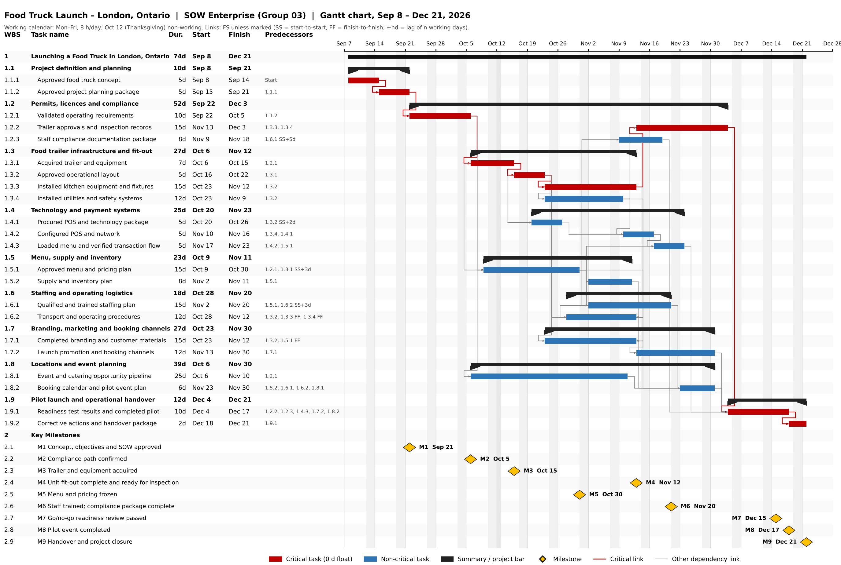
Note. Red bars are critical tasks (zero total float), blue bars are non-critical tasks, black bars are summary tasks, and diamonds are milestones M1 to M9. Dur. = duration in working days; SS = start-to-start; FF = finish-to-finish; +nd = lag of n working days. The chart is generated from the schedule data in the Microsoft Project file Food_Truck_Project_Plan.xml.

Table 5
Schedule of Deliverables
WBS | Deliverable | Act. | Duration (d) | Start | Finish | Predecessor(s) | Float (d) | Critical
1.1.1 | Approved food truck concept | SOW | 5 | Sep 8, 2026 | Sep 14, 2026 | Start | 0 | Yes
1.1.2 | Approved project planning package | SOW | 5 | Sep 15, 2026 | Sep 21, 2026 | 1.1.1 | 0 | Yes
1.2.1 | Validated operating requirements | 1 | 10 | Sep 22, 2026 | Oct 5, 2026 | 1.1.2 | 0 | Yes
1.2.2 | Trailer approvals and inspection records | 2 | 15 | Nov 13, 2026 | Dec 3, 2026 | 1.3.3, 1.3.4 | 0 | Yes
1.2.3 | Staff compliance documentation package | 3 | 8 | Nov 9, 2026 | Nov 18, 2026 | 1.6.1 SS+5d | 11 | No
1.3.1 | Acquired trailer and equipment | 4 | 7 | Oct 6, 2026 | Oct 15, 2026 | 1.2.1 | 0 | Yes
1.3.2 | Approved operational layout | 5 | 5 | Oct 16, 2026 | Oct 22, 2026 | 1.3.1 | 0 | Yes
1.3.3 | Installed kitchen equipment and fixtures | 6 | 15 | Oct 23, 2026 | Nov 12, 2026 | 1.3.2 | 0 | Yes
1.3.4 | Installed utilities and safety systems | 7 | 12 | Oct 23, 2026 | Nov 9, 2026 | 1.3.2 | 3 | No
1.4.1 | Procured POS and technology package | 8 | 5 | Oct 20, 2026 | Oct 26, 2026 | 1.3.2 SS+2d | 18 | No
1.4.2 | Configured POS and network | 9 | 5 | Nov 10, 2026 | Nov 16, 2026 | 1.3.4, 1.4.1 | 8 | No
1.4.3 | Loaded menu and verified transaction flow | 10 | 5 | Nov 17, 2026 | Nov 23, 2026 | 1.4.2, 1.5.1 | 8 | No
1.5.1 | Approved menu and pricing plan | 11 | 15 | Oct 9, 2026 | Oct 30, 2026 | 1.2.1, 1.3.1 SS+3d | 3 | No
1.5.2 | Supply and inventory plan | 12 | 8 | Nov 2, 2026 | Nov 11, 2026 | 1.5.1 | 10 | No
1.6.1 | Qualified and trained staffing plan | 13 | 15 | Nov 2, 2026 | Nov 20, 2026 | 1.5.1, 1.6.2 SS+3d | 3 | No
1.6.2 | Transport and operating procedures | 14 | 12 | Oct 28, 2026 | Nov 12, 2026 | 1.3.2, 1.3.3 FF, 1.3.4 FF | 3 | No
1.7.1 | Completed branding and customer materials | 15 | 15 | Oct 23, 2026 | Nov 12, 2026 | 1.3.2, 1.5.1 FF | 3 | No
1.7.2 | Launch promotion and booking channels | 16 | 12 | Nov 13, 2026 | Nov 30, 2026 | 1.7.1 | 3 | No
1.8.1 | Event and catering opportunity pipeline | 17 | 25 | Oct 6, 2026 | Nov 10, 2026 | 1.2.1 | 11 | No
1.8.2 | Booking calendar and pilot event plan | 18 | 6 | Nov 23, 2026 | Nov 30, 2026 | 1.5.2, 1.6.1, 1.6.2, 1.8.1 | 3 | No
1.9.1 | Readiness test results and completed pilot | 19 | 10 | Dec 4, 2026 | Dec 17, 2026 | 1.2.2, 1.2.3, 1.4.3, 1.7.2, 1.8.2 | 0 | Yes
1.9.2 | Corrective actions and handover package | 20 | 2 | Dec 18, 2026 | Dec 21, 2026 | 1.9.1 | 0 | Yes
Note. Duration and float are in working days. Float is total float. Act. is the activity number in Group 03 (2026b). Shaded rows are critical.

Table 6
Milestones: Assignment 1 Targets Compared With the Scheduled Plan
ID | Milestone | Triggered by | Assignment 1 target | Scheduled | Variance (calendar days)
M1 | Concept, objectives and SOW approved | 1.1.2 | Sep 21, 2026 | Sep 21, 2026 | 0
M2 | Compliance path confirmed | 1.2.1 | Oct 5, 2026 | Oct 5, 2026 | 0
M3 | Trailer and equipment acquired | 1.3.1 | Oct 15, 2026 | Oct 15, 2026 | 0
M4 | Unit fit-out complete and ready for inspection | 1.3.3, 1.3.4 | Nov 5, 2026 | Nov 12, 2026 | +7
M5 | Menu and pricing frozen | 1.5.1 | Nov 15, 2026 | Oct 30, 2026 | −16
M6 | Staff trained; compliance package complete | 1.6.1, 1.2.3 | Nov 23, 2026 | Nov 20, 2026 | −3
M7 | Go/no-go readiness review passed | 1.9.1 SS+7d | Dec 15, 2026 | Dec 15, 2026 | 0
M8 | Pilot event completed | 1.9.1 | Dec 18, 2026 | Dec 17, 2026 | −1
M9 | Handover and project closure | 1.9.2 | Dec 21, 2026 | Dec 21, 2026 | 0
Note. Triggered by lists the deliverable (or deliverables) whose completion triggers the milestone; M7 is triggered seven working days after 1.9.1 starts. Milestone wording was aligned with the triggering deliverables. The Assignment 1 wording was: M2, compliance path, budget and event pipeline confirmed; M3, trailer shell delivered, equipment and fit-out contracted; M4, unit commissioned; M5, menu, pricing and standard operating procedures (SOPs) frozen; and M6, staff trained and health notices filed.
M1, M2, M3, M7, and M9 match the Assignment 1 targets. Four dates change because the dependency analysis sequenced the work in more detail than the high-level phase plan did. M4 is seven days later because installing the kitchen equipment (1.3.3) takes 15 working days after the layout is approved. M5 is 16 days earlier because the menu (1.5.1) can start as soon as the operating requirements are validated, while the standard operating procedures are finalized later in 1.6.2. M6 is three days earlier, and M8 is one day earlier. Because these dates were Assignment 1 baseline targets, the four changes should be recorded through the project’s change-control process (Group 03, 2026a).

Critical Path
The critical path is the longest sequence of dependent deliverables, and it fixes the earliest possible finish date (Kelley & Walker, 1959; PMI, 2021). In this plan it runs 1.1.1 → 1.1.2 → 1.2.1 → 1.3.1 → 1.3.2 → 1.3.3 → 1.2.2 → 1.9.1 → 1.9.2 (Table 7). Its nine deliverables total 74 working days with zero total float, and it is highlighted in red in Figures 2 and 3. Any delay to one of them delays the December 21, 2026 handover day for day.
Table 7
Critical Path Deliverables
Seq. | WBS | Deliverable | Duration (d) | Start | Finish
1 | 1.1.1 | Approved food truck concept | 5 | Sep 8, 2026 | Sep 14, 2026
2 | 1.1.2 | Approved project planning package | 5 | Sep 15, 2026 | Sep 21, 2026
3 | 1.2.1 | Validated operating requirements | 10 | Sep 22, 2026 | Oct 5, 2026
4 | 1.3.1 | Acquired trailer and equipment | 7 | Oct 6, 2026 | Oct 15, 2026
5 | 1.3.2 | Approved operational layout | 5 | Oct 16, 2026 | Oct 22, 2026
6 | 1.3.3 | Installed kitchen equipment and fixtures | 15 | Oct 23, 2026 | Nov 12, 2026
7 | 1.2.2 | Trailer approvals and inspection records | 15 | Nov 13, 2026 | Dec 3, 2026
8 | 1.9.1 | Readiness test results and completed pilot | 10 | Dec 4, 2026 | Dec 17, 2026
9 | 1.9.2 | Corrective actions and handover package | 2 | Dec 18, 2026 | Dec 21, 2026
 |  | Total | 74 | Sep 8, 2026 | Dec 21, 2026
Note. Duration is in working days. The path follows the physical trailer chain (acquisition, layout, kitchen installation), then the final trailer approvals and inspections, the pilot, and handover.

Schedule Implications
The path has no schedule reserve. Its highest-risk element is 1.2.2, trailer approvals and inspections (15 working days), because it depends on external inspectors and follows physical installation. The team can protect the date by booking inspection slots while 1.3.3 is still under way, asking contractors to pre-inspect the work, and running the fire, electrical, propane, and health inspections in parallel (fast-tracking). If the date is still at risk, adding installation crew to 1.3.3 would shorten it (crashing), funded from the Assignment 1 contingency (Group 03, 2026a; PMI, 2021).
Seven deliverables are near-critical, each with three working days of float: utilities installation (1.3.4), menu and pricing (1.5.1), staffing and training (1.6.1), operating procedures (1.6.2), branding (1.7.1), launch promotion (1.7.2), and the booking calendar (1.8.2). The staffing chain (1.6.1 → 1.8.2 → 1.9.1) would become critical if it slipped by more than three working days. The Project Manager should review both chains weekly and report any slip to the Sponsor.

References
Group 03. (2026a). Assignment 1: SOW Enterprise – Statement of work for launching a food truck in London, Ontario [Unpublished course assignment]. Fanshawe College.
Group 03. (2026b). Food truck project activities and interdependencies [Unpublished course document]. Fanshawe College.
Group 03. (2026c). Food truck project work breakdown structure [Unpublished course document]. Fanshawe College.
Kelley, J. E., Jr., & Walker, M. R. (1959). Critical-path planning and scheduling. In Papers presented at the December 1–3, 1959, Eastern Joint IRE-AIEE-ACM Computer Conference (pp. 160–173). Association for Computing Machinery. https://doi.org/10.1145/1460299.1460318
Project Management Institute. (2019). Practice standard for work breakdown structures (3rd ed.).
Project Management Institute. (2021). A guide to the project management body of knowledge (PMBOK® guide) (7th ed.).

