Assignment 3: Resource Plan, Stakeholder Analysis, and Communication Plan for Launching a Food Truck in London, Ontario

Group 03 – SOW Enterprise
Shah Masoom Kshitij, Adeniji Adekunle, Alain Rivera Sanchez, and Himanshu Verma
MGMT6128 Project Management (Online), Section MGMT-6128-01OL-26F
Fanshawe College
October 16, 2026

Author Note
Generative AI was used as a support tool at several stages of this project. The group supplied the operational knowledge, assumptions, and project context, and reviewed and approved the final content before submission.
- Assignments 1 and 2 (Group 03, 2026a, 2026d). ChatGPT supported brainstorming, organizing, and editing the statement of work. An AI assistant helped structure the activity list and review the work breakdown structure (Group 03, 2026b, 2026c), and Claude (Anthropic) proposed durations and link types and produced the schedule, diagrams, and Microsoft Project file.
- Assignment 3 (this report). Claude proposed the resource roles and work estimates, the stakeholder ratings and strategies, and the communication activities for the group to review; added the resources to the Microsoft Project file; produced the figures; checked loads and dates with independent calculations; and edited the text.

Assignment 3: Resource Plan, Stakeholder Analysis, and Communication Plan for Launching a Food Truck in London, Ontario
This report completes the planning baseline for SOW Enterprise’s food truck project in London, Ontario. Assignment 2 fixed what will be delivered and when: 22 deliverables on a 74-working-day schedule from September 8 to December 21, 2026, with nine milestones and a critical path (Group 03, 2026d). This report adds who will do the work, who can influence or be affected by it, and how both groups will be kept informed. The schedule itself is unchanged: the resources were added to the same Microsoft Project file without moving a date, link, or milestone.
Table 1 shows where each Assignment 3 requirement is met. The report draws on the group’s earlier work (Group 03, 2026a, 2026b, 2026c, 2026d) and on the guidance of the Project Management Institute (PMI, 2017, 2021).
Table 1
Assignment 3 Requirements and Where They Are Met
Requirement | Where it is met
Identify the human resources, add them to the Microsoft Project file, and assign them to each activity | Human Resource Plan: Tables 2 and 3 and Figure 1; the Microsoft Project file (Resource Sheet, Task Usage, and Resource Usage views)
Identify 5 stakeholders, with a mix of internal and external | Stakeholder Identification: Table 4
Place the stakeholders on a stakeholder analysis matrix and justify each placement | Stakeholder Analysis: Table 5 and Figure 2
Propose stakeholder management strategies for each stakeholder | Stakeholder Management Strategies: Table 6
Propose a communication strategy and a communication management table, with the technique for each stakeholder and the rationale | Communication Strategy: Tables 7 to 11 and Figure 3. Table 10 gives the who, what, when, how, where, and how many, and the rationale, for 21 activities

Human Resource Plan

Identifying the Resources Needed
Resources were identified by reading each of the 22 deliverables in the work breakdown structure (WBS; Group 03, 2026c) and asking which roles and skills are needed to produce it. The Sponsor and the four team roles come from Assignment 1 (Group 03, 2026a), which also budgets three event staff. The other roles come from the group’s activity list (Group 03, 2026b), which relies on the existing restaurant for production, supply, and branding and lists cooks, a cashier, customer-service staff, and a driver for events. The result is 16 human resources in five groups (Table 2): the project team (4), the Sponsor (1), restaurant staff (3), event crew (3), and external firms (5). The restaurant roles are described by function because no individuals are named; the Sponsor will confirm who fills them.
Regulators and inspectors are not scheduled as resources, because the project does not control their time; their lead time is already inside the 15 working days allowed for inspections (1.2.2). Maximum availability is an assumption for the Sponsor to confirm: the core team is full time, the Sponsor 25%, the three restaurant staff 50% (they keep their restaurant duties), the event crew full time while engaged, and each contractor supplies a two-person crew (200%).

Assigning Resources to Deliverables
Every one of the 22 deliverables has at least one resource, and each of the nine milestones has an accountable owner, so every task and milestone is allocated (Table 3). The 11 summary tasks hold no assignments and roll up the work beneath them. Work is estimated in hours for each resource and spread evenly over the deliverable’s duration, so a resource’s units equal its hours divided by eight times the duration in days. The 22 deliverables are set to fixed duration, so editing resources cannot move a date, and milestones carry no work. In all, 111 work assignments carry 2,201 hours: 1,543 (70%) from SOW Enterprise’s own people and 658 (30%) from outside firms.

Table 2
Resource Sheet: Human Resources Added to the Microsoft Project File
ID | Resource (role and name) | Group; source | Max. avail. | Needed (first start – last finish) | Work (h) | Deliverables | Peak load | Main responsibilities
PM | Project Manager – Shah Masoom Kshitij | Project team; internal | 100% | Sep 8 – Dec 21 | 240 | 17 | 75% | Leads the project; chairs meetings; Sponsor liaison; change control; risk and issue management.
PC | Planning Coordinator – Adeniji Adekunle | Project team; internal | 100% | Sep 8 – Dec 21 | 180 | 12 | 75% | Maintains the schedule baseline and project file; event pipeline and booking calendar; runs coordination meetings.
FH | Finance Head – Alain Rivera Sanchez | Project team; internal | 100% | Sep 8 – Dec 21 | 188 | 14 | 76% | Budget, procurement and contracts; supplier quotes and payments; insurance and WSIB evidence.
DA | Deliverables Analyst – Himanshu Verma | Project team; internal | 100% | Sep 8 – Dec 21 | 278 | 13 | 77% | Deliverables and compliance lead; validates requirements; permits and inspections; quality checks; staff compliance records.
SP | Project Sponsor – Nessen Ramsamy | Sponsor; internal | 25% | Sep 8 – Dec 21 | 23 | 5 | 75% | Approves scope, baselines, menu and pricing, go/no-go and handover; removes obstacles; approver time only.
KL | Kitchen Lead (restaurant chef) | Restaurant staff; internal | 50% | Sep 8 – Dec 17 | 130 | 10 | 97% | Menu and costing; kitchen workflow input; food-preparation training; supply quantities.
OL | Restaurant Operations Lead | Restaurant staff; internal | 50% | Sep 22 – Dec 21 | 122 | 14 | 88% | Supply and inventory; loading, towing and set-up procedures; crew scheduling; POS operating requirements.
MK | Marketing and Social Media Coordinator | Restaurant staff; internal | 50% | Oct 6 – Dec 17 | 120 | 4 | 92% | Brand content; website profile and booking form; social media and announcements; pilot promotion.
CK | Event Cook / Grill Operator | Event crew; internal | 100% | Nov 2 – Dec 17 | 82 | 3 | 68% | Cooks and operates the grill; trained and certified for food handling; readiness testing and pilot service.
CS | Event Cashier / POS Operator | Event crew; internal | 100% | Nov 2 – Dec 17 | 98 | 4 | 68% | Takes orders and payments; POS user testing; readiness testing and pilot service.
CA | Event Customer-Service Attendant | Event crew; internal | 100% | Nov 2 – Dec 17 | 82 | 3 | 68% | Customer service and order hand-off; readiness testing and pilot service.
TS | Trailer and Equipment Supplier | Supplier / contractor; external | 100% | Oct 6 – Oct 15 | 16 | 1 | 29% | Supplies and delivers the trailer and major equipment.
FO | Fit-Out Contractor (installation crew) | Supplier / contractor; external | 200% | Oct 16 – Nov 12 | 256 | 2 | 100% | Installs kitchen equipment and fixtures (two-person crew).
LT | Licensed Trades Contractor (gas / electrical / plumbing) | Supplier / contractor; external | 200% | Oct 23 – Dec 17 | 222 | 3 | 100% | TSSA-certified gas and propane, ESA-licensed electrical, plumbing and fire-suppression installation (two-person crew).
PV | POS Vendor Technician | Supplier / contractor; external | 100% | Oct 20 – Dec 17 | 72 | 4 | 90% | Supplies, installs and configures POS hardware, network and software.
GD | Graphic Designer and Wrap Installer | Supplier / contractor; external | 100% | Oct 23 – Nov 30 | 92 | 2 | 67% | Designs and installs the exterior wrap, signage and menu displays.
 | Total |  |  |  | 2,201
Note. Max. avail. = Max. Units in Microsoft Project; Peak load = highest daily load as a percentage of maximum availability. Shaded rows are external firms. POS = point of sale; TSSA = Technical Standards and Safety Authority; ESA = Electrical Safety Authority; WSIB = Workplace Safety and Insurance Board.
Table 3
Resource Assignments by Deliverable
WBS | Deliverable | Duration (d) | Resources and work (hours) | Total work (h) | No. of resources
1.1.1 | Approved food truck concept | 5 | PM 16; PC 8; FH 8; DA 24; SP 4; KL 6 | 66 | 6
1.1.2 | Approved project planning package | 5 | PM 24; PC 24; FH 20; DA 12; SP 6 | 86 | 5
1.2.1 | Validated operating requirements | 10 | PM 8; FH 12; DA 56; OL 6 | 82 | 4
1.2.2 | Trailer approvals and inspection records | 15 | PM 16; PC 8; DA 54; OL 6; LT 24 | 108 | 5
1.2.3 | Staff compliance documentation package | 8 | PC 8; FH 16; DA 16 | 40 | 3
1.3.1 | Acquired trailer and equipment | 7 | PM 12; FH 28; DA 12; OL 6; TS 16 | 74 | 5
1.3.2 | Approved operational layout | 5 | PM 8; DA 16; KL 6; OL 6; FO 16 | 52 | 5
1.3.3 | Installed kitchen equipment and fixtures | 15 | PM 12; DA 12; OL 6; FO 240 | 270 | 4
1.3.4 | Installed utilities and safety systems | 12 | PM 10; DA 12; LT 192 | 214 | 3
1.4.1 | Procured POS and technology package | 5 | FH 16; OL 6; PV 12 | 34 | 3
1.4.2 | Configured POS and network | 5 | FH 8; CS 8; PV 36 | 52 | 3
1.4.3 | Loaded menu and verified transaction flow | 5 | PC 4; KL 12; OL 4; CK 8; CS 16; CA 8; PV 16 | 68 | 7
1.5.1 | Approved menu and pricing plan | 15 | PM 12; FH 24; SP 4; KL 40; OL 6 | 86 | 5
1.5.2 | Supply and inventory plan | 8 | PC 8; FH 16; KL 8; OL 8 | 40 | 4
1.6.1 | Qualified and trained staffing plan | 15 | PM 12; DA 8; KL 20; OL 12; CK 20; CS 20; CA 20 | 112 | 7
1.6.2 | Transport and operating procedures | 12 | PM 8; PC 12; DA 8; KL 8; OL 16 | 52 | 5
1.7.1 | Completed branding and customer materials | 15 | PM 8; KL 4; MK 36; GD 80 | 128 | 4
1.7.2 | Launch promotion and booking channels | 12 | PM 6; PC 16; FH 8; MK 44; GD 12 | 86 | 5
1.8.1 | Event and catering opportunity pipeline | 25 | PM 24; PC 50; FH 12; MK 24 | 110 | 4
1.8.2 | Booking calendar and pilot event plan | 6 | PM 12; PC 20; FH 4; KL 6; OL 12 | 54 | 5
1.9.1 | Readiness test results and completed pilot | 10 | PM 40; PC 16; FH 12; DA 40; SP 6; KL 20; OL 24; MK 16; CK 54; CS 54; CA 54; LT 6; PV 8 | 350 | 13
1.9.2 | Corrective actions and handover package | 2 | PM 12; PC 6; FH 4; DA 8; SP 3; OL 4 | 37 | 6
 | Total |  | 111 work assignments | 2,201
Note. Resource abbreviations are the IDs in Table 2. Duration is in working days (Group 03, 2026d). Milestone owners, assigned with zero work: M1 SP, PM; M2 DA, PM; M3 FH, PM; M4 DA, PM; M5 KL, SP; M6 OL, DA; M7 SP, PM; M8 OL, PM; M9 SP, PM.

Checking the Load
The daily load of every resource was calculated and compared with its maximum availability. No resource is over-allocated on any working day, so no leveling is needed and the Assignment 2 dates, links, milestones, and critical path are unchanged (Figure 1). The core team never exceeds 77% of a day and 75% of a week, which leaves at least a fifth of every day for the meetings, reports, and follow-up in the communication plan. Those tasks are not scheduled separately.
Figure 1
Weekly Resource Load as a Percentage of Maximum Availability
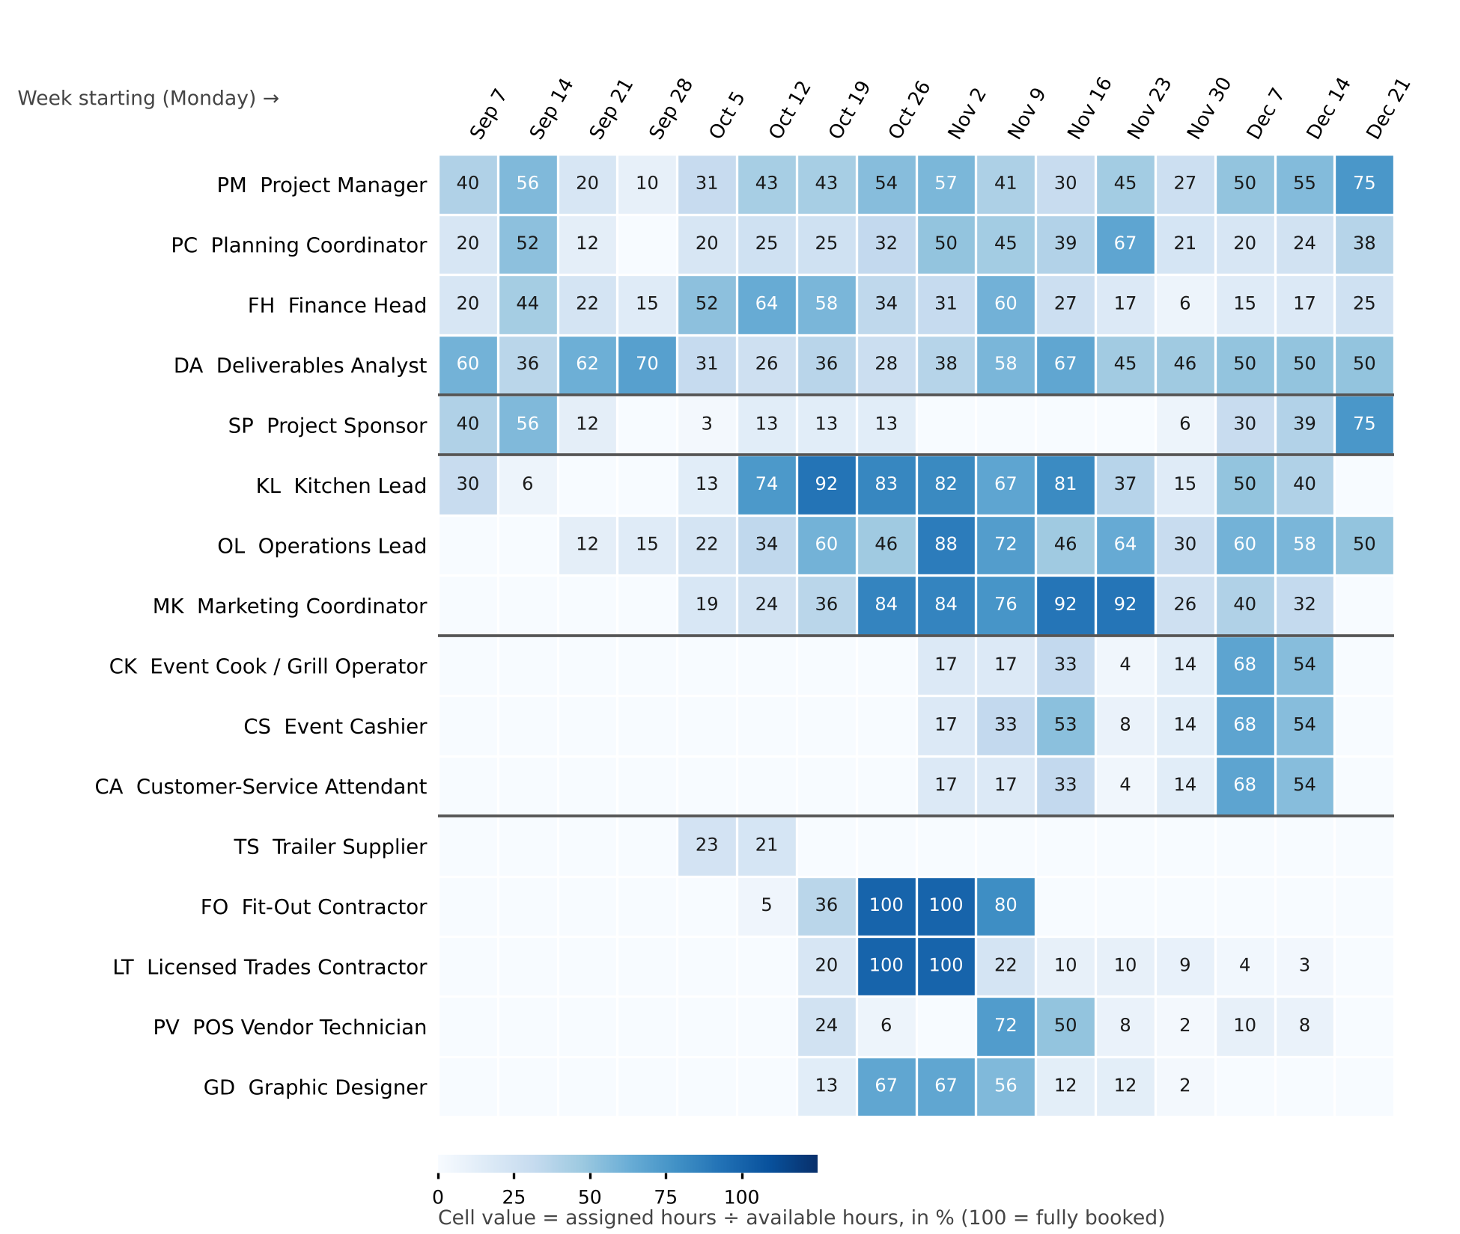
Note. No resource exceeds 100% in any week. The core team (PM, PC, FH, DA) peaks at 75% in a week. The first and last columns cover only the project’s working days (September 8–11 and December 21). Groups, from the top: project team, Sponsor, restaurant staff, event crew, and external firms.
The tightest roles are the fit-out and trades contractors, who are fully booked (200%) while they install the kitchen and utilities (1.3.3 and 1.3.4); the Kitchen Lead, at 97% of availability on October 16–22; the Marketing Coordinator, at 92% between November 13 and 30; and the POS vendor technician, at 90% during POS configuration (1.4.2). Eight deliverables run in parallel on November 9–10, and the busiest week is the week of November 2, with 328 hours of work.
Two findings need a Sponsor decision. First, the event crew’s 262 planned hours (training 60, POS set-up and testing 40, readiness testing 72, and pilot events 90) are 172 hours more than the 90 event hours in the Assignment 1 staffing line, which was built from 3 staff × 10 hours × 3 events (Group 03, 2026a). At Assignment 1’s planning rate of $22 an hour, the extra hours cost about $3,784, or 63% of the $6,011 contingency. Second, the equipment, fit-out, and safety lines in Assignment 1 list equipment and services but do not mention installation labour, yet the fit-out and trades crews carry 478 hours in 1.3.3 and 1.3.4 (Group 03, 2026a). The Finance Head should confirm that the supplier quotes include installation. No rates are entered in the Microsoft Project file, so it reports hours but not cost.

Stakeholder Identification and Analysis

Identifying the Stakeholders
Stakeholders were identified by reviewing the statement of work, the WBS, the schedule, and the regulatory and event items in Assignments 1 and 2 (Group 03, 2026a, 2026c, 2026d), and asking who can affect or is affected by the deliverables. Five were selected because each influences the critical path or the revenue channel, each touches specific deliverables, and each needs a different style of communication. They mix internal and external stakeholders: the Sponsor and the restaurant and event staff are internal to SOW Enterprise, and regulators, suppliers and contractors, and customers are external. Table 4 is the stakeholder register.
Table 4
Stakeholder Register
ID | Stakeholder | Type | Who | What they need from the project | Deliverables and milestones
S1 | Project Sponsor | Internal | Nessen Ramsamy, SOW Enterprise | Launch by December 21, 2026 within the approved scope and budget; timely, decision-ready information; assurance that the truck is safe, legal and ready. | Has assigned work in 5 of the 22 deliverables: 1.1.1–1.1.2 (concept and planning baseline), 1.5.1 (menu approval), 1.9.1 (go/no-go), 1.9.2 (handover); owns M1, M5, M7, M9
S2 | Restaurant and event staff | Internal | Kitchen lead, operations lead and marketing coordinator, plus the event crew (cook/grill operator, cashier, customer-service attendant) | Clear roles and a realistic workload; training and certification; shift schedules at least 7 days ahead; safe, well-laid-out equipment; support while they cover restaurant duties. | Works on 19 of the 22 deliverables; the main ones are 1.4.3, 1.5.1–1.5.2, 1.6.1–1.6.2, 1.7.1–1.7.2, 1.8.2, and 1.9.1; owns M5, M6, M8
S3 | Regulators and inspectors | External | City of London (business licensing and by-law services), the local public health unit (Middlesex-London Health Unit), London Fire Department, Technical Standards and Safety Authority (TSSA), Electrical Safety Authority (ESA) | Complete, accurate applications; equipment, utilities and safety systems that meet the codes; documentation and access at inspection. | Not resources. They act on 1.2.1–1.2.3 (requirements, approvals, staff compliance) and inspect 1.3.4 (utilities and safety systems); M2, M4, M6, M7
S4 | Suppliers and contractors | External | Trailer and equipment supplier, fit-out contractor, licensed trades contractor, POS vendor, graphic designer and wrap installer | Clear specifications and the approved layout; timely decisions, site access and payment against agreed milestones; a stable schedule. | Works on 11 of the 22 deliverables; the main ones are 1.3.1–1.3.4 (1.3.1 and 1.3.3 are critical), 1.4.1–1.4.3, and 1.7.1–1.7.2; M3, M4
S5 | Customers and event clients | External | Event-goers who buy food, and event and catering clients (organizers of festivals, markets, schools, community groups and private events) who book the truck | Tasty, safe, fairly priced food; short waits; cash, card, gift-card and loyalty payments; clear information on menu, locations and booking. Organizers also need complete vendor applications and reliability. | Not resources. They are affected by 1.4.3 (payments), 1.5.1 (menu), 1.7.1–1.7.2 (branding, promotion), 1.8.1–1.8.2 (events), and 1.9.1–1.9.2 (pilot and feedback); M5, M8
Note. The project team prepares this analysis and is not listed. TSSA = Technical Standards and Safety Authority; ESA = Electrical Safety Authority; POS = point of sale. Deliverable codes and milestones (M1–M9) are those of Assignment 2 (Group 03, 2026d).

Analyzing Power and Interest
Each stakeholder was scored from 1 to 5 for power over the project and for interest in it, and placed on a power/interest grid, one of the stakeholder mapping methods in the PMBOK Guide (PMI, 2017). Power is the ability to approve, block, delay, or redirect scope, schedule, cost, or the launch. Interest is how strongly the outcome affects the stakeholder. Scores of 3.0 or lower are treated as low and scores above 3.0 as high, so no stakeholder sits on a boundary. Table 5 gives the scores and the justification for each placement, and Figure 2 shows the matrix.
Table 5
Stakeholder Analysis Matrix: Scores and Justification for Each Placement
Stakeholder | Power | Interest | Quadrant | Justification for the placement
S1 Project Sponsor  Internal | 5 | 5 | Manage closely | Power. Approves the scope, objectives and statement of work (M1) and, under this plan, the baselines, the menu, the go/no-go decision (M7) and the handover (M9), and can stop the project. Significant delays are reported to the Sponsor (Group 03, 2026a).  Interest. Accountable for the outcome. The truck carries the existing restaurant brand and follows its customer-service practices (Group 03, 2026a, 2026b), so the result reflects on the restaurant as well as on the project.  Placement. High power and high interest place the Sponsor in the top-right quadrant, so this is the stakeholder to manage most closely.
S2 Restaurant and event staff  Internal | 2.5 | 5 | Keep informed | Power. Staff cannot approve or block a deliverable, and the Sponsor can reassign them. Their limited availability (50% for the three restaurant leads) does slow work, so power is low to moderate.  Interest. The project changes their roles, workload and training, and they will operate the truck, so their interest is very high.  Placement. Low power and high interest place staff in the bottom-right quadrant: keep them informed and use the restaurant leads’ expertise.
S3 Regulators and inspectors  External | 5 | 2 | Keep satisfied | Power. They hold statutory authority. Without approvals and passed inspections (1.2.2, on the critical path) the truck cannot operate, so they can stop or delay the launch.  Interest. They act on a legal duty and are neutral to the venture’s success. They do not follow progress and engage only when an application or inspection is due.  Placement. High power and low interest place regulators in the top-left quadrant: keep them satisfied by being complete, early and compliant.
S4 Suppliers and contractors  External | 4 | 4 | Manage closely | Power. They deliver the critical-path work in 1.3.1 and 1.3.3, and 1.3.4 has only 3 days of float, so a late or defective job moves the December 21 finish day for day. Power is 4, not 5, because alternative vendors exist at a cost.  Interest. They are paid by the project, want repeat business and a reference, and depend on clear specifications and prompt payment.  Placement. High power and high interest place suppliers and contractors in the top-right quadrant, below the Sponsor.
S5 Customers and event clients  External | 2.5 | 4 | Keep informed | Power. Individual event-goers have no say over a deliverable (1–2). Event organizers have more (3–4), because accepting a vendor application gates the pilot event (1.8.2). The group is rated 2.5 overall.  Interest. They care about food, price, waiting time and payment options, and respond once they know the truck exists, so interest is high but depends on awareness.  Placement. Low power and high interest place customers in the bottom-right quadrant. Organizers get a named contact within this group.
Note. Power: 1 = no say over any deliverable; 3 = can delay non-critical work; 5 = can stop the project or the launch. Interest: 1 = indifferent to the outcome; 3 = moderately affected; 5 = the outcome directly determines their income, job, results or reputation. Scores of 3.0 or lower are treated as low and scores above 3.0 as high.
Figure 2
Stakeholder Power/Interest Grid
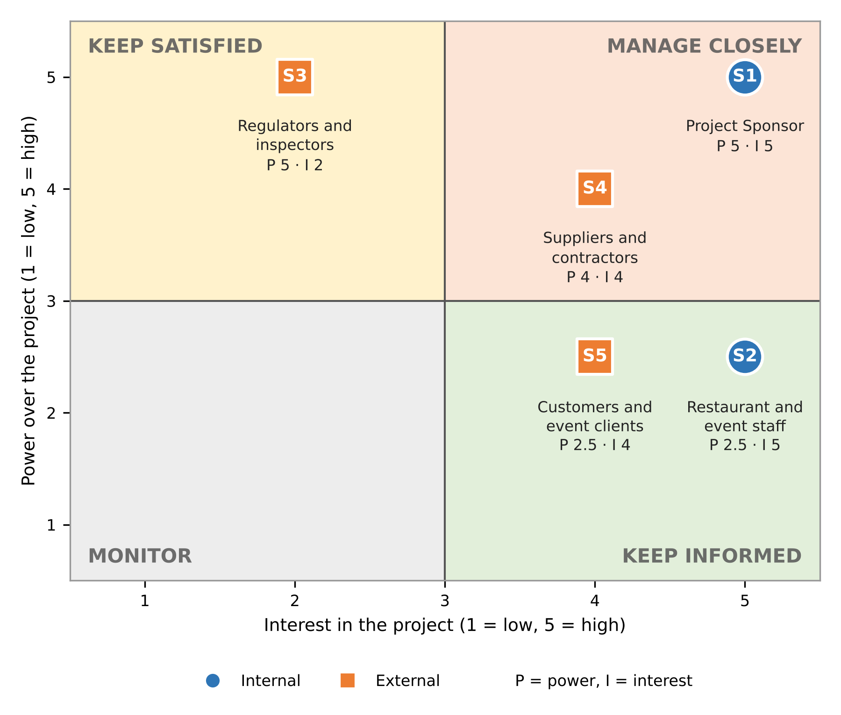
Note. P = power and I = interest, each scored from 1 to 5. The vertical and horizontal lines at 3.0 separate low from high.
Three of the four quadrants are occupied. Nothing falls in Monitor because the five stakeholders were chosen for their influence on the plan. Groups that would fall there, such as neighbouring businesses and residents, competing vendors, and local media, stay on a watch list, and the insurance broker is handled by the Finance Head through the insurance quote and certificate. The ratings are the group’s judgment at the planning baseline and will be reassessed at M2, M4, and M7, when the influence of regulators and contractors changes most.

Stakeholder Management Strategies
The strategy for each stakeholder follows its quadrant and aims to close the gap between its current and desired engagement on PMI’s (2017) five-level scale: unaware, resistant, neutral, supportive, and leading. Current levels are the group’s assessment at the planning baseline. Table 6 gives the actions, owner, success measures, and main risk for each stakeholder. Activity IDs (C1–C21) refer to the communication management table (Table 10). Stakeholder engagement is also a performance domain in the current PMBOK Guide (PMI, 2021).
Table 6
Stakeholder Management Strategies
Stakeholder and engagement | Strategies and actions | Owner and frequency | Success measures | Main risk and response
S1 Project Sponsor  Manage closely  Engagement (current → desired): Supportive → Leading | - Hold the weekly decision meeting and one-page report (C1, C2) and the nine gate reviews (C3).  - Agree decision rights and a 2-working-day turnaround at the first meeting; keep a decision log and name an alternate approver for routine decisions.  - Escalate critical-path slips the same day, with options rather than only the problem (C4).  - Ask the Sponsor to release restaurant staff time (50%) and confirm crew hiring by Nov 2.  - Invite the Sponsor to the pilot (Dec 15–17). | Project Manager; weekly and at 9 gates | Decisions made within 2 working days; no gate approved late; no unreported slip. | Late or deferred decisions delay critical deliverables. Response: use the alternate approver and escalate through C4.
S2 Restaurant and event staff  Keep informed (restaurant leads also consulted as experts)  Engagement (current → desired): Neutral → Supportive | - Explain the project, each person’s role and the time needed (Table 2) at kick-off; confirm availability and backfill with the Sponsor.  - Include the restaurant leads in the weekly team meeting (C6) so workload conflicts surface early.  - Deliver the crew training on schedule (C14), with Food Handler certification tracked by the Deliverables Analyst.  - Issue shift schedules at least 7 days ahead and hold a briefing on each pilot day (C15).  - Recognize contributions at M6 and M8 and collect suggestions at the debrief. | Operations Lead (day to day) and Project Manager; weekly, plus 5 training sessions | 3 of 3 crew trained and certified by Nov 20 (M6); no one above their stated availability; crew confirm readiness at M7. | The Kitchen Lead reaches 97% of availability on Oct 16–22. Response: backfill kitchen duties during those days and protect the time.
S3 Regulators and inspectors  Keep satisfied  Engagement (current → desired): Neutral → Supportive | - Name the Deliverables Analyst as the single point of contact and ask each authority for a named contact.  - Consult each authority after M2 (Oct 5), then submit complete packages (C8) before requesting inspections.  - Have the fit-out and trades contractors pre-inspect their work and attend inspections (C9).  - Keep the compliance binder current (C10) and close deficiencies within 2 working days.  - Do not ask for exceptions, and keep contact planned (consultation, submission, inspection) rather than ad hoc. | Deliverables Analyst (Project Manager as backup); Oct 6 – Dec 3 | 5 of 5 packages complete by Nov 6; 4 of 4 inspections passed by Dec 3 with no more than 2 re-inspections; no stop-work order. | An inspection slot is unavailable or fails. Response: book early, run the inspections in parallel (fast-tracking) and escalate through C4.
S4 Suppliers and contractors  Manage closely  Engagement (current → desired): Neutral → Supportive | - Set scope, dates, acceptance criteria and payment milestones in writing (C11), with notice-of-delay terms and a named backup crew for 1.3.3 and 1.3.4.  - Hold the kick-off, weekly site meetings and daily check-ins during fit-out (C12).  - Share the schedule extract each week (C13) and give prompt decisions and payments.  - Control every change through a written change order (C11).  - Inspect the work at each walk-through before accepting it. | Finance Head (commercial), Deliverables Analyst (site), Project Manager (escalation); Oct 6 – Nov 12 | 1.3.1 finished by Oct 15 and 1.3.3 by Nov 12; no unapproved change; all work accepted at the walk-through. | A crew shortage or late delivery on the critical path. Response: use the backup crew and the notice-of-delay terms, and escalate through C4.
S5 Customers and event clients  Keep informed (organizers get a named contact)  Engagement (current → desired): Unaware → Supportive | - Build awareness from Nov 13 with the website profile, QR code, social posts and opt-in email (C18–C20), using the existing restaurant brand.  - Apply to at least 5 events and keep a named contact at each organizer (C16, C17); confirm in writing at least 7 days before each event.  - Collect feedback at the pilot by conversation and QR survey (C21) and reply to comments within 1 working day.  - Use the feedback in the corrective actions (1.9.2) and tell customers what changed.  - Follow the anti-spam and privacy rules when collecting contact details and feedback. | Marketing Coordinator (customers) and Planning Coordinator (organizers); Nov 13 – Dec 21 | At least 5 applications sent by Nov 10; 3 events confirmed 7 or more days ahead; at least 60 survey responses; feedback actions closed by Dec 21. | Low turnout or declined applications. Response: apply to more events and add posts in the final two weeks.
Note. Engagement levels follow PMI (2017): unaware, resistant, neutral, supportive, leading. Dates are those of the Assignment 2 baseline.

Communication Strategy

Strategy
The strategy is to give each stakeholder the right information, at the right time, in the right form, so that decisions are fast where the schedule has no float and effort is not wasted where it does. It builds on what Assignment 1 already commits the team to: the Project Manager reviews milestone status regularly, significant delays are reported to the Sponsor and team, schedule changes go through change control, and the team uses one shared source of truth, one accountable owner for each item, and early escalation of blockers (Group 03, 2026a). Four decisions follow from the baseline:
- Match the technique to the stakeholder. High-power stakeholders get interactive contact plus a written record, large audiences get pull channels, and people who must act on specific information get push messages (Tables 7 and 8).
- Concentrate effort on the critical path. Communication is most intensive during the three critical stretches: fit-out (1.3.3, October 23 – November 12), trailer approvals (1.2.2, November 13 – December 3), and the pilot (1.9.1, December 4–17).
- Keep one source of truth. The schedule, assignments, and approvals live in one shared folder (C7), and contractors and the public see only extracts.
- Escalate by float. Triggers are tied to the float in Assignment 2 (Table 9) rather than to opinion.
The plan also reflects the size of the team. Sixteen resources have 16 × 15 ÷ 2 = 120 possible communication paths (PMI, 2017), and regulators, event organizers, and customers add more. Each external relationship therefore has a named owner (Figure 3), so that not everyone talks to everyone.
Five measures show whether the communication is working: Sponsor decisions are made within 2 working days; every critical-path slip is reported the same day; all five submission packages reach the authorities before inspections are requested; all three crew members are trained and certified by M6; and at least 60 pilot feedback responses are collected. Table 12 lists the assumptions behind the plan for the Sponsor to confirm.
Messages to customers follow Canada’s anti-spam legislation (CASL), which requires consent, sender identification, and an unsubscribe mechanism for commercial electronic messages (Canadian Radio-television and Telecommunications Commission [CRTC], n.d.). Survey and booking data follow the Personal Information Protection and Electronic Documents Act (2000): collect only what is needed, say why, and keep it secure.

Communication Techniques
PMI (2017) describes three types of communication method. Interactive communication is a real-time, two-way exchange; push communication sends information to specific recipients; and pull communication makes information available for people to use when they choose. Table 7 shows when each type is chosen and where it is used. Of the 21 activities, 12 use interactive, 10 use push, and 5 use pull methods, and several combine two types.
Table 7
Communication Techniques: What They Are, When They Are Chosen, and Where They Are Used
Technique | What it is | Chosen when | Used in (activity IDs)
Interactive | Real-time, two-way exchange between two or more parties, such as meetings, phone and video calls and instant messaging (PMI, 2017). | The topic is complex or urgent, a decision is needed, a relationship matters, or feedback is needed at once. | 12 activities: C1, C3, C4, C5, C6, C9, C12, C14, C15, C17, C19, C21
Push | Information sent to specific recipients, such as letters, reports and emails. It ensures delivery but not that the message was read or understood (PMI, 2017). | A written record or formal approval is needed, the content is time-bound, or the recipients are specific people. | 10 activities: C2, C3, C4, C6, C8, C9, C11, C15, C16, C20
Pull | Information made available for a large audience, or a large volume of material, to use at the recipient’s own discretion, such as portals and intranet sites (PMI, 2017); here, shared folders and a website. | The audience is large or scattered, the material is reference content, or people need it at different times. | 5 activities: C7, C10, C13, C18, C21
Note. The counts add to more than 21 because some activities combine two types. Social media (C19) is classed as interactive because followers can reply and the team responds.
Table 8 shows which techniques are used for which stakeholder, and why; Table 10 gives every activity in full.
Table 8
Communication Techniques Used for Each Stakeholder
Stakeholder and quadrant | Interactive | Push | Pull | Why this mix
S1 Project Sponsor  Manage closely | C1, C3, C4 | C2, C3, C4 | – | Interactive for decisions and early warning; push for the written record that approvals and change control need.
S2 Restaurant and event staff  Keep informed | C14, C15 | C15 | – | Training is learned by demonstration and practice, so it is interactive; schedules and checklists are pushed in writing.
S3 Regulators and inspectors  Keep satisfied | C9 | C8, C9 | C10 | Formal written submissions (push), verbal clarification at inspections (interactive), and documents available on demand (pull).
S4 Suppliers and contractors  Manage closely | C12 | C11 | C13 | Contracts and change orders in writing (push), face-to-face contact during the critical-path fit-out (interactive), and a read-only schedule extract (pull).
S5 Customers and event clients  Keep informed | C17, C19, C21 | C16, C20 | C18, C21 | A large, scattered audience uses pull channels; organizers get push applications and calls; consented emails and social media build awareness; feedback is collected in person and by QR survey.
Project team (with the restaurant leads)  Internal | C5, C6 | C6 | C7 | Daily and weekly meetings keep parallel work in step (interactive), minutes are pushed, and one shared folder is the single source of truth (pull).
Note. Entries are activity IDs from Table 10. A dash means the technique is not used for that stakeholder.

Escalation and Review
Table 9 sets the triggers that move information out of the routine cycle, and Table 11 shows the communication planned at each milestone.
Table 9
Escalation Triggers
Trigger | Who is told | How fast | Technique and activity
A critical deliverable (0 days of float) is forecast to finish late | Sponsor, plus the owners of dependent deliverables | Same day | Phone call, then confirming email (C4)
A near-critical deliverable (3 days of float) has used 2 days | Project Manager, then Sponsor | Within 1 working day | Flag in the weekly report; call if it will use all 3 days (C2, C4)
A change affects scope, budget or the baseline | Sponsor (decision) | At the next gate or within 2 working days | Written change request and gate review (C3)
An inspection fails or an approval is delayed | Sponsor, Deliverables Analyst and the contractor concerned | Same day | Phone call, then written follow-up (C9)
A safety incident (injury, fire or gas leak) | Emergency services if needed, then the Sponsor | Immediately | Phone call, then incident report within 24 hours
Note. Float is total float from Assignment 2 (Group 03, 2026d): the critical deliverables have 0 days, and the seven near-critical deliverables have 3 days. The plan is reviewed at M2, M4, and M7 and after any approved change, and lessons are recorded at M9 (C3).

Communication Management Table
Table 10 is the communication management table. For each of the 21 activities it gives the who, what, when, how, where, and how many, and the rationale for the technique. Group S1–S5 refers to the stakeholders in Table 4, and Team means the core team with the restaurant leads. Figure 3 shows who owns each relationship. Dates are those of the Assignment 2 baseline.
Figure 3
Communication Structure: Owners and Techniques for Each Stakeholder
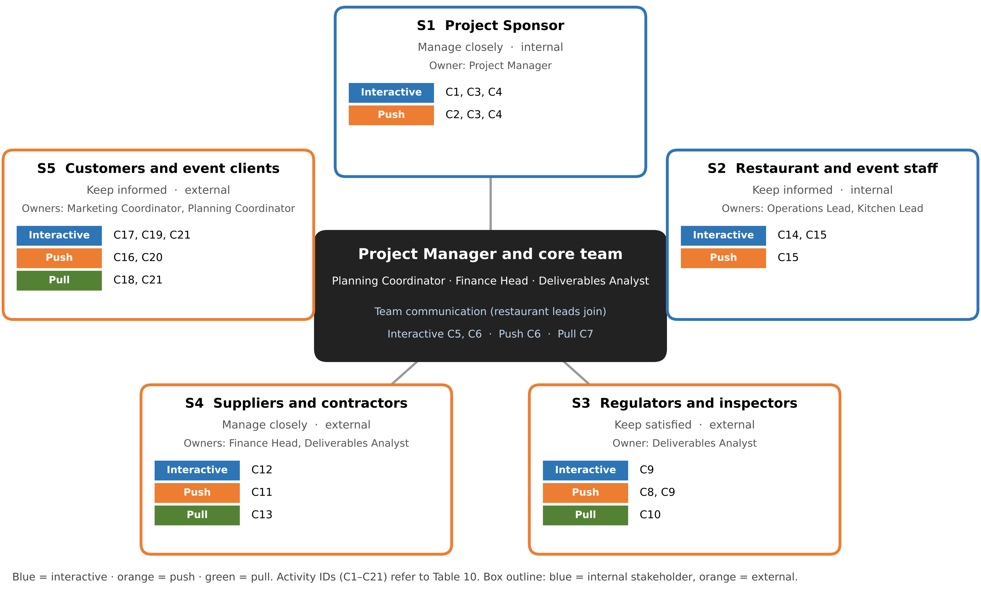
Table 10
Communication Management Table
ID | Group | Who | What | When | How | Where | How many | Rationale for the technique
C1 | S1 | Project Manager (with Planning Coordinator) → Sponsor | Progress against the baseline: critical path, float on near-critical deliverables, milestone forecast, budget and risks, and decisions needed. | Fridays, 30 minutes (Sep 11 – Dec 18). | Interactive: scheduled formal meeting. | Video call, or in person at SOW Enterprise. | 3 attendees; 15 meetings. | The Sponsor has the most power and interest and must make quick decisions on the menu, budget and go/no-go. A two-way conversation settles questions in one sitting, which matters because the critical path has no float.
C2 | S1 | Project Manager (compiled with Planning Coordinator) → Sponsor; copy to core team | One-page status report: schedule and float, milestones, work done, resource load, risks and issues, and decisions needed. | Thursdays, a day before the Sponsor meeting (Sep 10 – Dec 17). | Push: formal written report (PDF). | Email; copy in the shared project folder. | 5 recipients; 15 reports. | A short written record lets the Sponsor read ahead, so meeting time goes to decisions, and it documents what was reported. Push guarantees delivery without the Sponsor having to look for it.
C3 | S1 | Project Manager → Sponsor (decides), with each deliverable’s owner | Evidence that the milestone’s deliverables are complete; approval to proceed; approval of any baseline change; the go/no-go decision at M7. | At the nine milestones: Sep 21, Oct 5, Oct 15, Oct 30, Nov 12, Nov 20, Dec 15, Dec 17 and Dec 21. | Interactive: formal review meeting. Push: signed approval sent by email. | Video call or in person; approvals filed in the shared folder. | 3–5 attendees; 9 reviews. | Gates are where scope, schedule or budget can change, so decisions need the Sponsor’s authority and a written record for change control. Four milestone dates already differ from the Assignment 1 targets (Group 03, 2026d).
C4 | S1 | Project Manager → Sponsor, and affected team members and contractors | Alert that a critical deliverable will finish late, or that a near-critical one has used 2 of its 3 days of float, with options and the decision needed. | The same day the trigger is found; confirming email within 24 hours. | Interactive: phone call. Push: confirming email. | Phone; email. | 2 people, more as needed; as triggered (allowance: 3 alerts). | A delay on the critical path moves the December 21 handover day for day, and the weekly meeting may come too late. A call gets immediate attention and the email creates a record.
C5 | Team | Planning Coordinator (facilitator), Project Manager, Finance Head, Deliverables Analyst; restaurant leads when active | What was done, what is planned today, and blockers for each active deliverable; hand-offs between parallel deliverables. | Every working day, 15 minutes (Sep 8 – Dec 21). | Interactive: informal stand-up meeting. | Video call, or at the trailer on site days. | 4–7 participants; 74 stand-ups. | Up to 8 deliverables run in parallel (Nov 9–10) and share the same few people. A short daily contact clears blockers before they use up float, and an informal format is enough for a small team.
C6 | Team | Project Manager (chair) → core team and the three restaurant leads | Two-week look-ahead, resource load, risks, issues, change requests and action items. | Mondays, 45 minutes (Sep 14 – Dec 21; Oct 13 replaces Thanksgiving Monday); minutes emailed within 24 hours. | Interactive: formal meeting. Push: written minutes. | Video call or in person. | 4–7 participants; 15 meetings. | Decisions and actions need a documented forum where the restaurant leads, who have only 50% availability, can raise workload conflicts early. The minutes create accountability.
C7 | Team | Planning Coordinator (maintains) → all 16 resources | Current schedule (project file and PDF Gantt chart), resource assignments, action, risk and issue log, approvals and document folders. | Continuous; schedule refreshed every Monday (Oct 13 replaces Thanksgiving Monday); 15 updates. | Pull: shared project folder with version control. | Shared online folder. | 16 people with access; 15 weekly refreshes. | Sixteen resources, eleven from SOW Enterprise and five from outside firms, have 120 possible communication paths. A single source of truth lets each person pull their own tasks instead of waiting for messages.
C8 | S3 | Deliverables Analyst (Project Manager approves) → City of London, public health unit, fire department, TSSA, ESA | Complete applications, notifications and supporting documents: forms, layout and equipment lists, insurance evidence, staff certification. | Oct 6 – Nov 6, after M2 (Oct 5): one package per authority; inspections requested by Nov 6. | Push: formal written submission through each authority’s process. | Authority portal, email or counter, as each requires. | 5 authorities; 5 packages, plus any resubmissions. | Regulators decide on written, standard submissions and keep their own records. Complete, early submissions give an audit trail and reduce rejections that would delay the inspections (1.2.2) on the critical path.
C9 | S3 | Deliverables Analyst and Project Manager (with the contractor lead when technical) ↔ inspectors | Pre-inspection consultation on requirements; on-site inspection; deficiency list and confirmation that each item is closed. | Consultations Oct 19 – Nov 6; inspections within 1.2.2 (Nov 13 – Dec 3). | Interactive: on-site meetings and calls. Push: written follow-up. | At the trailer; phone. | 4 authorities; 4 consultations and 4 inspections (allowance: 2 re-inspections). | Inspectors often explain requirements verbally, and clarifying them before installation ends avoids rework. Walking the trailer shows compliance directly, and written follow-up confirms what was agreed.
C10 | S3 | Deliverables Analyst (maintains) → inspectors, organizers, Sponsor and crew, on request | Licences, permits, inspection records, insurance and WSIB evidence, and staff certificates (Food Handler, and WHMIS as applicable). | Updated within 1 working day of any new document; complete for M6 (Nov 20); reviewed at M7 (Dec 15). | Pull: compliance binder, digital and printed. | Shared folder; printed copy kept in the trailer. | 1 binder in 2 copies; about 11 expected users. | Inspectors and organizers ask for documents on demand, often on site. A ready source answers at once and avoids repeated calls.
C11 | S4 | Finance Head (commercial) and Deliverables Analyst (technical) → the 5 suppliers and contractors | Contracts, purchase orders, specifications and approved layout drawings; later, written change orders and requests for information with cost and time impact. | Trailer supplier in 1.3.1 (by Oct 15); POS vendor in 1.4.1 (by Oct 26); fit-out, trades and graphic contractors by Oct 22; change orders answered within 1 working day. | Push: formal written documents. | Email with signed PDFs, filed in the shared folder. | 5 suppliers; 5 contracts; change orders as needed (allowance: 10). | Scope, price, dates and acceptance criteria must be clear in writing. Written documents prevent disputes and give the Finance Head the evidence for change control and for drawing on contingency.
C12 | S4 | Deliverables Analyst and Project Manager → fit-out and trades leads; Operations and Kitchen Leads when needed | Progress against plan, access, power and utility conflicts, quality checks, safety and change requests. | Kick-off Oct 23; Mondays Oct 26, Nov 2 and Nov 9; walk-through Nov 12; daily 10-minute check-in Oct 23 – Nov 12. | Interactive: site meetings and a daily phone or text check-in. | On site at the trailer. | 4–6 attendees; 5 meetings and 15 daily check-ins. | Installing equipment and utilities in one small trailer is physical and interdependent, and 1.3.3 is on the critical path. Face-to-face and daily contact resolve conflicts in real time.
C13 | S4 | Planning Coordinator → the 5 suppliers and contractors | Read-only schedule extract: dates, site-access windows, deliveries and the deliverables that depend on their work. | Mondays Oct 5 – Nov 30 (Oct 13 replaces Thanksgiving Monday); 9 updates. | Pull: read-only shared-folder link. | Shared online folder. | 5 suppliers; 9 updates. | Contractors check dates when it suits them, which cuts repeated questions and keeps everyone on one version of the schedule.
C14 | S2 | Kitchen Lead and Operations Lead → 3 event crew; Deliverables Analyst tracks certification | Food Handler certification, food safety, POS and payment handling, opening and closing procedures, customer service. | Five 4-hour sessions, Nov 2 – Nov 20 (1.6.1), finished by M6 (Nov 20); POS practice with the vendor in 1.4.3 (Nov 17 – 23). | Interactive: demonstration, hands-on practice and Q&A. | Restaurant kitchen, and the trailer once fit-out is complete (Nov 12). | 3 crew and 2 trainers; 5 sessions (20 hours per crew member). | Skills are learned by demonstration and practice, and trainers need immediate feedback on understanding. Certification is a compliance requirement and must be complete before the readiness review.
C15 | S2 | Operations Lead (Kitchen Lead joins briefings) → the 3 event crew | Shift schedules, event details (location, set-up, menu and roles) and printed checklists for opening, service, closing and teardown. | Schedule by Dec 8, 7 or more days before Dec 15; 15-minute briefing each pilot day (Dec 15, 16, 17). | Push: group message and printed checklists. Interactive: briefing. | Group messaging app; printed copy in the trailer; briefing on site. | 3 crew; 1 schedule and 3 briefings. | Shift information must reach every crew member quickly and stay available for reference, so it is pushed in writing. Briefings let the crew ask questions before service starts.
C16 | S5 | Planning Coordinator (with Marketing Coordinator) → event organizers and catering clients | Vendor application with insurance certificate, licences and approvals as available, menu, and power and water needs; later a confirmation pack with arrival time, set-up and contacts. | Applications Oct 6 – Nov 10 (1.8.1); confirmation pack 7 or more days before each event (by Dec 8 for Dec 15). | Push: formal written application and email. | Organizer portals or email. | At least 5 organizers and 5 applications (to secure 3 events); 3 confirmation packs. | Organizers screen many vendors through deadline-driven written processes. Complete packages avoid delay and show reliability, and written confirmation prevents last-minute conflicts (it feeds the booking calendar in 1.8.2).
C17 | S5 | Planning Coordinator (with Project Manager) ↔ organizers’ vendor coordinators | Pitch location, power and water, fees, rules and timing; thanks and feedback after each event. | At application (Oct 6 – Nov 10), after acceptance (Nov 23 – 30, in 1.8.2) and after each event (from Dec 18). | Interactive: phone or video calls and a site visit. | Phone or video; on site at the pilot venue before Dec 8. | 3 accepted organizers × 3 contacts = 9 conversations. | Fees, pitch and utilities are negotiated, and a personal relationship improves the chance of repeat bookings. Organizers hold more power than other customers, so they get a named contact.
C18 | S5 | Marketing Coordinator (content) and Graphic Designer (graphics) → customers and event clients | Menu, prices, payment options (cash, credit, debit, gift cards, loyalty), event dates and locations, and the “book our food truck” form. | Built in 1.7.2 (Nov 13 – 30), live by Nov 30; updated Mondays Dec 7, 14 and 21. | Pull: website profile, QR code and printed menus. | Website; QR code on the trailer wrap and flyers. | Open audience; 1 website profile, 1 booking form, 4 releases. | Customers are a large, scattered audience who look up the menu, location and booking at their own pace. Pull content scales without extra effort per customer and works at events through the QR code.
C19 | S5 | Marketing Coordinator → followers of the truck’s social media accounts (the restaurant’s accounts, if the Sponsor agrees) | Teasers (menu, brand), event dates and locations, behind-the-scenes content, replies to comments, and the booking call to action once the website is live (Nov 30). | Two posts a week for the 5 weeks from Nov 16, plus daily stories on pilot days (Dec 15–17). | Interactive: social media posts with two-way comments. | Social media accounts (new, or the restaurant’s existing ones). | All followers (count taken at launch); 10 posts and 3 daily stories. | It reaches customers on platforms they already use, builds awareness before the pilot at low cost, and the comments give early informal feedback. Followers can reply, so it is treated as two-way.
C20 | S5 | Marketing Coordinator → opt-in email subscribers (only people who have consented) | Launch announcement, pilot event dates, booking link, and gift-card and loyalty details. | Nov 30 (after the website is live) and Dec 11 (reminder), if a consented list exists; otherwise sign-ups are collected on the website and at the pilot. | Push: email newsletter. | Email. | All subscribers who have consented (count taken on Nov 30); 2 emails. | Time-sensitive dates should reach people directly. Email goes only to people who have consented, with sender identification and an unsubscribe link, as Canada’s anti-spam legislation requires (CRTC, n.d.).
C21 | S5 | Event cashier, attendant and Operations Lead (collect); Marketing Coordinator (analyses) ↔ customers at the pilot | Satisfaction with food, price, wait time and payment options, and suggestions for improvement. | Pilot days Dec 15–17; summary to the Sponsor and team on Dec 18 (1.9.2). | Interactive: short staff conversations. Pull: QR code survey. | At the truck; QR code on the counter and menu. | Planning target of at least 20 responses a day (60 in total). | Customer feedback is a required output of 1.9.1. Conversations give quick, rich comments, and a QR survey collects structured data without slowing service. Responses collect only the personal information needed, as privacy law requires.
Note. Interactive, push, and pull follow PMI (2017). Several activities combine two types. WHMIS = Workplace Hazardous Materials Information System; WSIB = Workplace Safety and Insurance Board; QR = quick response; POS = point of sale. Recipient counts are planning figures; follower and subscriber counts will be taken from the restaurant’s accounts at launch. Event and survey targets are planning figures for the Sponsor to confirm.

Communication Calendar
Table 11
Communication Calendar by Milestone
Milestone | Date | Communication focus | Activities
M1 | Sep 21 | Sponsor approves the concept, objectives and statement of work; team confirms the resource plan. | C3, C6
M2 | Oct 5 | Compliance path confirmed; submissions to the five authorities and event applications begin on Oct 6. | C3, C8, C16
M3 | Oct 15 | Trailer and equipment acquired; fit-out, trades and graphic contracts issued before Oct 23; first schedule extract sent. | C3, C11, C13
M5 | Oct 30 | Sponsor approves the menu and pricing; crew hiring confirmed by Nov 2; training sessions scheduled. | C3, C14
M4 | Nov 12 | Fit-out complete: walk-through held, inspections requested and booked. | C3, C9, C12
M6 | Nov 20 | Crew trained and certified; compliance package complete; event applications reviewed. | C3, C10, C14
M7 | Dec 15 | Go/no-go: inspection records, readiness-test results, crew briefing and confirmation pack reviewed. | C3, C9, C10, C15, C16
M8 | Dec 17 | Pilot completed; customer feedback summarized for Dec 18. | C3, C21
M9 | Dec 21 | Handover: lessons-learned workshop, closure report, and thanks to organizers. | C3, C6, C17
Note. Milestones are in date order, so M5 falls before M4.

Assumptions and Items to Confirm
Table 12
Assumptions to Confirm
Area | Assumption | Confirmed by
Availability | The core team is available full time, the Sponsor 25%, and the Kitchen Lead, Operations Lead, and Marketing Coordinator 50%, with their restaurant duties covered (Table 2). | Sponsor
Event crew | Three event crew are in place by November 2, and the 172 extra hours of training and testing are funded from the staffing line or the contingency. | Sponsor, Finance Head
Contractors | The supplier quotes include installation, and the fit-out and trades contractors can each supply a two-person crew for 1.3.3 and 1.3.4, with a named backup. | Finance Head
Regulators | Each authority names a contact and offers inspection slots between November 13 and December 3. | Deliverables Analyst
Customers | The truck has social media accounts (new, or the restaurant’s with the Sponsor’s agreement). Any email list holds only people who consented; otherwise sign-ups are collected on the website and at the pilot. | Marketing Coordinator, Sponsor
Towing | A tow vehicle and a licensed driver (the Operations Lead or a crew member) are available on pilot days (Group 03, 2026b), within the hours assigned in 1.9.1. | Operations Lead, Sponsor
Events and feedback | At least 5 organizers are approached to secure the 3 events assumed in Assignment 1, and the 60-response survey target is a planning figure. | Planning Coordinator, Sponsor
Cost | No rates are entered in Microsoft Project, so cost is outside this assignment. | Finance Head

References
Canadian Radio-television and Telecommunications Commission. (n.d.). Frequently asked questions about Canada’s anti-spam legislation. https://crtc.gc.ca/eng/com500/faq500.htm
Group 03. (2026a). Assignment 1: SOW Enterprise [Unpublished manuscript]. Fanshawe College.
Group 03. (2026b). Food truck project activities and interdependencies [Unpublished manuscript]. Fanshawe College.
Group 03. (2026c). Food truck project work breakdown structure [Unpublished manuscript]. Fanshawe College.
Group 03. (2026d). Assignment 2: Project planning for launching a food truck in London, Ontario [Unpublished manuscript]. Fanshawe College.
Personal Information Protection and Electronic Documents Act, S.C. 2000, c. 5.
Project Management Institute. (2017). A guide to the project management body of knowledge (PMBOK® guide) (6th ed.).
Project Management Institute. (2021). A guide to the project management body of knowledge (PMBOK® guide) (7th ed.).

