MINISTRY OF EDUCATION AND SCIENCE OF THE REPUBLIC OF KAZAKHSTAN

International University of Information Technology

Faculty of Information Technology

Department of Information Systems

**Project**«Amazing Events»

**Data and information management**

***Students:*** Yenglik Zhubanova (27325), Azhar Kurmangalieva (27734),  
Assel Temirkhan (27439)

***Teacher:*** Madina B. Aitbekova

Almaty, 2022

**Content**

**Description of project 3**

Amazing Events 3

Amazing events Management System 3

**Logical design 3**

Entities and attributes 3

Weak and strong entities 3

Four types of attributes 4

**Relationships: PK, FK** **5**

**Normalization 6**

**Specialization and Generalization 7**

**ER-Diagram 8**

**SQL – Create Tables 9**

**SQL – Foreign Key 10**

**All tables are created**  **11**

Database diagram 12

Add Contraints 12

**Insert Statements** **13**

**Select 17**

Update 19

Delete 19

View 20

DBMS and Driver 22

**Description of project**

***Amazing events***

«Amazing events» is large company that organizes events in New York. During the whole year, the company holds a variety of events. These include fashion shows, meetings and interviews with celebrities, musical extravaganzas, exhibitions, fairs and charity performances.

***Amazing events Management System***

«Amazing events» organizes events of various types. Information about the various types of events is stored in the file named **Event Types**. This file contains information including codes of events and description of the activity of the corresponding type. Every client who wants to organize an event should provide information about the features of this event. Along with the transfer of information it makes the payment for the event. Payment is paid partly, according to the price list of fees. The client must pay all of the payment before or on the day of the event.

All information related to the **event** - the event id, the id of the event type, the event location, status, start date, end date, description of event, number of participants - are stored in the file named Events.

**Payment** information, including the amount of the payment, discount, the date of payment, method of payment code and a description of the method of payment, is also stored in the Events file.

The **client** information - client id, client name and address are in the file named Client.

Each event is managed by a certain **organizer** of «Amazing events». Organizer information - organizer id, name, e-mail is stored in the file named Organizers

**Logical design**

***Entities and attributes***

In the ER diagram for our project, the main entity is **Events**, and the rest in the form of ***Organizers, Space_Request*** are dependent and auxiliary entities. Each of these entities has its own attributes.

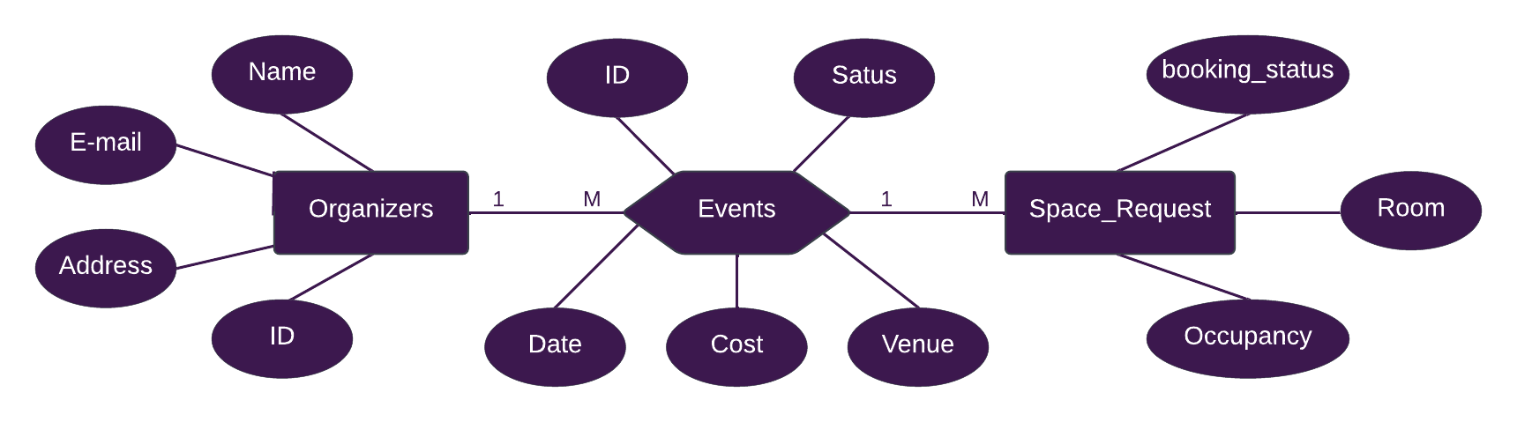

***Weak and strong entities***

Any object in the system that we want to model and store information in it is an entity. We have 2 types of entities: weak and strong.

In our information system, the **Venues** is a strong entity, and the **Venue_facilities** is a weak entity. Because this entity may or may not exist. And the rest are strong subjects.

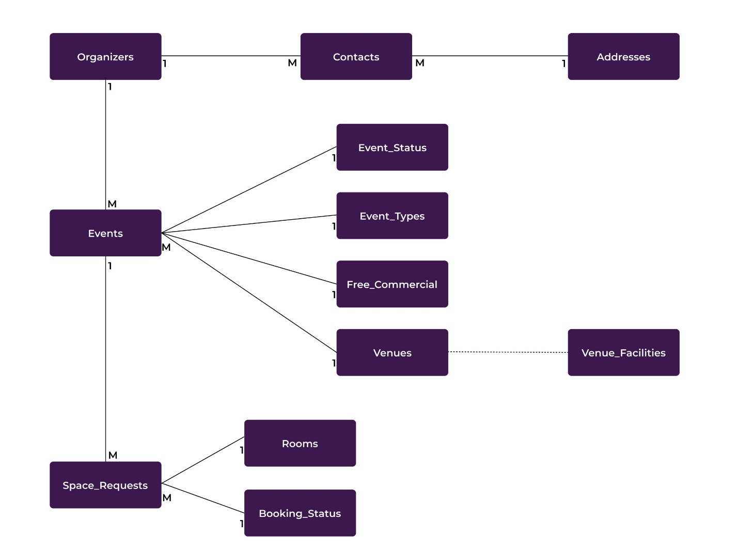

***There are*** ***four types of attributes****:*

**Simple attributes** are separate components of atomic and elemental. For example, in our system there are objects "Event_Status" and "Booking_Status" with attributes: "Event_Status_Description", "booking_status_description".

**Composite attributes** consist of multiple components, each component being simple or complex. In our case, the table "Addresses" consists of two attributes: "City" and "Street".

**Multi-valued attributes** have multiple values for a particular object. Attribute addresses are created using multi-valued attributes and compound attributes and are called compound attributes. In the tables "Contacts", "Addresses" and "Organizers" e-mail ddress and telephone may use more than one value.

**Derived attributes** are attributing whose values are calculated from other attributes. If an attribute's value can be determined from the values of other attributes, then the attribute is derivable. In the "Client" object the attribute "Age" can be counted from the current date by using "Birth_date". Hence, the "Age" attribute is derived one.

**Relationships: PK, FK**

|  |  |
| --- | --- |
| **Table name** | **Foreign key** |
| *Contacts* | *Organizer_ID* |
| *Address_ID* |
| *Events* | *Organizer_ID* |
| *Event_Status_Code* |
| *Event_Type_Code* |
| *Free_or_Commercial_Code* |
| *Venue_ID* |
| *Space_Requests* | *Event_ID* |
| *Booking_status_code* |
| *Room_ID* |

In our database, we tried to avoid many-to-many relationships and stick to the one-to-many structure.

|  |  |
| --- | --- |
| **Table name** | **Primary key** |
| *Organizers* | *Organizer_ID* |
| *Addresses* | *Address_ID* |
| *Events* | *Event_ID* |
| *Event_Status* | *Event_Status_Code* |
| *Event_Type* | *Event_Type_Code* |
| *Free_or_Commercial* | *Free_or_Commercial_Code* |
| *Venues* | *Venue_ID* |
| *Rooms* | *Room_ID* |
| *Booking_Status* | *Booking_status_code* |
| *Space_Requests* | *Space_Request_ID* |
| *Contacts* | *Contact_ID* |

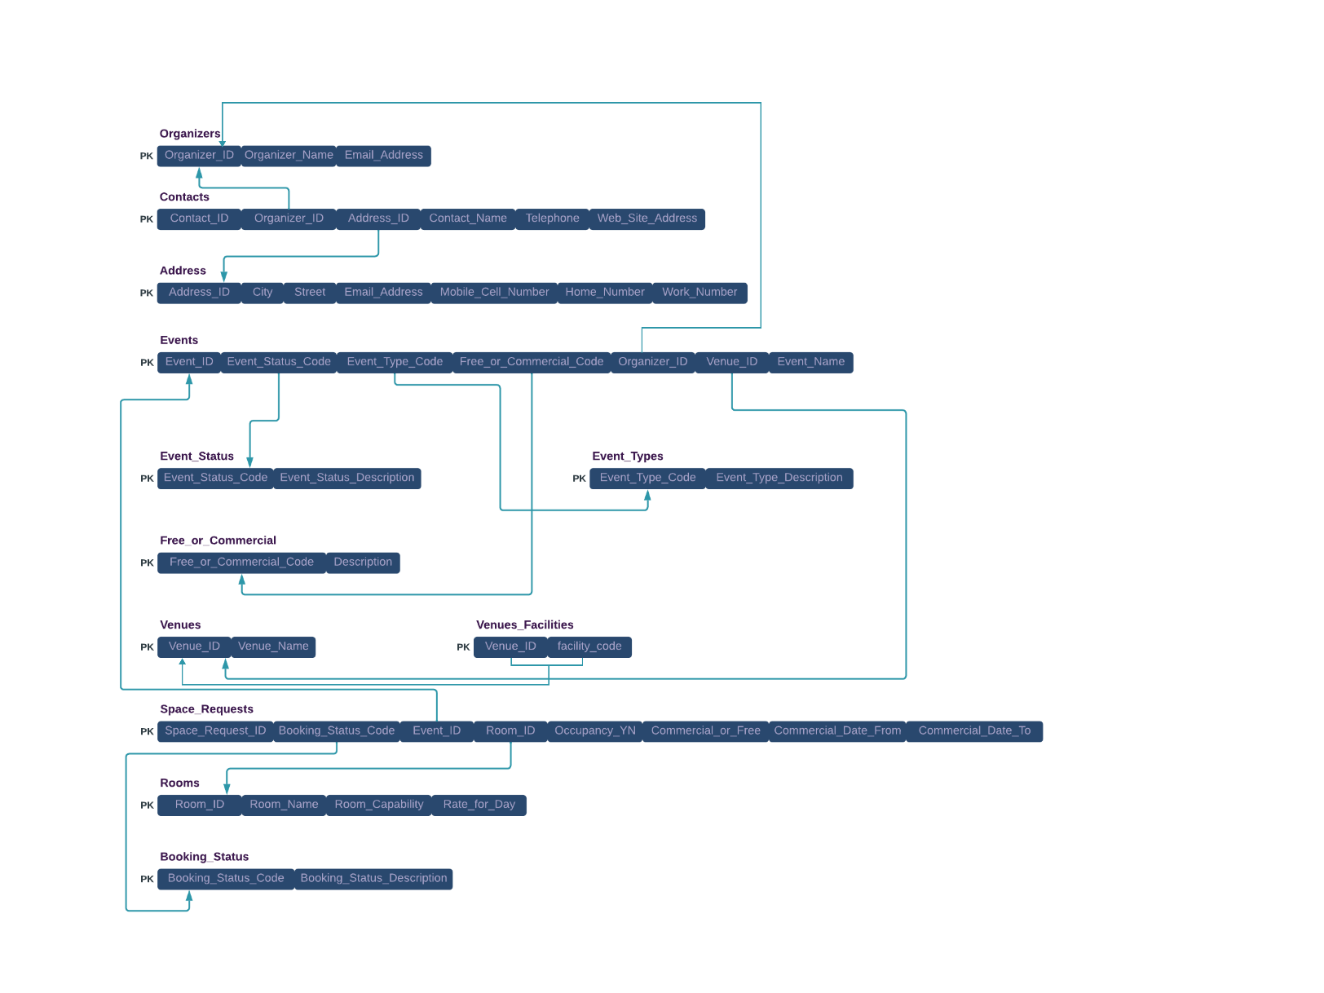

**Normalization**

**Third normal form** (**3NF**) is a [normal form](https://en.wikipedia.org/wiki/Database_normalization#Normal_forms) that is used in [normalizing](https://en.wikipedia.org/wiki/Database_normalisation) a [database](https://en.wikipedia.org/wiki/Database) design to reduce the duplication of data and ensure [referential integrity](https://en.wikipedia.org/wiki/Referential_integrity) by ensuring that:-

* the entity is in [second normal form](https://en.wikipedia.org/wiki/Second_normal_form)
* all the attributes in a table are determined only by the [candidate keys](https://en.wikipedia.org/wiki/Candidate_key) of that relation and not by any non-prime attributes.

3NF was designed to improve database processing while minimizing storage costs. 3NF data modeling was ideal for [online transaction processing (OLTP)](https://en.wikipedia.org/wiki/Online_transaction_processing) applications with heavy order entry type of needs.

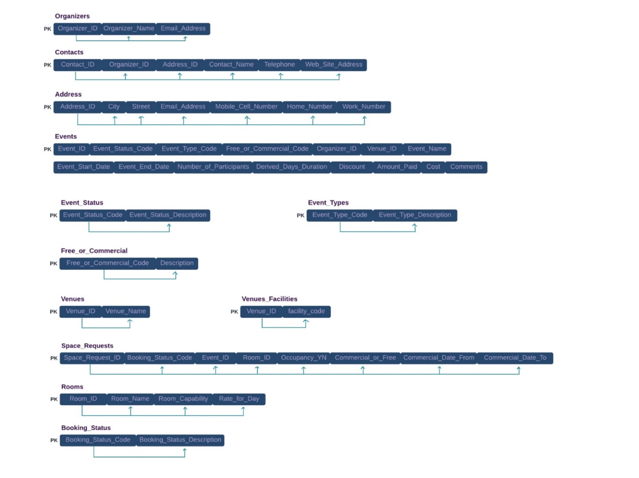

Functional dependency:

FD1: **{Organizer_id}**->{Organizer_Name,Email-Address}

FD2: **{Contact_ID}**->{ Organizer_id ,Address_ID,Contact_Name,Telephone,Web_Site_Address,}

FD3: **{Address_ID}**->{City,Street,Email-Address,Mobile_Cell_Number,Home_Number,Work_Number }

FD4**:{Event_ID}**->{Event_Status_Code,Event_Type_Code,Free_or_Commercial_Code,Organizer_ID,Venue_ID,Event_Name,Event_Status_Date,Event_End_Date,Number_of_Participants,Derrived_Days_Duration, Discount, Amount_Paid, Cost, Comments}

FD5: **{Event_Satus_Code}**->{ Event_Satus_Description}

FD6: **{Event_Type_Code}**->{ Event_Type_Description}

FD7: **{Free_or_Commercial_Code}**->{Description}

FD8: **{Venue_ID}**->{ Venue_Name}

FD9: **{Venue_ID,facility_code}**->{}

FD10: **{Space_Request _ID}**->{Booking_Status_Code,Event_ID,Room_ID,Occupancy_YN,Commercial_or_Free,Commercial_Date_From,Commercial_Date_To}

FD11: **{ Booking_Status_Code }**->{ Booking_Status_Description}

FD12: **{Room_ID}**->{ Room_Name,Room_Capability,Rate_for_Day}

**Specialization and Generalization**

**Generalization** is the process of extracting shared characteristics from two or more classes, and combining them into a **generalized** superclass. Shared characteristics can be attributes, associations, or methods.

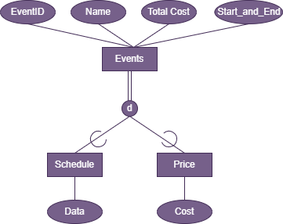

**Specialization** means creating new subclasses from an existing class.

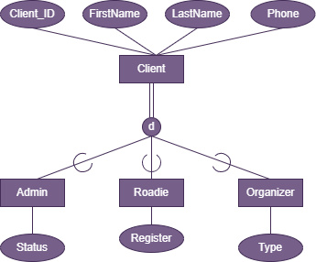

**ER-Diagram**

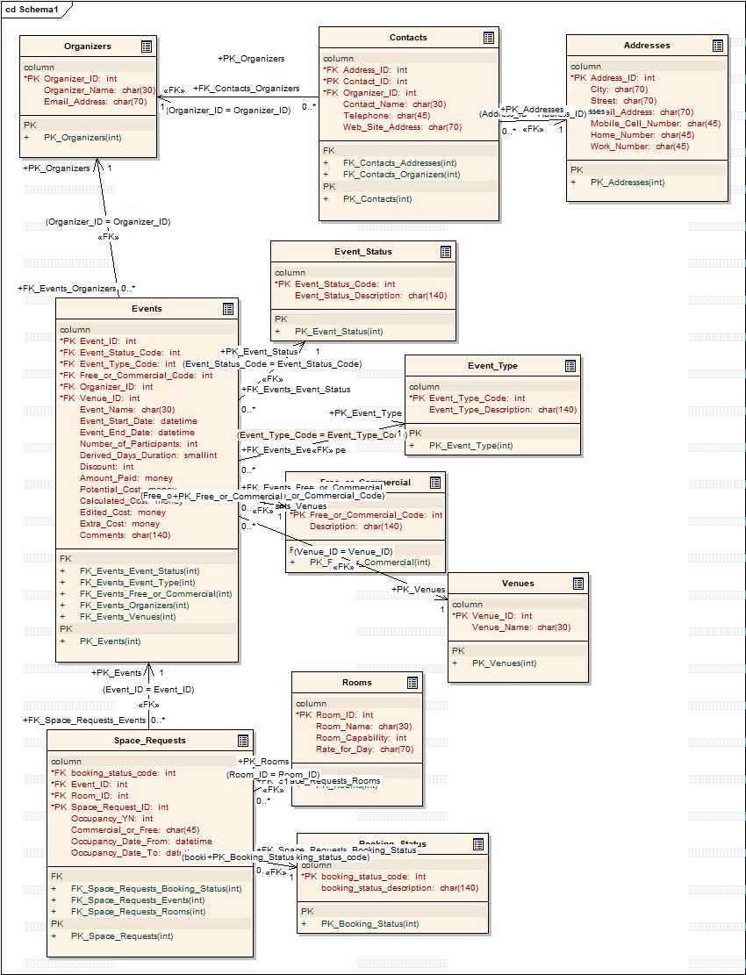

**SQL – Create Tables**

CREATE TABLE Addresses (

Address_ID int NOT NULL,

City char(70),

Street char(70),

Email_Address char(70),

Mobile_Cell_Number char(45),

Home_Number char(45),

Work_Number char(45));

CREATE TABLE Booking_Status (

booking_status_code int NOT NULL,

booking_status_description char(140));

CREATE TABLE Contacts (

Address_ID int NOT NULL,

Contact_ID int NOT NULL,

Organizer_ID int NOT NULL,

Contact_Name char(30),

Telephone char(45),

Web_Site_Address char(70));

CREATE TABLE Event_Status (

Event_Status_Code int NOT NULL,

Event_Status_Description char(140));

CREATE TABLE Event_Type (

Event_Type_Code int NOT NULL,

Event_Type_Description char(140));

CREATE TABLE Events (

Event_ID int NOT NULL,

Event_Status_Code int NOT NULL,

Event_Type_Code int NOT NULL,

Free_or_Commercial_Code int NOT NULL,

Organizer_ID int NOT NULL,

Venue_ID int NOT NULL,

Event_Name char(30),

Event_Start_Date datetime,

Event_End_Date datetime,

Number_of_Participants int,

Derived_Days_Duration smallint,

Discount int,

Amount_Paid money,

Potential_Cost money,

Calculated_Cost money,

Edited_Cost money,

Extra_Cost money,

Comments char(140));

CREATE TABLE Free_or_Commercial (

Free_or_Commercial_Code int NOT NULL,

Description char(140));

CREATE TABLE Organizers (

Organizer_ID int NOT NULL,

Organizer_Name char(30),

Email_Address char(70));

CREATE TABLE Rooms (

Room_ID int NOT NULL,

Room_Name char(30),

Room_Capability int,

Rate_for_Day char(70));

CREATE TABLE Space_Requests (

booking_status_code int NOT NULL,

Event_ID int NOT NULL,

Room_ID int NOT NULL,

Space_Request_ID int NOT NULL,

Occupancy_YN int,

Commercial_or_Free char(45),

Occupancy_Date_From datetime,

Occupancy_Date_To datetime);

CREATE TABLE Venues (

Venue_ID int NOT NULL,

Venue_Name char(30));

**SQL – Foreign Key**

ALTER TABLE Addresses ADD CONSTRAINT PK_Addresses

PRIMARY KEY (Address_ID);

ALTER TABLE Booking_Status ADD CONSTRAINT PK_Booking_Status

PRIMARY KEY (booking_status_code);

ALTER TABLE Contacts ADD CONSTRAINT PK_Contacts

PRIMARY KEY (Contact_ID);

ALTER TABLE Event_Status ADD CONSTRAINT PK_Event_Status

PRIMARY KEY (Event_Status_Code);

ALTER TABLE Event_Type ADD CONSTRAINT PK_Event_Type

PRIMARY KEY (Event_Type_Code);

ALTER TABLE Events ADD CONSTRAINT PK_Events

PRIMARY KEY (Event_ID);

ALTER TABLE Free_or_Commercial ADD CONSTRAINT PK_Free_or_Commercial

PRIMARY KEY (Free_or_Commercial_Code);

ALTER TABLE Organizers ADD CONSTRAINT PK_Organizers

PRIMARY KEY (Organizer_ID);

ALTER TABLE Rooms ADD CONSTRAINT PK_Rooms

PRIMARY KEY (Room_ID);

ALTER TABLE Space_Requests ADD CONSTRAINT PK_Space_Requests

PRIMARY KEY (Space_Request_ID);

ALTER TABLE Venues ADD CONSTRAINT PK_Venues

PRIMARY KEY (Venue_ID);

ALTER TABLE Contacts ADD CONSTRAINT FK_Contacts_Addresses

FOREIGN KEY (Address_ID) REFERENCES Addresses (Address_ID);

ALTER TABLE Contacts ADD CONSTRAINT FK_Contacts_Organizers

FOREIGN KEY (Organizer_ID) REFERENCES Organizers (Organizer_ID);

ALTER TABLE Events ADD CONSTRAINT FK_Events_Event_Status

FOREIGN KEY (Event_Status_Code) REFERENCES Event_Status (Event_Status_Code);

ALTER TABLE Events ADD CONSTRAINT FK_Events_Event_Type

FOREIGN KEY (Event_Type_Code) REFERENCES Event_Type (Event_Type_Code);

ALTER TABLE Events ADD CONSTRAINT FK_Events_Free_or_Commercial

FOREIGN KEY (Free_or_Commercial_Code) REFERENCES Free_or_Commercial (Free_or_Commercial_Code);

ALTER TABLE Events ADD CONSTRAINT FK_Events_Organizers

FOREIGN KEY (Organizer_ID) REFERENCES Organizers (Organizer_ID);

ALTER TABLE Events ADD CONSTRAINT FK_Events_Venues

FOREIGN KEY (Venue_ID) REFERENCES Venues (Venue_ID);

ALTER TABLE Space_Requests ADD CONSTRAINT FK_Space_Requests_Booking_Status

FOREIGN KEY (booking_status_code) REFERENCES Booking_Status (booking_status_code);

ALTER TABLE Space_Requests ADD CONSTRAINT FK_Space_Requests_Events

FOREIGN KEY (Event_ID) REFERENCES Events (Event_ID);

ALTER TABLE Space_Requests ADD CONSTRAINT FK_Space_Requests_Rooms

FOREIGN KEY (Room_ID) REFERENCES Rooms (Room_ID);

**All tables are created**

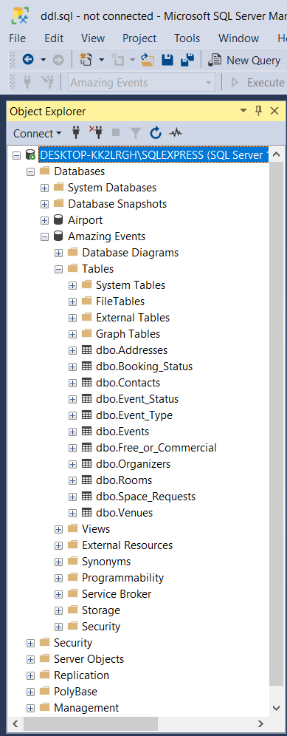

**Database diagram**

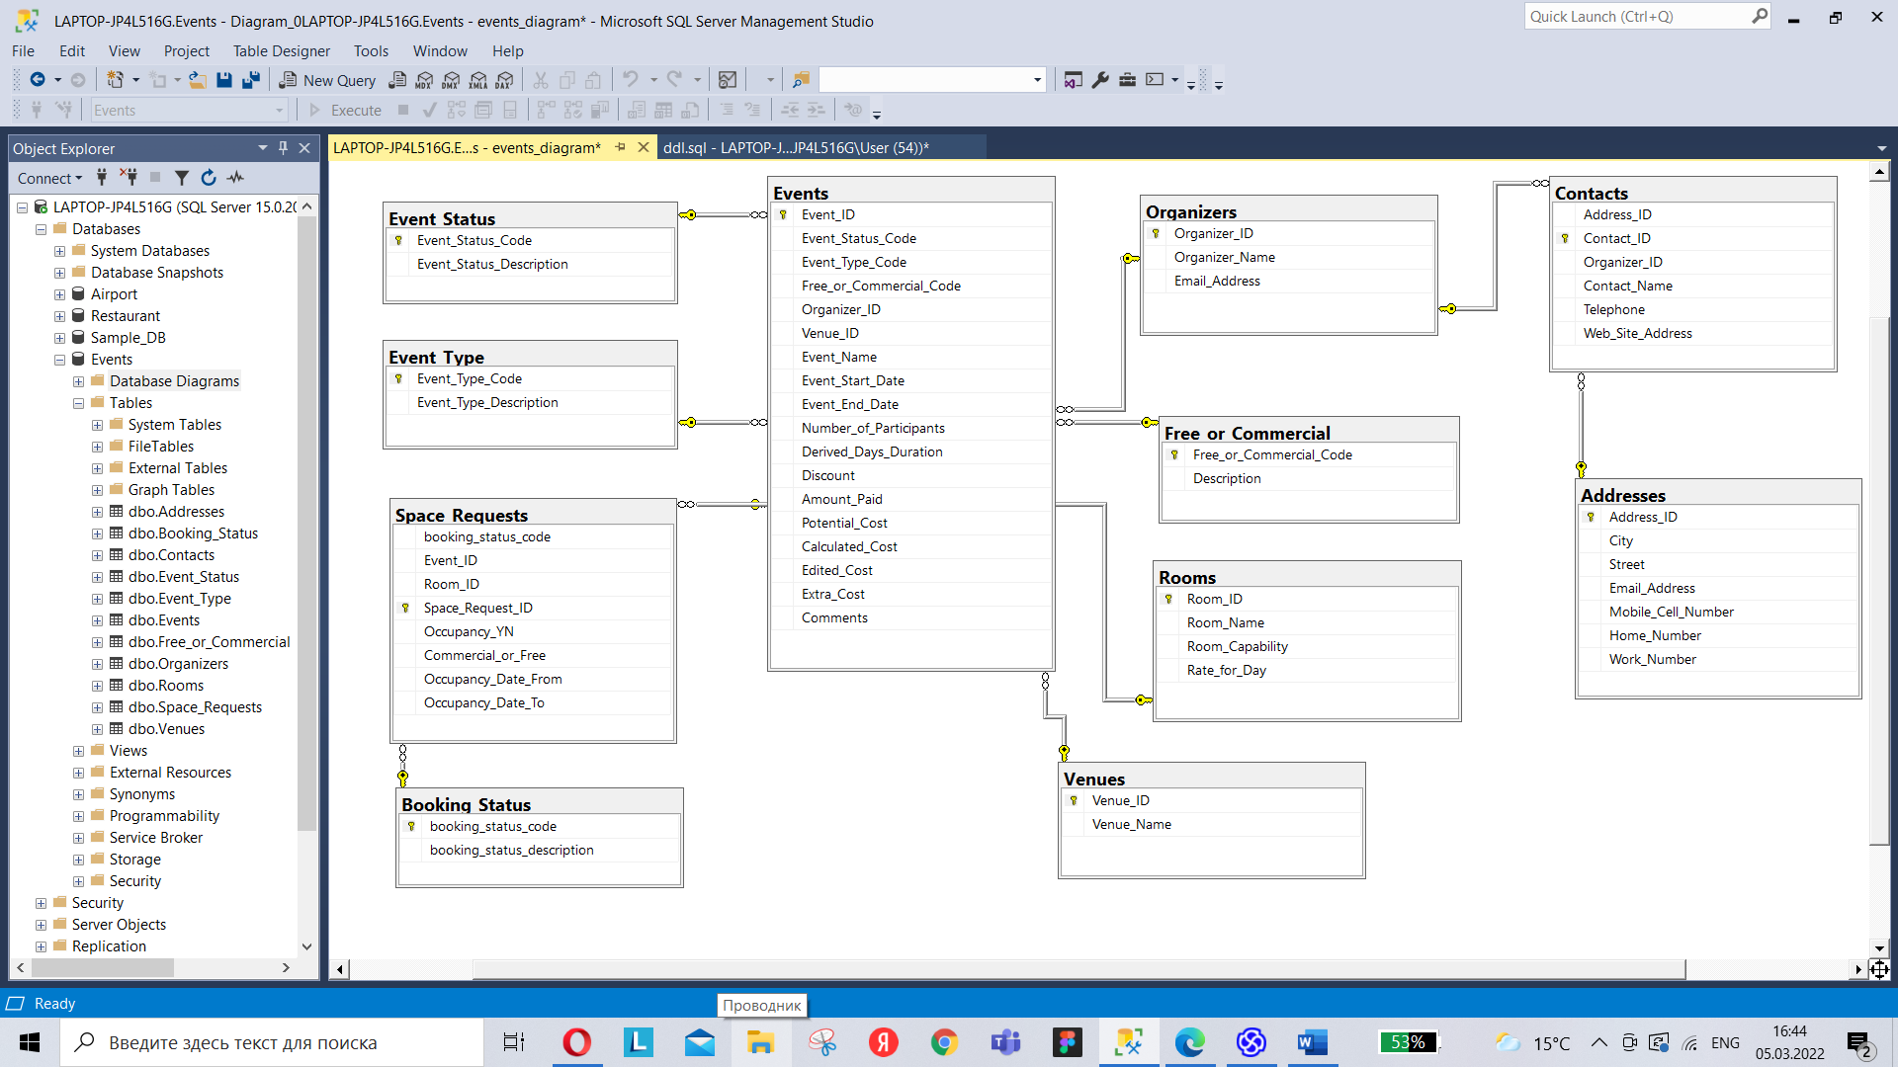

**Add Constraints**

Constraints in SQL are rules and constraints that are set on one or more tables. Such restrictions are necessary to maintain the integrity, accuracy, and reliability of the data in the table. In other words, if the entered values match the restriction rule, they will be successfully entered into the table itself. Otherwise, if the entered values do not match the conditions in the constraint rule, the data will not be entered into the table and the operation will be aborted. There are 6 main limitations in SQL Server:

1. SQL NOT NULL

This restriction prevents a NULL value from being inserted into a table column. When populating data into a table, this constraint indicates an error if the corresponding column has not been populated.

CREATE TABLE Event_Status (

Event_Status_Code int NOT NULL,

Event_Status_Description char(140));

1. UNIQUE

This constraint is used to prevent duplicate values by making the data in the table unique. In other words, the UNIQUE constraint ensures that no rows have the same value.

ALTER TABLE Contacts ADD CONSTRAINT UQ_Contacts_Contact_ID

UNIQUE(Contact_ID);

1. PRIMARY KEY

This constraint is used to identify each row in the table. Due to the PRIMARY KEY constraint, a table with this value cannot be NULL and duplicate values are not allowed when populating data in the table.

ALTER TABLE Events ADD CONSTRAINT PK_Events

PRIMARY KEY (Event_ID);

1. FOREIGN KEY

A FOREIGN KEY constraint is used to identify values in a table for a relationship between other tables by referencing a column in child columns that contains a foreign key. This can be seen in our example below.

ALTER TABLE Contacts ADD CONSTRAINT FK_Contacts_Addresses

FOREIGN KEY (Address_ID) REFERENCES Addresses (Address_ID);

1. CHECK

The CHECK constraint is designed to limit the range of values when entering data into a table by using a certain condition.

*Thanks to the "LIKE" operator, we specify that when entering data into the table, check the mail for the presence of the "@" sign, otherwise the data entry will not be allowed and an error will be displayed.*

ALTER TABLE Addresses ADD CONSTRAINT CK_Email_Address

CHECK(Email_Address LIKE '%@%');

1. DEFAULT

This constraint helps to populate the table with the default values that were specified in the condition. It will fill a row in the table with a default value if no value’s specified when you enter it.

*In our case, thanks to the DEFAULT constraint, we specify that if the string for the date is not filled, it will default to the current date using the GETDATE() statement.*

ALTER TABLE Events ADD CONSTRAINT CK_Events_StarDate

DEFAULT GETDATE() FOR Event_Start_Date;

ALTER TABLE Events ADD CONSTRAINT CK_Events_EndDate

DEFAULT GETDATE() FOR Event_End_Date;

**Insert Statements**

* **Addresses**

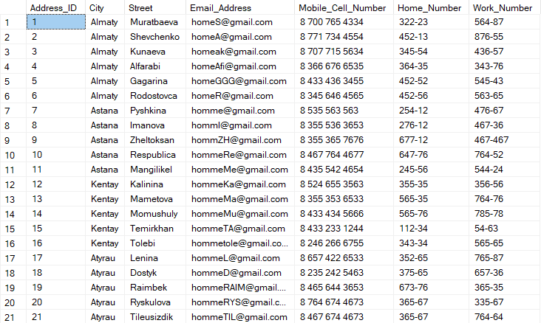

* **Booking_Status**

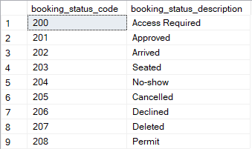

* **Contacts**

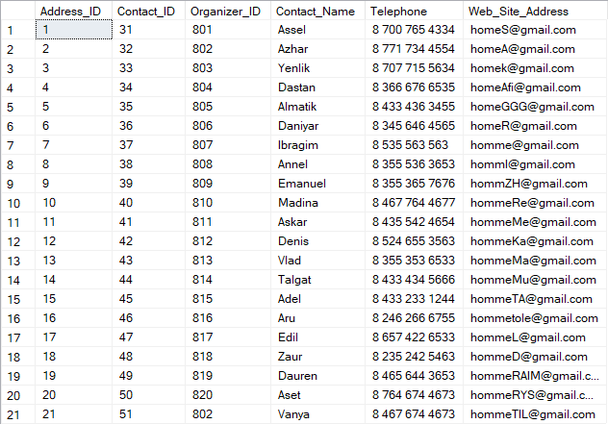

* **Event_Status**

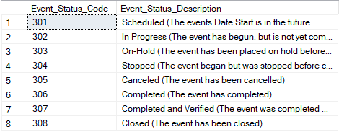

* **Event_Type**

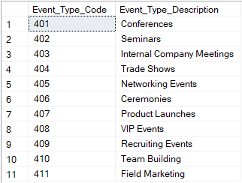

* **Events**

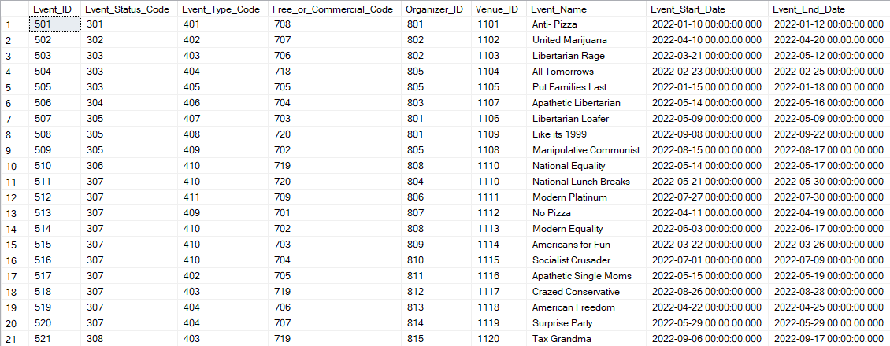

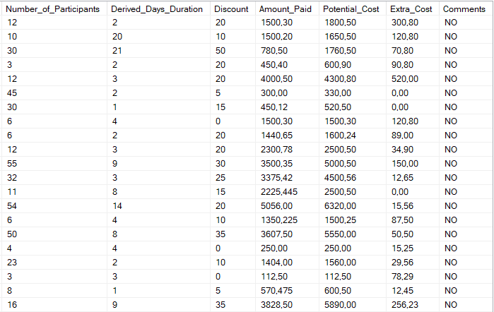

* **Free_or_Commercial**

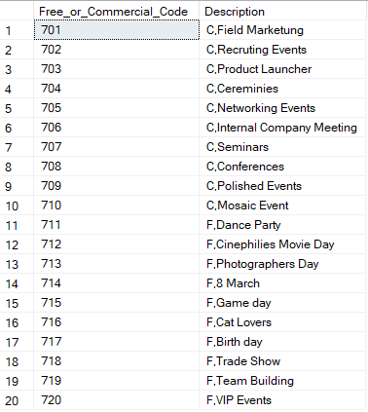

* **Organizers**

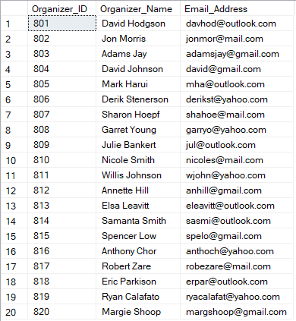

* **Rooms**

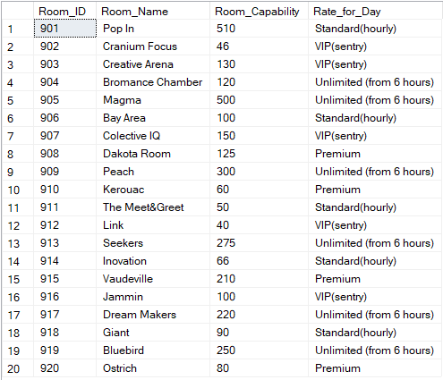

* **Space_Requests**

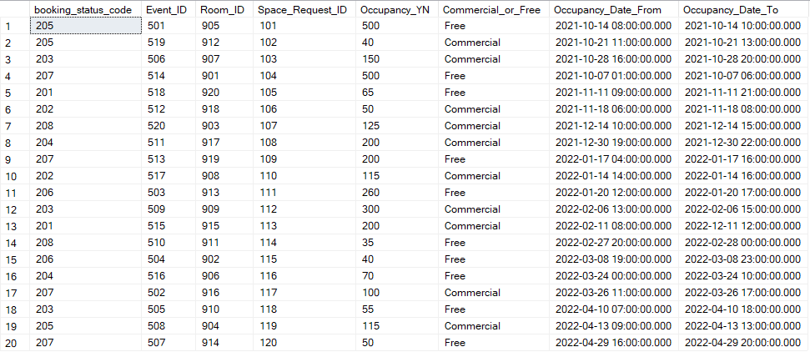

* **Venues**

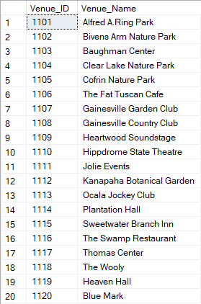

**Select**

--1. Display the first and last date of the event for each tariff with their count and sum of amount where the payment for the event exceeds 700 dollars

SELECT R.Rate_for_Day,

count(*) as count,

min(SR.Occupancy_Date_From) as first_date_from,

max(SR.Occupancy_Date_To) as end_date_to,

sum(E.Amount_Paid) as sum_amount

FROM Rooms R JOIN Space_Requests SR ON R.Room_ID=SR.Room_ID

JOIN Events E ON SR.Event_ID=E.Event_ID

where E.Amount_Paid>700.0

GROUP BY R.Rate_for_Day

ORDER BY first_date_from

Result:

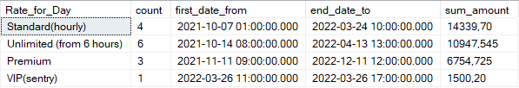

(4 rows affected)

Completion time: 2022-04-18T22:51:45.8016989+06:00

--2. Find past events in ascending order when the occupancy of a place request was less than 500

SELECT DISTINCT SR.Event_ID,E.Event_Name,E.Event_Start_Date,E.Event_End_Date,E.Number_of_Participants,E.Derived_Days_Duration,E.Amount_Paid,SR.Commercial_or_Free FROM Events E,Space_Requests SR WHERE

SR.Event_ID IN(SELECT Event_ID FROM Space_Requests

GROUP BY Event_ID HAVING COUNT(Space_Requests.Occupancy_YN)<500) AND

E.Event_End_Date<'2022-04-19 00:00:00' AND

E.Event_ID=SR.Event_ID

ORDER BY Event_ID;

Result:



(4 rows affected)

Completion time: 2022-04-18T22:55:58.0610303+06:00

--3. Print the name of the client indicating his city and organizer, where the potential cost exceeds the extra costs, sorted in descending order of the potential cost

SELECT A.City,C.Contact_Name,O.Organizer_Name, E.Potential_Cost FROM Addresses A

JOIN Contacts C ON A.Address_ID=C.Address_ID

JOIN Organizers O ON C.Organizer_ID=O.Organizer_ID

JOIN Events E ON O.Organizer_ID=E.Organizer_ID

WHERE Potential_Cost>(SELECT SUM(Extra_Cost)FROM Events)

ORDER BY Potential_Cost DESC

Result:

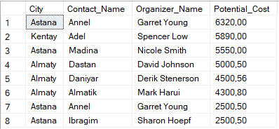

(8 rows affected)

Completion time: 2022-04-19T03:00:33.0062656+06:00

--4. Display in one table the average amount paid by booking code and individual values of the amount paid of events grouped by booking code where booking status starts with D

SELECT Event_Name,BS.booking_status_code,Amount_Paid FROM Events E

JOIN Space_Requests SR ON E.Event_ID=SR.Event_ID

JOIN Booking_Status BS ON SR.booking_status_code=BS.booking_status_code

WHERE booking_status_description LIKE 'D%'

UNION

(SELECT 'Z-AVG' AS Event_Name,BS.booking_status_code,AVG(Amount_Paid) AS Amount_Paid FROM Events E

JOIN Space_Requests SR ON E.Event_ID=SR.Event_ID

JOIN Booking_Status BS ON SR.booking_status_code=BS.booking_status_code

WHERE booking_status_description LIKE 'D%'

GROUP BY BS.booking_status_code)

ORDER BY BS.booking_status_code,Event_Name

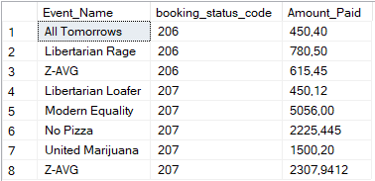

(8 rows affected)

Completion time: 2022-04-19T03:26:53.8132501+06:00

**Update**

--1. Increase by 30% the potential cost and amount paid for events where the name contains American

UPDATE Events

SET Potential_Cost=1.3*Potential_Cost,Amount_Paid=1.3*Amount_Paid

WHERE Event_Name LIKE '%American%'

(2 rows affected)

Completion time: 2022-04-19T02:09:31.8764057+06:00

--2. Change the occupancy for an event with ID 520 or with a occupancy date from January 20 at 12 p.m.

UPDATE Space_Requests

SET Occupancy_YN=130

WHERE Event_ID=520

OR Occupancy_Date_From = '2022-01-20 12:00:00'

(2 rows affected)

Completion time: 2022-04-19T02:17:46.5909811+06:00

--3. Update the contact name from id 44 to Asset and number to 8 701 469 58 89

UPDATE Contacts

SET Contact_Name='Asset', Telephone='8 701 469 58 89'

WHERE Contact_ID=44

(1 row affected)

Completion time: 2022-04-19T02:30:37.8725291+06:00

--4. Update from address mobile number to contact telephones for all addresses with an ID less than 7

UPDATE Addresses

SET Mobile_Cell_Number = C.Telephone

FROM Addresses A

INNER JOIN Contacts C

ON (A.Email_Address = C.Web_Site_Address)

WHERE A.Address_ID <7 ;

(5 rows affected)

Completion time: 2022-04-19T02:44:16.6547981+06:00

**Delete**

--1. Remove a description from a free or commercial table that has a Day

DELETE FROM Free_or_Commercial

WHERE Description LIKE '%Day%'

(4 rows affected)

Completion time: 2022-04-19T03:37:13.6977822+06:00

--2. Delete customers whoms name's leght is 5 letters and starts from A

DELETE FROM Contacts

WHERE len(Contact_Name) = 5

AND Contact_Name LIKE 'A%'

(5 rows affected)

Completion time: 2022-04-19T13:15:48.4493579+06:00

--3. Remove from Venues where Venue name include word Park

DELETE FROM Venues

WHERE Venue_Name LIKE '%Park'

(4 rows affected)

Completion time: 2022-04-19T13:21:47.9592773+06:00

--4. Remove Events which price is low than average cost of full events

DELETE FROM Events

WHERE Amount_Paid < (SELECT AVG(Amount_Paid) FROM Events)

(13 rows affected)

Completion time: 2022-04-19T13:20:11.3105898+06:00

**View**

--1. Event, start and end date of the event, number of participants more than 20, event status, venue name, discount on the event

SELECT * FROM Eventdetails

CREATE VIEW Eventdetails

AS

SELECT dbo.Events.Event_Name,

dbo.Events.Event_Start_Date,

dbo.Events.Event_End_Date,

dbo.Events.Number_of_Participants,

dbo.Event_Status.Event_Status_Description,

dbo.Venues.Venue_Name,

((dbo.Events.Potential_Cost*dbo.Events.Discount)/100) as Discount_Cost

FROM dbo.Event_Status INNER JOIN dbo.Events ON

dbo.Event_Status.Event_Status_Code = dbo.Events.Event_Status_Code INNER JOIN

dbo.Venues ON dbo.Events.Venue_ID = dbo.Venues.Venue_ID

WHERE dbo.Events.Number_of_Participants > 20

GROUP BY dbo.Events.Event_Name,

dbo.Events.Event_Start_Date,

dbo.Events.Event_End_Date,

dbo.Events.Number_of_Participants,

dbo.Event_Status.Event_Status_Description,

dbo.Venues.Venue_Name,

((dbo.Events.Potential_Cost*dbo.Events.Discount)/100)

Result:

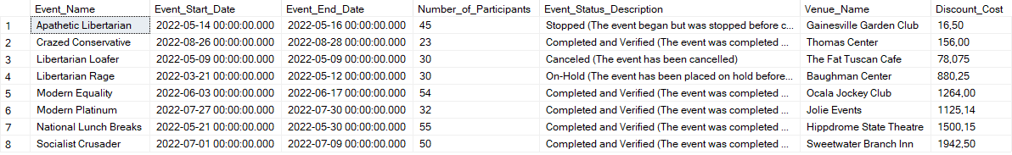

(8 rows affected)

Completion time: 2022-04-18T23:30:30.9748400+06:00

--2. Booking status and its count, average occupancy and sum number of participants for each status, where the duration of the event days is more than a week

SELECT * FROM Booking

CREATE VIEW Booking

AS

SELECT BS.booking_status_description,count(*) AS count, AVG(SR.Occupancy_YN) AS avg_occupancy,SUM(E.Number_of_Participants) as sum_num_of_participant

FROM Booking_Status BS

INNER JOIN Space_Requests SR ON BS.booking_status_code = SR.booking_status_code

INNER JOIN Events E ON SR.Event_ID = E.Event_ID

WHERE E.Derived_Days_Duration >7

GROUP BY BS.booking_status_description

Result:

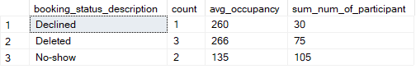

(3 rows affected)

Completion time: 2022-04-19T00:05:20.1423422+06:00

--3. Declined booking status where Organizer is Jon Morris

SELECT * FROM DeclinedStatus_details

CREATE VIEW DeclinedStatus_details

AS

SELECT Contact_Name, Telephone, City,booking_status_description, Organizers.Organizer_ID, Organizer_Name

FROM Contacts

JOIN Addresses ON Contacts.Address_ID = Addresses.Address_ID

JOIN Booking_Status ON Booking_Status.booking_status_description = Booking_Status.booking_status_description

JOIN Organizers ON Contacts.Organizer_ID = Organizers.Organizer_ID

WHERE booking_status_description = 'Declined' AND Organizers.Organizer_ID = 802

Result:



(1 row affected)

Completion time: 2022-04-19T13:25:13.5055922+06:00

--4. Event's price is above the average price, and has status Completed

SELECT * FROM EventsAboveaveragePrice

CREATE VIEW EventsAboveaveragePrice

AS

SELECT Event_Name, Amount_Paid, Event_Status_Description,Event_Type_Description

FROM Events

JOIN Event_Type ON Events.Event_Type_Code = Event_Type.Event_Type_Code

JOIN Event_Status ON Events.Event_Status_Code = Event_Status.Event_Status_Code

WHERE Amount_Paid > (SELECT AVG(Amount_Paid) FROM Events) AND Event_Status_Description LIKE '%Completed%'

Result:

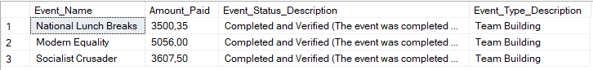

(3 rows affected)

Completion time: 2022-04-19T13:32:26.0526301+06:00

--5. Find amont of duration where cost is more than 1550

SELECT * FROM AmountOfDuration

CREATE VIEW AmountOfDuration

AS

SELECT Event_Name, Amount_Paid, DATEDIFF(DAY, Event_Start_Date, Event_End_Date) as kunder

FROM Events

WHERE Amount_Paid > 1550

Result:

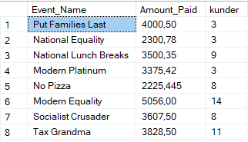

(8 rows affected)

Completion time: 2022-04-19T13:35:18.5756928+06:00

**DBMS and Driver**

**Microsoft SQL Server** is a relational database management system developed by Microsoft Corporation. It allows you to connect to it locally or over the network, send a command using a special TDS protocol and, accordingly, receive a response. This server supports remote connections, works with many popular data types, makes it possible to create triggers and stored data, has practical and convenient utilities for configuration;

SQL Server is characterized by such features as:

* Efficiency. SQL Server is very fast.
* Reliability and safety. SQL Server provides data encryption.
* Simplicity. This DBMS is relatively easy to work with and administer.

**JDBC – Java DataBase Connectivity** – connection to Java databases. This is the standard of interaction with the database. Its interface comes in a standard JDK in the form of a java.sql package. Whatever library you use to work with the database, it is almost always based on low-level JDBC.

JDBC driver is a JDBC implementation for a specific database. Several different drivers can be registered in the application. When connecting to the database, the desired one is selected based on the connection URL.