Workshop – Analysis of the amount of data downloaded from an Earth Observation (EO) satellite using Adaptive Coding and Modulation (ACM).

Máster Universitario en Sistemas Espaciales

Course: Communications. Academic course: 2020/21

|  |  |  |
| --- | --- | --- |
| Group members: | | |
| Name: | WL (X) | E-mail |
| David Estébanez Mérida |  | _________@alumnos.upm.es | |
| Andrés Pedraza Rodríguez |  | ________@alumnos.upm.es | |
| María Elena Piqueras Carreño |  | _________@alumnos.upm.es | |
| Daniel del Río Velilla |  | _________@alumnos.upm.es | |
| Ana Isabel Soria Carro |  | _________@alumnos.upm.es | |
|  |  | _________@alumnos.upm.es | |

Scope – The scope of this workshop is to analyse the amount of data that can be downloaded from an EO satellite in a sun-synchronous orbit (SSO) by a predefined ground station using ACM (Adaptive Coding and Modulation).

This document explains the tasks than shall be carried out by students in order to complete the workshop.

Organization: Students shall be organized themselves in groups of 5-6 students each with a workshop leader (WL). The WL will report the team members in the corresponding Moodle task.

Note.- This project shall be performed avoiding on-site meetings, so student groups are required to organize themselves using Teams.

It is recommended that each team shares the document with the lecturers using Microsoft Office 365. This would allow the supervision project progress.

Planning: each team WL will submit the document in Moodle before **April 30th, 2021**. Supervisors suggests to follow the next planning and incorporate the dates in which every task is finished in the following table.

|  |  |  |  |  |  |  |  |
| --- | --- | --- | --- | --- | --- | --- | --- |
|  | Week 1 | Week 2 | Week 3 | Week 4 | Week 5 | Week 6 | Week 7 |
| Task 0 |  |  |  |  |  |  |  |
| Task 1 |  |  |  |  |  |  |  |
| Task 2 |  |  |  |  |  |  |  |
| Task 3 |  |  |  |  |  |  |  |
| Task 4 |  |  |  |  |  |  |  |
| Task 5 |  |  |  |  |  |  |  |
| Task 6 |  |  |  |  |  |  |  |
| Task 7 |  |  |  |  |  |  |  |
| Task 8 |  |  |  |  |  |  |  |

Supervision and support: on-line tutorials in Teams will be carried out on demand by the students.

Input data (communications):

* Minimum elevation angles: 10, 20, 30 degrees
* EIRP of the satellite: 22 dBW
* G/T of the ground station: antenna diameter is 5 m, antenna temperature is 40 K and receiver noise figure is 2 dB
* Bandwidth: 300 MHz
* Mission analysis period: 60 days
* Losses due to gaseous absorption, rain attenuation and other impairments: 3 dB (X band), 6 dB (Ka).

# Task 0. Selection of system parameters

Each team shall investigate and select the next information:

* SSO – Select a typical SSO orbit for EO. At least, inclination and altitude shall be provided.
* Select a ground station location

Please fill in the shadowed column of the table.

|  |  |  |
| --- | --- | --- |
| Parameter | | *Input* |
| Reference EO mission selected and URL where information has been obtained | | Sentinel-3 https://sentinels.copernicus.eu/web/sentinel/missions/sentinel-3/satellite-description/orbit |
| Orbital inclination (degrees) | | 98.65º |
| Orbital altitude (km) | | 814.5 km |
| Ground station | Longitude (deg E): | 15º 24’ |
| Latitude (deg N): | 78º 13’ |
| Frequency (GHz) | | X-Band (8-12 GHz) |

# Task 1. Ground station to satellite range

Using a mission analysis simulator (GMAT, STK, Freeflyer), each team shall produce a matrix with information of the distance (range) to the satellite from the selected ground stations under different minimum elevation conditions.

During the pass, consider 20 seconds as sampling time to calculate the distances.

Export this range information to Matlab or similar software. In the next steps or tasks, this is the software that shall be used for the postprocessing and extraction of results.

Deliverable from this task: set of range data for the three minimum elevation angles specified in the workshop.

# Task 2. Histogram with duration of visibility intervals.

For the periods of visibility generated in Task 1, generate a histogram with the duration of the passes.

Three histograms (one per minimum elevation angle) will be graphed in the same figure for comparison purposes. Fill in the next table with information of the average pass duration:

|  |  |
| --- | --- |
| Minimum elevation (deg) | *Average pass duration (minutes)* |
| 10 | *8.94* |
| 20 | *6.67* |
| 30 | *4.90* |

Please include the figure in the next table.

|  |
| --- |
|  |

# Task 3. Calculation of C/N during the pass

The carrier to noise ratio (C/N) in the downlink can be calculated as:

Where:

* : EIRP of the satellite transmitter
* : G/T of the ground station
* : free space losses of the link
* : additional losses
* is the Boltzmann constant (-228,6 dBW/(K·Hz))
* is the noise bandwidth in Hz

First step in this task is the calculation of the ground station G/T. Antenna gain can be calculated using:

Consider a 60% antenna efficiency.

In this case study, noise temperature of the receiver is formed by the contribution of the antenna temperature and the receiver temperature in Kelvin:

Where is the receiver noise figure in dB, is the reference temperature (290 K).

Thus, the G/T of the ground station is obtained as:

For each of the passes, generate a script that:

* Calculate the free space losses (in dB) during the pass each 10 seconds
* Calculate the C/N of the link (*CNlink*) in dB each 10 seconds

Plot in the same graph with a *plotyy* or similar function the distance vs time and C/N variation during the pass.

|  |
| --- |
|  |

# Task 4. Selection of MODCOD and calculation of the amount of data downloaded during each pass and in total.

MODCOD defines a joint modulation and channel coding scheme (e.g. QPSK ¾ means a signal modulated in QPSK that has been channel encoded with a coding rate of ¾ - 1 redundant bit per each 3 information bits).

In this wokshop we consider ACM (Adaptive Coding ad Modulation) transmission scheme. It means that ground station and satellite can exchange information about the status of the link (e.g. C/N) and the satellite can modify the MODCOD in order to maximize the capacity of the link (i.e. select the MODCOD with higher spectral efficiency that satisfies the C/N of the link).

Consider the next table of MODCOD with information of the required C/N (*CNreq*) and spectral efficiency in bps/Hz (i.e. if the spectral efficiency is 3 bps/Hz, it means that in B MHz, 3B Mbps can be transmitted). The required C/N states which is the minimum C/N in the link to detect the received signal with a bit error rate low enough to consider a useful communication. Thus:

* If *CNlink* > *CNreq*, it means that the link is feasible and there exists a link margin (*LM* [dB] = *CNlink* - *CNreq*) to reduce transmit power, antenna gain, etc. The higher the link margin, the more over dimensioned the communication equipment is.
* If *CNlink* < *CNreq*, it implies a number of errors higher than specified, and the link is not feasible.

*Table. List of available MODCODs for the satellite link.*

|  |  |  |  |
| --- | --- | --- | --- |
| ID | MODCOD | *CNreq* [dB] | Efficiency [bps/Hz] |
| 1 | 32APSK 9/10 | 16,13 | 4,15 |
| 2 | 32APSK 8/9 | 15,83 | 4,10 |
| 3 | 32APSK 5/6 | 14,41 | 3,84 |
| 4 | 32APSK 4/5 | 13,83 | 3,68 |
| 5 | 32APSK 3/4 | 12,90 | 3,45 |
| 6 | 16APSK 8/9 | 12,08 | 3,28 |
| 7 | 16APSK 5/6 | 11,77 | 3,07 |
| 8 | 16APSK 4/5 | 11,19 | 2,94 |
| 9 | 16APSK 3/4 | 10,35 | 2,76 |
| 10 | 16APSK 2/3 | 9,08 | 2,45 |
| 11 | 8PSK 3/4 | 8,05 | 2,07 |
| 12 | 8PSK 2/3 | 6,68 | 1,84 |
| 13 | 8PSK 3/5 | 5,63 | 1,66 |
| 14 | QPSK 5/6 | 5,34 | 1,54 |
| 15 | QPSK 4/5 | 4,82 | 1,48 |
| 16 | QPSK 3/4 | 4,21 | 1,38 |
| 17 | QPSK 2/3 | 3,23 | 1,23 |
| 18 | QPSK 3/5 | 2,40 | 1,10 |
| 19 | QPSK 1/2 | 1,14 | 0,92 |
| 20 | QPSK 2/5 | -0,25 | 0,73 |
| 21 | QPSK 1/3 | -1,30 | 0,61 |
| 22 | QPSK 1/4 | -2,54 | 0,46 |

In this task, prepare a Matlab script that: 1) selects the most appropriate MODCOD to maximize the amount of data downlinked and 2) calculates the amount of data downlinked in each pass considering the spectral efficiency of the selected MODCOD and the time during which each MODCOD is used.

The selection of the MODCOD shall be carried out considering:

* The *CNreq*, of the selected MODCOD shall comply with *CNlink* > *CNreq ;*
* Each MODCOD shall be used during at least 30 seconds to avoid the continuous exchange of information between satellite and ground station
* Selection of the MODCOD must be done each ten seconds.

Plot the list of used MODCODs used in a representative pass (hint: use the *stairs* function in Matlab). Complete with a table showing the percentage of time that each MODCOD would be used.

|  |  |  |  |  |  |  |  |  |  |  |  |  |  |  |  |  |  |  |  |  |  |  |  |  |
| --- | --- | --- | --- | --- | --- | --- | --- | --- | --- | --- | --- | --- | --- | --- | --- | --- | --- | --- | --- | --- | --- | --- | --- | --- |
| |  |  |  | | --- | --- | --- | | Modulacion | Duracion | Porcentaje | | 32APSK 9/10 | 290 | 44,546851 | | 32APSK 8/9 | 60 | 9,216589862 | | 32APSK 5/6 | 60 | 9,216589862 | | 32APSK 4/5 | 60 | 9,216589862 | | 32APSK 3/4 | 60 | 9,216589862 | | 16APSK 8/9 | 60 | 9,216589862 | | 16APSK 4/5 | 61 | 9,370199693 | |
|  |
| |  |  |  | | --- | --- | --- | | Modulacion | Duracion | Porcentaje | | 32APSK 9/10 | 280 | 60,60606061 | | 32APSK 8/9 | 60 | 12,98701299 | | 32APSK 5/6 | 60 | 12,98701299 | | 32APSK 4/5 | 62 | 13,41991342 | |
|  |
| |  |  |  | | --- | --- | --- | | Modulacion | Duracion | Porcentaje | | 32APSK 9/10 | 336 | 100 | |

# Task 5. Comparison of results of downlinked data

Use the script developed in the previous task to obtain the amount of data that can be downlinked in each satellite pass.

If a MODCOD with spectral efficiency is used during seconds of the link, the amount of data downlinked in can be approximated as:

Where *B* is the signal bandwidth.

Students shall see the time each MODCOD is used and aggregate the amount of data downlinked during each interval.

Fill in the next table with information of the average data downlinked per pass and the total data downloaded in the 60 days for different minimum elevation angles:

|  |  |  |
| --- | --- | --- |
| Minimum elevation (deg) | *Average data downlinked per pass (MB)* | *Total downlinked in 60 days (MB)* |
| 10 |  |  |
| 20 |  |  |
| 30 |  |  |

# Task 6. Source encoding

Which source encoder would you select for the payload data (consider the payload instrument and proposed services by the mission)? Is it the source encoder lossy or lossless? Compare the number of raw images that could be downlinked to that using the proposed source encoder. Comment on the impact of the source encoder on the platform subsystems. Justify the answers.

|  |
| --- |
|  |

|  |  |  |
| --- | --- | --- |
| Minimum elevation (deg) | *Number of raw images downlinked per pass* | *Number of compressed images downlinked per pass* |
| 10 |  |  |
| 20 |  |  |
| 30 |  |  |

# Task 7. Communication system architecture

Sketch in the next table a block diagram of the communication system architecture used to downlink payload data to the ground segment. Start from the instrument (radar, camera, etc.) and finish in the transmit antenna to see the data flow in the satellite.

|  |
| --- |
|  |

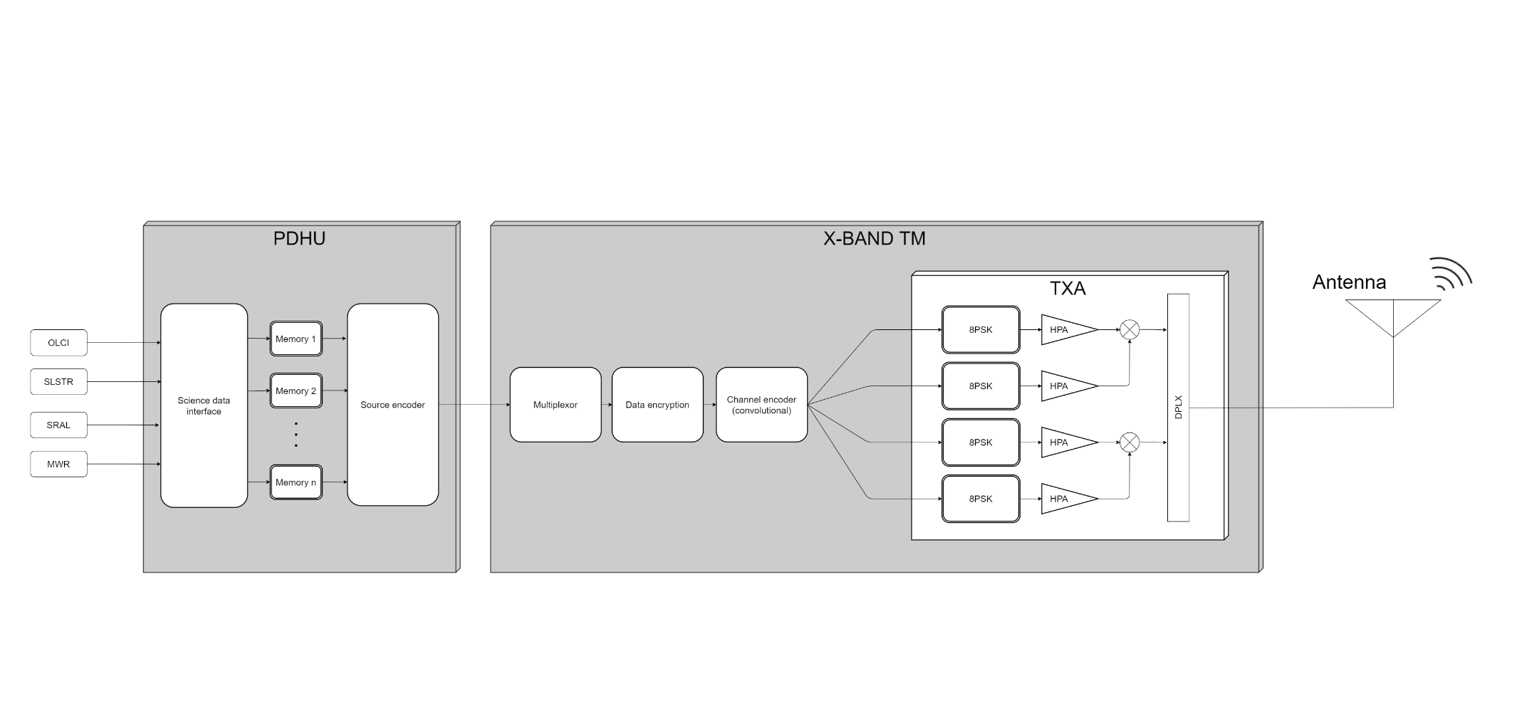

Explain how the process of adapting the transmission scheme would be carried out. Provide pros and cons of the proposed solution.

|  |
| --- |
|  |

# Task 8. Conclusions

Considering the previous results, fill in next table your conclusions. Indicate how would you increase the amount of downloaded data and the impact on the system architecture.

|  |
| --- |
|  |